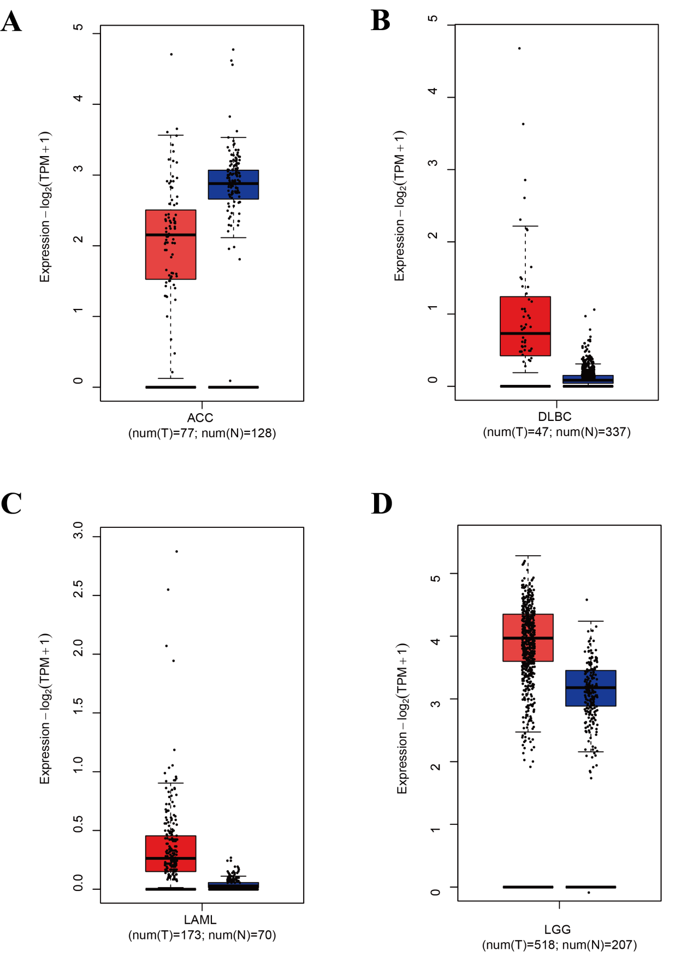
Supplementary Figure 1 shows that DIP2C expression levels do not exhibit significant differences in ACC (adrenocortical carcinoma), DLBA (diffuse large B-cell lymphoma), LAML (acute myeloid leukemia), and LGG (low-grade glioma).

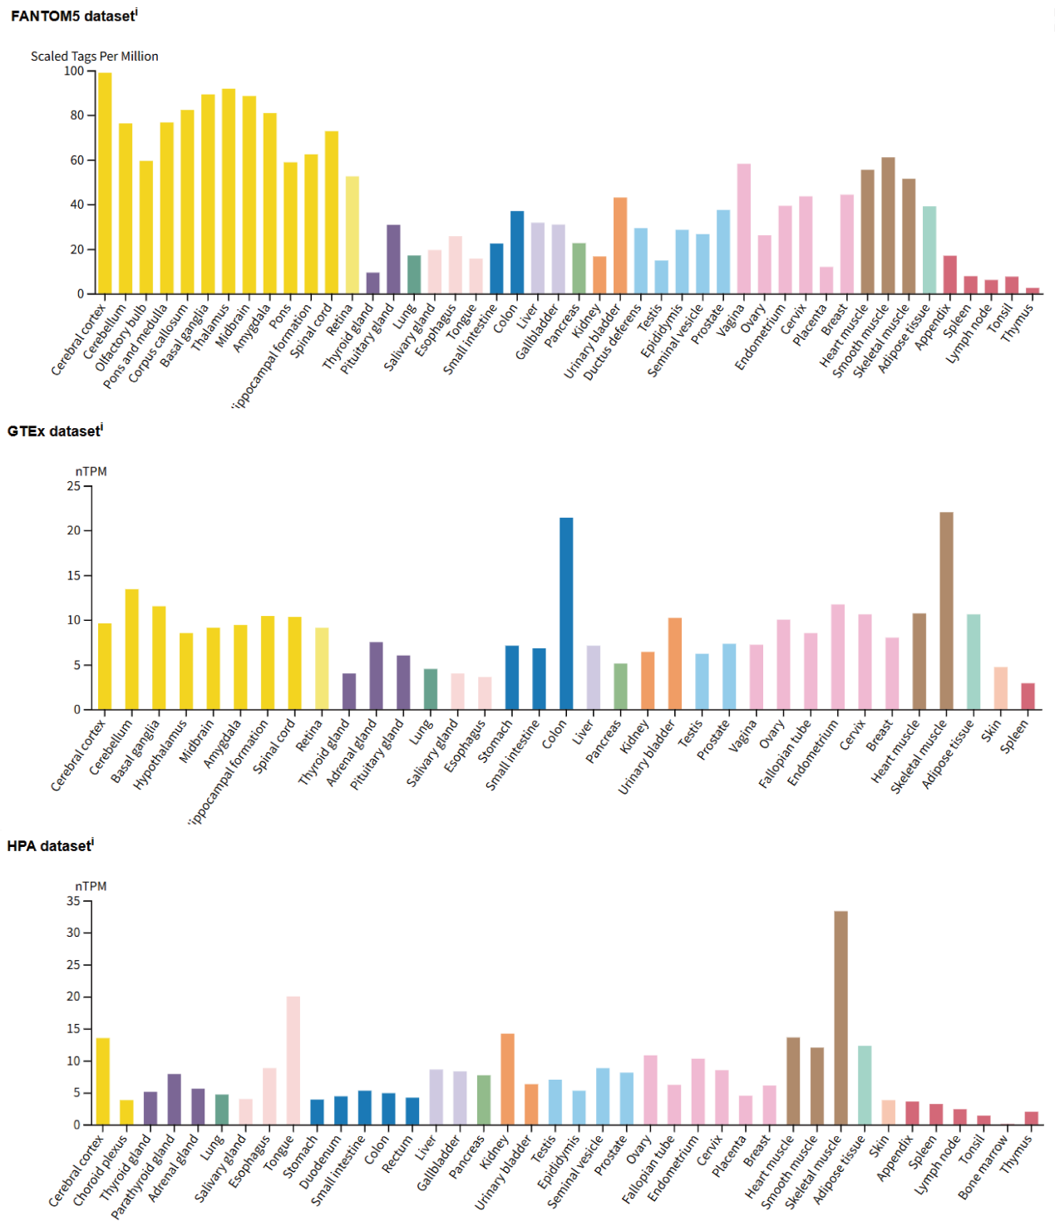
Supplementary Figure 2 DIP2C Expression Status in Various Normal Tissues. (A-C) DIP2C tissue expression profiles derived from the Function Annotation of the Mammalian Genome 5 (FANTOM5) databases, GTEx, and the Human Protein Atlas (HPA).

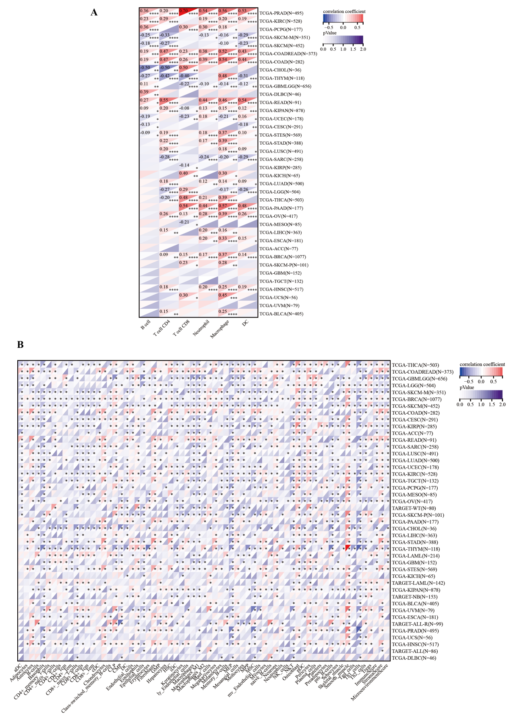
Supplementary Figure 3 Correlation between DIP2C expression and immune cell infiltration levels. (A) Correlation between DIP2C expression and the infiltration levels of various immune cells across TCGA cancer types analyzed using the TIMER database. (B) Correlation between DIP2C expression and immune cell infiltration levels analyzed based on the xCell database. *P < 0.05, **P < 0.01, ***P < 0.001, ****P < 0.0001.

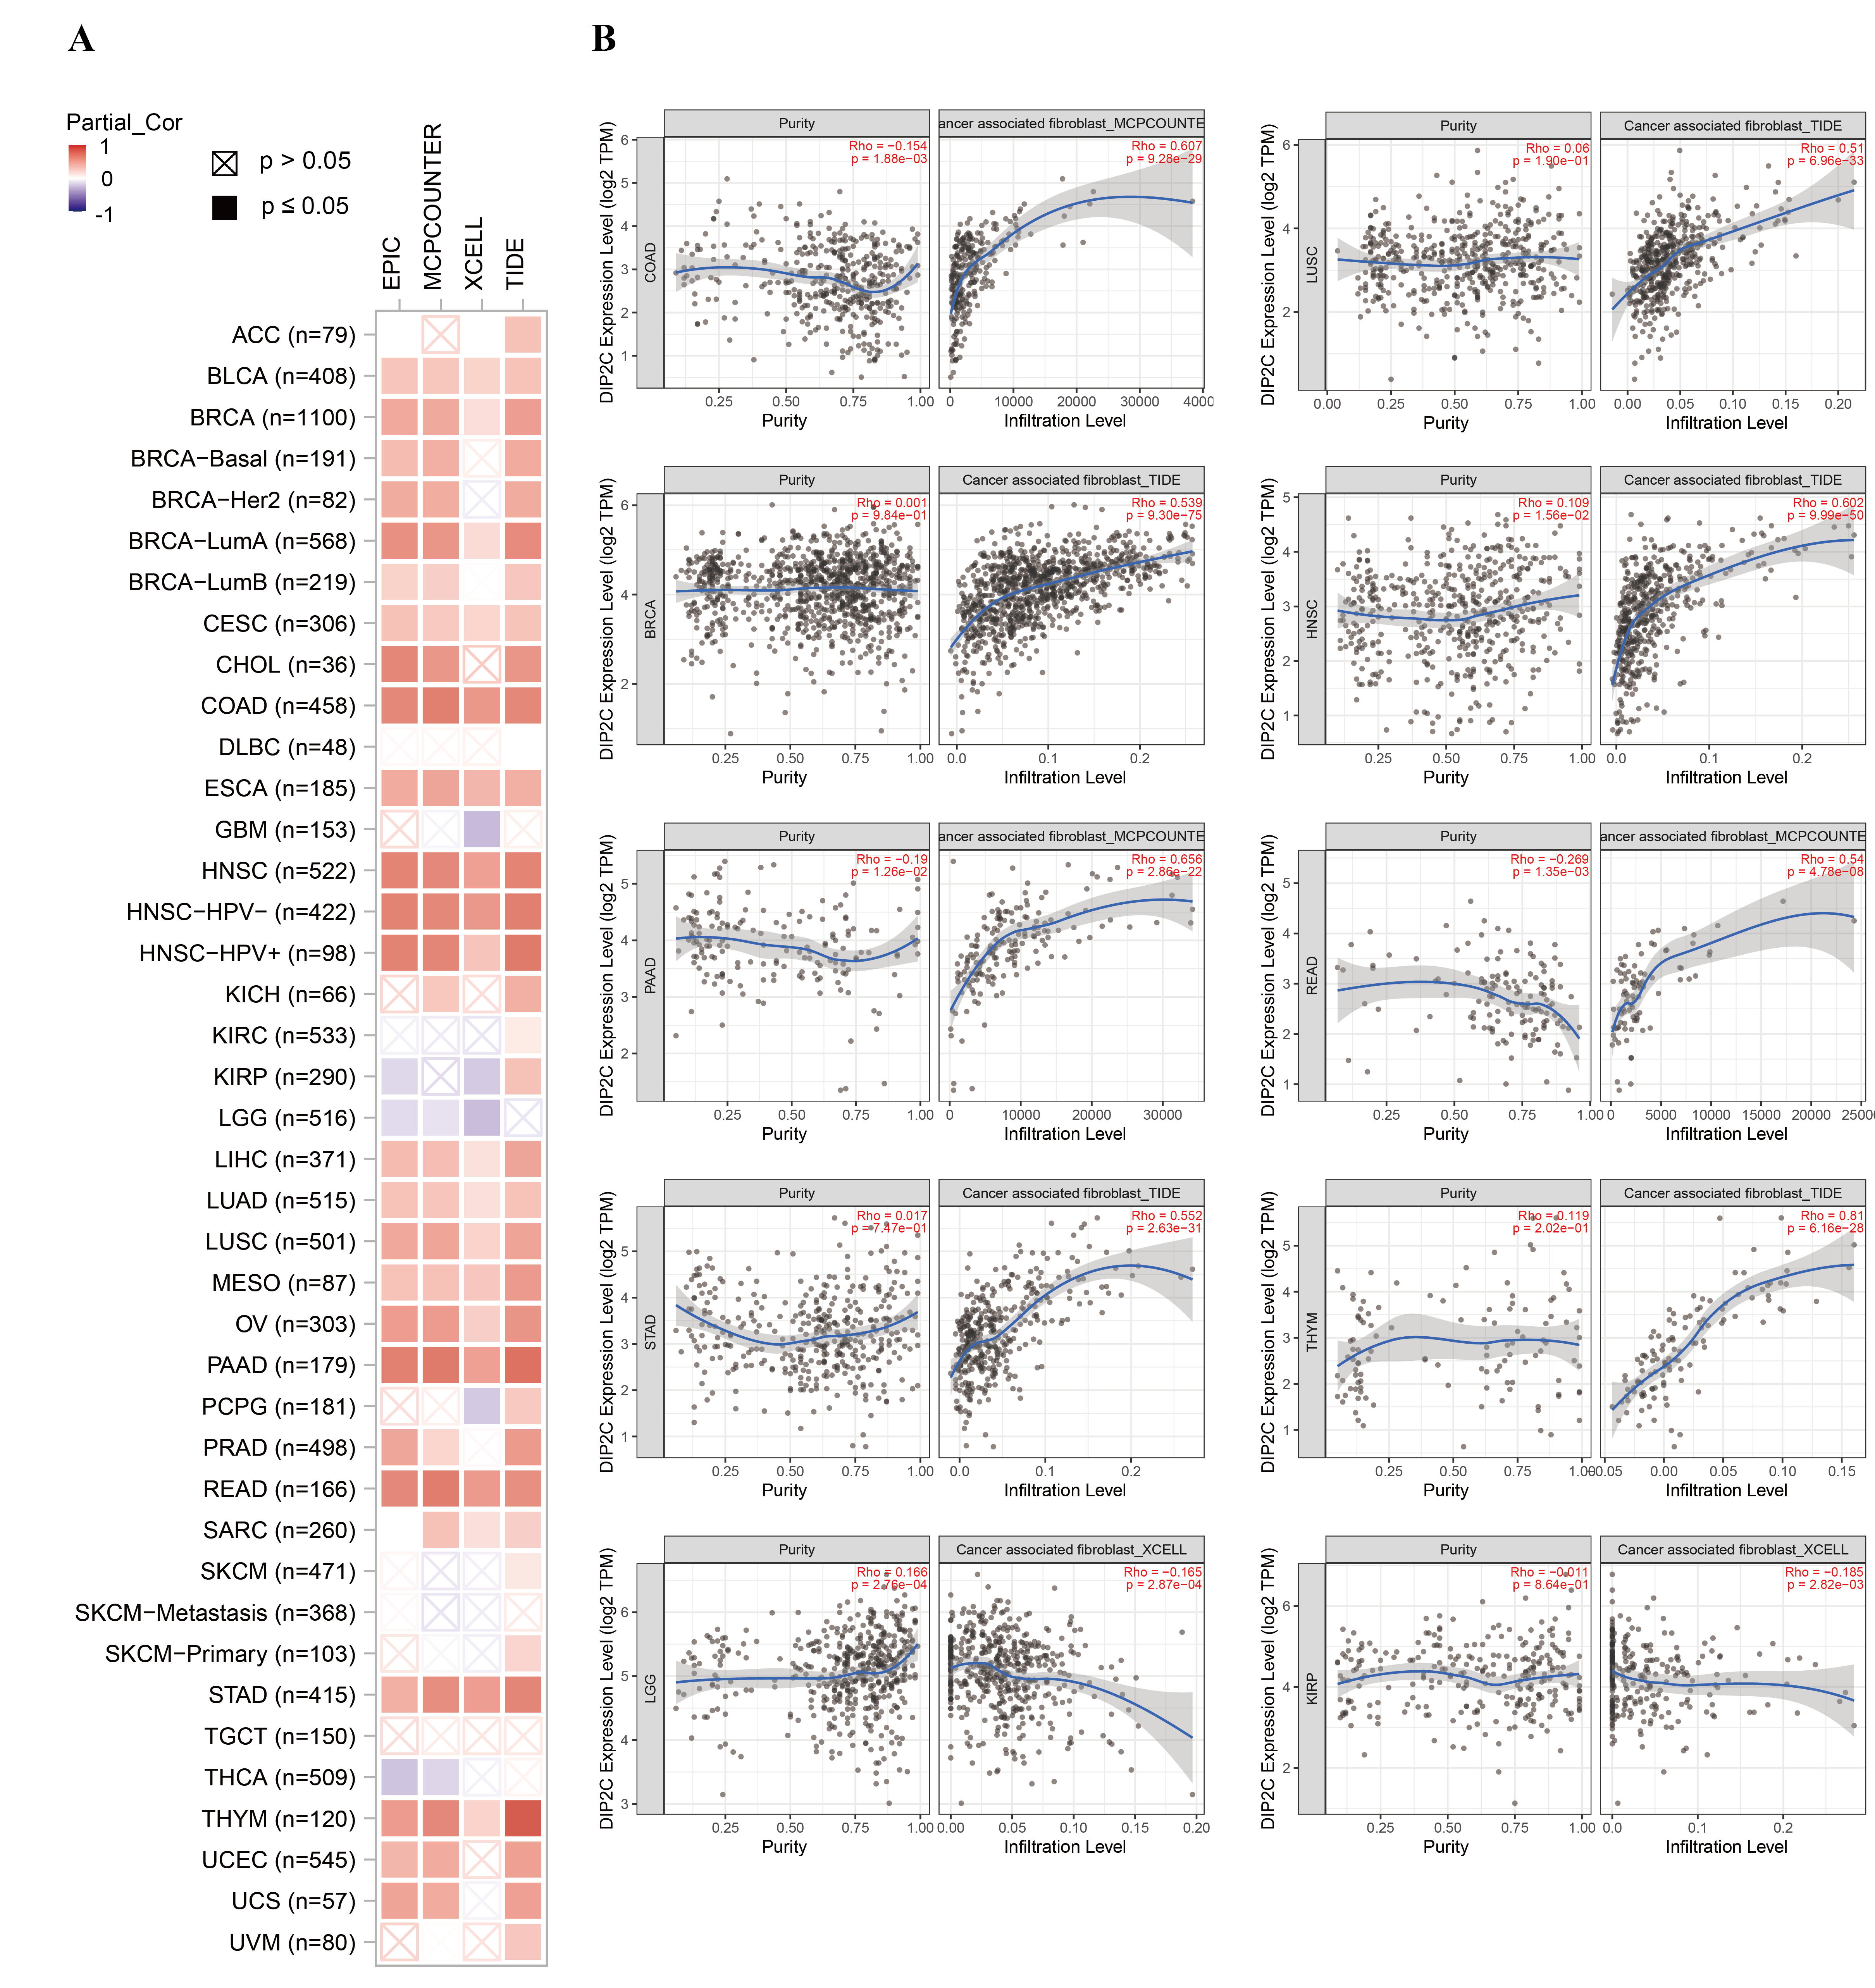
Supplementary Figure 4 Correlation between DIP2C expression and cancer-associated fibroblast (CAF) immune infiltration. (A) Correlations between DIP2C expression and CAF immune infiltration across all TCGA tumor types, calculated using the EPIC, MCPCOUNTER, XCELL, and TIDE algorithms. (B) Scatter plot data of COAD, LUSC, MESO, OV, PAAD, READ, STAD, THYM, LGG and KIRP generated by a single algorithm.

Supplementary Figure 5 DIP2C immune checkpoint gene map. *P<0.05, **P<0.01, ***P<0.001, ****P<0.0001.

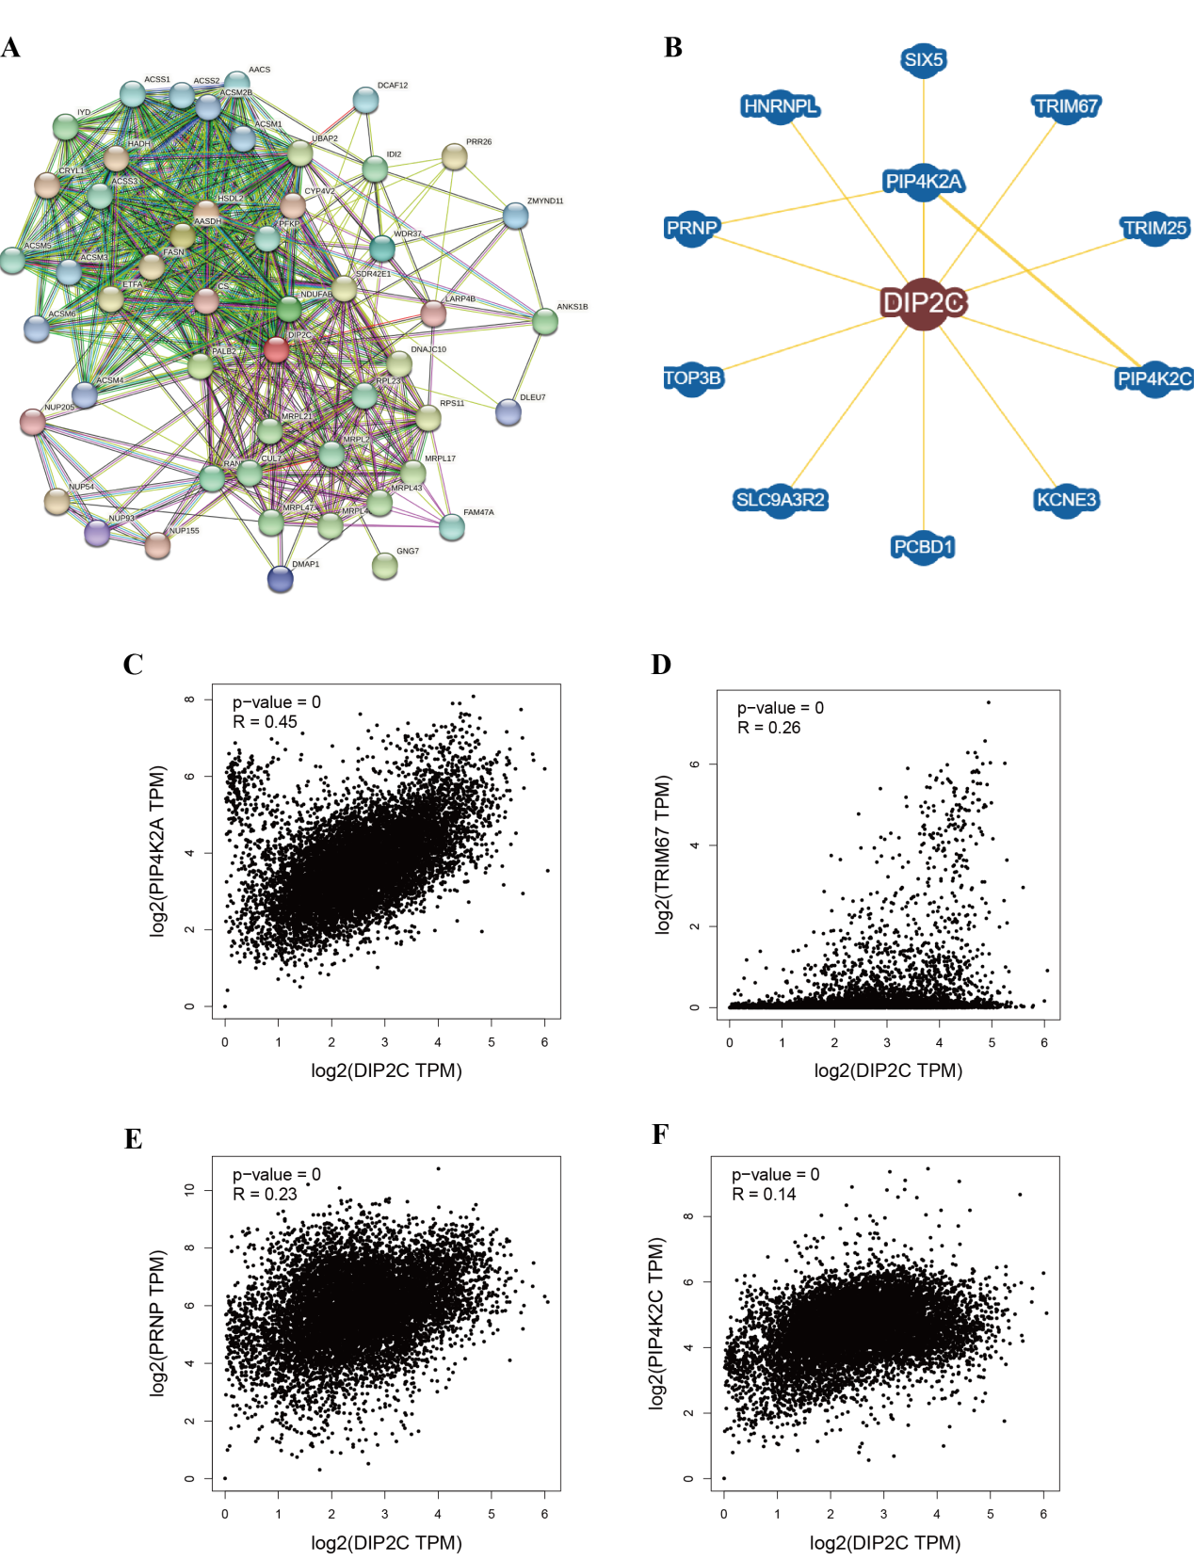
Supplementary Figure 6 Protein interaction and co-expression analysis of DIP2C. (A) Co-expression network of the top 50 genes correlated with DIP2C obtained by the STRING database. (B) Protein–protein interaction network of DIP2C obtained by BioGRID. (C-F) Correlation analyses between DIP2C expression and that of PIP4K2A, TRIM67, PRNP and PIP4K2C across TCGA pan-cancer datasets using GEPIA2.

Supplementary Figure 7 Analysis of miRNAs potentially targeting DIP2C.（A）hsa-miR-18a-5p、hsa-miR-130a-5p、hsa-miR-135b-5p.（B）hsa-miR-139-5p、hsa-miR-545-3p、hsa-miR-579-3p.（C）hsa-miR-642a-3p、hsa-miR-101-3p、hsa-miR-1301-3p.

