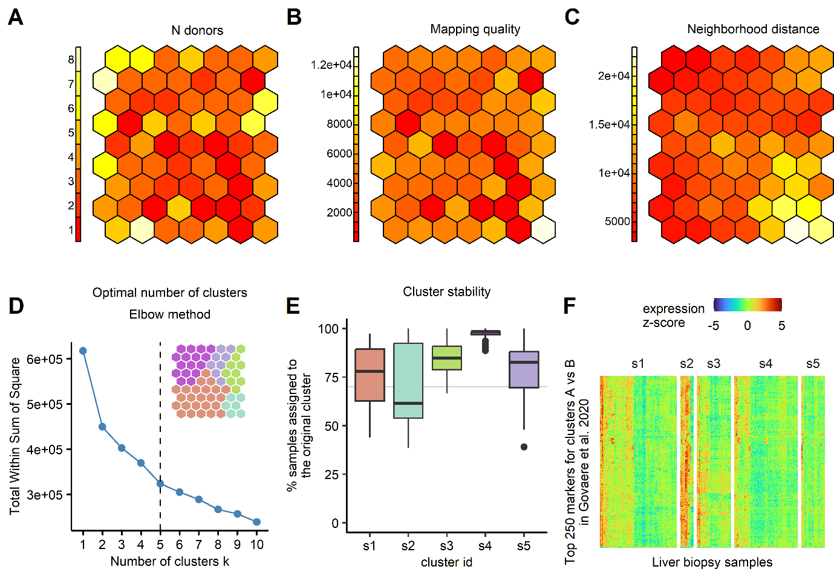Fig. S1. Technical quality control of the self-organizing map (SOM) model. (A) The map was constructed on the discovery cohort GSE135251 and contained no empty SOM units. One hexagon is one unit. Each unit contained from 1 to 8 donors with a median of 3. (B) The distribution of quality scores was homogenous between the SOM units. (C) The neighborhood distances were relatively homogenous except for less “tight” clustering in the lower right corner, which corresponded to the subsequently identified subtype s2. (D) The SOM units were grouped into five clusters based on the elbow method. (E) The clustering was stable and at least 70% of the samples (above grey line) were assigned to the same cluster as in the original SOM in the majority of 100 iterations when SOM model was re-estimated with different random seeds. (F) The five SOM clusters did not coincide with the two MASLD subtypes reported for the discovery cohort GSE135251 in the original Govaere et al. 2020 publication.

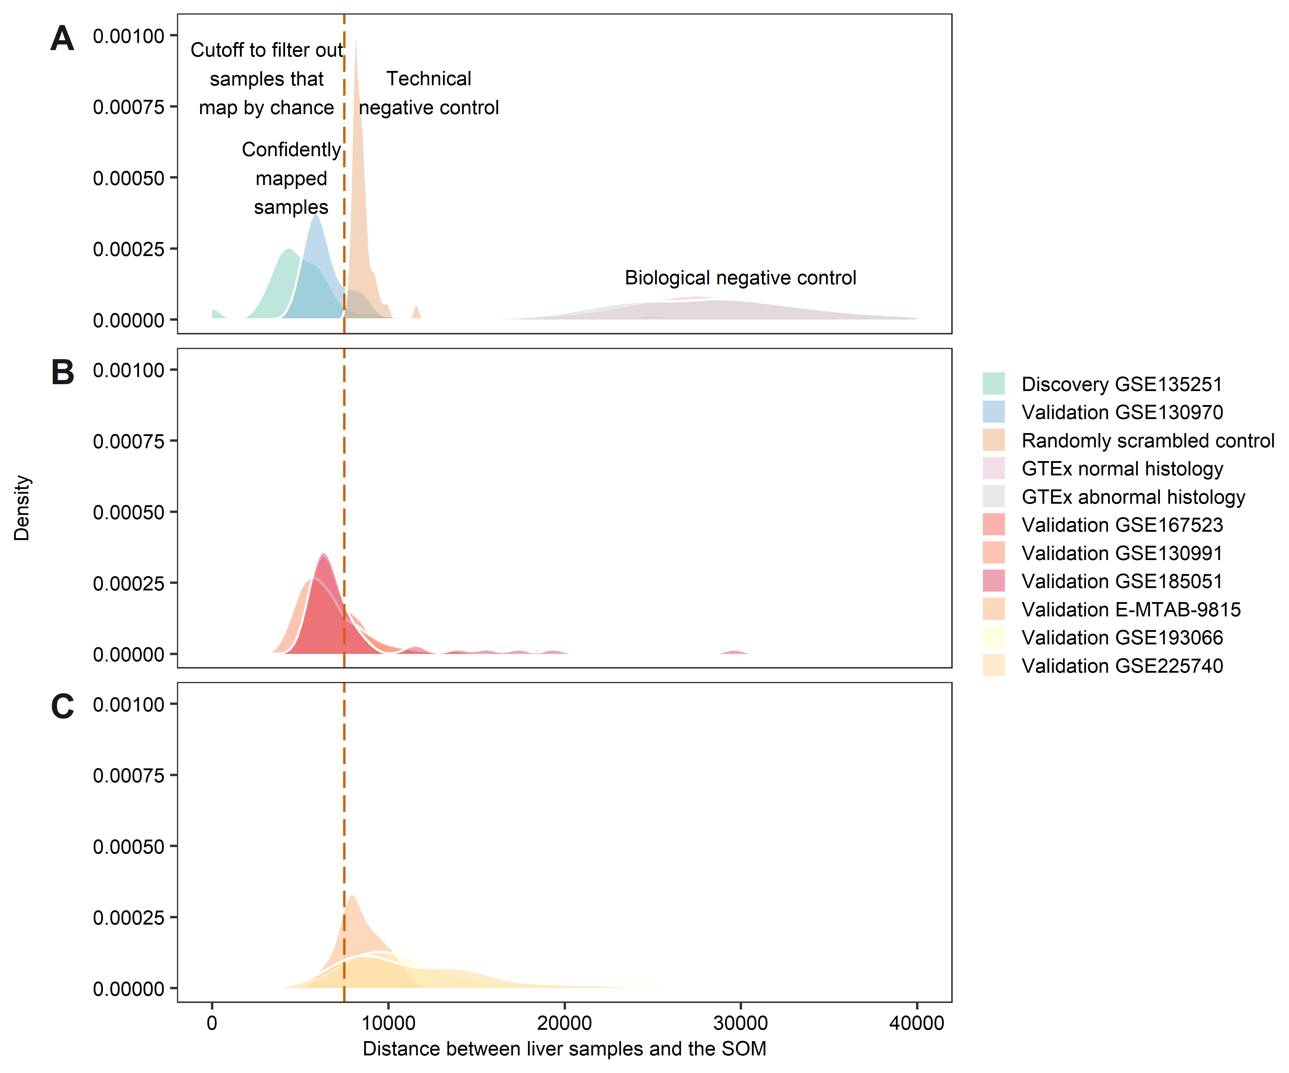Fig. S2. Technical quality control for mapping of validation cohorts onto the SOM model. (A) Distances to the closest SOM unit for the mapped samples from the validation cohort GSE130970 were within the range of distances in the discovery cohort and lower than the distances to technical negative control and biological negative control. (B) Mapping distances in validation cohorts with good mapping rate were mostly within the distance range of the discovery cohort. (C) Mapping distances in validation cohorts with poor mapping rate were still below the biological negative control.

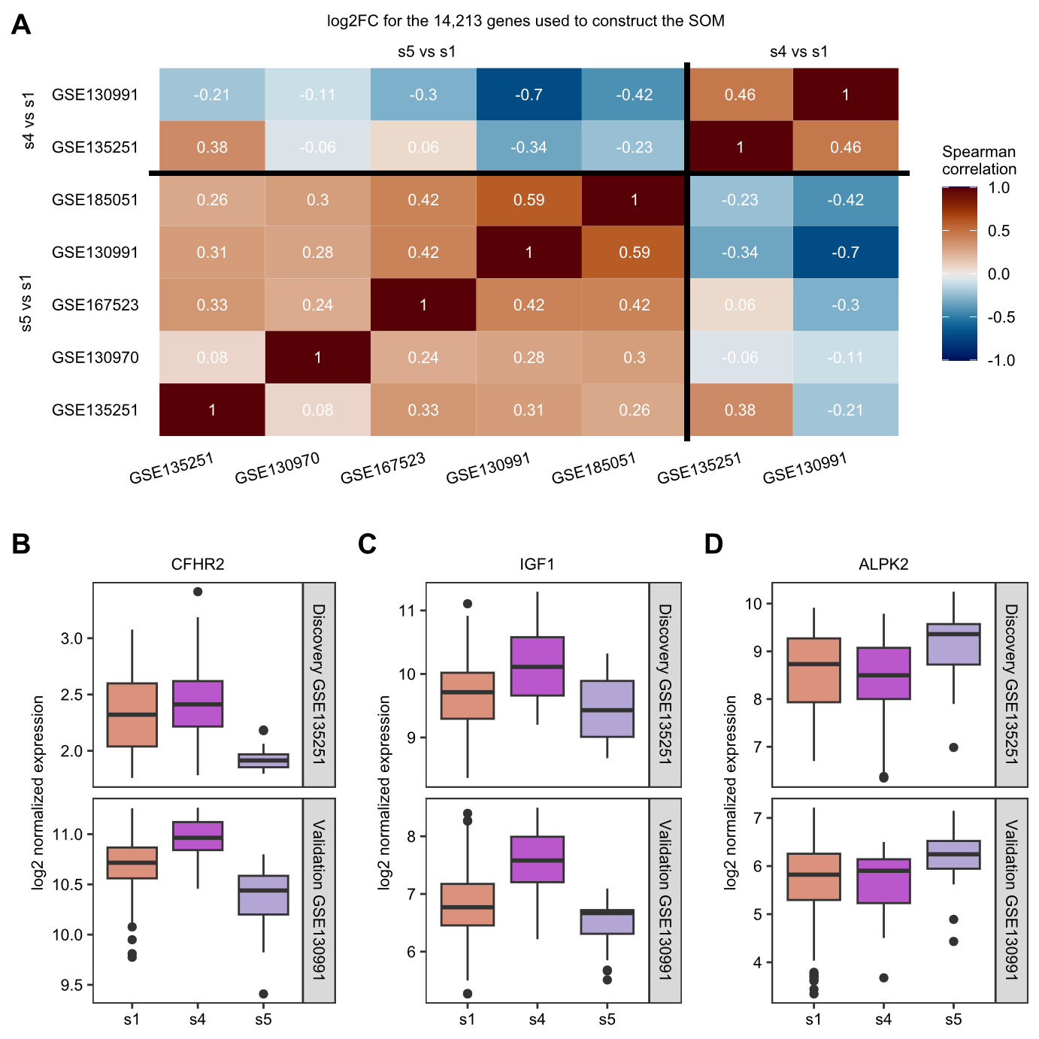
Fig. S3. Gene expression pattern, that was learnt by the SOM in the discovery cohort, was reproduced in the validation cohorts. (A) Transcriptome-wide comparison among the cohorts with good mapping rate. (B-D) Example genes.

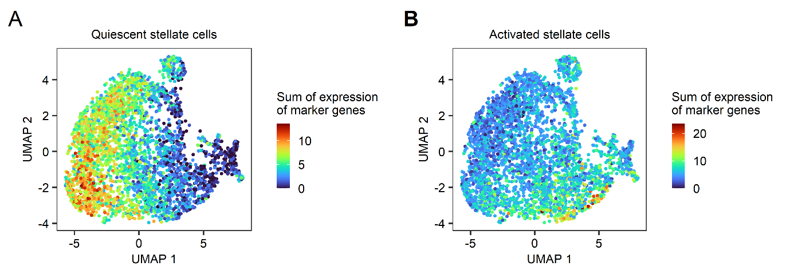Fig. S4. Stellate cells in the reference single-cell dataset GSE202379 were classified into quiescent and activated stellate cells based on expression of marker genes. (A) Quiescent cells were defined based on total SCT-normalized expression of COLEC11, PTH1R, VIPR1, RELN, HGF and RBP1. (B) Activated stellate cells were defined based on low expression of quiescent stellate cell markers are high expression of ACTA2, CCDC102B, CDH6, COL1A1, COL1A2, CPNE7, FAP, FAP, FBXO32, FN1, GEM, GREM1, IL7, KCNE4, KIAA1324L, LINC00607, LINC01609, LTBP2, MYL9, MYO1E, NAV2, OSBPL8, P4HA3, POT1-AS1, PTPRE, RASD1, RORB, RUNX1, SRGAP1, TAGLN, TANC2, VCAN-AS1 and VMP1.
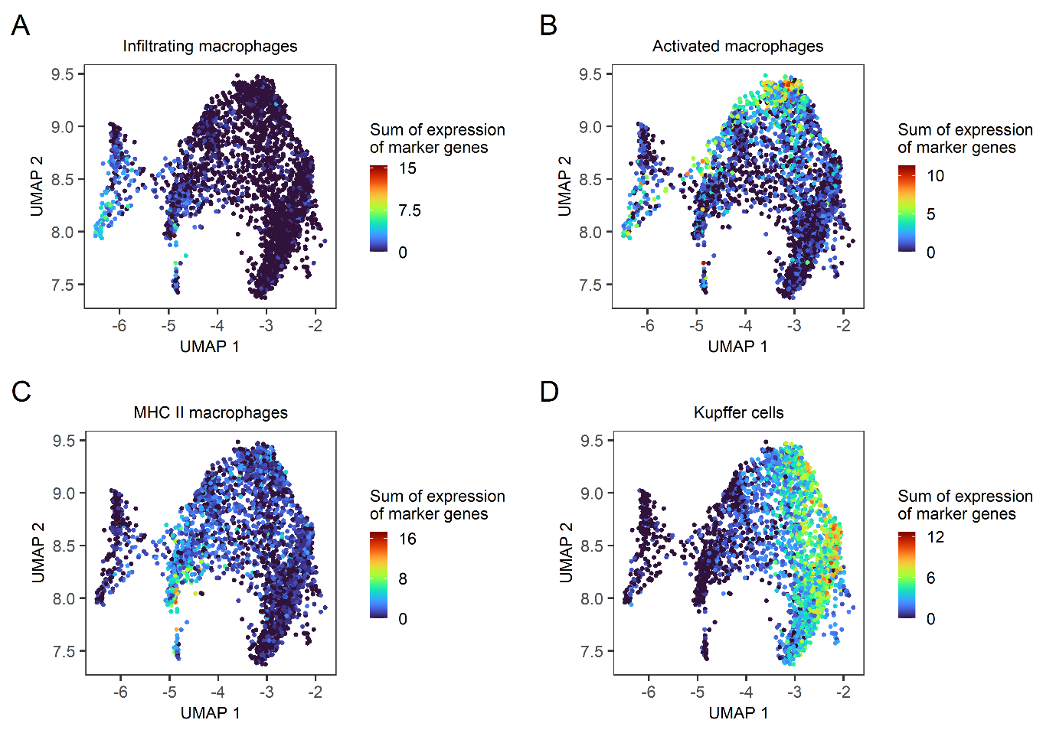
Fig. S5. Macrophages in the reference single-cell dataset GSE202379 were classified into four subtypes based on expression of marker genes. (A) Infiltrating (monocyte-derived) macrophages were defined based on total SCT-normalized expression of LYZ, FCN1, VCAN, MNDA and S100 genes (S100A1, S100A2, S100A4, S100A8, S100A9, S100A10, S100A11, S100A12, S100A13, S100A14 and S100A16). (B) Activated macrophages were defined based on total expression of CXCL3, THBS1, NAMPT, CXCL2, CD83, IL1B, AREG, CCL3, PLAUR and SRGN. (C) MHC II macrophages were defined based on CD74, HLA-DRA, HLA-DPA1, HLA-DPB1 and HLA-DQB1. (D) Kupffer cells were defined based on MARCO, CD5L, TIMD4, FOLR2, CD163 and VCAM1.
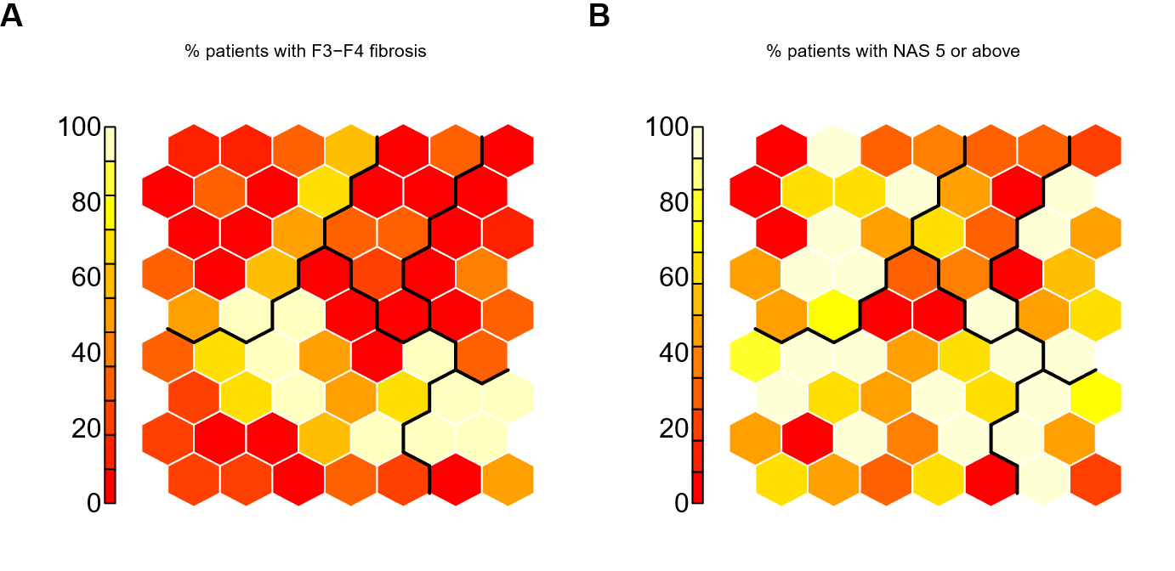Fig S6. The molecular subtypes did not correspond to histological severity of MASLD. The distribution of (A) fibrosis and (B) non-alcoholic steatohepatitis activity (NAS) scores in the discovery cohort.

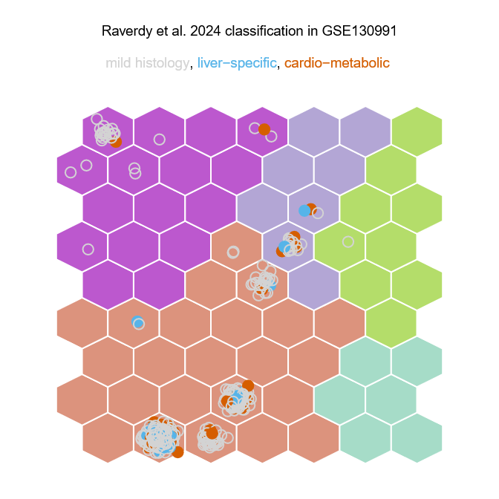
Fig S7. The molecular subtypes identified based on hepatic gene expression with SOM did not correspond to the previously published clinical classification of MASLD.

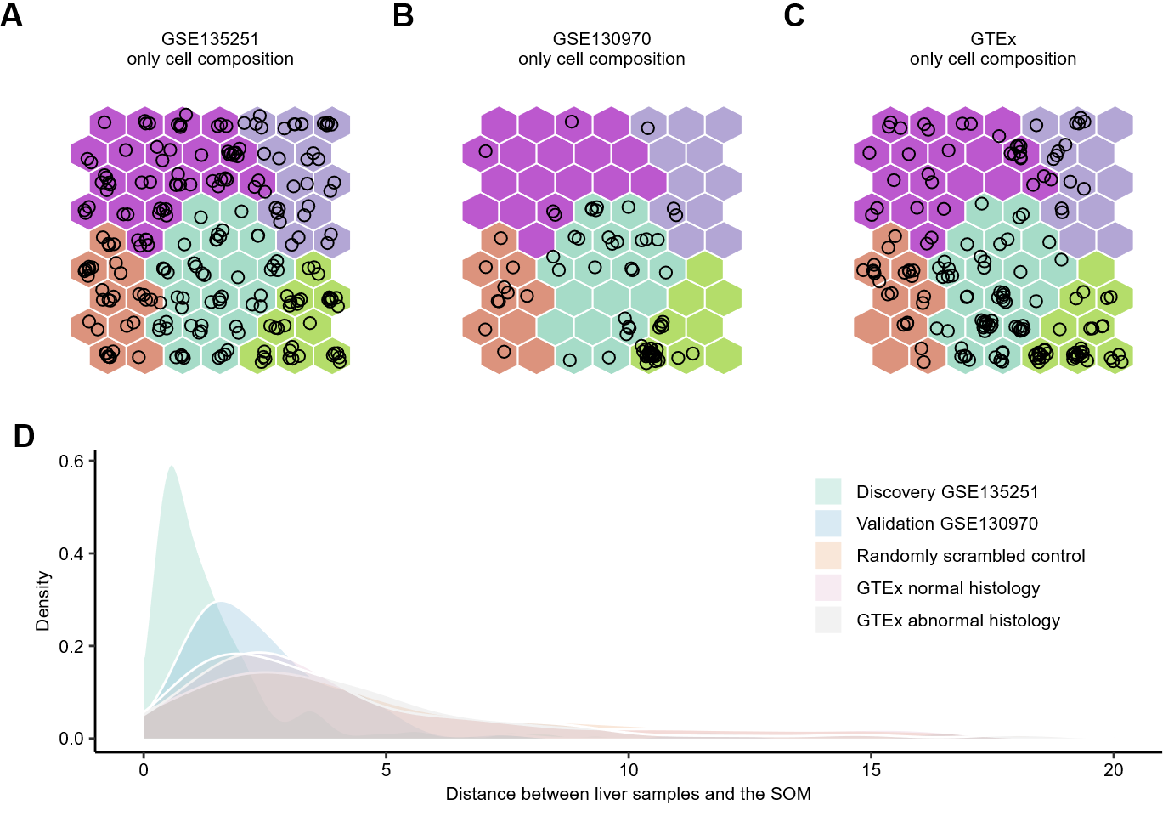
Fig. S8. Molecular subtypes could not be recapitulated solely based on sampling variability of liver biopsies. (A) A self organizing map fitted de novo only based on cell type composition of the liver biopsies in the discovery cohort. (B) Validation cohort GSE130970 mapped onto the de novo SOM. (C) Biological negative control samples from GTEx mapped onto the de novo SOM. (D) SOM based only on cell type composition did not offer discrimination versus the biological negative control and technical negative control.

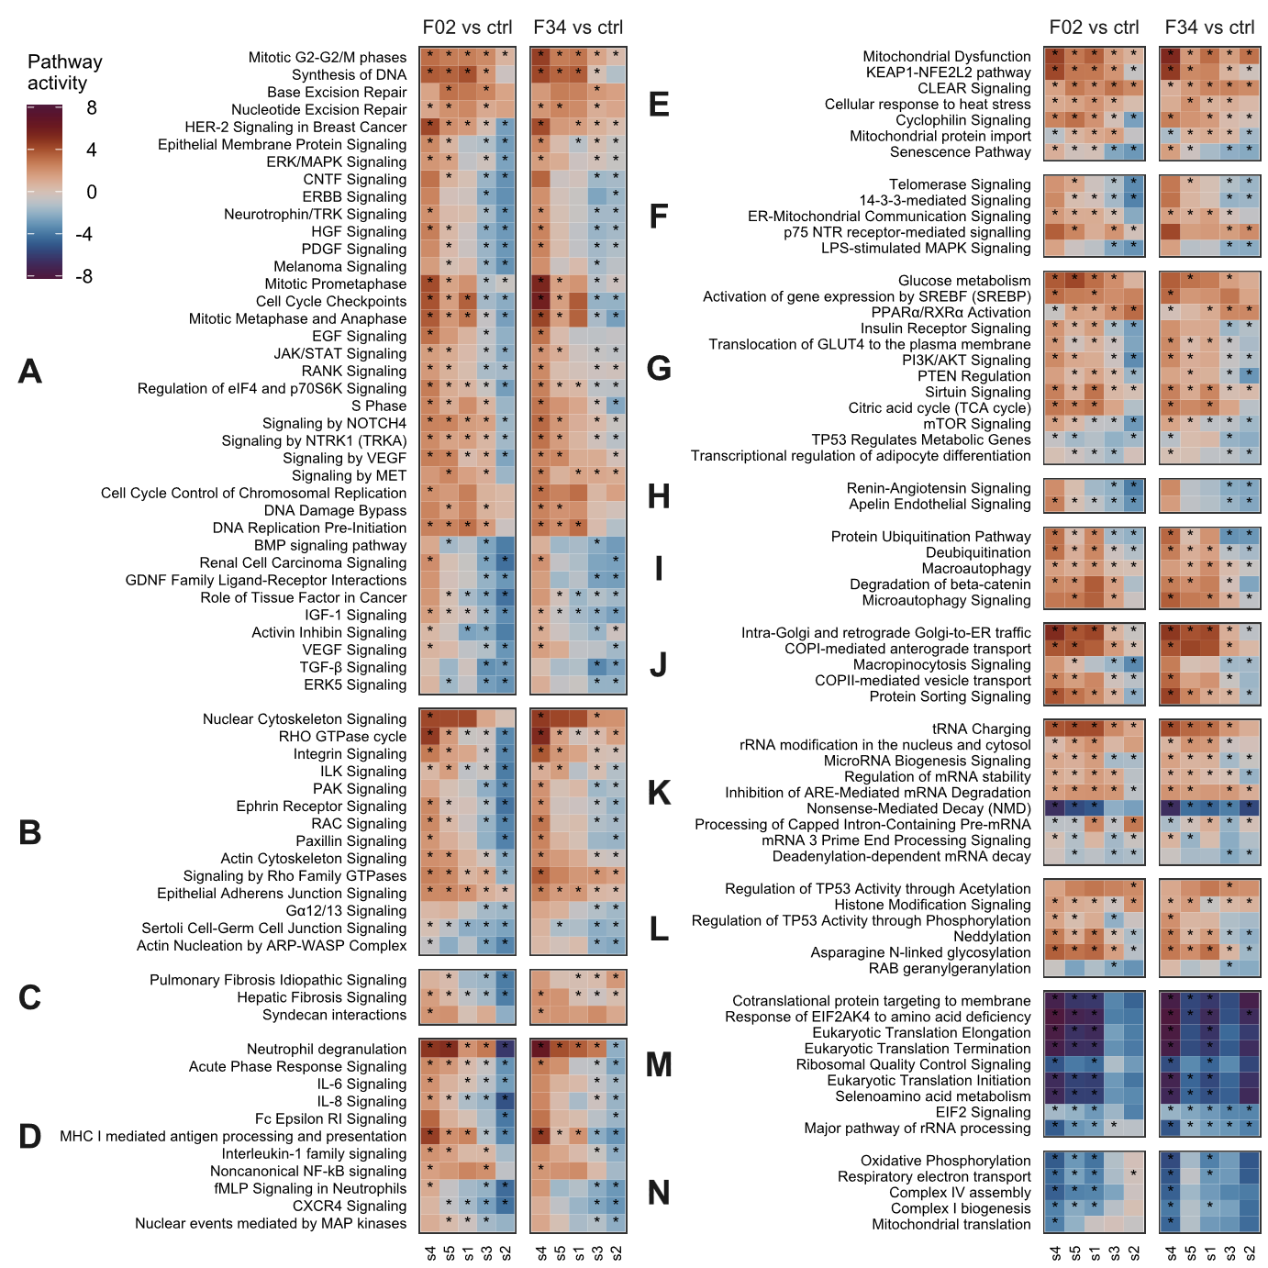Fig. S9. The molecular subtypes differed in magnitude of pathway activation or inhibition relative to the obese non-MASLD controls, both in mild (F0-F2) and advanced (F3-F4) fibrosis. The plots show pathway enrichment in the discovery cohort GSE135251. (A) Cellular growth, division and development. (B) Cytoskeletal, adherens and cell junction signaling. (C) Fibrosis. (D) Immune and inflammatory response. (E) Cellular stress and injury. (F) Regulation of death / survival. (G) Lipid and carbohydrate metabolism and their regulation. (H) Cardiovascular signaling. (I) Autophagy and protein degradation. (J) Vesicle mediated transport. (K) RNA metabolism. (L) Post-translational modifications. (M) Translation. (N) Mitochondrial function. Fisher test pathway enrichment p< 1e-5 was considered significant and marked with a *. Change in pathway activity was inferred with the Ingenuity Pathway Analysis software based on log2 fold changes of individual differentially expressed genes within each pathway.
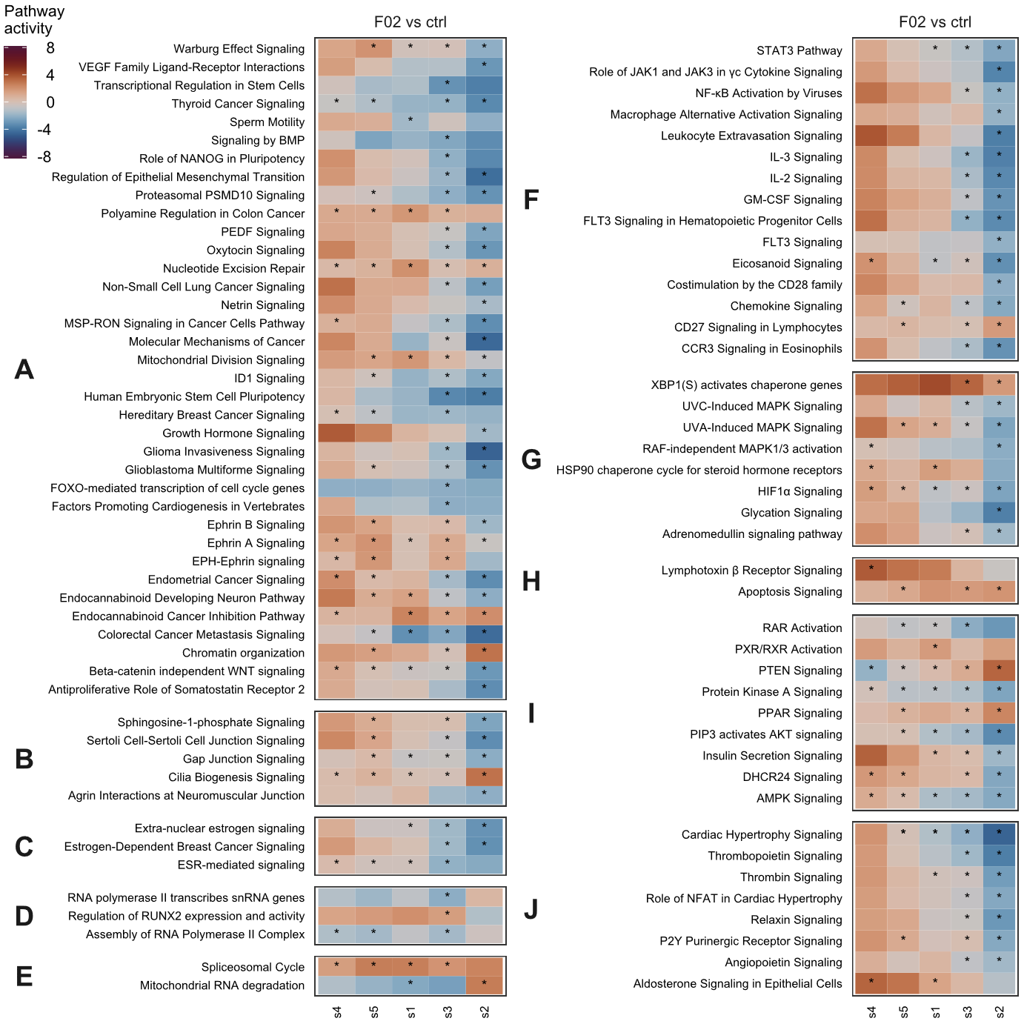Fig. S10. Additional pathways were significantly dysregulated only in mild fibrosis. The plots show pathway enrichment in the discovery cohort GSE135251. (A) Cellular growth, division and development. (B) Cytoskeletal, adherens and cell junction signaling. (C) Estrogen receptor signaling. (D) Generic transcription. (E) RNA metabolism. (F) Immune and inflammatory response. (G) Cellular stress and injury. (H) Regulation of death / survival. (I) Lipid and carbohydrate metabolism and their regulation. (J) Cardiovascular signaling. Fisher test pathway enrichment p< 1e-5 was considered significant and marked with a *. Change in pathway activity was inferred with the Ingenuity Pathway Analysis software based on log2 fold changes of individual differentially expressed genes within each pathway.

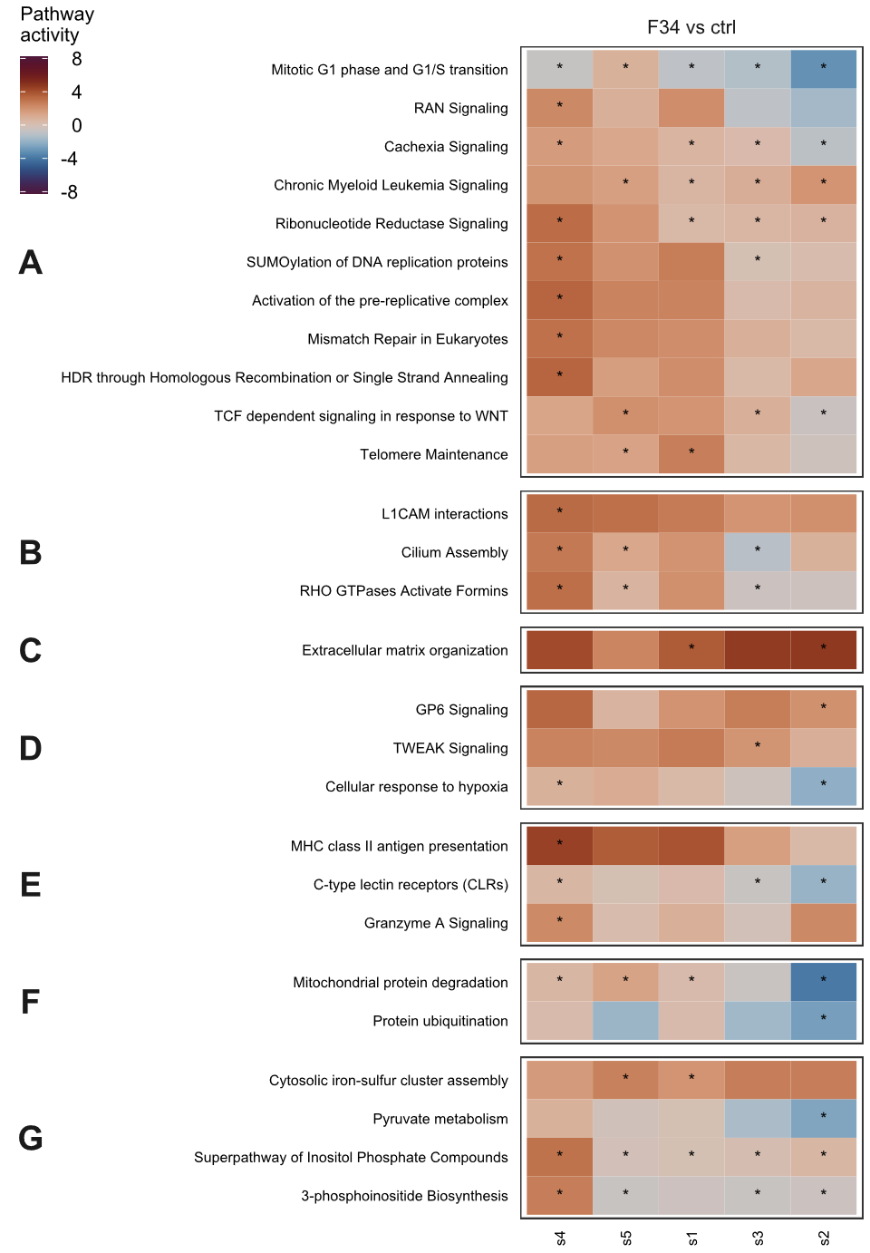
Fig. S11. Additional pathways were significantly dysregulated only in advanced fibrosis. The plots show pathway enrichment in the discovery cohort GSE135251. (A) Cellular growth, division and development. (B) Cytoskeletal, adherens and cell junction signaling. (C) Fibrosis. (D) Cellular stress and injury. (E) Immune and inflammatory response. (F) Protein degradation. (G) Metabolic pathways. Fisher test pathway enrichment p< 1e-5 was considered significant and marked with a *. Change in pathway activity was inferred with the Ingenuity Pathway Analysis software based on log2 fold changes of individual differentially expressed genes within each pathway.

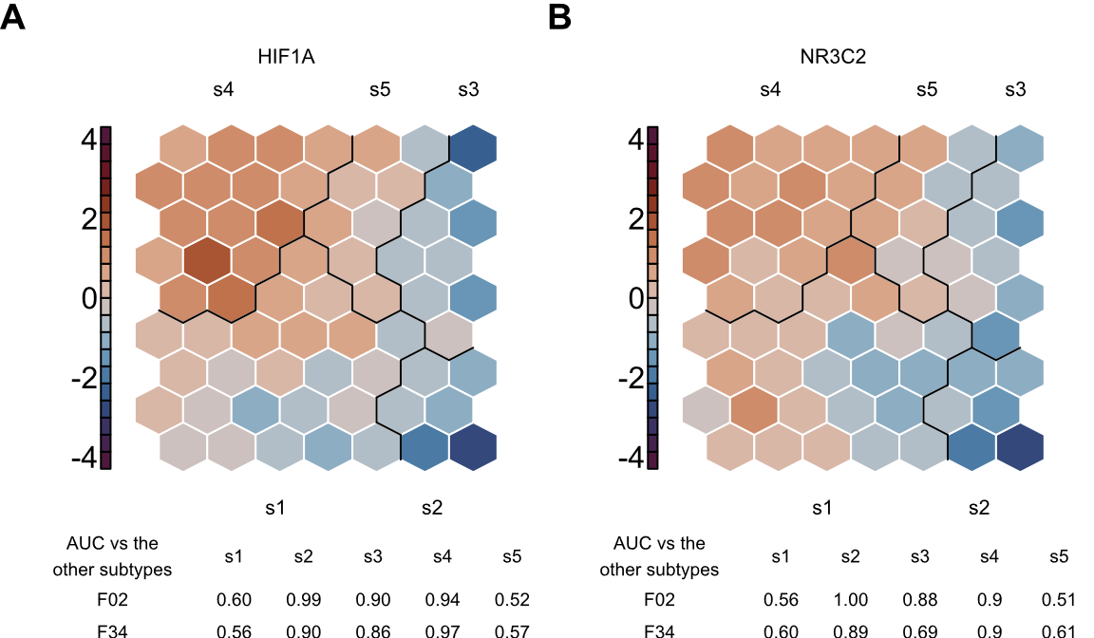
Fig. S12. The subtype s4 had high expression of hypoxia-induced factor 1A (A) and mineralocorticoid receptor (B) compared to other MASLD subtypes. The figures show relative expression pattern in arbitrary units that was learnt by the SOM. Areas under the curve (AUC) were calculated on the underlying MASLD liver samples and indicated how well gene expression levels within each molecular subtype separated from the remaining subtypes. AUC >= 0.8 was considered good separation of expression levels.

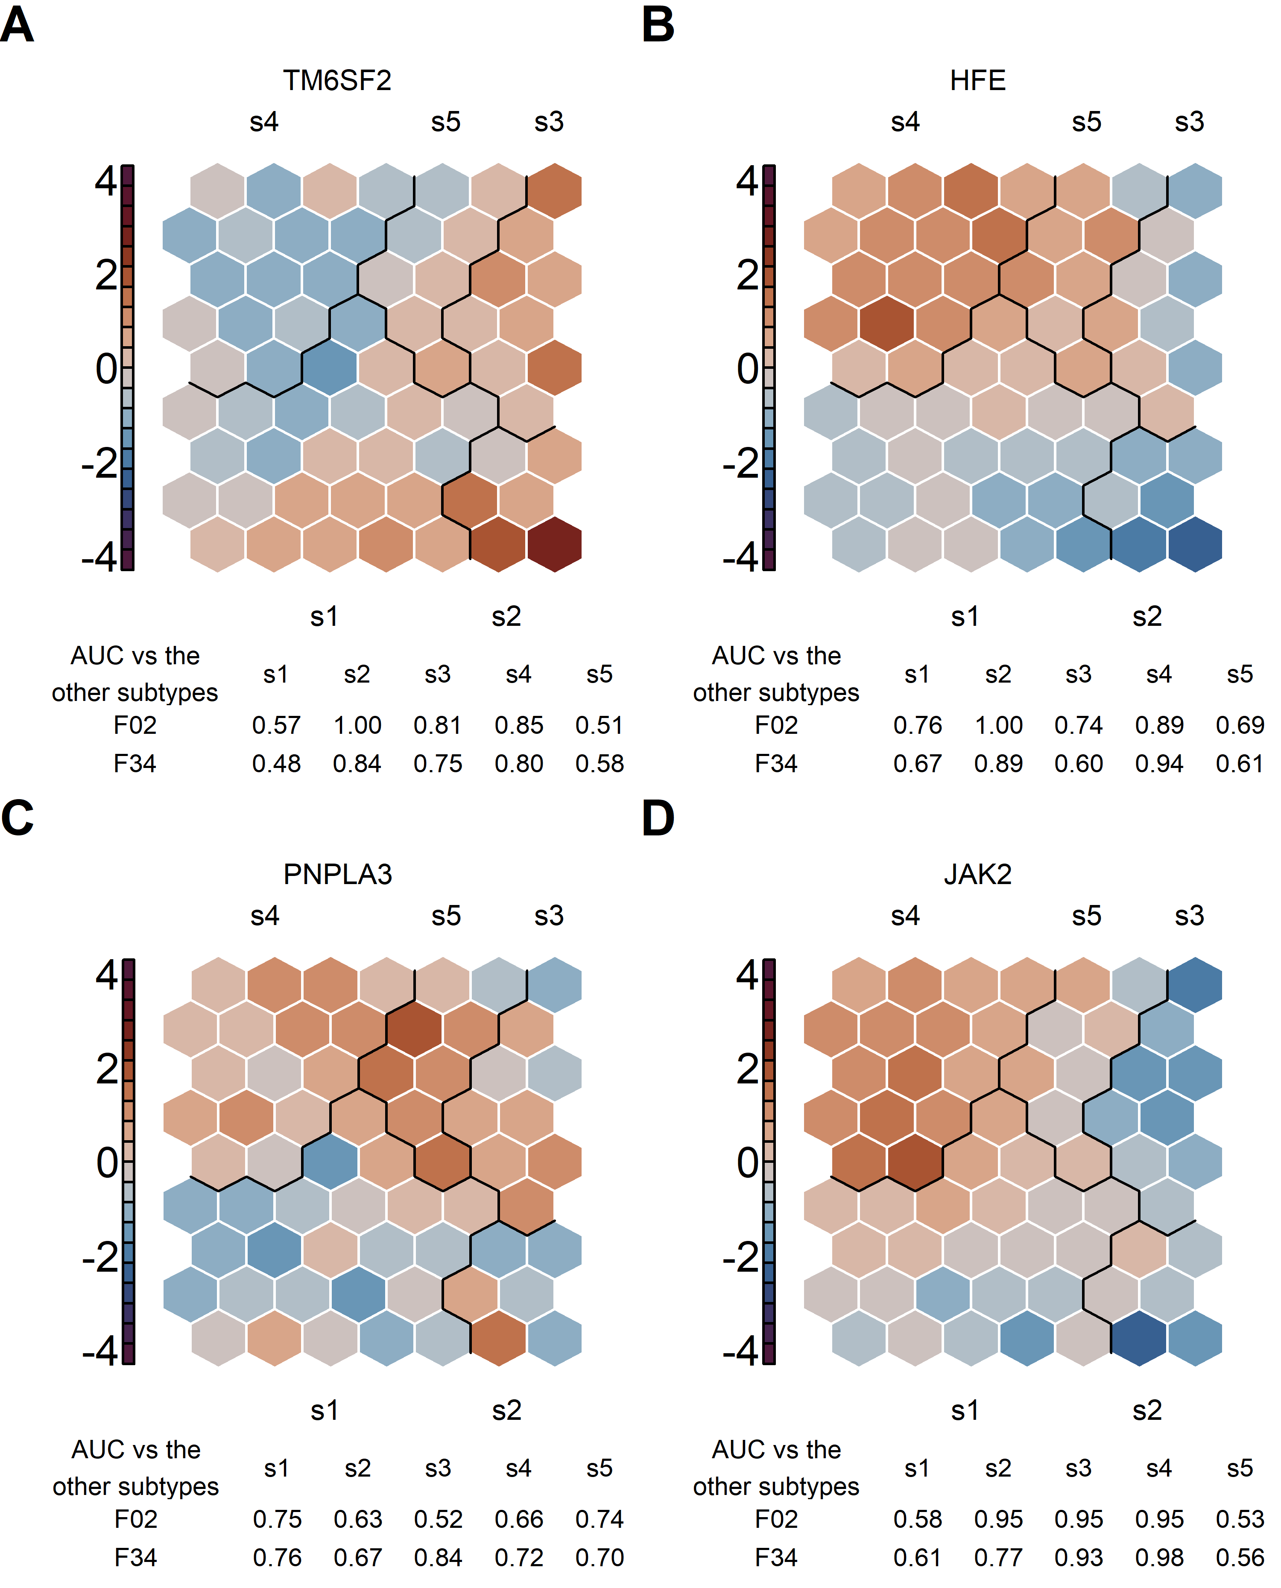
Fig. S13. Expression of GWAS genes associated with risk of hepatocellular carcinoma (A-C) and risk of portal hypertension and esophageal varices (D) in MASLD molecular subtypes. The figures show relative expression pattern in arbitrary units that was learnt by the SOM. Areas under the curve (AUC) were calculated on the underlying MASLD liver samples and indicated how well gene expression levels within each molecular subtype separated from the remaining subtypes. AUC >= 0.8 was considered good separation of expression levels.

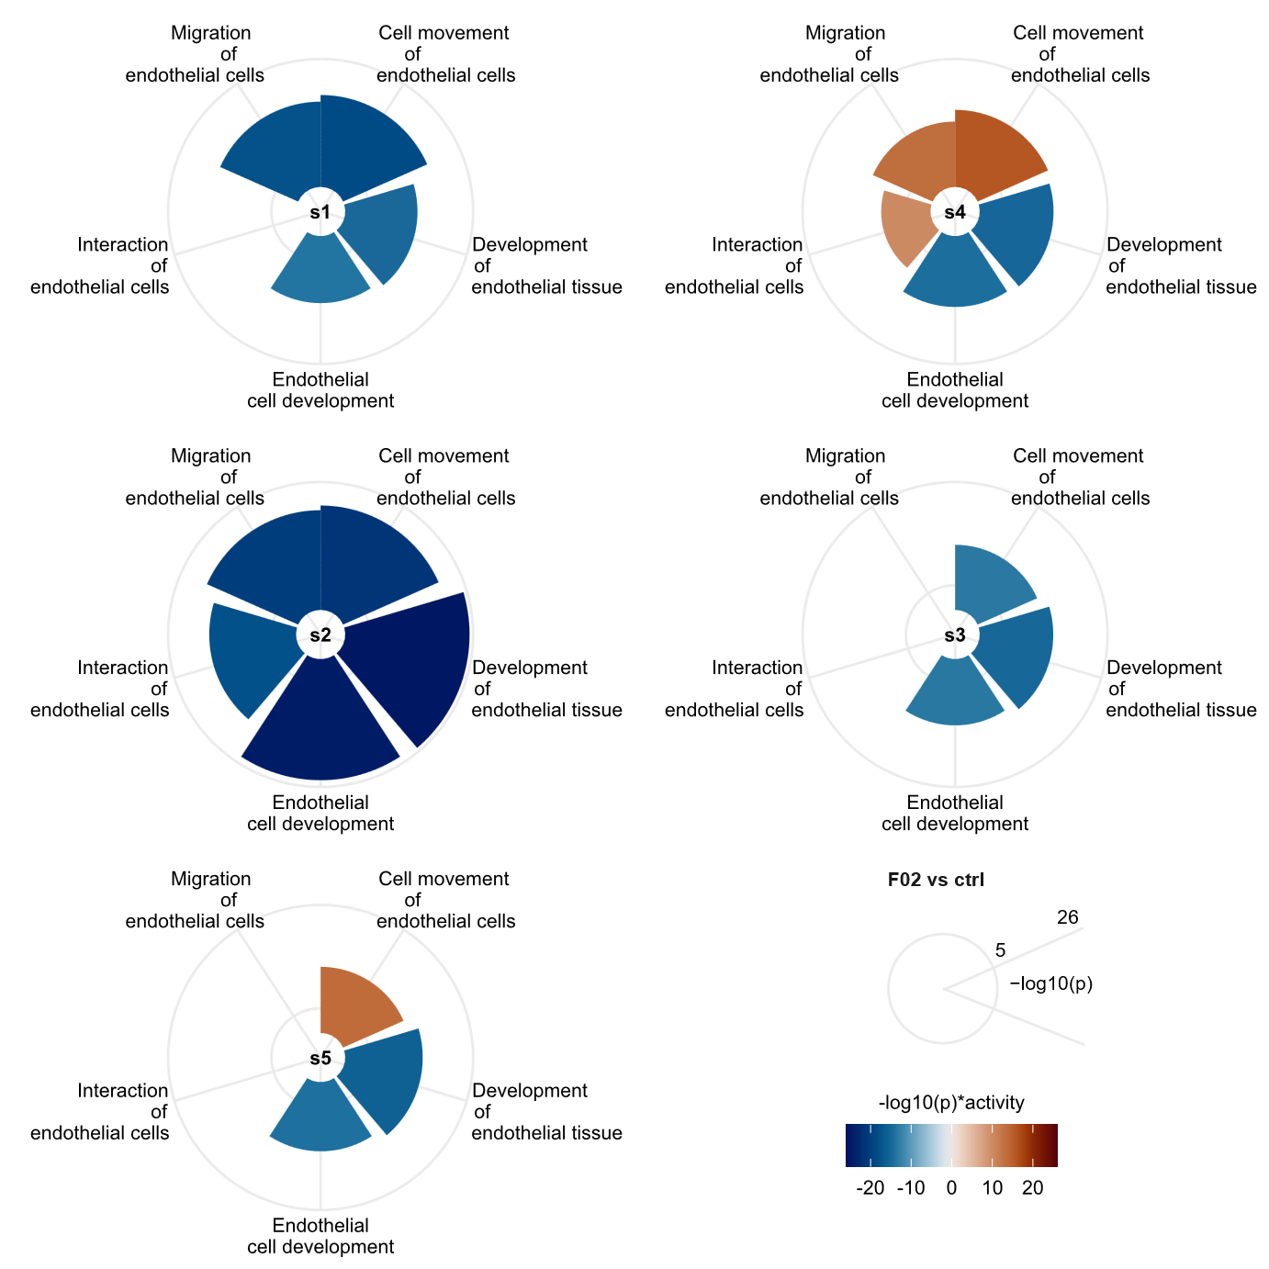
Fig S14. Subtypes s1 and s2 had the most pronounced decrease in endothelial function in mild fibrosis. The gene sets are defined based on IPA diseases and functions analysis. The charts show enrichment p-value (longer bar length = stronger enrichment) multiplied by the directionality of dysregulation (bar colour, blue = lower and orange = higher) compared to non-MASLD controls.

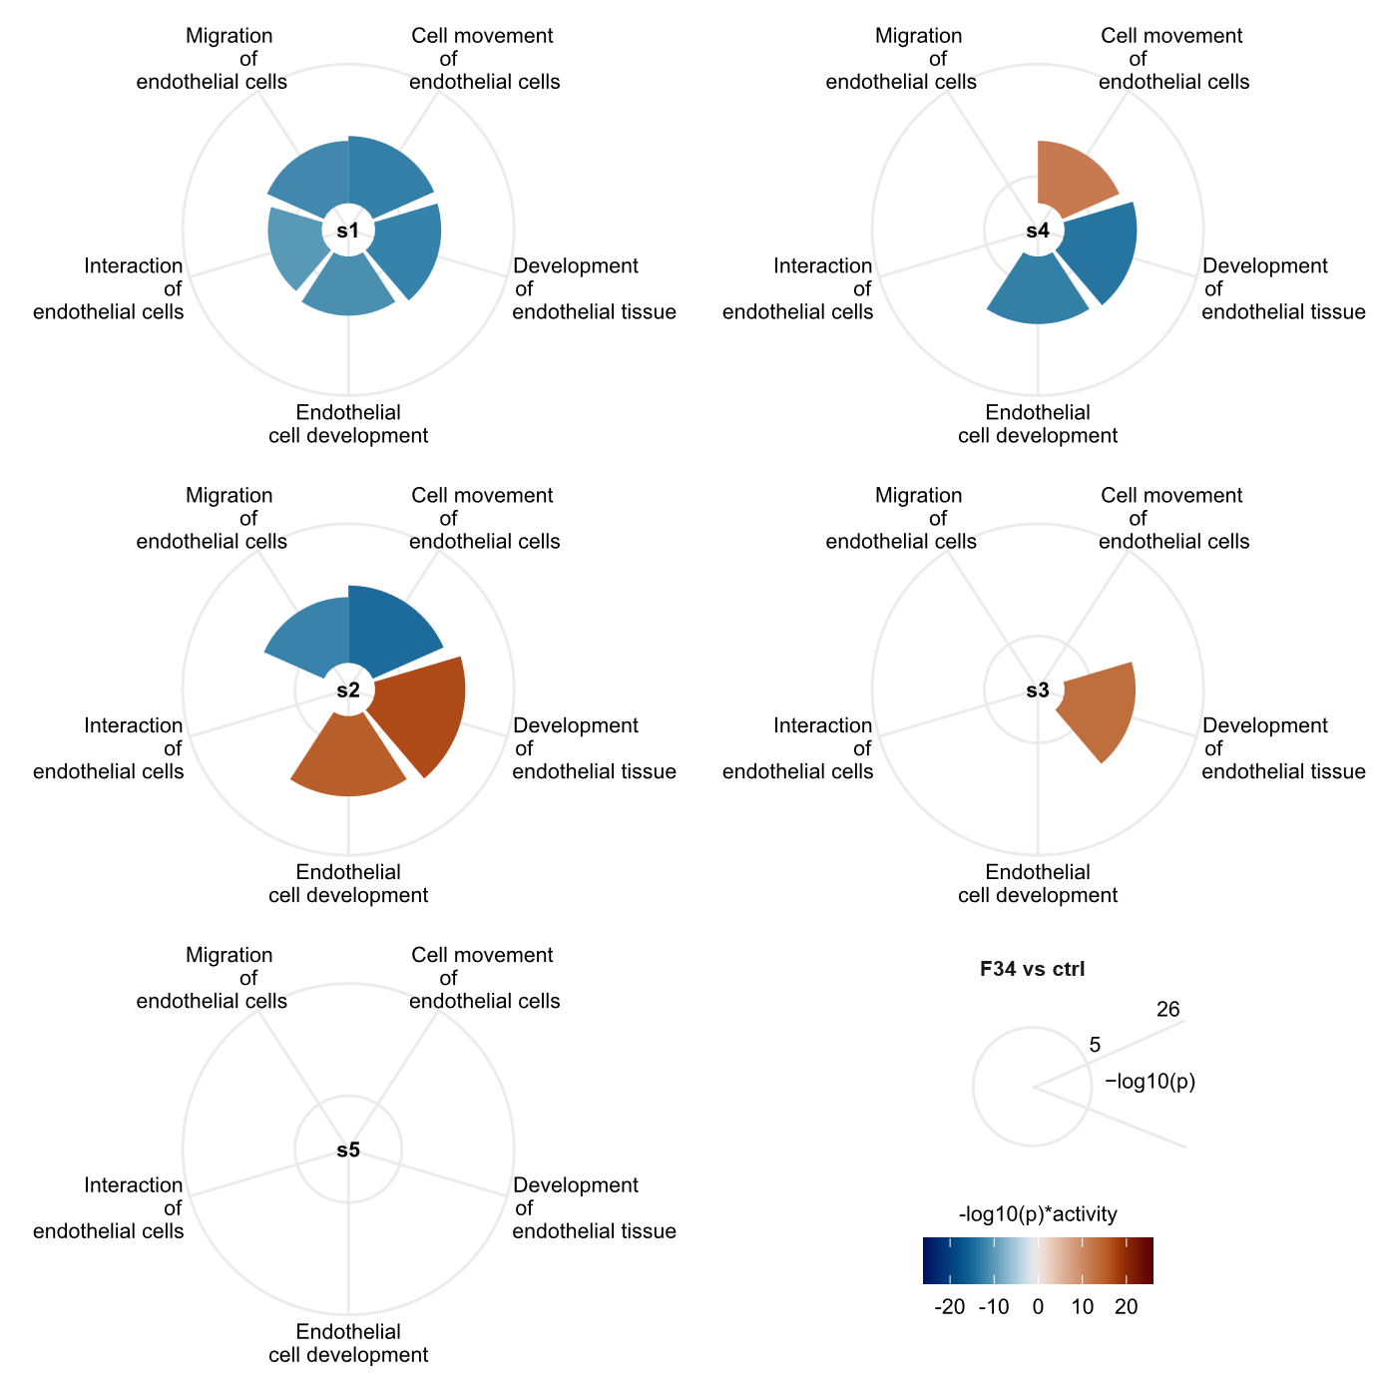
Fig S15. The subtype s1 had the most pronounced decrease in endothelial function in advanced fibrosis. The gene sets are defined based on IPA diseases and functions analysis. The charts show enrichment p-value (longer bar length = stronger enrichment) multiplied by the directionality of dysregulation (bar colour, blue = lower and orange = higher) compared to non-MASLD controls.

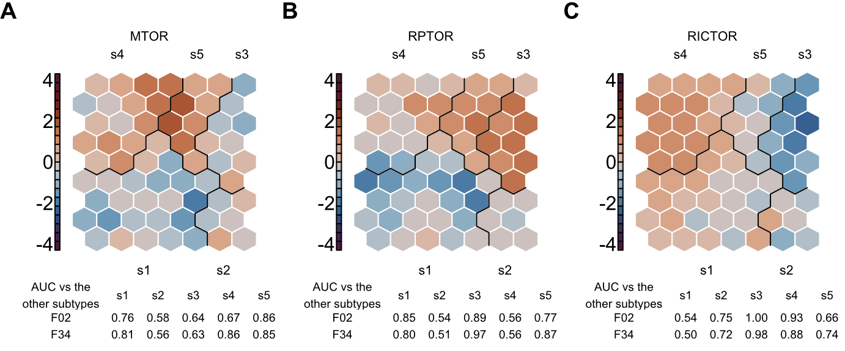
Fig. S16. The subtypes s4 and s5 differentiated based on the dominant type of mTORC. (A) MTOR, the common component of both mTORC1 and mTORC2 complexes. (B) RPTOR, is the specific component of mTORC1 complex. (C) RICTOR, the spcific component of the mTORC2 complex. The figures show relative expression pattern in arbitrary units that was learnt by the SOM. Areas under the curve (AUC) were calculated on the underlying MASLD liver samples and indicated how well gene expression levels within each molecular subtype separated from the remaining subtypes. AUC >= 0.8 was considered good separation of expression levels.

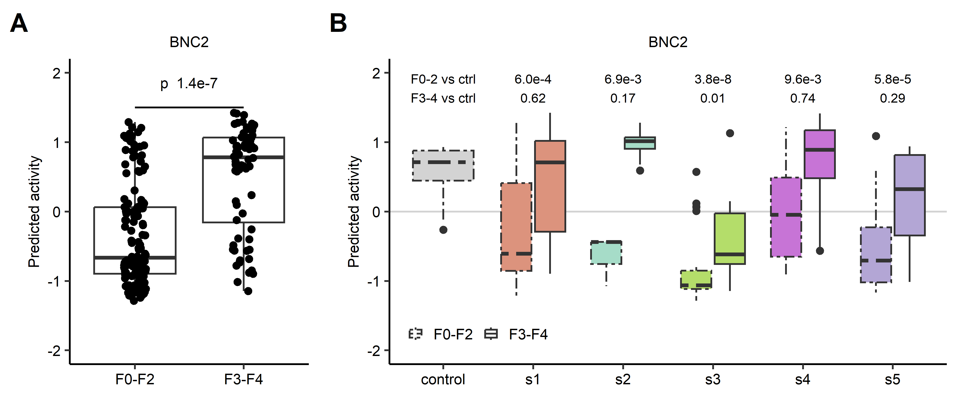
Fig. S17. Predicted activity of BNC2 was higher in advanced fibrosis than in mild fibrosis (A) but lower in mild fibrosis than in obese non-MASLD controls (B) irrespective of molecular subtype. GSE135251. P values correspond to the main effect of fibrosis in linear regression model adjusted for molecular subtype and interaction between fibrosis stage and molecular subtype in panel A and comparison between each molecular subtype and non-MASLD controls in panel B. P< 0.005 was considered significant.

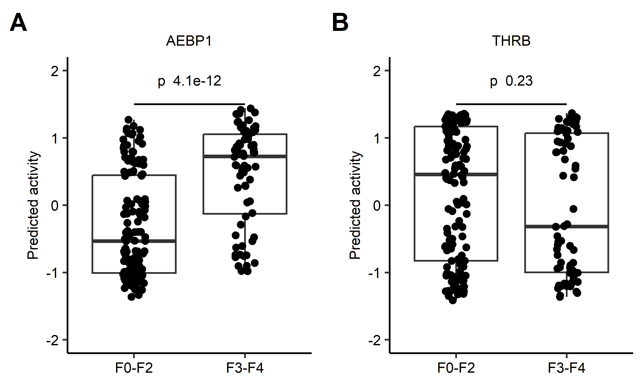
Fig. S18. Predicted activity of AEBP1 (A) and THRB (B) in advanced fibrosis compared to mild fibrosis irrespective of molecular subtype. GSE135251. P values correspond to the main effect of fibrosis in linear regression model adjusted for molecular subtype and interaction between fibrosis stage and molecular subtype. P< 0.005 was considered significant.

