Supplementary Table 1. Library of 42 bioactive metabolites identified from Cordyceps militaris used for virtual screening. The table includes the compound names, PubChem Compound Identifiers (CID), canonical SMILES notations, and corresponding three-dimensional (3D) molecular structures retrieved from the PubChem database for subsequent drug-likeness evaluation, molecular docking, molecular dynamics simulations, and ADMET analysis.

S.No | COMPOUND NAME | PubChem  CID | SMILES | 3D STRUCTURE
 | Cordycepin(3’-deoxyadenosine) | 6303 | C1[C@H](O[C@H]([C@@H]1O)N2C=NC3=C(N=CN=C32)N)CO | 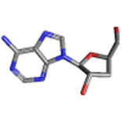
 | Adenosine | 60961 | C1=NC(=C2C(=N1)N(C=N2)[C@H]3[C@@H]([C@@H]([C@H](O3)CO)O)O)N | 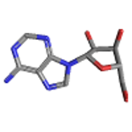
 | Inosine | 135398641 | C1=NC2=C(C(=O)N1)N=CN2[C@H]3[C@@H]([C@@H]([C@H](O3)CO)O)O | 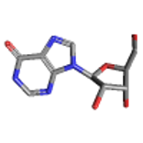
 | Guanosine | 135398635 | C1=NC2=C(N1[C@H]3[C@@H]([C@@H]([C@H](O3)CO)O)O)N=C(NC2=O)N | 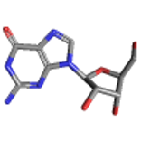
 | Uridine | 6029 | C1=CN(C(=O)NC1=O)[C@H]2[C@@H]([C@@H]([C@H](O2)CO)O)O | 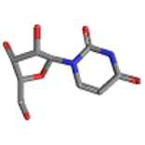
 | Cytidine | 6175 | C1=CN(C(=O)N=C1N)[C@H]2[C@@H]([C@@H]([C@H](O2)CO)O)O | 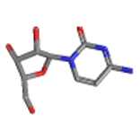
 | Thymidine | 5789 | CC1=CN(C(=O)NC1=O)[C@H]2C[C@@H]([C@H](O2)CO)O | 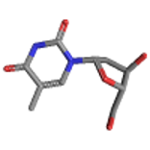
 | Adenine | 190 | C1=NC2=NC=NC(=C2N1)N | 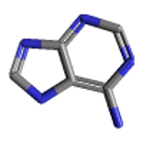
 | Uracil | 1174 | C1=CNC(=O)NC1=O | 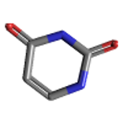
 | Hypoxanthine | 135398638 | C1=NC2=C(N1)C(=O)NC=N2 | 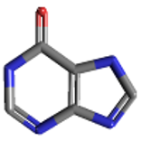
 | Ergosterol | 444679 | C[C@H](/C=C/[C@H](C)C(C)C)[C@H]1CC[C@@H]2[C@@]1(CC[C@H]3C2=CC=C4[C@@]3(CC[C@@H](C4)O)C)C | 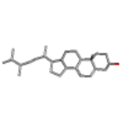
 | Ergosterol peroxide | 5351516 | C[C@H](/C=C/[C@H](C)C(C)C)[C@H]1CC[C@@H]2[C@@]1(CC[C@H]3[C@]24C=C[C@@]5([C@@]3(CC[C@@H](C5)O)C)OO4)C | 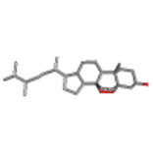
 | Campesterol | 173183 | C[C@H](CC[C@@H](C)C(C)C)[C@H]1CC[C@@H]2[C@@]1(CC[C@H]3[C@H]2CC=C4[C@@]3(CC[C@@H](C4)O)C)C | 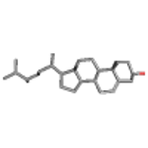
 | Beta-sitosterol | 222284 | CC[C@H](CC[C@@H](C)[C@H]1CC[C@@H]2[C@@]1(CC[C@H]3[C@H]2CC=C4[C@@]3(CC[C@@H](C4)O)C)C)C(C)C | 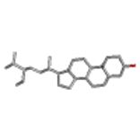
 | Stigmasterol | 5280794 | CC[C@H](/C=C/[C@@H](C)[C@H]1CC[C@@H]2[C@@]1(CC[C@H]3[C@H]2CC=C4[C@@]3(CC[C@@H](C4)O)C)C)C(C)C | 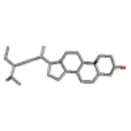
 | Lanosterol | 246983 | C[C@H](CCC=C(C)C)[C@H]1CC[C@@]2([C@@]1(CCC3=C2CC[C@@H]4[C@@]3(CC[C@@H](C4(C)C)O)C)C)C | 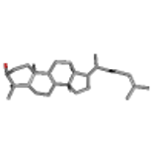
 | 24-methylenecholesterol | 92113 | C[C@H](CCC(=C)C(C)C)[C@H]1CC[C@@H]2[C@@]1(CC[C@H]3[C@H]2CC=C4[C@@]3(CC[C@@H](C4)O)C)C | 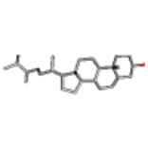
 | Ergosta-5,7,22-trienol | 68930746 | C[C@H](C=C[C@H](C)C(C)CO)[C@H]1CC[C@@H]2[C@@]1(CC[C@H]3C2=CC=C4[C@@]3(CCCC4)C)C | 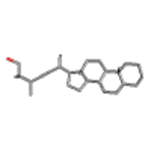
 | Brassicasterol | 5281327 | C[C@H](/C=C/[C@H](C)C(C)C)[C@H]1CC[C@@H]2[C@@]1(CC[C@H]3[C@H]2CC=C4[C@@]3(CC[C@@H](C4)O)C)C | 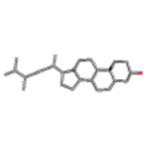
 | Protocatechuic acid | 72 | C1=CC(=C(C=C1C(=O)O)O)O | 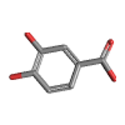
 | D-Mannitol | 6251 | C([C@H]([C@H]([C@@H]([C@@H](CO)O)O)O)O)O | 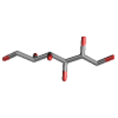
 | Trehalose | 7427 | C([C@@H]1[C@H]([C@@H]([C@H]([C@H](O1)O[C@@H]2[C@@H]([C@H]([C@@H]([C@H](O2)CO)O)O)O)O)O)O)O | 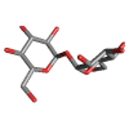
 | Gallic acid | 370 | C1=C(C=C(C(=C1O)O)O)C(=O)O | 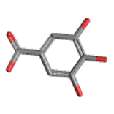
 | ferulic acid | 445858 | COC1=C(C=CC(=C1)/C=C/C(=O)O)O | 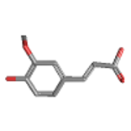
 | Caffeic acid | 689043 | C1=CC(=C(C=C1/C=C/C(=O)O)O)O | 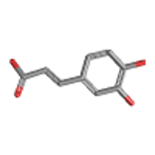
 | Linoleic acid | 5280450 | CCCCC/C=C\\C/C=C\\CCCCCCCC(=O)O | 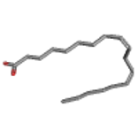
 | Oleic acid | 445639 | CCCCCCCC/C=C\\CCCCCCCC(=O)O | 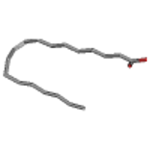
 | Palmitic acid | 985 | CCCCCCCCCCCCCCCC(=O)O | 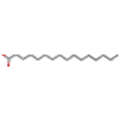
 | L-Alanine | 5950 | C[C@@H](C(=O)O)N | 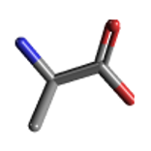
 | L-Valine | 6287 | CC(C)[C@@H](C(=O)O)N | 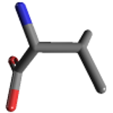
 | L-Leucine | 6106 | CC(C)C[C@@H](C(=O)O)N | 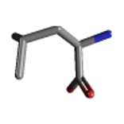
 | L-Isoleucine | 6306 | CC[C@H](C)[C@@H](C(=O)O)N | 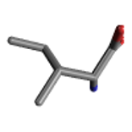
 | L-Phenylalanine | 6140 | C1=CC=C(C=C1)C[C@@H](C(=O)O)N | 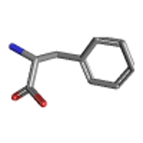
 | Ergothioneine | 5351619 | C[N+](C)(C)[C@@H](CC1=CNC(=S)N1)C(=O)[O-] | 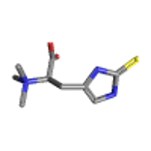
 | γ-Aminobutyric acid (GABA) | 119 | C(CC(=O)O)CN | 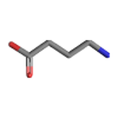
 | β-Carotene | 5280489 | CC1=C(C(CCC1)(C)C)/C=C/C(=C/C=C/C(=C/C=C/C=C(/C=C/C=C(/C=C/C2=C(CCCC2(C)C)C)\\C)\\C)/C)/C | 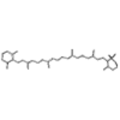
 | Lutein | 5281243 | CC1=C(C(C[C@@H](C1)O)(C)C)/C=C/C(=C/C=C/C(=C/C=C/C=C(\\C)/C=C/C=C(\\C)/C=C/[C@H]2C(=C[C@@H](CC2(C)C)O)C)/C)/C | 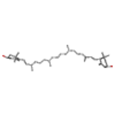
 | Lovastatin | 53232 | CC[C@H](C)C(=O)O[C@H]1C[C@H](C=C2[C@H]1[C@H]([C@H](C=C2)C)CC[C@@H]3C[C@H](CC(=O)O3)O)C | 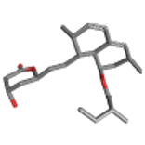
 | Myristic acid | 11005 | CCCCCCCCCCCCCC(=O)O | 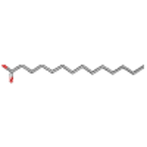
- hep | Heptadecanoic acid | 10465 | CCCCCCCCCCCCCCCCC(=O)O | 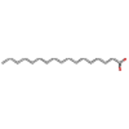
 | Syringic acid | 10742 | COC1=CC(=CC(=C1O)OC)C(=O)O | 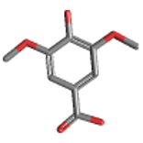
 | Pentadecanoic acid | 13849 | CCCCCCCCCCCCCCC(=O)O | 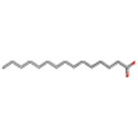

Supplementary Table S2. Complete molecular docking results of the 42 bioactive metabolites from Cordyceps militaris against four validated Plasmodium falciparum therapeutic targets: dihydrofolate reductase–thymidylate synthase (PfDHFR-TS; PDB ID: 7F3Y), lactate dehydrogenase (PfLDH; 1CEQ), multidrug resistance protein 1 (PfMDR1; 3QG2), and apical membrane antigen 1 (PfAMA1; 9EVO). The table presents the predicted binding affinities (kcal/mol) obtained from molecular docking for all screened compounds. Top-performing metabolites selected for detailed interaction analysis, molecular dynamics simulations, and ADMET evaluation were identified based on their docking scores.
S.No | COMPOUND NAME | PDB ID
S.No | COMPOUND NAME | 7F3Y | 1CEQ | 3QG2 | 9EVO
 | Cordycepin(3’-deoxyadenosine) | -7.5 | -5.9 | -7.0 | -5.9
 | Adenosine | -7.9 | -5.8 | -7.3 | -6.0
 | Inosine | -6.8 | -6.0 | -6.5 | -6.1
 | Guanosine | -7 | -6.4 | -7.2 | -6.5
 | Uridine | -6.3 | -6.1 | -6.9 | -5.6
 | Cytidine | -6.5 | -5.9 | -6.1 | -5.9
 | Thymidine | -6.9 | -5.8 | -6.6 | -5.5
 | Adenine | -5.9 | -4.6 | -5.3 | -4.8
 | Uracil | -5 | -5.2 | -4.7 | -4.8
 | Hypoxanthine | -6.2 | -4.8 | -5.4 | -4.9
 | Ergosterol | -9.2 | -8.5 | -10.1 | -7.8
 | Ergosterol peroxide | -9.9 | -8.5 | -10 | -7.4
 | Campesterol | -9.6 | -7.8 | -10 | -6.9
 | Beta-sitosterol | -9.7 | -7.7 | -9.9 | -6.2
 | Stigmasterol | -10.2 | -8.4 | -10.3 | -7.0
 | Lanosterol | -10.1 | -8.5 | -9.4 | -7.5
 | 24-methylenecholesterol | -9.6 | -7.8 | -10.2 | -6.5
 | Ergosta-5,7,22-trienol | -10 | -8.6 | -9.8 | -7.5
 | Brassicasterol | -10.5 | -8.5 | -10.2 | -7.4
 | Protocatechuic acid | -7.8 | -6.3 | -5.8 | -5.6
 | D-Mannitol | -5.2 | -4.5 | -5.3 | -4.6
 | Trehalose | -6.7 | -6.3 | -6.2 | -5.7
 | Gallic acid | -6 | -5.5 | -5.9 | -5.7
 | ferulic acid | -6.9 | -5.4 | -6.6 | -5.1
 | Caffeic acid | -6.9 | -5.8 | -6.3 | -5.5
 | Linoleic acid | -6.2 | -5.0 | -5.8 | -3.9
 | Oleic acid | -6.4 | -5.1 | -6.0 | -4.5
 | Palmitic acid | -6.2 | -4.9 | -5.4 | -3.9
 | L-Alanine | -5.4 | -3.8 | -4.0 | -4.0
 | L-Valine | -5.2 | -4.2 | -4.7 | -4.0
 | L-Leucine | -7.2 | -4.2 | -4.6 | -4.1
 | L-Isoleucine | -6.1 | -4.4 | -4.5 | -4.4
 | L-Phenylalanine | -7.7 | -5.3 | -6.0 | -4.9
 | Ergothioneine | -5.9 | -5.2 | -5.1 | -4.5
 | γ-Aminobutyric acid (GABA) | -4.6 | -3.6 | -3.8 | -3.9
 | β-Carotene | -9.7 | -8.4 | -9.6 | -8.3
 | Lutein | -9.5 | -8.4 | -9.5 | -7.8
 | Lovastatin | -7.7 | -7.3 | -7.6 | -6.5
 | Myristic acid | -6 | -4.6 | -5.4 | -4.8
 | Heptadecanoic acid | -6.1 | -5.0 | -5.2 | -4.3
 | Syringic acid | -6.5 | -5.2 | -5.8 | -5.4
 | Pentadecanoic acid | -5.8 | -4.6 | -5.0 | -4.7

