Additional file 1:

Random forest for land use change
For complete names of the variables, please see Additional file 2

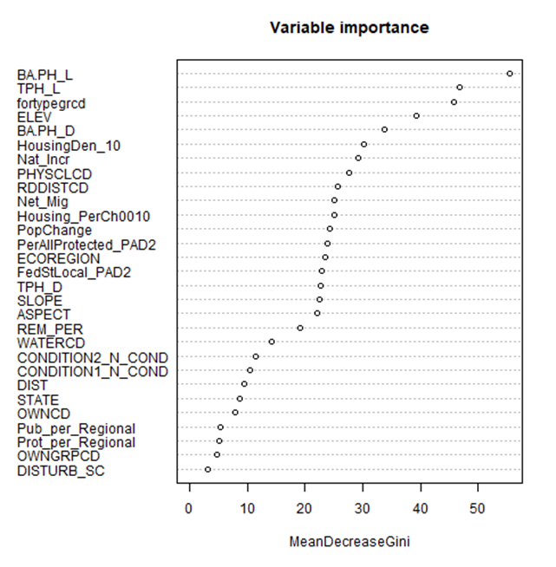

Random forest for aboveground carbon stock changes
For complete names of the variables, please see Additional file 3

