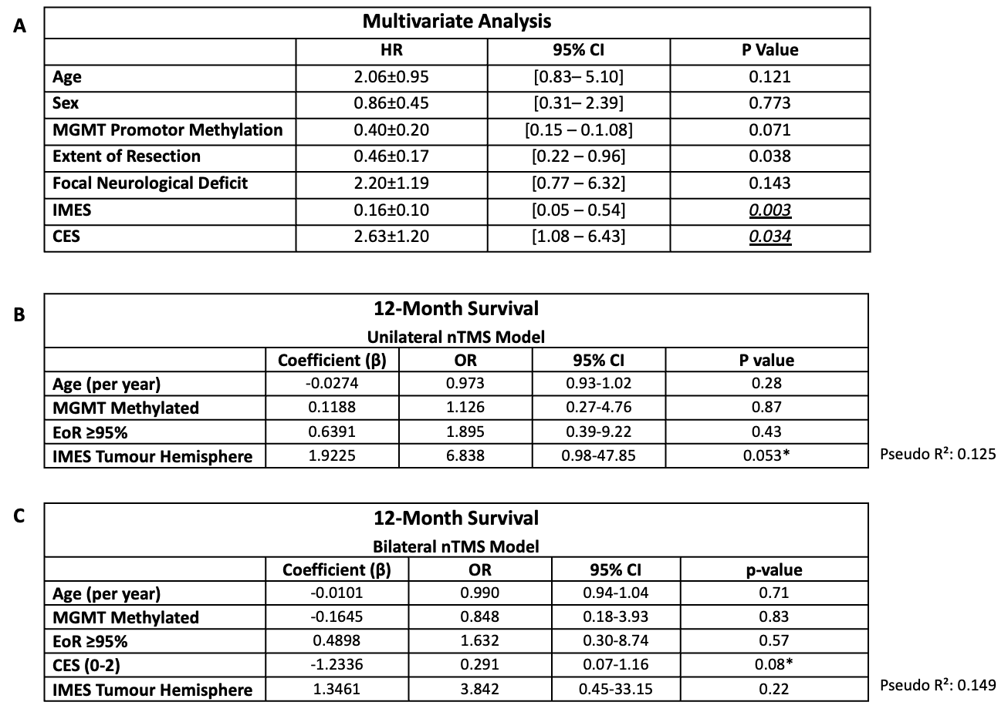Table 2. Regression analysis for overall survival and 12-month survival prediction. (A) Multivariate Cox regression for overall survival. (B) Logistic regression for 12-month survival prediction—unilateral model (n = 50). (C) Logistic regression for 12-month survival prediction—bilateral model (n = 46). CES = Cortical Excitability Score (range 0–2); IMES = IntraM1 Excitability Score; HR = hazard ratio; OR = odds ratio; CI = confidence interval.
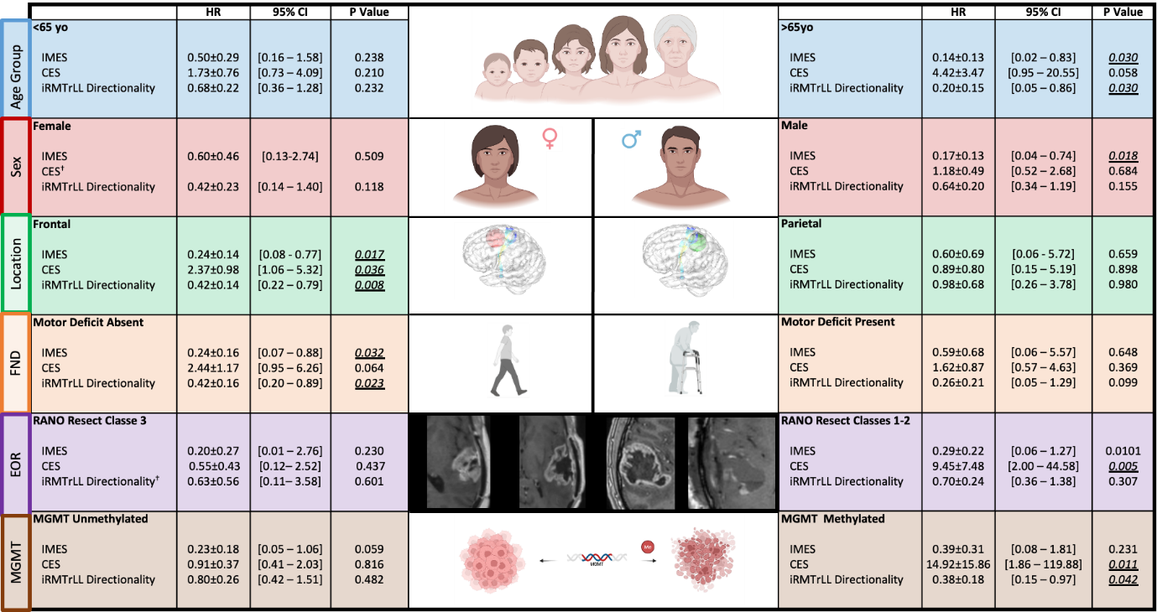Table 3. Subgroup analysis: log-rank p-values for IMES, CES, and iRMTr-LL directionality stratified by demographic, clinical, and histological characteristics.

