SUPPLEMENTARY MATERIAL

Supplementary Figure 1. Limited preoperative choroidal assessment in a highly myopic eye

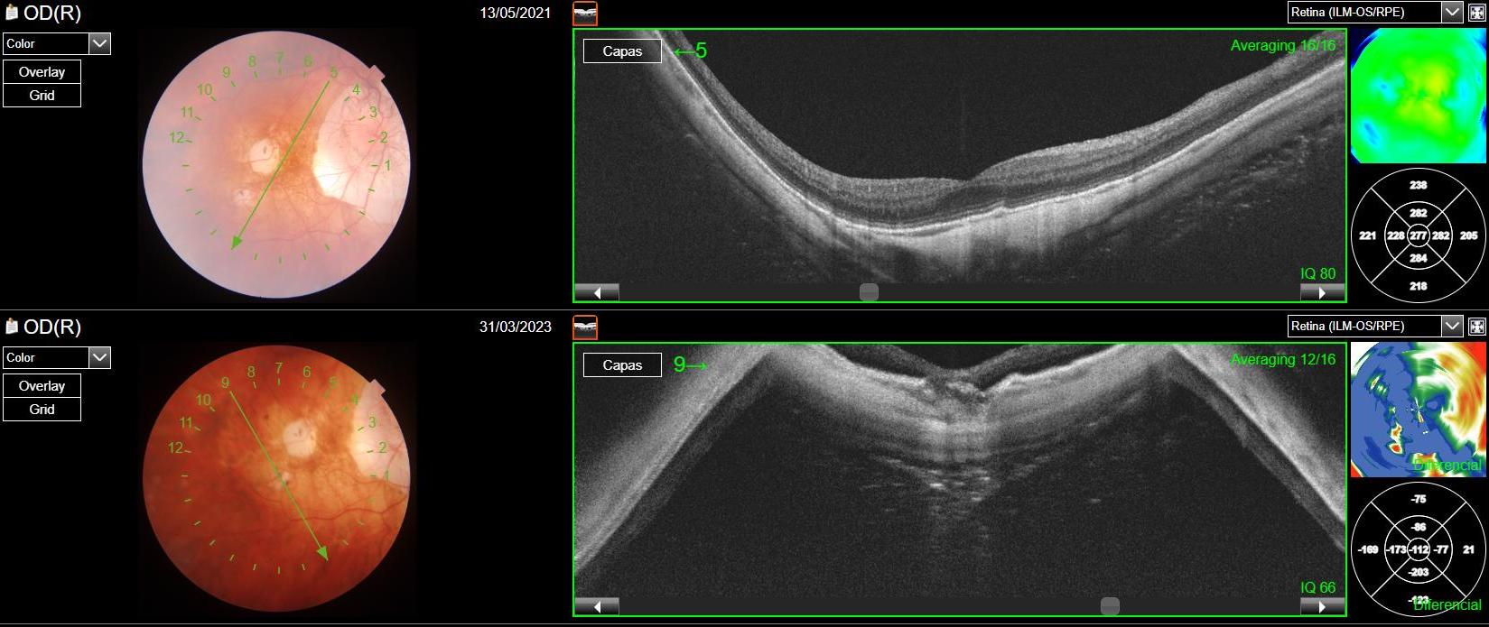
Supplementary Figure 1.
Preoperative swept-source optical coherence tomography (SS-OCT) image of a highly myopic eye with primary rhegmatogenous retinal detachment. The elongated posterior segment, steep retinal curvature, and poor delineation of the choroid–sclera interface prevent accurate identification of choroidal boundaries, precluding reliable subfoveal choroidal thickness (SFCT) measurement despite adequate image acquisition.

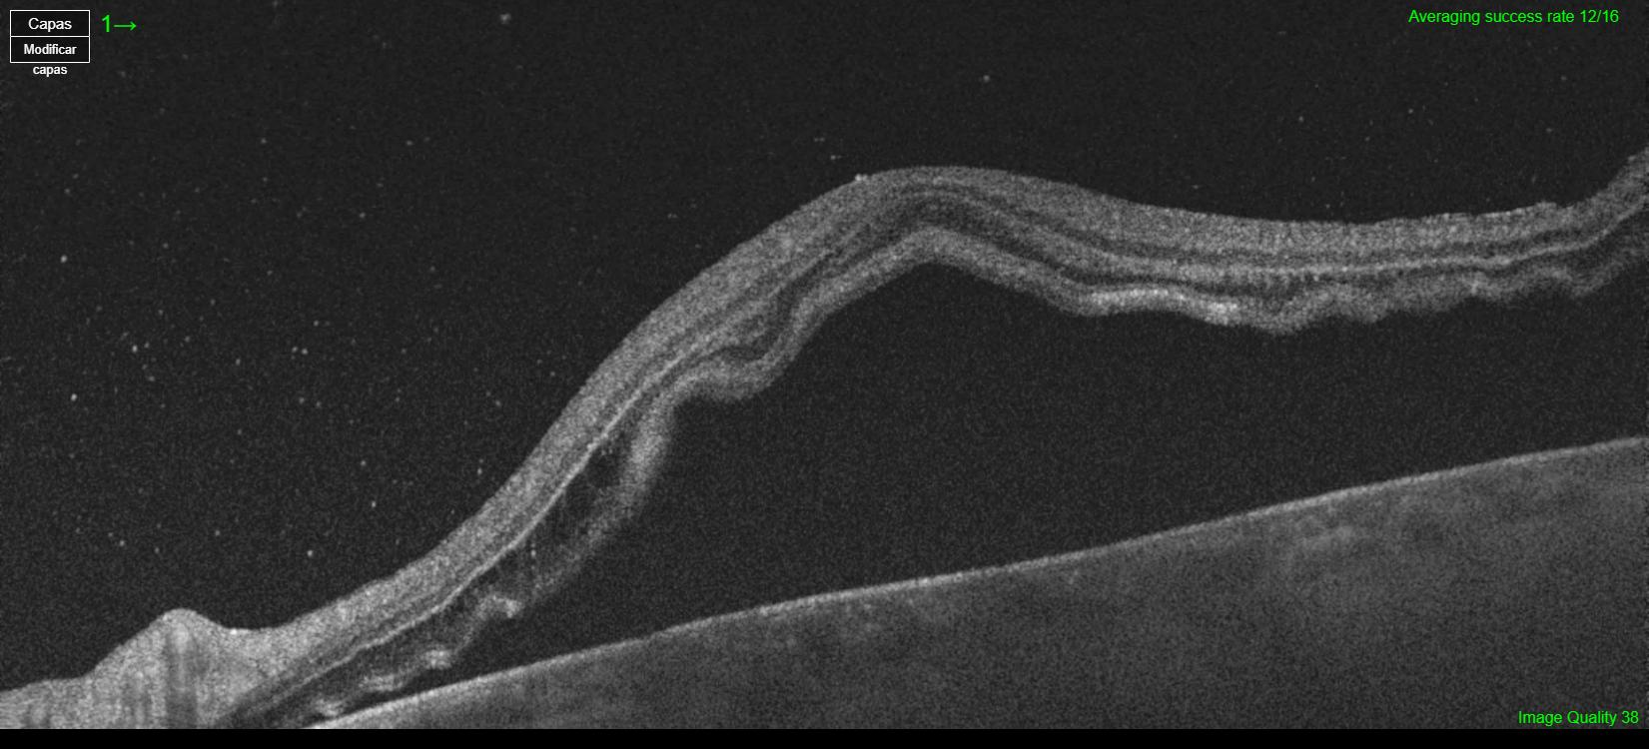
Supplementary Figure 2. Limited preoperative choroidal assessment in macula-off retinal detachment
Supplementary Figure 2.
Preoperative swept-source optical coherence tomography (SS-OCT) image of a macula-off rhegmatogenous retinal detachment. Elevation of the neurosensory retina, presence of subretinal fluid, and attenuation of the OCT signal in deeper layers impair visualization of the choroid–sclera junction, rendering preoperative subfoveal choroidal thickness (SFCT) measurement unreliable.

