Supplementary Information
Coding Metasurfaces with Coral-like Graphene for Thin and Strong Microwave Absorption

Jie Liang,¹ Yi An,¹ Yuchen Cao,¹ Wenting Zhi,¹ Chuchu Guo,¹ Xiaomeng Fan,¹ Fang Ye,¹* Qiang Song¹*

¹Science and Technology on Thermostructural Composite Materials Laboratory, Northwestern Polytechnical University, Xi’an 710072, People’s Republic of China
*Corresponding authors: Fang Ye, yefang511@nwpu.edu.cn
Qiang Song: songqiang511@nwpu.edu.cn

Supplementary Text
Pyrolysis calculations of carbon source
The gas-phase reaction process provides the essential material basis for solid-phase deposition and constitutes the primary reaction pathway in vapor-phase pyrolysis (Fig. 1a). To accurately describe the gas-phase pyrolysis of ethanol (C₂H₅OH) during chemical vapor deposition (CVD) and to quantify the concentrations of pyrolysis products, it is crucial to elucidate the fundamental gas-phase reaction mechanism. CVD processes typically employ a tubular reactor, which is commonly approximated as a plug-flow reactor. C₂H₅OH vapor was introduced into such a plug-flow reactor to analyze its gas-phase pyrolysis behavior. The reaction zone was a straight cylindrical tube without internal structures, resulting in a low specific surface area. Consequently, the deposition rate of solid pyrolytic carbon approaches zero and can be considered negligible. Ethanol was vaporized in a water bath, fed into the reactor inlet, and reacted at 1223 K and 8 kPa. Within the reaction zone (length 10 cm, diameter 5 cm; Fig. S1A), the gas reacted over a defined residence time before the products exited through the outlet. Figure S1A shows the residence time at different axial positions, revealing a gradual increase toward the reactor outlet.
Figure S1B presents the mole fractions of the various species, revealing that the oxidative byproducts of C₂H₅OH, CO₂ and H₂O, exhibit markedly higher concentrations than most hydrocarbon molecules. CO₂ is capable of selectively etching small crystallites, thereby reducing grain boundary density and enhancing the graphitic texture. H₂O etches the edges of upper-layer graphene while simultaneously promoting the growth of the underlying layer, which facilitates the formation of uniform multilayer graphene. In the chemical vapor deposition of carbon-based materials, graphene deposition reactions are broadly classified into three categories (C₁, C₂, C₆) based on the depositing gaseous carbon-source species. Previous mechanistic studies have indicated that methyl radicals (CH₃) serve as the primary carbon source for graphene deposition. Acetylene (C₂H₂) deposits graphene through surface addition reactions, whereas an increased concentration of C6 species (represented by C₆H₆) enhances the structural ordering of the deposited graphene. Consequently, the relative concentrations of the three carbon radicals and the two byproducts play a critical role in governing the crystalline structure and defect configuration of graphene. The results demonstrate that C₂H₂ is the dominant species, followed by C₆H₆, while CH₃ exhibits the lowest abundance. Under such a concentration profile, large curved carbon clusters readily form, leading to the deposition of carbon with a low-textured pyrolytic character.
Computational simulations systematically evaluated the distribution of pyrolysis products under different CH₃OH-to-C₂H₅OH ratios. As shown in Fig. S2, with a progressive increase in the ethanol fraction, the mole fractions of C₂H₂ and C₆H₆ in the pyrolysis products exhibit a pronounced upward trend, whereas the concentration of CH₃ changes relatively gently, showing only slight fluctuations. Notably, the oxidative byproducts H₂O and CO₂ follow opposite trends: as the ethanol content increases, the production of water vapor continuously rises, primarily because the higher abundance of hydroxyl groups (–OH) in ethanol molecules facilitates the release of hydrogen-oxygen moieties that readily combine with hydrogen atoms to form water; in contrast, the yield of CO₂ displays a declining tendency, indicating that the introduction of ethanol alters the pyrolysis reaction pathways and suppresses complete oxidation side reactions.
Fig. S2F further quantifies the relative contents of the three key carbon-source gases (C₁, C₂, C₆) under different feedstock ratios. The results show that the relative proportions of C₂H₂ and benzene (C₆H₆) increase continuously with higher ethanol content, whereas the increase in CH₃ is comparatively limited. This differentiated growth behavior reveals that ethanol molecules are more prone to generate unsaturated hydrocarbons rather than simple CH₃ fragments during pyrolysis. By precisely controlling the methanol-to-ethanol carbon-source ratio, this study successfully achieves a tunable proportion of the three critical growth precursor gases—C₁, C₂, and C₆—thereby providing an ideal carbon-source environment for the subsequent oriented growth of coral-like graphene. This finding not only deepens the understanding of alcohol pyrolysis mechanisms but also offers a new technical pathway for tailoring graphene micromorphology through feedstock design.

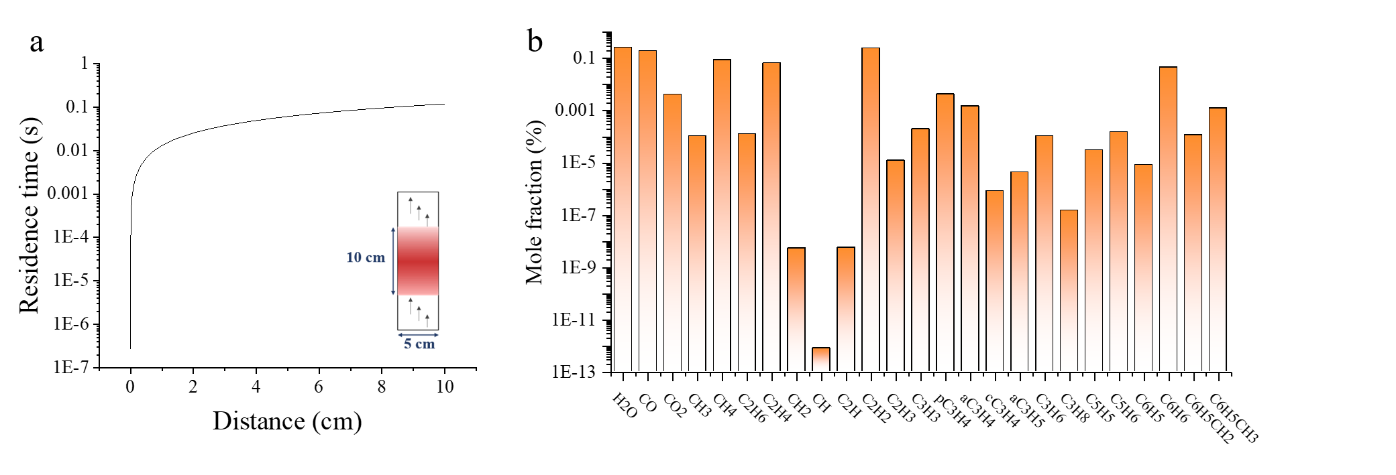

Fig. S1 Pyrolysis simulation of C₂H₅OH.
a Relaxation time at different positions in the reactor (inset: reactor model). b Mole fraction of molecule at a relaxation time of 0.12 s

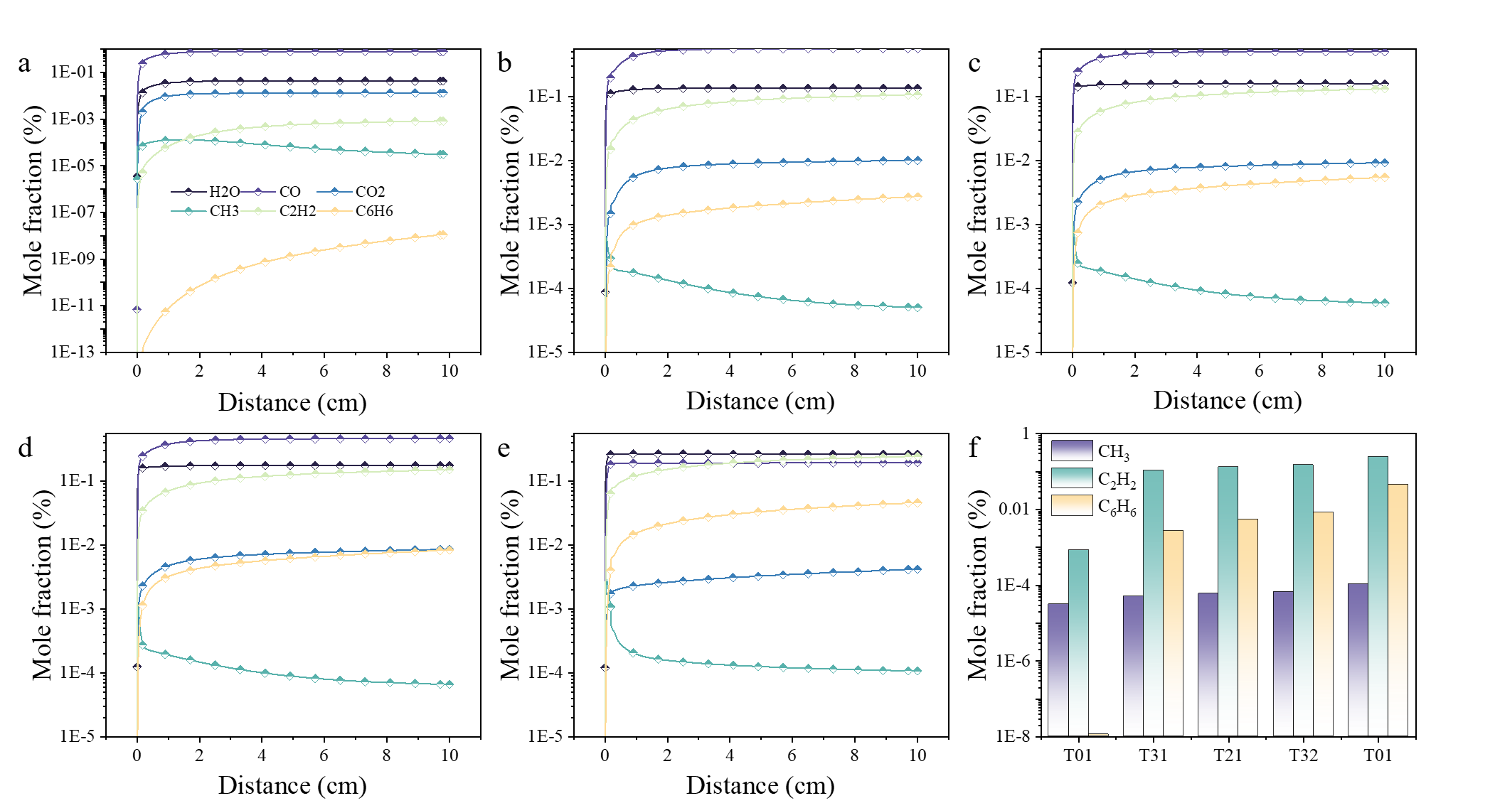

Fig. S2 Mole fraction of molecules produced after high-temperature pyrolysis.
a T10. b T31. c T21. d T32. e T01. f Mole fraction of molecule at a relaxation time of 0.12 s

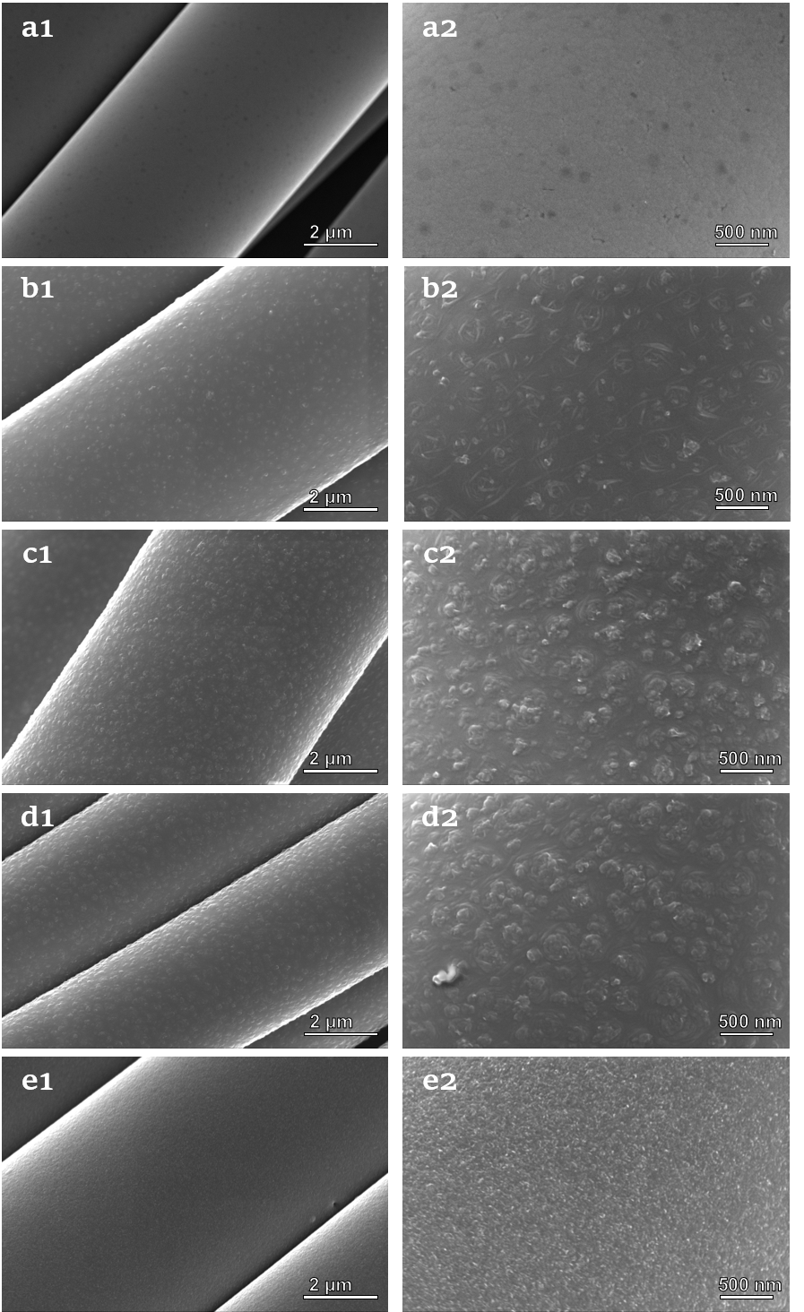

Fig. S3 Scanning electron microscope (SEM) image of carbon structure derived from different carbon source.
a T10. b T31. c T21. d T32. e T01.
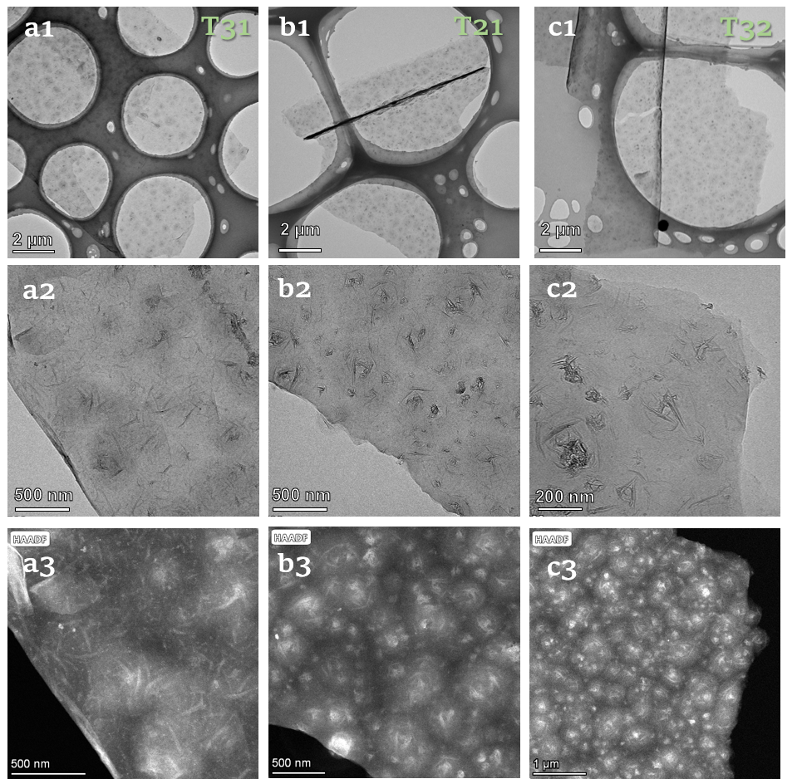

Fig. S3 Transmission electron microscopy (TEM) image of the coral-like graphene structure derived from CH₃OH-C₂H₅OH.
a1 T31. b1 T21. c1 T32. a2 High resolution-TEM image of T31. b2 High resolution-TEM image of T21. c2 High resolution-TEM image of T32. a3 HAADF-STEM image of T31. b3 HAADF-STEM image of T21. c3 HAADF-STEM image of T32.

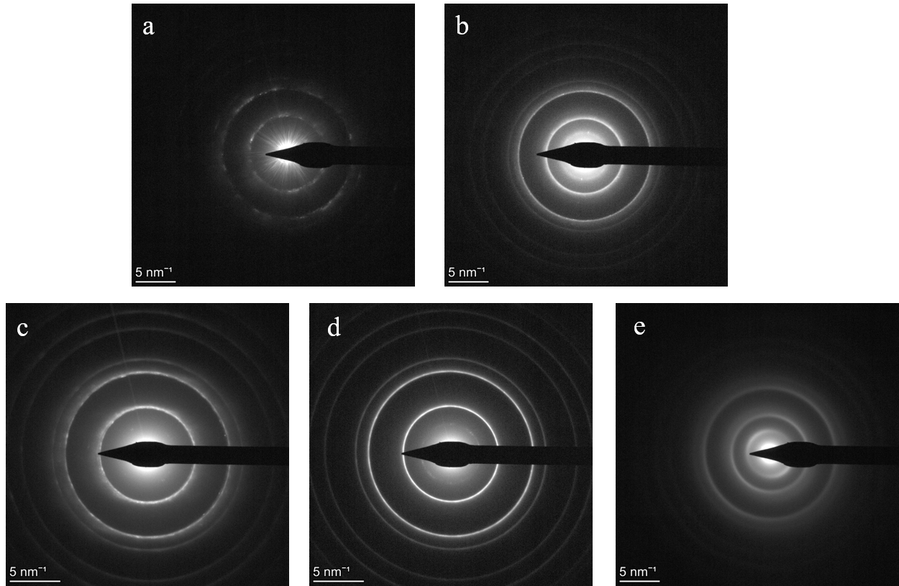

Fig. S4 Selected area electron diffraction (SAED) pattern.
a T10. b T31. c T21. d T32. e T01.

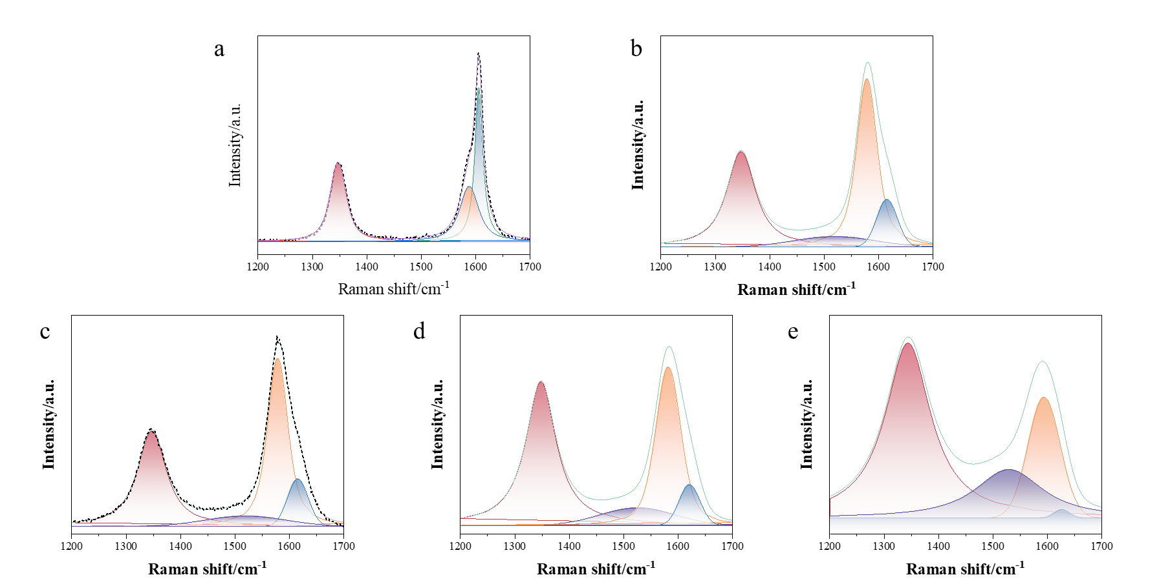

Fig. S5 Raman peak fitting deconvolution.
a T10. b T31. c T21. d T32. e T01.

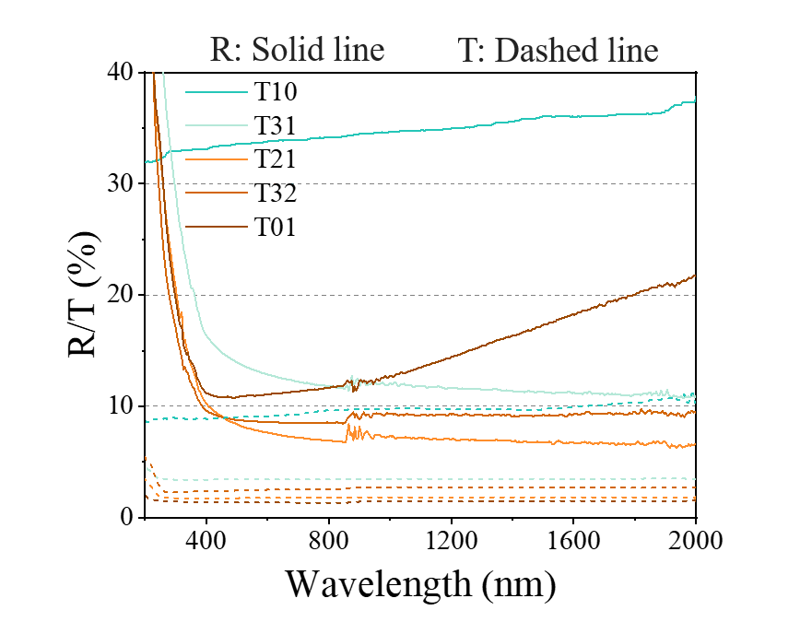

Fig. S6 Optical reflectance (R) and transmittance(T) in the 200-2000 nm spectral range.

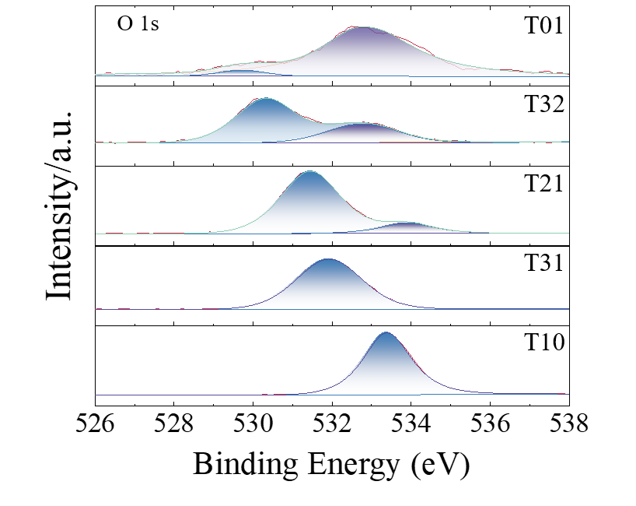

Fig. S7 Deconvolution of O 1s spectrum in XPS

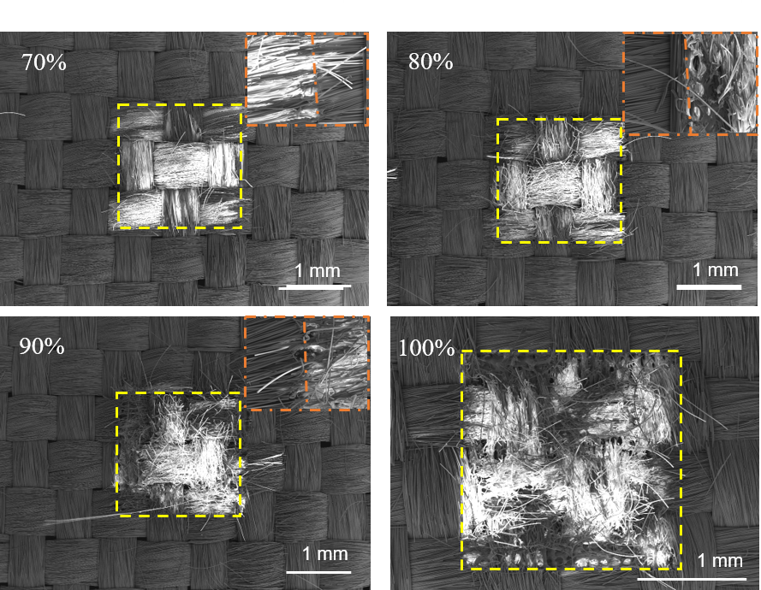

Fig. S8 Changes in microscopic morphology after laser etching at different laser powers (70%-100%)

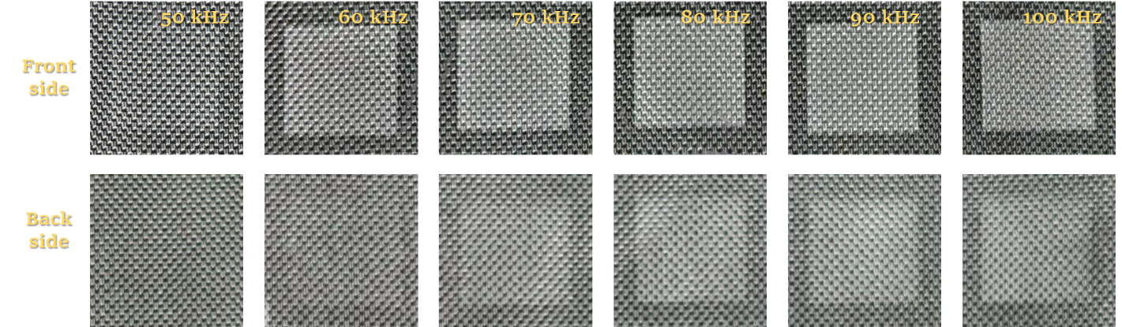

Fig. S9 Changes in macroscopic morphology after laser etching at different laser frequency (50-100 kHz).

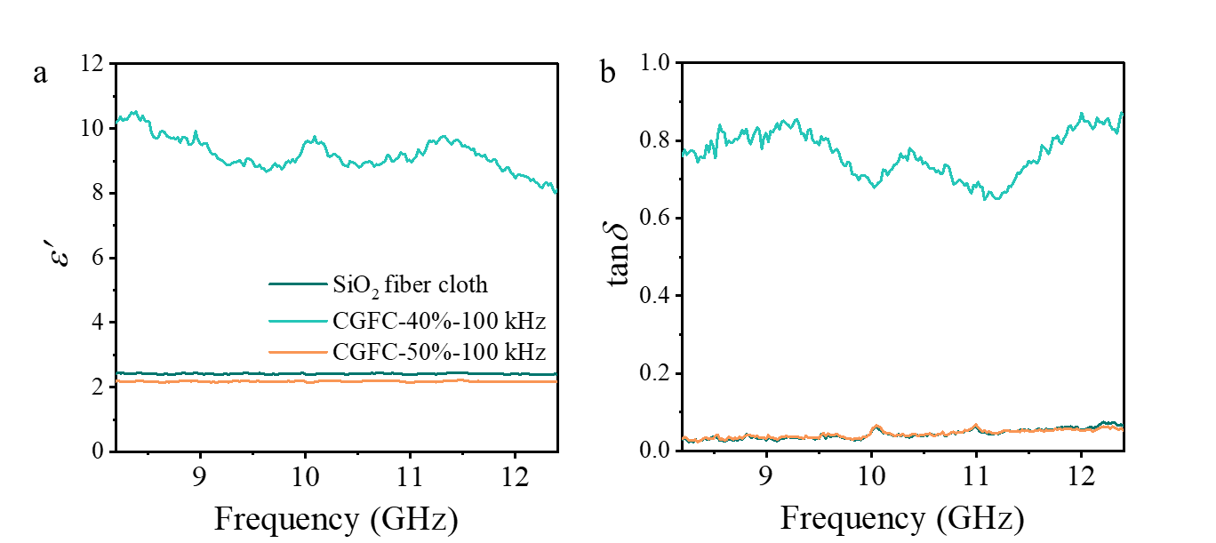

Fig. S10 Dielectric properties of CGCF after laser etching with different laser parameters. a ε׳. b tanδ

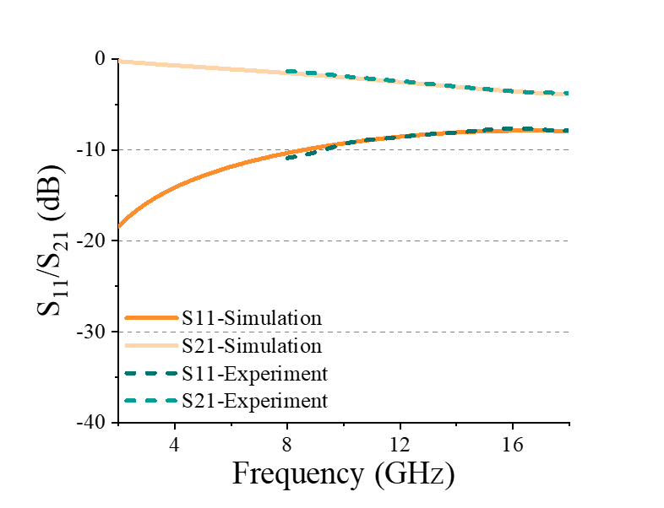

Fig. S11 Simulation and experimental results of graphene coding metasurfaces based on free-space method

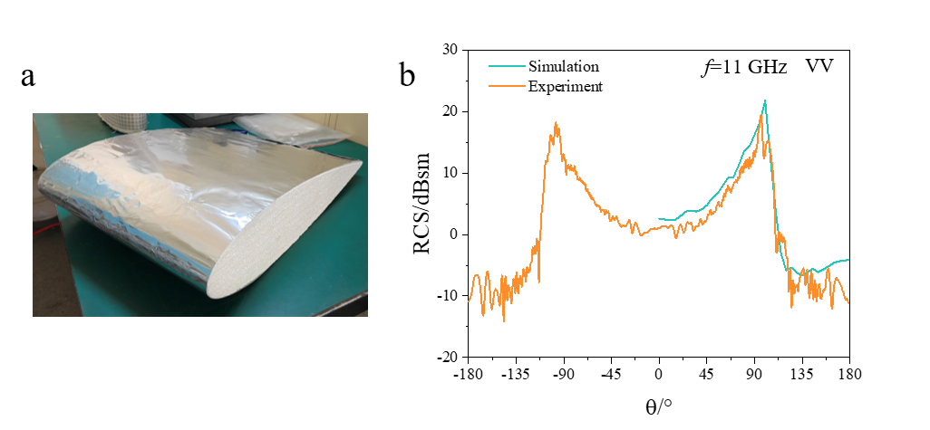

Fig. S12 Wing-structure and its RCS
a Image of Al-foil wings. b Comparison of RCS simulation and experiment

Tab. S1
Average RCS test results for the different angle range

f (GHz) | Theta (°) | RCS of PEC (dBsm) |  | RCS of graphene coding metasurfaces (dBsm) |  | RCS reduction (dBsm)
f (GHz) | Theta (°) | HH | VV | HH | VV | HH | VV
5 | -30−30 | -2.50 | -1.62 | -5.35 | -4.76 | -2.85 | -3.13
5 | ±30−150 | -0.63 | 1.59 | -15.85 | -15.58 | -15.22 | -17.17
11 | -30−30 | -0.51 | 0.99 | -10.57 | -12.55 | -10.06 | -13.54
11 | ±30−150 | -4.45 | 3.21 | -13.82 | -13.39 | -9.37 | -16.59
16 | -30−30 | 1.14 | 0.73 | -13.01 | -14.29 | -14.16 | -15.02
16 | ±30−150 | -6.07 | -5.93 | -16.76 | -17.46 | -10.70 | -11.53

