- Archeological seal-level marker
This study is based on high-precision geoarchaeological sea-level markers from the Tyrrhenian coast of Italy, with particular focus on Roman fish tanks (piscinae) and Roman harbour pilae. These archaeological structures are particularly valuable for reconstructing Late Holocene relative sea-level (RSL) changes because their construction, use, and maintenance were directly constrained by the position of the sea at the time, allowing their well-preserved diagnostic architectural elements to be used as high-precision sea-level index points (SLIPs) keeping into account specific values of functional clearance (FC; i.e., minimum elevation of each structure above the MSL at the time of its construction) and indicative range (IR; i.e., elevation range over which the marker forms, sensu Shennan, 2015).
Roman fish tanks were single or multiple tanks, used as ornamental water features associated with coastal villas, used for fish farming and connected to the open sea through channels to ensure continuous water exchange while preventing fish from escaping during high tide (Scognamiglio, 1997). For this reason, some architectural features of these structures, particularly the crepidines and the sluice gate, are considered highly reliable archaeological sea-level markers for RSL reconstruction (Figure 1; Leoni and Dai Pra, 1997; Lambeck et al., 2004; 2018; Auriemma and Solinas, 2009; Aucelli et al., 2020; Mattei et al., 2023; 2024).
The crepidines are walking surfaces or borders surrounding the tanks and internal pools, with the lowest crepido generally positioned close to the former mean sea level (MSL) to allow practical use and maintenance of the structure.
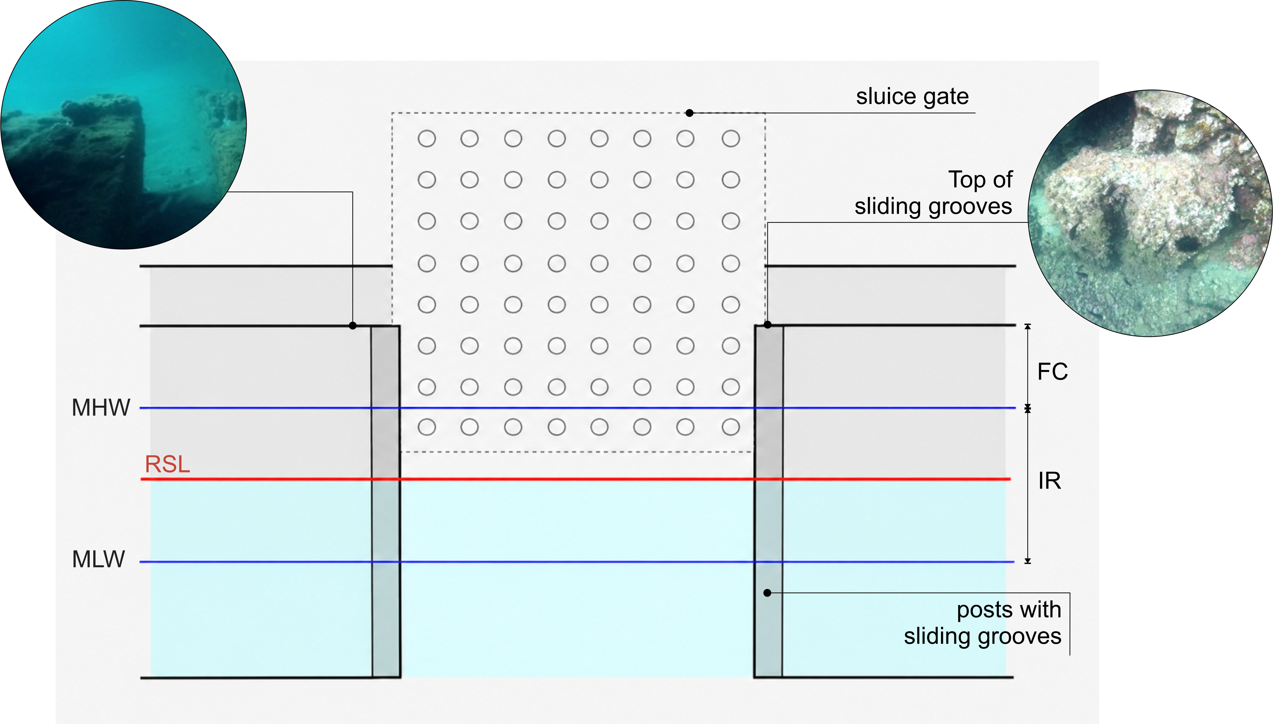Figure 1. Interpretation of the structural elements of a fish tank as RSL marker (modified after Aucelli et al., 2020).
The sluice gate, or cataractae, regulated seawater exchange between the tanks and the open sea and consisted of a movable perforated gate, designed to allow water circulation while preventing fish loss, set on a stone threshold and inserted between vertical posts equipped with grooves that guided its movement. The position of sluice gates is particularly diagnostic because this structural element had to remain above mean high water to ensure proper functioning of the fishtank and to avoid uncontrolled exchange with the open sea.
In this work, the sluice gates and the lower crepido levels are treated as SLIPs by assuming a functional clearance of about 0.20 m and an IR directly related to the tidal range ranging between mean high water (MHW) and mean low water (MLW). The assessed value of FC is based on the archaeological and functional interpretation of the structures and on direct field observations of well-preserved sluice-gate posts.
Therefore, the related determination of the RSL can be evaluated by using the following equation (Aucelli et al., 2020):
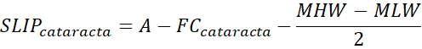
Roman pilae were square structures built on the seabed, generally with their upper portion emerging above the ancient sea surface, and were commonly arranged in single or multiple alignments, sometimes connected by arches to form the opus pilarum. Their construction became widespread after the development of Roman hydraulic concrete, which allowed maritime structures to be built directly in underwater environments using the cofferdam technique (Figure 2; Gianfrotta, 1996; Brandon et al., 2014; Mattei et al., 2018; Aucelli et al., 2020), whereby wooden frameworks composed of vertical posts (i.e., stipites and destinae) and horizontal beams (i.e., catenae)were placed on the seabed, filled with hydraulic concrete, and left to set in direct contact with seawater (Vitruvius, De Architectura II; 15 BC, Volume 6, p. 1).
The diagnostic element used for sea-level reconstruction is the so-called concrete change (Mattei et al., 2018; Aucelli et al., 2020), defined as the visible transition between the lower hydraulic concrete and the upper concrete laid in subaerial conditions. Because these materials underwent differential erosion, with the hydraulic concrete generally more resistant than the subaerial portion, this boundary can reflect the original relationship between the pila and the ancient sea level, where clearly preserved, and be used as a SLIP.
In the case of the pilae, the IR is considered directly related to the tidal range (between MHW and MLW) and a FC of approximately 0.50 m is assumed because, as described by Vitruvius (De Architectura II; 15 BCE, Vol. 6), the cofferdams had to emerge above the ancient MSL by an amount equivalent to a wooden board, corresponding to about 0.50 m.
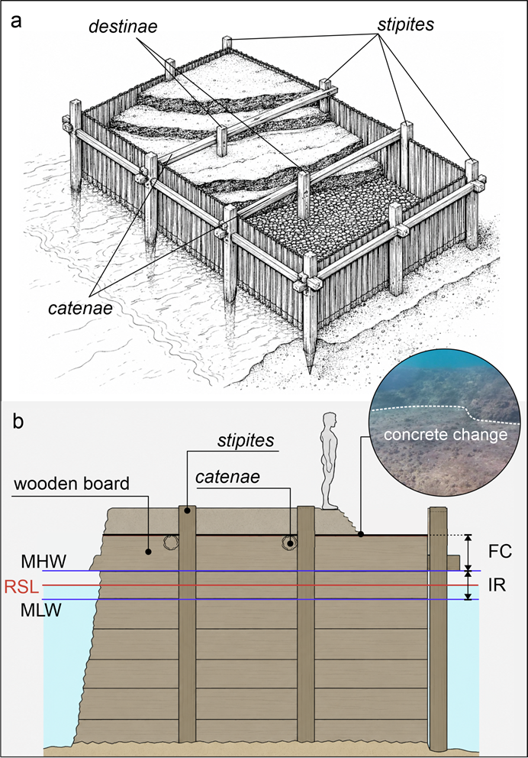
Figure 2. a: reconstruction of cofferdam technique based on Vitruvius description; b: interpretation of concrete change as RSL marker (images modified after Mattei et al., 2018).
Therefore, the related determination of the RSL can be evaluated by using the following equation (Aucelli et al., 2020 and reference therein):
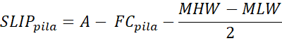
All measurements used in this study were directly carried out by the research groups involved in the investigation by using both a graduated scale and GNSS (see following section).
The total vertical error (or vertical uncertainty, u) was calculated by adding in quadratic individual errors according to the following equation:
u=(u₁²+ u₂² +…. + u_{n}²)^{1/2}
- GNSS measurements
Although some of the markers considered in this study had already been published, including the fish tanks from the Formia–Gaeta sector reported by Caporizzo et al. (2024) and the archaeological markers from the Sorrento Peninsula investigated by Aucelli et al. (2016), their elevations were re-evaluated within the methodological framework adopted here and verified by GNSS measurements (see also Supplementary Geodatabase). In addition to these re-assessed markers, the present study also includes new investigations at the Roman fish-tank complex of Ponza Island, the Roman harbour of San Marco, on the Cilento Promontory, and the famous fish tank complex of Torre Astura.
High-precision GNSS surveys were conducted using an Emlid Reach S2+ receiver operating in real-time kinematic (RTK) mode. All observations were acquired with a fixed (FIX) solution in the RDN2008 / UTM Zone 33N coordinate reference system. GNSS-derived ellipsoidal heights were converted to orthometric elevations referenced to local mean sea level (MSL) using the Italian gravimetric geoid ITG2009 (Corchete, 2010).
The geoid undulation was applied to transform ellipsoidal heights into orthometric elevations,thereby allowing all measured elevations and submersions to be referenced to MSL. The estimated vertical uncertainty for all measurements was ≤ 0.05 m.

- Direct geoarchoelogical surveys
The newly investigated Ponza site corresponds to the Roman fish-tank complex located below Punta della Madonna (SE sector of the island), known as Pilato Caves (Grotte di Pilato) and dated to the I century BC (Lombardi, 1996). The complex includes four tanks directly carved into the rock (i.e., ex petra excisae category; Varro, De Re Rustica III, 37 BC; Columella, De Re Rustica XVII, 30 AD) and an external tank (i.e., in litore constructae category; Varro, De Re Rustica III, 37 BC; Columella, De Re Rustica XVII, 30 AD). The two systems are independent in terms of their connection with the sea.
In this work, the main inner fishtank tank and the external one were directly investigated in May 2024 after an extensive bibliographic analysis and preliminary field inspections, and the measurements were carried out using both a graduated scale and GPS. The inner fish tank, located below the area formerly occupied by a Roman villa, preserves several characteristic architectural elements, including different crepido levels and sluice gates (Figure 3a and b) visible on all four sides of the structure.
The external fishtank is more exposed to meteomarine events and wave action and is therefore more degraded. Here, the surveyed elements included sluice gates, lateral walkways, and crepidines.
The RSL value was obtained from the submersion of the best-preserved sluice gate resulting in a SLIP at −1.35 ± 0.02 m MSL for the I century BC.
On the Cilento Promontory, the Roman harbour of San Marco, identified with the ancient Roman settlement of Erculia, was interpreted as an important supply harbour for vessels sailing toward Misenum, as well as a military base or support site for the imperial fleet. The archaeological remains consist of two main pier structures that delimited the navigable entrance to the harbour: a shorter NS-oriented breakwater, less than 50 m long and poorly preserved, and main EW-oriented pier, in a better state of preservation, about 90 m long (Figure 4a).
The EW pier was built by using the cofferdam technique, using a gently sloping rocky tongue as foundation (Benini, 2002). In its eastern sector, only scattered remains of concrete are preserved in direct contact with the bedrock, whereas westward, where the seabed becomes progressively deeper, the structure is preserved up to approximately 3 m in height.
A key diagnostic feature of the site is the presence of holes for the insertion of vertical wooden posts used to support the cofferdam, together with horizontal grooves related to the placement of the catenae (Figure 2b). These grooves occur at the level of the hydraulic concrete conglomerate and therefore correspond to the same elevation as the concrete change, making them suitable markers for reconstructing the ancient sea level (Figure 4b).
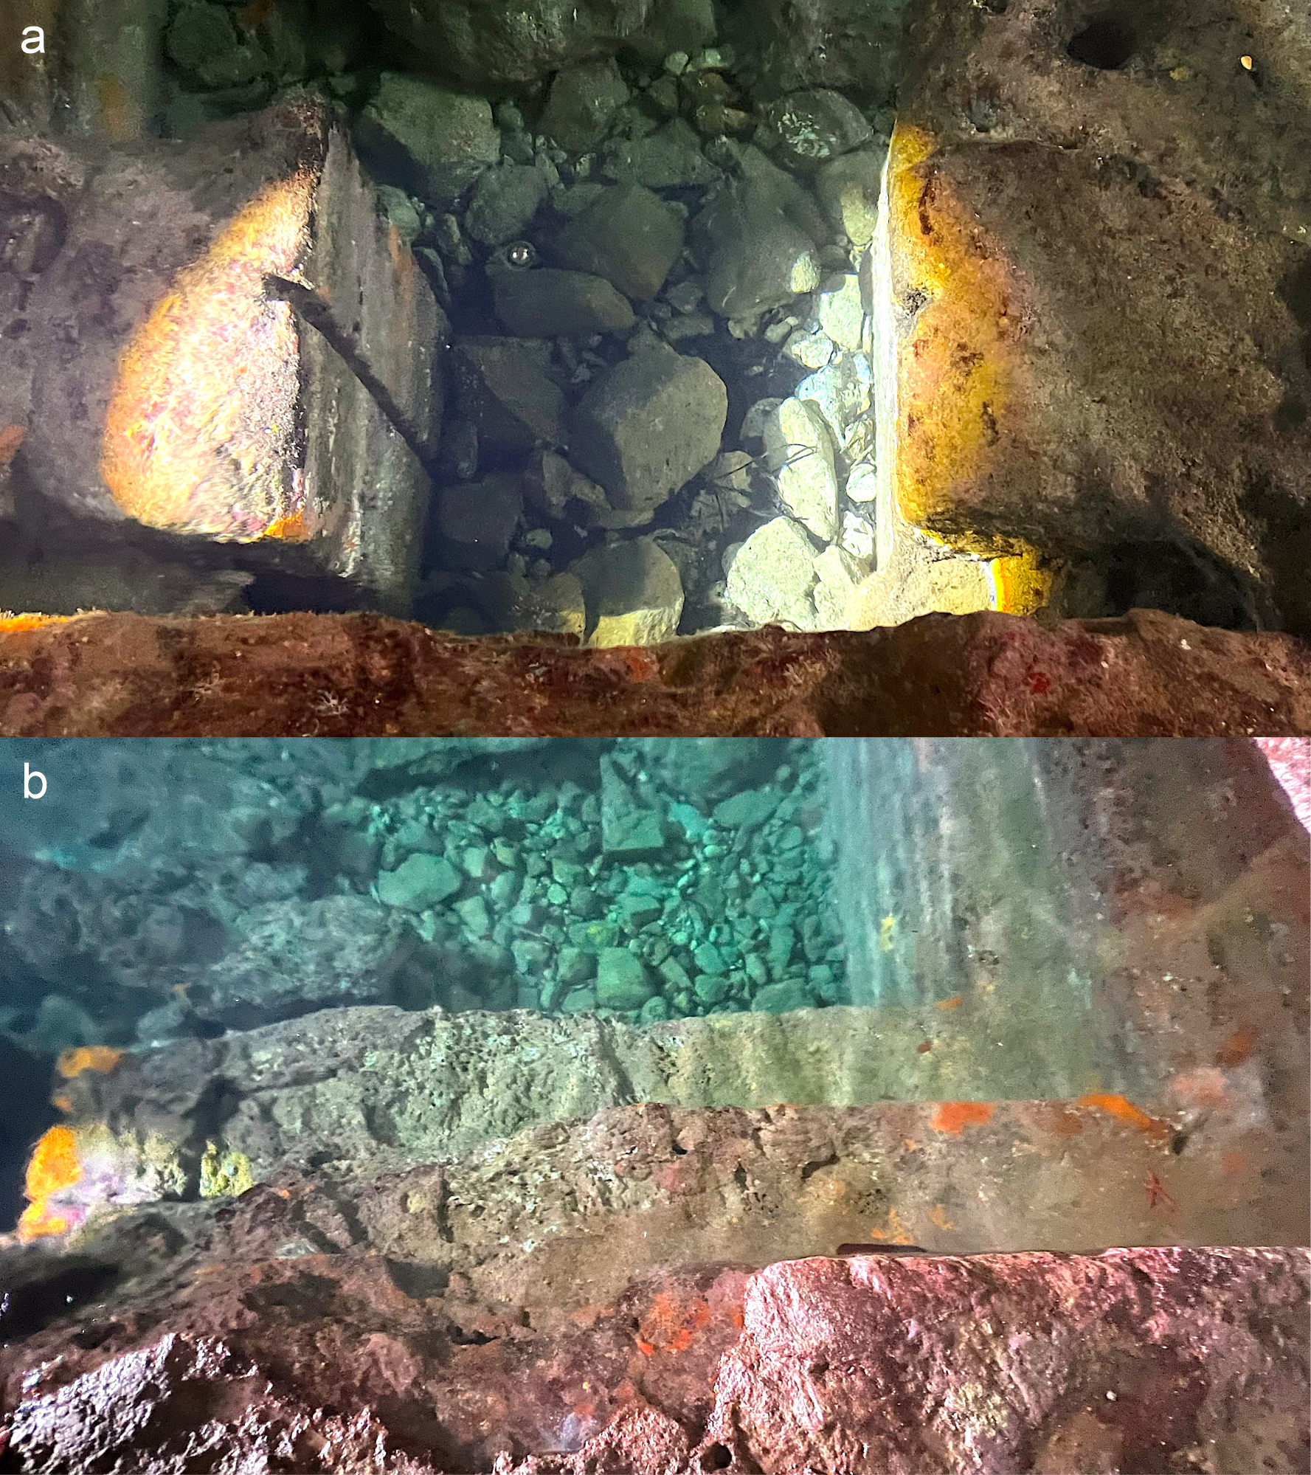
Figure 3. Geoarchaeological direct survey of the inner tank. a: perfectly preserved sluice gate; b: different levels of crepidines.
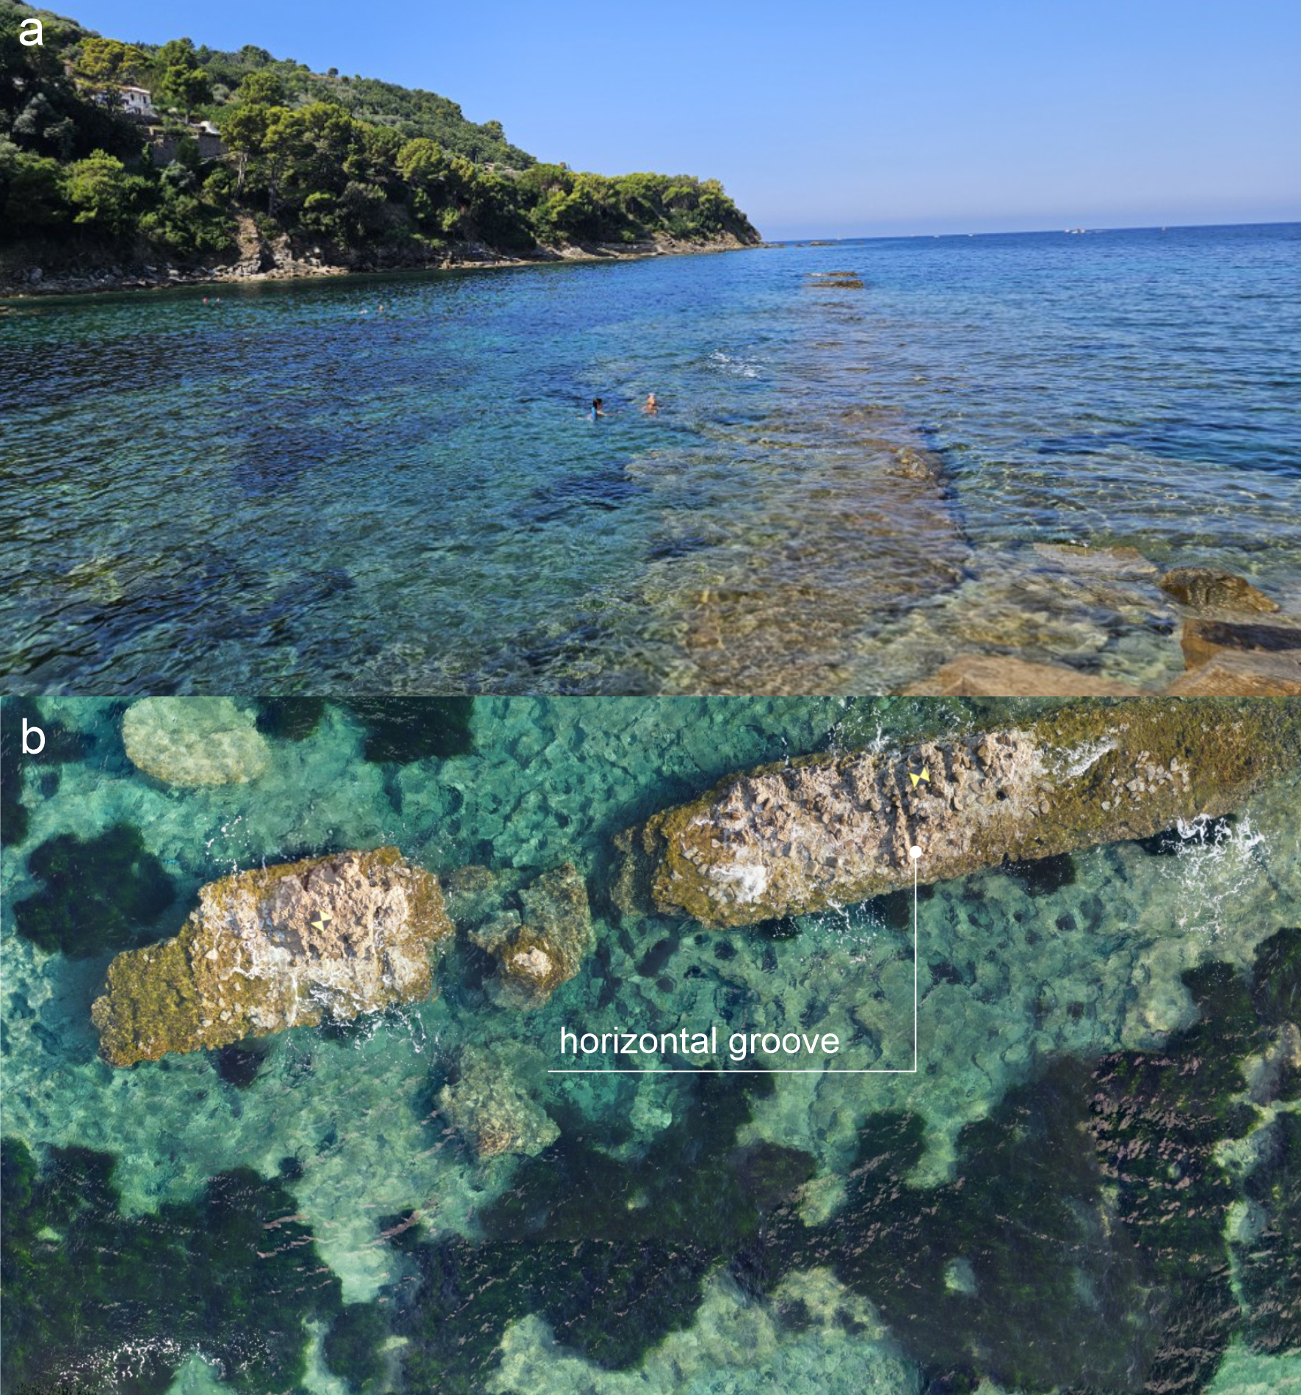
Figure 4. Geoarchaeological survey of San Marco harbour. a: extension of the longest EO-oriented pier; b: location of the horizontal groove measured during the direct survey.
Field activities carried out in August 2024 included measurements acquired using both GNSS and a graduated scale, together with an aerial photogrammetric survey performed by drone. The drone survey allowed the production of a DTM with a resolution of 0.2 m, which supported the characterization of the seabed morphology in the harbour area.
Submersion measurements along the EO-oriented breakwater were carried out at 5 m intervals from the present coastline, for a total of about 18 measurements. Among these, the submersion of the best-preserved horizontal groove was selected as the most reliable diagnostic marker, resulting, after the standard corrections, into a SLIP at −0.54 ± 0.20 m MSL deduced for the I century BCE.
The Torre Astura fish-tank complex is associated with the Roman villa built on the small offshore island facing the coast, which became connected to the mainland during the nineteenth century and was historically linked to it by a bridge, today partly buried by sand (Leoni and Dai Pra, 1997).
The villa, supplied by an aqueduct built within the bridge, originally occupied the entire island, although only a few vaulted structures supporting the terraces overlooking the sea are currently preserved. Around the main building, a system of rectangular and rhomboidal tanks formed the fish-tank complex, dated to the first half of the 1st century AD (Piccarreta, 1977; Leoni and Dai Pra, 1997).
Direct field measurements were carried out using GNSS and focused on the sluice gates of the tank system, including both the outermost elements, more exposed to marine processes and therefore more deteriorated (Figure 5a), and one of the inner sluice gates, which is better preserved (Figure 5b). After the standard corrections, the submersion measurements resulted in a SLIP at –0.51 ± 0.2 m MSL, deduced for the beginning of the I century BC.

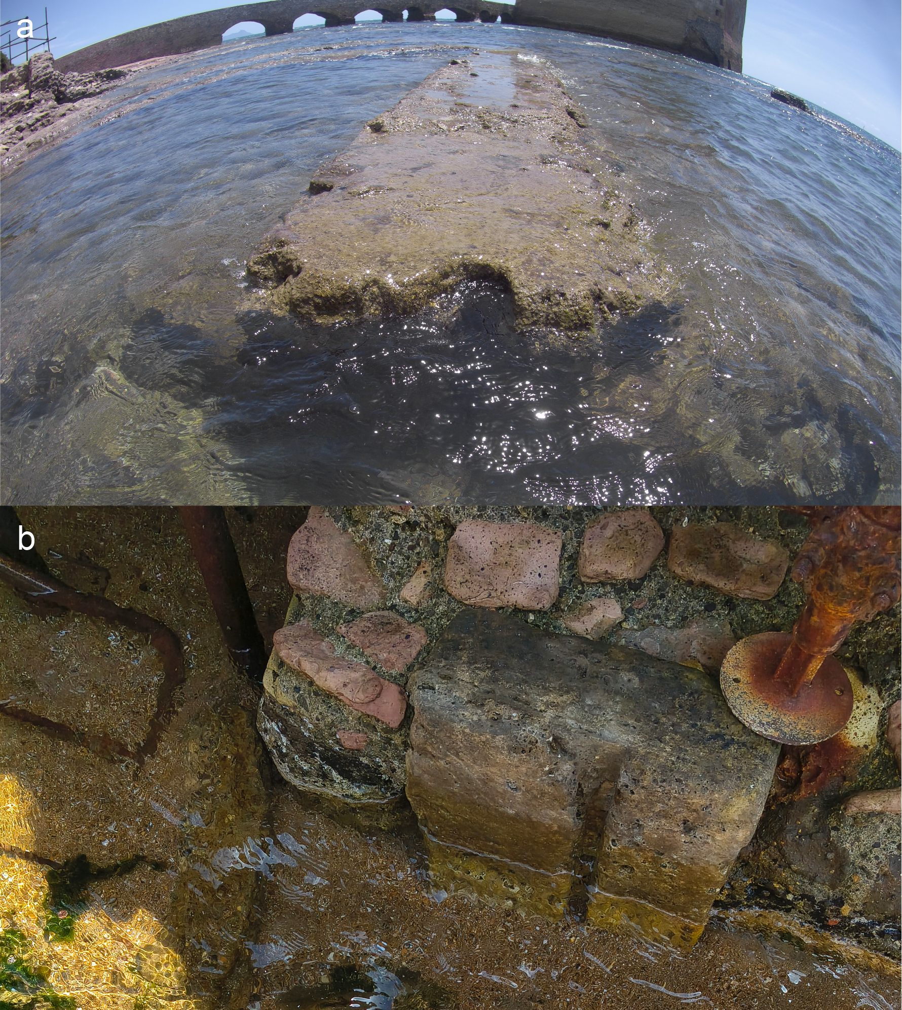
Figure 5. Geoarchaeological direct survey of Torre Astura fish tank. a: external and more deteriorated sluice gate; b: inner and perfectly preserved sluice gate.

References
Aucelli, P.P.C., Cinque, A., Mattei, G., Pappone, G., 2016. Historical sea level changes and effects on the coasts of Sorrento Peninsula (Gulf of Naples): New constrains from recent geoarchaeological investigations. Palaeogeography, Palaeoclimatology, Palaeoecology 463, 112-125. http://dx.doi.org/10.1016/j.palaeo.2016.09.022
Aucelli, P.P.C., Mattei, G., Caporizzo, C., Cinque, A., Troisi, S., Peluso, F., Stefanile, M., Pappone, G., 2020. Ancient coastal changes due to ground movements and human interventions in the Roman Portus Julius (Pozzuoli Gulf, Italy): Results from photogrammetric and direct surveys. Water 12(3), 658. https://doi.org/10.3390/w12030658
Auriemma, R., Solinas, E., 2009. Archaeological remains as sea level change markers: a review. Quaternary International 206 (1), 134-146. https://doi.org/10.1016/j.quaint.2008.11.012
Benini, A., 2002. Note sulla tecnica edilizia del molo romano di S. Marco di Castellabate nel Cilento. In: Archeologia subacquea: studi, ricerche e documenti 3, 39-46.
Brandon, C.J., Hohlfelder, R.L., Jackson, M.D., Oleson, J.P., 2014. Building for Eternity: The History and Technology of Roman Concrete Engineering in the Sea; Oxbow Books: Oxford/Barnsley, UK.
Caporizzo, C.. Gionta, A.. Mattei, G.. Vacchi, M.. Aiello, G., Barra, D., Parisi, R., Corrado, G., Pappone, G., Aucelli, P.P.C., 2024. Investigating Holocene relative sea-level changes and coastal dynamics in the mid-Tyrrhenian coast, Italy: An interdisciplinary study. Quaternary International 710. https://doi.org/10.1016/j.quaint.2024.08.009
Corchete, V., 2010. The high-resolution gravimetric geoid of Italy: ITG2009. Journal of African Earth Sciences, 58, pp. 580-584. DOI: 10.1016/j.jafrearsci.2010.05.010
Gianfrotta, P.A., 1996. Structures of the Augustan Age in Italy. In Caesarea Maritima, a Retrospective after Two Millennia; Raban, A., Holum, K.G., Eds.; Brill: Leiden, Netherlands,65-76.
Lambeck, K., Antonioli, F., Purcell, A., Silenzi, S., 2004. Sea-level change along the Italian coast for the past 10,000yr, Quat. Sci. Rev. 23 (14-15), 1567-1598. https://doi.org/10.1016/j.quascirev.2004.02.009
Lambeck, K., Antonioli, F., Anzidei, M., Ferranti, L., Leoni, G., Scicchitano, G., Silenzi, S., 2011. Sea level change along the Italian coasts during Holocene and prediction for the future. Quat. Int. 232 (1-2), 250.257. https://doi.org/10.1016/j.quaint.2010.04.026
Leoni, G., Dai Pra, G., 1997. Variazioni del livello del mare nel tardo olocene, ultimi 2500 anni, lungo la costa del Lazio in base ad indicatori geo-archeologici: interazioni fra neotettonica, eustatismo e clima. ENEA, Unità comunicazione e informazione.
Lombardi, L., 1996. Ponza. Impianti idraulici romani. Fratelli Palombi Editori.
Mattei, G., Troisi, S., Aucelli, P.P.C., Pappone, G., Peluso, F., Stefanile, M., 2018. Sensing the Submerged Landscape of Nisida Roman Harbour in the Gulf of Naples from Integrated Measurements on a USV. Water, 10 (11), 1686. https://doi.org/10.3390/w10111686
Mattei, G., Amato, L., Caporizzo, C., Cinque, A., Pappone, G., Sorrentino, A., Stocchi, P., Troisi S., Aucelli, P.P.C., 2023. Reconstructing anthropic coastal landscape of Campi Flegrei volcanic area (Southern Italy) during the Roman period from multi-technique surveys. Journal of Maps. https://doi.org/10.1080/17445647.2023.2187320
Mattei, G., Caporizzo, C., Amato, L., Cinque, A., Pappone, G., Aucelli, P.P.C., 2024. An updated reconstruction of Campi Flegrei caldera (southern Italy) ground deformation history and its interaction with the human sphere since Roman time. Quaternary Science Reviews, 340. https://doi.org/10.1016/j.quascirev.2024.108857
Piccaretta, F., 1977. Astura. Forma Italiae, Regio I, 13, Firenze.
Scognamiglio, E., 1997. Aggiornamenti per la topografia di Baia sommersa. Archeol. Sub. 2, 35-45.
Shennan, I., 2015. Handbook of sea-level research: Framing research questions. In: Handbook of Sea-Level Research; Shennan, I., Long, A.J., Horton, B.P. (Eds.). John Wiley & Sons: Oxford, UK, pp. 3-25. https://doi.org/10.1002/9781118452547

