Progressive dataset filtering and identification of the regional signal
To assess the influence of dataset composition on the reconstructed relative sea-level (RSL) signal, a progressive filtering procedure was applied and four dataset configurations were evaluated: (i) the full dataset including all available indicators (M1 full), (ii) a dataset excluding coastal plain environments (M1 no plains), (iii) a regional rocky-coast dataset including Latium North, Gaeta–Formia–Sperlonga, Sorrento Peninsula and Cilento (M2), and (iv) a refined dataset restricted to the sectors considered most stable based on the combined geomorphological and statistical analyses (Latium North, Gaeta–Formia–Sperlonga and Cilento; M3 refined).
For each configuration, descriptive statistics and Bayesian model estimates were recalculated, including the posterior mean RSL at approximately 2000 yr BP, its 95% credible interval, and the posterior inter-site variability parameter (τ). The results are summarized in Table S1 and illustrated in Fig. S1.
The full dataset (M1 full; n = 17) yields an estimated RSL of −0.815 m (95% credible interval: −1.000 to −0.633 m), accompanied by substantial inter-site variability (τ = 0.338 m). Excluding coastal plain environments (M1 no plains; n = 14) reduces the estimated variability (τ = 0.292 m) and shifts the reconstructed RSL to −0.745 m.
The regional rocky-coast dataset (M2; n = 13), which excludes coastal plains and Ponza Island while retaining the Sorrento Peninsula sector, produces an estimated RSL of −0.692 m (95% credible interval: −0.856 to −0.534 m) and a further reduction in inter-site variability (τ = 0.235 m). Although dispersion decreases relative to the broader datasets, the persistence of elevated variability indicates the presence of residual sector-scale differences within the regional signal.
The refined dataset (M3; n = 10), restricted to Latium North, Gaeta–Formia–Sperlonga and Cilento, yields the most tightly constrained reconstruction, with an estimated RSL of −0.571 m (95% credible interval: −0.664 to −0.482 m) and very low inter-site variability (τ = 0.048 m; 95% credible interval: 0.002–0.150 m). The corresponding reduction in both posterior uncertainty and dataset dispersion suggests that these sectors share a coherent regional signal and are less affected by local-scale processes.
This sensitivity analysis provides a quantitative assessment of how dataset composition influences the reconstructed RSL signal. Rather than imposing predefined assumptions regarding site stability, the procedure evaluates the effect of progressive filtering through changes in posterior uncertainty, dispersion metrics, and inter-site variability. The results demonstrate that the inclusion of sites affected by local geomorphological or tectonic factors increases both dataset heterogeneity and uncertainty in the regional RSL reconstruction.
The progressive convergence of the estimated RSL and the marked reduction of τ from M1 to M3 support the identification of a stable subset of indicators that best represents the regional late-Holocene sea-level signal.
Table S1 — Comparative statistics across dataset configurations
Statistic | M1 full | M1 no plains | M2 | M3 refined
n | 17 | 14 | 13 | 10
Mean RSL (m) | -0.819 | -0.759 | -0.713 | -0.577
Median RSL (m) | -0.62 | -0.61 | -0.6 | -0.55
Standard deviation, SD (m) | 0.334 | 0.308 | 0.268 | 0.075
Interquartile range, IQR (m) | 0.55 | 0.463 | 0.2 | 0.087
MAD (m) | 0.12 | 0.095 | 0.08 | 0.045
Robust σ (m) | 0.178 | 0.141 | 0.119 | 0.067
Weighted mean RSL (m) | -0.92 | -0.728 | -0.687 | -0.568
Standard error (m) | 0.03 | 0.036 | 0.037 | 0.042
Inter-site variability τ (m) | 0.338 | 0.292 | 0.235 | 0.048
τ 95% CI (m) | 0.226 – 0.505 | 0.167 – 0.472 | 0.123 – 0.403 | 0.002 – 0.150
Estimated RSL (m) | -0.815 | -0.745 | -0.692 | -0.571
RSL 95% CI (m) | -1.000 – -0.633 | -0.933 – -0.570 | -0.856 – -0.534 | -0.664 – -0.482
Posterior distributions of the regional mean relative sea level (μ) and inter-site variability (τ) were compared across the four dataset configurations described above (Table S2).
The estimated value of μ shows a systematic shift toward higher (less negative) elevations as the dataset is progressively refined. The full dataset (M1 full) yields an estimated RSL of −0.813 m (95% credible interval: −0.989 to −0.643 m). Excluding coastal plain environments (M1 no plains) shifts the estimate to −0.744 m (95% credible interval: −0.924 to −0.570 m). The regional rocky-coast dataset (M2), comprising Latium North, Gaeta–Formia–Sperlonga, Sorrento Peninsula and Cilento, further increases the estimate to −0.695 m (95% credible interval: −0.852 to −0.548 m). The refined dataset (M3), restricted to Latium North, Gaeta–Formia–Sperlonga and Cilento, yields the highest estimate, with μ = −0.570 m (95% credible interval: −0.658 to −0.482 m).
A corresponding reduction in posterior inter-site variability is observed. Mean τ decreases from 0.331 m in M1 full to 0.288 m in M1 no plains and 0.234 m in M2, before collapsing to 0.046 m in M3. The associated credible intervals contract substantially, from 0.219–0.498 m in the full dataset to 0.001–0.150 m in the refined configuration.
Overall, the comparison demonstrates a systematic relationship between dataset composition, central RSL estimates, and posterior inter-site variability. The progressive convergence of μ and the marked reduction of τ support the identification of a coherent subset of indicators that best represents the regional late-Holocene sea-level signal.
Table S2 - Bayesian posterior estimates of regional relative sea level (μ) and inter-site variability (τ) for the four dataset configurations used in the sensitivity analysis.
Scenario | N | mu_mean | mu_low_95 | mu_high_95 | tau_mean | tau_low_95 | tau_high_95 | shift_from_M3_refined
M1 full | 17 | -0.813 | -0.989 | -0.643 | 0.331 | 0.219 | 0.498 | -0.242
M1 no plains | 14 | -0.744 | -0.924 | -0.570 | 0.288 | 0.170 | 0.480 | -0.173
M2 dataset | 13 | -0.695 | -0.852 | -0.548 | 0.234 | 0.123 | 0.406 | -0.124
M3 refined reference (Latium North + GF-S + Cilento) | 10 | -0.570 | -0.658 | -0.482 | 0.046 | 0.001 | 0.150 | 0.001
The distributions of individual observations (Fig. S1c) show a progressive reduction in dataset dispersion and a decreasing influence of observations characterized by strong local offsets. This behavior is consistent with the progressive narrowing of the posterior distributions and the reduction of inter-site variability.
Figure S1. Sensitivity of the regional RSL reconstruction to dataset composition. (a) Posterior regional RSL estimates (μ). (b) Posterior inter-site variability (τ). (c) Distribution of RSL observations for each dataset configuration.
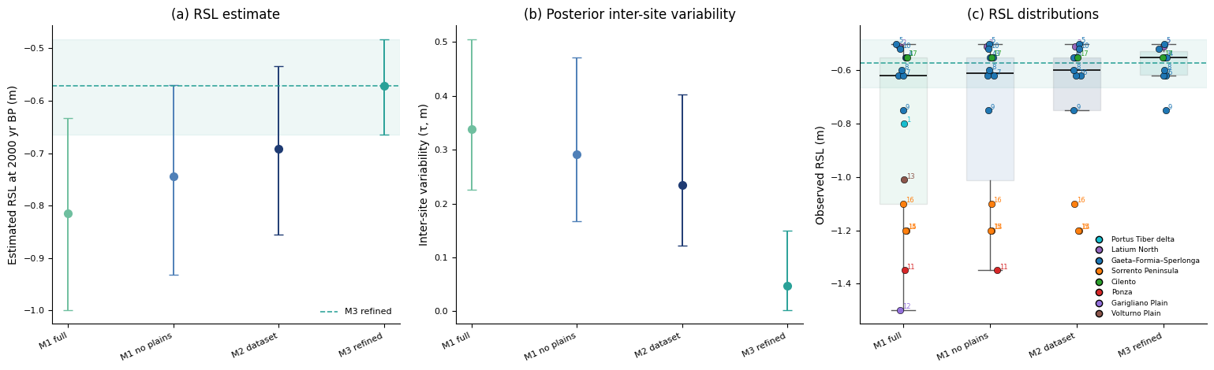To evaluate the influence of the Sorrento Peninsula sector on the regional reconstruction, posterior distributions of the regional mean relative sea level (μ) and inter-site variability (τ) were compared between the regional rocky-coast dataset (M2: Latium North, Gaeta–Formia–Sperlonga, Sorrento Peninsula and Cilento) and the final refined dataset (M3: Latium North, Gaeta–Formia–Sperlonga and Cilento) (Fig. S2; Table S2).
The posterior distribution of μ (Fig. S2a) exhibits a clear shift toward higher (less negative) elevations in M3 relative to M2. The posterior mean increases from −0.695 m to −0.570 m, corresponding to a shift of approximately 0.12 m. In addition, the M3 posterior distribution is noticeably narrower, reflecting the improved internal consistency of the retained observations.
An even stronger contrast is observed for τ (Fig. S2b). The M2 posterior is centered at τ ≈ 0.23 m and displays a broad distribution extending toward higher values, whereas the M3 posterior is strongly concentrated near zero, with a mean τ of only 0.046 m. This reduction indicates that most of the residual variability present in M2 is associated with the Sorrento Peninsula observations.
Together, these results demonstrate that the exclusion of the Sorrento sector produces both a higher regional RSL estimate and a substantial reduction in inter-site variability. The resulting M3 dataset is therefore characterized by a coherent and internally consistent regional signal, supporting its adoption as the preferred reconstruction for subsequent analyses.
Figure S2. Posterior comparison between the regional (M2) and refined (M3) datasets. (a) Posterior distributions of regional RSL (μ). (b) Posterior distributions of inter-site variability (τ).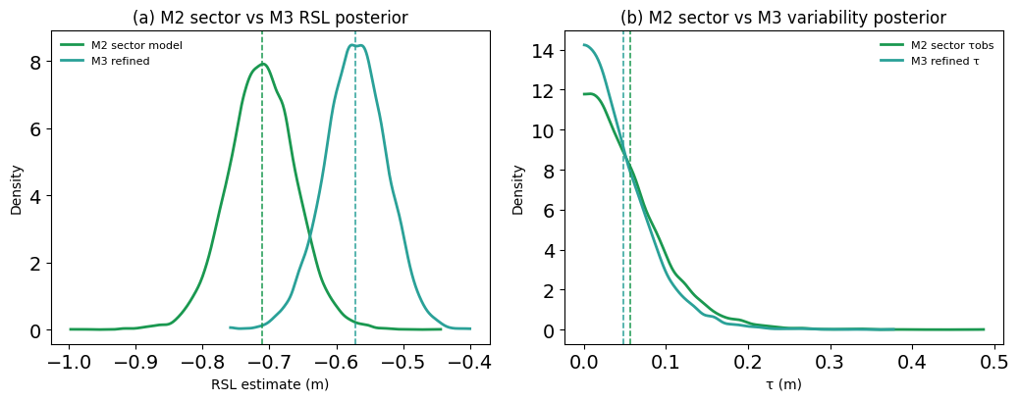Identification of sector-scale heterogeneity
To further evaluate model performance and assess the robustness of the inferred spatial structure, residual analyses were conducted for both the single-mean and sector-based formulations, together with an examination of the posterior sector-specific RSL distributions inferred by the hierarchical model (Fig. S3).
Residuals computed for the single-mean model (Fig. S3a) exhibit a pronounced spatial structure. Observations from the Gaeta–Formia–Sperlonga sector are systematically positive, whereas observations from the Sorrento Peninsula are consistently negative. Latium North and Cilento also show sector-consistent offsets relative to the pooled estimate. This pattern indicates that a single regional mean fails to capture the spatial variability present within the dataset and produces sector-dependent bias.
In contrast, the sector-based model substantially reduces residual structure (Fig. S3b). Residuals are more evenly distributed around zero within each sector, and systematic offsets are greatly diminished. Although a small amount of within-sector variability remains, the absence of strong directional patterns indicates that the hierarchical formulation successfully captures the dominant spatial structure of the observations.
The posterior sector-specific distributions further illustrate these differences (Fig. S4c). The Gaeta–Formia–Sperlonga and Cilento sectors cluster around similar RSL values, whereas the Sorrento Peninsula is characterized by a markedly lower posterior distribution. Latium North occupies an intermediate position but remains broadly consistent with the Gaeta–Formia–Sperlonga and Cilento estimates within uncertainty. The separation of the Sorrento posterior from the other sectors provides independent support for its identification as the primary source of inter-sector variability in the regional dataset.
Taken together, the residual diagnostics and posterior sector estimates demonstrate that explicitly accounting for sector-specific variability provides a substantially improved representation of the data relative to a single-mean formulation and supports the interpretation of a coherent regional signal shared by Latium North, Gaeta–Formia–Sperlonga and Cilento.
Figure S3. Residual diagnostics and sector-specific posterior estimates for the regional dataset (M2). (a) Single-mean residuals. (b) Sector-model residuals. (c) Posterior sector-specific RSL distributions.
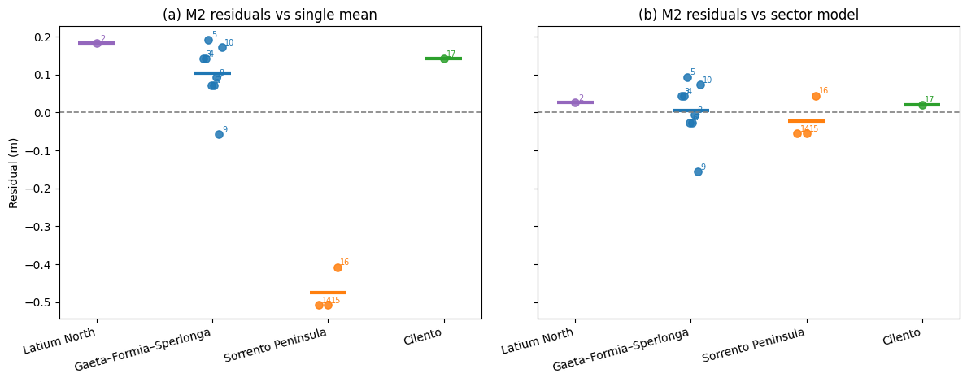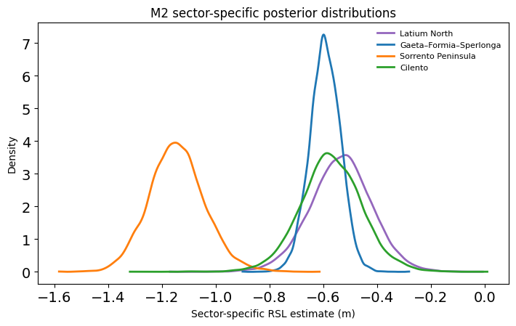
Posterior pairwise probabilities were calculated to quantify the degree of separation between sector-specific RSL estimates inferred by the hierarchical model (Fig. S4). For each pair of sectors, the probability that the posterior mean RSL of one sector exceeded that of another was computed directly from the posterior distributions.
The results indicate a clear distinction between the Sorrento Peninsula and the remaining sectors. The probability that the Latium North, Gaeta–Formia–Sperlonga, or Cilento sectors exhibit higher RSL values than Sorrento is effectively equal to one (P ≈ 1.0 in all comparisons). This demonstrates that the lower RSL values observed in the Sorrento Peninsula are not simply a consequence of posterior uncertainty but represent a statistically robust offset relative to the rest of the dataset.
In contrast, comparisons among Latium North, Gaeta–Formia–Sperlonga, and Cilento yield probabilities close to 0.5. These values indicate substantial overlap between their posterior distributions and provide little evidence for systematic differences among these sectors. The absence of strong pairwise separation supports the interpretation that these three sectors record a common regional late-Holocene sea-level signal.
Taken together, the pairwise probability analysis independently confirms the conclusions derived from the residual diagnostics and sensitivity tests. The Sorrento Peninsula behaves as a statistically distinct sector, whereas Latium North, Gaeta–Formia–Sperlonga and Cilento form a coherent group characterized by mutually overlapping posterior estimates.
Figure S4. Posterior pairwise probabilities among sector-specific RSL estimates. Values represent the probability that the sector in each row has a higher posterior mean RSL than the sector in each column.
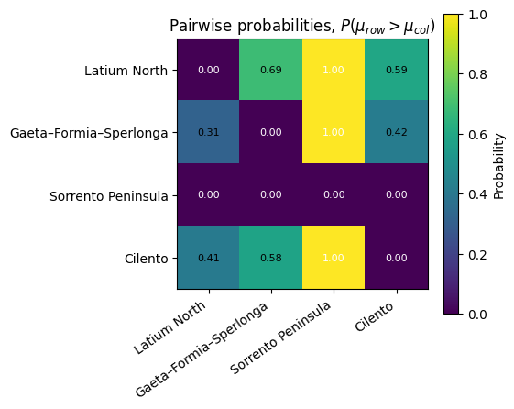

Model validation
Model performance was quantitatively evaluated using Pareto-smoothed importance sampling leave-one-out cross-validation (PSIS-LOO; Table S3).
For the regional dataset (M2), the sector-based hierarchical model substantially outperforms the single-mean formulation. The hierarchical model yields an expected log predictive density of 6.89, whereas the single-mean model produces a markedly lower value of −3.46. The resulting difference (Δelpd ≈ 10.35) strongly favors the sector-based formulation, indicating that explicit representation of sector-specific variability substantially improves predictive performance. Model weights assign essentially all support to the hierarchical model.
A different pattern emerges for the refined dataset (M3). Once the Sorrento Peninsula sector is removed, the predictive performance of the two formulations becomes very similar. The single-mean model yields a slightly higher elpdloo (8.15) than the sector model (7.23), with a modest difference of approximately 0.92. This result indicates that, after removal of the sector responsible for most of the inter-site variability, the remaining observations are largely consistent with a common regional signal and no longer require strong hierarchical structure to achieve good predictive performance.
These findings are fully consistent with the residual analyses, posterior predictive checks, and Pareto-k diagnostics. In the regional dataset (M2), spatial structure is essential for accurately representing the observations, whereas in the refined dataset (M3) the remaining sectors exhibit sufficient internal consistency that a pooled regional estimate performs comparably to a sector-specific model.
Overall, the PSIS-LOO results support both the identification of the Sorrento Peninsula as the principal source of sector-scale variability and the interpretation of M3 as a coherent regional dataset suitable for estimating late-Holocene relative sea level.
Table S3. PSIS-LOO model comparison for the regional (M2) and refined (M3) datasets. Reported metrics include elpdloo, effective number of parameters (ploo), Δelpd, stacking weights, and associated standard errors.
Dataset | Model | Rank | elpdloo | ploo | Δelpd | Weight | SE | ΔSE
M2 | Sector model | 0 | 6.893 | 2.632 | 0.000 | 1.0 | 1.018 | 0.000
M2 | Single-mean model | 1 | -3.461 | 2.808 | 10.354 | 0.0 | 3.650 | 3.329
M3 | Single-mean model | 0 | 8.147 | 0.385 | 0.000 | 1.0 | 0.753 | 0.000
M3 | Sector model | 1 | 7.231 | 1.002 | 0.916 | 0.0 | 0.573 | 0.472
Posterior predictive checks (PPC) were performed to evaluate the ability of the alternative model formulations to reproduce the observed distribution of relative sea-level (RSL) indicators (Fig. S5).
The M2 single-mean model generates broad predictive distributions that only partially reproduce the structure of the observed dataset (Fig. S5a). Although the overall range of values is captured, the predictive realizations fail to reproduce the sector-dependent clustering evident in the observations. This limitation is also apparent in the ordered PPC representation (Fig. S6d), where the observed values deviate systematically from many of the predictive realizations.
The M2 sector-based model provides a substantially improved fit (Fig. S5b,e). Both the histogram-based and ordered PPCs show a closer agreement between predictive simulations and observed values. Incorporating sector-specific effects allows the model to reproduce the observed spatial structure while reducing systematic deviations present in the pooled formulation.
The refined M3 model exhibits the strongest agreement between predictive simulations and observations (Fig. S5c,f). The predictive distributions closely match the central tendency and dispersion of the retained observations, and the ordered PPC indicates that the observed data fall well within the posterior predictive envelope. The associated reduction in predictive spread reflects the low inter-site variability inferred for the refined dataset.
Overall, the PPC analyses demonstrate that accounting for spatial structure substantially improves model performance relative to a single-mean formulation and that the refined M3 dataset yields the most internally consistent representation of the regional late-Holocene sea-level signal.
Figure S5. Posterior predictive checks for alternative model formulations. (a–c) Histogram-based PPCs. (d–f) Ordered PPCs for the corresponding models.
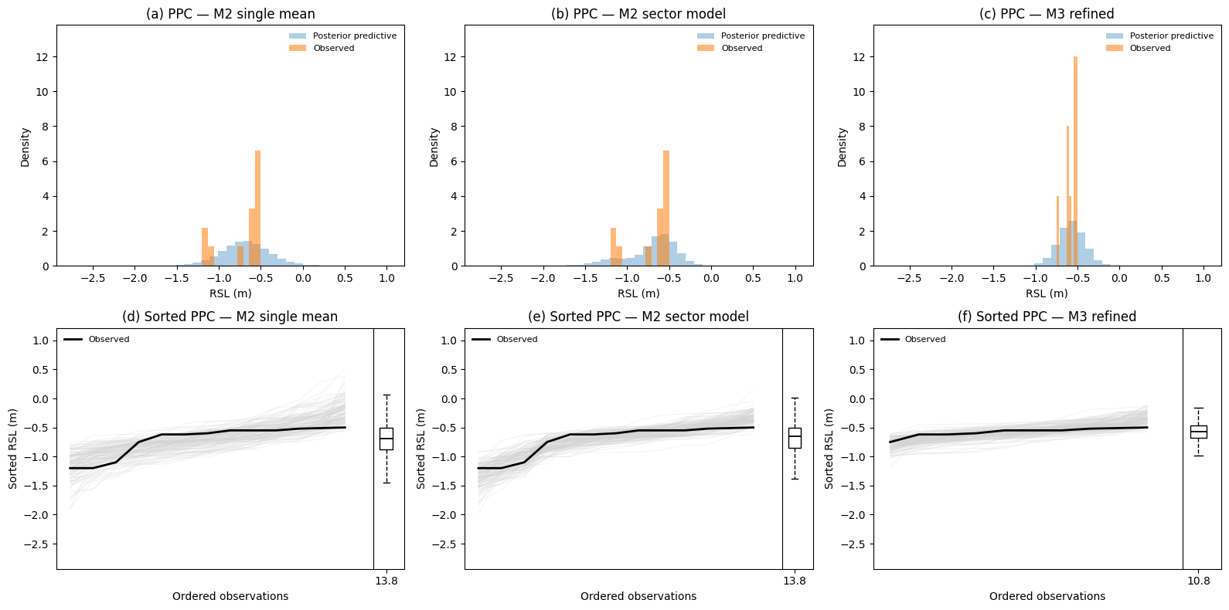
Pareto-k diagnostics (Fig. S6) were used to assess the reliability of the PSIS-LOO approximation and to identify potentially influential observations.
The M2 single-mean model exhibits one highly influential observation (ID 14), with a Pareto-k value exceeding 0.8 (Fig. S6a). This observation corresponds to a fish-tank crepido from the Sorrento Peninsula and indicates that the leave-one-out approximation becomes unstable when a single regional mean is forced to represent all sectors simultaneously. The remaining observations generally show low Pareto-k values, suggesting that the model inadequacy is primarily associated with sector-dependent structure rather than widespread lack of fit.
The M2 sector-based hierarchical model improves the representation of the dataset by explicitly accounting for sector-specific variability (Fig. S6b). Most observations display low Pareto-k values; however, three observations exceed the commonly adopted threshold of 0.7. These correspond to Latium North (ID 2), the Sorrento Peninsula fish-tank crepido (ID 14), and the Cilento observation (ID 17). The elevated influence of Latium North and Cilento reflects their representation by a single observation each, whereas the Sorrento value indicates a genuine mismatch between this sector and the dominant regional signal.
The refined M3 model exhibits a substantial improvement in PSIS-LOO stability following removal of the Sorrento Peninsula sector (Fig. S6c). All remaining observations display Pareto-k values below the reliability threshold of 0.7, including the Latium North and Cilento indicators. The absence of highly influential observations indicates that the refined dataset is internally coherent and that no single observation exerts a disproportionate influence on posterior estimates.
Overall, the Pareto-k diagnostics support the progressive refinement strategy adopted in this study. The single-mean formulation fails to accommodate sector-scale variability, the regional sector-based model identifies the Sorrento Peninsula as the principal source of influence, and the final refined dataset achieves a stable and statistically robust representation of the regional late-Holocene sea-level signal.
Figure S6. Pareto-k diagnostics for alternative model formulations. Dashed lines indicate commonly adopted reliability thresholds.
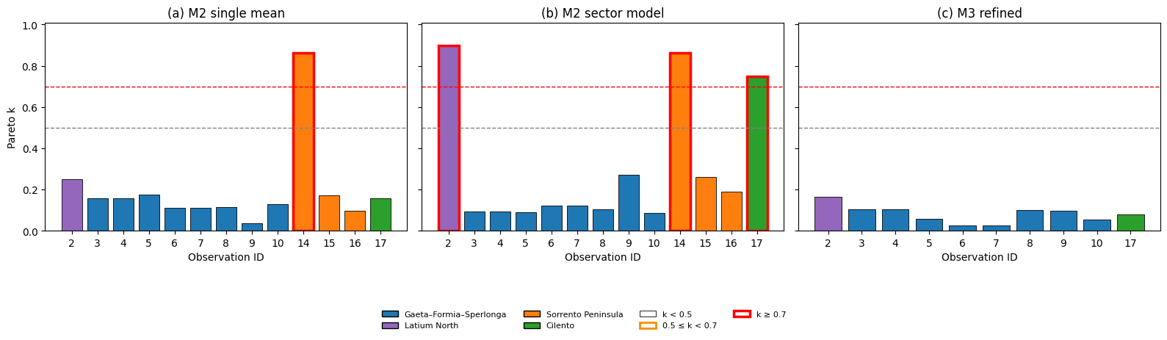Influence and sensitivity analyses
To evaluate the robustness of the preferred reconstruction, two complementary analyses were performed. First, a leave-one-observation-out analysis was applied to the refined dataset (M3), whereby each observation was sequentially removed and the model refitted. Second, a series of sector and dataset scenarios was explored by selectively excluding or reintroducing individual sectors relative to the refined reconstruction.
The leave-one-observation-out analysis indicates a very high degree of stability of the refined estimate (Fig. S7a). Removal of individual observations produces only minor variations in the posterior mean RSL, with all shifts remaining below approximately 0.02 m. No single observation exerts a disproportionate influence on the reconstructed regional signal.
The scenario analysis provides further insight into the relative influence of individual sectors and dataset configurations (Fig. S7b). Excluding Latium North or Cilento produces only negligible deviations from the refined estimate, whereas exclusion of the GF-S sector results in the largest shift, highlighting its dominant role in constraining the regional signal. Reintroduction of the Sorrento Peninsula systematically lowers the estimated RSL, while the inclusion of Ponza, Portus Tiber delta, and coastal plain indicators produces progressively larger deviations from the refined reconstruction.
Overall, the results demonstrate that the preferred estimate is robust to the removal of individual observations and sectors. The influence analysis confirms that the refined dataset provides a stable representation of the regional late-Holocene sea-level signal, while also identifying the GF-S sector as the principal source of statistical constraint.
Figure S7. Influence analysis of the refined dataset (M3). (a) Leave-one-observation-out sensitivity analysis. (b) Effects of excluding or reintroducing individual sectors.
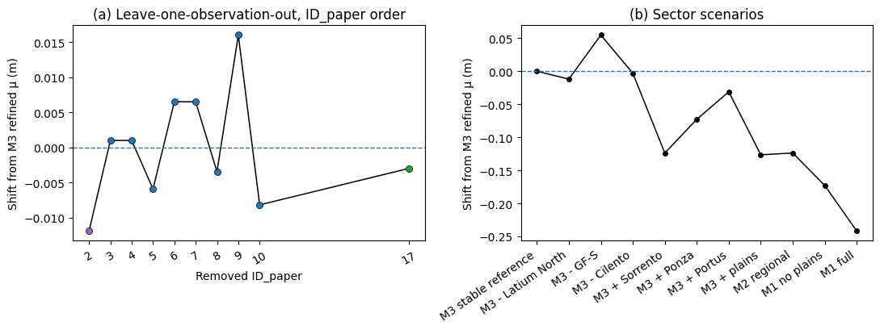The baseline sensitivity analysis indicates a high degree of stability of the reconstructed RSL signal (Fig. S8a). Estimates derived from GF-S alone and from the combined GF-S + Cilento dataset are nearly identical and exhibit overlapping credible intervals. In contrast, the Cilento-only configuration yields substantially larger uncertainty, reflecting the smaller number of available observations and the correspondingly weaker statistical constraint provided by this sector.
The leave-one-sector-out analysis further highlights the relative contribution of the individual sectors (Fig. S8b). Excluding the Sorrento Peninsula produces virtually no change relative to the refined estimate, indicating that this sector contributes little to constraining the preferred reconstruction. Excluding Cilento results in a modest shift, whereas exclusion of the GF-S sector produces the largest deviation and the broadest uncertainty interval. This demonstrates that GF-S provides the strongest constraint on the regional late-Holocene sea-level signal.
Taken together, these analyses indicate that the reconstructed RSL is robust to alternative baseline definitions and sector selection. The preferred estimate is not controlled by a single anomalous sector, although the GF-S observations provide the primary statistical constraint owing to their larger sample size and lower internal variability.
Figure S8. Sensitivity of the refined reconstruction to alternative stable-sector configurations. (a) Alternative baseline estimates. (b) Leave-one-sector-out analysis.
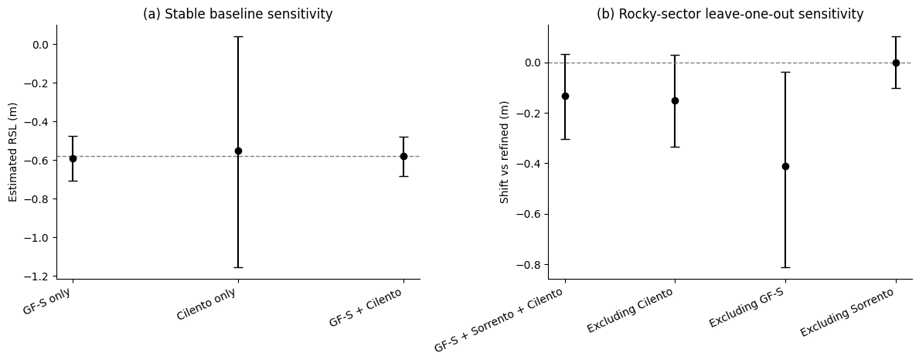

Prior sensitivity analysis
To assess the influence of prior assumptions on the estimated inter-site variability, a prior sensitivity analysis was performed for the variance parameter τ across all dataset configurations (M1 full, M1 no plains, M2 regional, and M3 refined). A range of weakly informative priors was tested, including Half-Normal distributions with scales ranging from 0.1 to 1.0, Half-Cauchy distributions with scale parameters of 0.3 and 0.5, and an Exponential prior with rate parameter 0.5 (Fig. S9).
The posterior distributions of τ remain remarkably consistent across all prior specifications. Although the most restrictive prior (HalfNormal(0.1)) produces slightly lower posterior means, the remaining priors yield nearly overlapping posterior distributions and very similar posterior summaries.
For the full dataset (M1 full), posterior estimates of τ remain centered around 0.33 m regardless of prior choice. Similar behavior is observed for M1 no plains and M2, where posterior estimates remain consistently concentrated around approximately 0.29 m and 0.24 m, respectively. The relative ordering of the datasets is therefore preserved under all tested prior specifications.
The refined dataset (M3) exhibits substantially lower inter-site variability, with posterior τ values concentrated near 0.05 m across all priors. Importantly, the reduction in variability observed in M3 is maintained irrespective of the assumed prior distribution, indicating that the collapse of τ is driven by the data rather than by prior regularization.
The forest plots provide a complementary summary of posterior means and 95% credible intervals, further demonstrating the strong agreement among prior formulations. Across all datasets, differences between prior specifications are small compared with the separation observed between dataset configurations.
Overall, these results indicate that the inferred inter-site variability is robust to reasonable prior choices and that the progressive reduction of τ from M1 to M3 reflects a genuine property of the data rather than a consequence of prior assumptions.
Figure S9. Prior sensitivity analysis for the inter-site variability parameter (τ). Posterior distributions and posterior summaries obtained under alternative prior specifications.
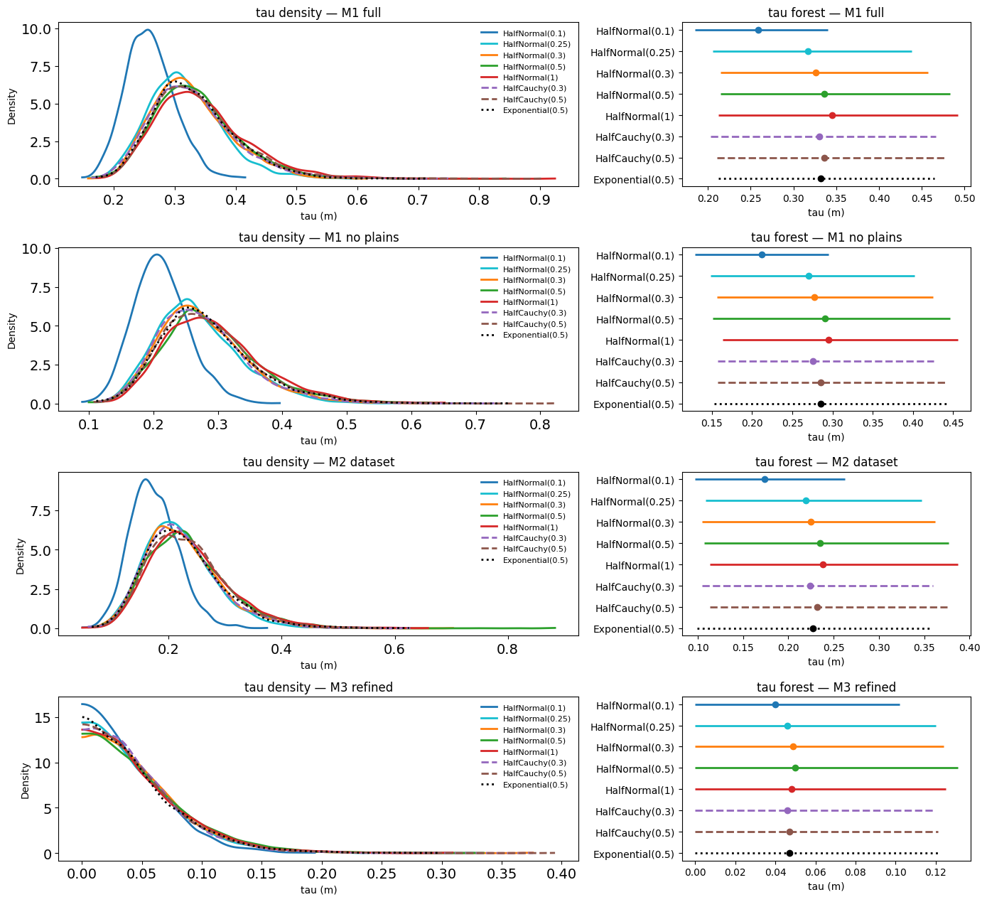To assess the influence of prior assumptions on the reconstructed regional relative sea level, a prior sensitivity analysis was performed for the posterior mean RSL parameter (μ) across all dataset configurations (M1 full, M1 no plains, M2 regional, and M3 refined). A range of weakly informative priors was tested for the variance component, including Half-Normal distributions with scales ranging from 0.1 to 1.0, Half-Cauchy distributions with scale parameters of 0.3 and 0.5, and an Exponential prior with rate parameter 0.5 (Fig. S10).
The posterior estimates of μ remain highly consistent across all prior specifications. Although the most restrictive priors produce slightly narrower posterior distributions, posterior means and credible intervals remain remarkably stable. For each dataset configuration, the posterior distributions obtained under alternative priors almost completely overlap.
The full dataset (M1 full) consistently yields posterior means close to −0.81 m, while M1 no plains and M2 are centered around −0.74 m and −0.69 m, respectively. The refined dataset (M3) remains centered near −0.57 m under all tested prior formulations. Importantly, the relative ordering of the four dataset configurations is preserved regardless of prior choice.
The forest plots provide a complementary summary of posterior means and 95% credible intervals. Differences among prior specifications are minimal compared with the differences observed among dataset configurations. This indicates that the shifts in reconstructed RSL associated with progressive dataset refinement are driven by the observational data rather than by prior assumptions.
Overall, the near-complete overlap of posterior distributions demonstrates that μ is strongly constrained by the data and effectively insensitive to reasonable prior choices. The progressive increase in reconstructed RSL from M1 to M3 therefore reflects genuine differences in dataset composition rather than artefacts introduced by prior specification.
Figure S10. Prior sensitivity analysis for the regional mean relative sea level (μ). Posterior distributions and posterior summaries obtained under alternative prior specifications.
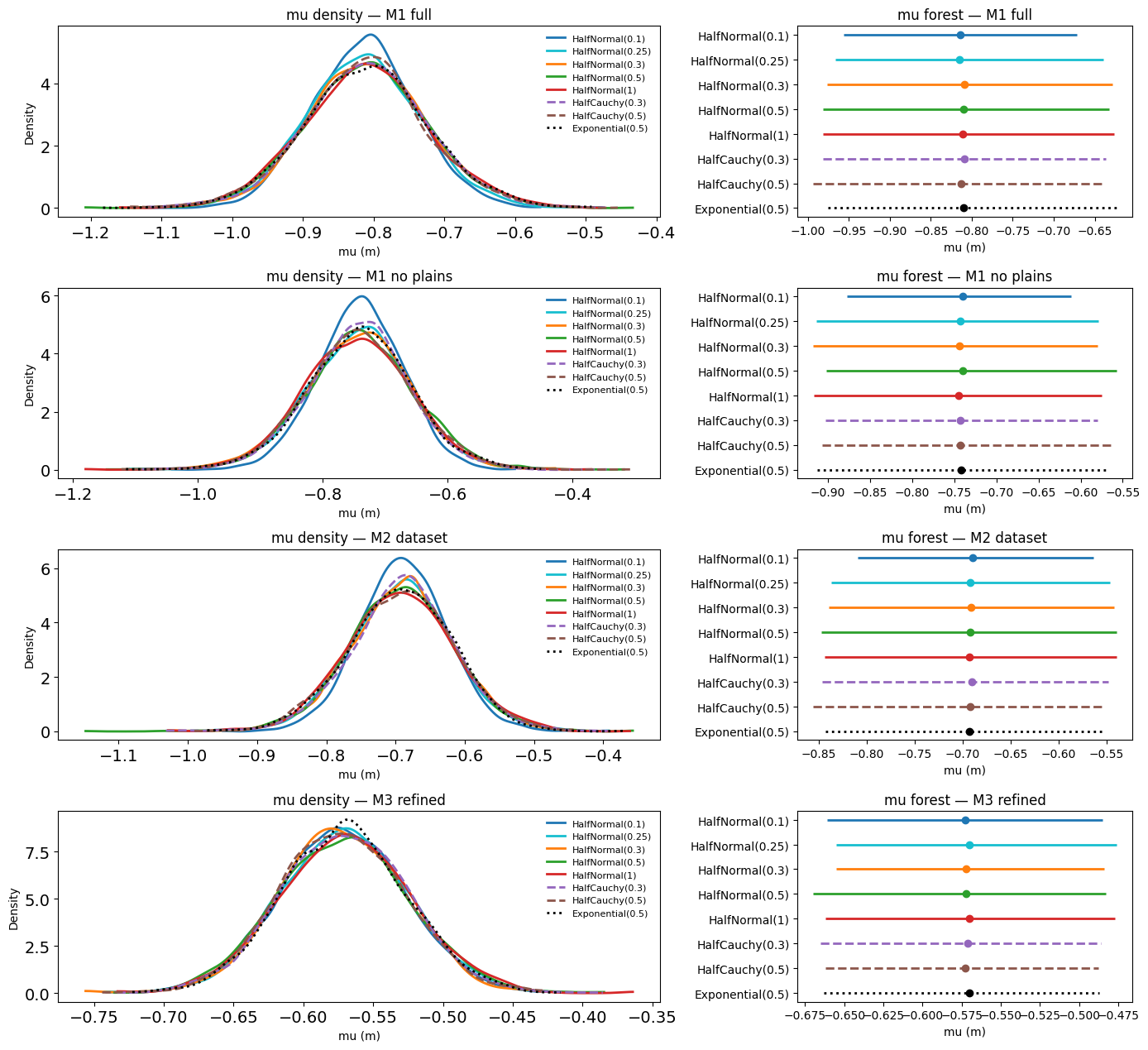The preferred M3 estimate remains stable across alternative prior specifications and stable-sector configurations (Fig. S11). Removal of Latium North or Cilento produces negligible changes, whereas progressive reintroduction of excluded sectors systematically shifts the reconstructed RSL toward lower values. These results confirm that the refined reconstruction is robust and that most variability in the broader datasets arises from geologically heterogeneous sectors.
Taken together, these analyses demonstrate that the preferred M3 reconstruction is robust to both prior specification and dataset composition. The stability of the estimate following removal of individual stable sectors, combined with the systematic shifts observed when excluded sectors are reintroduced, supports the interpretation that M3 provides the most coherent representation of the regional late-Holocene sea-level signal.
Figure S11. Robustness of the refined reconstruction (M3). Top panels show prior sensitivity for μ. Bottom panels show sensitivity to alternative stable-sector configurations.
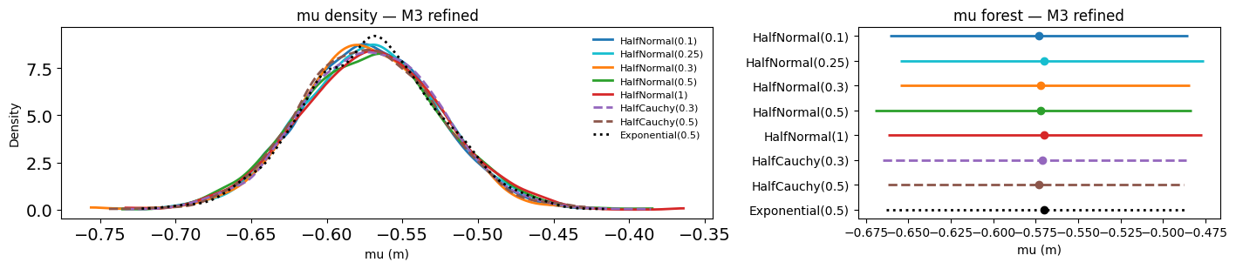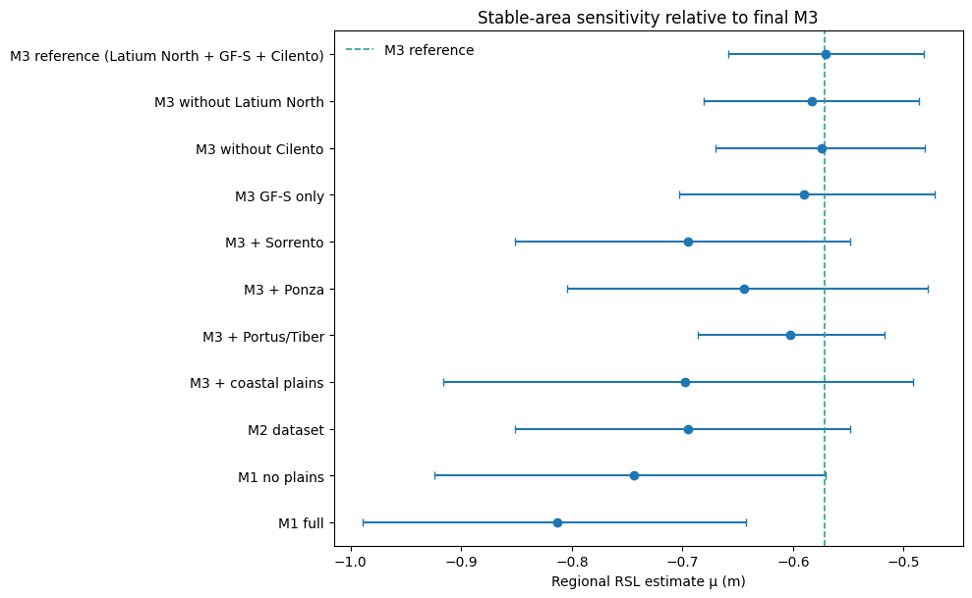Likelihood sensitivity analysis
To evaluate the robustness of the inferred spatial structure to the assumed likelihood function, alternative Student-t formulations were fitted using fixed degrees of freedom (ν = 3 and ν = 5) as well as a model in which ν was estimated directly from the data (Fig. S13). Across both datasets, posterior means and distributional shapes remain remarkably stable as ν varies from 3 to 5 or is estimated from the data. The consistency of the results indicates that the inferred spatial structure reflects genuine differences among sectors rather than assumptions regarding the error model.
Overall, the Student-t sensitivity analysis confirms that the identification of the Sorrento Peninsula as a distinct sector and the coherence of the refined M3 reconstruction are robust to alternative likelihood specifications.
Figure S13. Sector-specific posterior distributions obtained using alternative Student-t likelihood specifications for the regional (M2) and refined (M3) datasets.
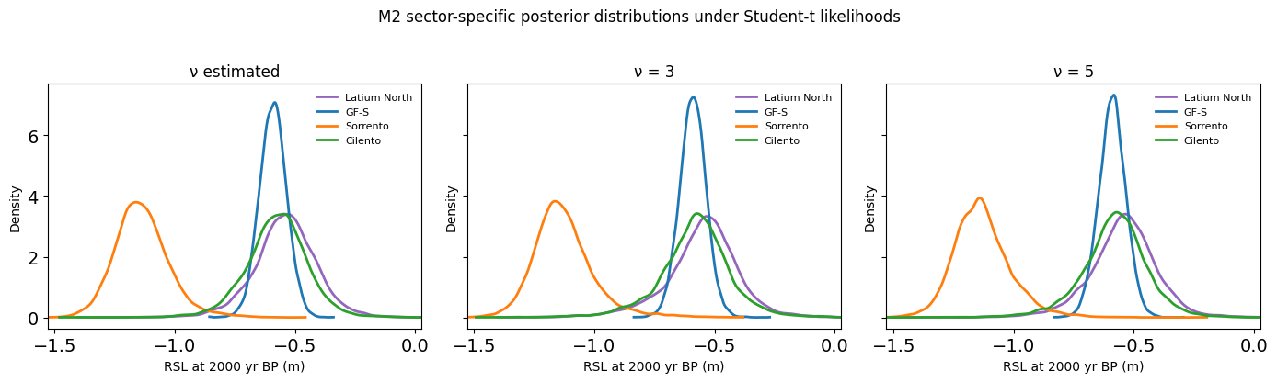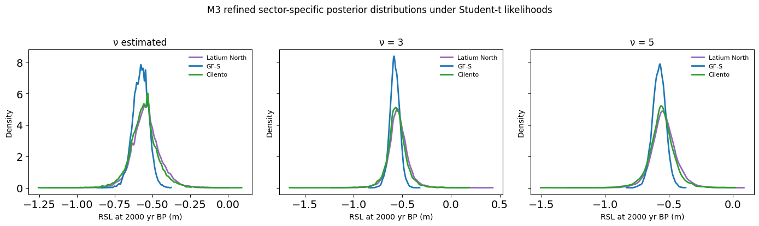Model comparison including Student-t formulations confirms the conclusions obtained from the Gaussian models (Table S4). For M2, the sector-based model remains strongly preferred, whereas M3 is best represented by a single regional mean. Alternative likelihood formulations do not alter model ranking or interpretation.
Table S4. PSIS-LOO comparison of Gaussian and Student-t model formulations for the regional (M2) and refined (M3) datasets.
Dataset | Model | N | IDs | elpdloo | SE | Δelpd | ploo
M2 | Sector model (Gaussian) | 13 | 2,3,4,5,6,7,8,9,10,14,15,16,17 | 6.893 | 1.018 | 0.000 | 2.632
M2 | Sector model (Student-t, ν = 5) | 13 | 2,3,4,5,6,7,8,9,10,14,15,16,17 | 4.947 | 1.469 | -1.946 | 3.575
M2 | Single mean (Gaussian) | 13 | 2,3,4,5,6,7,8,9,10,14,15,16,17 | -3.461 | 3.650 | -10.354 | 2.808
M3 | Single mean (Gaussian) | 10 | 2,3,4,5,6,7,8,9,10,17 | 8.147 | 0.753 | 0.000 | 0.385
M3 | Sector model (Gaussian) | 10 | 2,3,4,5,6,7,8,9,10,17 | 7.231 | 0.573 | -0.916 | 1.002
M3 | Sector model (Student-t, ν = 5) | 10 | 2,3,4,5,6,7,8,9,10,17 | 6.285 | 0.640 | -1.862 | 1.255
Model performance and predictive accuracy were further evaluated using PSIS-LOO cross-validation and associated stability diagnostics (Fig. S14; Table S4).
For the regional dataset (M2), the sector-based Gaussian model provides the highest predictive performance, with an expected log predictive density of 6.89 (Fig. S14a). The corresponding Student-t formulation yields a slightly lower value (elpdloo = 4.95), whereas the single-mean Gaussian model performs substantially worse (elpdloo = −3.46). These results indicate that explicit representation of sector-specific structure is essential when the Sorrento Peninsula is included in the dataset and confirm the presence of meaningful spatial heterogeneity.
The PSIS stability diagnostics show that all M2 formulations contain influential observations, with maximum Pareto-k values approaching or exceeding the commonly adopted reliability threshold of 0.7 (Fig. S14b). Although the Student-t likelihood provides a modest reduction in the influence of individual observations relative to the single-mean formulation, none of the alternative likelihood specifications eliminate the underlying sector-scale heterogeneity present in the dataset.
A markedly different pattern is observed for the refined dataset (M3). The highest predictive performance is achieved by the single-mean Gaussian model (elpdloo = 8.15), while the sector-based Gaussian and Student-t models yield only slightly lower values (Fig. S14c). This result indicates that, once the Sorrento Peninsula is removed, the remaining observations are largely consistent with a common regional signal and can be adequately represented without hierarchical sector-specific structure.
The corresponding PSIS diagnostics show a substantial improvement in sampling stability (Fig. S14d). The single-mean Gaussian model exhibits low maximum Pareto-k values, while the sector-based formulations retain only marginally influential observations associated with the sparse representation of Latium North and Cilento. The overall reduction in influence diagnostics is consistent with the lower inter-site variability observed in the refined dataset.
Taken together, these results demonstrate that spatial structure is required to explain the regional dataset (M2) but becomes largely unnecessary after removal of the Sorrento Peninsula. The transition from M2 to M3 therefore reflects a genuine reduction in dataset heterogeneity rather than a consequence of model specification, further supporting the interpretation of M3 as the most coherent representation of the regional late-Holocene sea-level signal.
Figure S14. Predictive performance and PSIS-LOO diagnostics for Gaussian and Student-t model formulations. Left panels show expected log predictive density (elpdloo); right panels show maximum Pareto-k values.
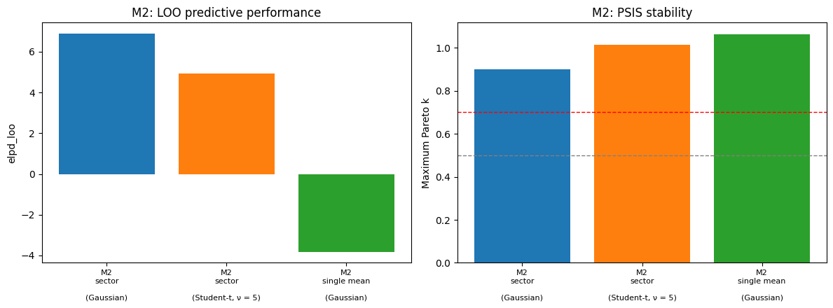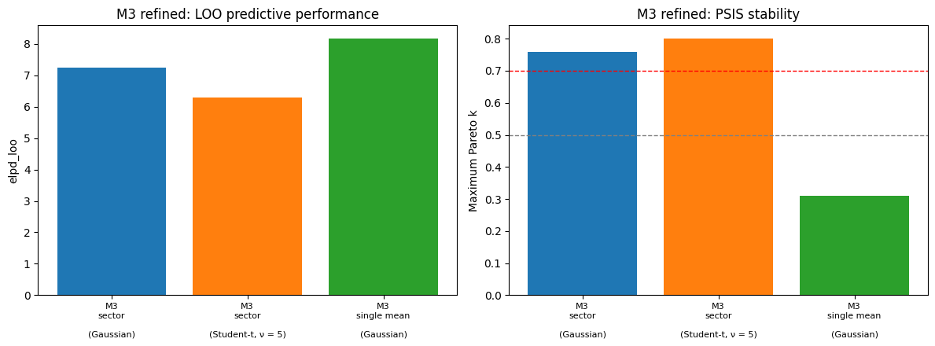To identify the observations responsible for the PSIS-LOO warnings, Pareto-k values were examined at the observation level for all model formulations (Fig. S15).
For the regional dataset (M2), the sector-based Gaussian and Student-t models identify three influential observations: the Latium North indicator (ID 2), the Sorrento Peninsula fish-tank crepido (ID 14), and the Cilento observation (ID 17). The influence of ID 14 persists across likelihood formulations and represents the strongest departure from the dominant regional signal. In contrast, the elevated Pareto-k values associated with IDs 2 and 17 reflect the fact that Latium North and Cilento are each represented by a single observation within the hierarchical structure.
The single-mean Gaussian model for M2 exhibits a different pattern. The strongest influence is concentrated in the Sorrento Peninsula observation (ID 14), whereas the remaining observations generally display low Pareto-k values. This behaviour is consistent with the inability of a pooled model to accommodate the pronounced offset associated with the Sorrento sector.
For the refined dataset (M3), the Sorrento Peninsula is no longer present and the diagnostic structure changes substantially. The single-mean Gaussian model shows uniformly low Pareto-k values, with no observation approaching the commonly adopted reliability threshold. The sector-based Gaussian and Student-t formulations retain elevated Pareto-k values for Latium North (ID 2) and Cilento (ID 17), reflecting the sparse representation of these sectors rather than a lack of consistency within the refined dataset.
These observation-level diagnostics confirm that the principal source of instability in the regional dataset is associated with the Sorrento Peninsula sector. Following its removal, the remaining observations form a substantially more coherent dataset and no longer generate influential diagnostics in the preferred single-mean M3 reconstruction.
Figure S15. Observation-level Pareto-k diagnostics for the Gaussian and Student-t models applied to the regional (M2) and refined (M3) datasets.
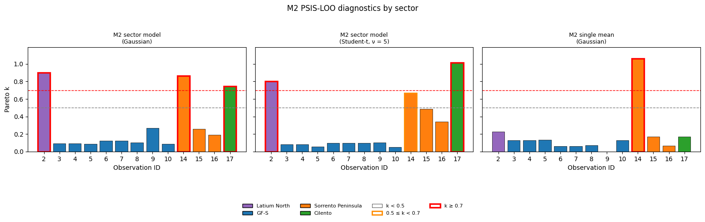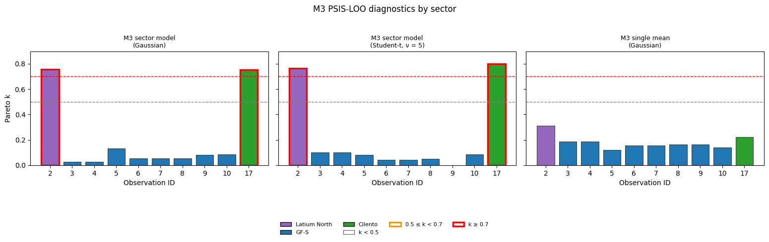Overall, these results demonstrate that the principal conclusions are robust to the choice of likelihood formulation and that the observed spatial structure cannot be attributed to a small number of outlying observations.
The Student-t sector model provides an independent test of this interpretation. For the regional dataset (M2), which includes Latium North, Gaeta–Formia–Sperlonga, Sorrento Peninsula, and Cilento, the robust formulation recovers the same sectoral ordering obtained under the Gaussian model. The Sorrento Peninsula consistently yields lower RSL estimates, whereas the Gaeta–Formia–Sperlonga, Latium North, and Cilento sectors cluster at higher elevations. The persistence of this structure across likelihood specifications demonstrates that the observed sectoral differences are not artefacts of the Gaussian assumption.
The estimated degrees-of-freedom parameter (ν) indicates only moderate departure from normality, suggesting that the data are broadly compatible with Gaussian residuals while still benefiting from the robustness provided by heavier tails. Consistent with this interpretation, the Student-t models yield posterior estimates that are highly similar to those obtained from the Gaussian formulations, while producing only modest changes in predictive performance and PSIS-LOO diagnostics.
Observation-level Pareto-k diagnostics further indicate that the principal source of influence within M2 is associated with the Sorrento Peninsula sector, particularly the fish-tank crepido observation (ID 14). By contrast, elevated Pareto-k values for Latium North (ID 2) and Cilento (ID 17) arise primarily because these sectors are represented by single observations rather than because they are inconsistent with the regional signal.
Following removal of the Sorrento Peninsula, the refined dataset (M3) exhibits strongly overlapping posterior distributions for Latium North, Gaeta–Formia–Sperlonga, and Cilento under both Gaussian and Student-t likelihoods. In this configuration, the single-mean Gaussian model provides the highest predictive performance and the most stable PSIS-LOO diagnostics, indicating that the remaining observations are compatible with a common regional late-Holocene RSL signal.
Taken together, these results indicate that the variability observed in the regional dataset is not the product of random scatter or isolated outliers, but instead reflects the presence of a distinct sectoral signal associated with the Sorrento Peninsula. Although the Cilento sector is currently represented by a single observation, its close agreement with the Gaeta–Formia–Sperlonga and Latium North sectors provides independent support for the reconstructed regional sea-level estimate, while also highlighting the value of future observations for better constraining intra-sector variability.

Temporal robustness
Because the difference between 1950 yr BP and 2000 yr BP is negligible relative to the millennial timescale represented by the dataset, no meaningful changes in the reconstructed regional signal are expected. Nevertheless, to formally verify that the results are independent of the adopted temporal reference, the refined Bayesian model was re-centred at 1950 yr BP, corresponding approximately to the mean age of the available observations.
The resulting regional relative sea-level estimate is −0.577 m (95% credible interval: −0.699 to −0.454 m), virtually identical to the preferred estimate obtained at 2000 yr BP. Posterior inter-site variability remains low (τ = 0.054 m; 95% credible interval: 0.002–0.168 m), indicating that the strong internal consistency of the refined dataset is preserved irrespective of the chosen reference age.
The temporal slope parameter (β) is poorly constrained, with a posterior mean close to zero (β = −0.098 m kyr⁻¹) and a broad 95% credible interval spanning both negative and positive values (−1.819 to 1.647 m kyr⁻¹). Because the credible interval includes zero, no statistically significant temporal trend can be resolved within the age range represented by the dataset.
The posterior distributions further support this interpretation (Fig. S16). The regional RSL posterior is narrow and well constrained, remaining centred near −0.58 m, while the posterior distribution of τ is strongly concentrated toward low values, confirming limited inter-site dispersion. In contrast, the posterior distribution of β is broad and approximately symmetric around zero, indicating that the available observations do not contain sufficient temporal information to resolve a meaningful trend over the sampled time interval.
These results demonstrate that the refined reconstruction is insensitive to minor changes in the reference age and that the preferred estimate at 2000 yr BP is not an artefact of the temporal centring adopted in the model. Instead, the reconstructed signal is dominated by the spatial consistency of the observations rather than by temporal evolution within the age range represented by the dataset.
Figure S16. Posterior distributions obtained after re-centering the refined model at 1950 yr BP. (a) Regional RSL (μ). (b) Inter-site variability (τ). (c) Temporal slope (β)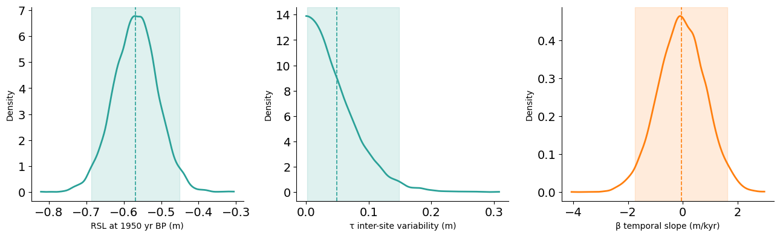The absence of a statistically resolvable temporal trend further supports the use of a quasi-synchronous reference framework for the refined dataset. The observations retained in M3 (Latium North, Gaeta–Formia–Sperlonga, and Cilento) cluster within the same late-Holocene time window and exhibit very low inter-site variability, indicating that they are compatible with a common regional RSL signal.
This interpretation is independently supported by the posterior predictive checks, PSIS-LOO diagnostics, prior-sensitivity analyses, and alternative likelihood formulations, all of which indicate that the refined dataset behaves as a coherent statistical population. In particular, the superior predictive performance of the single-mean model in M3 suggests that sector-specific structure is no longer required once the Sorrento Peninsula is excluded.
Consequently, the combined Latium North–Gaeta–Formia–Sperlonga–Cilento dataset can be regarded as a robust regional baseline for the late Holocene. This baseline was therefore used to define the reference RSL level against which sector-specific departures and relative vertical land-motion estimates were evaluated.

