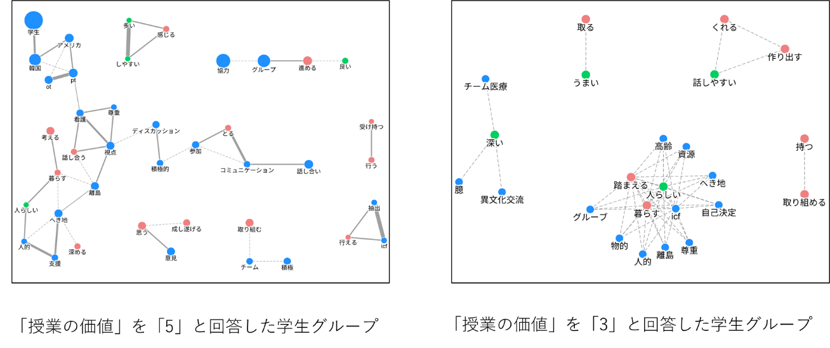
Supplementary Figure S1. Co-occurrence network analysis of open-ended responses according to perceived course value
Co-occurrence networks of words extracted from students' open-ended responses describing factors that contributed to achieving the learning goals. Networks are shown separately for students who rated the course value as 5 (high perceived value) and 3 (moderate perceived value). Nodes represent individual words, and connecting lines indicate co-occurrence relationships. Larger nodes indicate higher word frequency, whereas thicker connecting lines indicate stronger co-occurrence. Students assigning the highest ratings emphasized holistic, ICF-based understanding and integration of multiple professional perspectives, whereas those assigning moderate ratings focused primarily on communication and collaborative learning processes.

Abbreviation: ICF, International Classification of Functioning, Disability and Health.

