Table S1. MRI acquisition parameters.
center | scanner | subjs | TR (ms) | TE (ms) | coil channels | flip angle (°) | n. of avgs | field strength [T]
A | Philips Achieva | 6 | 3199.99 – 4658.36 | 90 – 100 | n.a. | 90 | 3 | 1.5
 | Philips Achieva dStream 1.5 | 5 | 2999.99 – 5308.01 | 90 – 110 | n.a. | 90 | 2 – 4 | 1.5
 | Philips Achieva dStream 3 | 1 | 4545.63 | 80 | n.a. | 90 | n.a. | 3
 | Philips Ingenia | 5 | 3565.77 – 4185.92 | 80 – 100 | n.a. | 90 | 3 | 1.5
 | GE Optima MR450w | 4 | 5500 – 11361.25 | 112.42 – 117.57 | 24 – 36 | 160 | 2.58 – 3 | 1.5
 | GE SIGNA Artist | 4 | 4103 – 9563 | 111.10 – 119.95 | 16 – 30 | 160 | 2.02 – 4 | 1.5
 | GE SIGNA Creator | 1 | 4455 | 98.48 | n.a. | 160 | 2.5 | 1.5
 | GE SIGNA Hdxt | 6 | 3180 – 8208 | 102.43 – 119.39 | 8 | 90 | 1.5 – 3 | 1.5
 | Siemens Aera | 9 | 4430 – 10110 | 80 – 102 | n.a. | 127 – 164 | 2 – 3 | 1.5
 | Siemens Avanto | 17 | 2721.7 – 9070 | 86 – 123 | n.a. | 150 – 180 | 2 – 4 | 1.5
 | Siemens Avanto Fit | 24 | 2640 – 8270 | 59 – 125 | n.a. | 124 – 160 | 2 – 3 | 1.5
 | Siemens Biograph mMR | 9 | 3900 – 5220 | 123 – 124 | n.a. | 150 | 2 | 3
 | Siemens Espree | 11 | 3571 – 11030 | 92 – 119 | n.a. | 150 | 3 – 5 | 1.5
 | Siemens Skyra | 1 | 6770 | 104 | n.a. | 160 | 3 | 3
 | Siemens SymphonyTim | 1 | 1036 | 85 | n.a. | 142 | 2 | 1.5
 | Siemens Verio | 1 | 6010 | 93 | n.a. | 140 | 3 | 3
 | Hitachi Echelon | 1 | 4016 | 120 | 16 | 90 | 2 | 1.5
D | Siemens SymphonyTim | 33 | 4450 – 5930 | 98 | n.a. | 180 | 2 | 1.5
B | GE Optima MR450w | 35 | 2580 – 10318 | 89.29 – 100.22 | 8 – 36 | 90 – 160 | 1 – 2 | 1.5
 | GE SIGNA Hdxt | 6 | 3120 – 5800 | 88.96 – 118.48 | 8 | 90 | 1 – 2 | 1.5
 | GE SIGNA Voyager | 6 | 5722 – 6559 | 119.66 | 48 | 160 | 1 | 1.5
 | Philips Ingenia | 1 | 4619.95 | 100 | n.a. | 90 | n.a. | 1.5
 | Siemens Aera | 3 | 5920 | 102 | n.a. | 125 | 2 | 1.5
C | Philips Achieva dStream 1.5 | 5 | n.a. | n.a. | n.a. | n.a. | n.a. | 1.5
 | Toshiba Titan | 31 | n.a. | n.a. | n.a. | n.a. | n.a. | 3
Table S1 - For each center and each scanner, the table reports the number of subjects, the repetition time (TR, ms), the echo time (TE, ms), the number of coil channels, the flip angle (°), the number of averages, and the magnetic field strength (T). Parameters that vary across subjects are expressed as ranges. Values marked as "n.a." indicate that the information was not found in the DICOM metadata.
Table S2. Training configuration for the two architectures.
architecture | batch size | patch size | LR scheduler | initial LR | loss | optimizer | weight decay
nnUNet | 2 | 256×256×28 | polynomial | 0.01 | DC and CE | SGD | 3e-05
U-MambaBot | 2 | 256×256×28 | polynomial | 0.01 | DC and CE | SGD | 3e-05
Table S2 - Detailed training configuration for nnUNet and U-MambaBot. Identical hyperparameters and preprocessing settings were used for both in-distribution (ID) and out-of-distribution (OOD) experiments. The training loss is the sum of Dice loss (DC, implemented as MemoryEfficientSoftDiceLoss) and Cross-Entropy loss (CE, implemented as RobustCrossEntropyLoss).
Table S3. Validation DSC per fold — In-Distribution (ID) setting.
architecture | data augmentation | fold 0 | fold 1 | fold 2 | fold 3 | fold 4
nnUNet | base | 0.811 | 0.746 | 0.798 | 0.768 | 0.811
U-MambaBot | base | 0.819 | 0.744 | 0.800 | 0.766 | 0.810
nnUNet | extended | 0.813 | 0.746 | 0.795 | 0.765 | 0.807
U-MambaBot | extended | 0.822 | 0.742 | 0.803 | 0.757 | 0.804
Table S3 - Comparison of validation DSC values obtained by nnUNet and U-MambaBot across the five cross-validation folds under both base and extended data augmentation regimes. For each fold, the architecture achieving the highest validation DSC (shown in bold) was selected for inclusion in the fold-wise ensemble.
Table S4. Validation DSC per fold — Out-of-Distribution (OOD) setting.
architecture | data augmentation | fold 0 | fold 1 | fold 2 | fold 3 | fold 4
nnUNet | base | 0.859 | 0.811 | 0.750 | 0.740 | 0.724
U-MambaBot | base | 0.849 | 0.812 | 0.747 | 0.728 | 0.730
nnUNet | extended | 0.867 | 0.795 | 0.752 | 0.743 | 0.733
U-MambaBot | extended | 0.866 | 0.800 | 0.757 | 0.744 | 0.743
Table S4 - Comparison of validation DSC values obtained by nnUNet and U-MambaBot across the five cross-validation folds under both base and extended data augmentation regimes. For each fold, the architecture achieving the highest validation DSC (shown in bold) was selected for inclusion in the fold-wise ensemble.

Figure S5. Volumes distribution

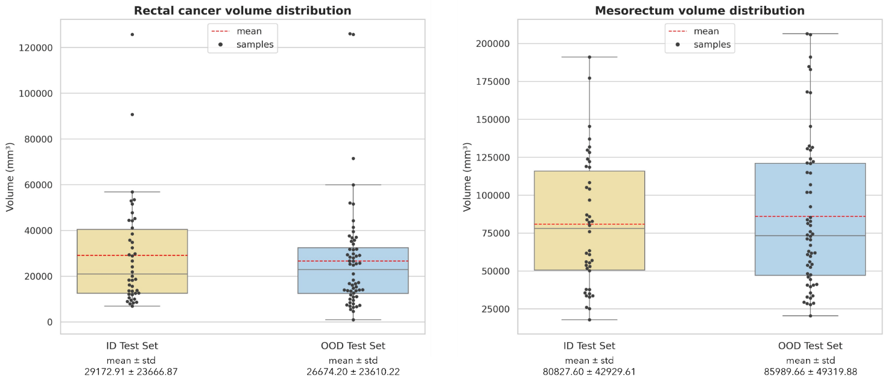

Figure S5 - Volume distribution of rectal tumor (left) and mesorectum (right) in the in-distribution (ID) and out-of-distribution (OOD) test sets. Boxplots report the variability of anatomical volumes across subjects, with individual samples shown as black dots and mean values indicated by red dashed lines. Rectal tumors in the OOD cohort exhibit smaller mean volumes compared to the ID cohort, whereas mesorectal volumes are larger in the OOD set. These anatomical differences contribute to the observed performance trends in segmentation accuracy between ID and OOD experiments.
Table S6. Training details for the best-performing configuration used in RectoMap.
architecture | fold | training time  [dd-hh:mm:ss] | training epochs | GPU | validation DSC
nnUNet | 0 | 00-23:35:00 | 895 | RTX 3090 | 0.813
 | 1 | 00-17:01:00 | 891 | A40 | 0.746
 | 2 | 01-01:47:00 | 979 | RTX 3090 | 0.795
 | 3 | 01-05:27:00 | 947 | RTX 3090 | 0.765
 | 4 | 00-21:39:00 | 909 | RTX 3090 | 0.807
U-MambaBot | 0 | 01-13:19:00 | 938 | A40 | 0.822
 | 1 | 01-12:36:00 | 972 | RTX 3090 | 0.742
 | 2 | 01-07:06:00 | 837 | RTX 3090 | 0.803
 | 3 | 01-09:16:00 | 836 | A40 | 0.757
 | 4 | 01-07:50:00 | 800 | A40 | 0.807

Table S6 - For each architecture and each of the five cross-validation folds, the table reports the total training time (dd–hh:mm:ss), the number of epochs completed at the best validation checkpoint, the GPU model employed (NVIDIA A40 or NVIDIA GeForce RTX 3090), and the mean validation DSC across the two target structures.

