SUPPLEMENTARY INFORMATION

ATRX Loss-Induced Chromatin Spatial Remodeling Upregulates UGDH to Promote SOX2 m6A Methylation and Stemness Maintenance via UDP-Glc Depletion in Glioblastoma

Tian et al.

Supplementary Figures and Figure legends
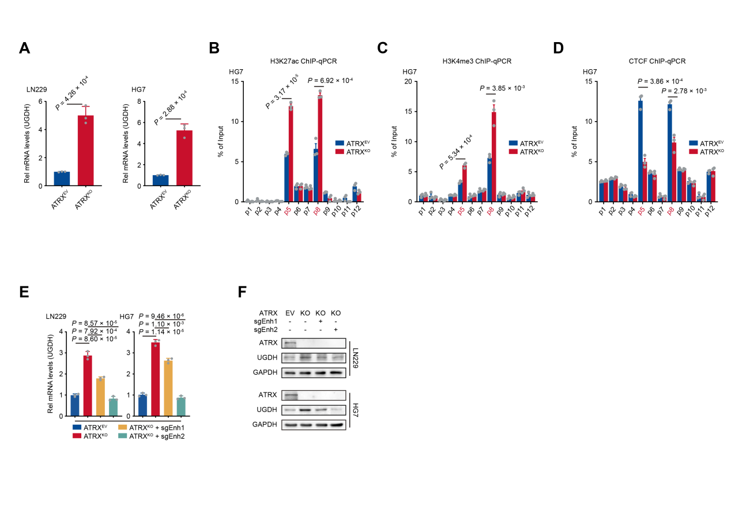
Supplementary Figure 1. ATRX knockout induces aberrant activation of the UGDH enhancer.
- Relative UGDH mRNA levels in LN229 and HG7 cells with or without ATRX knockout (n = 3). Data are presented as the mean ± S.D. P value was determined by Student's t - test.
- ChIP-qPCR data of HG7 cells showing the enrichment of H3K27ac in the upstream promoter of UGDH (n = 3). Data are presented as the mean ± S.D. P value was determined by Student's t - test.
- ChIP-qPCR data of HG7 cells showing the enrichment of H3K4me3 in the upstream promoter of UGDH (n = 3). Data are presented as the mean ± S.D. P value was determined by Student's t - test.
- ChIP-qPCR data of HG7 cells to determine the occupancy of CTCF in the upstream promoter of UGDH (n = 3). Data are presented as the mean ± S.D. P value was determined by Student's t - test.
- Relative UGDH mRNA expression in ATRX^{EV} and ATRX^{KO} cells transduced with sgRNA targeting candidate enhancers. Data are presented as the mean ± S.D. P value was determined by Student's t - test.
- Western blotting of ATRX, UGDH and GAPDH in cells from the same grouping.

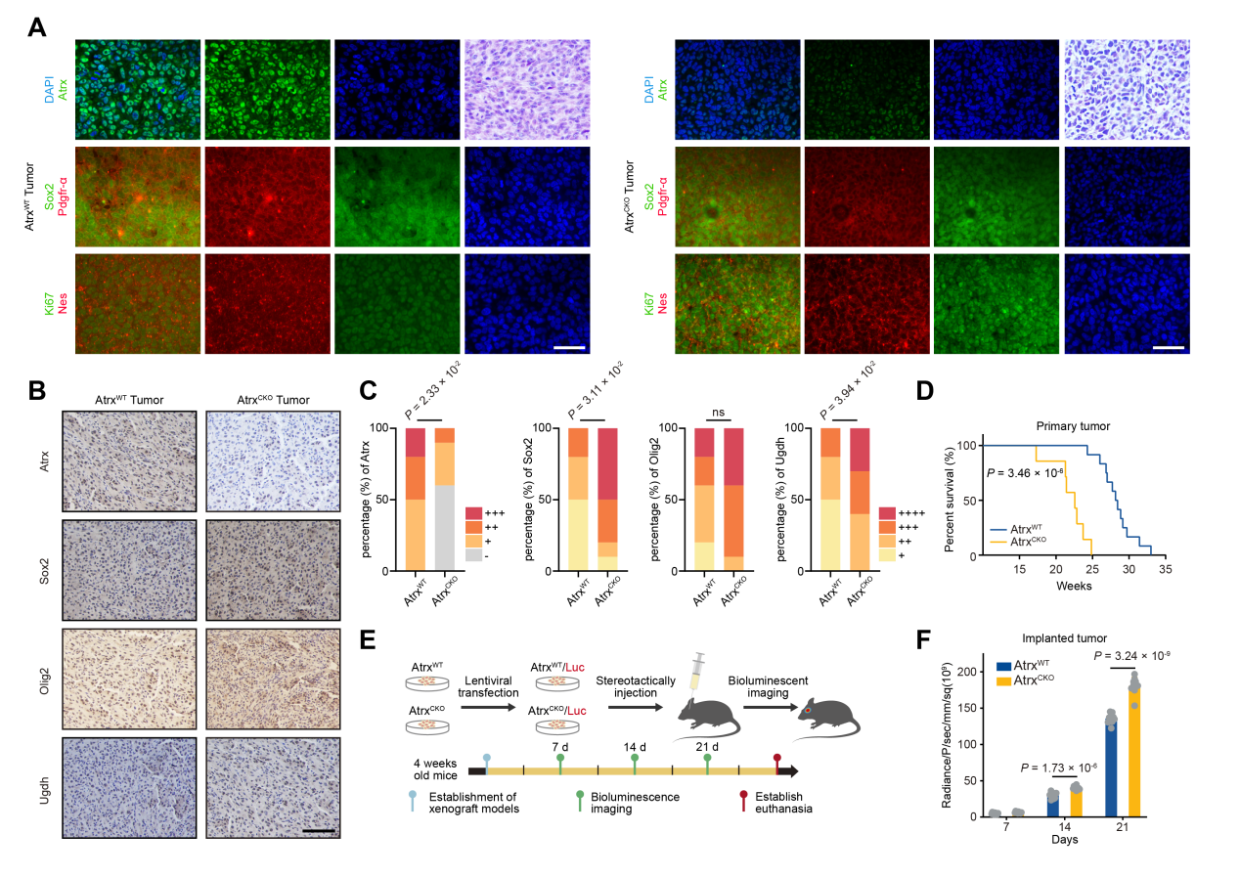
Supplementary Figure 2. Primary tumors in ATRX CKO mice exhibit worse prognosis.
- H&E staining and immunofluorescence of Atrx^{WT} and Atrx^{CKO} tumor tissues. Scale bar, 20 μm.
- Immunohistochemical analysis of ATRX, SOX2, OLIG2, and UGDH expression in DAB-stained Atrx^{WT} and Atrx^{CKO} primary tumor sections. Scale bar, 100 μm.
- The histogram represented the quantitative evaluation of the immunohistochemistry assays (n = 10). P value was determined by Chi-squared test.
- Kaplan-Meier survival curves were generated for mice bearing primary tumor (Atrx^{WT} group = 12, Atrx^{CKO} group = 7). P value was determined by Log-rank test.
- Schematic illustration: bioluminescence imaging of primary mouse tumor cell lines after implantation.
- Quantification of bioluminescence signals in mice implanted with primary tumor cell lines (n = 10). P value was determined by Student's t - test.

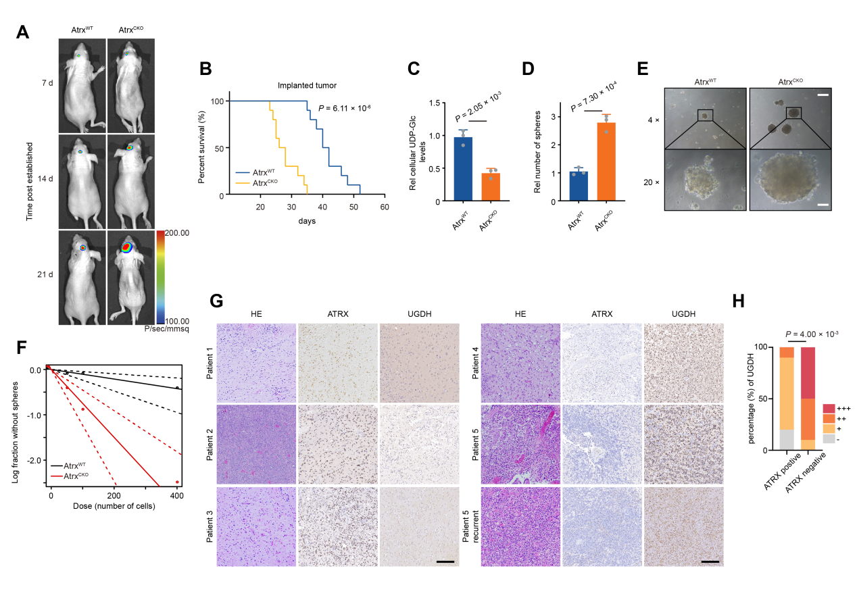
Supplementary Figure 3. ATRX loss correlates with UGDH overexpression in human and murine tumors..
- Representative bioluminescence images of mice bearing tumors derived from Atrx^{WT} or Atrx^{CKO} primary tumor cell lines (n = 10).
- Kaplan-Meier survival curves were generated for mice bearing planted tumors (n = 10). P value was determined by Log-rank test.
- The concentrations of intracellular UDP-Glc were determined (n = 3). Data are presented as the mean ± S.D. P value was determined by Student's t - test.
- Sphere formation assays were performed using mice derived tumor cell lines. Tumor spheres with diameters > 50 μm were counted (n = 3). Data are presented as the mean ± S.D. P value was determined by Student's t - test.
- Representative images of sphere formation assays using primary mouse tumor cell lines with either Atrx^{WT} or Atrx^{CKO}. Top Scale bar, 200 μm. Bottom Scale bar, 50 μm.
- Limited dilution assays (LDA) were performed to test self-renewal ability of ATRX^{WT} and ATRX^{CKO} cells.
- Representative H&E and immunohistochemical (IHC) staining of patient-derived tumor tissues. Sections from ATRX-positive (patients 1-3) and ATRX-negative (patients 4-5) tumors were probed with anti-ATRX and anti-UGDH antibodies. Scale bar, 100 μm.
- The histogram represented the quantitative evaluation of the immunohistochemistry (IHC) assays (n = 10). P value was determined by Chi-squared test.

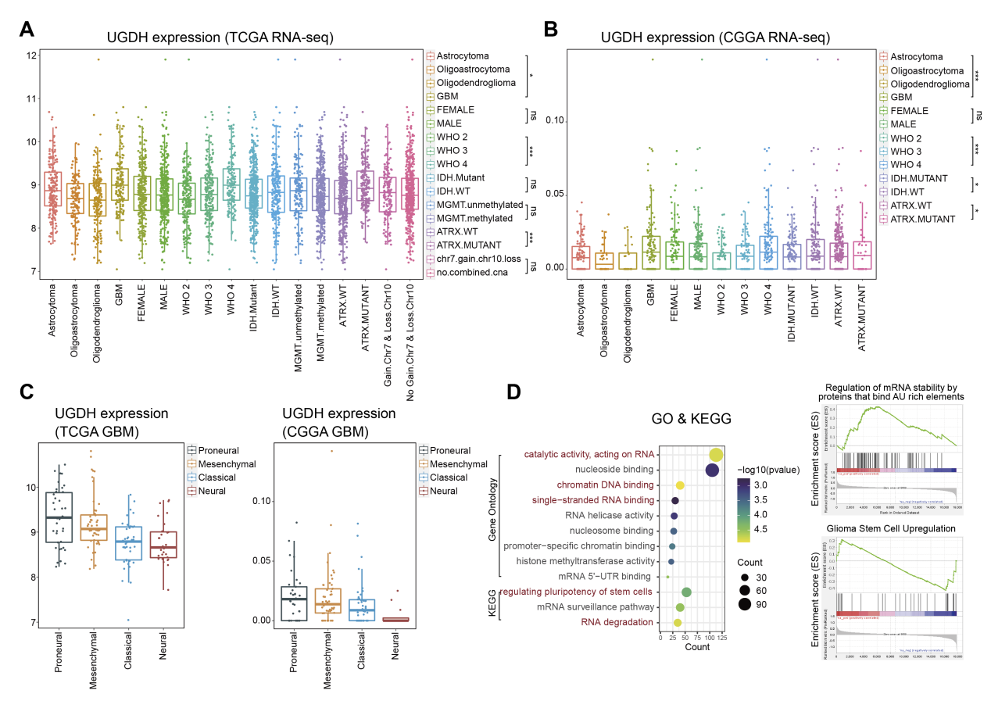
Supplementary Figure 4. Comprehensive analysis of UGDH expression and functional pathways in glioma.
- Analysis of UGDH mRNA expression (RNA-seq) in TCGA glioma datasets. *P < 0.05, **P < 0.01, ***P < 0.001.
- Analysis of UGDH mRNA expression (RNA-seq) in CCGA glioma datasets. *P < 0.05, **P < 0.01, ***P < 0.001.
- UGDH expression across GBM molecular subtypes in TCGA and CGGA datasets.
- Left: Gene Ontology (GO) and Kyoto Encyclopedia of Genes and Genomes (KEGG) pathway enrichment analysis of UGDH-associated genes. Right: Gene set enrichment analysis (GSEA) of UGDH-associated genes in glioma.

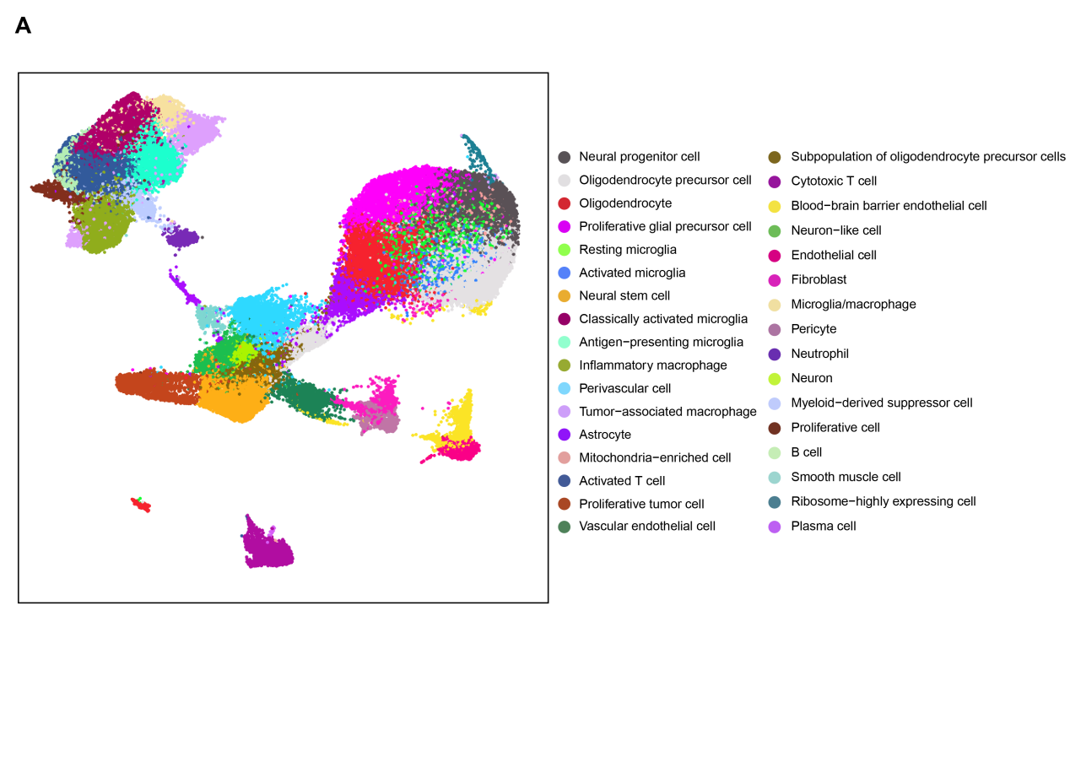
Supplementary Figure 5. Cell classification of scRNA-seq data.
- Cell annotation of scRNA-seq data on 4 patient-derived tumor tissue samples.

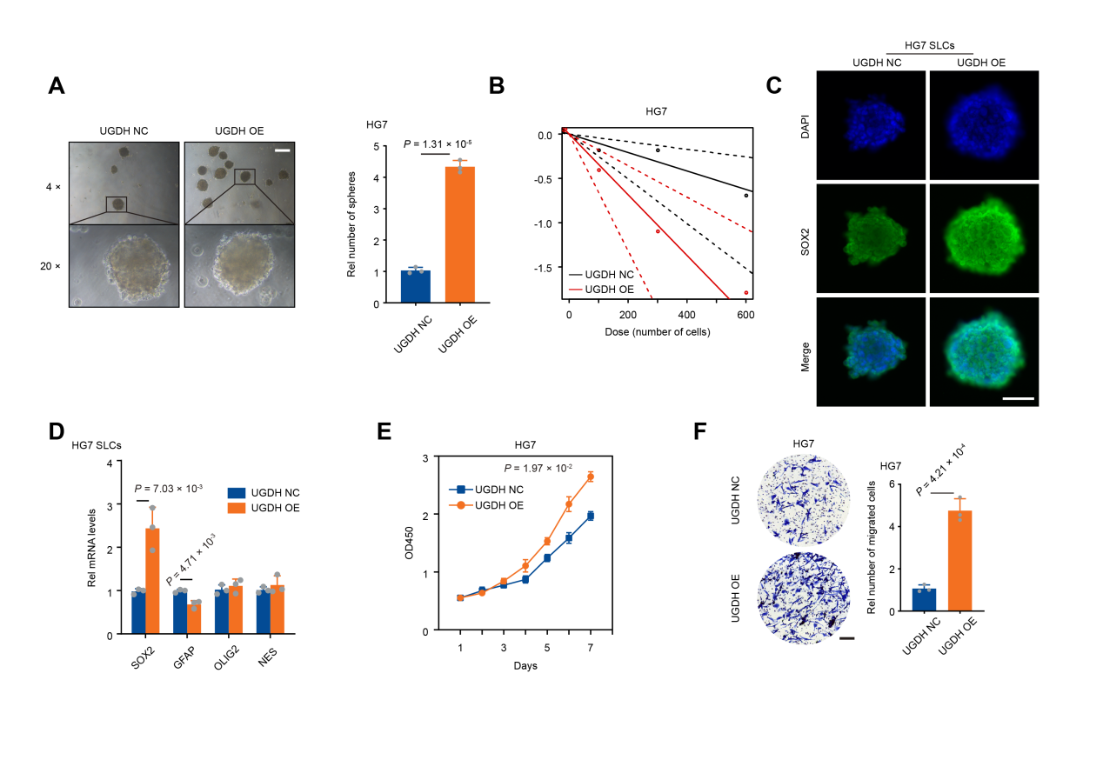
Supplementary Figure 6. UGDH overexpression promotes malignant behaviors in GBM cells.
- Left: Representative images of sphere formation of HG7 cells that have either normal (NC) or overexpression (OE) of UGDH. Right: Relative number of sphere formation are shown in histogram. Tumor spheres with diameters > 50 μm were counted (n = 3). Data are presented as the mean ± S.D. P value was determined by Student's t - test.
- Limited dilution assays (LDA) were used to test self-renewal ability of HG7 cells after UGDH overexpressing.
- Representative images of IF assays show SOX2 expression in HG7 cells with UGDH overexpression or not. Scale bar, 100 μm.
- The qRT-PCR analysis of mRNA levels of SOX2, GFAP, OLIG2, NES in sphere cells of HG7 with UGDH overexpressing or not (n = 3). Data are presented as the mean ± S.D. P value was determined by Student's t - test.
- CCK-8 assay of HG7 cell growth following UGDH overexpression. (n = 3). cells were transfected with UGDH overexpression vector or empty vector control. Cell viability was measured at indicated time points using the CCK-8 reagent. Data are presented as the mean ± S.D. P value was determined by Student's t - test.
- Left: Representative images of transwell assays performed by using HG7 cell, with transfected with UGDH overexpression vector or empty vector control. Right: The statistical analyses of numbers of migrated cells (n = 3). Scale bar, 100 μm. Images are representative of three independent experiments. Data are presented as the mean ± S.D. P value was determined by Student's t - test.

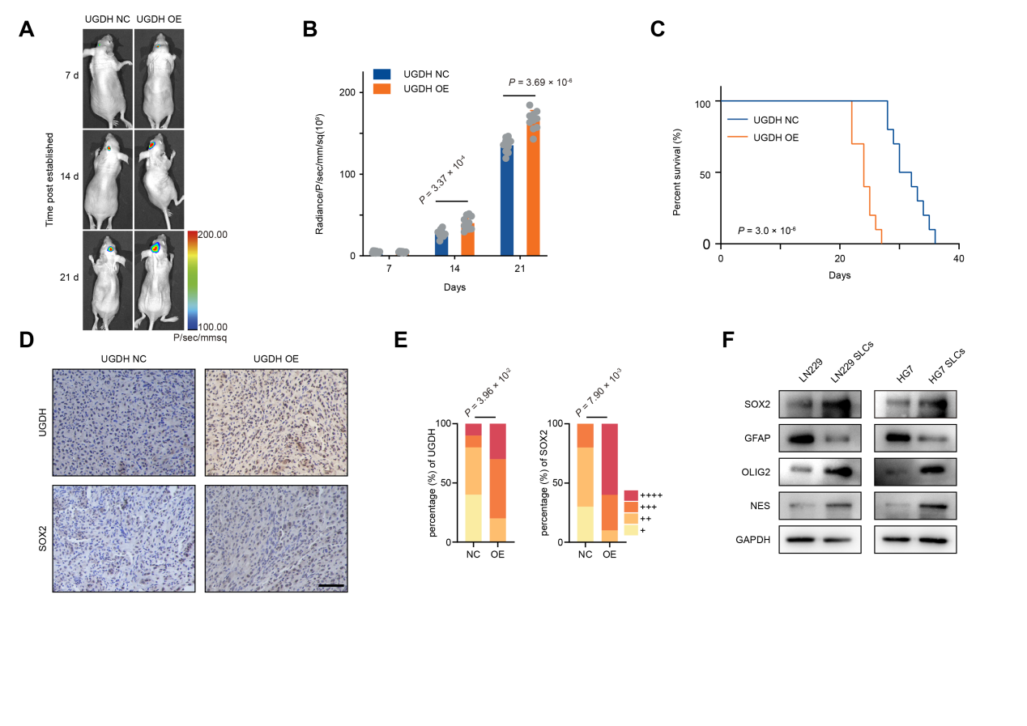
Supplementary Figure 7. Tumor models engineered with UGDH overexpression demonstrate worse prognostic outcomes.
- Representative bioluminescence images of tumor-bearing mice at the indicated time points. Mice were implanted with tumor cells transfected with UGDH overexpression vector or empty vector control. Bioluminescence signals reflect tumor burden in each group (n = 10).
- Quantification of bioluminescent imaging signal intensities (n = 10). P value was determined by Student's t - test.
- Kaplan-Meier survival curves were generated for mice bearing tumors (n = 10). P value was determined by Log-rank test.
- Representative images of IHC staining of mice tumors with anti-UGDH and anti-SOX2 are shown. Scale bar, 100 μm.
- The histogram represents the quantitative evaluation of IHC staining (n = 10). P value was determined by Chi-squared test.
- Western blot analysis of SOX2, OLIG2, NES and GFAP expression in stem-like cells (SLCs) derived from the indicated cell lines.

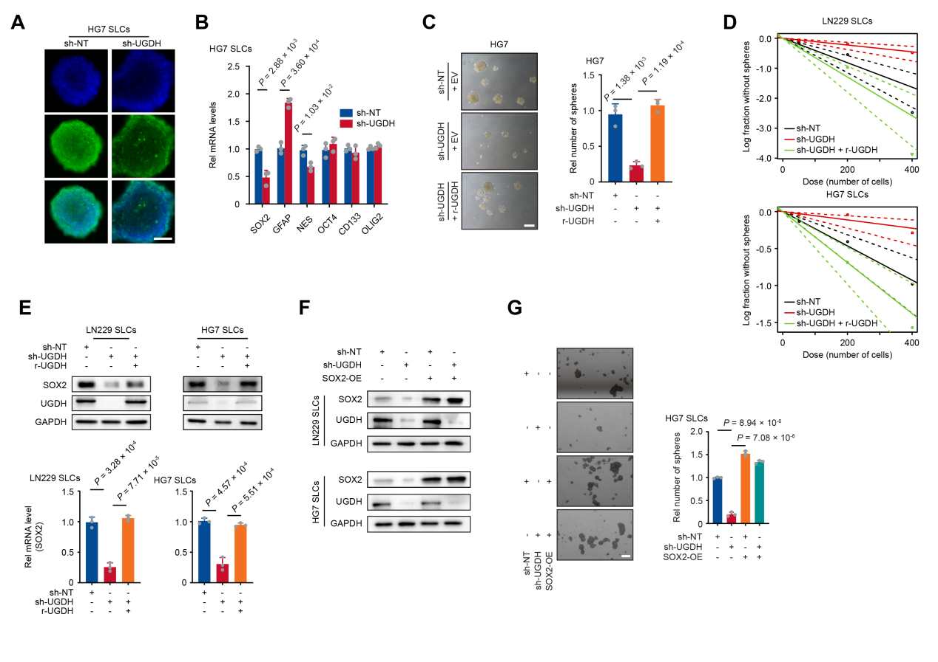
Supplementary Figure 8. UGDH knockdown suppresses SOX2 expression and impairs sphere-forming capacity.
- Representative images of IF assays show SOX2 expression in HG7 SLCs with UGDH knockdown or not. Scale bar, 100 μm.
- The qRT-PCR analysis of mRNA levels of SOX2, NES, OCT4, CD133, OLIG2 and GFAP after UGDH knockdown (n = 3). Data are presented as the mean ± S.D. P value was determined by Student's t - test.
- Left: Sphere formation assays were performed in UGDH knockdown HG7 cells rescued with empty vector (EV) or r-UGDH. Scale bar, 200 μm. Images are representative of three independent experiments. Right: Relative number of sphere formation are shown in histogram. Tumor spheres with diameters > 50 μm were counted (n = 3). Data are presented as the mean ± S.D. P value was determined by Student's t - test.
- Limited dilution assays (LDA) were used to test self-renewal ability of UGDH knockdown LN229, HG7 SLCs rescued with empty vector (EV) or r-UGDH.
- Top: The Western blot analyses show expression of SOX2 in UGDH knockdown LN229 and HG7 SLCs rescued with empty vector (EV) or r-UGDH. Data are representative of three independent experiments. Bottom: The SOX2 mRNA level was examined by qRT-PCR (n = 3). Data are presented as the mean ± S.D. P value was determined by Student's t - test.
- The Western blot analyses show expression of SOX2, UGDH in LN229, HG7 SLCs expressing sh-NT and sh-UGDH were infected with or without SOX2 overexpressing.
- Left: Sphere formation assays were performed in HG7 SLCs expressing sh-NT or sh-UGDH were infected with or without SOX2 overexpressing. Scale bar, 200 μm. Right: Relative number of sphere formation are shown in histogram. Tumor spheres with diameters > 50 μm were counted (n = 3). Data are presented as the mean ± S.D. P value was determined by Student's t - test.

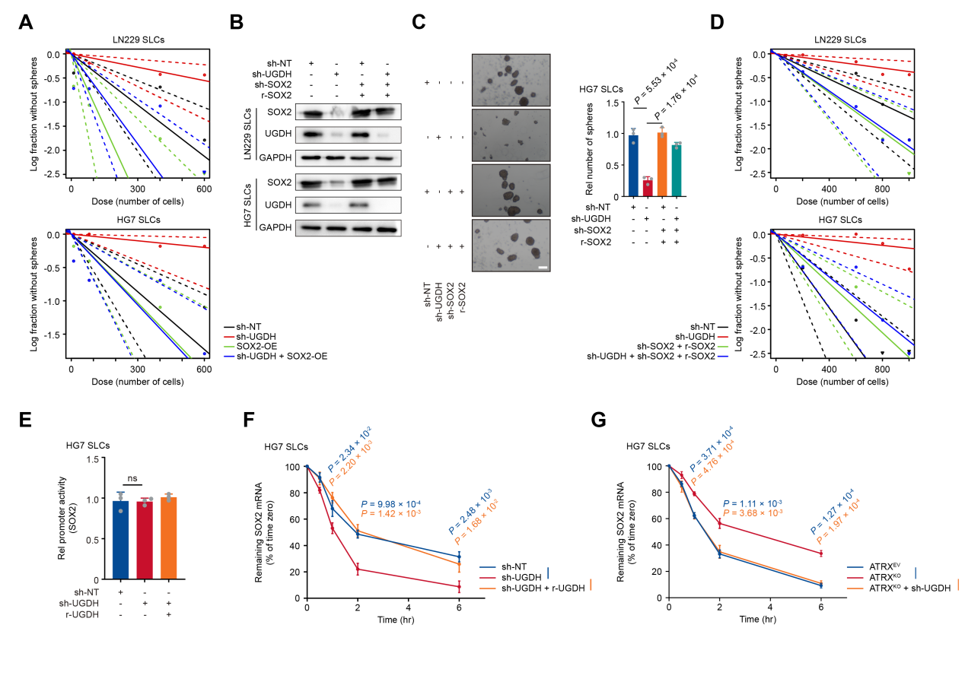
Supplementary Figure 9. UGDH sustains GSC stemness through SOX2 mRNA stabilization.
- Limited dilution assays (LDA) were used to test self-renewal ability of LN229 and HG7 SLCs expressing sh-NT or sh-UGDH were infected with or without SOX2 overexpressing.
- The Western blot analyses show expression of SOX2, UGDH in LN229, HG7 SLCs expressing sh-NT or sh-UGDH were infected with or without sh-SOX2 and r-SOX2.
- Left: Sphere formation assays were performed in HG7 SLCs expressing sh-NT or sh-UGDH were infected with or without sh-SOX2 and r-SOX2. Scale bar, 200 μm. Right: Relative number of sphere formation are shown in histogram. Tumor spheres with diameters > 50 μm were counted (n = 3). Data are presented as the mean ± S.D. P value was determined by Student's t - test.
- Limited dilution assays (LDA) were used to test self-renewal ability of LN229 and HG7 SLCs expressing sh-NT or sh-UGDH were infected with or without sh-SOX2 and r-SOX2.
- HG7 SLCs were transfected sh-NT and sh-UGDH with or without rescued by r-UGDH, and luciferase activity of SOX2 promoter reporter was measured (n = 3). Data are presented as the mean ± S.D. P value was determined by Student's t-test. ns (no significance).
- UGDH knockdown HG7 SLCs rescued with empty vector (EV) or r-UGDH were treated with actinomycin D (1 μg/mL). The remaining SOX2 mRNA were examined by qRT-PCR at indicated time (n = 3). Data are presented as the mean ± S.D. P value was determined by Student's t-test.
- ATRX^{EV} and ATRX^{KO} HG7 SLCs with or without UGDH knockdown were treated with actinomycin D (1 μg/mL). The remaining SOX2 mRNA were examined by qRT-PCR at indicated time (n = 3). Data are presented as the mean ± S.D. P value was determined by Student's t-test.

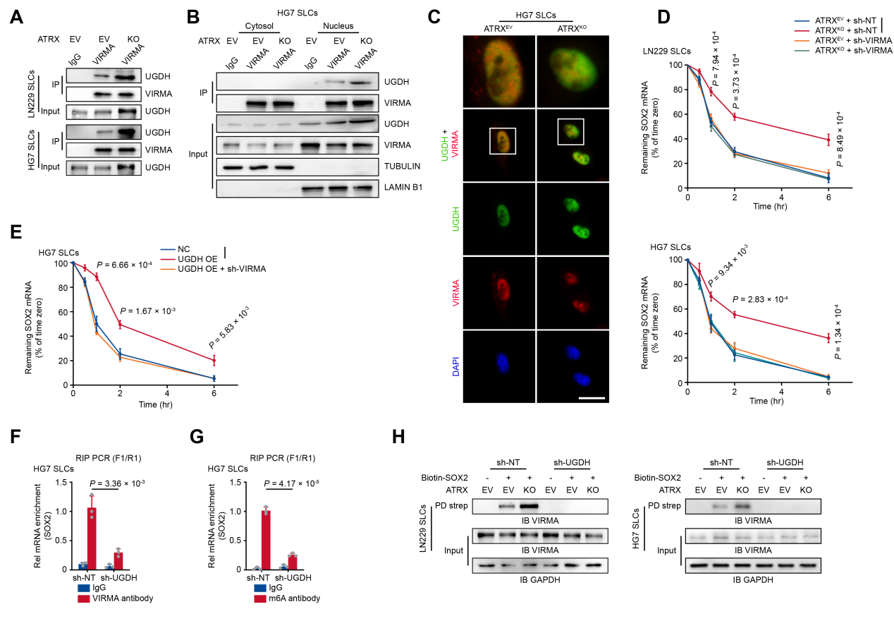
Supplementary Figure 10. UGDH interacts with VIRMA to regulate SOX2 mRNA stability.
- Immunoprecipitation (IP) samples of ATRX^{EV} and ATRX^{KO} LN229 and HG7 SLCs were extracted with anti-VIRMA and anti-IgG. WB analyses are shown.
- Cytoplasmic and nuclear proteins from ATRX^{EV} and ATRX^{KO} cells were extracted separately for IP experiments. WB analyses are shown.
- Immunofluorescence (IF) were performed with anti-UGDH and anti-VIRMA antibodies in adherent ATRX^{EV} and ATRX^{KO} HG7 SLCs. Scale bar, 10 μm.
- ATRX^{EV} and ATRX^{KO} LN229 and HG7 SLCs transfected with sh-NT or sh-VIRMA were treated with actinomycin D (1 μg/mL). The remaining SOX2 mRNA were examined by qRT-PCR at indicated time (n = 3). Data are presented as the mean ± S.D. P value was determined by Student's t-test.
- HG7 SLCs transfected with UGDH OE with or without sh-VIRMA were followed by treatment with actinomycin D (1 μg/mL). The remaining SOX2 mRNA were examined by qRT-PCR at indicated time (n = 3). Data are presented as the mean ± S.D. P value was determined by Student's t - test.
- RNA immunoprecipitation (RIP) assays were performed in ATRX^{EV} and ATRX^{KO} HG7 SLCs transfected with sh-NT or sh-UGDH using anti-VIRMA, followed by qRT-PCR analyses to assess precipitated SOX2 mRNA levels (n = 3). Data are presented as the mean ± S.D. P value was determined by Student's t - test.
- RNA immunoprecipitation (RIP) assays were performed in ATRX^{EV} and ATRX^{KO} HG7 SLCs transfected with sh-NT or sh-UGDH using anti-m⁶A, followed by qRT-PCR analyses to assess precipitated SOX2 mRNA levels (n = 3). Data are presented as the mean ± S.D. P value was determined by Student's t - test.
- LN229 and HG7 SLCs with or without ATRX knockout were transfected with sh-NT or sh-UGDH, then cells were lysed to conduct pull-down assays by incubating cell lysates with or without biotin-SOX2 for 4 hours.

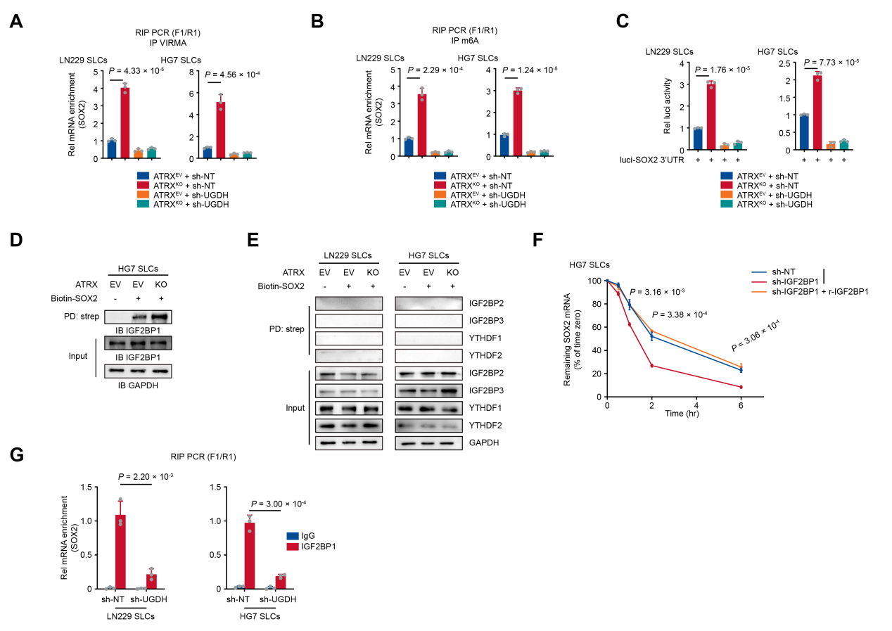
Supplementary Figure 11. IGF2BP1 recognizes m6A-modified SOX2 and enhances its stability.
- ATRX^{EV} and ATRX^{KO} cells were transfected with sh-NT or sh-UGDH, and RNA immunoprecipitation (RIP) was performed using anti-VIRMA antibody. Precipitated SOX2 mRNA levels were measured by qRT-PCR. Data are presented as the mean ± S.D. P value was determined by Student's t - test.
- ATRX^{EV} and ATRX^{KO} cells were transfected with sh-NT or sh-UGDH, and RNA immunoprecipitation (RIP) was performed using anti-m⁶A antibody. Precipitated SOX2 mRNA levels were measured by qRT-PCR. Data are presented as the mean ± S.D. P value was determined by Student's t - test.
- Cells were transfected with sh-NT or sh-UGDH along with a luciferase reporter construct driven by the SOX2-3' UTR. The luciferase activity was measured. Data are presented as the mean ± S.D. P value was determined by Student's t - test.
- Pull-down assays were performed by incubating the cell lysates of ATRX^{EV} and ATRX^{KO} SLCs with or without biotin-SOX2. WB analyses using anti-IGF2BP1 are shown.
- Pull-down assays were performed by incubating the cell lysates of ATRX^{EV} and ATRX^{KO} SLCs with or without biotin-SOX2. WB analyses using anti-IGF2BP2, anti-IGF2BP3, YTHDF1 and YTHDF2 are shown.
- IGF2BP1 knockdown HG7 SLCs rescued with empty vector (EV) or r-IGF2BP1 followed by treatment with actinomycin D (1 μg/mL). The remaining SOX2 mRNA were examined by qRT-PCR at indicated time (n = 3). Data are presented as the mean ± S.D. P value was determined by Student's t - test.
- LN229 and HG7 SLCs were transfected with sh-NT or sh-UGDH, and RNA immunoprecipitation (RIP) was performed using anti-IGF2BP1 antibody. Precipitated SOX2 mRNA levels were measured by qRT-PCR. Data are presented as the mean ± S.D. P value was determined by Student's t - test.

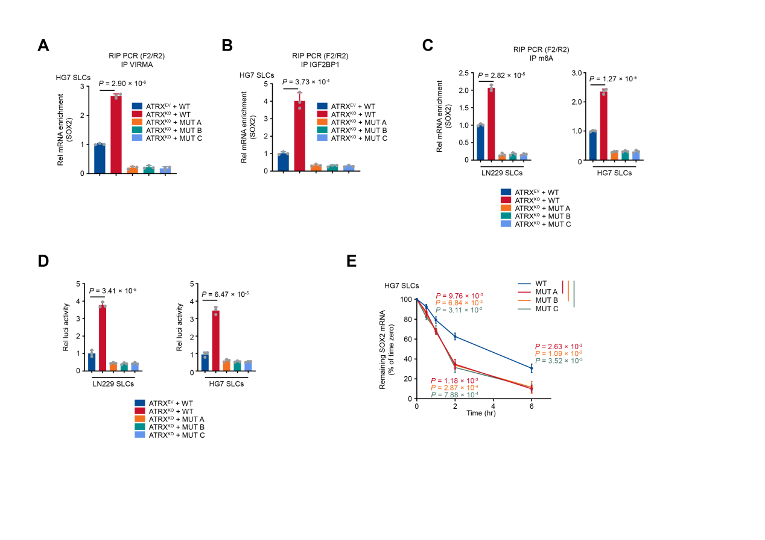
Supplementary Figure 12. The m6A sites of SOX2 affect its binding to VIRMA and IGF2BP1.
- RNA immunoprecipitation (RIP) assays were performed in ATRX^{EV} and ATRX^{KO} HG7 SLCs transfected with wild-type or mutant SOX2-3' UTR. The relative precipitated SOX2 mRNA levels of anti-VIRMA were examined by qRT-PCR (n = 3). Data are presented as the mean ± S.D. P value was determined by Student's t - test.
- RNA immunoprecipitation (RIP) assays were performed in ATRX^{EV} and ATRX^{KO} HG7 SLCs transfected with wild-type or mutant SOX2-3' UTR. The relative precipitated SOX2 mRNA levels of anti-IGF2BP1 were examined by qRT-PCR (n = 3). Data are presented as the mean ± S.D. P value was determined by Student's t - test.
- RNA immunoprecipitation (RIP) assays were performed in ATRX^{EV} and ATRX^{KO} LN229 and HG7 SLCs transfected with wild-type or mutant SOX2-3' UTR. The relative precipitated SOX2 mRNA levels of anti-m⁶A were examined by qRT-PCR (n = 3). Data are presented as the mean ± S.D. P value was determined by Student's t - test.
- ATRX^{KO} SLCs were transfected with wild-type or mutant SOX2-3' UTR along with a luciferase reporter. The luciferase activity was measured. Data are presented as the mean ± S.D. P value was determined by Student's t - test.
- HG7 SLCs were transfected with wild-type or mutant SOX2-3' UTR were treated with actinomycin D (1 μg/mL). The remaining SOX2 mRNA were examined by qRT-PCR at indicated time (n = 3). Data are presented as the mean ± S.D. P value was determined by Student's t - test.
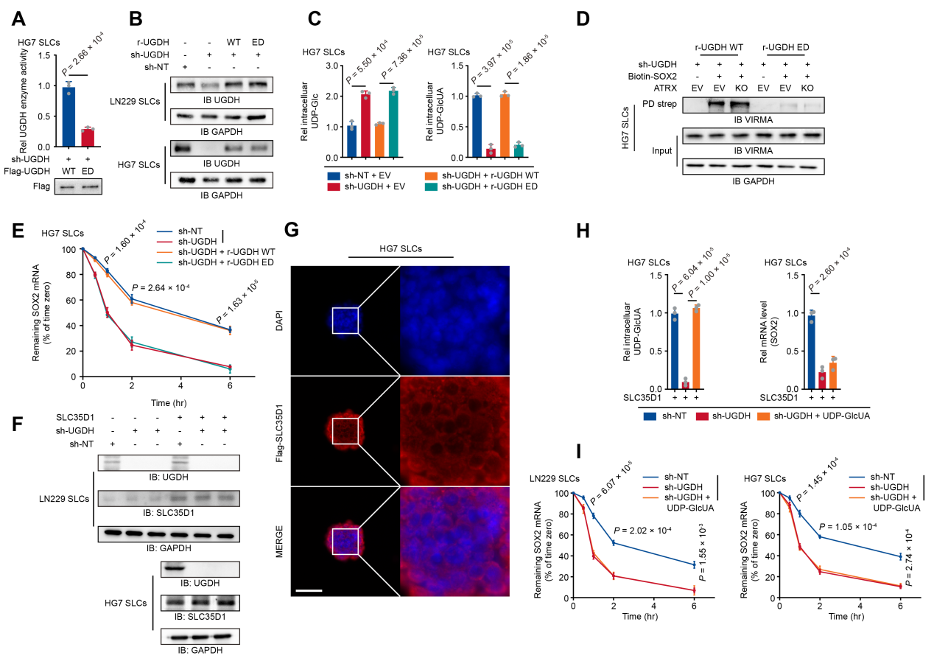
Supplementary Figure 13. UGDH's metabolic function influences SOX2 mRNA stability.
- HG7 SLCs were transfected with sh-UGDH and Flag-UGDH (WT) or Flag-UGDH (ED), then the enzymatic activity was measured (n = 3). Data are presented as the mean ± S.D. P value was determined by Student's t - test.
- The Western blot analyses of UGDH level in LN229 and HG7 SLCs transfected with sh-NT or sh-UGDH rescued with r-UGDH (WT) or r-UGDH (ED) are shown.
- The UDP-Glc and UDP-GlcUA intracellular concentrations of HG7 SLCs transfected with sh-NT or sh-UGDH rescued with r-UGDH (WT) or r-UGDH (ED) were measured (n = 3). Data are presented as the mean ± S.D. P value was determined by Student's t - test.
- ATRX^{EV}/ATRX^{KO} HG7 SLCs with UGDH knockdown were rescued with r-UGDH (WT) or r-UGDH (ED). Pull-down assays were conducted by incubating the cell lysates with or without biotin-SOX2 for 4 hours.
- HG7 SLCs were transfected with sh-UGDH and rescued by r-UGDH (WT) or r-UGDH (ED), followed by treatment with actinomycin D (1 μg/mL). The remaining SOX2 mRNA were examined by qRT-PCR at indicated time (n = 3). Data are presented as the mean ± S.D. P value was determined by Student's t - test.
- The Western blot analysis confirmed the expression of SLC35D1 and UGDH of cell transfected with Flag-SLC35D1.
- Representative images of IF assays confirmed Flag-SLC35D1 expression in HG7 SLCs. Scale bar, 50 μm.
- Left: SLC35D1-overexpressing cells, with or without UGDH knockdown, were supplemented with UDP-GlcUA (5 mM). Then the intracellular UDP-GlcUA levels were measured (n = 3). Right: SLC35D1-overexpressing cells, with or without UGDH knockdown, were supplemented with UDP-GlcUA (5 mM). Then the SOX2 mRNA levels were measured (n = 3). Data are presented as the mean ± S.D. P value was determined by Student's t - test.
- LN229 and HG7 SLCs overexpressing SLC35D1, transfected with sh-NT or sh-UGDH, were supplemented with or without UDP-GlcUA (5mM), followed by treatment with actinomycin D (1 μg/mL). The remaining SOX2 mRNA were examined by qRT-PCR at indicated time (n = 3). Data are presented as the mean ± S.D. P value was determined by Student's t - test.

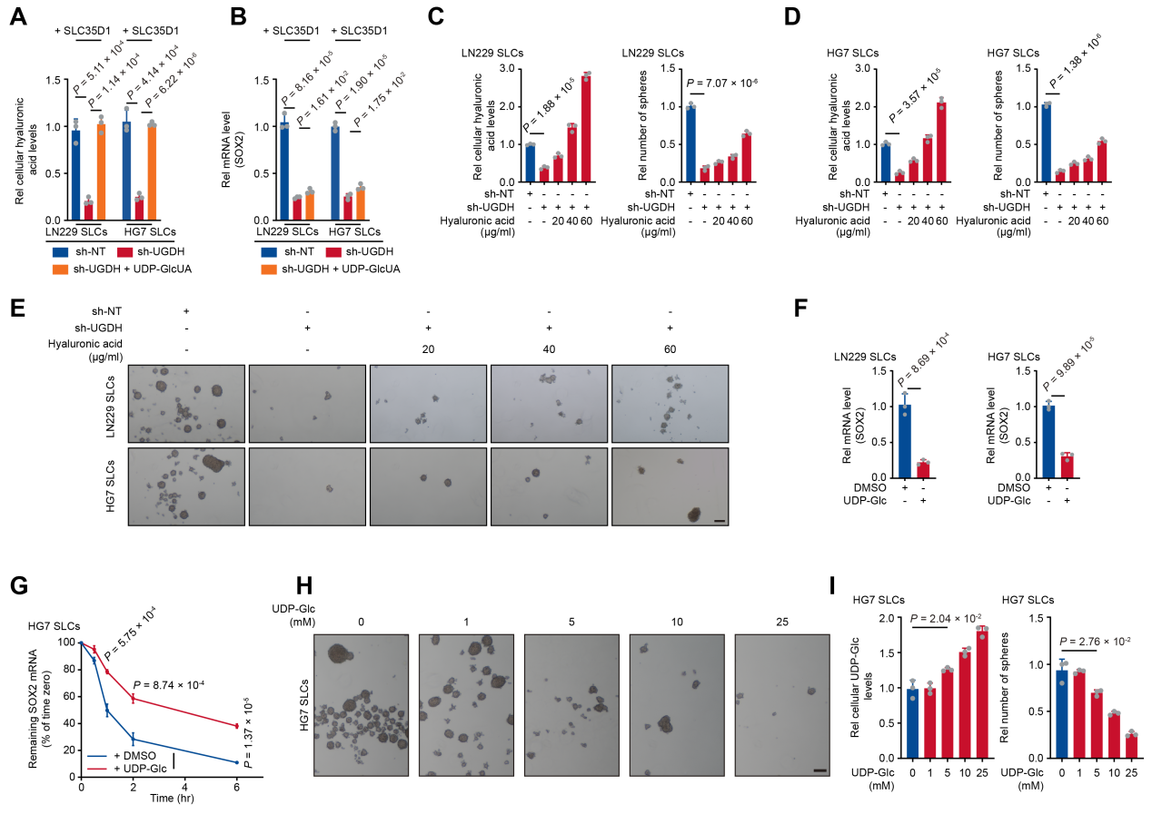
Supplementary Figure 14. UDP-Glc suppresses tumor cell sphere formation and destabilizes SOX2 mRNA.
- SLC35D1-overexpressing LN229 and HG7 SLCs, with or without UGDH knockdown, were supplemented with UDP-GlcUA (5 mM). Then the cellular HA levels were measured (n = 3). Data are presented as the mean ± S.D. P value was determined by Student's t - test.
- SLC35D1-overexpressing LN229 and HG7 SLCs, with or without UGDH knockdown, were supplemented with UDP-GlcUA (5 mM). Then the SOX2 mRNA levels were measured (n = 3). Data are presented as the mean ± S.D. P value was determined by Student's t - test.
- Left: LN229 SLCs, with or without UGDH knockdown, were supplemented with different dose of HA. The concentrations of cellular HA were determined (n = 3). Right: The sphere formation assays were performed. Tumor spheres with diameters > 50 μm were counted (n = 3). Data are presented as the mean ± S.D. P value was determined by Student's t - test.
- Left: HG7 SLCs, with or without UGDH knockdown, were supplemented with different dose of HA. The concentrations of cellular HA were determined (n = 3). Right: The sphere formation assays were performed. Tumor spheres with diameters > 50 μm were counted (n = 3). Data are presented as the mean ± S.D. P value was determined by Student's t - test.
- Sphere formation assays were performed in LN229 and HG7 SLCs with different dose of HA; Scale bar, 200 μm. Images are representative of three independent experiments.
- The qPCR analysis of SOX2 were performed in LN229 and HG7 SLCs with or without UDP-Glc (5 mM) supplemented (n = 3). Data are presented as the mean ± S.D. P value was determined by Student's t - test.
- HG7 SLCs were supplemented with or without UDP-Glc (5mM), followed by treatment with actinomycin D (1 μg/mL). The remaining SOX2 mRNA were examined by qRT-PCR at indicated time (n = 3). Data are presented as the mean ± S.D. P value was determined by Student's t - test.
- Sphere formation assays were performed in HG7 SLCs with different dose of UDP-Glc; Scale bar, 200 μm. Images are representative of three independent experiments.
- Left: HG7 SLCs were supplemented with different dose of UDP-Glc. The concentrations of cellular UDP-Glc were determined (n = 3). Right: Relative number of sphere formation are shown in histogram. Tumor spheres with diameters > 50 μm were counted (n = 3). Data are presented as the mean ± S.D. P value was determined by Student's t - test.

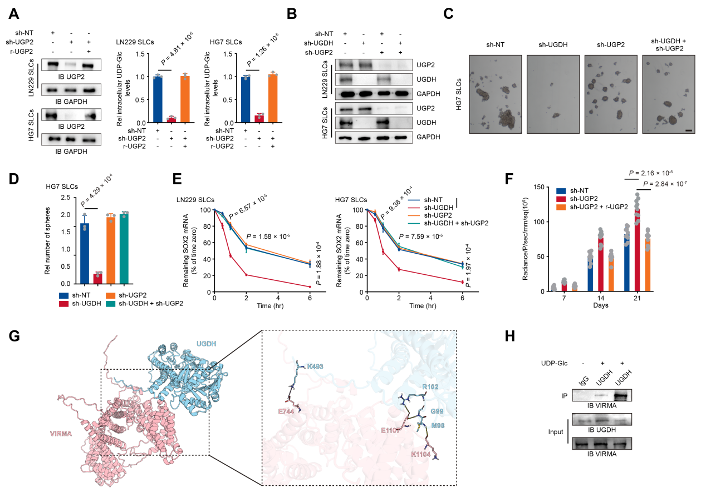
Supplementary Figure 15. Suppressing UDP-Glc production promotes tumor sphere-forming capacity
- Left: WB analysis of UGP2 expression in LN229 and HG7 SLCs transfected with sh-UGP2 with or without rescue. Right: The concentrations of cellular HA were determined (n = 3). Data are presented as the mean ± S.D. P value was determined by Student's t - test.
- WB analyses of UGP2 and UGDH expression in LN229 and HG7 SLCs transfected with sh-UGDH or sh-UGP2 or both.
- Sphere formation assays were performed in HG7 SLCs transfected with sh-UGDH or sh-UGP2 or both; Scale bar, 200 μm. Images are representative of three independent experiments.
- The sphere formation assays of HG7 SLCs, transfected with sh-UGDH or sh-UGP2 or both, were performed. Tumor spheres with diameters > 50 μm were counted (n = 3). Data are presented as the mean ± S.D. P value was determined by Student's t - test.
- LN229 and HG7 SLCs were transfected with sh-UGDH or sh-UGP2 or both, followed by treatment with actinomycin D (1 μg/mL). The remaining SOX2 mRNA were examined by qRT-PCR at indicated time (n = 3). Data are presented as the mean ± S.D. P value was determined by Student's t - test.
- Quantification of bioluminescent imaging signal intensities of mice bearing tumor (n = 10). P value was determined by Student's t - test.
- Binding mode of the UGDH-VIRMA complex. UGDH is shown in blue and VIRMA in pink. Yellow dashed lines indicate hydrogen bonds, and purple dashed lines indicate salt bridges.
- Recombinant VIRMA was pretreated with or without UDP-Glc, then mixed with UGDH. Immunoprecipitation (IP) with anti-UGDH followed by WB analyses.

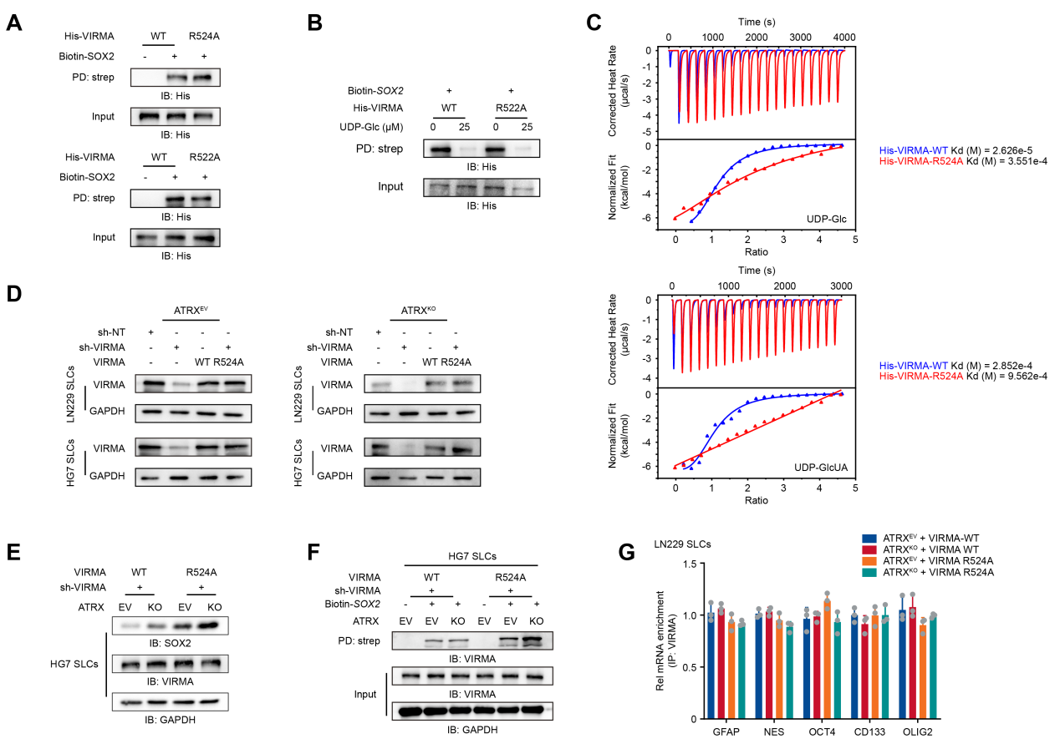
Supplementary Figure 16. The R524A mutation in VIRMA eliminates UDP-Glc inhibition of VIRMA binding to SOX2.
- The recombinant His-VIRMA-WT, His-VIRMA-R524A and His-VIRMA-R522A (5 μg) was incubated with biotin-SOX2 (1 μM) and followed by pull-down assays.
- The recombinant His-VIRMA-WT and His-VIRMA-R522A (5 μg) was incubated with biotin-SOX2 (1 μM) with or without UDP-Glc. Then followed by pull-down assays.
- Isothermal titration calorimetry assays were performed with purified recombinant His-VIRMA-R524A (0.1 mM) and UDP-Glc (1 mM) or UDP-GlcUA (1 mM). Kd, dissociation constant.
- The expression of VIRMA in ATRX^{EV} and ATRX^{KO} cells, expressing WT or R524A VIRMA, were examined by WB analyses.
- ATRX^{EV} and ATRX^{KO} HG7 SLCs with VIRMA knockdown were rescued by VIRMA-WT or VIRMA-R524A. The Western blot analyses were performed to confirm the expression of VIRMA and SOX2.
- Pull-down assays were performed by incubating the cell lysates with or without biotin-SOX2 in ATRX^{EV} or ATRX^{KO} HG7 SLCs expressing WT or R524A VIRMA. WB analyses are shown.
- ATRX^{EV} and ATRX^{KO} LN229 SLCs with VIRMA knockdown were rescued by VIRMA-WT or VIRMA-R524A. RIP-PCR were performed by anti-VIRMA to determine the mRNA enrichment levels of GFAP, NES, OCT4, CD133 and OLIG2 (n = 3). Data are presented as the mean ± S.D. P value was determined by Student's t - test.

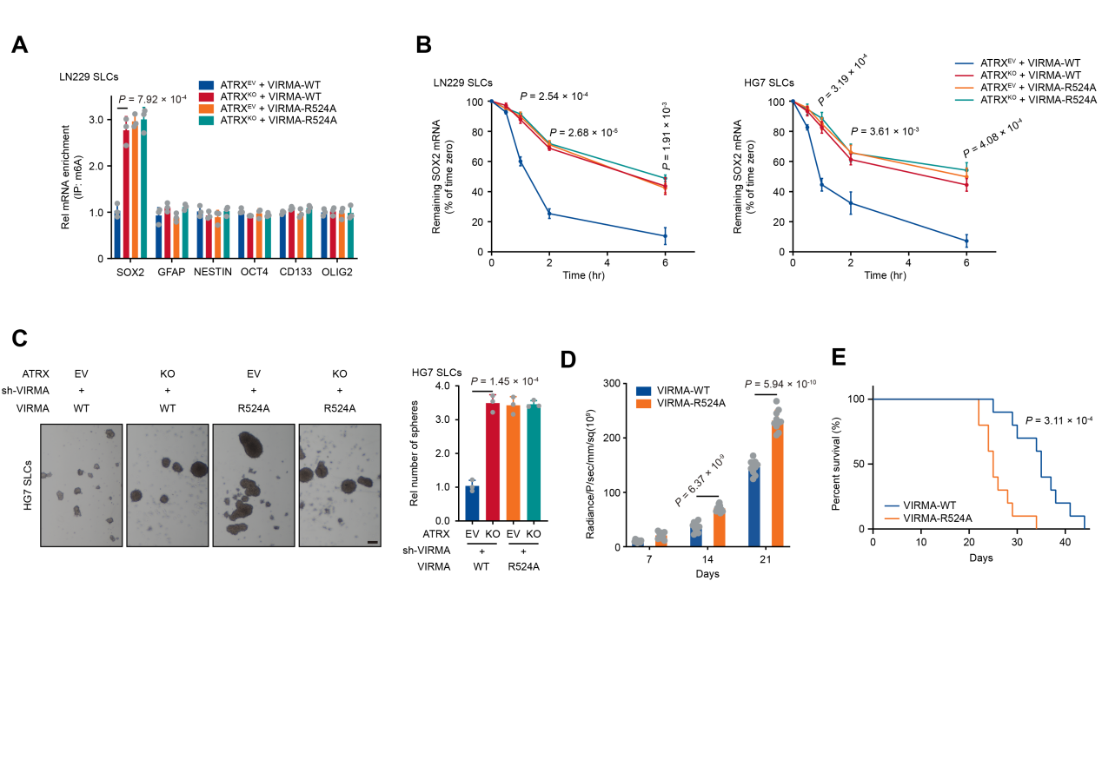
Supplementary Figure 17. The R524A mutation in VIRMA relieves UDP-Glc suppression of SOX2 m⁶A modification and enhances tumor sphere formation.
- ATRX^{EV}/ATRX^{KO} LN229 SLCs with VIRMA knockdown were rescued by VIRMA-WT or VIRMA-R524A. RIP-PCR were performed to determine the mRNA enrichment levels of SOX2, GFAP, NES, OCT4, CD133 and OLIG2 (n = 3). Data are presented as the mean ± S.D. P value was determined by Student's t - test.
- LN229 and HG7 ATRX^{EV} or ATRX^{KO} SLCs rescued by wild-type or mutant VIRMA were treated with actinomycin D (1 μg/mL). The remaining SOX2 mRNA were examined by qRT-PCR at indicated time (n = 3). Data are presented as the mean ± S.D. P value was determined by Student's t - test.
- Left: Sphere formation assays were performed using HG7 ATRX^{EV} or ATRX^{KO} rescued with either wild-type or mutant VIRMA. Images are representative of three independent experiments. Scale bar, 200 μm. Right: Relative number of sphere formation are shown in histogram. Tumor spheres with diameters > 50 μm were counted (n = 3). Data are presented as the mean ± S.D. P value was determined by Student's t - test.
- Quantification of bioluminescent imaging signal intensities of mice bearing tumor (n = 10). P value was determined by Student's t - test.
- Kaplan-Meier survival curves were generated for mice bearing tumors (n = 10 mice). P value was determined by Log-rank test.

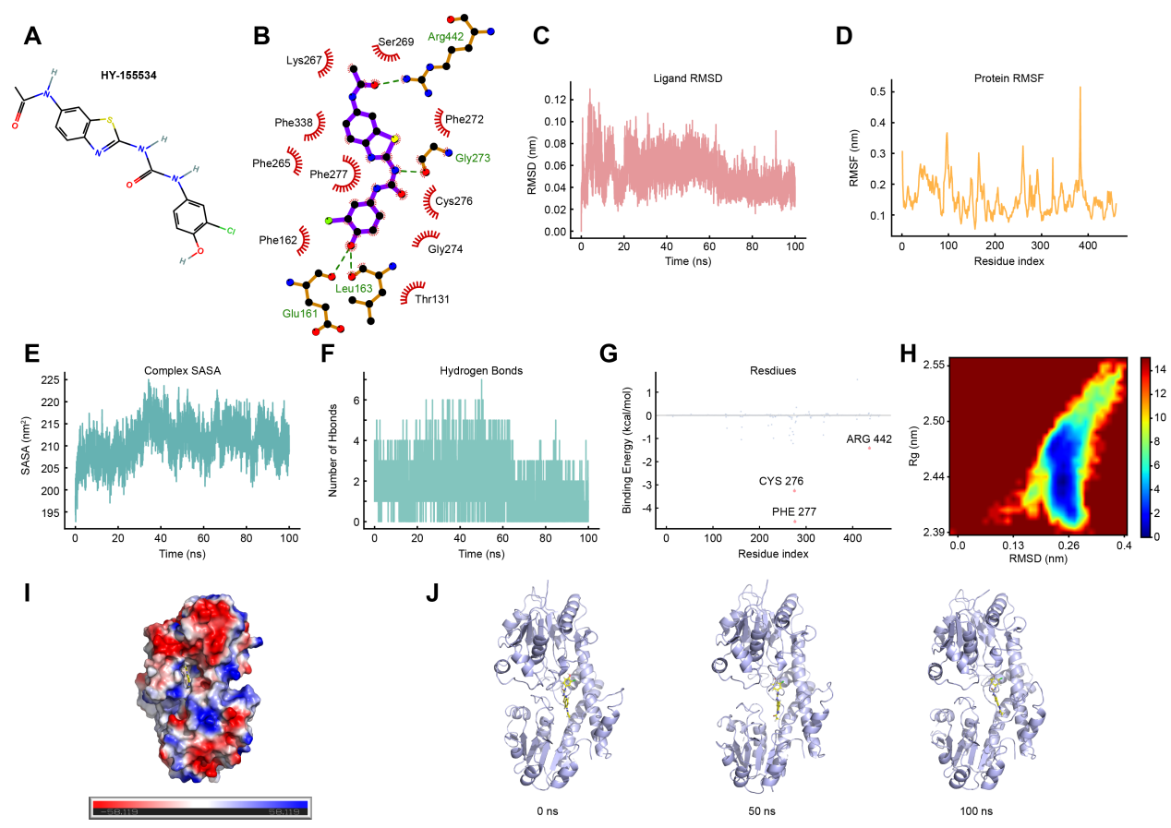
Supplementary Figure 18. Molecular dynamics simulation reveals stable binding of HY-155534 to UGDH.
- Chemical structure of HY-155534.
- Two-dimensional interaction diagram of HY-155534 with key residues of UGDH.
- RMSD trajectories of the protein, ligand, and complex during the 100 ns MD simulation.
- Root Mean Square Fluctuation (RMSF) distribution of protein backbone residues during the 100 ns molecular dynamics (MD) simulation.
- Solvent Accessible Surface Area (SASA) of the complex over the 100 ns MD simulation.
- Number of hydrogen bonds formed between the protein and ligand during the 100 ns MD simulation.
- Per-residue binding free energy decomposition analysis of key amino acids in the UGDH-HY-155534 complex. Binding free energy contributions of individual residues were calculated using MM-GBSA method.
- Two-dimensional free energy landscape of the UGDH-HY-155534 complex as a function of RMSD and Rog. The color bar represents the Gibbs free energy (kJ/mol), with blue/dark blue indicating low-energy regions.
- Electrostatic potential surface of the UGDH protein. The molecular surface is colored according to the electrostatic potential, with red representing negative potential, blue representing positive potential, and white representing neutral regions. The ligand is indicated by stick.
- Superimposed conformations of the UGDH-HY-155534 complex at 0, 50 and 100 ns of the MD simulation. UGDH is shown in light-purple carton and HY-155534 is shown in stick.

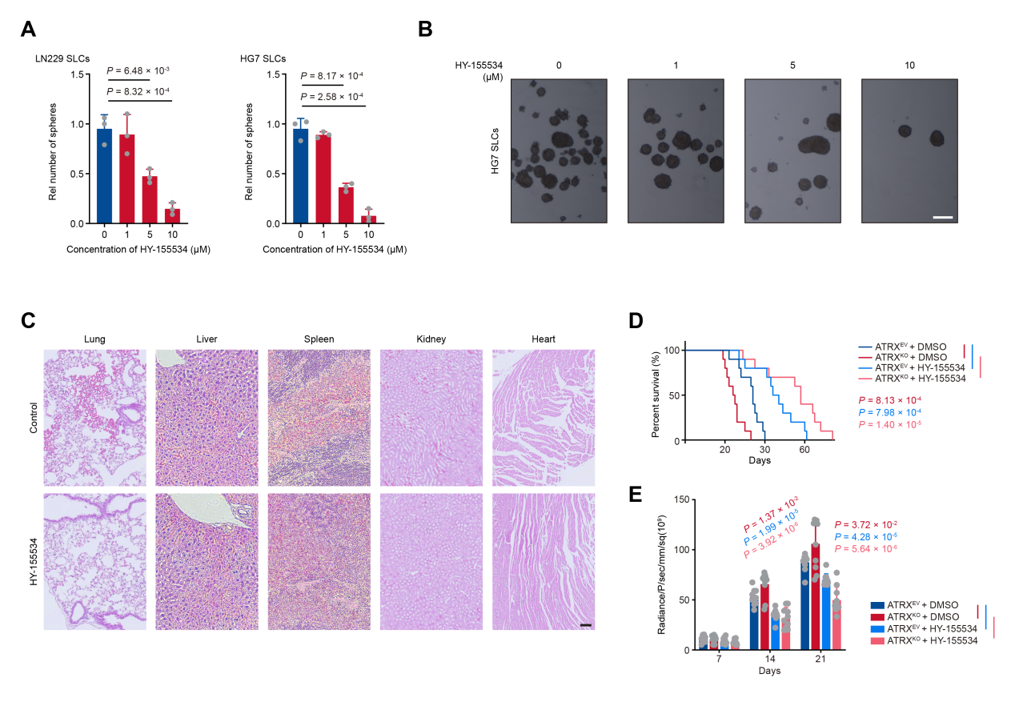
Supplementary Figure 19. HY-155534 suppresses sphere-forming capacity and impairs tumor growth in vivo.
- Sphere formation assays were performed by LN229 and HG7 SLCs, supplementing with different dose of HY-155534. Relative number of sphere formation are shown in histogram. Tumor spheres with diameters > 50 μm were counted (n = 3). Data are presented as the mean ± S.D. P value was determined by Student's t - test.
- Sphere formation assays were performed in HG7 SLCs with different dose of HY-155534. Scale bar, 200 μm. Images are representative of three independent experiments.
- H&E staining of major organs from tumor-bearing mice treated with intraperitoneal injection of HY-155534 or DMSO control.
- Kaplan-Meier survival curves were generated for mice bearing tumors (n = 10 mice). The mice were implanted with ATRX^{EV} or ATRX^{KO} LN229 cells and treated with HY-155534 (4 mg/kg) or an equivalent volume of DMSO control. P value was determined by Log-rank test.
- Quantification of bioluminescent imaging signal intensities (n = 10). P value was determined by Student's t - test.

Raw data of Western blot
