Supplementary material
Table of Contents
Supplementary Figure A: Participant flow diagram 5
Supplementary Table B: Definition of chronic conditions used to define multimorbidity 6
Supplementary Table C: Operationalisation of frailty definition in the three study countries 7
Supplementary Table D: Operationalisation of Washington Group disability domains 9
Supplementary Table E: Prevalence of frailty criteria and frailty status in men and women across the five study sites 11
Supplementary Table F: Prevalence of ‘a lot of difficulty’ or ‘cannot do at all’ in the Washington Group disability domains and disability in men and women across the five study sites 12
Supplementary Table G: Counts and proportions in overlaps between frailty, multimorbidity, and disability by site and overall 13
Supplementary Figure C: Overlaps between people living with pre-frailty, multimorbidity and disability. 14
Supplementary Table H: Counts and proportions in overlaps between pre-frailty, multimorbidity, and disability by site and overall 15
Supplementary Table J: Associations between chronic conditions and frailty and disability 15
Supplementary Table K: Estimated marginal means contrasts in HRQoL using Robust, Non-multimorbid, Non-disabled as reference 16
Supplementary Figure D: Associations between frailty, multimorbidity and disability overlaps and health-related quality of life utility scores 19
Supplementary Figure E: Associations between frailty, multimorbidity and disability overlaps and health-related quality of life utility scores by sex and age-group using the Ghanaian value set 20
Supplementary Figure F: Associations between frailty, multimorbidity and disability overlaps and health-related quality of life visual analogue scale scores by sex and age group 21

Supplementary Table A: STROBE Statement—Checklist of items that should be included in reports of cross-sectional studies
 | Item No | Recommendation | Where item is reported
Title and abstract | 1 | (a) Indicate the study’s design with a commonly used term in the title or the abstract | Title and abstract
Title and abstract | 1 | (b) Provide in the abstract an informative and balanced summary of what was done and what was found | Abstract
Introduction
Background/rationale | 2 | Explain the scientific background and rationale for the investigation being reported | Pages 4-5
Objectives | 3 | State specific objectives, including any prespecified hypotheses | Page 5
Methods
Study design | 4 | Present key elements of study design early in the paper | Page 5
Setting | 5 | Describe the setting, locations, and relevant dates, including periods of recruitment, exposure, follow-up, and data collection | Page 5-6
Participants | 6 | (a) Give the eligibility criteria, and the sources and methods of selection of participants | Page 6
Variables | 7 | Clearly define all outcomes, exposures, predictors, potential confounders, and effect modifiers. Give diagnostic criteria, if applicable | Pages 7-8
Data sources/ measurement | 8* | For each variable of interest, give sources of data and details of methods of assessment (measurement). Describe comparability of assessment methods if there is more than one group | Pages 7-8
Bias | 9 | Describe any efforts to address potential sources of bias | Page 8-9
Study size | 10 | Explain how the study size was arrived at | Page 5-6
Quantitative variables | 11 | Explain how quantitative variables were handled in the analyses. If applicable, describe which groupings were chosen and why | Page 8-9
Statistical methods | 12 | (a) Describe all statistical methods, including those used to control for confounding | Page 8-9
Statistical methods | 12 | (b) Describe any methods used to examine subgroups and interactions | Page 8-9
Statistical methods | 12 | (c) Explain how missing data were addressed | Page 9
Statistical methods | 12 | (d) If applicable, describe analytical methods taking account of sampling strategy | N/A
Statistical methods | 12 | (e) Describe any sensitivity analyses | Page 9
Results
Participants | 13* | (a) Report numbers of individuals at each stage of study—eg numbers potentially eligible, examined for eligibility, confirmed eligible, included in the study, completing follow-up, and analysed | Page 10, Figure A in Appendix
Participants | 13* | (b) Give reasons for non-participation at each stage | Figure A in Appendix
Participants | 13* | (c) Consider use of a flow diagram | Figure A in Appendix
Descriptive data | 14* | (a) Give characteristics of study participants (eg demographic, clinical, social) and information on exposures and potential confounders | Table 1
Descriptive data | 14* | (b) Indicate number of participants with missing data for each variable of interest | Table 1
Outcome data | 15* | Report numbers of outcome events or summary measures | Pages 10-11; Figure 1
Main results | 16 | (a) Give unadjusted estimates and, if applicable, confounder-adjusted estimates and their precision (eg, 95% confidence interval). Make clear which confounders were adjusted for and why they were included | Figure 3
Main results | 16 | (b) Report category boundaries when continuous variables were categorized | N/A
Main results | 16 | (c) If relevant, consider translating estimates of relative risk into absolute risk for a meaningful time period | N/A
Other analyses | 17 | Report other analyses done—eg analyses of subgroups and interactions, and sensitivity analyses | Pages 12-13
Discussion
Key results | 18 | Summarise key results with reference to study objectives | Page 13-14
Limitations | 19 | Discuss limitations of the study, taking into account sources of potential bias or imprecision. Discuss both direction and magnitude of any potential bias | Page 16-17
Interpretation | 20 | Give a cautious overall interpretation of results considering objectives, limitations, multiplicity of analyses, results from similar studies, and other relevant evidence | Page 14-16
Generalisability | 21 | Discuss the generalisability (external validity) of the study results | Page 17
Other information
Funding | 22 | Give the source of funding and the role of the funders for the present study and, if applicable, for the original study on which the present article is based | Page 20

Supplementary Figure A: Participant flow diagram
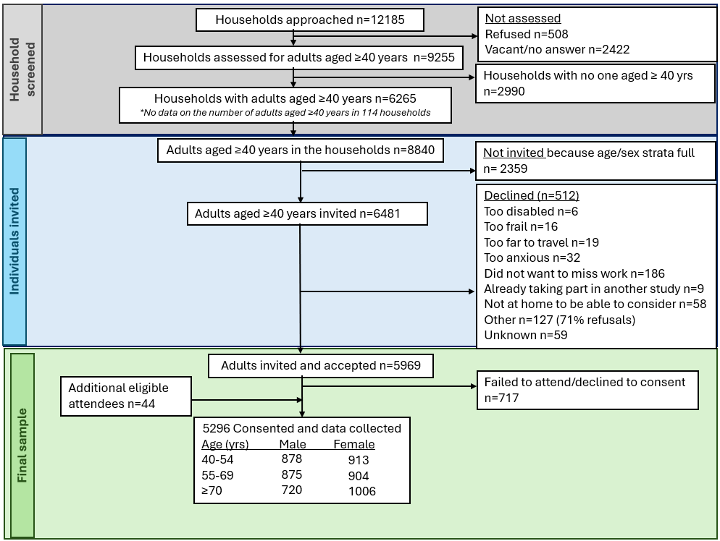

Supplementary Table B: Definition of chronic conditions used to define multimorbidity
Long-term condition | Definition
- Epilepsy | Self-reported diagnosis or medication for epilepsy, including post-stroke epilepsy
- Kidney disease | Self-reported diagnosis or use of medication for chronic kidney disease
- Prior or current Tuberculosis | Self-reported diagnosis or medication use
- HIV | Self-reported diagnosis, medication use or tested during data collection and newly diagnosed
- Lung disease | Self-reported diagnosis or medication for lung disease
- Cardiac disease | Self-reported diagnosis for heart problems or medication for cardiovascular disease, congestive cardiac failure, atrial fibrillation, ischaemic heart disease, angina, or arrhythmia
- High Cholesterol | Self-reported diagnosis or medication for Hypercholesterolaemia
- Thyroid disease | Self-reported diagnosis or medication for Hyperthyroidism or Hypothyroidism
- Cancer | Self-reported diagnosis or medication for any cancer, including Prostate cancer, brain tumour, and malignancy
- Prostatic hypertrophy | Self-reported medication for prostatic hypertrophy
- Stroke | Self-reported diagnosis of stroke or ‘mini’ stroke or medication for stroke
- Dementia/cognitive impairment | Self-reported diagnosis or medication for dementia and including cognitive impairment
- Arthritis | Self-reported diagnosis or medication for any type of arthritis, or joint pain
- Fragility fracture | Self-reported broken bone due to slips, trips or falls from a standing height or less
- Bowel disease | Self-reported diagnosis or medication for bowel disease
- Mood disorders | Self-reported diagnosis or medication for depression/anxiety, or similar for bipolar disorder/mood disorder, or Shona Symptom Questionnaire score >8 or suicide ideation
- Severe mental illness | Self-reported diagnosis or medication for schizophrenia or Psychosis, or self-reported hallucination (Shona Symptom Questionnaire)
- Migraine | Self-reported diagnosis or medication for migraine
- Gastro-oesophageal reflux disease/ peptic ulcer disease | Self-reported medication for GORD or peptic ulcer
- Anaemia | Self-reported diagnosis or medication for anaemia, iron deficiency, or folate deficiency
- Neuropathy | Self-reported medication for neuropathy
- Myopathy | Self-reported medication for myopathy
- Parkinsonism | Self-reported diagnosis or medication for Parkinsonism
- Gout | Self-reported diagnosis or medication for Gout
- Diabetes | Self-reported diagnosis or medication for diabetes, or newly diagnosed based on fasting or random blood glucose: fasting blood glucose, a cutoff of >=7 mmol/L and for random blood glucose, a cutoff of 11 mmol/L
- Hypertension | Self-reported diagnosis or medication for hypertension, or diagnosed based on systolic or diastolic blood pressure measurement if systolic blood pressure was =< 140 or diastolic was => 90 based on 3 or 4 blood pressure measurements
- Glaucoma | Self-reported diagnosis or medication for Glaucoma.
- Allergy | Self-reported medication for allergy, dry eyes or hay fever

Supplementary Table C: Operationalisation of frailty definition in the three study countries
 | Zimbabwe | The Gambia | South Africa
Weight loss | Self-report to “Have you, or those close to you, noticed that you have lost weight or become thinner in the last 12 months?”
Exhaustion | Self-reported based on one question of the Shona Symptom Questionnaire¹, which translates to mean “I felt run down”.
Low physical activity | Self-reported based on the International Physical Activity Questionnaire - Short Form². Metabolic equivalent (METS) minutes per week calculated³ and converted to Kcal per week. Cutoffs proposed by Fried et al⁴ used: Men using <383 Kcals/week and Women using <270 Kcals/week
Low grip strength  (Maximal grip strength of six measures was used) | Cut-offs generated as part of the operationalisation of a sarcopenia definition in Africa using pooled data from The Gambia, Zimbabwe, and South Africa. Cut-offs based on 2 Standard Deviations below the mean grip in men and women: 20kg in women, 28kg in men
Low gait speed  (Mean measured time of two 4-metre (13.1 feet) walks) | Slowest 20% by sex and median height:  Men  Height ≤ 171.1cm: ≥ 6.3 seconds  Height > 171.1cm: ≥ 5.6 seconds  Women  Height ≤ 159.7cm: ≥ 8.3 seconds  Height > 159.7cm: ≥ 6.6 seconds  †Plus, those with mobility challenges who did not complete the walk test, see footnote | Slowest 20% by sex and median height:  Men  Height ≤ 171.1cm: ≥ 6.7 seconds  Height > 171.1cm: ≥ 5.7 seconds  Women  Height ≤ 159.4cm: ≥ 8.2 seconds  Height > 159.4cm: ≥ 7.2 seconds  †Plus, those with mobility challenges who did not complete the walk test, see footnote | Slowest 20% by sex and median height:  Men  Height ≤ 167.8cm: ≥ 6.0 seconds  Height > 167.8cm: ≥ 5.9 seconds  Women  Height ≤ 155.5cm: ≥ 7.6 seconds  Height > 155.5cm: ≥ 7.0 seconds  †Plus, those with mobility challenges who did not complete the walk test, see footnote
†Further, those who did not complete the walk test and (i) self-reported immobility or mobility only with aids AND (ii) moderate to extreme problems with mobility AND (iii) 0 walking MET-minutes per week, were considered to meet the frailty criteria.
*Those who declined the grip strength test because they felt too weak, unsafe, or unable, had shaky hands or a stroke limiting use, were classified as having low grip strength.

Supplementary Table D: Operationalisation of Washington Group disability domains
Washington Group Domain | Question and response options in our research-administered questionnaire | How this differed to the Washington Group intended question | How we derived the response options
Seeing  Do you have difficulty seeing, even if wearing glasses? | Do you have difficulty seeing, even if wearing glasses or contact lenses?  Response options:  - No - no difficulty  - Yes - some difficulty but can clearly see someone's face across a room  - Yes - some difficulty, including some difficultly clearly seeing someone's face across a room  - Yes - a lot of difficulty but can clearly see someone's face across a room  - Yes - a lot of difficulty, including a lot of difficultly clearly seeing someone's face across a room  - Cannot do at all  - Refuse to answer  - Don't know | The response options differed, with more options to choose from and more description within each of the response options. | The responses from our question were categorized into the 4 groups of the Washington Group responses. Response options 1 and 2 became “some difficulty”. Response options 3 and 4 became “a lot of difficulty”. Response option 5 was “cannot do at all”. Response options 6 and 7 were unknown data.
Hearing  Do you have difficulty hearing, even if using a hearing aid? | Do you have difficulty hearing, even if using a hearing aid?  Response options:  - No - no difficulty  - Yes - some difficulty  - Yes - a lot of difficulty  - Cannot hear at all  - Refuse to answer  - Don't know | Question the same as WG-SS the addition of a response option “Refuse to Answer” | Responses to 4 and 5 were categorized as unknown.
Mobility  Do you have difficulty walking or climbing steps? | What best describes your MOBILITY today  Response options:  - I have no problems in walking about  - I have slight problems in walking about  - I have moderate problems in walking about  - I have severe problems in walking about  - I am unable to walk about | Different questioning and response options. Does not include detail on stairs. | Response option 1 became “No difficulty”.  Response option 2 became “Some difficulty”.  Response option 3 and 4 were categorized as “a lot of difficulty”  Response option 5 became “Cannot do at all.”
Cognition  Do you have difficulty remembering or concentrating? | This variable was derived from 3 sources of information:  Question on forgetfulness:  Have you been more forgetful in the last 12 months to the extent that it has significantly affected your daily life?  Response options:  - Yes  - No  Question on concentration:  I found myself sometimes failing to concentrate  Response options:  - Yes  - No  Question on consent:  How was consent given?  Response options:  - Participant signature  - Participant Mark or Thumb print (witnessed)  - Proxy Signature  - Proxy Mark or Thumb print (witnessed) | Different questions and response options, multiple sources. Not relying on self-report alone. | The responses of the questions were categorized into the 4 responses of the Washington Group.  If a person had self-reported “No” to both questions on forgetfulness and concentration, they were deemed to have “no difficulty.”  If a person had self-reported “Yes” to one of these questions they were deemed to have “some difficulty”.  If a person had self-reported “Yes” to both questions they were deemed to have “a lot of difficulty”.  If any response options were missing from either the forgetfulness or concentration question it was treated as missing data.  If a person had been consented using proxy signature or thumb print they were deemed to not have capacity and were categorized within the “cannot do at all”.
Self-care  Do you have difficulty (with self-care such as) washing all over or dressing? | What best describes your SELF-CARE today  Response options:  - I have no problems washing or dressing myself  - I have slight problems washing or dressing myself  - I have moderate problems washing or dressing myself  - I have severe problems washing or dressing myself  - I am unable to wash or dress myself | Different question and response options. | Response option 1 was categorized as “no difficulty”.  Response option 2 was cateogrised as “some difficulty”.  Response options 3 and 4 were categorized within the “a lot of difficulty”.  Response option 5 was categorized into the “cannot do at all”.

Supplementary Table E: Prevalence of frailty criteria and frailty status in men and women across the five study sites
 | Overall |  | Men |  |  |  | Women
 | Overall | Gambia rural | Gambia urban | Zimbabwe urban | SA rural | SA urban | Gambia rural | Gambia urban | Zimbabwe urban | SA rural | SA urban
Frailty criteria
Self-reported unintentional weight loss | 1,707/5,285 (32.3%) | 235/505 (46.5%) | 92/546 (16.8%) | 104/538 (19.3%) | 138/434 (31.8%) | 147/447 (32.9%) | 307/546 (56.2%) | 171/667 (25.6%) | 97/572 (17.0%) | 224/512 (43.8%) | 192/518 (37.1%)
Self-reported exhaustion | 1,297/5,281 (24.6%) | 177/504 (35.1%) | 166/545 (30.5%) | 9/538 (1.7%) | 49/435 (11.3%) | 155/447 (34.7%) | 211/546 (38.6%) | 223/667 (33.4%) | 19/572 (3.3%) | 83/510 (16.3%) | 205/517 (39.7%)
Low physical activity | 1,949/4,854 (40.2%) | 82/492 (16.7%) | 226/522 (43.3%) | 265/523 (50.7%) | 89/369 (24.1%) | 126/333 (37.8%) | 93/524 (17.7%) | 353/636 (55.5%) | 298/561 (53.1%) | 189/468 (40.4%) | 228/426 (53.5%)
Low gait speed | 1,069/5,096 (21.0%) | 98/493 (19.9%) | 109/541 (20.1%) | 113/528 (21.4%) | 66/377 (17.5%) | 96/433 (22.2%) | 72/523 (13.8%) | 172/666 (25.8%) | 136/565 (24.1%) | 103/481 (21.4%) | 104/489 (21.3%)
Low grip strength | 899/5,086 (17.7%) | 70/498 (14.1%) | 56/541 (10.4%) | 78/483 (16.1%) | 93/417 (22.3%) | 86/437 (19.7%) | 106/542 (19.6%) | 71/665 (10.7%) | 89/505 (17.6%) | 136/493 (27.6%) | 114/505 (22.6%)
Frailty status
Frail | 741/5,267 (14.1%) | 67/505 (13.3%) | 75/546 (13.7%) | 45/537 (8.4%) | 39/427 (9.1%) | 75/444 (16.9%) | 70/546 (12.8%) | 118/668 (17.7%) | 56/572 (9.8%) | 83/504 (16.5%) | 113/518 (21.8%)
Pre-frail | 3,199/5,267 (60.7%) | 335/505 (66.3%) | 287/546 (52.6%) | 326/537 (60.7%) | 224/427 (52.5%) | 255/444 (57.4%) | 392/546 (71.8%) | 416/668 (62.3%) | 348/572 (60.8%) | 300/504 (59.5%) | 316/518 (61.0%)
Robust | 1,327/5,267 (25.2%) | 103/505 (20.4%) | 184/546 (33.7%) | 166/537 (30.9%) | 164/427 (38.4%) | 114/444 (25.7%) | 84/546 (15.4%) | 134/668 (20.1%) | 168/572 (29.4%) | 121/504 (24.0%) | 89/518 (17.2%)

Supplementary Table F: Prevalence of ‘a lot of difficulty’ or ‘cannot do at all’ in the Washington Group disability domains and disability in men and women across the five study sites
 |  | Men |  |  |  |  | Women
Domain | Overall | Gambia rural | Gambia urban | Zimbabwe urban | SA rural | SA urban | Gambia rural | Gambia urban | Zimbabwe urban | SA rural | SA urban
Vision | 181 (3.5%) | 4 (0.8%) | 5 (0.9%) | 12 (2.2%) | 30 (6.9%) | 5 (1.1%) | 6 (1.1%) | 4 (0.6%) | 14 (2.5%) | 95 (18.6%) | 6 (1.2%)
Hearing | 47 (1.0%) | 5 (1.0%) | 5 (0.9%) | 6 (1.2%) | 2 (0.6%) | 3 (0.7%) | 5 (0.9%) | 0 (0.0%) | 8 (1.5%) | 10 (2.9%) | 3 (0.6%)
Mobility | 418 (7.9%) | 30 (5.9%) | 37 (6.8%) | 34 (6.3%) | 26 (6.0%) | 26 (5.8%) | 40 (7.3%) | 44 (6.6%) | 58 (10.1%) | 85 (16.6%) | 38 (7.3%)
Self-care | 271 (5.1%) | 27 (5.3%) | 29 (5.3%) | 25 (4.6%) | 14 (3.2%) | 10 (2.2%) | 36 (6.6%) | 33 (4.9%) | 31 (5.4%) | 52 (10.2%) | 14 (2.7%)
Cognition | 730 (13.8%) | 11 (2.2%) | 64 (11.7%) | 50 (9.3%) | 34 (7.8%) | 113 (25.3%) | 29 (5.3%) | 152 (22.8%) | 82 (14.3%) | 54 (10.6%) | 141 (27.3%)
Disability | 1211 (22.9%) | 47 (9.3%) | 99 (18.1%) | 92 (17.1%) | 82 (18.9%) | 135 (30.2%) | 73 (13.3%) | 186 (27.8%) | 127 (22.2%) | 195 (38.1%) | 175 (33.8%)

Supplementary Table G: Counts and proportions in overlaps between frailty, multimorbidity, and disability by site and overall
Category | Gambia rural  n=1051 | Gambia urban  n=1214 | Zimbabwe urban  n=1109 | SA rural  n=931 | SA urban  n=962 | Overall  N=5267
None of the three | 777 (73.9%) | 685 (56.4%) | 573 (51.7%) | 289 (31%) | 235 (24.4%) | 2559 (48.6%)
Frail only | 67 (6.4%) | 64 (5.3%) | 36 (3.2%) | 16 (1.7%) | 24 (2.5%) | 207 (3.9%)
Multimorbid only | 71 (6.8%) | 154 (12.7%) | 261 (23.5%) | 327 (35.1%) | 333 (34.6%) | 1146 (21.8%)
Disabled only | 53 (5%) | 124 (10.2%) | 97 (8.7%) | 69 (7.4%) | 67 (7%) | 410 (7.8%)
Frail & Multimorbid | 16 (1.5%) | 26 (2.1%) | 20 (1.8%) | 27 (2.9%) | 61 (6.3%) | 150 (2.8%)
Frail & Disabled | 39 (3.7%) | 62 (5.1%) | 20 (1.8%) | 35 (3.8%) | 26 (2.7%) | 182 (3.5%)
Multimorbid & Disabled | 13 (1.2%) | 58 (4.8%) | 77 (6.9%) | 124 (13.3%) | 139 (14.4%) | 411 (7.8%)
Frail & Multimorbid & Disabled | 15 (1.4%) | 41 (3.4%) | 25 (2.3%) | 44 (4.7%) | 77 (8%) | 202 (3.8%)
Note: Percentages are row proportions within each site based on individuals with complete data on all three conditions.

Supplementary Figure C: Overlaps between people living with pre-frailty, multimorbidity and disability.
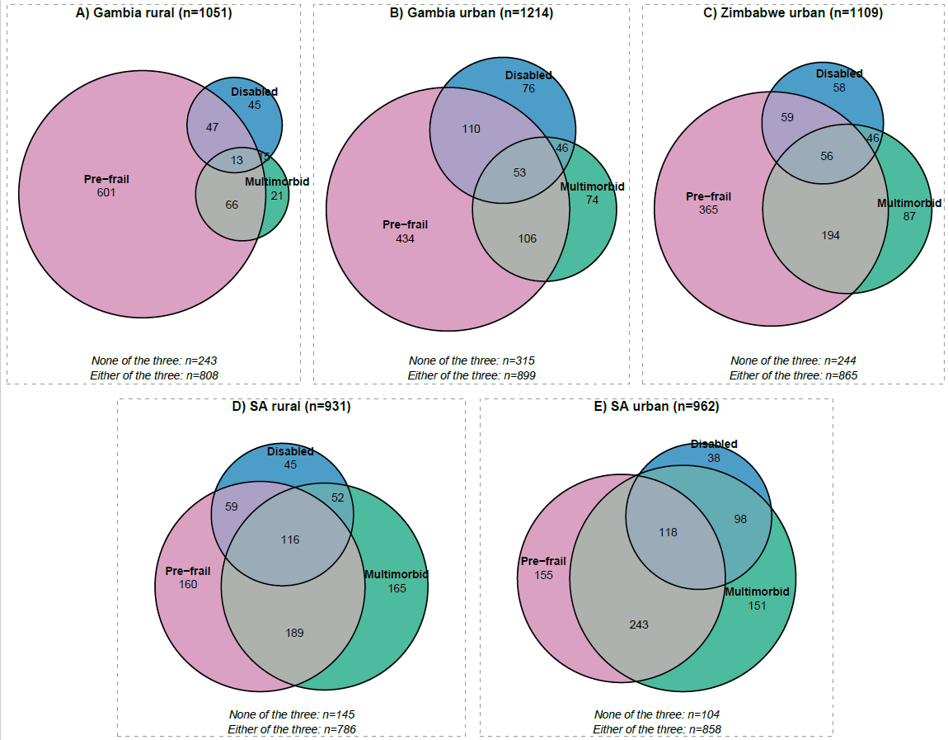
Numbers in circles show the counts of people with condition or overlap of conditions. Sizes of circles are proportional to the number of people.

Supplementary Table H: Counts and proportions in overlaps between pre-frailty, multimorbidity, and disability by site and overall
Category | Gambia rural  n=1051 | Gambia urban  n=1214 | Zimbabwe urban  n=1109 | SA rural  n=931 | SA urban  n=962 | Overall  N=5267
None of the three | 243 (23.1%) | 315 (25.9%) | 244 (22%) | 145 (15.6%) | 104 (10.8%) | 1051 (20%)
Pre-frail only | 601 (57.2%) | 434 (35.7%) | 365 (32.9%) | 160 (17.2%) | 155 (16.1%) | 1715 (32.6%)
Multimorbid only | 21 (2%) | 74 (6.1%) | 87 (7.8%) | 165 (17.7%) | 151 (15.7%) | 498 (9.5%)
Disabled only | 45 (4.3%) | 76 (6.3%) | 58 (5.2%) | 45 (4.8%) | 38 (4%) | 262 (5%)
Pre-frail & Multimorbid | 66 (6.3%) | 106 (8.7%) | 194 (17.5%) | 189 (20.3%) | 243 (25.3%) | 798 (15.2%)
Pre-frail & Disabled | 47 (4.5%) | 110 (9.1%) | 59 (5.3%) | 59 (6.3%) | 55 (5.7%) | 330 (6.3%)
Multimorbid & Disabled | 15 (1.4%) | 46 (3.8%) | 46 (4.1%) | 52 (5.6%) | 98 (10.2%) | 257 (4.9%)
Pre-frail & Multimorbid & Disabled | 13 (1.2%) | 53 (4.4%) | 56 (5%) | 116 (12.5%) | 118 (12.3%) | 356 (6.8%)
Note: Percentages are calculated within each site based on individuals with complete data on all three conditions.

Supplementary Table J: Associations between chronic conditions and frailty and disability
Disease | Frailty (Frail vs Robust) |  |  | Disability
Disease | Unadjusted  (Model 1) | Age-adjusted  (Model 2) | Age + site adj.  (Model 3) | Unadjusted  (Model 1) | Age-adjusted  (Model 2) | Age + site adj.  (Model 3)
Hypertension | 2.63 (2.17; 3.19) | 1.22 (0.99; 1.51) | 1.39 (1.11; 1.73) | 1.94 (1.69; 2.22) | 1.46 (1.27; 1.69) | 1.30 (1.12; 1.51)
Diabetes | 1.80 (1.40; 2.31) | 1.42 (1.09; 1.85) | 1.28 (0.98; 1.68) | 1.41 (1.18; 1.68) | 1.26 (1.05; 1.50) | 1.13 (0.94; 1.36)
High Cholesterol | 2.24 (1.47; 3.43) | 1.51 (0.97; 2.36) | 1.02 (0.64; 1.64) | 1.95 (1.46; 2.57) | 1.64 (1.23; 2.17) | 1.05 (0.78; 1.42)
Cardiac Disease | 3.01 (2.00; 4.52) | 1.73 (1.13; 2.65) | 1.43 (0.92; 2.23) | 2.30 (1.77; 2.96) | 1.81 (1.39; 2.35) | 1.28 (0.98; 1.67)
Stroke | 3.04 (1.78; 5.22) | 2.61 (1.46; 4.66) | 2.83 (1.57; 5.11) | 2.44 (1.66; 3.56) | 2.21 (1.49; 3.25) | 1.93 (1.30; 2.86)
Chronic Kidney Disease | 4.25 (1.62; 11.10) | 4.25 (1.55; 11.63) | 2.58 (0.93; 7.22) | 1.22 (0.67; 2.12) | 1.16 (0.63; 2.05) | 0.76 (0.41; 1.36)
Lung Disease | 1.43 (0.85; 2.41) | 1.60 (0.91; 2.81) | 1.36 (0.77; 2.43) | 1.47 (1.01; 2.10) | 1.53 (1.04; 2.20) | 1.21 (0.82; 1.75)
HIV | 0.44 (0.34; 0.58) | 1.20 (0.90; 1.59) | 1.27 (0.92; 1.74) | 1.18 (1.00; 1.38) | 1.84 (1.54; 2.19) | 1.35 (1.11; 1.64)
Prior Tuberculosis | 1.28 (0.87; 1.88) | 2.37 (1.57; 3.57) | 1.95 (1.26; 3.00) | 1.38 (1.06; 1.78) | 1.70 (1.30; 2.22) | 1.27 (0.96; 1.67)
Arthritis | 3.46 (2.43; 4.92) | 2.35 (1.62; 3.41) | 2.19 (1.50; 3.20) | 2.40 (1.93; 2.98) | 2.02 (1.62; 2.52) | 1.66 (1.32; 2.09)
Fragility Fracture | 1.79 (1.24; 2.60) | 1.81 (1.22; 2.69) | 1.53 (1.02; 2.31) | 1.75 (1.37; 2.22) | 1.74 (1.35; 2.22) | 1.22 (0.94; 1.57)
Mood Disorders | 7.00 (4.23; 11.58) | 13.45 (7.92; 22.83) | 11.19 (6.55; 19.11) | 2.94 (2.32; 3.74) | 3.69 (2.88; 4.73) | 3.55 (2.74; 4.58)
Mood Disorders * | 6.94 (2.58; 18.65) | 12.62 (4.36; 36.51) | 12.00 (4.11; 35.06) | 8.39 (4.58; 16.19) | 10.28 (5.51; 20.17) | 8.28 (4.46; 16.17)
Severe Mental Illness | 4.21 (2.28; 7.78) | 6.74 (3.53; 12.90) | 5.84 (3.04; 11.21) | 3.05 (2.19; 4.25) | 3.62 (2.57; 5.09) | 3.15 (2.22; 4.46)
Epilepsy | 1.95 (0.91; 4.17) | 3.77 (1.68; 8.44) | 3.77 (1.67; 8.52) | 1.67 (1.00; 2.70) | 2.10 (1.25; 3.44) | 1.67 (0.99; 2.76)
Bowel Disease | 1.08 (0.39; 3.00) | 0.78 (0.27; 2.23) | 0.72 (0.25; 2.12) | 1.75 (0.98; 3.02) | 1.56 (0.87; 2.72) | 1.35 (0.74; 2.38)
GORD | 0.73 (0.30; 1.78) | 0.54 (0.21; 1.37) | 0.43 (0.17; 1.11) | 1.18 (0.62; 2.12) | 1.06 (0.55; 1.94) | 0.78 (0.40; 1.45)
* Mood Disorders excluding use of Shona Symptom Questionnaire definition and using self-report anxiety or depression or medication use
Frailty estimates are from a multinomial logistic regression (Frail vs Robust; reference category: Robust). Disability estimates are from a binary logistic regression.
Model 1: unadjusted. Model 2: adjusted for age. Model 3: adjusted for age and site.

Supplementary Table K: Estimated marginal means contrasts in HRQoL using Robust, Non-multimorbid, Non-disabled as reference
Sex | Age group | Group | Estimate (95% CI)
Men | 40-54 | Frail, multimorbid, disabled | -0.198 (-0.273, -0.123)
Men | 40-54 | Frail, multimorbid, nondisabled | -0.057 (-0.136, 0.021)
Men | 40-54 | Frail, nonmultimorbid, disabled | -0.131 (-0.246, -0.017)
Men | 40-54 | Frail, nonmultimorbid, nondisabled | -0.068 (-0.146, 0.010)
Men | 40-54 | (Pre-frail, multimorbid, disabled) | -0.057 (-0.103, -0.010)
Men | 40-54 | (Pre-frail, multimorbid, nondisabled) | -0.018 (-0.047, 0.012)
Men | 40-54 | (Pre-frail, nonmultimorbid, disabled) | -0.073 (-0.119, -0.028)
Men | 40-54 | (Pre-frail, nonmultimorbid, nondisabled) | -0.007 (-0.029, 0.015)
Men | 40-54 | Robust, multimorbid, disabled | -0.036 (-0.117, 0.046)
Men | 40-54 | Robust, multimorbid, nondisabled | 0.002 (-0.032, 0.036)
Men | 40-54 | Robust, nonmultimorbid, disabled | -0.035 (-0.126, 0.056)
Men | 55-69 | Frail, multimorbid, disabled | -0.190 (-0.246, -0.134)
Men | 55-69 | Frail, multimorbid, nondisabled | -0.053 (-0.121, 0.015)
Men | 55-69 | Frail, nonmultimorbid, disabled | -0.225 (-0.304, -0.146)
Men | 55-69 | Frail, nonmultimorbid, nondisabled | -0.040 (-0.095, 0.016)
Men | 55-69 | (Pre-frail, multimorbid, disabled) | -0.075 (-0.116, -0.034)
Men | 55-69 | (Pre-frail, multimorbid, nondisabled) | -0.014 (-0.043, 0.015)
Men | 55-69 | (Pre-frail, nonmultimorbid, disabled) | -0.065 (-0.109, -0.021)
Men | 55-69 | (Pre-frail, nonmultimorbid, nondisabled) | -0.019 (-0.043, 0.005)
Men | 55-69 | Robust, multimorbid, disabled | -0.007 (-0.104, 0.091)
Men | 55-69 | Robust, multimorbid, nondisabled | -0.012 (-0.047, 0.023)
Men | 55-69 | Robust, nonmultimorbid, disabled | -0.022 (-0.083, 0.039)
Men | 70+ | Frail, multimorbid, disabled | -0.259 (-0.307, -0.211)
Men | 70+ | Frail, multimorbid, nondisabled | -0.071 (-0.130, -0.011)
Men | 70+ | Frail, nonmultimorbid, disabled | -0.214 (-0.257, -0.171)
Men | 70+ | Frail, nonmultimorbid, nondisabled | -0.044 (-0.085, -0.004)
Men | 70+ | (Pre-frail, multimorbid, disabled) | -0.120 (-0.171, -0.069)
Men | 70+ | (Pre-frail, multimorbid, nondisabled) | -0.015 (-0.053, 0.022)
Men | 70+ | (Pre-frail, nonmultimorbid, disabled) | -0.099 (-0.142, -0.056)
Men | 70+ | (Pre-frail, nonmultimorbid, nondisabled) | -0.024 (-0.056, 0.008)
Men | 70+ | Robust, multimorbid, disabled | -0.047 (-0.164, 0.069)
Men | 70+ | Robust, multimorbid, nondisabled | -0.013 (-0.069, 0.043)
Men | 70+ | Robust, nonmultimorbid, disabled | 0.005 (-0.125, 0.134)
Women | 40-54 | Frail, multimorbid, disabled | -0.072 (-0.143, -0.002)
Women | 40-54 | Frail, multimorbid, nondisabled | -0.001 (-0.079, 0.078)
Women | 40-54 | Frail, nonmultimorbid, disabled | -0.018 (-0.124, 0.087)
Women | 40-54 | Frail, nonmultimorbid, nondisabled | -0.024 (-0.107, 0.058)
Women | 40-54 | (Pre-frail, multimorbid, disabled) | -0.079 (-0.116, -0.041)
Women | 40-54 | (Pre-frail, multimorbid, nondisabled) | 0.005 (-0.024, 0.034)
Women | 40-54 | (Pre-frail, nonmultimorbid, disabled) | -0.035 (-0.074, 0.004)
Women | 40-54 | (Pre-frail, nonmultimorbid, nondisabled) | 0.007 (-0.017, 0.030)
Women | 40-54 | Robust, multimorbid, disabled | -0.032 (-0.111, 0.046)
Women | 40-54 | Robust, multimorbid, nondisabled | 0.013 (-0.024, 0.050)
Women | 40-54 | Robust, nonmultimorbid, disabled | 0.019 (-0.042, 0.080)
Women | 55-69 | Frail, multimorbid, disabled | -0.163 (-0.214, -0.113)
Women | 55-69 | Frail, multimorbid, nondisabled | -0.000 (-0.062, 0.061)
Women | 55-69 | Frail, nonmultimorbid, disabled | -0.101 (-0.160, -0.042)
Women | 55-69 | Frail, nonmultimorbid, nondisabled | -0.029 (-0.095, 0.037)
Women | 55-69 | (Pre-frail, multimorbid, disabled) | -0.105 (-0.141, -0.069)
Women | 55-69 | (Pre-frail, multimorbid, nondisabled) | -0.001 (-0.033, 0.030)
Women | 55-69 | (Pre-frail, nonmultimorbid, disabled) | -0.085 (-0.130, -0.040)
Women | 55-69 | (Pre-frail, nonmultimorbid, nondisabled) | -0.014 (-0.043, 0.014)
Women | 55-69 | Robust, multimorbid, disabled | -0.034 (-0.106, 0.038)
Women | 55-69 | Robust, multimorbid, nondisabled | 0.005 (-0.035, 0.044)
Women | 55-69 | Robust, nonmultimorbid, disabled | -0.028 (-0.094, 0.038)
Women | 70+ | Frail, multimorbid, disabled | -0.196 (-0.240, -0.152)
Women | 70+ | Frail, multimorbid, nondisabled | -0.022 (-0.067, 0.023)
Women | 70+ | Frail, nonmultimorbid, disabled | -0.176 (-0.219, -0.132)
Women | 70+ | Frail, nonmultimorbid, nondisabled | -0.040 (-0.083, 0.004)
Women | 70+ | (Pre-frail, multimorbid, disabled) | -0.168 (-0.211, -0.125)
Women | 70+ | (Pre-frail, multimorbid, nondisabled) | -0.026 (-0.065, 0.012)
Women | 70+ | (Pre-frail, nonmultimorbid, disabled) | -0.077 (-0.119, -0.035)
Women | 70+ | (Pre-frail, nonmultimorbid, nondisabled) | -0.028 (-0.065, 0.009)
Women | 70+ | Robust, multimorbid, disabled | -0.036 (-0.131, 0.059)
Women | 70+ | Robust, multimorbid, nondisabled | 0.010 (-0.042, 0.062)
Women | 70+ | Robust, nonmultimorbid, disabled | -0.056 (-0.133, 0.022)

Supplementary Figure D: Associations between frailty, multimorbidity and disability overlaps and health-related quality of life utility scores
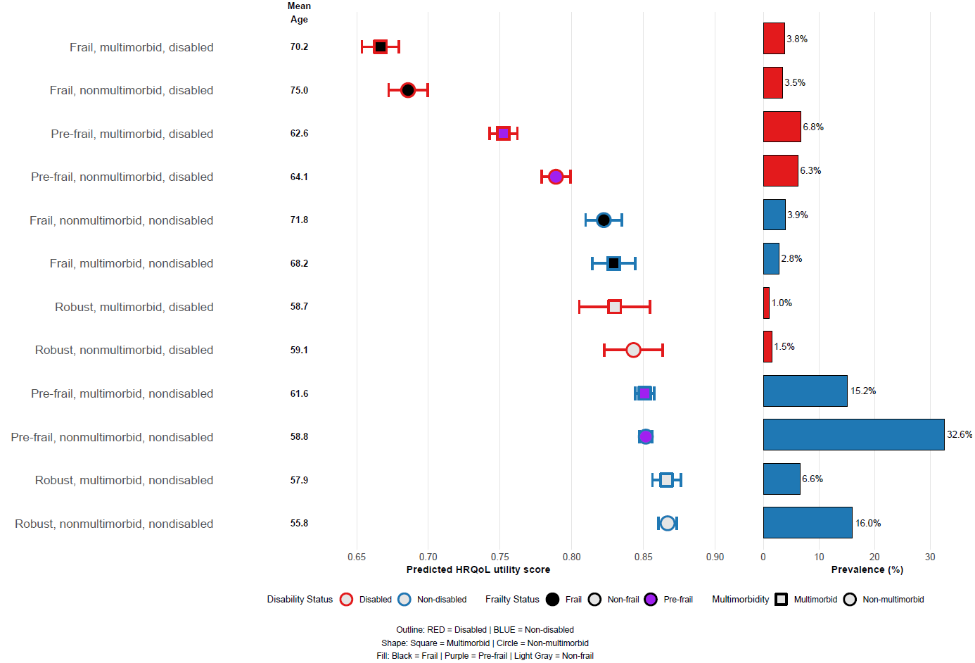

Supplementary Figure E: Associations between frailty, multimorbidity and disability overlaps and health-related quality of life utility scores by sex and age-group using the Ghanaian value set
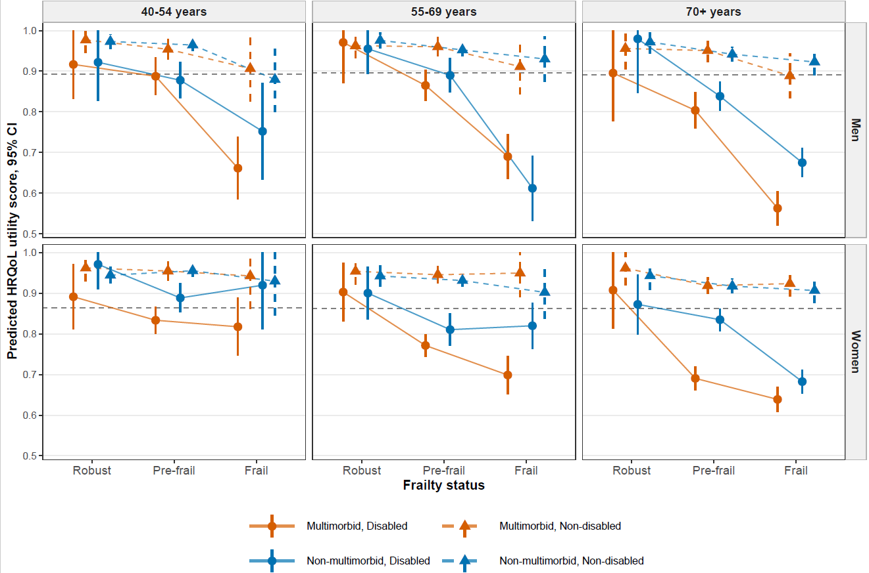

Supplementary Figure F: Associations between frailty, multimorbidity and disability overlaps and health-related quality of life visual analogue scale scores by sex and age group
