Supporting information
Low-Background 3D Bi₂WO₆ Enables In Situ Sulfidation-Induced Photocurrent Polarity Switching for Highly Selective Photoelectrochemical Detection of Sulfide Ions
Zi Min¹, Li Li¹, Chuanfa Luo, Chuchu Hu, Zihan Li, Yansha Gao*, Shaosheng Rao*, Li-Min Lu*
Key Laboratory of Modern Agricultural Equipment in Jiangxi Province, Key Laboratory of Chemical Utilization of Plant Resources of Nanchang, College of Chemistry and Materials, Jiangxi Agricultural University, Nanchang, Jiangxi, 330045, China
¹Zi Min and Li Li contributed equally to this work.
* Corresponding authors.
E-mail addresses: gaoyansha@126.com (Y. Gao), shaosheng_rao@163.com (S. Rao), lulimin816@126.com (L. Lu)

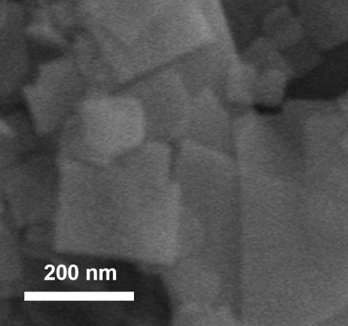
Figure S1. SEM images of the 2D Bi₂WO₆.

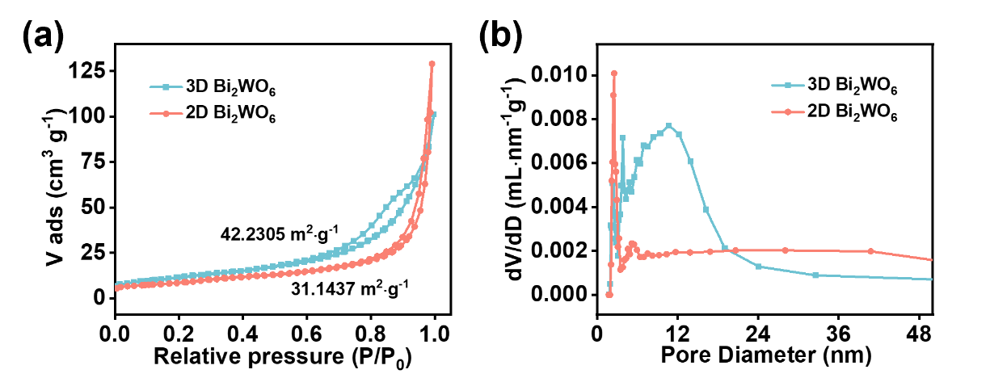
Figure S2. (a) N₂ adsorption–desorption isotherms, (b) pore-size distributions of 3D Bi₂WO₆ and 2D Bi₂WO₆.
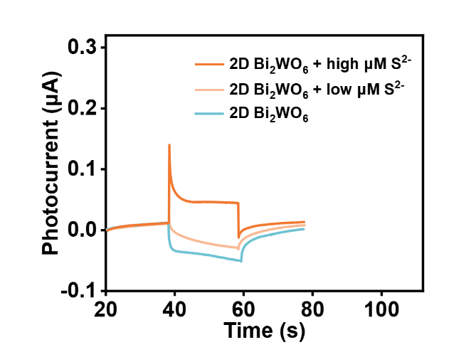
Figure S3. Photocurrent responses of 2D Bi₂WO₆, 2D Bi₂WO₆ with low μM S²⁻ and 2D Bi₂WO₆ with high μM S²⁻.

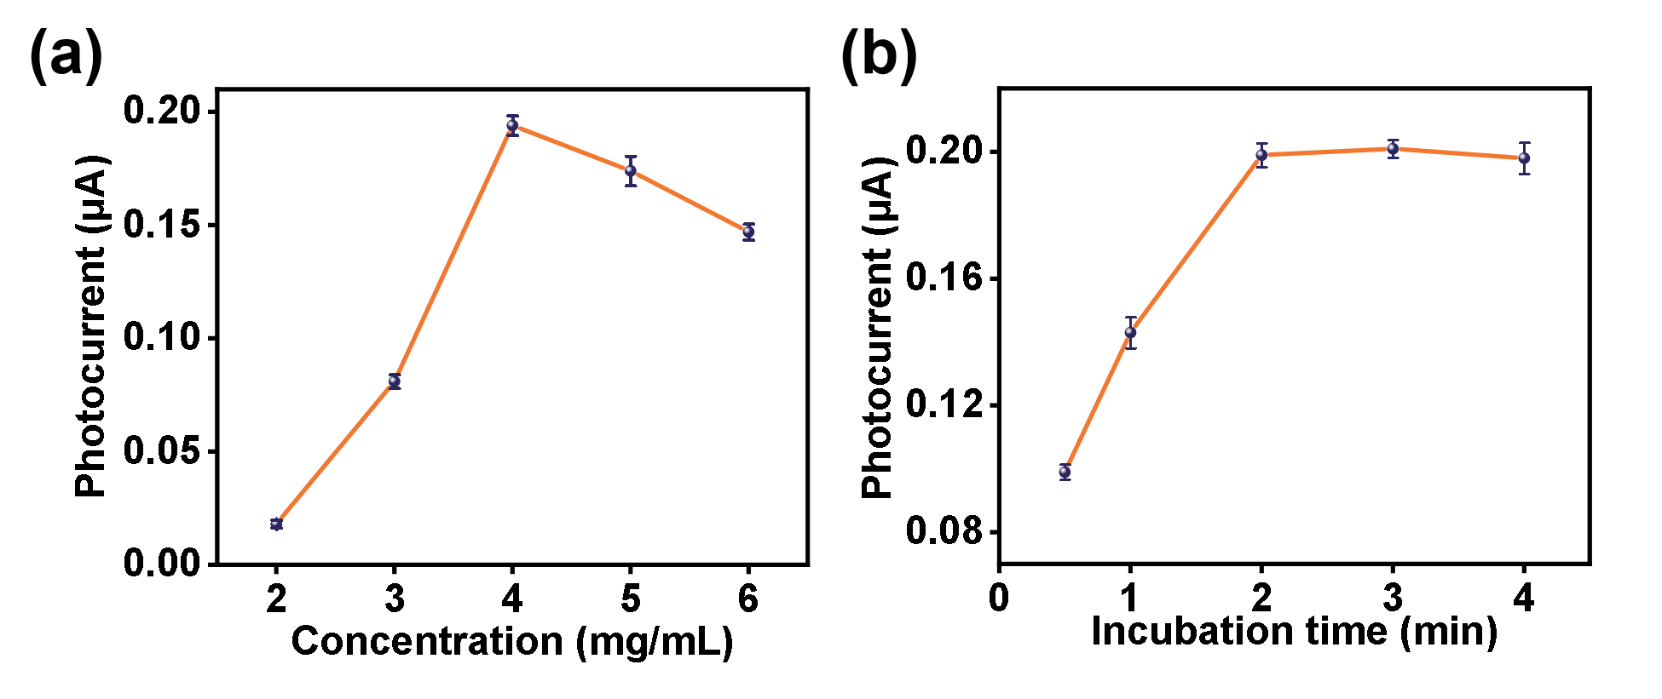
Figure S4. Effects of (a) 3D Bi₂WO₆ concentration and (b) incubation time with S²⁻ on the photocurrent response.

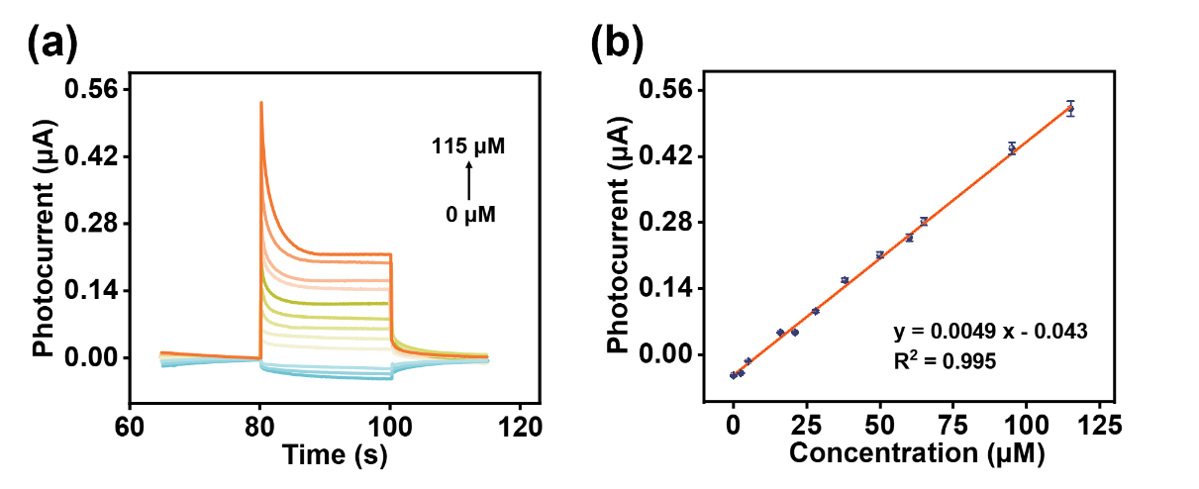
Figure S5. (a) Photocurrent responses of 2D Bi₂WO₆ modified electrode toward different S²⁻ concentrations. (b) Linear calibration between photocurrent response and concentration of S²⁻.

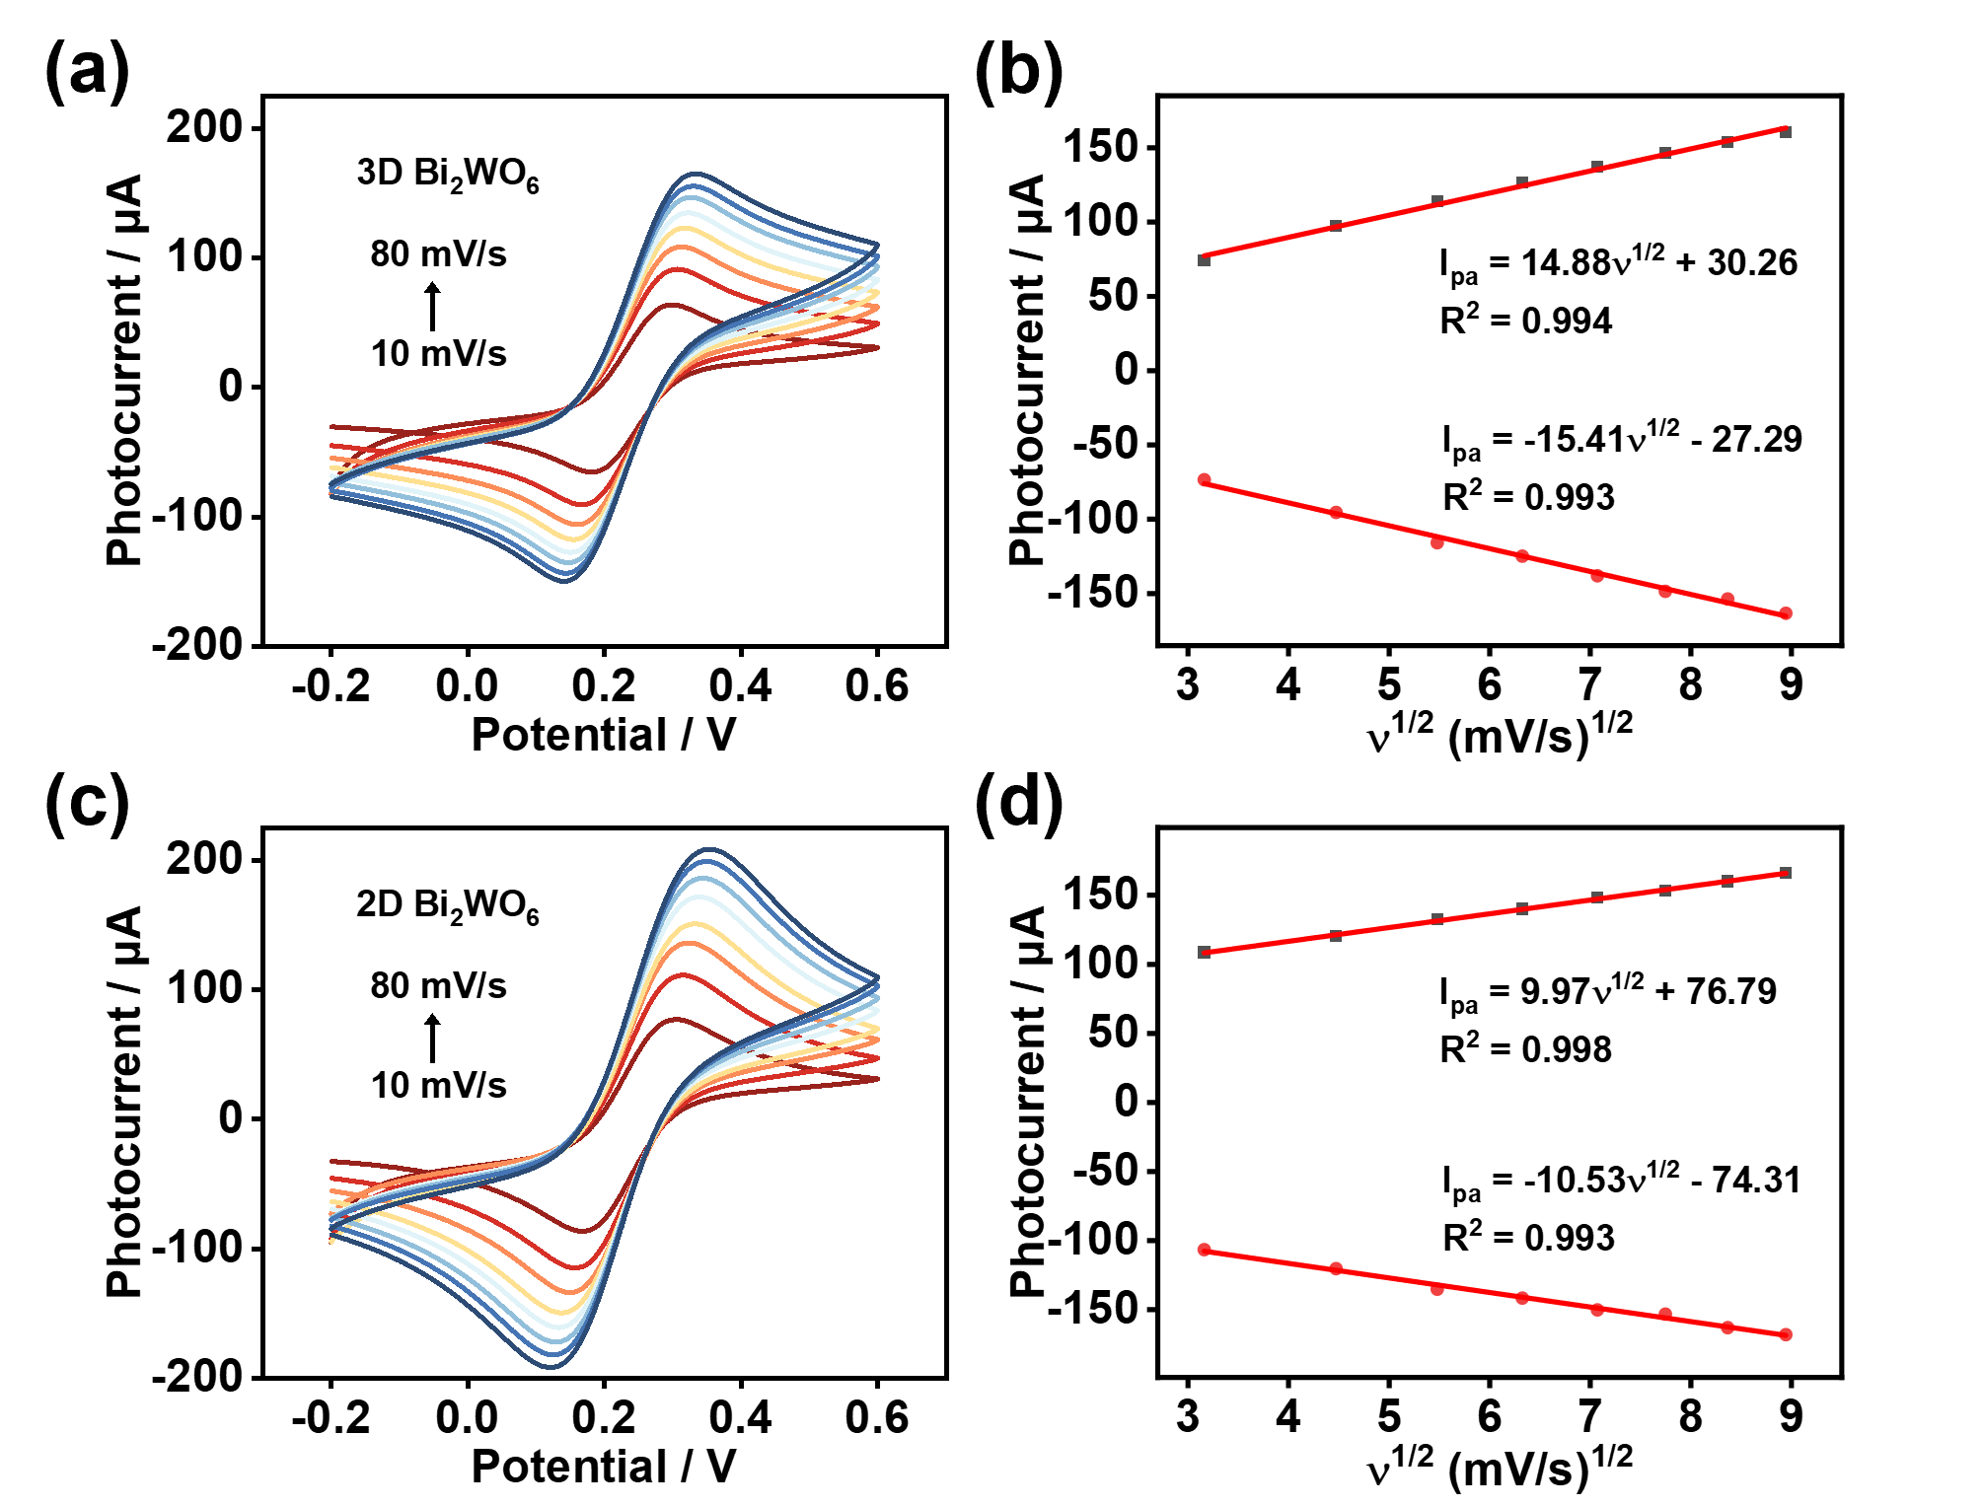
Figure S6. The cyclic voltammograms (CVs) plots of 3D Bi₂WO₆ (a) and 2D Bi₂WO₆ (c) in 0.1 M KCl containing 5.0 mM [Fe(CN)₆]^{3-/4-} at different scan rate (from 10 to 80 mV/s); Linear relationships of peak potential and logarithm of scan rate (b, d).

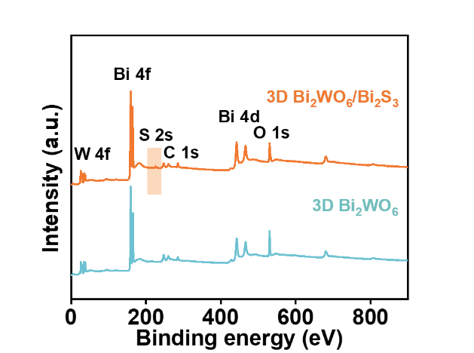
Figure S7. Full-scan XPS spectrum of 3D Bi₂WO₆/Bi₂S₃ and 3D Bi₂WO₆.

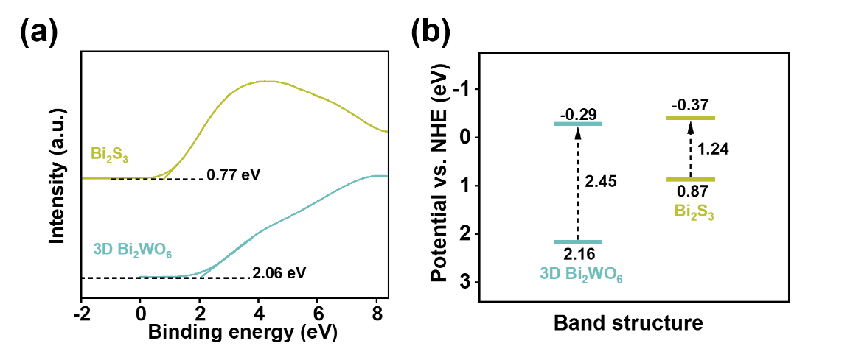
Figure S8. (a) Valence-band XPS spectra and (b) Band structures of 3D Bi₂WO₆ and Bi₂S₃ (potential vs. NHE).

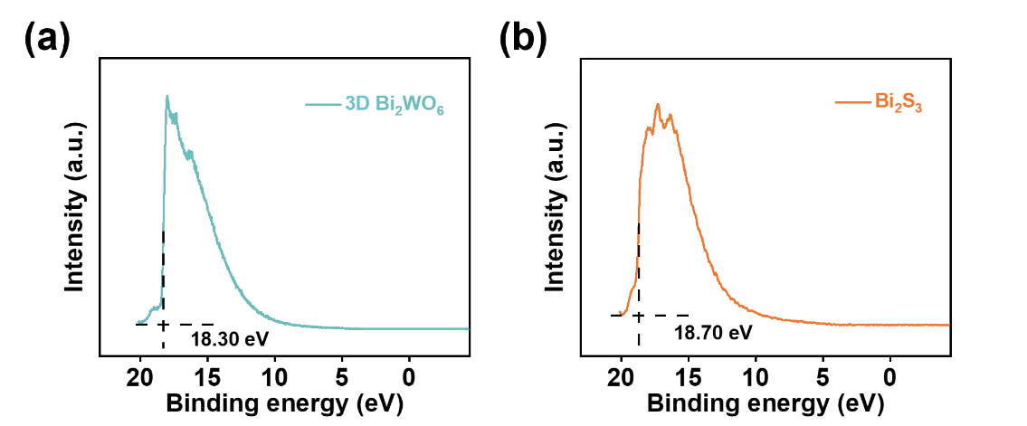
Figure S9. UPS spectra of 3D Bi₂WO₆ (a) and Bi₂S₃ (b).

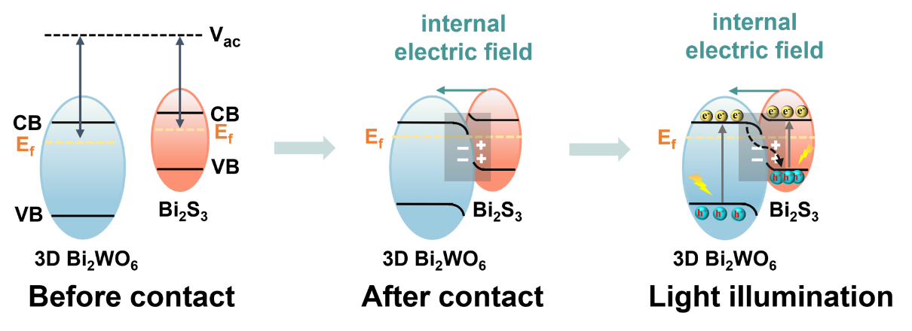
Figure S10. Schematic illustration of the charge transfer mechanism between 3D Bi₂WO₆ and Bi₂S₃, before and after contact, as well as that of 3D Bi₂WO₆/Bi₂S₃ under light illumination (V_{ac} and E_{f} stand for vacuum level and Fermi level, respectively).

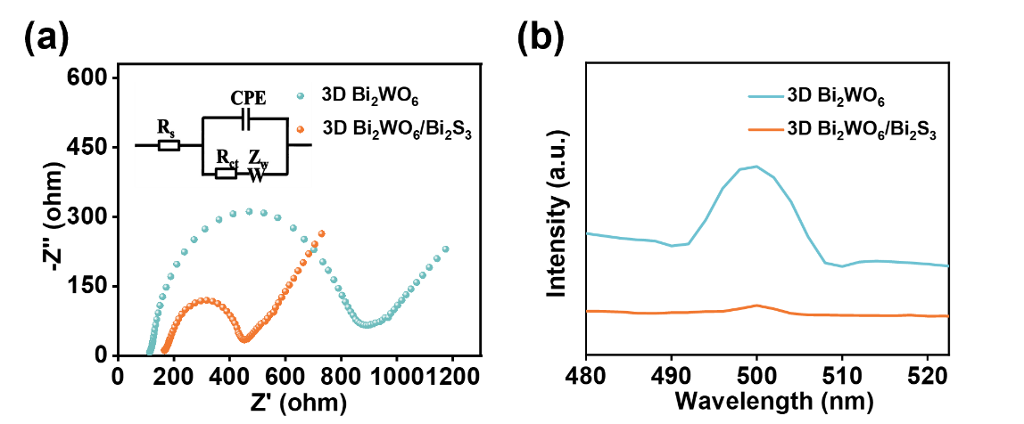
Figure S11. (a) EIS Nyquist curves, (b) PL spectra of 3D Bi₂WO₆, and 3D Bi₂WO₆/Bi₂S₃.

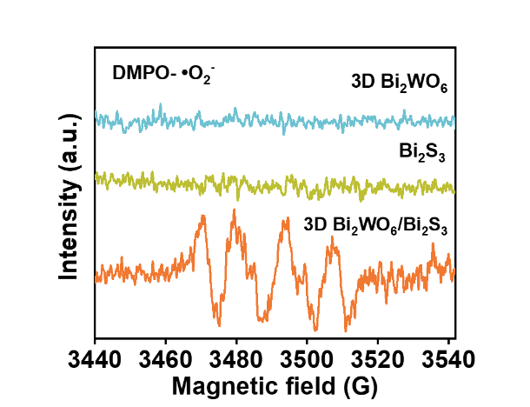
Figure S12. EPR spectra of DMPO-•O₂⁻ radicals for 3D Bi₂WO₆, Bi₂S₃, and 3D Bi₂WO₆/Bi₂S₃ under light illumination for 5 min.

Table S1. Comparison of the limit of detection (LOD) for S²⁻ detection between the proposed sensor and other reported methods.
Materials | Detection methods | Linear range | LOD | Ref
Functionalized CdS | Fluorometry | 3-56 μM | 6500 nM | [1]
ZAB-SPES | Electrochemistry | 5-1000 nM | 4000 nM | [2]
Lys-Ag NCs | Fluorometry | 5-100 μM | 1100 nM | [3]
APTMS/ITO | Electrochemistry | 30-1000 nM | 900 nM | [4]
Cu-HHTP@Zn-TCPP | PEC | 0.1-1500 μM | 620 nM | [5]
Ag | Colorimetry | 0.8-6.4 μM | 350 nM | [6]
ABTS-Au(III)system | Colorimetry | 0.5-15 μM | 280 nM | [7]
UiO-66-NH₂@NDBPA | Fluorometry | 0.1-900 μM | 120 nM | [8]
SiO₂@AgNCs | Fluorometry | 0-20 μM | 62 nM | [9]
THQ-L | Fluorometry | 20-70 μM | 38.3 nM | [10]
WO₃/Bi₂O₃ | PEC | 0.1-500 μM | 38 nM | [11]
MoS₂/g-C₃N₄ | Colorimetry | 0.1-10 μM | 37 nM | [12]
3D Bi₂WO₆ | PEC | 0.05-13 μM | 16 nM | This work

Table S2. Determination of S²⁻ in lake water, tap water, egg, milk and wine samples.
Sample | Add (µM) | Found (µM) | Recovery (%) | RSD (%)
Lake-water | 1 | 1.0203 | 102.03 | 2.17
 | 0.1 | 0.1028 | 102.80 | 1.78
 | 0.01 | 0.009897 | 98.97 | 2.22
Tap-water | 1 | 0.9852 | 98.52 | 3.56
 | 0.1 | 0.09795 | 97.95 | 1.86
 | 0.01 | 0.009923 | 99.23 | 2.63
Egg | 1 | 1.0120 | 101.20 | 1.46
 | 0.1 | 0.09824 | 98.24 | 2.38
 | 0.01 | 0.01025 | 102.50 | 3.52
Milk | 1 | 0.9874 | 98.74 | 1.82
 | 0.1 | 0.1016 | 101.60 | 2.74
 | 0.01 | 0.009683 | 96.83 | 3.85
Wine | 1 | 1.0150 | 101.50 | 1.68
 | 0.1 | 0.09753 | 97.53 | 2.95
 | 0.01 | 0.01042 | 104.20 | 3.62

Reference
- A. H. Gore, S. B. Vatre, P. V. Anbhule, S.-H. Han, S. R. Patil, G. B. Kolekar, Direct detection of sulfide ions [S²⁻] in aqueous media based on fluorescence quenching of functionalized CdS QDs at trace levels: analytical applications to environmental analysist, Analyst, 138 (2013) 1329-1333.
- J. Zhu, Y. Xiao, W. Hu, Q. Cui, Y. Yuan, X. Peng, W. Wen, X. Zhang, S. Wang, A portable self-powered electrochemical sensor based on zinc-air battery for detection of hydrogen sulfide, Anal. Chem., 96 (2024) 1852-1860.
- H. Sun, D. Lu, M. Xian, C. Dong, S. Shuang, A lysozyme-stabilized silver nanocluster fluorescent probe for the detection of sulfide ions, Anal. Methods-UK, 8 (2016) 4328-4333.
- M. A. Aziz, W. Mahfoz, M. Nasiruzzaman Shaikh, M. H. Zahir, A. Al-Betar, M. Oyama, D. Theleritis, Z. H. Yamani, Preparation of indium tin oxide nanoparticle-modified 3-aminopropyltrimethoxysilane-functionalized indium tin oxide electrode for electrochemical sulfide detection, Electroanal., 29 (2017) 1683-1690.
- H. Zhao, X. Li, K. Yu, H. Xu, Z. Zhang, H. Chai, M. Tian, L. Qu, X. Zhang, G. Zhang, A MOF-on-MOF based photoelectrochemical sensor for hydrogen sulfide detection in food quality assessment, Sens. Actuators B: Chem., 433 (2025) 137525.
- K. Shanmugaraj, M. Ilanchelian, Colorimetric determination of sulfide using chitosan-capped silver nanoparticles, Microchim. Acta, 183 (2016) 1721-1728.
- C. Chen, D. Zhao, L. Lu, F. Yang, X. Yang, A simple and rapid colorimetric sensor for sulfide anion detection based on redox reaction of ABTS with Au (III), Sens. Actuators B: Chem., 220 (2015) 1247-1253.
- Y. Ma, M. Li, G. Gao, S. Luo, Y. Cao, X. Qi, W. Zhang, B. Tang, Coordination compensated metal-organic framework fluorescent sensor for highly selective and sensitive dual-detection of phosphate and hydrogen sulfide, Sens. Actuators B: Chem., 409 (2024) 135621.
- X. Huang, S. A. Shahzad, Y. Li, Y. Zhang, L. Sang, H. Zhou, H. Jiang, K. K. Lo, C. Yu, Silver nanoclusters capped silica nanoparticles as a ratiometric photoluminescence nanosensor for the selective detection of I⁻ and S²⁻, Analytica Chimica Acta, 988 (2017) 74-80.
- K. Zhong, Y. He, L. Deng, X. Yan, X. Li, Y. Tang, S. Hou, L. Tang, A near-infrared fluorescent probe for H₂S based on tandem reaction to construct iminocoumarin-benzothiazole and its application in food, water, living cells, Anal. Chim. Acta, 1127 (2020) 49-56.
- J. Wang, J Chen, F. Liu, M. Jia, Z. Zhang, M. Liu, L. Jiang, Renewable WO₃/Bi₂O₃ heterojunction for photoelectrochemical and visual dual-mode detection of hydrogen sulfide, Sens. Actuators B Chem., 369 (2022) 132274.
- X. Liu, L. Huang, Y. Wang, J. Sun, T. Yue, W. Zhang, J. Wang, One-pot bottom-up fabrication of a 2D/2D heterojuncted nanozyme towards optimized peroxidase-like activity for sulfide ions sensing, Sens. Actuators B: Chem., 306 (2020) 127565.

