Appendix A. Supplementary data

Unraveling the spatial patterns and underlying mechanisms of flowering times in subtropical mountains of Jiangxi Province

Dongmin Shiª, Guojin Zhuª, Qing Yeª, Dagen Wangª, Yuting Zhangª, Prabin Bhandari^{b}, Xiaotao Songª, Kuiling Zuª*

ªJiangxi Provincial Key Laboratory of Conservation Biology, College of Forestry, Jiangxi Agricultural University, Nanchang, 330045, China

^{b}Department of Botany, Amrit Campus, Tribhuvan University, Kathmandu, 44600, Nepal

Corresponding author at: College of Forestry, Jiangxi Agricultural University, Nanchang 330045, China
E-mail address: kuiling010@163.com (Kuiling Zu)

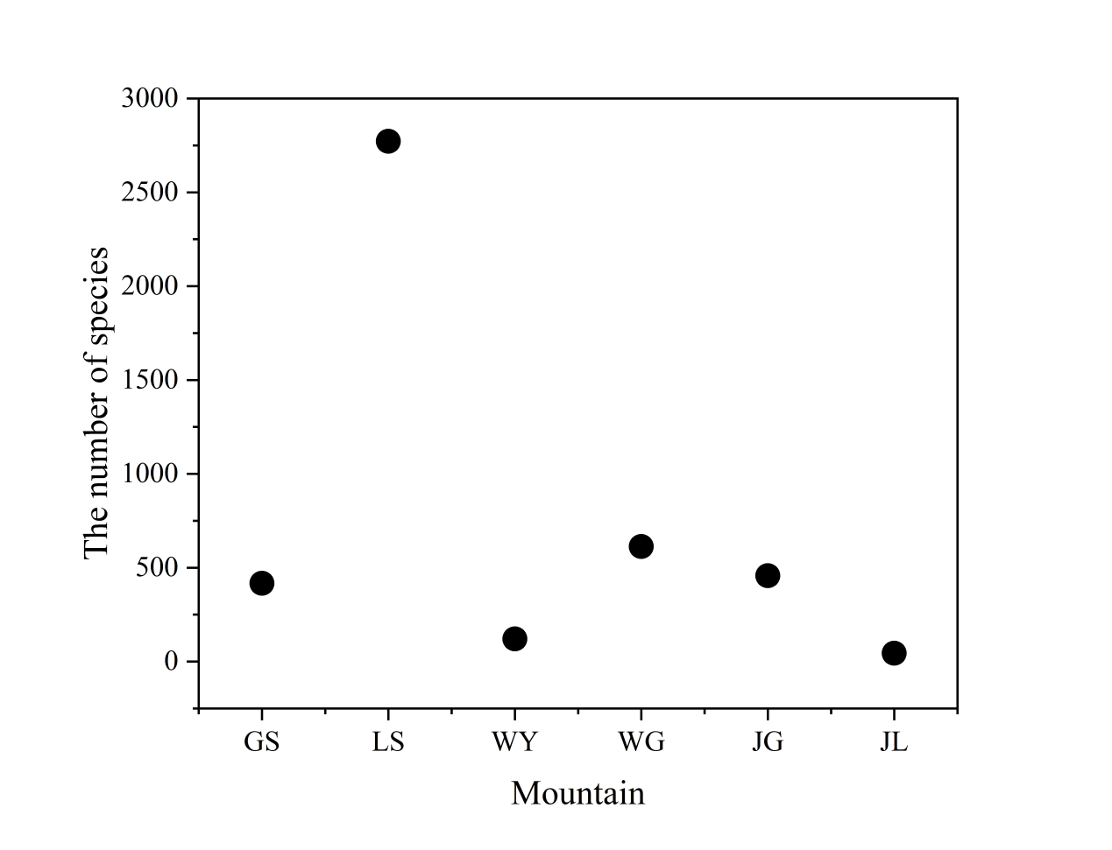
Fig. S1. Number of flowering species in each mountain range. GS (417), LS (2772), WY(121), WG (613), JG (457), JL (44).

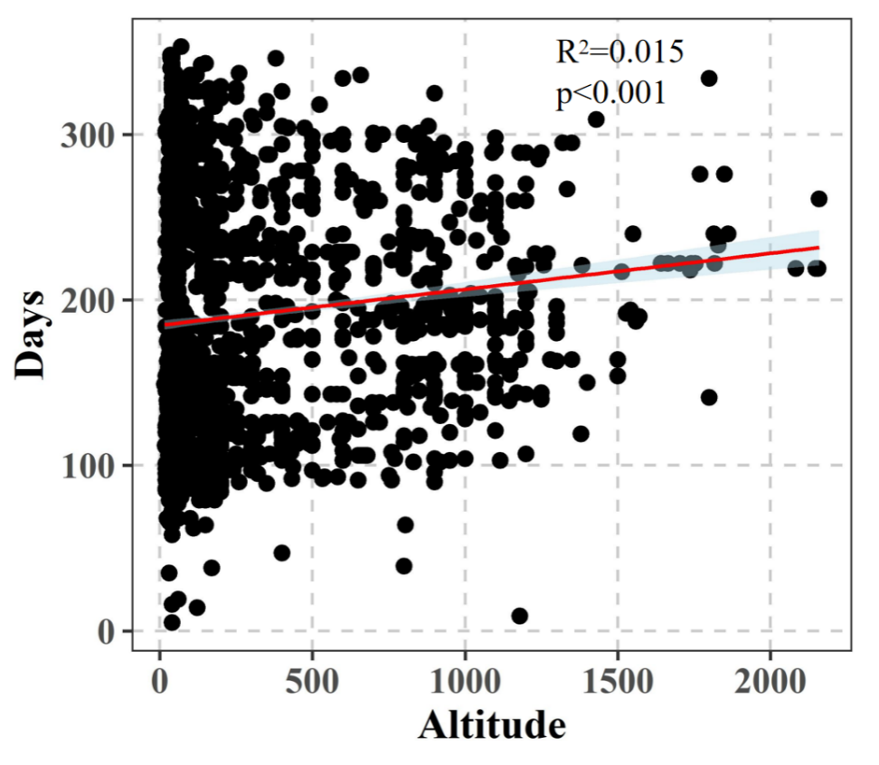
Fig. S2. Variation in plant flowering time along elevation gradients.
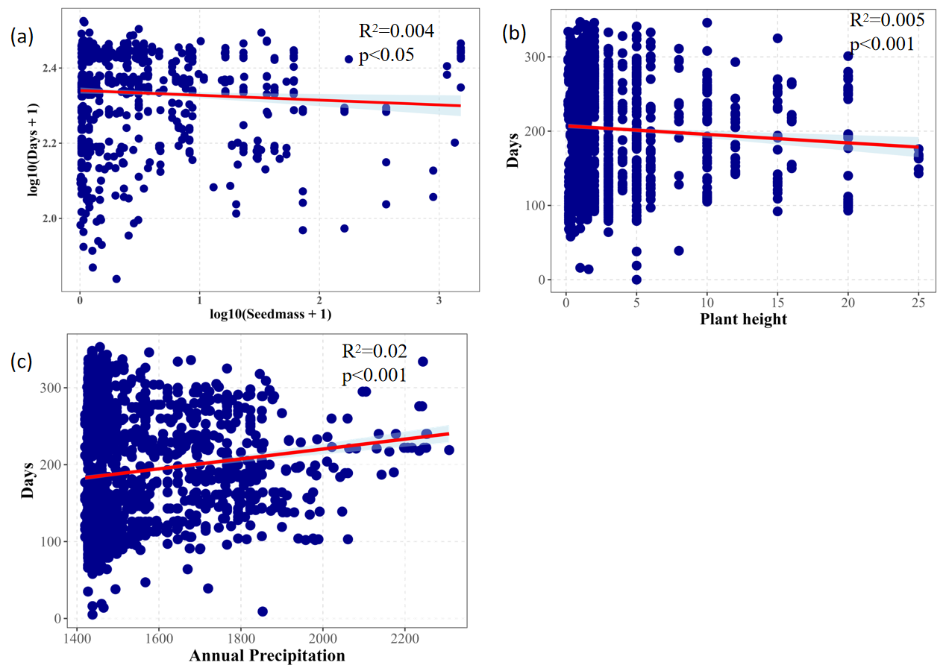
Fig. S3. Analysis of the relationships between seed mass, maximum plant height, annual precipitation, and flowering time.

Table S1. Plant functional traits used in this study

Type | The level of category
Life form | Herbs、Woody
Flower color | Yellow、White、Red、Purple、Green、Chartreuse、Blue
Fruit type | Utricle、Schizocarp、Pod、Drupe、Capsule、Berry、Achene
Dispersal | Animal、Wind、Unassist

Table S2. Average, median, standard deviation and sample size of flowering periods across low and high altitude zones in mountainous regions
Mountain | Altitude | Average Flowering Days | Median | Standard Deviation | Sample Size
GS | Low | 226 | 231 | 28.5 | 316
GS | High | 246 | 229 | 21.3 | 34
LS | Low | 181.38 | 156 | 74.1 | 2389
LS | High | 194.51 | 186 | 56.5 | 380
WG | Low | 217.27 | 216 | 5.92 | 179
WG | High | 177.31 | 219 | 89.0 | 10
WY | Low | 216.07 | 218 | 86.3 | 10
WY | High | 213.6 | 221 | 56.0 | 98
JG | Low | 221.30 | 237 | 41.2 | 72
JG | High | 201.12 | 196 | 47.3 | 218
JL | Low | 146.68 | 154 | 46.9 | 27
JL | High | 174.64 | 193 | 39.9 | 11

Table S3. Flowering period values for each habitat in the low-altitude section (0-600m)
Habitat | n | Mean  days | Median  days | Sd  days | Se  days | Cv  days | Sync  index
Hillside | 18 | 161 | 130 | 73.2 | 17.3 | 0.456 | 2.19
Hillfoot | 25 | 164 | 143 | 78.2 | 15.6 | 0.476 | 2.10
Watersie | 191 | 171 | 141 | 63.9 | 4.62 | 0.374 | 2.67
Field | 774 | 187 | 162 | 76.8 | 2.76 | 0.411 | 2.43
Meadow | 588 | 178 | 152 | 72.3 | 2.98 | 0.406 | 2.47
Forest  understory | 449 | 187 | 191 | 64.7 | 3.05 | 0.347 | 2.88
Special landforms | 8 | 191 | 195 | 73.4 | 26.0 | 0.384 | 2.60
Bushwood | 440 | 195 | 184 | 70.2 | 3.34 | 0.360 | 2.78
Roadside | 292 | 205 | 216 | 60.36 | 3.53 | 0.295 | 3.39
Valley | 138 | 222 | 229 | 30.4 | 2.59 | 0.137 | 7.30

Habitat refers to the environmental type; n is the sample size; Mean days is the arithmetic mean of flowering time; Median days is the median flowering time; Sd days is the standard deviation of flowering time; Se days is the standard error of the mean; Cv days is the coefficient of variation; and Sync index is the synchrony index.
Table S4. Flowering period values for each habitat in the high-altitude section (>600m)
Habitat | n | Mean  days | Median  days | Sd  days | Se  days | Cv  days | Sync  index
Field | 7 | 188 | 157 | 65.2 | 24.6 | 0.346 | 2.898
Bushwood | 83 | 184 | 161 | 50.4 | 5.53 | 0.273 | 3.66
Forest understory | 214 | 200 | 196 | 56.6 | 3.87 | 0.283 | 3.54
Special landforms | 20 | 207 | 221 | 43.8 | 9.79 | 0.212 | 4.72
Meadow | 107 | 209 | 198 | 56.0 | 5.42 | 0.268 | 3.73
Roadside | 37 | 214 | 219 | 68.9 | 11.3 | 0.321 | 3.11
Water side | 26 | 216 | 224 | 61.3 | 12.0 | 0.284 | 3.52
Hillside | 24 | 217 | 234 | 63.8 | 13.0 | 0.294 | 3.40
Valley | 15 | 229 | 229 | 66.7 | 17.2 | 0.292 | 3.43

Table S5. Mean Squared Error Results and Significance of the Random Forest Model for Biotic and Abiotic Factors Affecting Plant Flowering Time
Name |  | X.IncMSE | X.IncMSE.pval | IncNodePurity | IncNodePurity.pval | Label
Life.form | 7.838 |  | 0.04 | 4207.402 | 0.149 | *
Min.Temperature.Coldest.Month | 16.04 |  | 0.02 | 11878.243 | 0.03 | *
Dispersal | 16.61 |  | <0.01 | 14725.856 | 0.03 | **
Fruit.type | 18.176 |  | <0.01 | 21456.128 | 0.02 | **
Max.Temperature.Hottest.Month | 18.231 |  | 0.04 | 18649.833 | 0.644 | *
Mean.Temperature | 18.329 |  | <0.01 | 17329.764 | 0.06 | **
Flower.color | 20.317 |  | <0.01 | 32460.406 | <0.01 | **
Annual.Precipitation | 23.447 |  | <0.01 | 55584.066 | 0.198 | **
Plant.height | 25.54 |  | <0.01 | 53424.984 | <0.01 | **
Seedmass | 41.58 |  | <0.01 | 109501.499 | <0.01 | **

Table S6. Construct a null model to generate random predictions of plant flowering time for comparison with observed flowering times.
Mountain | T statistic | P value
GS | 1.86 | P<0.01
LS | -0.06 | P<0.05
WG | 0.20 | P<0.001
WY | -0.30 | P<0.001
JG | -1.53 | P<0.01
JL | -0.90 | P<0.001

