Supplementary Figures
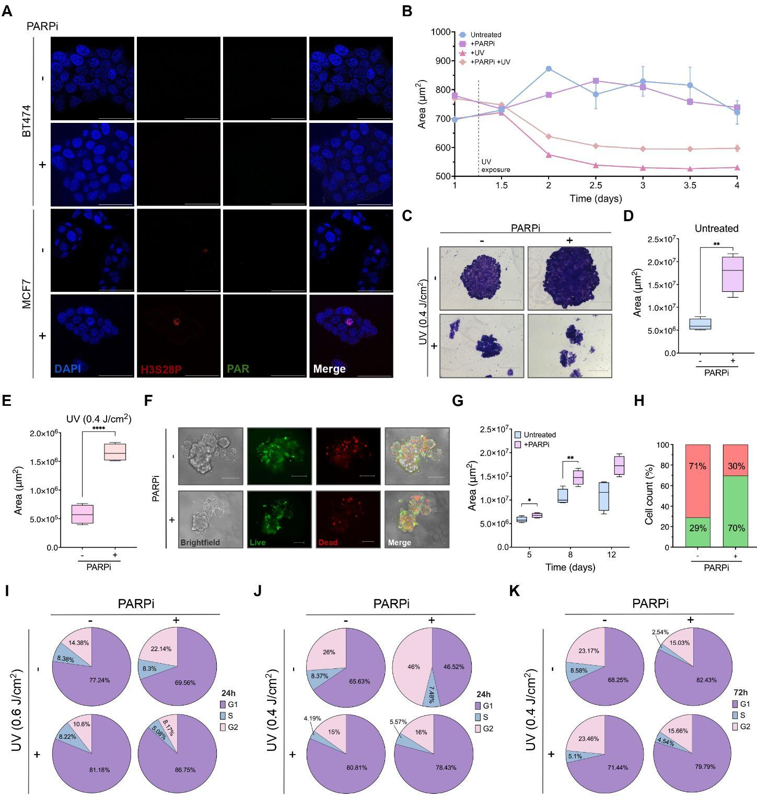
Supplementary Figure 1: Combined UV damage and PARP inhibition impair proliferation and survival in MCF7 cells. A. Representative immunofluorescence images showing serine 28 phosphorylation (red) and PAR (green) protein expression in BT474 and MCF7 cells treated with PARPi. Nuclei were stained with DAPI (blue). Scale bar, 50 μm. B. Cell proliferation of MCF7 cells monitored over time using the IncuCyte® Live Cell Analysis System following treatment with PARPi, UV irradiation or their combination. Two-way ANOVA statistical analysis was performed and significant differences between all groups were represented as # (p-value <0.0001). C. Representative colony formation images of MCF7 cells under the indicated experimental conditions. Scale bar, 300 μm. D. Box plot quantifying single-colony area in control vs PARPi-treated MCF7 cells. Statistical analysis was performed using Student’s t-test and p-values represented as ** (p <0.005). E. Box plot comparing colony area in PARPi-treated cells vs cells treated with PARPi combined with UV irradiation. Statistical analysis was performed using Student’s t-test and p-values represented as **** (p <0.0001). F Representative brightfield and fluorescence images of MCF7 spheroids showing live (GFP, in green) and dead (RFP, red) cells following PARPi treatment. Scale bar, 200 μm. G. Box plot quantifying spheroid area in untreated and PARPi-treated MCF7 cells over time. Statistical analysis was performed using Student’s t-test and p-values represented as * (p <0.05) and ** (p <0.005). H. Bar graph showing the percentage of live (green) and dead (red) cells quantified from spheroids in panel F. I. Pie charts showing the distribution of BT474 cells across cell cycle phases (G0/G1, purple; S, blue; G2/M, pink) 24 h after treatment. J-K. Pie charts showing the distribution of MCF7 cells across cell cycle phases (G0/G1, purple; S, blue; G2/M, pink) 24 h (J) and 72 h (K) after treatment.

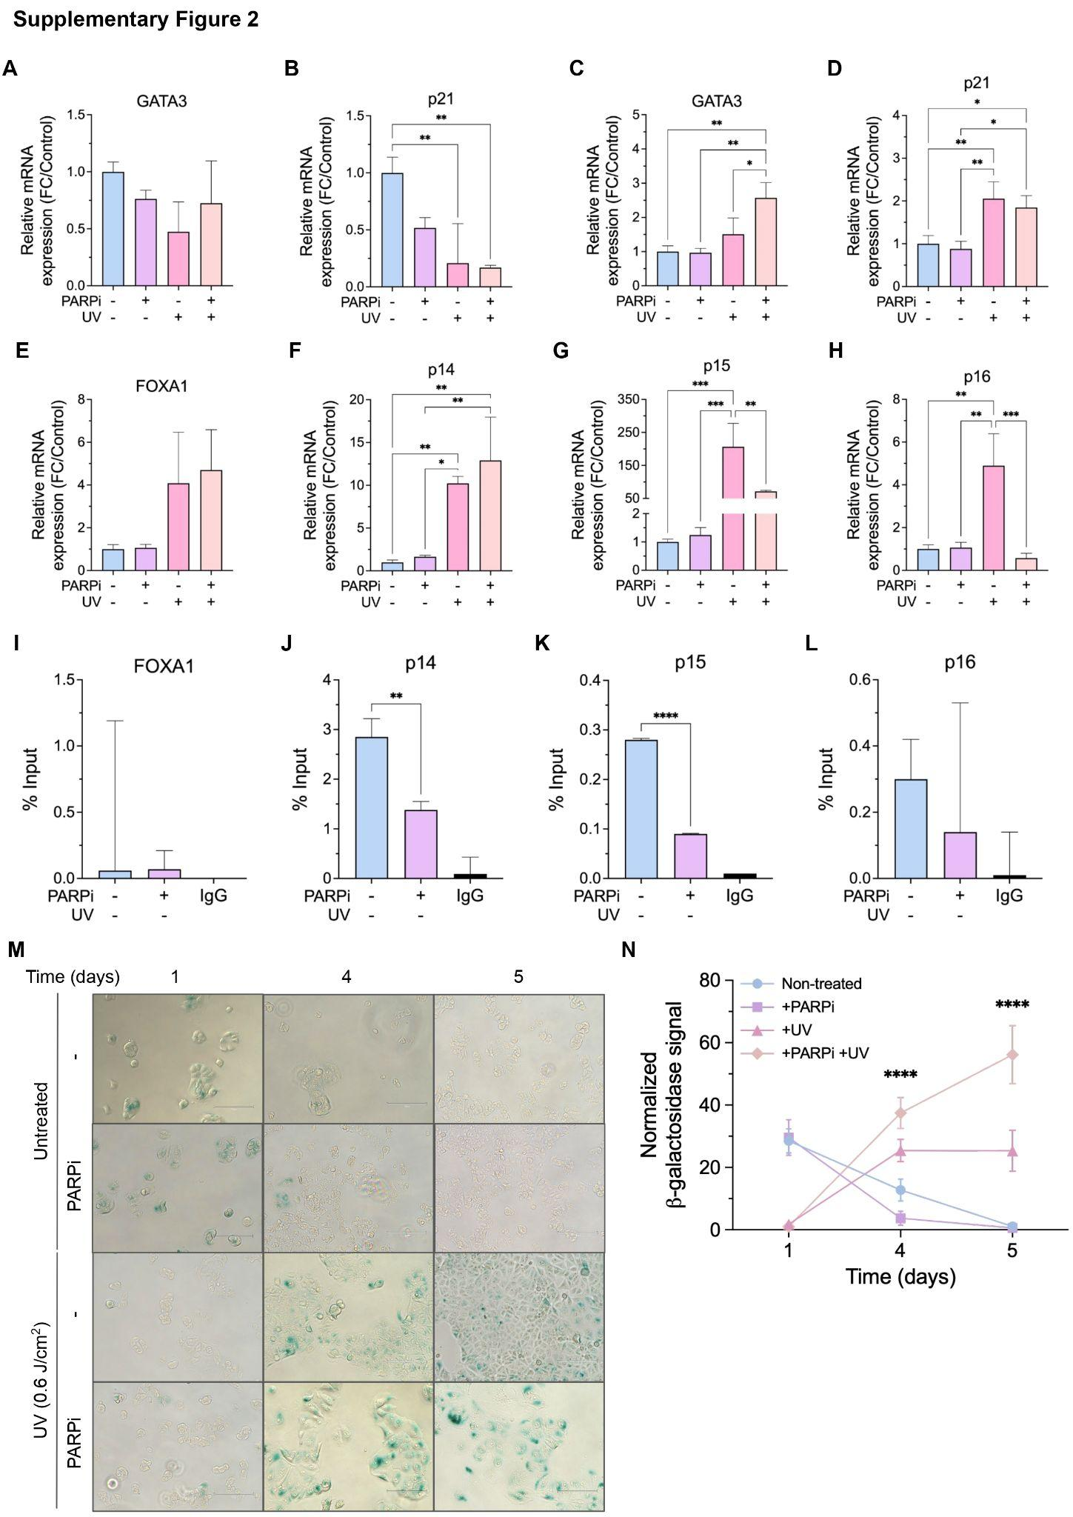
Supplementary Figure 2: H3S28 phosphorylation correlates with senescence gene transcription and promoter occupancy. A-H. Relative mRNA expression analysis by RT-qPCR. (A–B) Expression of GATA3 (A) and p21 (B) in BT474 cells. (C–H) Expression of GATA3 (C), p21 (D), FOXA1 (E), p14 (F), p15 (G), and p16 (H) in MCF7 cells. Cells were treated with control, PARPi, UV irradiation or the combination of UV + PARPi. Expression levels were normalized to GAPDH housekeeping gene. One-way ANOVA statistical analysis was performed and p-values represented as * (p <0.05), ** (p <0.005) and *** (p <0.0005). I-L. ChIP-qPCR analysis of H3S28 phosphorylation enrichment at the promoter regions of FOXA1 (I), p14 (J), p15 (K) and p16 (L) in untreated BT474 cells or treated PARPi. Data is presented as a percentage of input chromatin. IgG immunoprecipitation was included as a negative control. One-way ANOVA statistical analysis was performed and p-values represented as ** (p <0.005) and **** (p <0.0001). M. Representative brightfield images of MCF7 cells under the indicated experimental conditions at different timepoints for ꞵ-galactosidase staining (blue) to assess senescence. Scale bar, 150 μm. N. Quantification of normalized ꞵ-galactosidase signal over time in MCF7 cells under the indicated experimental conditions. Two-way ANOVA statistical analysis was performed and p-values represented as **** (p <0.0001).

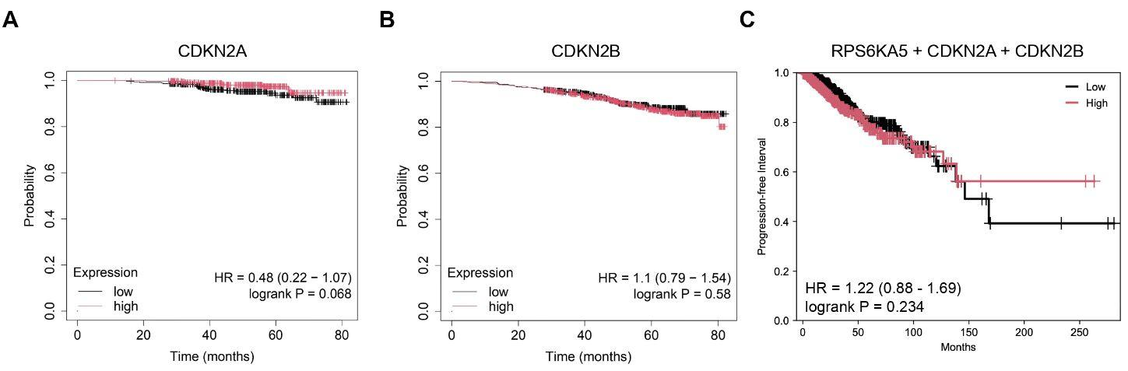
Supplementary Figure 3: Overall survival and progression-free survival of HR+ breast cancer patients stratified by gene expression. A. Kaplan-Meier OS curves for HR⁺ breast cancer patients with low (black) or high (red) CDKN2A (p14/p16) expression treated with chemotherapy and hormone therapy. Survival curves were generated using the Kaplan-Meier Plotter. B. Kaplan-Meier OS curves for HR⁺ breast cancer patients with low (black) or high (red) CDKN2B (p15) expression treated with chemotherapy and hormone therapy. Survival curves were generated using the Kaplan-Meier Plotter. C. Kaplan-Meier progression-free survival curves for HR⁺ breast cancer patients stratified by low (black) or high (red) expression of the gene signature (RPS6KA5 + CDKN2A + CDKN2B) generated using GEPIA3.

Supplementary Tables
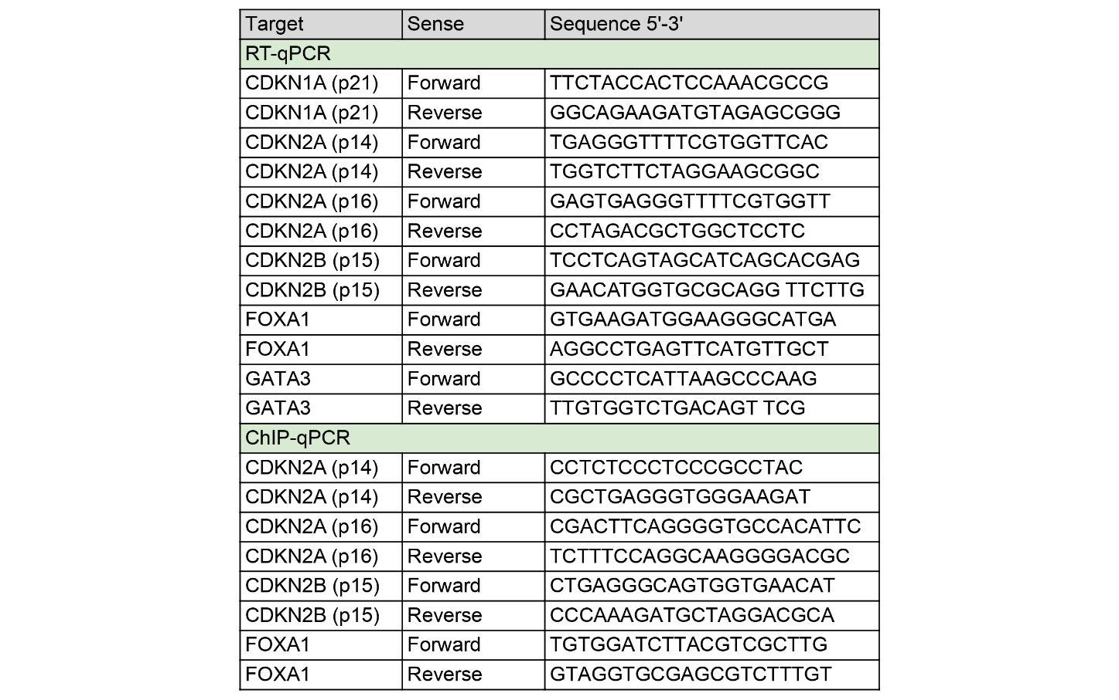
Supplementary Table 1. Primer sequences used for RT-qPCR and ChIP-qPCR analysis. This table includes both forward and reverse primers and each primer sequence is provided in the 5'-3' direction.

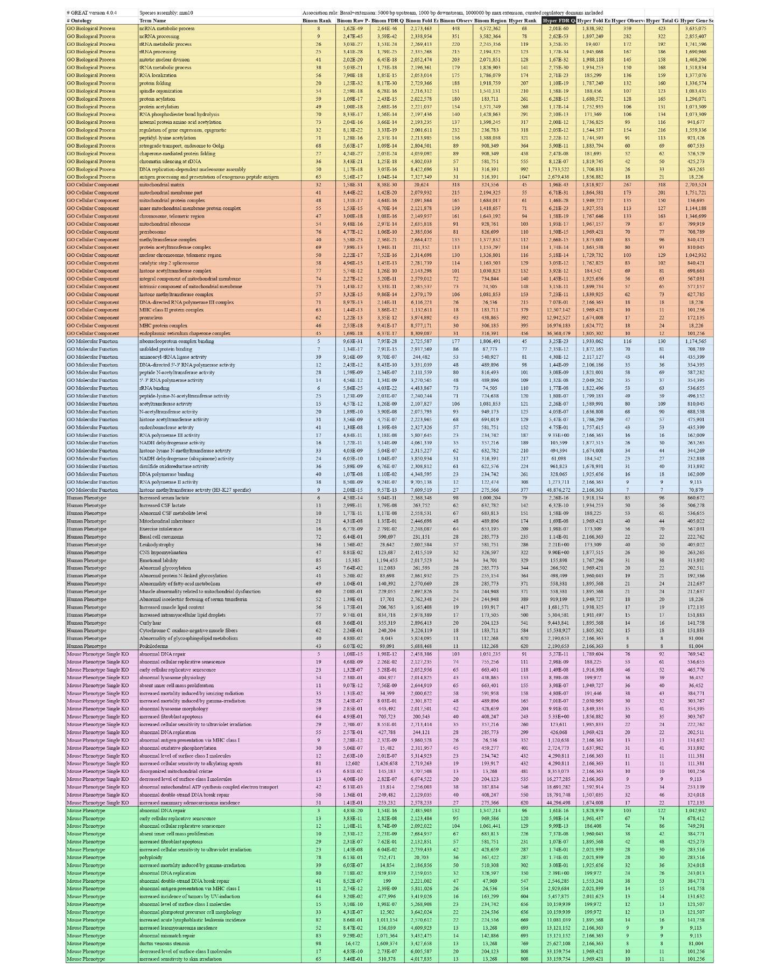
Supplementary Table 2. Functional enrichment analysis of H3S28ph-associated genomic regions using GREAT. Gene Ontology analysis was performed on H3S28ph ChIP-seq peaks using the GREAT tool [19] with default parameters. Peaks were associated with nearby genes based on GREAT-defined regulatory domains. Enriched terms are grouped by ontology categories, including Biological Process, Cellular Component, Molecular Function and Mouse Phenotype, and are ranked according to significance (Hyper FDR Q-value).

