Supplementary Information for “Large-scale Domain Engineering in Two-Dimensional Ferroelectric CuInP₂S₆ via Giant Flexoelectric Effect”
Chen Chen^{1,2,} #, Heng Liu^{1,2, #}, Qinglin Lai^{1,2, #}, Xiaoyu Mao^{1,2}, Jun Fu^{1,2}, Zhaoming Fu^{3,4, *}, and Hualing Zeng^{1,2, *}

- International Center for Quantum Design of Functional Materials (ICQD), Hefei National Laboratory for Physical Science at the Microscale, University of Science and Technology of China, Hefei, Anhui 230026, People's Republic of China
- Key Laboratory of Strongly-Coupled Quantum Matter Physics, Chinese Academy of Sciences, Department of Physics, University of Science and Technology of China, Hefei, Anhui 230026, People's Republic of China
- College of Physics and Electronic Information, Yunnan Normal University, Kunming 650500, China
- Yunnan Key Laboratory of Opto-Electronic Information Technology, Kunming 650500, China
# Contribute equally to this work
* Corresponding author

Supplementary note 1: First-principle calculation methods
All calculations are performed by Vienna Ab initio Simulation Package (VASP) package^{1, 2}. The Perdew-Burke-Ernzerhof (PBE) functional^{3, 4} and projector augmented wave (PAW) method⁵ were respectively used to describe the correlation-exchange interaction and ion-electron interactions. The cut-off energy for the plane-wave basis set was 500 eV. The convergence criteria of energy and force were 1×10−6 eV and 0.02 eV/Å respectively. The climbing image nudged elastic band method (CI-NEB) is employed to identify the transition state⁶. The monolayer CIPS is simulated using a 1×8 supercell. The sampling in wave-vector space was performed with Monkhorst-Pack grids of 6×1×1. To investigate the bending strain, we construct a periodic corrugated structure (See Fig.4a inset). The degree of bending strain is controlled by changing the scale factors (λ) of supercell size, which is defined by the formula λ=1-t/l₀. Herein, the l₀ is the length of flat supercell, and t is the length of corrugated supercell including the same number of unit cells (See the inset in Fig.5c). It is found that, in this way, the stable corrugated structures can be obtained through structural relaxation of all atoms. For our modeling, it is not necessary to fix any atoms for preserving the corrugated configurations. We used the DFT-D3 method⁷ to check the effects of van der Waals (vdW) interactions on the calculated results. It is found that vdW correction does not affect our conclusions.

Supplementary figures
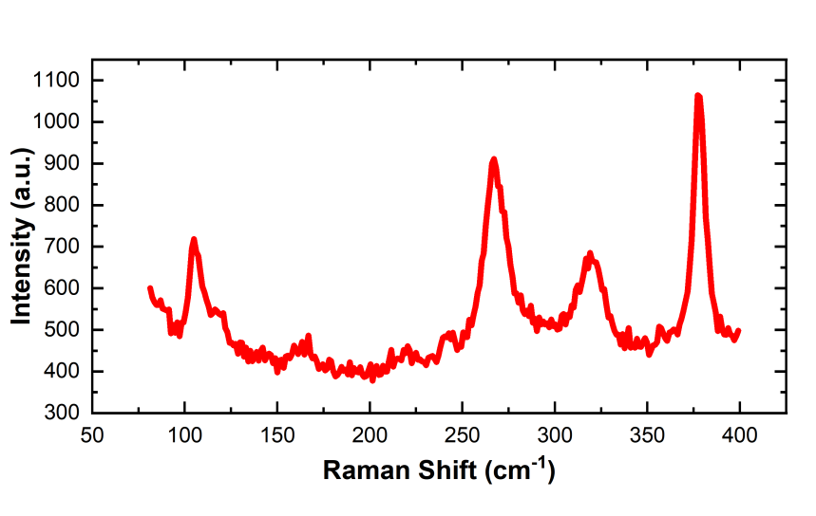
Fig. S1 Raman spectrum of the CIPS flake on the SiO₂/Si substrate.

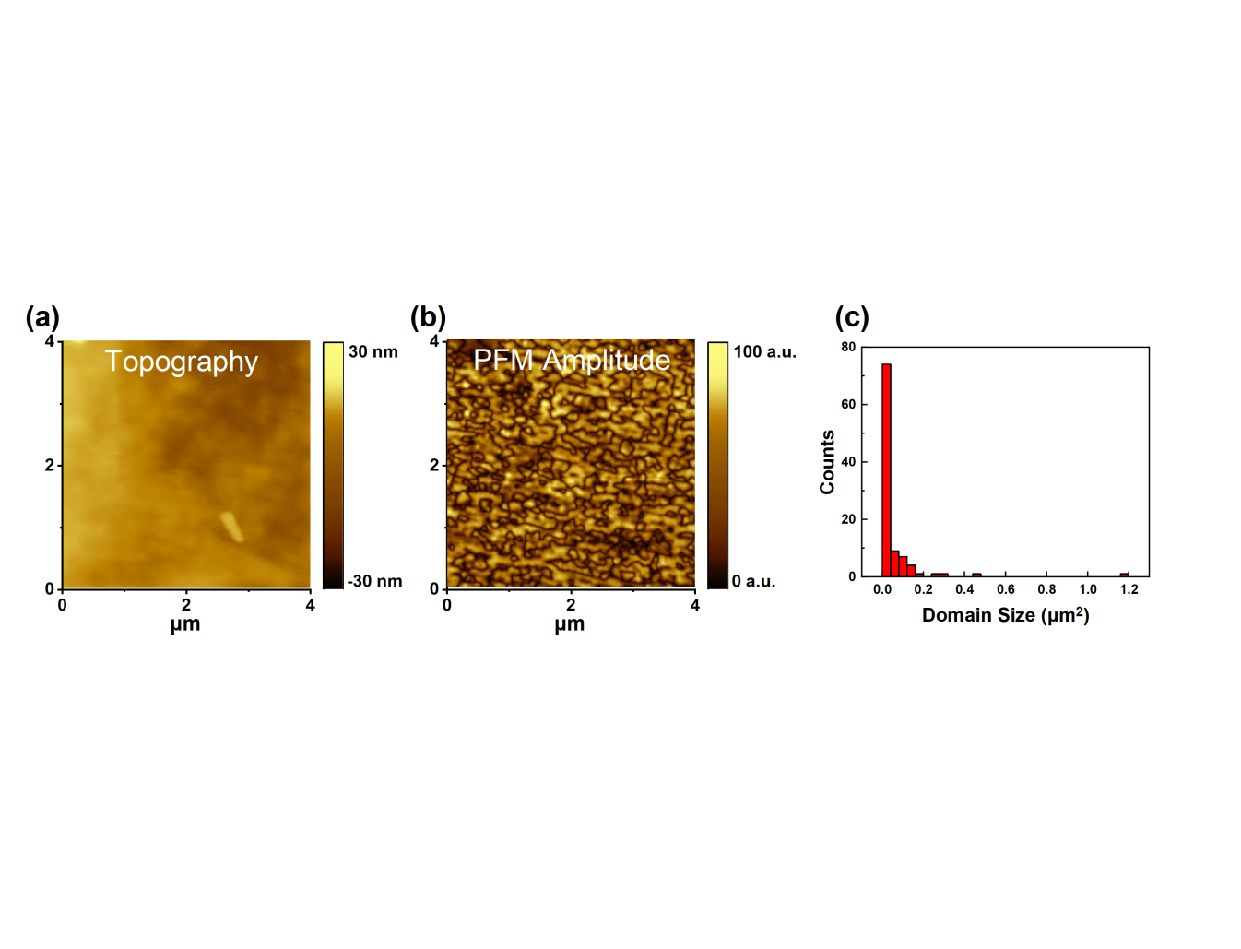
Fig. S2. The corresponding (a) topography image and (b) PFM amplitude image for the sample shown in Fig. 1c. (c) Histogram of domain sizes in the corresponding regions.

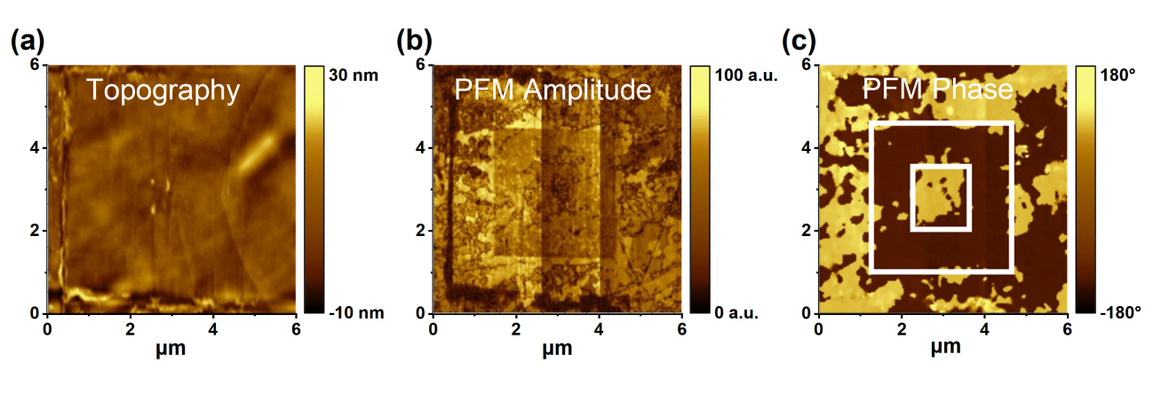
Fig. S3 Domain engineering in CIPS via electric poling. (a) The topography image, (b) PFM amplitude image, and (c) PFM phase image after electric poling. The applied tip bias is ±7V. The electric written area is indicated by the box-in-box pattern in white.

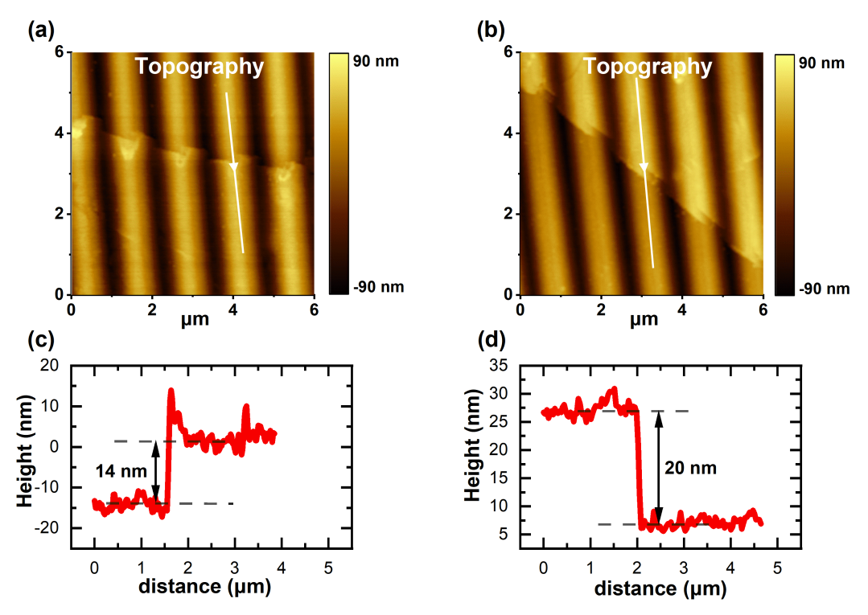
Fig. S4 Thickness characterization of the large scale CIPS flakes shown in Fig.2b. The topography images (a) & (b) and the selected line profile of height (c) & (d) for the thinnest area and the thickest area, respectively.

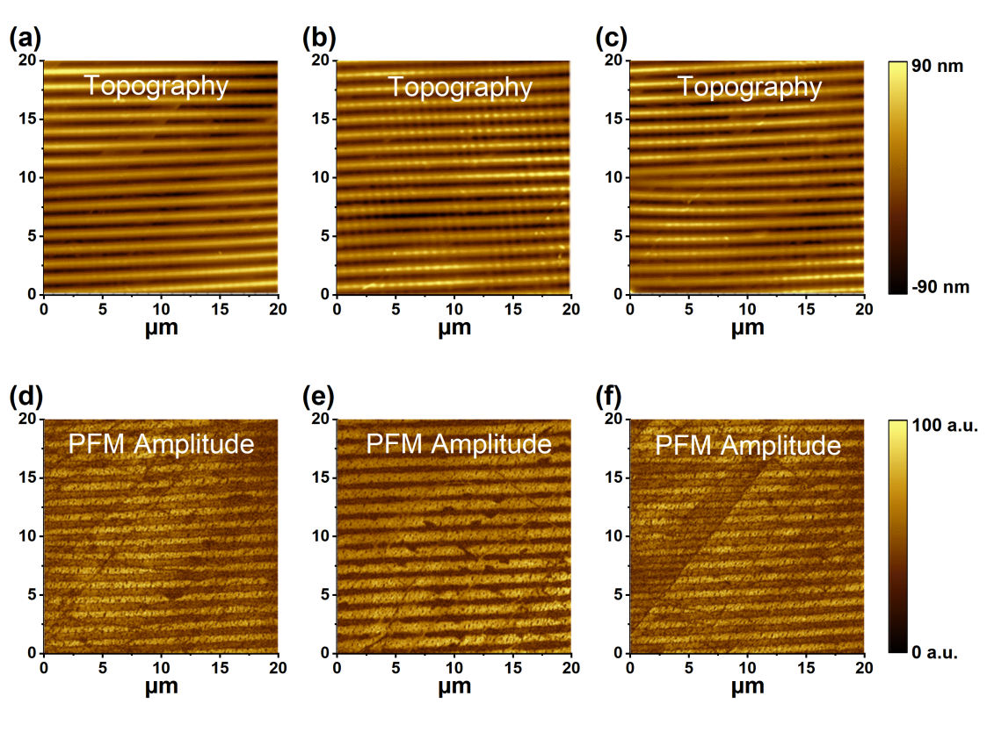
Fig. S5 (a)-(c) The corresponding topography images and (d)-(f) PFM amplitude images of green, black, and blue regions in Fig.2b.

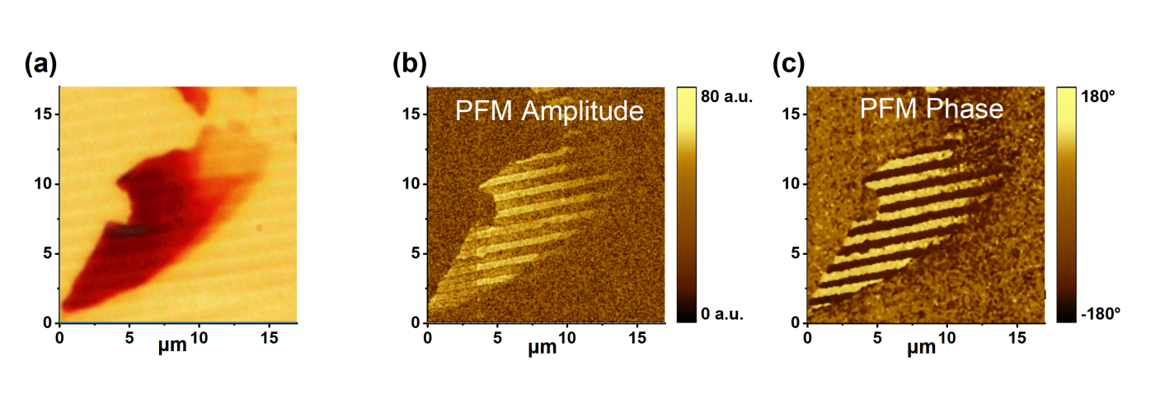
Fig. S6 (a) The optical image of the sample in Fig. 3a. (b) The corresponding PFM amplitude image and (c) PFM Phase image.

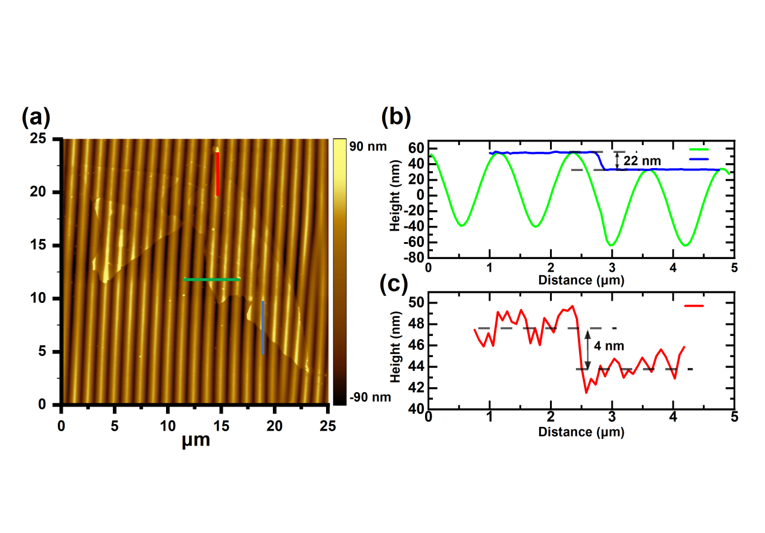
Fig. S7 (a) AFM topography image for the sample shown in Fig. 3a under tapping mode. (b) Selected line profiles of height as indicated by the blue, green, and red lines in (a).

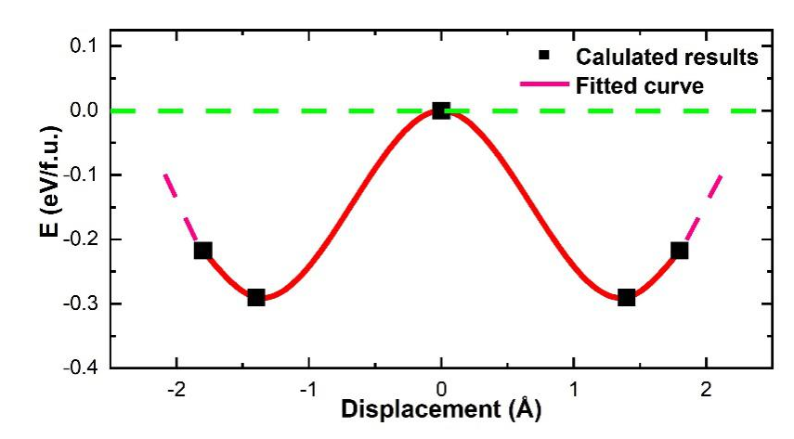
Fig. S8 Calculated potential energy profiles (PEP) with symmetric double-well potential for the flat CIPS.

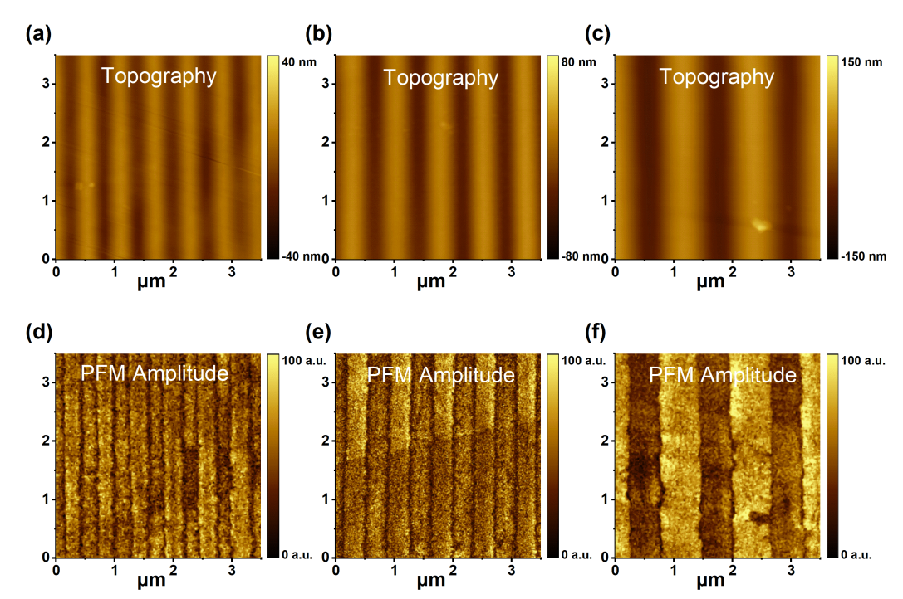
Fig. S9 Topography images (a)-(c) and PFM amplitude images (d)-(f) for the stripe domains with varied periodicities as shown in Fig. 5

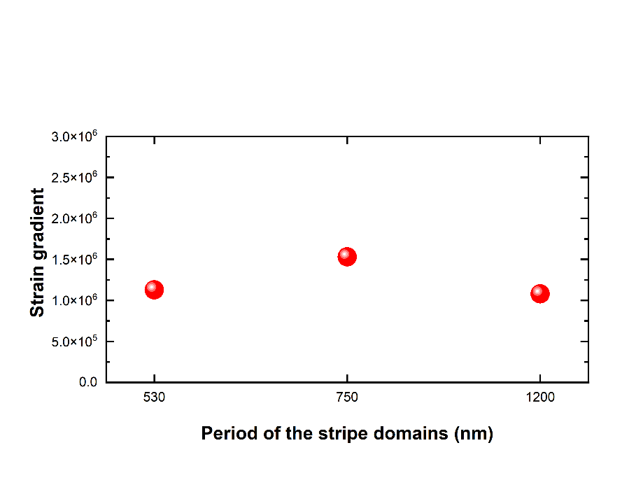
Fig. S10 Statistics of the strain gradients in stripe domains with varied periodicities shown in Fig. 5.

Reference
1. Kresse G, Furthmuller J. Efficient iterative schemes for ab initio total-energy calculations using a plane-wave basis set. Physical Review B 54, 11169-11186 (1996).
2. Kresse G, Hafner J. Abinitio molecular-dynamics for liquid-metals. Physical Review B 47, 558-561 (1993).
3. Blochl PE. Projector augmented-wave method. Physical Review B 50, 17953-17979 (1994).
4. Perdew JP, Zunger A. Self-interaction correction to density-functional approximations for many-electron systems. Physical Review B 23, 5048-5079 (1981).
5. Perdew JP, et al. Restoring the density-gradient expansion for exchange in solids and surfaces. Physical Review Letters 100, 136406 (2008).
6. Henkelman G, Uberuaga BP, Jonsson H. A climbing image nudged elastic band method for finding saddle points and minimum energy paths. Journal of Chemical Physics 113, 9901-9904 (2000).
7. Grimme S, Antony J, Ehrlich S, Krieg H. A consistent and accurate ab initio parametrization of density functional dispersion correction (DFT-D) for the 94 elements H-Pu. Journal of Chemical Physics 132, 154104 (2010).

