Extended Data
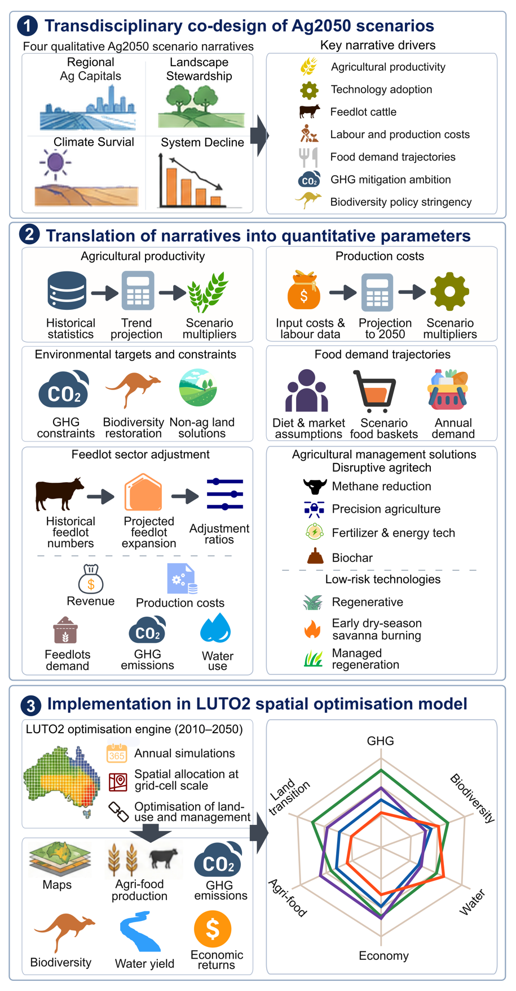
Extended Data Fig. 1 | Coupling co-designed narratives with spatial land-system modelling. (1) Transdisciplinary co-design of the Ag2050 narratives through iterative engagement among stakeholders, domain experts, and researchers; (2) translation of qualitative scenario narratives into quantitative and time-varying model parameters, including agricultural productivity, production costs, food demand, environmental targets, and agricultural management solutions; (3) implementation of scenario-specific settings within the LUTO2 spatial optimisation model to simulate land-use allocation and management dynamics; and (4) generation of model outputs and trade-off analyses, including land-use change, agri-food production, greenhouse gas emissions, biodiversity, water outcomes, and economic returns across scenarios.
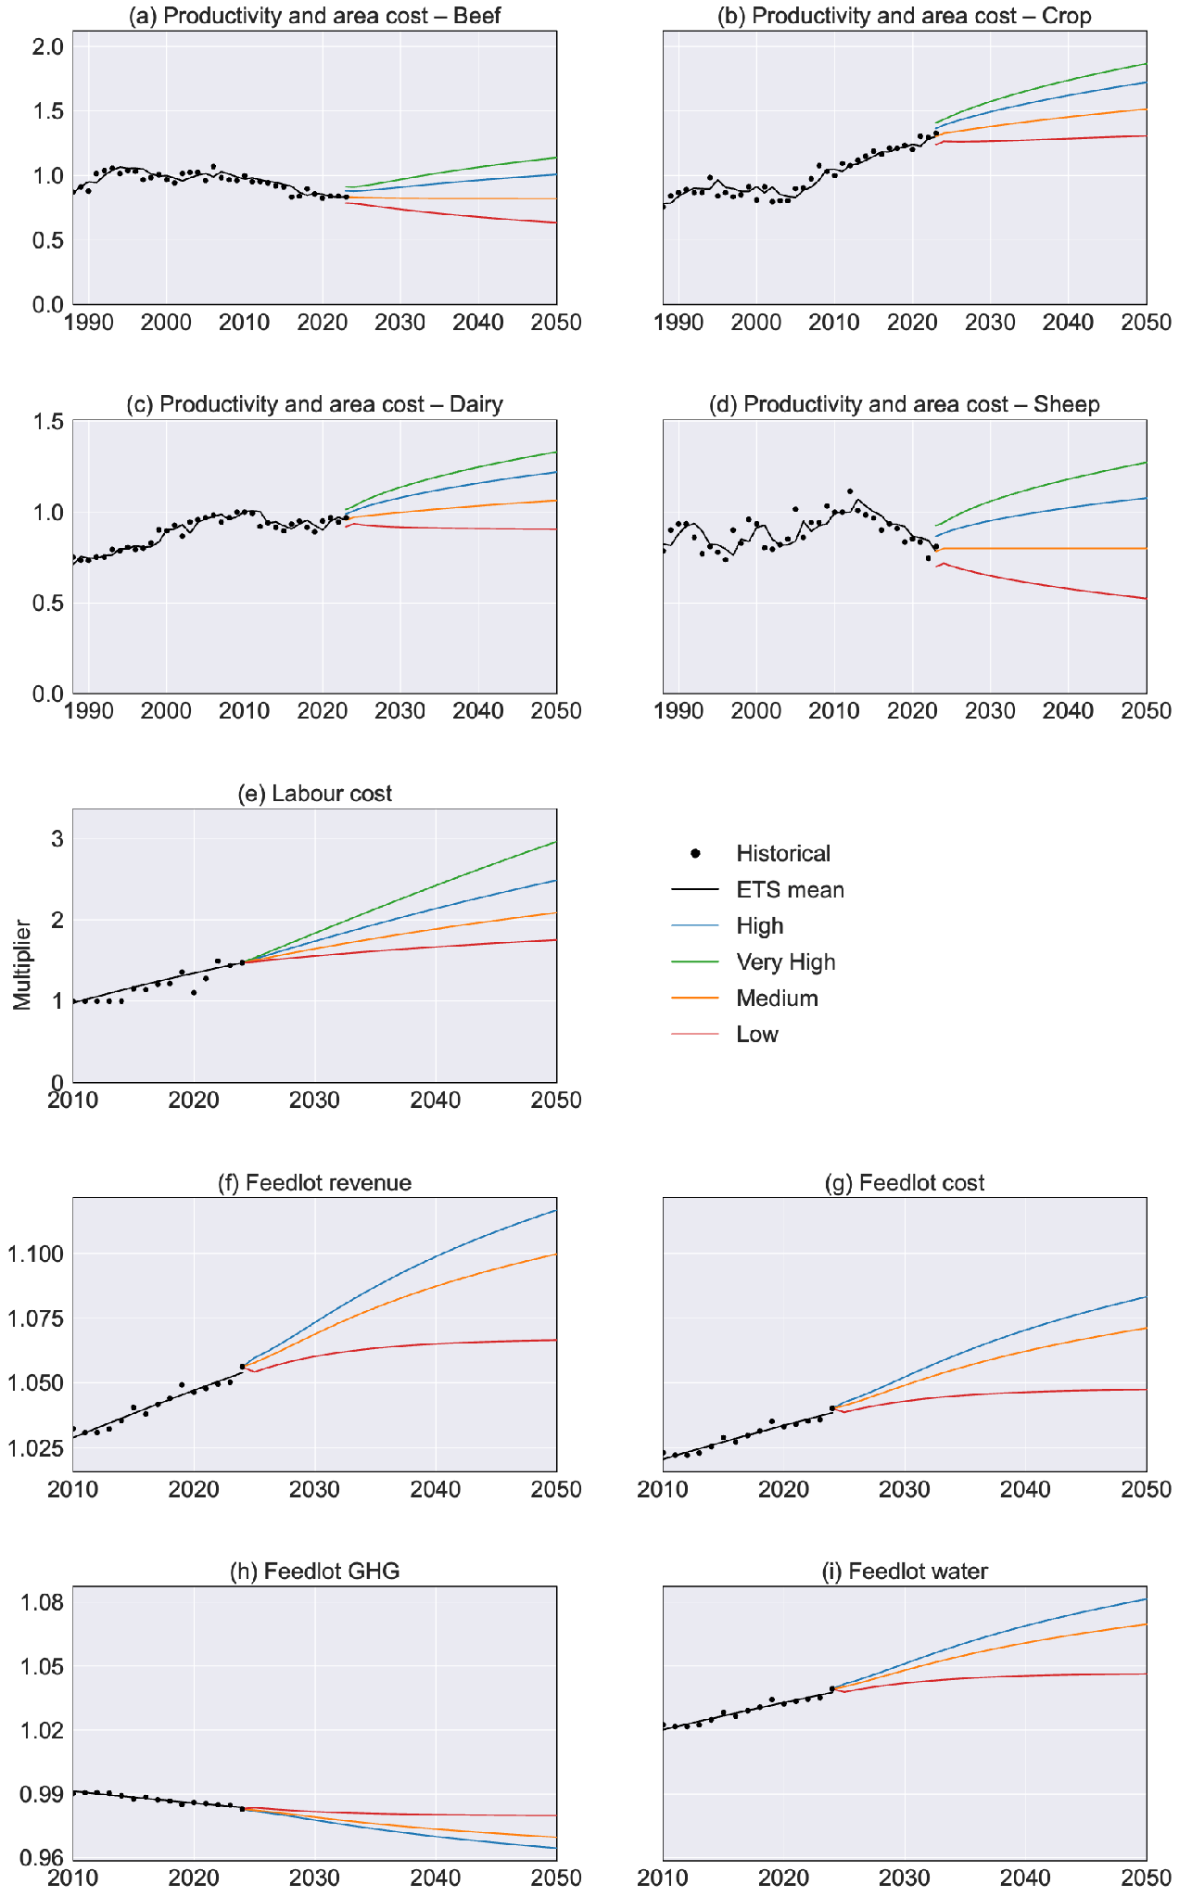
Extended Data Fig. 2 | Historical observations, fitted trends, and scenario-specific trajectories for the time-varying input parameters used in LUTO2. Panels (a–d) show the productivity and area-cost multipliers for beef, crop, dairy, and sheep; panel (e) shows the labour-cost multiplier; and panels (f–i) show the feedlot revenue, cost, GHG, and water adjustment ratios. Black points show historical observations, black lines show exponential-smoothing (ETS) fits, and coloured lines show the Low, Medium, High, and Very High scenario trajectories.
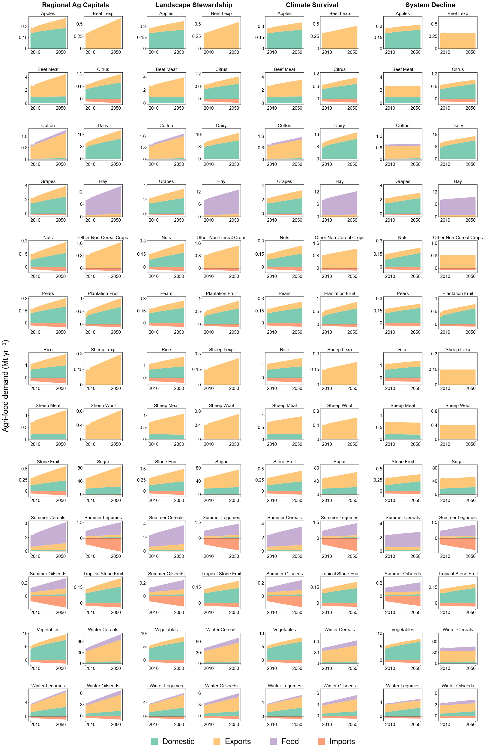
Extended Data Fig. 3 | Agri-food demand trajectories by commodity, 2010–2050, under the four Ag2050 scenarios. Stacked areas show annual demand (Mt yr⁻¹) decomposed into domestic, export, feed, and import components for each commodity group. Columns correspond to Regional Ag Capitals, Landscape Stewardship, Climate Survival, and System Decline.
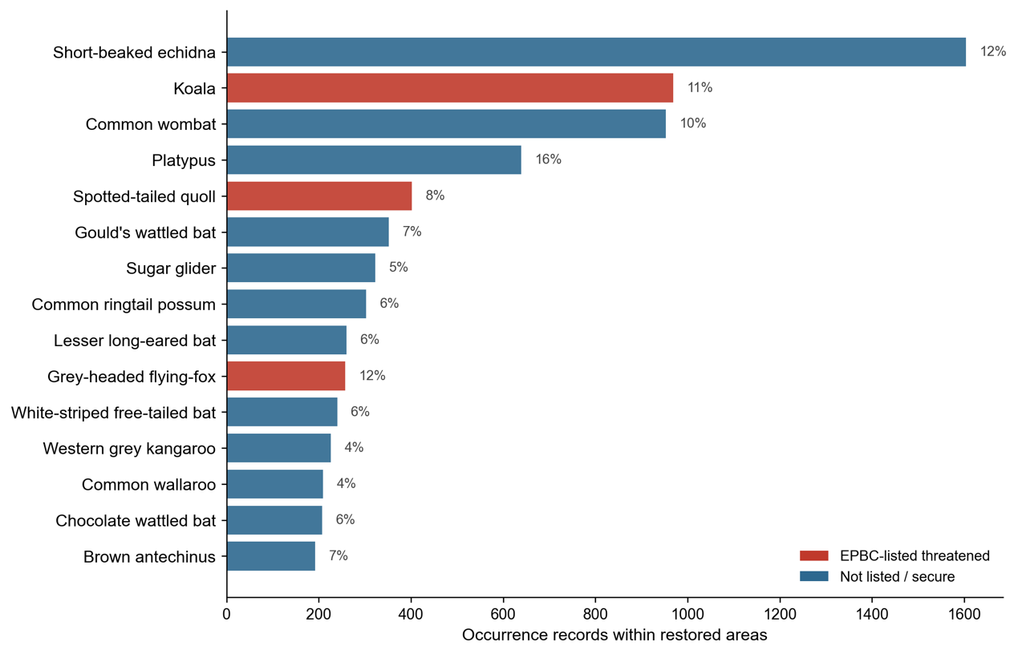
Extended Data Fig. 4 | Mammal species recorded in areas restored under the Landscape Stewardship scenario. Horizontal bars show the 15 mammal species with the most occurrence records within the grid cells reallocated to non-agricultural land uses under the Landscape Stewardship scenario in 2050, ranked by record count. Red bars denote species listed as threatened under the Environment Protection and Biodiversity Conservation Act 1999, and blue bars denote species not listed. Percentages give each species’ share of its national occurrence records that fall within the restored areas.

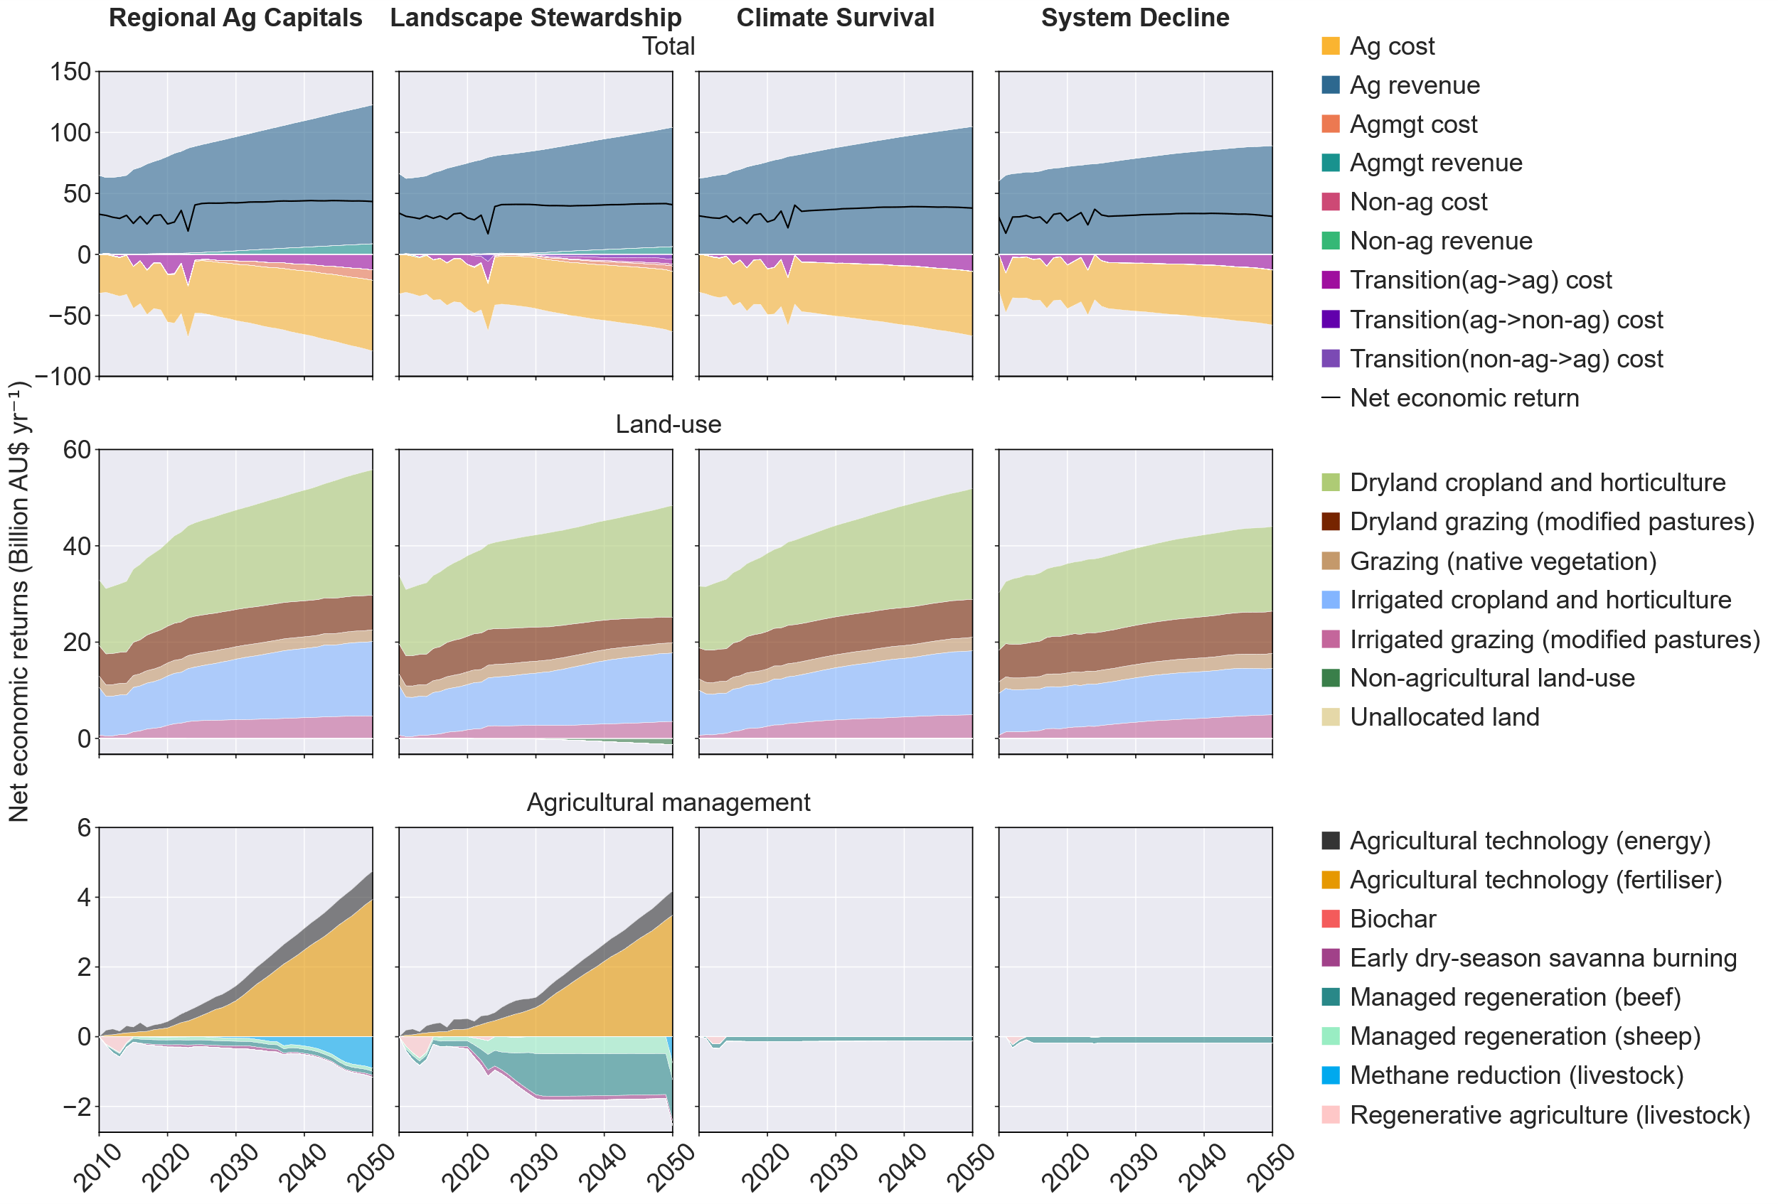
Extended Data Fig. 5 | Net economic returns, 2010–2050. The upper row shows total annual net economic returns (billion AU$ yr⁻¹) with revenue and cost components; the lower rows show the contributions of land-use and agricultural-management components under the four Ag2050 scenarios. Black lines show totals.
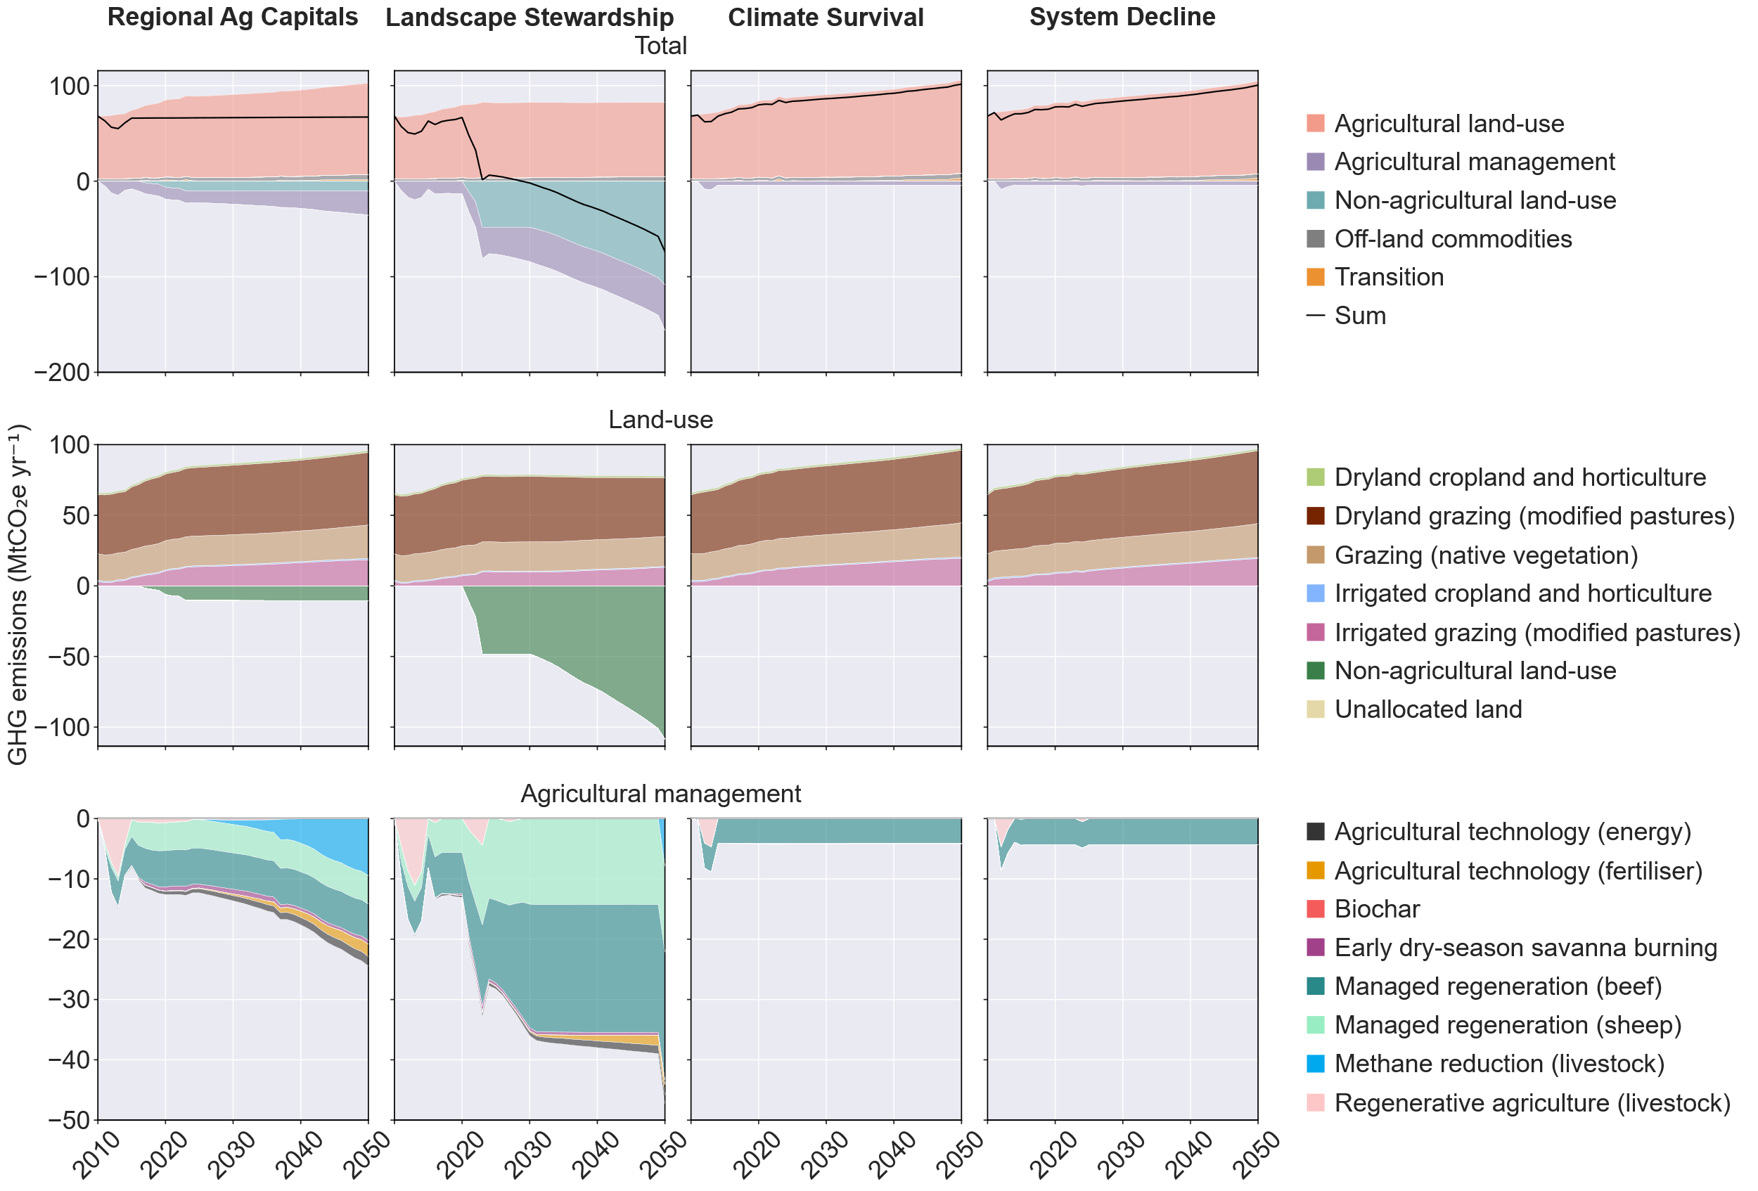
Extended Data Fig. 6 | GHG emissions, 2010–2050. The upper row shows total net emissions (Mt CO₂e yr⁻¹); the lower rows show the contributions of land-use and agricultural-management components under the four Ag2050 scenarios. Black lines show totals; negative values indicate net sequestration.

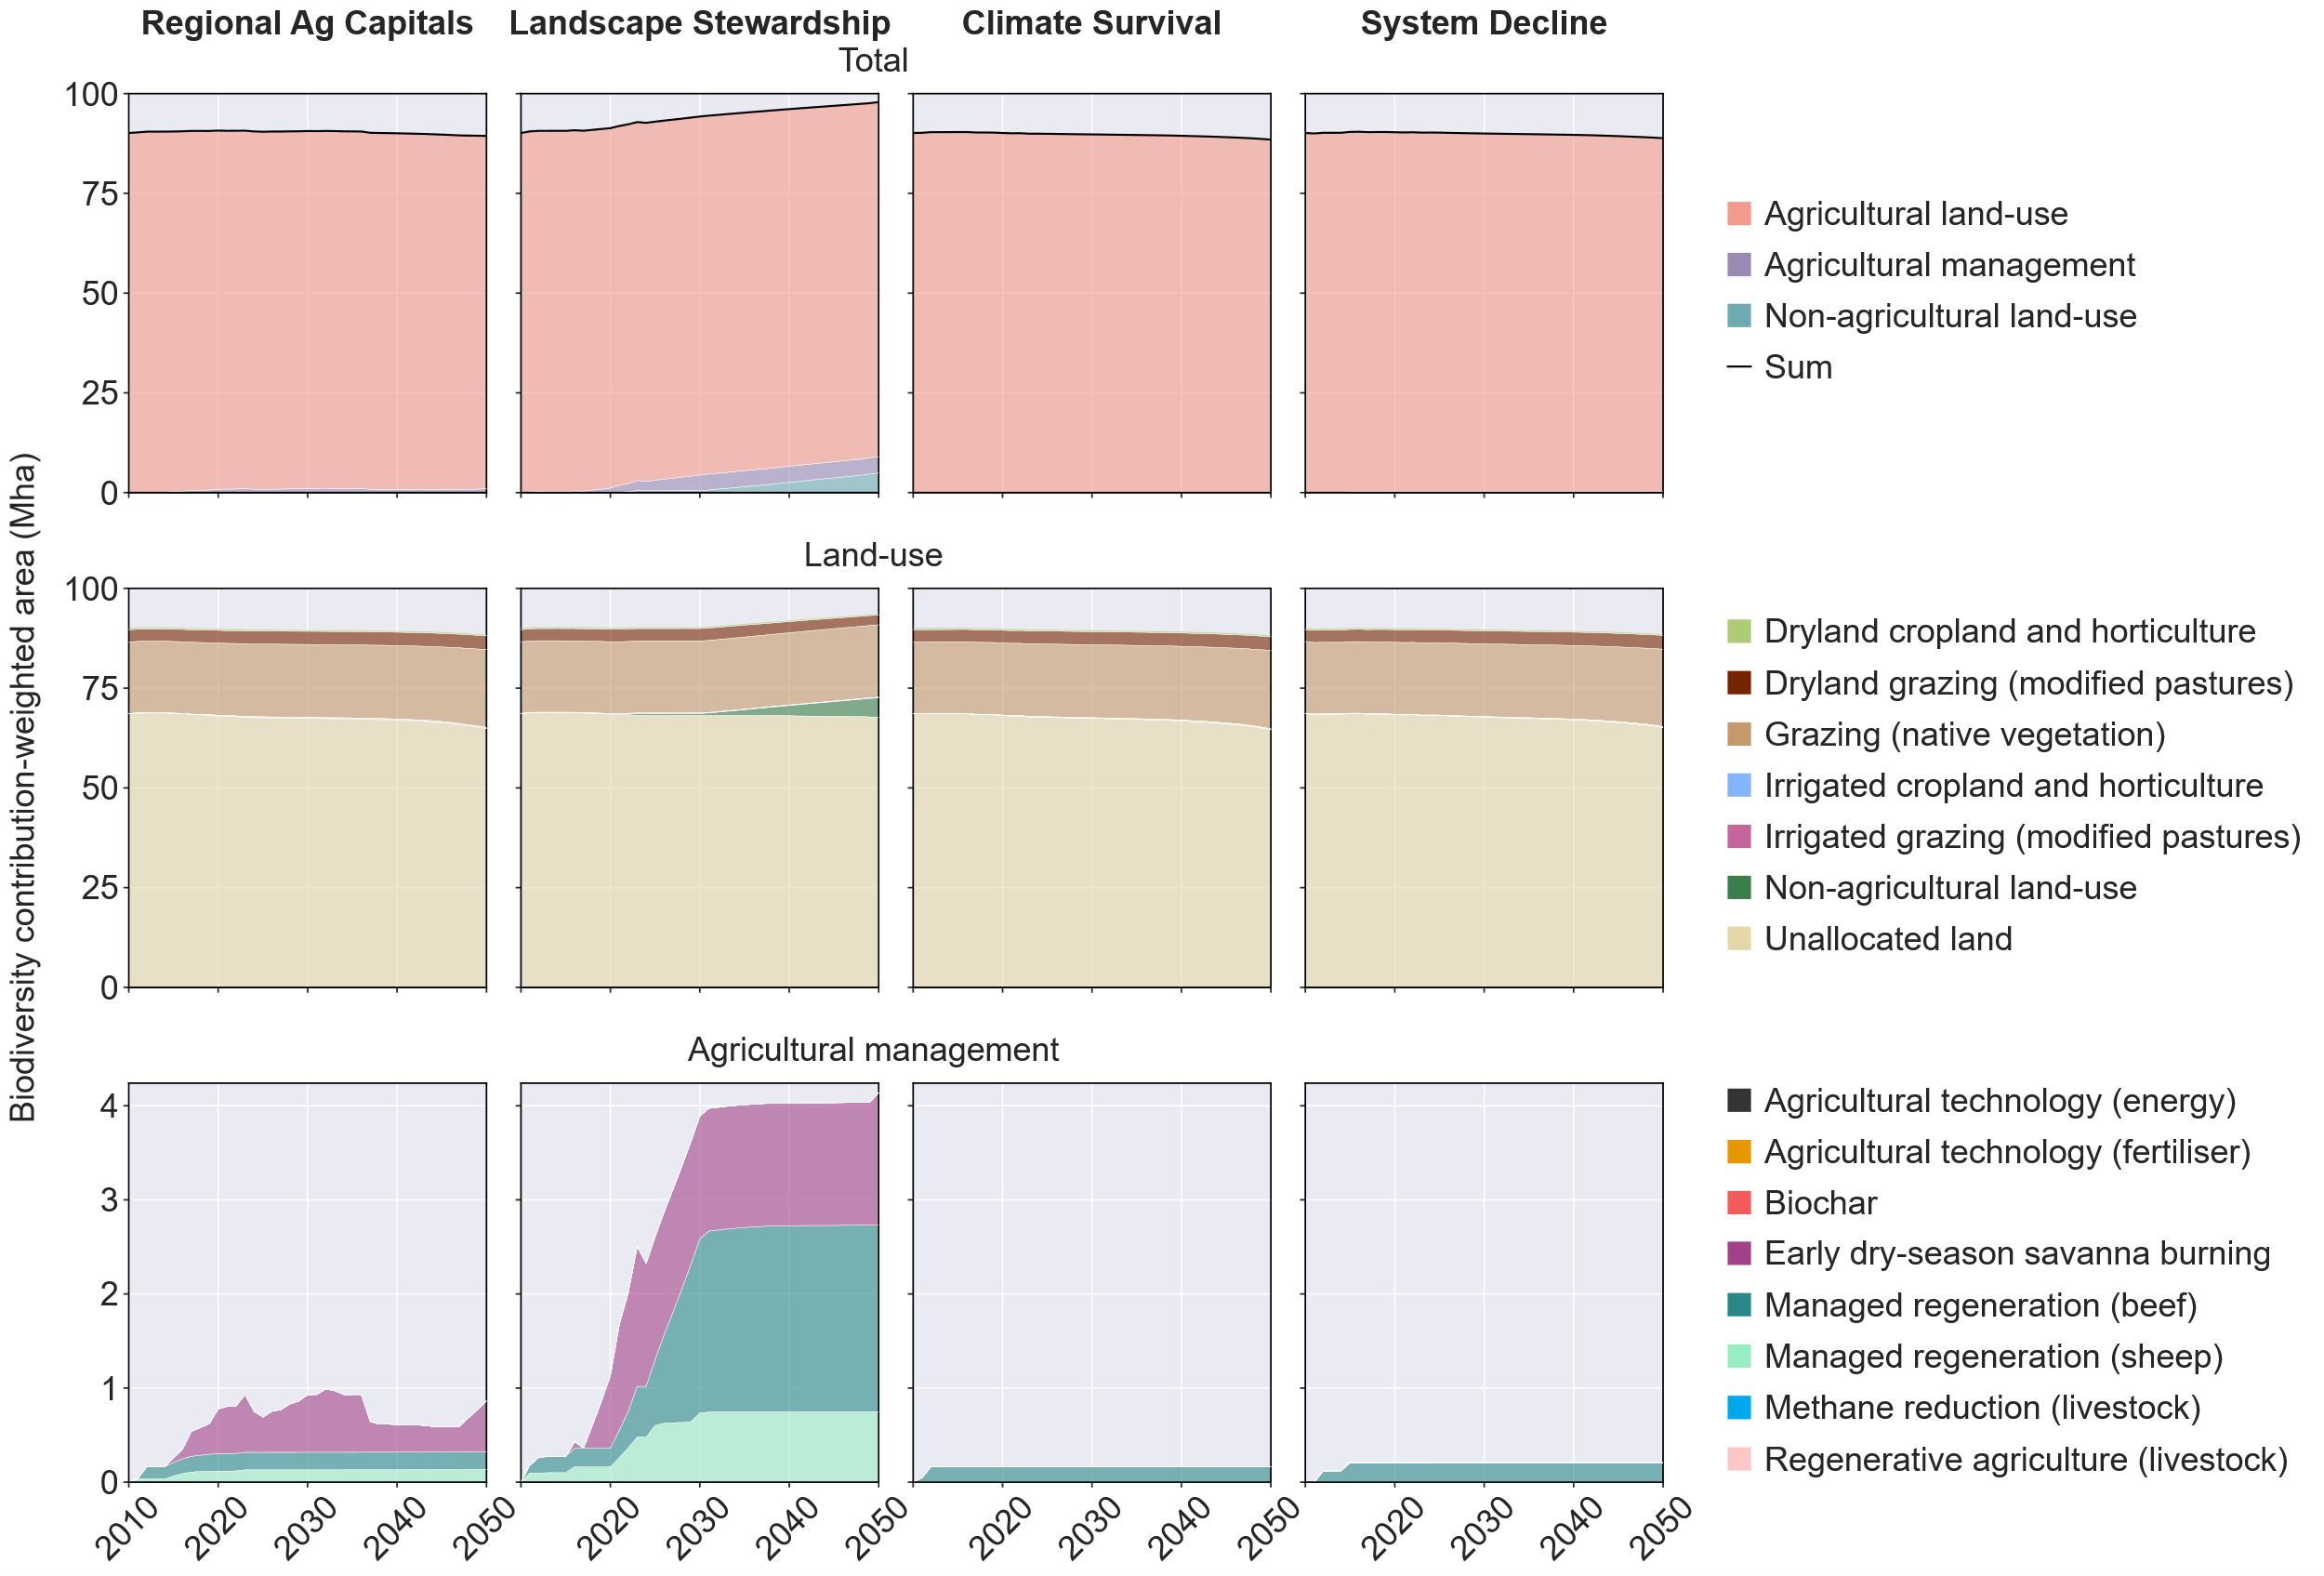
Extended Data Fig. 7 | Contribution-weighted biodiversity score, 2010–2050. The upper row shows the total continental biodiversity indicator (Mha); the lower rows show the contributions of land-use and agricultural-management components under the four Ag2050 scenarios.
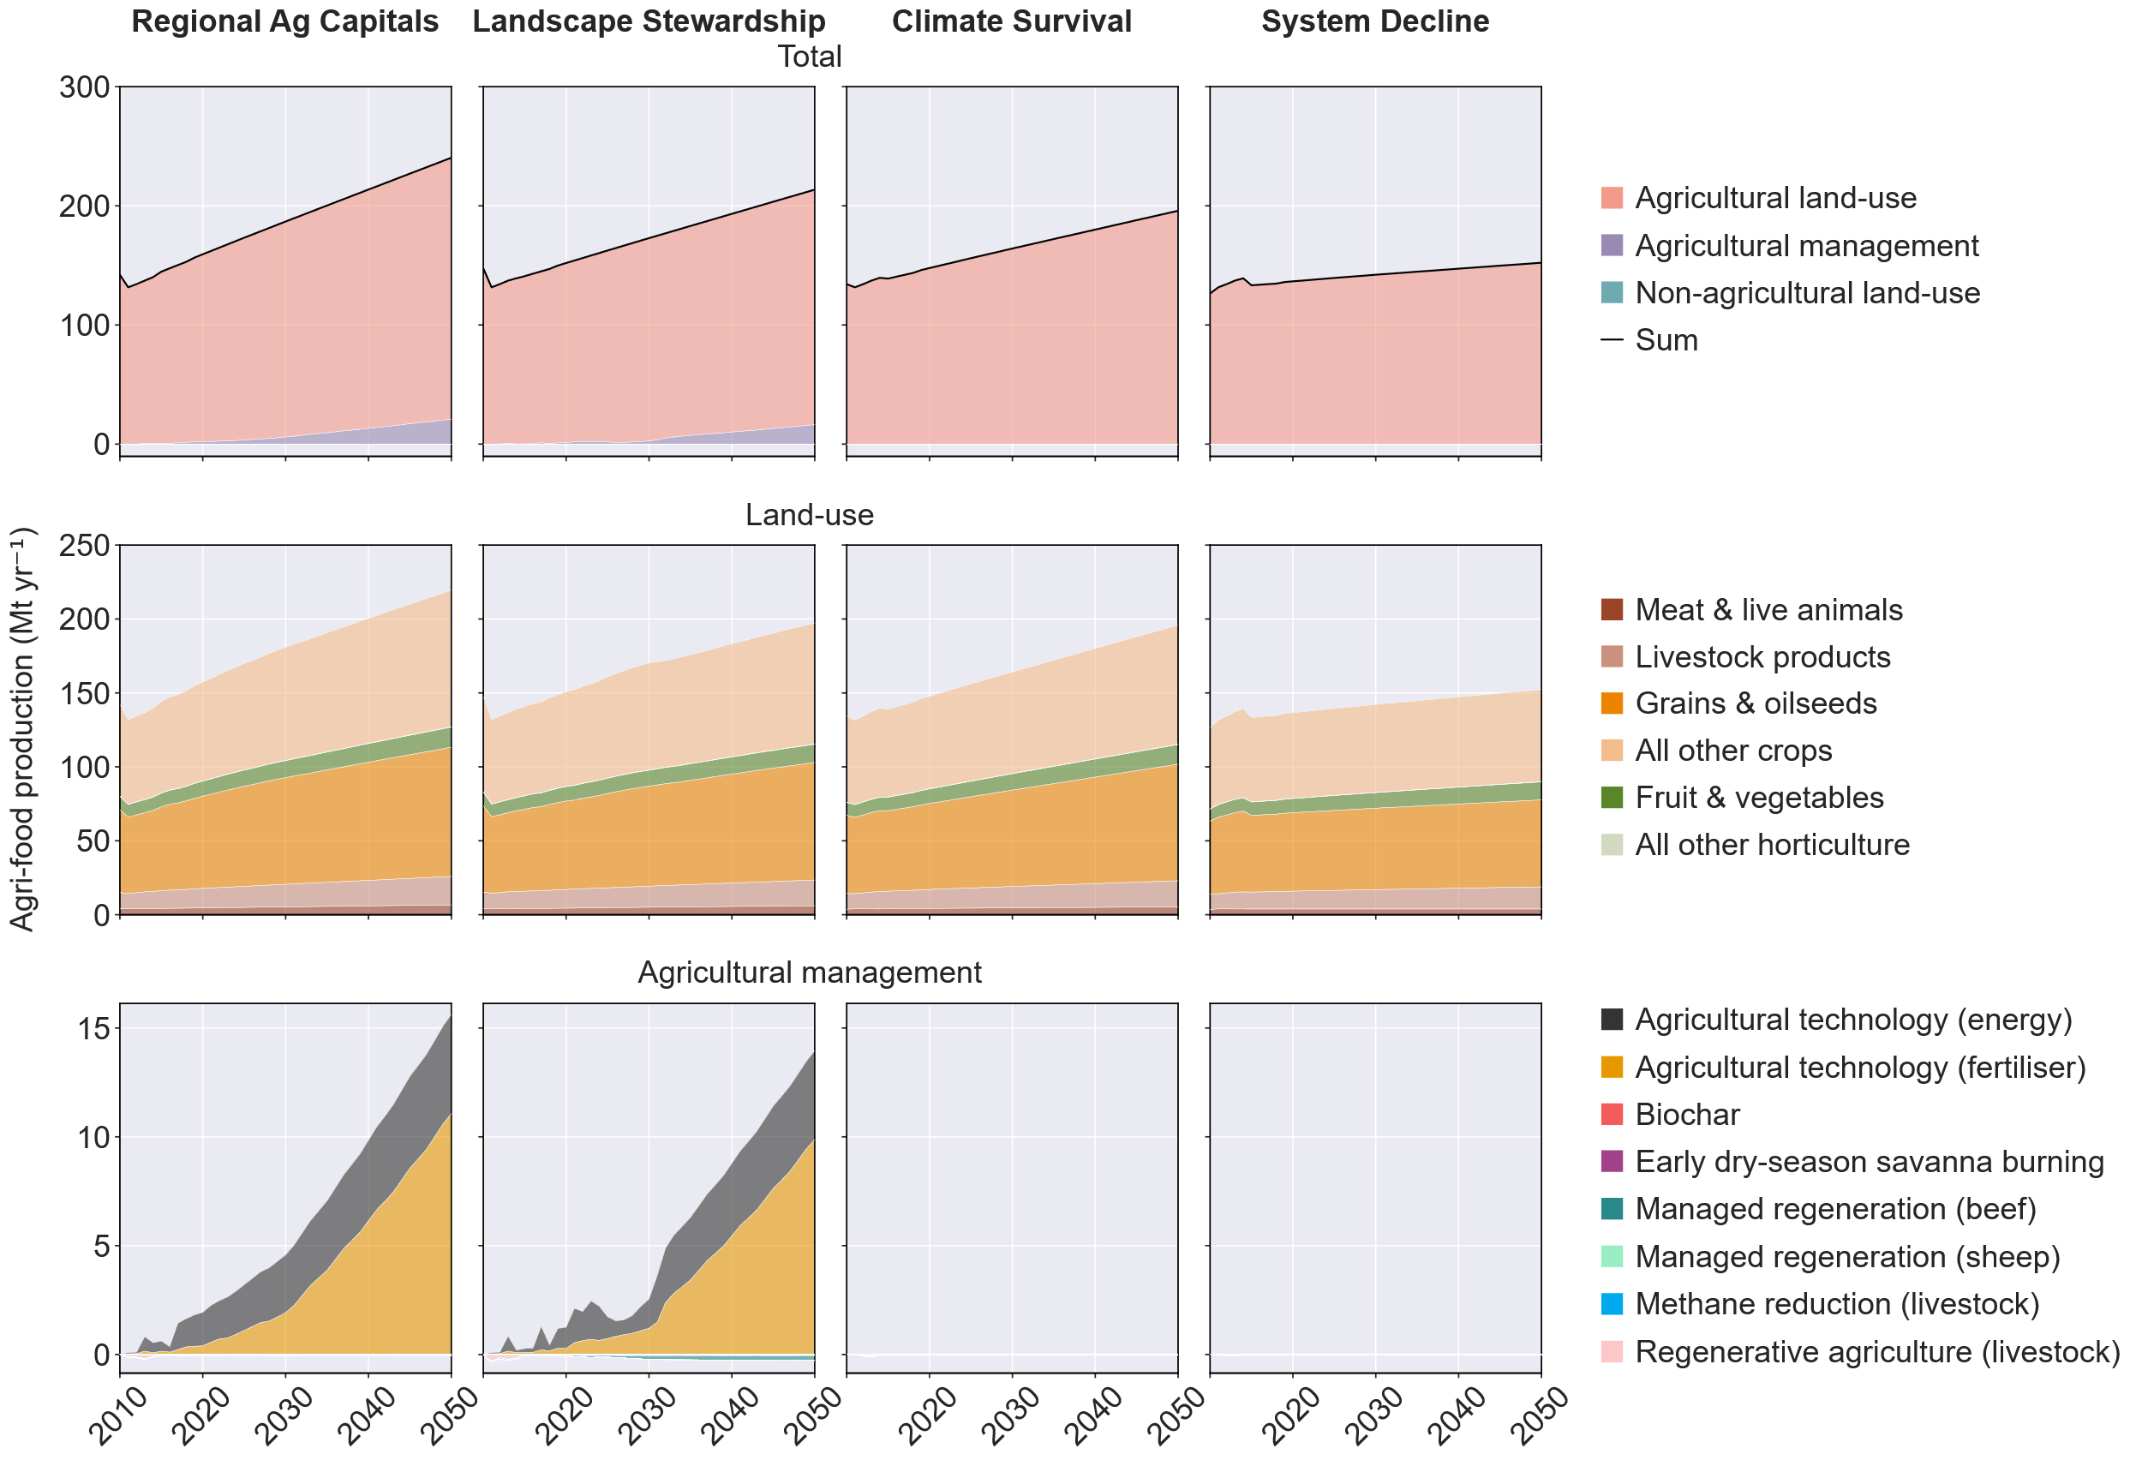
Extended Data Fig. 8 | Agri-food production, 2010–2050. The upper row shows total annual production (Mt yr⁻¹); the lower rows show the contributions of land-use and agricultural-management components under the four Ag2050 scenarios.

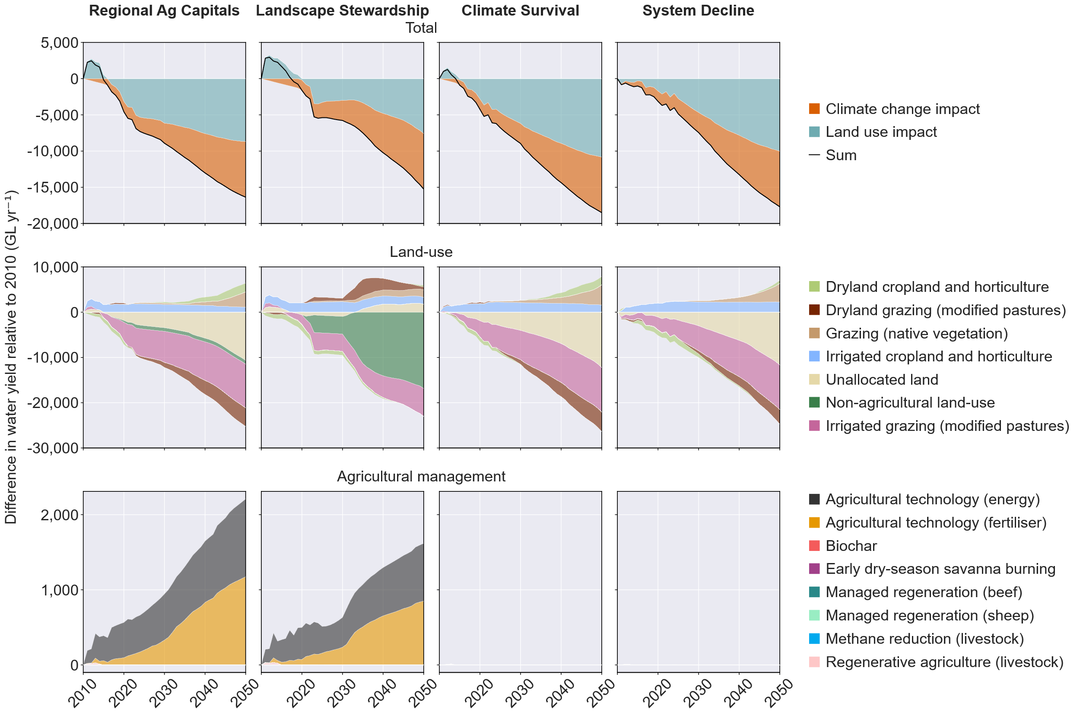
Extended Data Fig. 9 | Change in water yield relative to 2010, 2010–2050. The upper row shows the total change (GL yr⁻¹); the lower rows show the decomposition into the climate-change component and the land-use component, the latter resolved into irrigated agriculture, dryland agriculture, non-agricultural land use, and agricultural management, under the four Ag2050 scenarios.
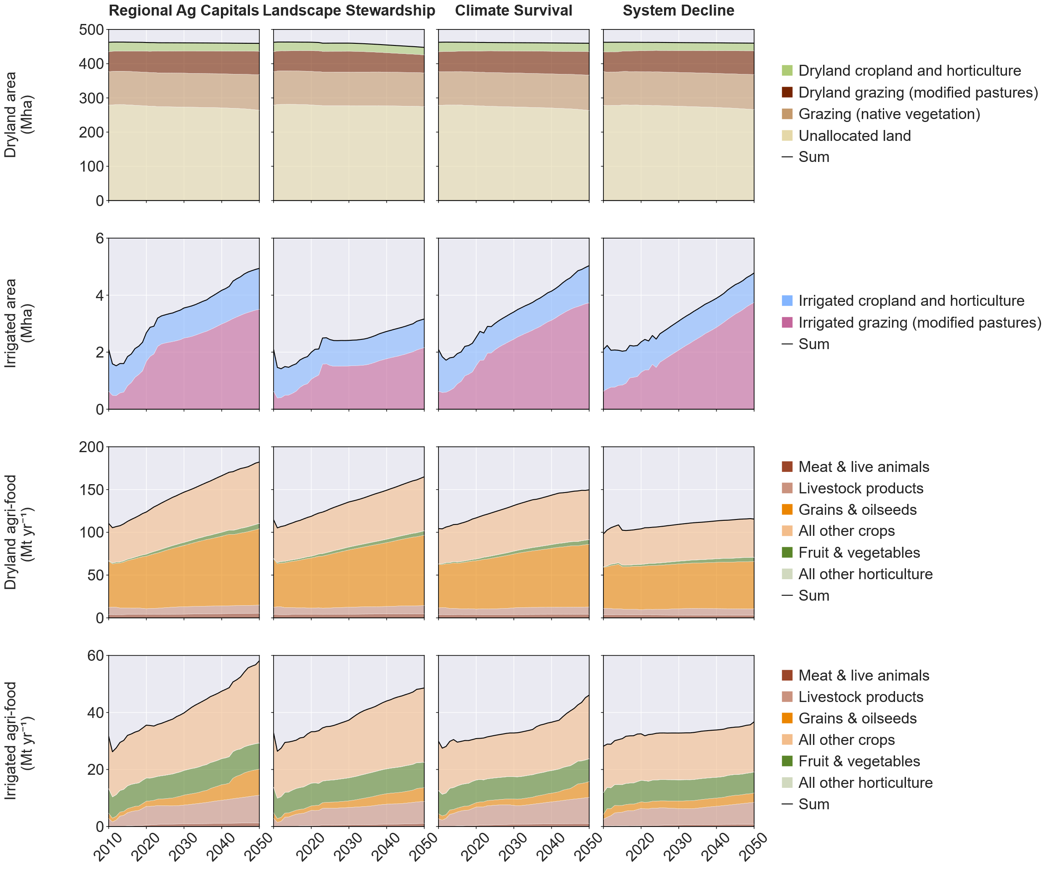
Extended Data Fig. 10 | Dryland and irrigated agricultural area and agri-food production, 2010–2050. Rows show, from top to bottom, dryland agricultural area (Mha), irrigated agricultural area (Mha), dryland agri-food production (Mt yr⁻¹), and irrigated agri-food production (Mt yr⁻¹). Columns correspond to the Regional Ag Capitals, Landscape Stewardship, Climate Survival, and System Decline scenarios. Coloured bands show component contributions and black lines show totals. Mha, million hectares; Mt, million tonnes.

