Reducing Particulate Matter Emissions in Landfills Using Novel Dust Suppressants: A New Approach to Improving Air Quality
Fahimeh Moghaddam¹, Maryam Sarkhosh^{2,3}, Mahdi Saeedi¹, Aliakbar Dehghan^{2,3*}
¹Student Research Committee, Department of Environmental Health Engineering, School of Health, Mashhad University of Medical Sciences, Mashhad, Iran. Tel: 985131892403, Fax: 985138552611, Email: moghaddamf4011@mums.ac.ir
²Social Determinants of Health Research Center, Mashhad University of Medical Sciences, Mashhad, Iran. Email: saeedim4011@mums.ac.ir
³Department of Environmental Health Engineering, School of Health, Mashhad University of Medical Sciences, Mashhad, Iran. Tel: 985131892403, Fax: 985138552611, Email: sarkhoshm@mums.ac.ir
³Social Determinants of Health Research Center, Mashhad University of Medical Sciences, Mashhad, Iran
⁴Department of Environmental Health Engineering, School of Health, Mashhad University of Medical Sciences, Mashhad, Iran. Tel: 985131892403, Fax: 985138552611, Corresponding Author, Email: dehghanaa@mums.ac.ir

Table S1. Specifications of the compost and vermicompost
variable | Compost | Vermicompost
Moisture % | 19.5 | 24.2
Organic Matter% r % | 50.2 | 40
Total Neutralizing Value% | 13.4 | 14.6
Organic Carbon% | 27 | 23.2
Na % | 0.7 | 0.5
K % | 1.2 | 1
P % | 1.05 | 1.4
Saturation Percentage % | 112 | 84
Total Nitrogen % | 1.52 | 1.7
pH | 7.3 | 7.8
EC | 7.1 | 4
C/N | 17.76 | 13.65
Specific Gravity % | 72 | 79
percentage of non-decomposable foreign materials | 0.9 | 0.5

Table S2. Properties of the soil used in the experiments
variable | pH | EC | Thermal conductivity | Moisture | Soil texture
Unit | - | ms/cm | % | % | %
Values | 7.97 | 6.9 | 16.6 | 0.93 | Clay = 14, Silt = 20, Sand = 66

Table S3. An overview of the tests performed for mesh 100, 50, 20
Exposure Time (min) | V(m/s) | Dust suppressant dose (gr) | Dust suppressants | Mesh
10, 15 | 4, 7 | 10, 20, and 30% of the tested soil | Compost, Vermicompost, Bentonite, Bentonite Nano Clay | 100
10, 15 | 4, 7 | 10, 20, and 30% of the tested soil | Compost, Vermicompost, Bentonite, Bentonite Nano Clay | 50
10, 15 | 4, 7 | 10, 20, and 30% of the tested soil | Compost, Vermicompost, Bentonite, Bentonite Nano Clay | 20

Table S4. Effect of speed on WER with optimal mesh and dose in time of 10 min
Dust suppressant | speed |  | Dust suppressant | speed
Dust suppressant | 4 (m/s) | 7 (m/s) | Dust suppressant | 4 (m/s) | 7 (m/s)
Compost, M20, D10 | 86.52 | 91.23 | Bentonite, M20, D10 | 79.96 | 92.14
Compost, M20, D20 | 74.22 | 89.12 | Bentonite, M20, D20 | 89.05 | 87.75
Compost, M20, D30 | 73.92 | 75.96 | Bentonite, M20, D30 | 79.14 | 83.73
Compost, M50, D10 | 88.84 | 67.74 | Bentonite, M50, D10 | 86.98 | 56.61
Compost, M50, D20 | 86.78 | 78.00 | Bentonite, M50, D20 | 86.14 | 81.69
Compost, M50 D30 | 69.00 | 48.71 | Bentonite, M50, D30 | 83.86 | 82.42
Compost, M100, D10 | 71.49 | 68.10 | Bentonite, M100, D10 | 91.39 | 78.87
Compost, M100, D20 | 96.05 | 48.16 | Bentonite, M100, D20 | 89.15 | 81.28
Compost, M100, D30 | 85.43 | 47.68 | Bentonite, M100, D30 | 89.98 | 79.46
Vermicompost, M20, D10 | 79.19 | 94.26 | Nano Clay, M20, D10 | 88.59 | 88.14
Vermicompost, M20, D20 | 83.75 | 90.09 | Nano Clay, M20, D20 | 78.81 | 90.04
Vermicompost, M20, D30 | 70.66 | 76.95 | Nano Clay, M20, D30 | 88.27 | 92.36
Vermicompost, M50, D10 | 84.65 | 71.53 | Nano Clay, M50, D10 | 62.80 | 57.99
Vermicompost, M50, D20 | 87.85 | 63.06 | Nano Clay, M50, D20 | 59.93 | 51.07
Vermicompost, M50, D30 | 75.21 | 74.06 | Nano Clay, M50, D30 | 57.51 | 90.77
Vermicompost, M100, D10 | 81.71 | 71.62 | Nano Clay, M100, D10 | 48.36 | 72.68
Vermicompost, M100, D20 | 79.29 | 39.45 | Nano Clay, M100, D20 | 46.75 | 84.31
Vermicompost, M100, D30 | 50.84 | 61.15 | Nano Clay, M100, D30 | 65.41 | 87.31
M= Mesh, D= Dust suppressant Dose

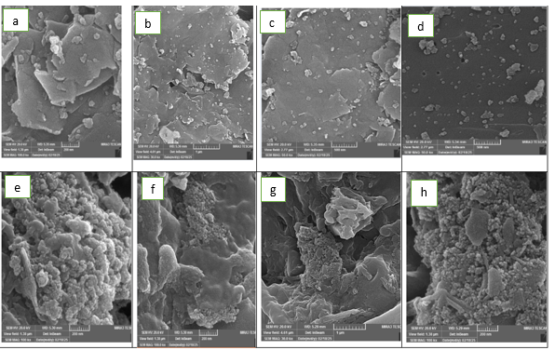
Fig. S1. SEM image for Bentonite (a-d) and Compost (e-h)
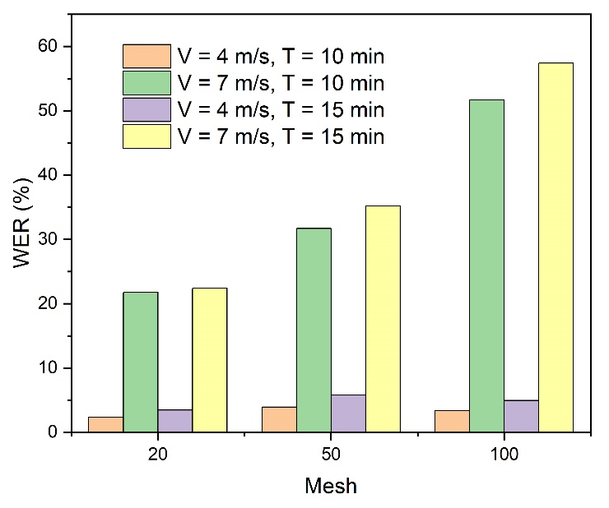
Fig. S2. WER of control samples with speeds of 4 and 7 m/s

