Supplementary Material for
Title: Ocean climate connectivity and the future range shifts of marine biodiversity.

Panagiotis Petsas^{1*}, Aggeliki Doxa¹, Vasiliki Almpanidou¹, Antonios D. Mazaris¹

¹Department of Ecology, School of Biology, Aristotle University of Thessaloniki, 54636, Thessaloniki, Greece
*author for correspondence:
email: pnpetsas@bio.auth.gr, tel.: +30 6944997084

Journal: Nature Climate Change

This document includes:

Supplementary Tables S1 - 2
Supplementary Figures S1 - 5

Table 1: Ocean surface temperature models used in the presented study. The models were derived from Coupled Model Intercomparison Project phase 6 (CMIP6). The models provide daily temperature values in Celsius. The resolution of the models is 100 km, except where noted.
Model
CanESM5
CESM2-WACCM
CMCC-CM2-SR5
EC-Earth3
EC-Earth3-Veg
MIROC6
MPI-ESM1-2-HR (50 km)
MRI-ESM2-0
NESM3
NorESM2-LM
NorESM2-MM

Table 2: Bioclimatic variables used for the identification of unique climates, calculated based on monthly temperature data. The loadings of principal components 1 and 2 are provided, which explained 61.96% and 31.37% of the total variance, respectively.
Code | Variable | PC1 loading | PC2 loading
BIO1 | Annual mean temperature | 0.41 | 0.11
BIO2 | Mean diurnal range | 0.25 | -0.46
BIO3 | Isothermality (BIO2/BIO7*100) | 0.21 | 0.33
BIO4 | Temperature seasonality (standard deviation*100) | 0.14 | -0.56
BIO5 | Max temperature of the warmest month | 0.42 | 0.02
BIO6 | Min temperature of the coldest month | 0.40 | 0.18
BIO7 | Temperature annual range (BIO5-BIO6) | 0.17 | -0.55
BIO10 | Mean temperature of the warmest quarter | 0.42 | 0.04
BIO11 | Mean temperature of the coldest quarter | 0.40 | 0.17

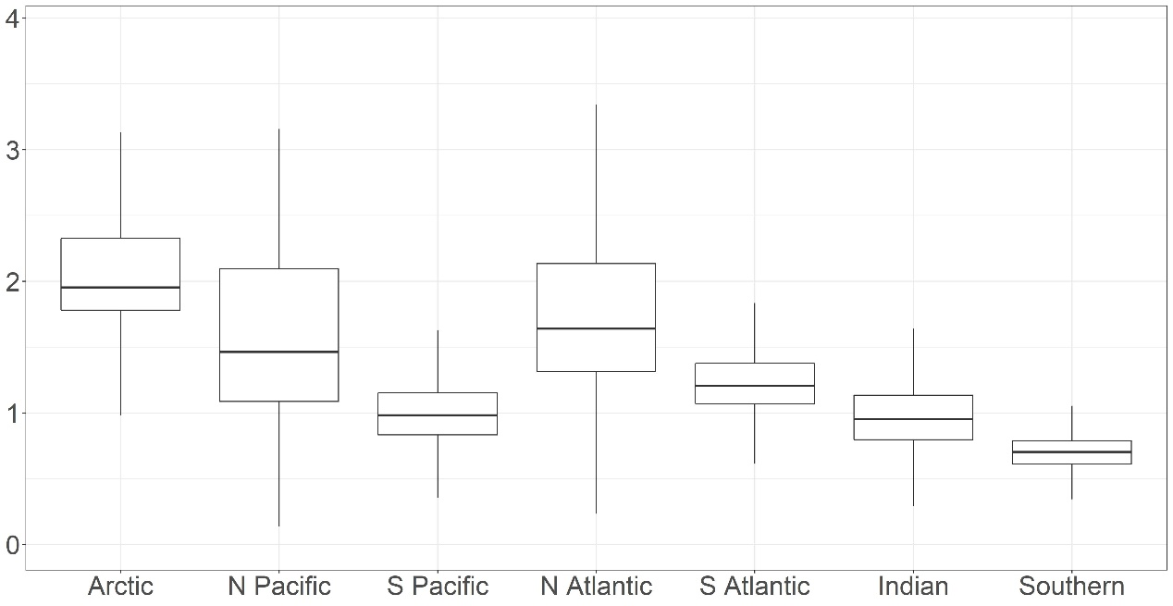

Fig. 1: Boxplot indicating current flow per ocean. Upper, mid, and lower horizontal lines of the box represent 75th percentile, median and 25th percentile of the values. The upper horizontal line represents the largest value within 1.5 times the interquartile range above 75th percentile. The lower horizontal line represents the smallest value within 1.5 times the interquartile range below 25th percentile. Values were log-transformed to aid interpretation.

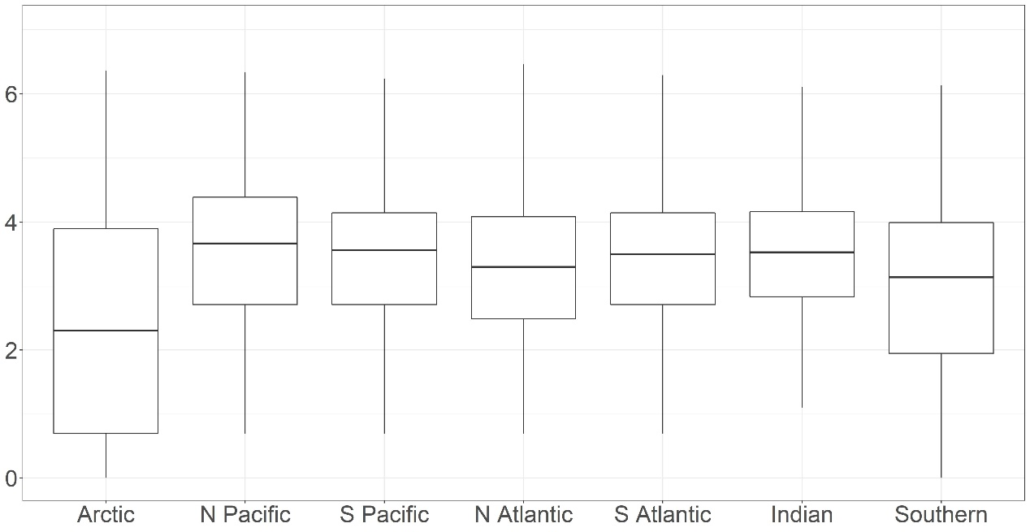

Fig. 2: Boxplot indicating path density per ocean. Upper, mid, and lower horizontal lines of the box represent 75th percentile, median and 25th percentile of the values. The upper horizontal line represents the largest value within 1.5 times the interquartile range above 75th percentile. The lower horizontal line represents the smallest value within 1.5 times the interquartile range below 25th percentile. Values were log-transformed to aid interpretation.

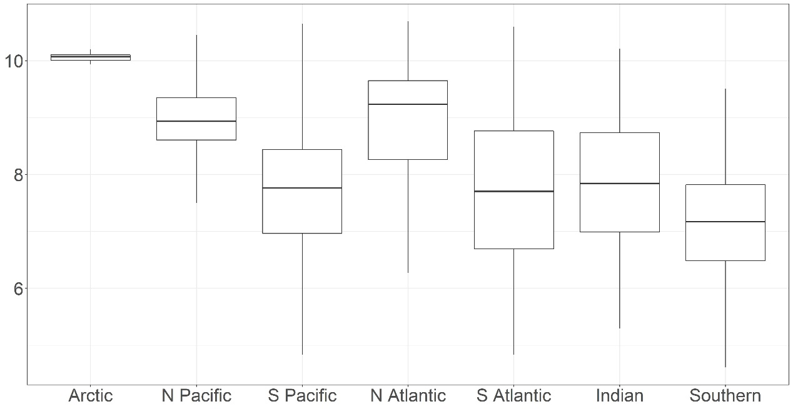

Fig. 3: Boxplot indicating minimum exposure distance (MED) per ocean. Upper, mid, and lower horizontal lines of the box represent 75th percentile, median and 25th percentile of the values. The upper horizontal line represents the largest value within 1.5 times the interquartile range above 75th percentile. The lower horizontal line represents the smallest value within 1.5 times the interquartile range below 25th percentile. Values were log-transformed to aid interpretation.
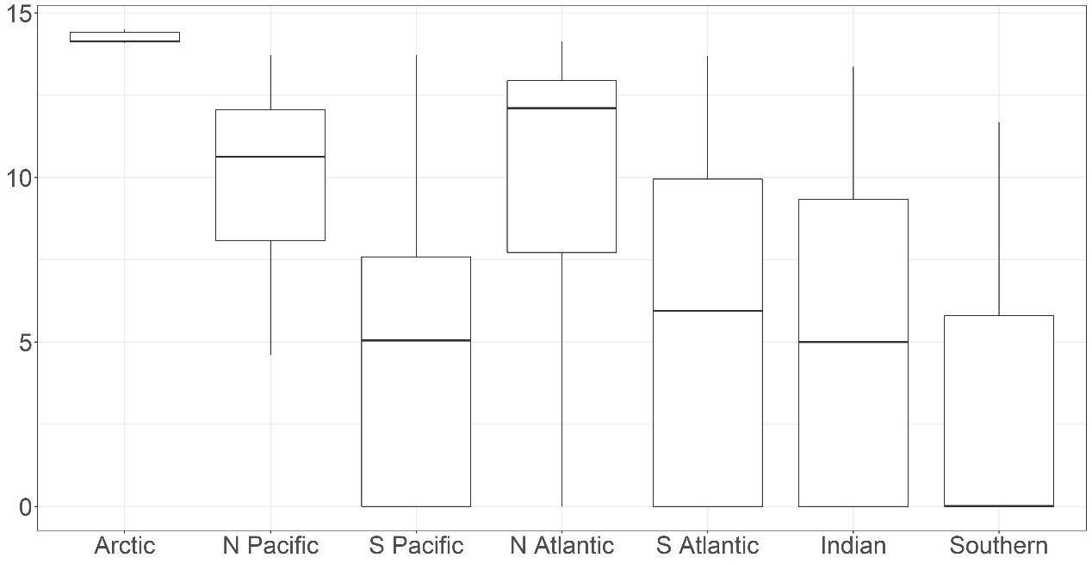

Fig. 4: Boxplot indicating minimum cumulative exposure (MCE) per ocean. Upper, mid, and lower horizontal lines of the box represent 75th percentile, median and 25th percentile of the values. The upper horizontal line represents the largest value within 1.5 times the interquartile range above 75th percentile. The lower horizontal line represents the smallest value within 1.5 times the interquartile range below 25th percentile. Values were log-transformed to aid interpretation.

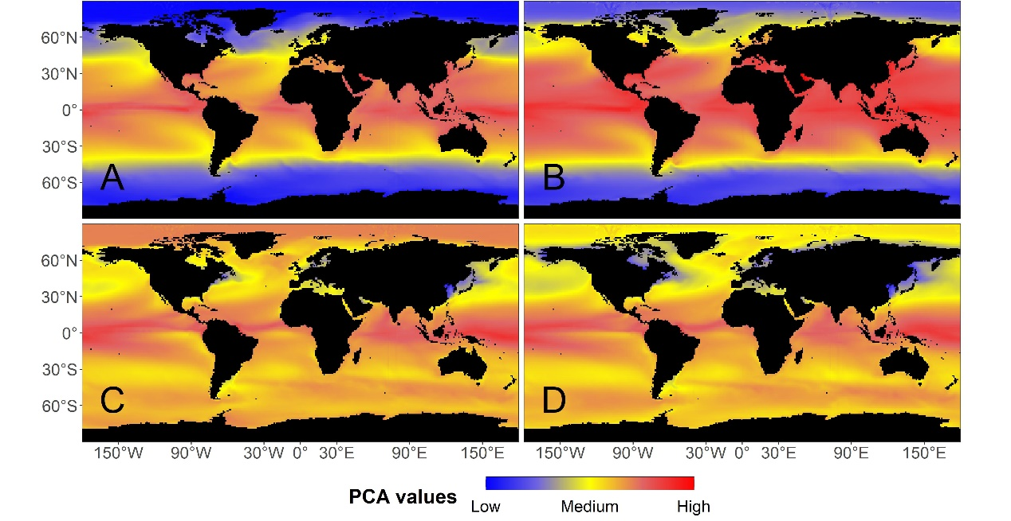
Fig. 5: Global map indicating the seascape climatic conditions based on principal component analysis (PCA). Two principal component axes (i.e., PC1 and PC2) were used to represent nine bioclimatic variables (Supplementary Table 2). Panels on the left (i.e., A and C) show the values of PC1 and PC2 during the mid of 20th century, respectively. Panels on the right (i.e., B and D) show the projected values of PC1 and PC2 at the end of 21st century, respectively. Black pixels indicate terrestrial areas and water masses that are blocked by terrestrial masses or pixels with no climatic data.

