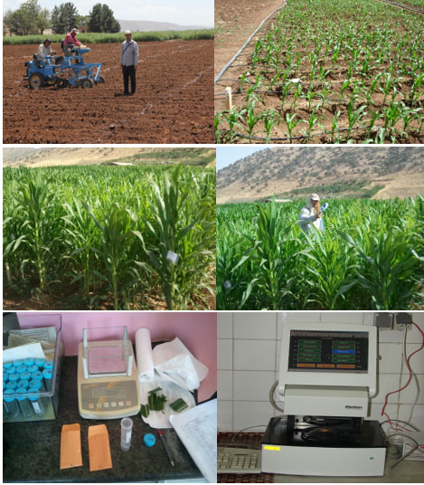
Fig.1 (supplementary) The different stages of experiment conduction and traits measurement

