Chemical Bonding Elucidation of Graphene Films Synthesized by Low Temperature CVD-Growth
Ahmed Ibrahim Farhan ª, Sundus Alzuhairi ^{b}, Alaa Y. Ali ^{a,c}, Mustafa Y. Ali ª
ª Electrical Department, Engineering College Alshirqat, Tikrit University, Tikrit 34001, Iraq
^{b} Physics Department, Education for Pure Science College, Anbar University, Iraq.
^{c} Natural Resources Research Center, Tikrit University, Tikrit 34001, Iraq.
Corresponding author: alaa.y.ali@tu.edu.iq , https://orcid.org/0000-0002-7095-2328

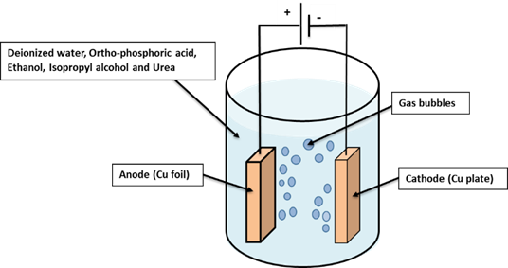

Figure S1. Electrochemical polishing apparatus for copper foil developed by us.

Figure 2S. XPS spectra of Cu foil (a) in its as-received state and (b) post-annealing.

Figure 3S. X-ray diffraction patterns of copper foil samples subjected to annealing at various temperatures for one hour.
Figure 4S. TGA plots of chlorobenzene-PMMA films dried at 180°C, air-dried, and drop-cast wet film in comparison to pure PMMA powder.

