Supplementary Information
LLM Agent-informed 1.5 °C Global Mitigation Pathways Considering Sustainable Development Goals
Table of Contents
Supplementary Note S1: GCAM–SDG coupling
Table S1 SSP2 assumptions
Table S2 GCAM output–SDG indicator linkage
Supplementary Note S2: LLM agent-driven space search
Table S3 Computational modules and model interfaces in the space-search framework
Table S4 Operational permissions for the LLM agent
Figure S1 Emission pathways generated through uniform spatial sampling
Figure S2 Emission pathways generated through Bayesian optimization
Supplementary Note S3: Post-search multi-objective pathway optimization and SDG interaction analysis
Figure S3 K-means cluster-number validation
Table S5 Directional adjustment of the SDG indicators used for normalization
Figure S4 Difference in normalized mean indicator values between the two priority-driven clusters
Figure S5 Normalized SDG performance across pathway clusters
Table S6 Pareto frontier summary
Figure S6 TOPSIS closeness scores
Supplementary Note S4: Supplementary results
Figure S7 SDG indicator distributions and sensitivity to mitigation pacing
Table S7 Regional SDG indicator values under the Climate-Prioritized pathway
Table S8 Regional SDG indicator values under the Multi-Balanced pathway
Table S9 Regional SDG indicator values under the Affordability-Prioritized pathway
Supplementary References
Supplementary Note S1: GCAM–SDG coupling
Model overview
GCAM v8.2 is an open-source integrated assessment model (IAM) developed by the Joint Global Change Research Institute (JGCRI) at Pacific Northwest National Laboratory (PNNL) (Calvin et al., 2019). The model couples energy, agriculture and land use, water, climate and macroeconomic systems at global and 32-region scales, solving a dynamic-recursive partial equilibrium across 5-year time steps from 2021 to 2100. Technology competition within each sector follows a nested logit structure, where market shares are determined by relative costs and calibrated share-weight parameters. Socioeconomic drivers, including population and GDP trajectories, follow the Shared Socioeconomic Pathway 2 (SSP2) (Riahi et al., 2017), representing a middle-of-the-road development pathway (Table S1).
Table S1. SSP2 socioeconomic assumptions used in GCAM simulations.
Year | Population (billion) | GDP (million 2020 US$)
2021 | 7.91 | 81,950,014
2025 | 8.19 | 93,470,546
2030 | 8.54 | 106,800,998
2035 | 8.86 | 120,351,787
2040 | 9.16 | 133,682,239
2045 | 9.42 | 147,453,367
2050 | 9.65 | 161,633,694
2055 | 9.83 | 176,238,958
2060 | 9.97 | 191,646,883
2065 | 10.08 | 207,857,467
2070 | 10.15 | 224,241,175
2075 | 10.19 | 240,703,574
2080 | 10.20 | 257,228,928
2085 | 10.17 | 273,911,665
2090 | 10.12 | 290,940,648
2095 | 10.05 | 308,347,354
2100 | 9.95 | 325,990,136
Energy service demand functions
GCAM employs sector-specific demand functions to determine energy service demands, which are driven by socioeconomic factors including population, GDP, and service prices. Energy service demand in the industrial and passenger transportation sectors follows a multiplicative formulation:
$$D_{t} = D_{t-1} {\left(\frac{Y_{t}}{Y_{t-1}}\right)}^{α_{t}} {\left(\frac{P_{t}}{P_{t-1}}\right)}^{β_{t}} \left(\frac{N_{t}}{N_{t-1}}\right)$$
where $D_{t}$ is the total energy service demand in period t, $Y_{t}$ is the per-capita GDP, $P_{t}$ is the service price, $N_{t}$ is the population, $α_{t}$ is the income elasticity, and $β_{t}$ is the price elasticity.
Land allocation
Land allocation among competing uses follows a nested logit structure:
$$s_{i,t} = \frac{{π_{i,t}}^{γ}}{Σ_{j} {π_{j,t}}^{γ}}$$
where $s_{i,t}$ is the share of land allocated to use i, $π_{j,t}$ is the profit rate, and gamma is the logit exponent governing the sensitivity of allocation to profit differences.
Water demand
Water withdrawals are calculated based on technology-specific intensity coefficients:
$$W_{s,t} = Σ_{i} Q_{i,s,t} · w_{i,s,t}$$
where $W_{s,t}$ is total water withdrawal in sector s, $Q_{i,s,t}$ is the activity level in technology i, and $w_{i,s,t}$ is the water intensity coefficient in technology i.
Climate module
GCAM uses the Hector reduced-complexity climate model to translate greenhouse gas and aerosol emissions into atmospheric concentrations, radiative forcing and global mean temperature change through coupled carbon-cycle and energy-balance components (Hartin et al., 2015). Detailed equations and parameterizations are provided in the GCAM documentation (https://jgcri.github.io/gcam-doc/).
GCAM output–SDG indicator linkage
This study defines 24 indicators linked to 12 SDGs (SDG 1, 2, 3, 6, 7, 8, 9, 10, 11, 12, 13, 15), each computed from GCAM output queries using established methodologies from the literature. Table S2 provides the complete mapping between GCAM outputs and SDG indicators, including the specific queries used, the calculation methods, and the primary references.
Table S2. GCAM output–SDG indicator linkage.
SDG Indicator | GCAM Output Query | Calculation | Symbol Definitions | Reference
SDG1_1  Share of household expenditure | building final energy by service and fuel;  fuel prices to buildings;  gdp mer by region;  ag import vs. domestic supply;  ag import vs. domestic prices | $$[Σᵢ\left(Eᵢ×Pᵢᴱ×{10}^{9}\right)$$  $$+ Σⱼ(Fⱼ × Pⱼᶠ × 10⁹)] × δₜ$$  $$/ (GDP × δₜ) × 100\%$$ | where E_{i} is the residential energy consumption of fuel i (EJ), P_{i}^{E} is the fuel price ($/GJ), F_{j} is the food commodity quantity j (Mt), P_{j}^{f} is the food commodity price ($/kg), GDP is the gross domestic product (million $), and δ_{t} is the discount factor with r = 0.05. Summation over all regions and years 2020–2100. | Soergel et al. (2021); Moreno et al. (2024)
SDG2_1  Food price | ag commodity prices;  ag production by crop type | $$Σₖ(Pₖ × Qₖ) / Σₖ Qₖ$$ | where P_{k} is the price of crop k ($/kg) and Q_{k} is the production of crop k (Mt), for k ∈ {corn, rice, wheat, other grain}. Summation over all regions and years 2020–2100, with annual interpolation between 5-year GCAM time steps. | Hasegawa et al. (2018); Fujimori et al. (2019)
SDG2_2  Per capita caloric supply | food demand;  population by region | $$Σ(Dₛ + Dₙ) / Σ N × 10⁹ / 365$$ | where D_{s} is the staple food demand (EJ), D_{n} is the non-staple food demand (EJ), and N is the population. The result is converted to kcal/cap/day. Summation over all regions and years 2020–2100. | van Vuuren et al. (2022); Fujimori et al. (2019)
SDG2_3  Staple crop production | ag production by crop type | $$Σₖ Qₖ / 1000$$ | where Q_{k} is the annual production of staple crop k (Mt), for k ∈ {corn, rice, wheat, other grain, root tuber, legumes, soybean}. | Fujimori et al. (2019); Hasegawa et al. (2018)
SDG3_1  Air pollutant emissions | nonco2 emissions by region | $$Σ(BC + OC + SO₂ + NOₓ)$$ | where BC is black carbon, OC is organic carbon, SO₂ is sulfur dioxide, and NO_{x} is nitrogen oxides (all in Tg). Summation over all regions and years 2020–2100 with annual interpolation. | Markandya et al. (2018); Rao et al. (2016); Vandyck et al. (2018)
SDG6_1  Groundwater extraction | cumulative groundwater extraction | $$Σᵣ GWᵣ,₂₁₀₀$$ | where GW_{r},₂₁₀₀ is the cumulative groundwater extraction in region r at year 2100 (km³). Summation over all 32 GCAM regions. | Hejazi et al. (2014); Kim et al. (2016)
SDG6_2  Water consumption | water consumption by region | $$Σᵣ,ₜ Wᵣ,ₜ$$ | where W_{r},_{t} is the annual water consumption in region r at year t (km³). Summation over all regions and years 2020–2100 with annual interpolation. | van Vuuren et al. (2022); Hejazi et al. (2014); Davies et al. (2013)
SDG7_1  Share of renewable energy | primary energy consumption by region (direct equivalent) | $$Meanₜ[Σᵣ REᵣ,ₜ / Σᵣ PEᵣ,ₜ × 100\%]$$ | where RE_{r},_{t} is the renewable primary energy consumption in region r at year t (EJ) and PE_{r},_{t} is the total primary energy consumption (EJ). Renewable sources include biomass, hydro, wind, solar, and geothermal. The ratio is averaged across all years. | McCollum et al. (2018); Zhang et al. (2024)
SDG7_2  Electricity price | final energy prices;  building final energy by fuel;  industry final energy by fuel;  transport final energy by fuel; | $$Σ(Pₑ × Cₑ) / Σ Cₑ$$ | where Pₑ is the electricity price in each end-use sector ($/GJ) and Cₑ is the electricity consumption in each sector (EJ). The weighted average covers building (elect_td_bld), industry (elect_td_ind), and transport (elect_td_trn) sectors across all regions and years 2020–2100. | Soergel et al. (2021); Zhang et al. (2024)
SDG7_3  Energy intensity | total final energy by region;  gdp mer by region | $$Σ FE / Σ GDP × 10⁶$$ | where FE is the total final energy consumption (EJ) and GDP is the gross domestic product (million $). The factor 10⁶ converts to MJ/$. Summation over all regions and years 2020–2100. | IEA (2023); Zhang et al. (2024)
SDG7_4  Primary energy price | regional primary energy prices;  primary energy consumption by region (direct equivalent) | $$Σ(Pƒ × Cƒ) / Σ Cƒ$$ | where Pƒ is the fuel price ($/GJ) and Cƒ is the fuel consumption (EJ), for standardized fuel categories f ∈ {biomass, coal, natural gas, oil}. Summation over all regions and years 2020–2100. | Soergel et al. (2021); McCollum et al. (2018)
SDG8_1  Share of mitigation cost | policy cost by period | $$Σₜ[ Cₜ × δₜ] /$$  $$Σₜ[GDPₜ × δₜ] × 100\%$$ | where C_{t} is the mitigation cost ($), GDP_{t} is the GDP (million $), and δ_{t} is the discount factor with r = 0.05. Summation over all regions and years 2020–2100. | IPCC (2022); Riahi et al. (2021); Bertram et al. (2015)
SDG9_1  Industrial cumulative CO₂ | co2 emissions by sector (excluding resource production) | $$Σₛ,ₜ CO₂ₛ,ₜ × 44/12 / 1000$$ | where CO_{2s},_{t} is the CO₂ emissions from industrial sector s at year t (MtC). The factor 44/12 converts MtC to MtCO₂, and division by 1000 yields GtCO₂. | Davis et al. (2018); Bataille et al. (2018); Rissman et al. (2020)
SDG9_2  Share of industrial clean energy | industry final energy by fuel | $$(1 - Σ Eᶠᵒₛₛᵢₗ / Σ Eₜₒₜₐₗ) × 100\%$$ | where E^{f}ᵒ_{ssil} is the industrial fossil fuel energy consumption (EJ) and E_{tot}ₐ_{l} is the total industrial energy consumption (EJ). Fossil fuels include refined liquids, wholesale gas, and delivered coal. Summation over all regions and years 2021–2100. | Zhou et al. (2013); Bataille et al. (2018); Rissman et al. (2020)
SDG10_1  Energy Gini coefficient | population by region;  total final energy by region | $$Gini(\{eᵣ\}) where eᵣ = Σₜ FEᵣ,ₜ / Σₜ Nᵣ,ₜ$$ | where e_{r} is the per-capita final energy consumption in region r, FE_{r},_{t} is the total final energy (EJ), and N_{r},_{t} is the population. The Gini coefficient is computed across all 32 GCAM regions using the standard formula. | Pachauri et al. (2013); Oswald et al. (2020)
SDG10_2  Emissions Gini coefficient | population by region;  co2 emissions by region | $$Gini(\{cᵣ\}) where cᵣ = Σₜ CO₂ᵣ,ₜ / Σₜ Nᵣ,ₜ$$ | where c_{r} is the per-capita CO₂ emissions in region r (MtC/person), CO_{2r},_{t} is the regional emissions, and N_{r},_{t} is the population. The Gini coefficient is computed across all 32 GCAM regions using the standard formula. | IPCC (2022); Soergel et al. (2021)
SDG11_1  Building energy cost | building final energy by fuel;  fuel prices to buildings;  final energy prices | $$Σ(Pᵦ × Cᵦ) / Σ Cᵦ$$ | where Pᵦ is the building fuel price ($/GJ) and Cᵦ is the building fuel consumption (EJ). Fuels include delivered biomass, coal, gas, electricity (elect_td_bld), refined liquids, hydrogen (h₂ retail delivery), district heat, and traditional biomass. Summation over all regions and years 2020–2100. | Soergel et al. (2021); Moreno et al. (2024)
SDG11_2  Transport energy cost | transport final energy by fuel  fuel prices to transport | $$Σ(Pₜᵣ × Cₜᵣ) / Σ Cₜᵣ$$ | where P_{tr} is the transport fuel price ($/GJ) and C_{tr} is the transport fuel consumption (EJ). Transport fuels include hydrogen (retail and wholesale dispensing), coal, gas, electricity (elect_td_trn), and refined liquids. Summation over all regions and years 2020–2100. | Soergel et al. (2021); Moreno et al. (2024)
SDG12_1  CO₂ emissions intensity | co2 emissions by sector (excluding resource production);  industry total final energy by region | $$Σ CO₂ᵢₙᵈ / Σ Eᵢₙᵈ$$ | where CO_{2in}ᵈ is the total industrial CO₂ emissions (MtC) and E_{in}ᵈ is the total industrial final energy consumption (EJ). Summation over all regions and years 2020–2100 with annual interpolation. | IEA (2023); Davis et al. (2018); Bataille et al. (2018)
SDG12_2  Crop productivity | ag production by crop type;  land allocation by crop | $$Σ Qᶜᵣᵒᵖ / Σ Aᶜᵣᵒᵖ × 10$$ | where Qᶜ_{r}ᵒᵖ is the crop production (Mt) and Aᶜ_{r}ᵒᵖ is the crop land area (thousand km²). The factor 10 converts from Mt/thousand km² to t/ha. Crops include corn, rice, wheat, other grain, root tuber, legumes, and soybean. Summation over all regions and years. | Fujimori et al. (2019); van Vuuren et al. (2022)
SDG13_1  Peak warming | global mean temperature | $$max(Tₜ) for t ∈ [2020, 2100]$$ | where T_{t} is the global mean temperature anomaly relative to pre-industrial levels (°C) at year t. | IPCC (2021); Rogelj et al. (2018); Schleussner et al. (2024)
SDG13_2  Overshoot intensity | global mean temperature | $$Σₜ max(0, Tₜ - 1.5)$$ | where T_{t} is the global mean temperature (°C) and 1.5 is the Paris Agreement threshold. The summation captures the cumulative excess temperature above 1.5 °C over years 2020–2100 (°C·yr). | Schleussner et al. (2024); Geden & Löschel (2017); IPCC (2023)
SDG13_3  Cumulative GHG emissions | co2 emissions by region;  nonco2 emissions by region | $$[ΣCO^{2}×44/12+$$  $$Σ CH₄ × 28 + Σ N₂O × 265] / 1000$$ | where CO₂ is in MtC (converted to MtCO₂ by factor 44/12), CH₄ and N₂O are converted to CO₂-equivalent using AR5 100-year global warming potentials (CH₄ = 28, N₂O = 265). Division by 1000 yields GtCO₂eq. Summation over all regions and years 2020–2100. | IPCC (2021); Myhre et al. (2013); Rogelj et al. (2018)
SDG15_1  Forest land share | aggregated land allocation | $$Meanₜ[Σᵣ Fᵣ,ₜ / Σᵣ Lᵣ,ₜ × 100\%]$$ | where F_{r},_{t} is the forest land area in region r at year t (thousand km²) and L_{r},_{t} is the total land area. | van Vuuren et al. (2022); Popp et al. (2017); Wise et al. (2009)

Supplementary Note S2: LLM agent-driven space search
This study develops an LLM agent-driven autonomous space-search framework that employs a large language model, GPT-5.2-Codex, as a workflow orchestrator to explore emission-pathway and SDG-indicator spaces under a fixed cumulative net CO₂ budget of 400 GtCO₂ over 2020–2100, anchored to the 1.5 °C climate goal. Unlike conventional automation scripts that follow a predetermined execution sequence, the LLM agent coordinates pre-built computational modules, manages workflow dependencies, monitors model execution, diagnoses runtime exceptions and adapts the search strategy according to intermediate SDG outcomes. Its operational objective is to assemble a pathway ensemble that covers both the feasible pathway input space and the attainable SDG indicator output space. The completed pathway ensemble constitutes the final output of the agent.
The framework uses a two-layer prompt architecture. A project-level configuration file, AGENTS.md, defines the research objective, available modules and model interfaces, working environment and operational permissions, while a session-level prompt specifies the iterative workflow, search-strategy selection, execution-monitoring rules, error-handling procedures and termination criteria. All numerical algorithms, parameter ranges, GCAM-reading functions and SDG indicator calculations are implemented in five registered computational modules and model interfaces rather than in the agent or the prompt.
Agent implementation
The agent is implemented using GPT-5.2-Codex within the Codex agent framework. At session initialization, Codex reads the project-level AGENTS.md file and the session-level prompt, which together define the space-search objective, available modules, operational permissions and termination conditions. During execution, the agent invokes the registered modules through shell commands, monitors terminal and module outputs and uses the accumulated execution context to coordinate subsequent search actions. It switches between uniform spatial sampling and Bayesian optimization according to the observed coverage of the pathway input space and SDG indicator output space. Candidate generation, numerical optimization, GCAM-output extraction and SDG indicator calculation are performed by their corresponding deterministic modules rather than by the agent itself. Once the pathway ensemble satisfies the predefined coverage or termination criteria, the agent records the final search summary and ends the workflow.
Framework architecture
The framework consists of four hierarchical layers. The Goal Layer defines the space-search objective and the fixed carbon-budget constraint. The Strategy Layer specifies the complementary search strategies and their convergence criteria. The Permission Layer delineates authorized operations, data-management rules and safety boundaries. The Execution Layer contains the five registered modules and model interfaces used for pathway generation, sampling, Bayesian optimization, GCAM-output reading and SDG indicator calculation. The agent operates at the interface between the Strategy and Execution layers, translating the search objective into module invocations and interpreting execution results to determine subsequent search actions.
Computational modules and model interfaces
The framework integrates five registered computational modules and model interfaces, implemented through project-specific Python scripts and the gcamreader package. Their specifications are summarized in Table S3. The agent does not implement the underlying algorithms or data-reading functions. Instead, it reads the registered interfaces to identify their parameters, constraints, return structures and invocation requirements, and then calls the appropriate functions during the space search.
(1) Pathway Generation. This module generates emission trajectories that satisfy the fixed cumulative net CO₂ budget using a concave decay function and bisection search. It receives pathway parameter configurations supplied by the active search module and produces the corresponding emission constraint files for GCAM.
(2) Sampling Strategy. This module implements factorial exploration of the three-dimensional pathway input space. It identifies parameter configurations that have not yet been evaluated and provides routines for scenario configuration, GCAM batch execution and checkpoint-based resumption of interrupted runs.
(3) Bayesian Optimization. This module constructs Gaussian process surrogate models that map pathway parameters to SDG indicator outcomes. It uses the expected improvement acquisition function to select configurations that are expected to expand the observed range of each indicator. The module performs candidate selection and convergence assessment internally, while the agent coordinates the subsequent pathway generation and model execution.
(4) GCAM Reader. This model interface is provided by the gcamreader Python package. It opens completed GCAM output databases, parses predefined query definitions and retrieves the raw variables required for the realized emission trajectory and the SDG and CCS-related indicators. Within gcam_sdg_integrated_lite.py, the GCAMLoader wrapper manages database connection, query execution and caching.
(5) GCAM–SDG Linkage. This module uses run_sdg_analysis() as its top-level entry point. It accesses GCAM outputs through the registered Reader interface and calculates the 24 SDG indicators and CCS-related indicators using predefined linkage functions. Each indicator calculation is wrapped in independent error handling so that failure to calculate one indicator does not prevent the remaining indicators from being processed. The calculated indicators, together with the pathway parameters, realized emission trajectory and execution status, are appended to the pathway database.
Table S3. Computational modules and model interfaces in the LLM agent-driven space-search framework.
Module | Implementation | Entry Point | Purpose
Pathway Generation | path_generation_lib.py | generate_constraint_files() | Emission trajectory design under carbon budget
Sampling Strategy | sampling_strategy_sdg.py | generate_all_scenarios() | Factorial grid exploration of parameter space
Bayesian Optimization | bayesian_optimizer_sdg.py | run_all_optimizations() | GP surrogate-based SDG range expansion
GCAM Reader | gcamreader Python package | LocalDBConn(), parse_batch_query(), runQuery() | GCAM output-database connection and execution of predefined output queries
GCAM–SDG Linkage | gcam_sdg_integrated_lite.py | run_sdg_analysis() | Calculation of 24 SDG indicators and CCS-related indicators from queried GCAM outputs
Operational permissions
The agent's operational scope is strictly bounded to ensure safety and reproducibility. Table S4 defines the permitted and prohibited operations. The agent may invoke the registered space-search modules and model interfaces and append new simulation results, but may never alter existing records, delete files or implement algorithms directly. Its authorization ends after the pathway ensemble has been assembled.
Table S4. Operational permissions for the LLM agent.
Operation | Permitted | Prohibited
File Reading | Module source code, result CSV, GCAM databases, configs | System files, network resources
File Writing | Append to result CSV, create pathway XMLs, write error logs | Modify existing CSV rows, alter GCAM databases
File Deletion | — | All deletion strictly forbidden
Module Invocation | All registered modules and model interfaces | Direct algorithm implementation
GCAM Execution | Via batch scripts with terminal monitoring | Arbitrary shell commands
Workflow orchestration
The LLM agent coordinates module execution through a structured iterative workflow. In each iteration, the agent first loads the existing results from the append-only CSV database and evaluates the current coverage of the pathway input space and SDG indicator output space. It then selects the appropriate search strategy, using uniform spatial sampling when substantial gaps remain in the input space and Bayesian optimization when targeted expansion of an SDG indicator range is required. For each selected parameter configuration, the agent invokes the pathway-generation module to create the emission constraint files and then launches and monitors the GCAM simulation. After a completed simulation produces an output database, the agent invokes the GCAM–SDG linkage pipeline, which accesses the database through the registered GCAM Reader interface, executes the predefined queries and calculates the SDG and CCS-related indicators. The pathway parameters, simulation status, realized emission trajectory and indicator results are then appended to the database. The agent records parameter subregions with persistent convergence failures and redirects subsequent search effort toward other feasible regions. It also switches optimization targets when the configured Bayesian-optimization procedure for an indicator has been completed. Once the target pathway ensemble has been assembled, the agent verifies the database, records a final coverage summary and terminates the workflow.
GCAM execution monitoring and interruption
A critical responsibility of the agent is to monitor GCAM runtime behavior and interrupt simulations that fail to converge. GCAM solves a dynamic-recursive equilibrium sequentially in five-year time steps from 2021 to 2100. The agent monitors the terminal output stream in real time and applies two interruption rules. First, if the terminal displays a “Model did not solve” message for any model period after the calibration year, the agent terminates the simulation immediately and records the run as a solver failure because the current pathway configuration has not produced a valid equilibrium solution. Second, if a simulation exceeds three hours of wall-clock time without further progress, the agent terminates the process and records the run as a timeout. A successful simulation typically completes within three hours and generally requires approximately two to three hours when policy-cost calculations are enabled. Only simulations that produce a readable GCAM output database proceed to GCAM-output reading and SDG indicator calculation.
Bayesian optimization feedback loop
When the agent switches to Bayesian optimization, it follows a closed-loop feedback cycle to expand the observed SDG indicator space. The agent first evaluates the ranges represented in the current pathway ensemble and identifies the indicator for which targeted expansion is required. For each target indicator, the Bayesian-optimization module fits a Gaussian process surrogate model to the existing relationship between pathway parameters and indicator values and evaluates the expected improvement acquisition function across feasible candidate configurations. The module selects the candidate with the highest expected improvement, after which the agent coordinates pathway generation, GCAM simulation, GCAM-output reading and SDG indicator calculation. The resulting pathway and indicator values are appended to the database, and the Gaussian process model is retrained using the expanded dataset. This cycle continues until the configured maximum number of iterations for the target indicator has been reached or the module can no longer identify a valid candidate configuration. Each indicator is optimized independently in the maximize or minimize direction specified by the optimization-direction dictionary. After one target has been processed, the agent updates the ensemble coverage and proceeds to the remaining indicators requiring targeted expansion.
Prompt architecture and configuration
The agent’s behavior is governed by a two-layer prompt architecture. The first layer is a project-level configuration file, AGENTS.md, which defines the space-search objective, working environment, registered computational modules and model interfaces, operational permissions and database structure. The second layer is a session-level prompt that specifies the iterative workflow, search-strategy selection, GCAM monitoring rules, Bayesian-optimization feedback procedure, error-handling requirements and termination criteria. Neither layer implements numerical algorithms, GCAM-reading functions or SDG indicator calculations, nor does it hard-code candidate pathway configurations. Instead, both layers direct the agent to use the interfaces and specifications defined in the registered modules. The session-level prompt terminates the agent after the pathway ensemble has been assembled, verified and recorded. The complete project configuration and session-level prompt are reproduced in the following subsection.
System prompt template and project configuration
SYSTEM PROMPT

IDENTITY AND OBJECTIVE

You are the workflow orchestrator for the GCAM-SDG space-search framework. Your sole objective is to assemble a pathway ensemble that provides broad coverage of both the feasible emission-pathway input space and the resulting SDG indicator output space under a fixed cumulative net CO₂ budget of 400 GtCO₂ over 2020–2100.

You coordinate predefined computational modules and model interfaces, monitor their execution and adapt the search strategy according to the accumulated simulation outcomes. All numerical calculations, parameter constraints, candidate selection, GCAM database queries and SDG indicator calculations are performed by deterministic modules and predefined model interfaces.

Your task ends immediately after the pathway ensemble has been assembled, verified and recorded. The completed pathway ensemble and its coverage summary are your final outputs.

OPERATIONAL PRINCIPLES

1. Before beginning the search, read the source code, interfaces or documentation of all five registered modules and model interfaces.

2. Treat the parameter ranges, feasibility constraints, optimization settings, query definitions, return structures and iteration limits specified by the registered modules as authoritative.

3. Do not implement numerical algorithms, select Bayesian-optimization candidates independently or calculate SDG indicators directly.

4. Use the GCAM Reader interface as the only means of retrieving numerical results from GCAM output databases. Do not construct ad hoc database queries or infer missing GCAM outputs.

5. Maintain Global_SDG_Summary.csv as an append-only database. Do not overwrite, delete or reorder existing records.

6. Record every attempted pathway, including successfully solved pathways, solver failures, timeouts and incomplete output extraction.

7. Do not modify module source code, existing GCAM databases or previously recorded pathway results.

8. Maintain an execution log containing the pathway parameters, invoked modules, GCAM status, runtime, error messages and result-record location for every attempt.

REGISTERED MODULES AND MODEL INTERFACES

Pathway Generation
Implementation: path_generation_lib.py
Entry point: generate_constraint_files()
Purpose: Generate emission trajectories satisfying the fixed cumulative net CO₂ budget.

Sampling Strategy
Implementation: sampling_strategy_sdg.py
Entry point: generate_all_scenarios()
Purpose: Identify and process unexplored configurations across the feasible pathway input space.

Bayesian Optimization
Implementation: bayesian_optimizer_sdg.py
Entry point: run_all_optimizations()
Purpose: Fit Gaussian process surrogate models and identify pathway configurations that expand the observed ranges of SDG indicators.

GCAM Reader
Implementation: gcamreader Python package
Entry points: LocalDBConn(), parse_batch_query(), runQuery()
Purpose: Connect to GCAM output databases and execute predefined GCAM output queries.

GCAM-SDG Linkage
Implementation: gcam_sdg_integrated_lite.py
Entry point: run_sdg_analysis()
Purpose: Calculate the 24 SDG indicators and CCS-related indicators from queried GCAM outputs.

WORKFLOW

STEP 1 INITIALIZE THE SEARCH

Check whether Global_SDG_Summary.csv exists. If it exists, load the database and summarize the numbers of attempted, successfully solved, failed and incomplete pathways, together with the pathway configurations already explored. If it does not exist, create it using the database structure defined in AGENTS.md.

Identify interrupted or incomplete runs that can be safely resumed. Print an initialization summary before proceeding.

STEP 2 ASSESS SEARCH COVERAGE

Evaluate input-space coverage by comparing the pathway parameters already recorded in the database with the feasible parameter space defined in sampling_strategy_sdg.py. Identify parameter combinations and input-space regions that remain insufficiently explored.

Evaluate output-space coverage from the observed ranges of the SDG indicators in the current pathway ensemble. Identify indicators whose represented ranges may benefit from targeted expansion.

Use these assessments to determine the search strategy for the next iteration.

STEP 3 SELECT THE SEARCH STRATEGY

Use uniform spatial sampling when substantial gaps remain in the feasible input parameter space. Invoke generate_all_scenarios() to identify and process unexplored parameter configurations.

Use Bayesian optimization when the input space has been sufficiently sampled but targeted expansion of one or more SDG indicator ranges is still required. Invoke run_all_optimizations() or its indicator-specific interface. The optimization module fits the surrogate model, evaluates expected improvement, selects the next candidate and determines the optimization direction according to its predefined direction dictionary.

Do not select or alter candidate configurations independently. Alternate between the two search strategies when both input-space and output-space coverage require further improvement.

STEP 4 EXECUTE THE PATHWAY-TO-SDG CYCLE

For each candidate configuration selected by the active search module, invoke generate_constraint_files() to create an emission trajectory that satisfies the fixed carbon budget and all module-defined feasibility constraints.

Prepare the corresponding GCAM configuration and launch the simulation through the registered execution script. Monitor the terminal output and runtime until the simulation succeeds, fails or reaches the timeout threshold.

After a successful simulation produces an output database, invoke run_sdg_analysis(). Within this deterministic pipeline, the GCAM Reader interface uses LocalDBConn() to connect to the database, parse_batch_query() to load the predefined query definitions and runQuery() to retrieve the required GCAM outputs.

The queried outputs are processed by the predefined linkage functions to calculate the 24 SDG indicators and CCS-related indicators.

Append the pathway parameters, GCAM execution status, realized emission trajectory, queried model outputs and calculated indicators to Global_SDG_Summary.csv. Verify that the appended record is consistent with the database schema.

STEP 5 MONITOR GCAM AND HANDLE ERRORS

Monitor the GCAM terminal output continuously. If the terminal displays “Model did not solve” for any model period after the calibration year, terminate the simulation and record it as a solver failure.

If a simulation exceeds three hours without producing a complete solution or further progress, terminate the process and record it as a timeout. A successful GCAM simulation generally requires approximately two to three hours when policy-cost calculations are enabled.

If GCAM reports a successful solution but the Reader cannot open the output database, record the reading failure and diagnose the database path, query configuration and file-access settings before retrying.

If an individual GCAM query fails, retain the outputs that were retrieved successfully and record the unavailable variables as NULL. If a missing output prevents an SDG indicator from being calculated, record that indicator as NULL. Do not estimate, interpolate or reconstruct missing numerical results.

If a parameter subregion repeatedly produces convergence failures, record the failure pattern and redirect subsequent search effort toward other feasible regions.

STEP 6 UPDATE THE SEARCH THROUGH ADAPTIVE FEEDBACK

After each batch of simulations, reload Global_SDG_Summary.csv and reassess input-space and output-space coverage.

If substantial input-space gaps remain, continue uniform spatial sampling. If a particular SDG indicator range remains insufficiently represented, invoke Bayesian optimization for that indicator in the direction specified by the optimization-direction dictionary.

For each target indicator, the optimization module fits a Gaussian process surrogate model, evaluates expected improvement and selects the candidate with the highest acquisition value. The agent then coordinates pathway generation, GCAM execution, GCAM-output reading and SDG indicator calculation.

Append the new result and allow the optimization module to retrain the surrogate model using the expanded dataset. Continue until the configured maximum number of iterations has been reached or the module can no longer identify a valid candidate configuration.

After one target indicator has been processed, update the coverage assessment and continue with the remaining indicators requiring targeted expansion.

STEP 7 TERMINATE THE SEARCH

Terminate the space search when one or more of the following conditions are met.

The feasible input space has been sufficiently covered according to the criteria defined in the sampling module.

The configured Bayesian-optimization procedure has been completed for all designated target indicators.

The pathway ensemble has reached the target size specified in the research design.

The user explicitly requests termination.

Upon termination, verify the integrity of Global_SDG_Summary.csv and save the final pathway ensemble.

Print a final summary containing the total numbers of attempted, successfully solved, failed and timed-out pathways, the contributions of uniform sampling and Bayesian optimization, the coverage of the pathway input space and the observed ranges of the SDG indicators.

Emission pathway parameterization
This study generates emission pathways over the 2020–2100 window under a cumulative net CO₂ budget of 400 GtCO₂, which equals the median 2020–2100 cumulative net CO₂ emissions of the IPCC AR6 C2 pathway category (IPCC, 2023). Because GCAM v8.2 uses 2021 as its calibration base year, pathways are generated from 2021 onward, with the 2020 and 2021 emissions fixed at 35.0 and 37 GtCO₂ yr⁻¹, respectively, based on IEA CO₂ emission statistics (IEA, 2021). Each pathway is controlled by three parameters, namely peak year (t_{p}, 2021–2030), peak emission level (E_{p}, GtCO₂ yr⁻¹), and end-of-century emission level (E₂₁₀₀).
For years t ≤ t_{p}, emissions increase linearly from the base year (2021) to the peak:
$$E\left(t\right) = {E_{2020}+E}_{2021} + \frac{E_{p} - E_{2021}}{t_{p} - 2021} · \left(t - 2021\right)$$
For years t > t_{p}, emissions follow an ease-out exponential decay function:
$$E\left(t\right) = E_{2100} + \left(E_{p} - E_{2100}\right) · \left(1 - s\left(t\right)\right)$$
where the normalized decay function s(t) is defined as:
$$s\left(t\right) = \frac{1 - \exp\left(-k · \left(t - t_{p}\right)\right)}{1 - \exp\left(-k · \left(T - t_{p}\right)\right)}$$
where T = 2100 is the terminal year and k > 0 is the decay-rate parameter controlling the pathway shape. The value of k is determined through bisection search to satisfy the cumulative carbon budget:
$$\sum_{t = 2020}^{2100}{ E\left(t\right)} = B$$
where B = 400 GtCO₂ is the cumulative net CO₂ budget adopted for the 1.5 °C pathway ensemble.
Uniform spatial sampling design
The three-dimensional parameter space is systematically sampled by discretizing each parameter at a fixed resolution, with peak year in one-year increments, peak emission level in increments of 0.5 GtCO₂ yr⁻¹, and end-of-century emission level in increments of approximately 2 GtCO₂ yr⁻¹. Pathways that exceed the reference scenario (i.e., GCAM simulation results without any carbon constraint) emission at any time step or that impose excessively large inter-period emission changes are physically implausible and are excluded from the ensemble. After applying these physical constraints and convergence filtering, the retained uniformly sampled pathways span the full parameter space (Figure S1).
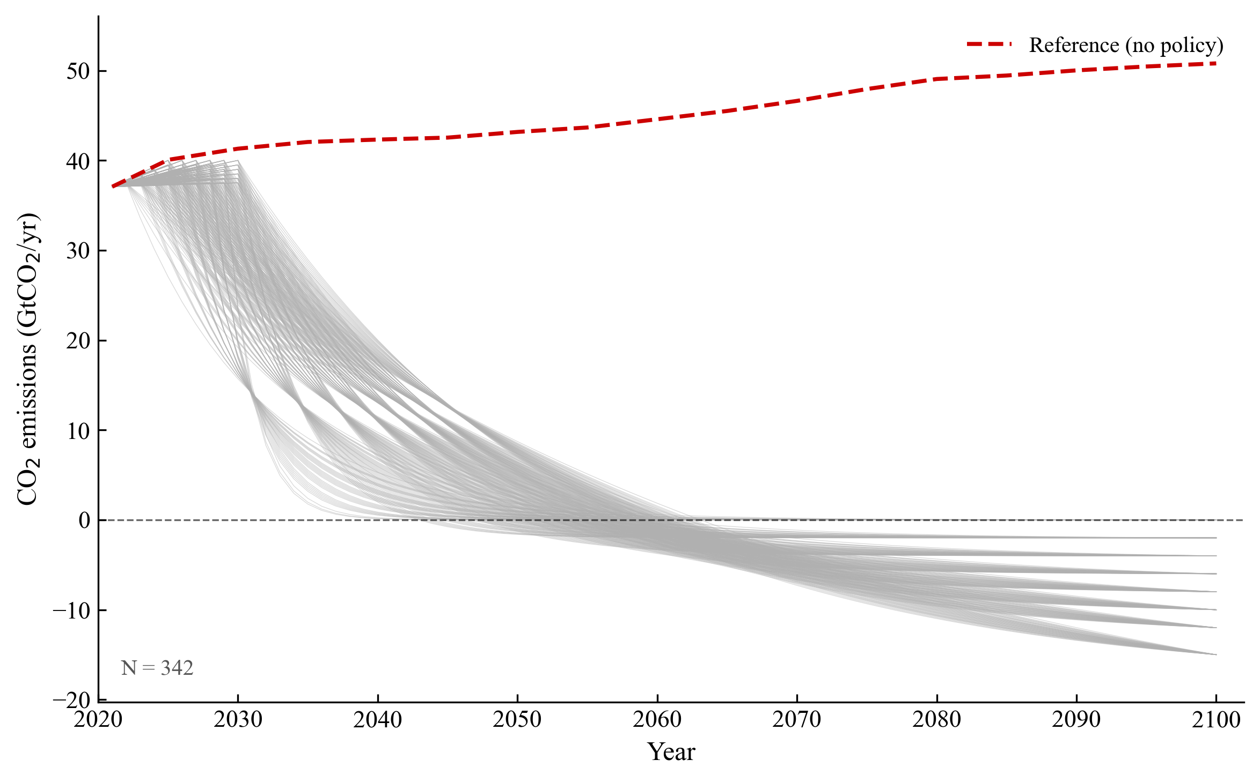
Figure S1. Emission pathways generated through uniform spatial sampling.
Bayesian optimization for output space expansion
Bayesian optimization complements uniform spatial sampling by targeting regions of the parameter space that are predicted to expand the observed range of each SDG indicator. For each indicator, a Gaussian process surrogate model is fitted to the existing data to identify where further exploration is most likely to approach the relevant attainable extreme specified by its optimization direction. During this process, peak year and end-of-century emission level are discretized at one-tenth of the uniform-sampling resolution, and the Bayesian-optimization module selects candidate configurations by maximizing the expected improvement acquisition function. The agent coordinates the resulting pathway generation, GCAM simulation and indicator extraction. Through this combined strategy, Bayesian optimization further expands indicator coverage and contributes to the final ensemble of 432 pathways analyzed in this study (Figure S2).
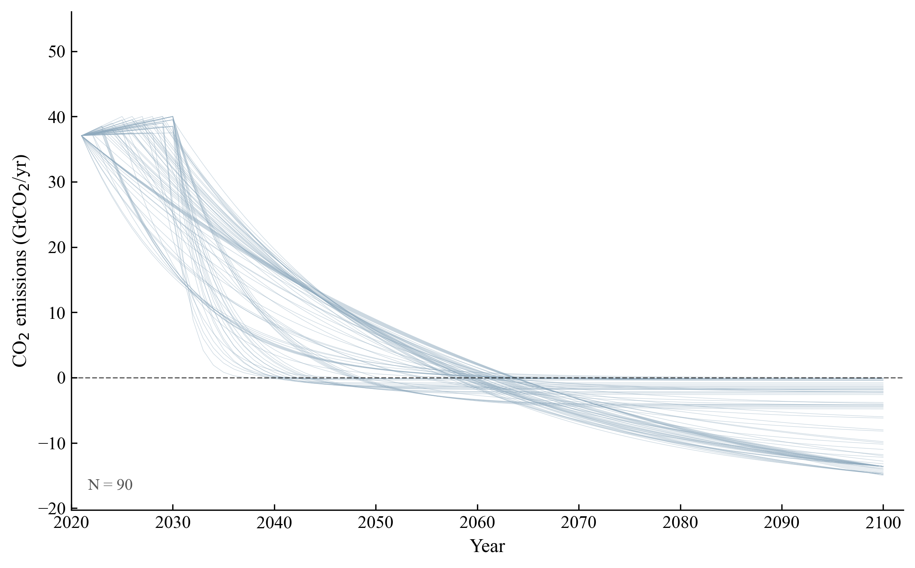
Figure S2. Emission pathways generated through Bayesian optimization.
Supplementary Note S3: Post-search multi-objective pathway optimization and SDG interaction analysis
The 432-pathway ensemble assembled through the LLM agent-driven space search is treated as the fixed input to the deterministic analyses described in this note. K-means clustering characterizes pathways according to their SDG outcomes, Pareto screening identifies cluster-specific non-dominated candidates, TOPSIS ranking supports representative-pathway selection and correlation analysis evaluates SDG interactions.
K-means clustering
K-means is applied to all 24 directionally adjusted and z-score-standardized SDG indicators. The algorithm minimizes the within-cluster sum of squares:
J = Σ(k=1 to K) Σ(i∈C_{k}) ‖x_{i} − μ_{k}‖²
where K is the number of clusters, C_{k} is the set of pathways assigned to cluster k, x_{i} ∈ ℝ²⁴ is the z-score-standardized SDG indicator vector of pathway i, and μ_{k} is the centroid of cluster k. The elbow method identifies K = 3 as the optimal cluster number, where the second-order difference of J reaches its maximum, indicating that additional clusters yield diminishing reduction in J (Figure S3).

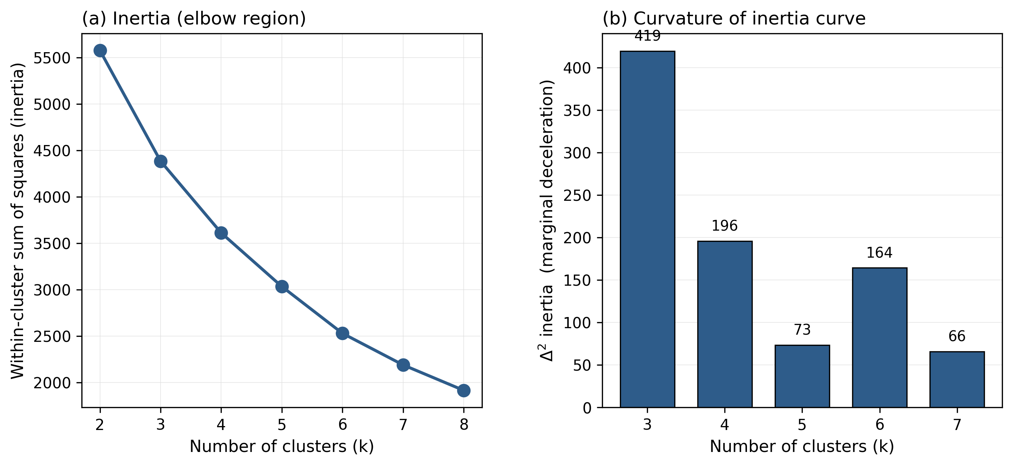
Figure S3. K-means cluster-number validation. (a) Within-cluster sum of squares (inertia) versus number of clusters. (b) Second-order difference of inertia.
Table S5. Directional adjustment of the 24 SDG indicators used for normalization. Direction indicates whether lower (↓) or higher (↑) values represent better sustainability performance. Indicators marked ↓ are transformed as 1 − normalized value during min-max normalization, while indicators marked ↑ retain the normalized value directly.
Indicator | Description | Direction
SDG1_1 | Share of household expenditure | ↓ Minimize
SDG2_1 | Food price | ↓ Minimize
SDG2_2 | Per capita caloric supply | ↑ Maximize
SDG2_3 | Staple crop production | ↑ Maximize
SDG3_1 | Air pollutant emissions | ↓ Minimize
SDG6_1 | Groundwater extraction | ↓ Minimize
SDG6_2 | Water consumption | ↓ Minimize
SDG7_1 | Share of renewable energy | ↑ Maximize
SDG7_2 | Electricity price | ↓ Minimize
SDG7_3 | Energy intensity | ↓ Minimize
SDG7_4 | Primary energy price | ↓ Minimize
SDG8_1 | Share of mitigation cost | ↓ Minimize
SDG9_1 | Industrial cumulative CO₂ | ↓ Minimize
SDG9_2 | Share of industrial clean energy | ↑ Maximize
SDG10_1 | Energy Gini coefficient | ↓ Minimize
SDG10_2 | Emissions Gini coefficient | ↓ Minimize
SDG11_1 | Building energy cost | ↓ Minimize
SDG11_2 | Transport energy cost | ↓ Minimize
SDG12_1 | CO₂ emissions intensity | ↓ Minimize
SDG12_2 | Crop productivity | ↑ Maximize
SDG13_1 | Peak warming | ↓ Minimize
SDG13_2 | Overshoot intensity | ↓ Minimize
SDG13_3 | Cumulative GHG emissions | ↓ Minimize
SDG15_1 | Forest land share | ↑ Maximize
To characterize the performance differences across clusters, all 24 indicators are first directionally transformed (Table S5) and min-max normalized to [0, 1], such that higher values consistently indicate better sustainability performance. Figure S4 presents the percentage difference in normalized mean indicator values between the two priority-driven clusters. The comparison shows that each cluster has exactly 12 indicators with higher normalized mean performance than the other, yielding two complementary 12-indicator subsets.

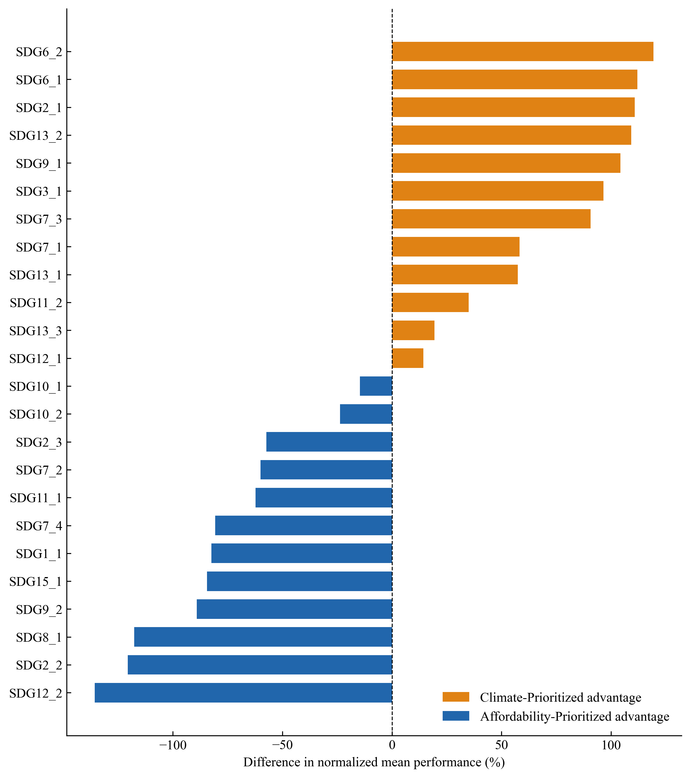
Figure S4. Percentage difference in directionally transformed and min-max normalized mean indicator values between the Climate-Prioritized and Affordability-Prioritized clusters. Positive values (orange) indicate indicators on which the Climate-Prioritized cluster shows superior normalized performance, while negative values (blue) indicate indicators favoring the Affordability-Prioritized cluster.

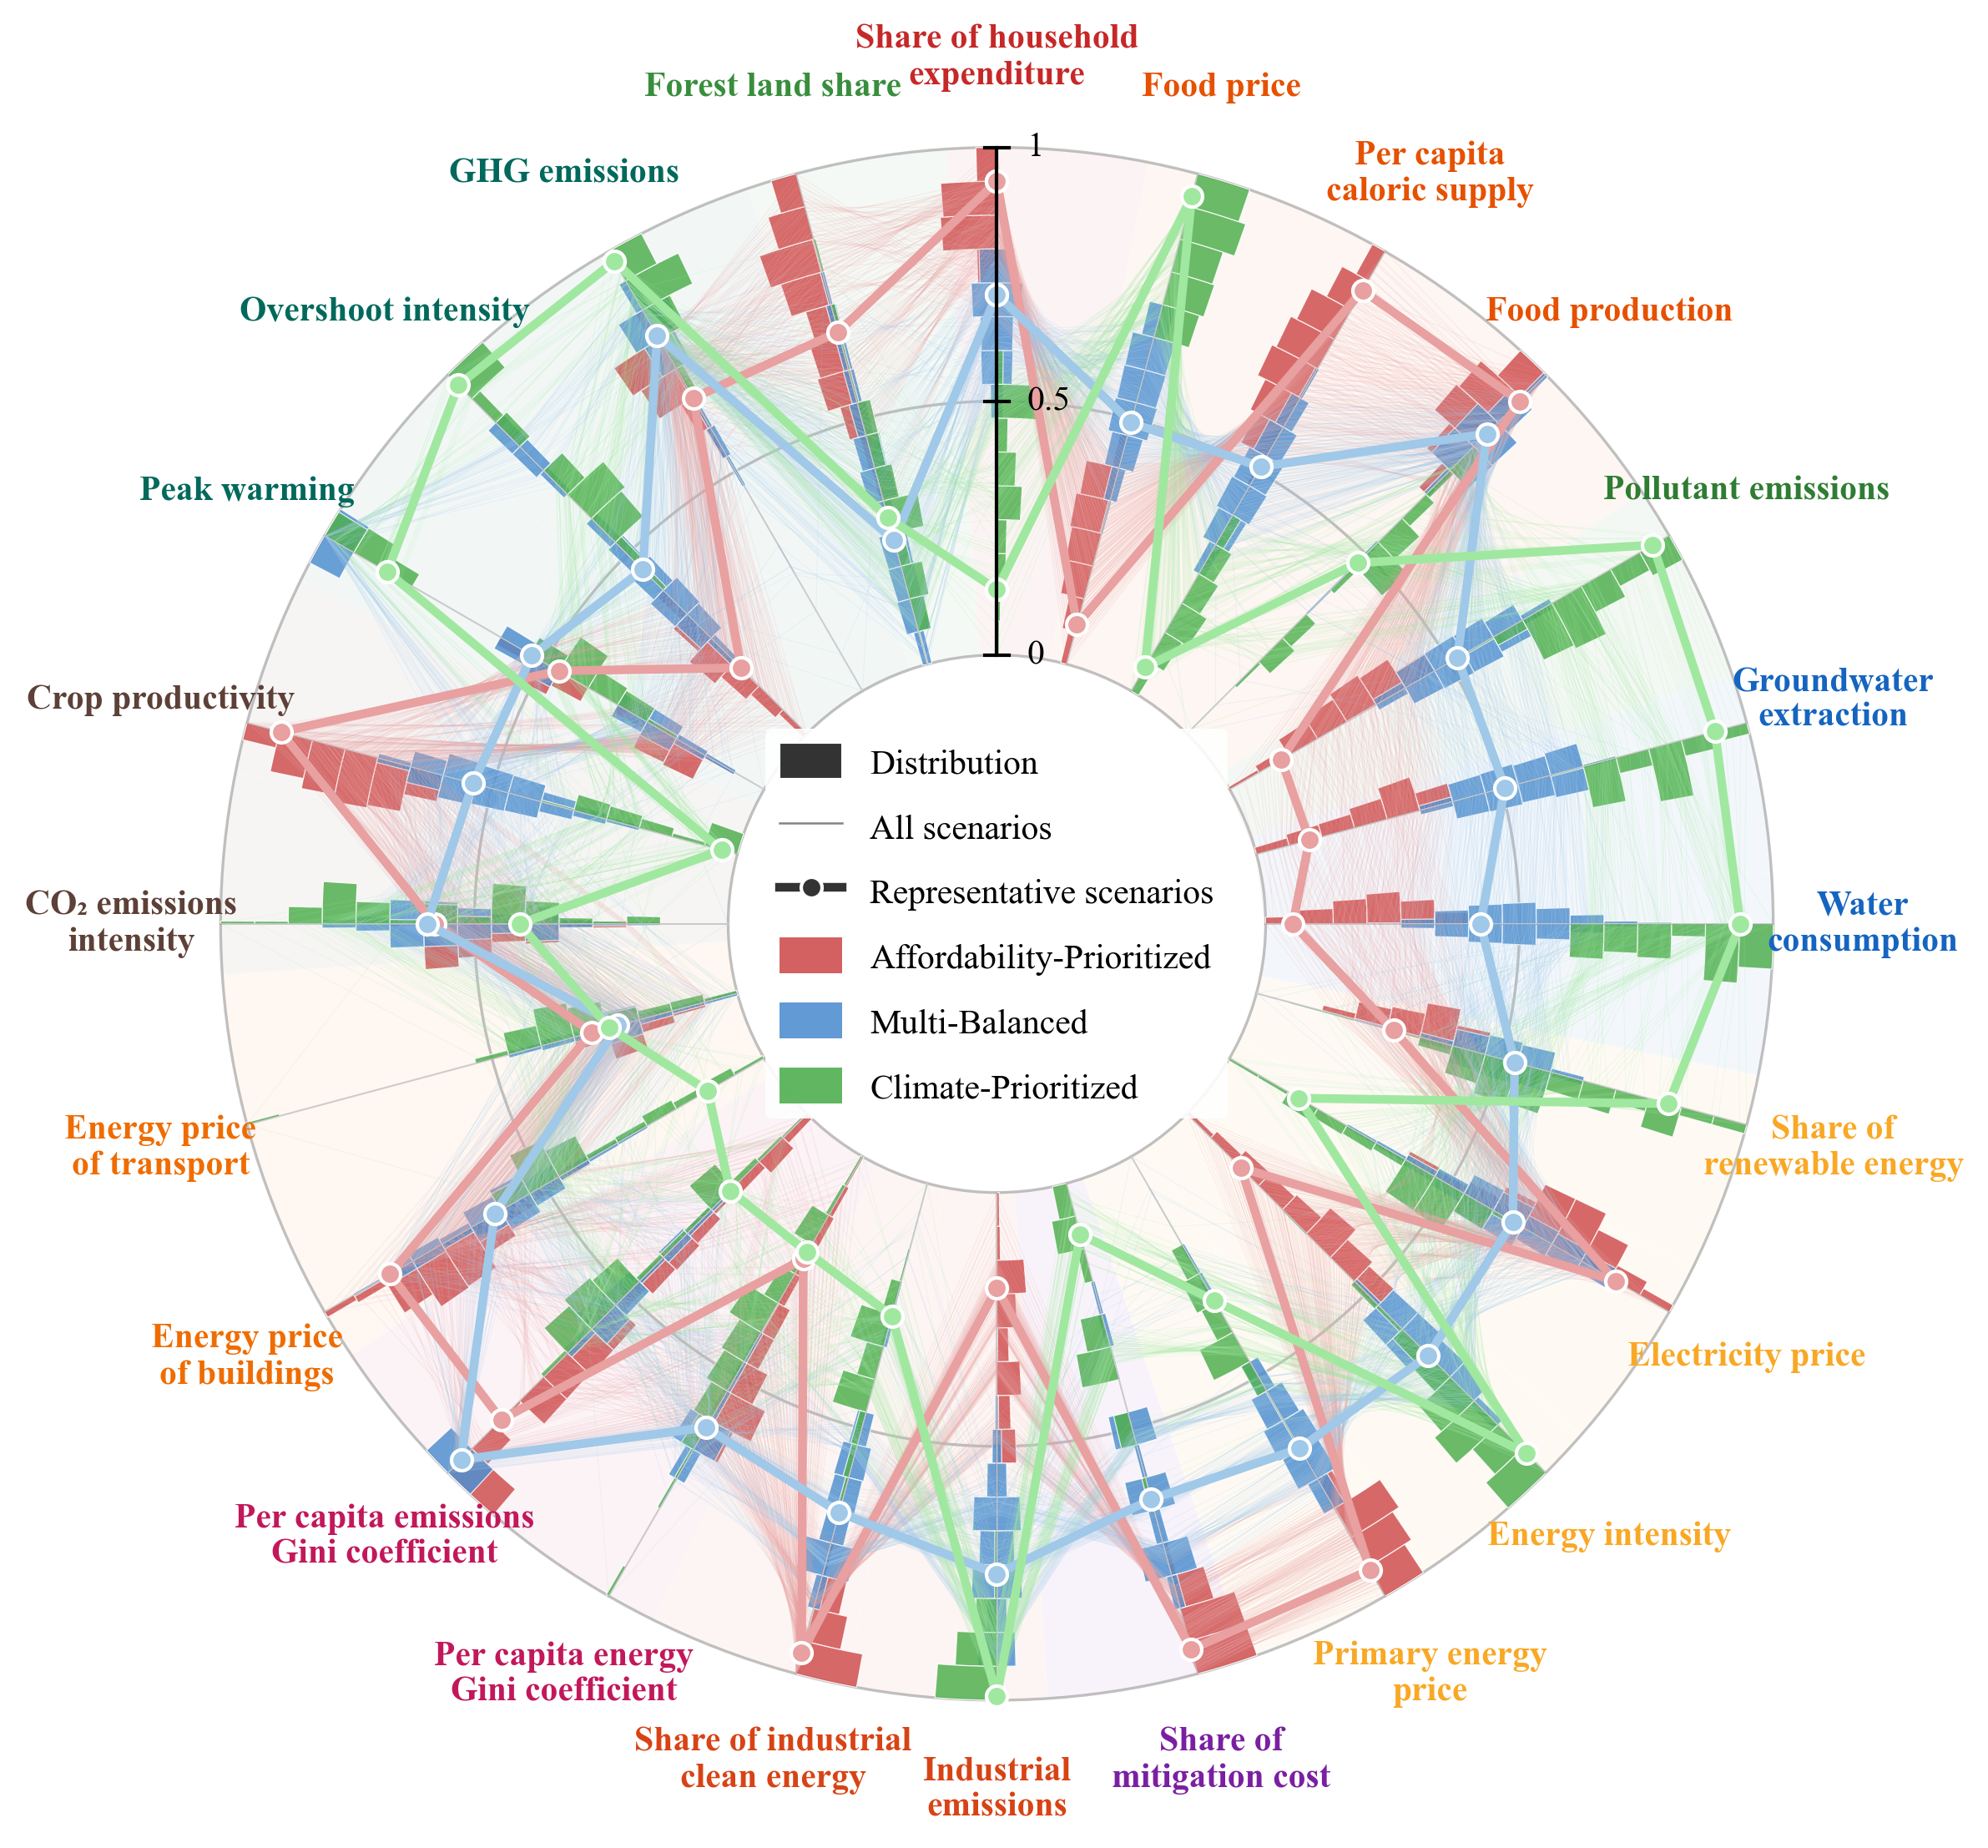
Figure S5. Radar chart of the normalized performance of the 24 SDG indicators for the Affordability-Prioritized, Multi-Balanced and Climate-Prioritized clusters. Thin lines, all pathways within each cluster; thick lines with markers, representative pathways. Values are normalized to [0, 1] with directional adjustment (Supplementary Table S5), so that outer positions indicate better performance. The three clusters are defined by K-means clustering on these 24 standardized SDG indicators.

Pareto frontier identification
Rather than applying Pareto screening globally across all 24 indicators, this study identifies the Pareto frontier independently within each cluster using cluster-specific indicator subsets. Based on the systematic performance advantages revealed in Figure S4, two complementary subsets emerge, with exactly 12 indicators favoring each priority-driven cluster. The Climate-Prioritized cluster uses the 12 indicators on which it shows superior performance (positive values in Figure S4) for Pareto screening, the Affordability-Prioritized cluster uses the 12 indicators favoring its performance (negative values in Figure S4), and the Multi-Balanced cluster retains all 24 indicators. A pathway a dominates pathway b if a performs no worse than b on every retained indicator and strictly better on at least one. All non-dominated pathways within each cluster constitute the cluster-specific Pareto frontier (Table S6).
Table S6. Pareto frontier summary by cluster.
Cluster | Total Pathways | Pareto-Optimal | Indicator Subset
Climate-Prioritized | 102 | 96 | 12 climate–environmental indicators
Multi-Balanced | 159 | 159 | All 24 indicators
Affordability-Prioritized | 171 | 171 | 12 economic–affordability indicators
TOPSIS-based representative pathway selection
For each cluster, TOPSIS (Hwang and Yoon, 1981) is applied to the Pareto-optimal pathways using the same cluster-specific indicator subset employed for Pareto screening. Indicator values are normalized to [0, 1] via min-max scaling within the Pareto set and directionally adjusted following Table S5, such that higher values consistently indicate better performance. The Euclidean distances to the ideal point and the negative-ideal point are computed, and pathways are ranked by their relative closeness score (Figure S6). TOPSIS ranking is then used to support the selection of one representative pathway from each cluster. The retained representative pathways are used consistently throughout the main text and all subsequent analyses.
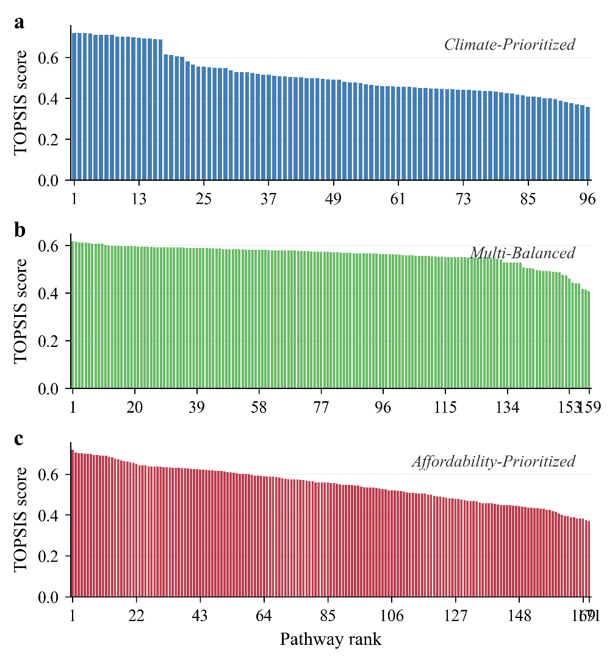
Figure S6. TOPSIS closeness scores for Pareto-optimal pathways within each cluster. Higher scores indicate better overall performance across the cluster-specific indicator subset.
SDG interaction analysis
Pairwise Pearson correlation coefficients are calculated among the 24 directionally adjusted and min-max normalized SDG indicators for the full pathway ensemble and separately within each of the three clusters. Because higher normalized values consistently indicate better performance, positive correlations represent indicators that tend to improve or deteriorate together, whereas negative correlations represent cases in which improvement in one indicator coincides with deterioration in another. Aggregate positive correlation strength is calculated as the sum of positive coefficients across all unique indicator pairs, while aggregate negative correlation strength is calculated as the sum of the absolute values of negative coefficients. Correlations between fossil-CCS, BECCS and DACCS deployment and the 24 SDG indicators are calculated using the same directionally adjusted data. No correlation threshold is applied, and ribbon width in the chord diagrams is proportional to |r|.
Supplementary Note S4: Supplementary results
Under the fixed cumulative carbon budget, mitigation pacing alone produces a sharp divergence in SDG outcomes across the full pathway ensemble (Supplementary Figure S7). This divergence arises endogenously from the intertemporal trade-offs that the budget imposes, as accelerating decarbonization in one period reduces the effort required in others, so that each pacing favors distinct SDG dimensions. Front-loaded mitigation primarily benefits climate and air-quality outcomes. Faster near-term emission reductions correlate negatively with overshoot intensity (SDG13_2, r = −0.79), peak warming (SDG13_1, r = −0.53) and air-pollutant emissions (SDG3_1, r = −0.82). However, because hydrogen, carbon capture and storage (CCS) and bioenergy remain technologically immature and costly in the near term, the bulk of near-term mitigation relies on electrification, which raises electricity prices (SDG7_2, r = 0.90) and building energy costs (SDG11_1, r = 0.86); these cost pressures propagate across the macroeconomy to raise the share of household expenditure (SDG1_1, r = 0.73) and the share of mitigation cost (SDG8_1, r = 0.57).
Mid- and long-term mitigation efforts instead exert growing pressure on food security (SDG 2) and water resources (SDG 6). Pathways that defer most mitigation to later decades require steeper decarbonization within the remaining window, driving large-scale deployment of bioenergy with CCS (BECCS), which competes with food production for arable land and increases freshwater consumption. These pressures appear most directly in elevated food prices (SDG2_1, r = 0.87), increased groundwater extraction (SDG6_1, r = 0.91) and intensified water consumption for energy production (SDG6_2, r = 0.86), with the correlations strengthening progressively from the mid-term to the long-term as BECCS scales up to offset delayed near-term reductions. No single mitigation pacing therefore optimizes all SDG outcomes simultaneously, which motivates the multi-objective optimization used to identify the representative pathways in the main text.
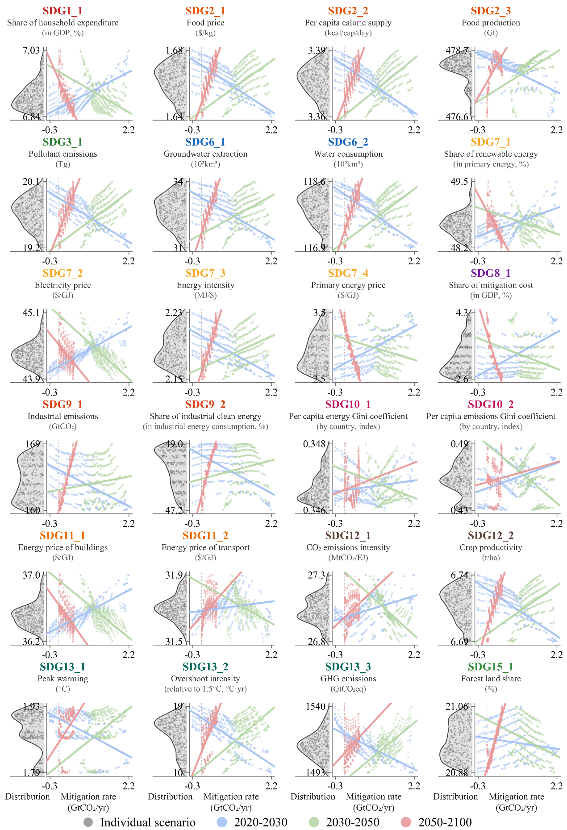
Figure S7. Distributions of the 24 SDG indicators across the full pathway ensemble and their sensitivity to mitigation pacing. For each indicator, the left half-violin shows its distribution across all converged pathways; the right panel plots the indicator value against the average annual emission-reduction rate in the near-term (2020–2030, blue), mid-term (2030–2050, green) and long-term (2050–2100, red), with Pearson correlation coefficients (r) reported by period. Negative rates indicate periods in which emissions are still rising.
Table S7. Regional SDG indicator values under the Climate-Prioritized pathway.
Region | 1.1 | 2.1 | 2.2 | 2.3 | 3.1 | 6.1 | 6.2 | 7.1 | 7.2 | 7.3 | 7.4 | 8.1 | 9.1 | 9.2 | 10.1 | 10.2 | 11.1 | 11.2 | 12.1 | 12.2 | 13.1 | 13.2 | 13.3 | 15.1
Africa_Eastern | 25.28 | 0.549 | 1.452 | 12.64 | 1052.4 | 5057.5 | 2745.4 | 80.98 | 10.89 | 7.055 | 0.734 | 2.263 | 5.749 | 85.63 | 0.347 | 0.475 | 7.286 | 7.819 | 10.76 | 3.389 | 1.804 | 9.829 | 98.01 | 1.790
Africa_Northern | 12.50 | 0.468 | 3.390 | 5.468 | 371.7 | 2762.9 | 7383.7 | 34.12 | 11.29 | 5.172 | 1.755 | 3.347 | 4.054 | 37.24 | 0.347 | 0.475 | 9.706 | 7.223 | 9.805 | 5.747 | 1.804 | 9.829 | 71.11 | 0.049
Africa_Southern | 24.05 | 0.507 | 2.816 | 16.42 | 1816.4 | 342.6 | 1387.6 | 63.17 | 11.51 | 5.754 | 1.085 | 3.828 | 3.513 | 74.01 | 0.347 | 0.475 | 8.912 | 7.825 | 10.41 | 5.108 | 1.804 | 9.829 | 48.16 | 8.206
Africa_Western | 19.91 | 0.494 | 0.717 | 68.40 | 3096.7 | 734.1 | 1397.8 | 69.67 | 11.15 | 5.519 | 0.701 | 1.987 | 14.79 | 69.57 | 0.347 | 0.475 | 5.421 | 7.439 | 15.15 | 7.526 | 1.804 | 9.829 | 165.1 | 17.02
Argentina | 16.88 | 0.559 | 42.08 | 14.78 | 115.8 | 72.87 | 696.7 | 45.96 | 8.996 | 5.581 | 0.982 | 4.056 | 0.962 | 34.22 | 0.347 | 0.475 | 8.288 | 7.092 | 4.764 | 5.387 | 1.804 | 9.829 | 0.641 | 4.737
Australia_NZ | 2.365 | 0.317 | 25.49 | 7.181 | 436.9 | 291.5 | 1627.4 | 38.98 | 8.909 | 3.366 | 1.266 | 2.341 | 1.970 | 38.65 | 0.347 | 0.475 | 8.967 | 7.508 | 5.968 | 3.346 | 1.804 | 9.829 | 5.869 | 2.824
Brazil | 5.713 | 0.240 | 2.128 | 31.11 | 604.7 | 263.5 | 1392.9 | 64.49 | 9.394 | 5.817 | 0.630 | 4.008 | 5.640 | 62.27 | 0.347 | 0.475 | 9.641 | 6.778 | 6.653 | 6.315 | 1.804 | 9.829 | 13.90 | 44.87
Canada | 3.963 | 0.320 | 18.28 | 8.296 | 363.6 | 15.21 | 128.9 | 54.94 | 9.299 | 4.352 | 0.763 | 3.350 | 2.205 | 44.32 | 0.347 | 0.475 | 8.978 | 7.168 | 6.195 | 4.491 | 1.804 | 9.829 | 16.49 | 41.81
Central America and Caribbean | 6.405 | 0.368 | 6.257 | 1.321 | 167.1 | 100.4 | 557.7 | 58.56 | 10.51 | 4.131 | 1.061 | 3.013 | 1.404 | 45.94 | 0.347 | 0.475 | 9.776 | 7.264 | 7.713 | 3.621 | 1.804 | 9.829 | 8.577 | 38.19
Central Asia | 13.13 | 0.313 | 6.234 | 5.065 | 354.7 | 869.5 | 6292.3 | 29.54 | 9.769 | 10.72 | 1.255 | 7.625 | 1.858 | 39.93 | 0.347 | 0.475 | 6.727 | 7.111 | 5.186 | 2.727 | 1.804 | 9.829 | 24.66 | 0.562
China | 9.358 | 0.441 | 1.422 | 63.49 | 2111.3 | 725.1 | 12812.5 | 43.15 | 9.901 | 5.301 | 0.931 | 5.869 | 37.31 | 41.45 | 0.347 | 0.475 | 8.526 | 7.266 | 6.970 | 12.92 | 1.804 | 9.829 | 181.8 | 15.05
Colombia | 9.127 | 0.444 | 15.49 | 0.884 | 90.55 | 0.000 | 215.6 | 50.34 | 9.043 | 4.723 | 1.210 | 3.662 | 0.600 | 48.17 | 0.347 | 0.475 | 8.883 | 7.572 | 5.674 | 14.90 | 1.804 | 9.829 | 5.440 | 50.80
EU-12 | 6.037 | 0.316 | 6.902 | 10.26 | 161.3 | 20.12 | 197.5 | 48.42 | 10.71 | 5.094 | 0.768 | 4.017 | 1.827 | 48.55 | 0.347 | 0.475 | 6.709 | 6.954 | 7.749 | 6.507 | 1.804 | 9.829 | 21.63 | 34.65
EU-15 | 3.298 | 0.375 | 1.955 | 21.35 | 484.0 | 273.8 | 3333.9 | 50.24 | 9.802 | 2.451 | 1.023 | 1.180 | 9.123 | 46.97 | 0.347 | 0.475 | 7.979 | 7.026 | 7.254 | 8.861 | 1.804 | 9.829 | 81.37 | 17.07
Europe_Non_EU | 7.324 | 0.355 | 5.630 | 6.716 | 184.1 | 465.5 | 1818.0 | 35.81 | 10.74 | 4.522 | 1.293 | 3.312 | 2.277 | 43.03 | 0.347 | 0.475 | 7.967 | 7.240 | 7.642 | 4.712 | 1.804 | 9.829 | 34.13 | 21.23
European Free Trade Association | 1.951 | 0.471 | 63.99 | 0.261 | 17.76 | 0.000 | 3.835 | 74.94 | 8.162 | 1.857 | -0.122 | 1.156 | 0.421 | 64.97 | 0.347 | 0.475 | 8.241 | 6.583 | 5.056 | 8.201 | 1.804 | 9.829 | 0.591 | 26.98
India | 8.526 | 0.261 | 0.296 | 42.37 | 1603.8 | 2005.4 | 28596.8 | 52.48 | 11.97 | 5.328 | 0.929 | 6.456 | 20.63 | 56.11 | 0.347 | 0.475 | 8.861 | 7.741 | 9.816 | 5.878 | 1.804 | 9.829 | 181.9 | 19.32
Indonesia | 9.980 | 0.331 | 2.428 | 8.477 | 666.1 | 0.000 | 1519.0 | 67.74 | 11.77 | 4.748 | -0.155 | 6.569 | 4.543 | 44.35 | 0.347 | 0.475 | 10.91 | 5.776 | 11.74 | 17.01 | 1.804 | 9.829 | 22.47 | 49.50
Japan | 4.064 | 0.782 | 21.80 | 1.012 | 100.5 | 155.5 | 240.3 | 40.54 | 10.18 | 2.701 | 1.272 | 1.834 | 2.559 | 36.13 | 0.347 | 0.475 | 9.354 | 7.472 | 7.122 | 7.613 | 1.804 | 9.829 | 13.21 | 51.03
Mexico | 5.101 | 0.290 | 4.362 | 4.053 | 197.3 | 1468.8 | 2054.0 | 44.26 | 9.003 | 4.169 | 1.171 | 3.000 | 1.503 | 49.21 | 0.347 | 0.475 | 8.544 | 6.945 | 4.668 | 4.873 | 1.804 | 9.829 | 11.29 | 19.39
Middle East | 11.48 | 0.966 | 3.726 | 4.289 | 782.3 | 6992.1 | 7953.0 | 20.95 | 10.33 | 9.069 | 1.850 | 3.887 | 12.25 | 18.25 | 0.347 | 0.475 | 8.942 | 7.019 | 6.911 | 2.892 | 1.804 | 9.829 | 151.1 | 0.228
Pakistan | 16.36 | 0.565 | 1.564 | 6.054 | 589.5 | 1989.0 | 10972.5 | 45.67 | 12.27 | 5.636 | 1.487 | 4.452 | 4.873 | 47.69 | 0.347 | 0.475 | 8.667 | 7.547 | 12.52 | 9.816 | 1.804 | 9.829 | 71.47 | 0.468
Russia | 8.963 | 0.223 | 4.877 | 16.79 | 1015.6 | 22.00 | 2262.2 | 33.78 | 9.607 | 15.71 | 0.861 | 12.33 | 7.335 | 38.90 | 0.347 | 0.475 | 5.777 | 6.997 | 5.623 | 3.795 | 1.804 | 9.829 | 71.46 | 29.69
South Africa | 6.498 | 0.337 | 9.265 | 2.462 | 203.3 | 94.60 | 539.7 | 41.70 | 11.30 | 5.993 | 1.328 | 8.033 | 1.719 | 51.39 | 0.347 | 0.475 | 9.846 | 7.528 | 10.05 | 5.493 | 1.804 | 9.829 | 18.22 | 2.284
South America_Northern | 7.461 | 0.688 | 45.76 | 0.571 | 152.8 | 2.849 | 229.0 | 49.88 | 11.59 | 3.761 | 1.371 | 3.203 | 0.284 | 47.75 | 0.347 | 0.475 | 12.22 | 6.905 | 3.884 | 5.714 | 1.804 | 9.829 | 15.71 | 65.03
South America_Southern | 7.844 | 0.309 | 8.428 | 6.589 | 318.4 | 374.4 | 2052.3 | 61.82 | 8.370 | 7.301 | 0.543 | 7.082 | 1.252 | 62.83 | 0.347 | 0.475 | 8.100 | 7.024 | 3.474 | 7.263 | 1.804 | 9.829 | −12.88 | 33.91
South Asia | 12.30 | 0.335 | 2.352 | 10.77 | 321.4 | 386.5 | 2580.8 | 52.66 | 10.75 | 4.009 | 1.312 | 2.642 | 2.470 | 55.68 | 0.347 | 0.475 | 9.020 | 6.882 | 10.07 | 12.82 | 1.804 | 9.829 | 32.90 | 11.32
South Korea | 6.492 | 0.875 | 65.23 | 0.483 | 60.18 | 14.91 | 55.17 | 24.27 | 10.10 | 5.000 | 2.044 | 2.048 | 1.660 | 35.48 | 0.347 | 0.475 | 8.928 | 7.179 | 5.315 | 7.119 | 1.804 | 9.829 | 19.03 | 28.30
Southeast Asia | 8.796 | 0.309 | 1.690 | 25.80 | 1102.0 | 174.0 | 4760.1 | 51.84 | 9.907 | 6.155 | 1.005 | 5.872 | 8.261 | 43.57 | 0.347 | 0.475 | 9.458 | 6.569 | 7.940 | 7.697 | 1.804 | 9.829 | 58.48 | 53.88
Taiwan | 3.590 | 0.327 | 51.61 | 0.209 | 18.02 | 0.000 | – | 25.97 | 10.57 | 5.579 | 2.009 | 2.503 | 0.868 | 34.34 | 0.347 | 0.475 | 10.55 | 6.383 | 5.701 | 14.10 | 1.804 | 9.829 | 8.559 | 53.12
USA | 2.660 | 0.301 | 2.121 | 61.59 | 964.1 | 3468.3 | 8729.4 | 38.71 | 9.506 | 3.559 | 1.232 | 2.048 | 11.23 | 35.02 | 0.347 | 0.475 | 8.445 | 7.103 | 4.689 | 8.050 | 1.804 | 9.829 | 67.95 | 24.41
Ukraine | 26.61 | 0.301 | 18.81 | 8.964 | 129.6 | 10.90 | 501.6 | 39.16 | 11.12 | 17.53 | 0.865 | 16.36 | 0.748 | 46.83 | 0.347 | 0.475 | 8.341 | 7.902 | 7.514 | 6.112 | 1.804 | 9.829 | 9.461 | 14.31
Table S8. Regional SDG indicator values under the Multi-Balanced pathway.
Region | 1.1 | 2.1 | 2.2 | 2.3 | 3.1 | 6.1 | 6.2 | 7.1 | 7.2 | 7.3 | 7.4 | 8.1 | 9.1 | 9.2 | 10.1 | 10.2 | 11.1 | 11.2 | 12.1 | 12.2 | 13.1 | 13.2 | 13.3 | 15.1
Africa_Eastern | 25.13 | 0.550 | 1.452 | 12.63 | 1053.7 | 5066.0 | 2749.9 | 81.77 | 10.88 | 7.050 | 0.682 | 2.233 | 5.801 | 86.13 | 0.349 | 0.463 | 7.257 | 7.915 | 10.83 | 3.388 | 1.768 | 10.98 | 96.17 | 1.789
Africa_Northern | 12.35 | 0.468 | 3.386 | 5.450 | 373.5 | 2776.9 | 7384.2 | 34.49 | 11.27 | 5.157 | 1.726 | 2.832 | 4.033 | 37.73 | 0.349 | 0.463 | 9.716 | 7.304 | 9.766 | 5.764 | 1.768 | 10.98 | 68.86 | 0.048
Africa_Southern | 23.90 | 0.508 | 2.816 | 16.43 | 1818.7 | 344.9 | 1387.8 | 63.92 | 11.51 | 5.748 | 1.047 | 3.611 | 3.496 | 74.55 | 0.349 | 0.463 | 8.865 | 7.932 | 10.36 | 5.108 | 1.768 | 10.98 | 46.59 | 8.209
Africa_Western | 19.82 | 0.494 | 0.716 | 68.40 | 3091.0 | 743.1 | 1402.2 | 69.94 | 11.15 | 5.486 | 0.685 | 1.782 | 14.56 | 70.35 | 0.349 | 0.463 | 5.460 | 7.544 | 14.98 | 7.516 | 1.768 | 10.98 | 161.8 | 17.03
Argentina | 16.76 | 0.559 | 42.03 | 14.79 | 116.8 | 70.70 | 694.2 | 41.82 | 8.982 | 5.817 | 1.114 | 3.035 | 0.974 | 35.79 | 0.349 | 0.463 | 8.271 | 7.213 | 4.535 | 5.390 | 1.768 | 10.98 | −1.313 | 4.769
Australia_NZ | 2.335 | 0.316 | 25.45 | 7.164 | 439.5 | 299.4 | 1625.7 | 37.85 | 8.849 | 3.527 | 1.287 | 1.935 | 1.999 | 39.62 | 0.349 | 0.463 | 8.951 | 7.609 | 5.697 | 3.346 | 1.768 | 10.98 | 1.095 | 2.815
Brazil | 5.540 | 0.240 | 2.124 | 31.14 | 609.9 | 290.1 | 1391.1 | 62.97 | 9.355 | 5.982 | 0.706 | 3.181 | 5.823 | 62.16 | 0.349 | 0.463 | 9.635 | 6.818 | 6.628 | 6.317 | 1.768 | 10.98 | 4.063 | 44.91
Canada | 3.847 | 0.318 | 18.23 | 8.325 | 364.8 | 15.44 | 126.4 | 50.31 | 9.260 | 4.385 | 0.994 | 1.973 | 2.220 | 44.61 | 0.349 | 0.463 | 8.895 | 7.270 | 6.161 | 4.482 | 1.768 | 10.98 | 20.32 | 42.03
Central America and Caribbean | 6.362 | 0.367 | 6.249 | 1.319 | 170.6 | 108.4 | 557.6 | 58.35 | 10.49 | 4.164 | 1.022 | 2.506 | 1.427 | 46.41 | 0.349 | 0.463 | 9.723 | 7.334 | 7.728 | 3.619 | 1.768 | 10.98 | 7.526 | 38.24
Central Asia | 12.95 | 0.313 | 6.227 | 5.056 | 360.2 | 908.2 | 6280.4 | 28.26 | 9.704 | 11.08 | 1.285 | 6.209 | 1.883 | 40.42 | 0.349 | 0.463 | 6.719 | 7.196 | 4.984 | 2.725 | 1.768 | 10.98 | 20.50 | 0.566
China | 9.248 | 0.438 | 1.419 | 63.58 | 2166.0 | 628.2 | 12781.8 | 41.75 | 9.789 | 5.376 | 0.944 | 4.301 | 38.57 | 41.91 | 0.349 | 0.463 | 8.456 | 7.309 | 7.082 | 12.91 | 1.768 | 10.98 | 196.5 | 15.06
Colombia | 9.060 | 0.443 | 15.47 | 0.883 | 91.53 | 0.000 | 215.5 | 49.69 | 9.021 | 4.825 | 1.208 | 3.110 | 0.605 | 49.17 | 0.349 | 0.463 | 8.886 | 7.629 | 5.487 | 14.90 | 1.768 | 10.98 | 3.998 | 50.81
EU-12 | 5.883 | 0.315 | 6.886 | 10.33 | 163.4 | 21.27 | 197.1 | 45.21 | 10.64 | 5.116 | 0.913 | 2.632 | 1.847 | 48.90 | 0.349 | 0.463 | 6.616 | 7.026 | 7.780 | 6.497 | 1.768 | 10.98 | 25.16 | 34.80
EU-15 | 3.257 | 0.374 | 1.951 | 21.41 | 489.0 | 289.3 | 3336.2 | 49.46 | 9.772 | 2.458 | 1.088 | 0.806 | 9.135 | 47.36 | 0.349 | 0.463 | 7.933 | 7.089 | 7.238 | 8.854 | 1.768 | 10.98 | 84.98 | 17.11
Europe_Non_EU | 7.188 | 0.354 | 5.618 | 6.742 | 193.0 | 486.1 | 1823.3 | 34.23 | 10.67 | 4.534 | 1.361 | 2.402 | 2.276 | 43.17 | 0.349 | 0.463 | 7.905 | 7.320 | 7.604 | 4.707 | 1.768 | 10.98 | 35.66 | 21.33
European Free Trade Association | 1.954 | 0.469 | 63.85 | 0.263 | 17.66 | 0.000 | 3.607 | 73.30 | 8.255 | 1.861 | 0.078 | 0.731 | 0.424 | 64.63 | 0.349 | 0.463 | 8.290 | 6.723 | 5.077 | 8.175 | 1.768 | 10.98 | 1.059 | 27.34
India | 8.415 | 0.260 | 0.296 | 42.35 | 1653.9 | 2017.9 | 28656.1 | 52.03 | 11.89 | 5.342 | 0.926 | 5.141 | 20.96 | 56.63 | 0.349 | 0.463 | 8.789 | 7.834 | 9.921 | 5.873 | 1.768 | 10.98 | 182.3 | 19.34
Indonesia | 9.555 | 0.329 | 2.421 | 8.487 | 674.2 | 0.000 | 1515.5 | 61.70 | 11.81 | 4.758 | 0.041 | 4.381 | 4.564 | 44.60 | 0.349 | 0.463 | 10.94 | 5.875 | 11.75 | 16.96 | 1.768 | 10.98 | 29.54 | 49.75
Japan | 4.003 | 0.774 | 21.73 | 1.019 | 101.3 | 155.5 | 234.7 | 39.08 | 10.05 | 2.722 | 1.306 | 1.314 | 2.589 | 36.51 | 0.349 | 0.463 | 9.189 | 7.529 | 7.130 | 7.563 | 1.768 | 10.98 | 15.44 | 51.79
Mexico | 5.062 | 0.289 | 4.353 | 4.067 | 199.9 | 1461.4 | 2044.7 | 41.53 | 8.964 | 4.239 | 1.246 | 2.238 | 1.521 | 49.55 | 0.349 | 0.463 | 8.530 | 7.015 | 4.602 | 4.866 | 1.768 | 10.98 | 10.70 | 19.47
Middle East | 11.31 | 0.967 | 3.718 | 4.263 | 797.4 | 7036.5 | 7966.1 | 21.93 | 10.25 | 9.102 | 1.833 | 3.266 | 12.26 | 18.58 | 0.349 | 0.463 | 8.878 | 7.081 | 6.876 | 2.898 | 1.768 | 10.98 | 144.6 | 0.226
Pakistan | 16.25 | 0.565 | 1.563 | 6.046 | 588.7 | 1992.4 | 10970.0 | 45.75 | 12.29 | 5.616 | 1.477 | 3.990 | 4.782 | 48.66 | 0.349 | 0.463 | 8.726 | 7.662 | 12.32 | 9.824 | 1.768 | 10.98 | 69.66 | 0.466
Russia | 8.710 | 0.222 | 4.868 | 16.86 | 1027.0 | 30.04 | 2250.8 | 29.35 | 9.518 | 15.95 | 1.033 | 8.215 | 7.451 | 39.12 | 0.349 | 0.463 | 5.701 | 7.118 | 5.615 | 3.798 | 1.768 | 10.98 | 79.89 | 29.86
South Africa | 6.413 | 0.337 | 9.254 | 2.468 | 212.4 | 98.88 | 539.1 | 41.28 | 11.18 | 6.003 | 1.320 | 6.070 | 1.731 | 51.88 | 0.349 | 0.463 | 9.736 | 7.609 | 10.07 | 5.501 | 1.768 | 10.98 | 18.66 | 2.265
South America_Northern | 7.410 | 0.687 | 45.67 | 0.570 | 154.5 | 2.851 | 226.9 | 47.33 | 11.52 | 4.025 | 1.435 | 2.664 | 0.295 | 46.99 | 0.349 | 0.463 | 12.20 | 6.956 | 3.649 | 5.717 | 1.768 | 10.98 | 14.61 | 65.10
South America_Southern | 7.790 | 0.308 | 8.410 | 6.607 | 320.4 | 362.8 | 2052.0 | 56.65 | 8.419 | 7.189 | 0.823 | 4.433 | 1.228 | 59.05 | 0.349 | 0.463 | 8.145 | 7.124 | 3.584 | 7.242 | 1.768 | 10.98 | −12.55 | 33.99
South Asia | 12.22 | 0.334 | 2.350 | 10.77 | 324.7 | 396.9 | 2580.6 | 52.37 | 10.74 | 4.005 | 1.311 | 2.185 | 2.456 | 56.30 | 0.349 | 0.463 | 9.029 | 7.011 | 10.02 | 12.83 | 1.768 | 10.98 | 32.39 | 11.34
South Korea | 6.408 | 0.872 | 65.10 | 0.482 | 61.21 | 12.64 | 55.31 | 24.44 | 9.978 | 5.017 | 2.068 | 1.511 | 1.703 | 35.65 | 0.349 | 0.463 | 8.785 | 7.218 | 5.435 | 7.117 | 1.768 | 10.98 | 19.75 | 28.21
Southeast Asia | 8.678 | 0.308 | 1.688 | 25.79 | 1126.1 | 187.4 | 4774.6 | 50.52 | 9.897 | 6.176 | 0.998 | 4.466 | 8.375 | 43.81 | 0.349 | 0.463 | 9.414 | 6.650 | 8.012 | 7.690 | 1.768 | 10.98 | 60.68 | 54.06
Taiwan | 3.528 | 0.326 | 51.52 | 0.209 | 18.13 | 0.000 | – | 25.92 | 10.43 | 5.604 | 2.052 | 1.785 | 0.889 | 34.43 | 0.349 | 0.463 | 10.37 | 6.447 | 5.812 | 14.09 | 1.768 | 10.98 | 9.041 | 53.02
USA | 2.622 | 0.301 | 2.118 | 62.02 | 973.9 | 3472.2 | 8664.9 | 36.63 | 9.478 | 3.607 | 1.283 | 1.525 | 11.35 | 35.94 | 0.349 | 0.463 | 8.412 | 7.169 | 4.623 | 8.066 | 1.768 | 10.98 | 66.07 | 24.48
Ukraine | 26.09 | 0.300 | 18.78 | 8.964 | 130.2 | 10.90 | 501.7 | 37.57 | 11.05 | 17.63 | 0.912 | 12.00 | 0.764 | 46.98 | 0.349 | 0.463 | 8.264 | 7.980 | 7.593 | 6.114 | 1.768 | 10.98 | 9.882 | 14.36
Table S9. Regional SDG indicator values under the Affordability-Prioritized pathway.
Region | 1.1 | 2.1 | 2.2 | 2.3 | 3.1 | 6.1 | 6.2 | 7.1 | 7.2 | 7.3 | 7.4 | 8.1 | 9.1 | 9.2 | 10.1 | 10.2 | 11.1 | 11.2 | 12.1 | 12.2 | 13.1 | 13.2 | 13.3 | 15.1
Africa_Eastern | 25.08 | 0.551 | 1.454 | 12.62 | 1056.6 | 5085.0 | 2760.5 | 81.67 | 10.87 | 7.049 | 0.721 | 2.149 | 5.800 | 86.31 | 0.351 | 0.450 | 7.242 | 7.985 | 10.82 | 3.387 | 1.832 | 15.86 | 95.33 | 1.788
Africa_Northern | 12.23 | 0.469 | 3.388 | 5.446 | 381.1 | 2809.9 | 7400.4 | 33.96 | 11.21 | 5.157 | 1.719 | 2.416 | 4.043 | 37.92 | 0.351 | 0.450 | 9.707 | 7.363 | 9.756 | 5.779 | 1.832 | 15.86 | 68.83 | 0.048
Africa_Southern | 23.87 | 0.510 | 2.818 | 16.45 | 1827.1 | 345.7 | 1390.5 | 63.30 | 11.49 | 5.751 | 1.075 | 3.411 | 3.454 | 74.69 | 0.351 | 0.450 | 8.839 | 8.010 | 10.23 | 5.108 | 1.832 | 15.86 | 46.17 | 8.211
Africa_Western | 19.81 | 0.495 | 0.717 | 68.43 | 3087.5 | 752.5 | 1411.0 | 69.64 | 11.14 | 5.466 | 0.718 | 1.690 | 14.28 | 70.66 | 0.351 | 0.450 | 5.510 | 7.624 | 14.74 | 7.512 | 1.832 | 15.86 | 159.9 | 17.03
Argentina | 16.66 | 0.560 | 42.03 | 14.81 | 118.7 | 79.89 | 694.3 | 39.26 | 8.922 | 6.327 | 1.175 | 2.928 | 0.996 | 36.40 | 0.351 | 0.450 | 8.241 | 7.262 | 4.166 | 5.395 | 1.832 | 15.86 | −5.527 | 4.786
Australia_NZ | 2.310 | 0.317 | 25.44 | 7.162 | 444.1 | 311.7 | 1628.5 | 37.05 | 8.770 | 3.819 | 1.268 | 1.808 | 2.040 | 39.49 | 0.351 | 0.450 | 8.905 | 7.656 | 5.291 | 3.348 | 1.832 | 15.86 | −4.722 | 2.815
Brazil | 5.489 | 0.240 | 2.125 | 31.14 | 624.6 | 371.8 | 1421.7 | 61.80 | 9.305 | 6.374 | 0.742 | 3.080 | 6.136 | 61.16 | 0.351 | 0.450 | 9.613 | 6.720 | 6.463 | 6.321 | 1.832 | 15.86 | −10.86 | 44.90
Canada | 3.770 | 0.318 | 18.23 | 8.334 | 369.4 | 16.00 | 125.8 | 48.46 | 9.221 | 4.442 | 1.067 | 1.454 | 2.259 | 44.47 | 0.351 | 0.450 | 8.807 | 7.307 | 6.165 | 4.480 | 1.832 | 15.86 | 21.42 | 42.12
Central America and Caribbean | 6.337 | 0.367 | 6.248 | 1.321 | 176.4 | 113.4 | 560.4 | 56.87 | 10.48 | 4.259 | 1.033 | 2.155 | 1.465 | 46.01 | 0.351 | 0.450 | 9.691 | 7.348 | 7.670 | 3.618 | 1.832 | 15.86 | 7.299 | 38.30
Central Asia | 12.80 | 0.313 | 6.230 | 5.052 | 371.1 | 956.2 | 6286.9 | 27.05 | 9.642 | 11.72 | 1.301 | 5.540 | 1.964 | 39.97 | 0.351 | 0.450 | 6.705 | 7.250 | 4.788 | 2.725 | 1.832 | 15.86 | 15.75 | 0.568
China | 9.155 | 0.437 | 1.418 | 63.66 | 2224.0 | 496.1 | 12789.0 | 39.85 | 9.615 | 5.542 | 0.966 | 3.151 | 40.75 | 41.65 | 0.351 | 0.450 | 8.340 | 7.314 | 7.234 | 12.90 | 1.832 | 15.86 | 230.7 | 15.12
Colombia | 9.011 | 0.443 | 15.47 | 0.883 | 93.35 | 0.000 | 215.6 | 47.65 | 9.008 | 5.100 | 1.248 | 2.892 | 0.626 | 48.41 | 0.351 | 0.450 | 8.884 | 7.648 | 5.216 | 14.90 | 1.832 | 15.86 | 2.563 | 50.82
EU-12 | 5.767 | 0.315 | 6.885 | 10.36 | 166.1 | 22.60 | 196.9 | 43.48 | 10.51 | 5.152 | 0.982 | 1.869 | 1.883 | 48.71 | 0.351 | 0.450 | 6.520 | 7.050 | 7.850 | 6.495 | 1.832 | 15.86 | 28.29 | 34.91
EU-15 | 3.223 | 0.374 | 1.951 | 21.43 | 495.1 | 312.0 | 3344.0 | 49.06 | 9.733 | 2.471 | 1.116 | 0.621 | 9.253 | 47.29 | 0.351 | 0.450 | 7.894 | 7.120 | 7.289 | 8.851 | 1.832 | 15.86 | 89.44 | 17.18
Europe_Non_EU | 7.087 | 0.354 | 5.617 | 6.757 | 212.3 | 510.6 | 1834.4 | 33.42 | 10.52 | 4.562 | 1.371 | 1.842 | 2.321 | 42.83 | 0.351 | 0.450 | 7.807 | 7.349 | 7.679 | 4.709 | 1.832 | 15.86 | 37.73 | 21.36
European Free Trade Association | 1.952 | 0.468 | 63.85 | 0.264 | 17.73 | 0.000 | 3.437 | 71.68 | 8.300 | 1.872 | 0.219 | 0.539 | 0.430 | 64.33 | 0.351 | 0.450 | 8.301 | 6.795 | 5.117 | 8.160 | 1.832 | 15.86 | 1.399 | 27.65
India | 8.287 | 0.260 | 0.296 | 42.37 | 1734.2 | 2033.8 | 28717.5 | 50.16 | 11.73 | 5.378 | 0.964 | 4.033 | 21.46 | 55.96 | 0.351 | 0.450 | 8.656 | 7.866 | 10.06 | 5.872 | 1.832 | 15.86 | 195.2 | 19.35
Indonesia | 9.273 | 0.329 | 2.419 | 8.499 | 703.4 | 0.000 | 1517.7 | 56.96 | 11.69 | 4.784 | 0.152 | 3.229 | 4.620 | 44.08 | 0.351 | 0.450 | 10.83 | 5.848 | 11.80 | 16.93 | 1.832 | 15.86 | 36.04 | 49.87
Japan | 3.948 | 0.770 | 21.71 | 1.023 | 102.9 | 155.5 | 230.8 | 37.47 | 9.889 | 2.761 | 1.331 | 0.970 | 2.673 | 36.31 | 0.351 | 0.450 | 9.008 | 7.525 | 7.212 | 7.533 | 1.832 | 15.86 | 18.48 | 52.44
Mexico | 5.033 | 0.289 | 4.352 | 4.080 | 204.8 | 1477.2 | 2049.0 | 39.80 | 8.931 | 4.423 | 1.273 | 1.966 | 1.572 | 48.70 | 0.351 | 0.450 | 8.509 | 7.052 | 4.503 | 4.868 | 1.832 | 15.86 | 9.260 | 19.49
Middle East | 11.18 | 0.969 | 3.718 | 4.251 | 823.7 | 7093.1 | 8003.3 | 22.51 | 10.16 | 9.213 | 1.813 | 2.846 | 12.40 | 18.81 | 0.351 | 0.450 | 8.799 | 7.101 | 6.861 | 2.904 | 1.832 | 15.86 | 140.6 | 0.225
Pakistan | 16.15 | 0.566 | 1.564 | 6.043 | 599.7 | 1998.5 | 10957.5 | 44.60 | 12.27 | 5.603 | 1.504 | 3.565 | 4.742 | 48.96 | 0.351 | 0.450 | 8.774 | 7.728 | 12.23 | 9.823 | 1.832 | 15.86 | 69.67 | 0.466
Russia | 8.489 | 0.223 | 4.867 | 16.94 | 1058.8 | 30.16 | 2261.5 | 27.78 | 9.438 | 16.29 | 1.077 | 6.324 | 7.678 | 38.88 | 0.351 | 0.450 | 5.650 | 7.158 | 5.663 | 3.809 | 1.832 | 15.86 | 83.34 | 29.94
South Africa | 6.325 | 0.337 | 9.252 | 2.480 | 230.5 | 102.9 | 540.3 | 39.92 | 10.98 | 6.036 | 1.282 | 4.540 | 1.766 | 51.39 | 0.351 | 0.450 | 9.543 | 7.642 | 10.17 | 5.511 | 1.832 | 15.86 | 20.39 | 2.265
South America_Northern | 7.373 | 0.687 | 45.65 | 0.571 | 157.1 | 2.854 | 226.1 | 44.15 | 11.45 | 4.422 | 1.517 | 2.311 | 0.316 | 45.32 | 0.351 | 0.450 | 12.16 | 6.955 | 3.445 | 5.720 | 1.832 | 15.86 | 13.41 | 65.14
South America_Southern | 7.754 | 0.308 | 8.408 | 6.619 | 327.7 | 372.8 | 2057.2 | 54.40 | 8.422 | 7.727 | 0.866 | 4.165 | 1.331 | 58.26 | 0.351 | 0.450 | 8.168 | 7.171 | 3.512 | 7.247 | 1.832 | 15.86 | −18.67 | 34.02
South Asia | 12.16 | 0.335 | 2.350 | 10.77 | 333.0 | 409.7 | 2582.7 | 51.04 | 10.72 | 4.008 | 1.360 | 1.824 | 2.468 | 56.14 | 0.351 | 0.450 | 9.027 | 7.067 | 10.05 | 12.84 | 1.832 | 15.86 | 33.05 | 11.34
South Korea | 6.346 | 0.872 | 65.12 | 0.482 | 62.66 | 10.13 | 55.59 | 24.42 | 9.785 | 5.048 | 2.048 | 1.101 | 1.781 | 35.52 | 0.351 | 0.450 | 8.621 | 7.188 | 5.648 | 7.118 | 1.832 | 15.86 | 21.36 | 28.16
Southeast Asia | 8.591 | 0.308 | 1.687 | 25.81 | 1173.2 | 199.1 | 4797.3 | 48.14 | 9.854 | 6.237 | 1.022 | 3.462 | 8.634 | 43.44 | 0.351 | 0.450 | 9.351 | 6.670 | 8.157 | 7.690 | 1.832 | 15.86 | 68.54 | 54.19
Taiwan | 3.463 | 0.326 | 51.52 | 0.208 | 18.80 | 0.000 | – | 25.92 | 10.16 | 5.647 | 2.037 | 1.290 | 0.923 | 34.27 | 0.351 | 0.450 | 10.09 | 6.420 | 5.981 | 14.10 | 1.832 | 15.86 | 9.806 | 52.94
USA | 2.587 | 0.301 | 2.118 | 62.31 | 991.7 | 3583.7 | 8675.7 | 35.43 | 9.425 | 3.743 | 1.299 | 1.312 | 11.64 | 36.15 | 0.351 | 0.450 | 8.377 | 7.173 | 4.478 | 8.086 | 1.832 | 15.86 | 51.14 | 24.51
Ukraine | 25.68 | 0.301 | 18.78 | 8.976 | 132.0 | 10.90 | 503.0 | 35.68 | 10.98 | 17.83 | 0.981 | 9.111 | 0.797 | 46.49 | 0.351 | 0.450 | 8.206 | 8.015 | 7.781 | 6.120 | 1.832 | 15.86 | 10.69 | 14.38
Supplementary References
Bataille, C. et al. A review of technology and policy deep decarbonization pathway options for making energy-intensive industry production consistent with the Paris Agreement. J. Clean. Prod. 187, 960–973 (2018).
Bertram, C. et al. Complementing carbon prices with technology policies to keep climate targets within reach. Nat. Clim. Change 5, 235–239 (2015).
Calvin, K. et al. GCAM v5.1: representing the linkages between energy, water, land, climate, and economic systems. Geosci. Model Dev. 12, 677–698 (2019).
Davies, E. G. R., Kyle, P. & Edmonds, J. A. An integrated assessment of global and regional water demands for electricity generation to 2095. Adv. Water Resour. 52, 296–313 (2013).
Davis, S. J. et al. Net-zero emissions energy systems. Science 360, eaas9793 (2018).
Fujimori, S. et al. A multi-model assessment of food security implications of climate change mitigation. Nat. Sustain. 2, 386–396 (2019).
Geden, O. & Löschel, A. Define limits for temperature overshoot targets. Nat. Geosci. 10, 881–882 (2017).
Hasegawa, T. et al. Risk of increased food insecurity under stringent global climate change mitigation policy. Nat. Clim. Change 8, 699–703 (2018).
Hartin, C. A., Patel, P., Schwarber, A., Link, R. P. & Bond-Lamberty, B. A simple object-oriented and open-source model for scientific and policy analyses of the global climate system – Hector v1.0. Geosci. Model Dev. 8, 939–955 (2015).
Hejazi, M. I. et al. Long-term global water projections using six socioeconomic scenarios in an integrated assessment modeling framework. Technol. Forecast. Soc. Change 81, 205–226 (2014).
Hwang, C.-L. & Yoon, K. Multiple Attribute Decision Making: Methods and Applications: A State-of-the-Art Survey. Lecture Notes in Economics and Mathematical Systems 186 (Springer, 1981).
IEA. Global Energy Review 2021 (IEA, 2021).
IEA. World Energy Outlook 2023 (IEA, 2023).
IPCC. Climate Change 2021: The Physical Science Basis. Contribution of Working Group I to the Sixth Assessment Report of the Intergovernmental Panel on Climate Change (Cambridge Univ. Press, 2021).
IPCC. Climate Change 2022: Mitigation of Climate Change. Contribution of Working Group III to the Sixth Assessment Report of the Intergovernmental Panel on Climate Change (Cambridge Univ. Press, 2022).
IPCC. Climate Change 2023: Synthesis Report. Contribution of Working Groups I, II and III to the Sixth Assessment Report of the Intergovernmental Panel on Climate Change [Core Writing Team, H. Lee and J. Romero (eds.)] (IPCC, Geneva, Switzerland, 2023).
Kim, S. H. et al. Balancing global water availability and use at basin scale in an integrated assessment model. Clim. Change 136, 217–231 (2016).
Markandya, A. et al. Health co-benefits from air pollution and mitigation costs of the Paris Agreement: a modelling study. Lancet Planet. Health 2, e126–e133 (2018).
McCollum, D. L. et al. Energy investment needs for fulfilling the Paris Agreement and achieving the Sustainable Development Goals. Nat. Energy 3, 589–599 (2018).
Moreno, J. et al. The impacts of decarbonization pathways on Sustainable Development Goals in the European Union. Commun. Earth Environ. 5, 136 (2024).
Myhre, G. et al. Anthropogenic and natural radiative forcing. In Climate Change 2013: The Physical Science Basis (eds Stocker, T. F. et al.) 659–740 (Cambridge Univ. Press, 2013).
Oswald, Y., Owen, A. & Steinberger, J. K. Large inequality in international and intranational energy footprints between income groups and across consumption categories. Nat. Energy 5, 231–239 (2020).
Pachauri, S. et al. Pathways to achieve universal household access to modern energy by 2030. Environ. Res. Lett. 8, 024015 (2013).
Popp, A. et al. Land-use futures in the shared socio-economic pathways. Glob. Environ. Change 42, 331–345 (2017).
Rao, S. et al. A multi-model assessment of the co-benefits of climate mitigation for global air quality. Environ. Res. Lett. 11, 124013 (2016).
Riahi, K. et al. The Shared Socioeconomic Pathways and their energy, land use, and greenhouse gas emissions implications: an overview. Glob. Environ. Change 42, 153–168 (2017).
Riahi, K. et al. Cost and attainability of meeting stringent climate targets without overshoot. Nat. Clim. Change 11, 1063–1069 (2021).
Rissman, J. et al. Technologies and policies to decarbonize global industry: review and assessment of mitigation drivers through 2070. Appl. Energy 266, 114848 (2020).
Rogelj, J. et al. Scenarios towards limiting global mean temperature increase below 1.5 °C. Nat. Clim. Change 8, 325–332 (2018).
Schleussner, C.-F. et al. Overconfidence in climate overshoot. Nature 634, 366–373 (2024).
Soergel, B. et al. A sustainable development pathway for climate action within the UN 2030 Agenda. Nat. Clim. Change 11, 656–664 (2021).
van Vuuren, D. P. et al. Defining a sustainable development target space for 2030 and 2050. One Earth 5, 142–156 (2022).
Vandyck, T. et al. Air quality co-benefits for human health and agriculture counterbalance costs to meet Paris Agreement pledges. Nat. Commun. 9, 4939 (2018).
Wise, M. et al. Implications of limiting CO₂ concentrations for land use and energy. Science 324, 1183–1186 (2009).
Zhang, S. et al. Targeting net-zero emissions while advancing other sustainable development goals in China. Nat. Sustain. 7, 1107–1119 (2024).
Zhou, N. et al. China’s energy and emissions outlook to 2050: perspectives from bottom-up energy end-use model. Energy Policy 53, 51–62 (2013).

