Supplementary information 1. Sample collection, transport and Laboratory analysis method
Food samples
Food samples were collected following standardized field protocols of NM SLD Environmental Microbiology Bureau- Food Sample Collection Instructions (2024). The temperature of each food sample was measured at the time of collection using a sterile digital thermometer. Approximately 50 g of food was aseptically collected using sterile stainless-steel spoons and transferred into sterile zip-lock bags. For stored and reheated foods, information on storage conditions, including storage location. We measured the temperature of each collected food sample with a TP300 digital food thermometer, designed for water, kitchen, and laboratory use.
Drinking water samples
Drinking water samples intended for child consumption were collected from the feeding bottle or jug aseptically in sterile 50 ml Whirl Pack bag following standardized field protocols [1,2].

Domestic surface samples
Domestic surface swab samples were collected from food preparation and feeding-related surfaces and food storage areas. Each surface was swabbed using a sterile swab following standardized field protocols. After collection, the swab was immediately placed into a tube containing viral transport medium (VTM) to preserve microbial nucleic acids during transport.
Each sample was labelled according to the sampled surface and transported to the laboratory in an insulated cooler box with ice packs at approximately 4-8 °C. Samples were processed within four hours of collection.

Enumeration of aerobic plate count and total coliform count in food samples
All food samples were tested for aerobic plate count (APC) and total coliform count (TCC) using standard microbiology methods described previously [3,4]. Briefly, an aliquot of 25 g of solid or 25 ml of liquid food sample was mixed well with 225 ml of 0.1% peptone water and homogenized in a Stomacher 400 circulator (Seward Co. Ltd., West Sussex, UK) at 230 rpm for 1 minute. 1 ml of the suspension was transferred to a tube containing 9 ml of sterile diluents and mixed thoroughly to obtain 10⁻² to 10⁻⁴ dilution. The diluted food samples were inoculated on standard plate count agar (Oxoid, UK) and violet red bile lactose agar (Oxoid, UK) plate to determine APC at 37 °C for 48 ± 2 hours and TCC at 44 °C for 18 to 24 hours [4] incubation, respectively. Red-purple colonies on the VRBL culture plate were indicative of coliforms, which were confirmed by the formation of gas in the Durham tube in brilliant green lactose bile broth following incubation at 37º for 24 h. For both APC and TCC, the bacterial count was reported as colony forming unit (CFU) per wet gram of food sample. For samples with fewer than 25 colonies on the initial dilution (10⁻¹) was reported as APC <250 CFU/g. We took E. coli ATCC 25922 as positive and a blank standard plate count agar plate as a negative control for APC. We took E. coli ATCC 25922 as positive and Enterococcus faecalis ATCC 29212 as a negative control for TCC.

Enumeration of total coliforms and aerobic bacteria in drinking water
According to James and Natalie et al., protocols [5] a total volume of 100 ml of water samples was drawn through a 0.22 μm pore-sized nitrocellulose filter using a vacuum pump after adequate sterilization of the filtration unit and the filtration materials. The filter paper was then aseptically transferred to the selective m-faecal coliform (mFC) agar plate and incubated at 35±0.5°C for 24 hours. Following incubation, the characteristic blue colonies were counted, and results were presented as CFU per 100 ml of the samples. In cases where the number of characteristic blue colonies exceeded 200 CFU per filter paper, the test was repeated through appropriate dilution to achieve countable colony. The total aerobic bacterial count is a routinely employed microbiological test to assess the number of viable aerobic organisms from water samples. As per the previously established protocols (cite) following the drop plate technique, a total volume of 100 μl water sample was pipetted directly on the surface of the non-selective universal nutrient agar media after adequately homogenizing the samples. The plates were dried before the process, and following inoculation, they were incubated upside down at 37°C for 24 hours. Any characteristic colony was presented as a CFU per ml of the samples, targeting any non-fastidious aerobic organisms present.
Molecular detection of foodborne pathogens in food, water, and surface swab
Real-time qPCR was performed to detect a panel of pathogens, including Salmonella spp., Shigella spp., Listeria monocytogenes, Vibrio cholerae, Vibrio parahaemolyticus, C. perfringens, S. aureus, B. cereus, C. jejuni, E. coli O157, rotavirus A, and norovirus (GI and GII). Before that total nucleic acid extraction was carried out using both manual and automated extraction methods depending on the type of samples. Water samples were subjected to nanoparticle entrapment by using Nanotrap® Microbiome A Particles (Ceres Nanosciences), followed by nucleic acid extraction with MagMAX Microbiome Ultra Nucleic Acid Isolation Kit (Thermo Fisher Scientific™) (Ceres Nanosciences, 2023). After that, extracted nucleic acid was treated with OneStep™ PCR Inhibitor Removal Kit (Zymo Research) to remove the presence of PCR inhibitors possibly present in drinking water .For processed food and domestic surfaces swab, nucleic acid extraction was performed using BIOBASE Nucleic Acid Extraction Kit in Automatic Nucleic Acid Extraction system BK-HS96 (BIOBASE) according to the manufacturer's instructions. For each PCR reaction, 4×TaqPath™ 1-Step Multiplex Master Mix with the specific concentration of primers and probes (as given in Table S1), along with 5 µL of extracted nucleic acid as a template, was used according to the procedures described previously [6–12]. The CFX Opus 96 qPCR Detection System (Bio-Rad, Hercules, California, USA) was used with the following thermal cycling program: 2 minutes at 95 °C for polymerase activation, followed by 40-45 cycles of 15 seconds at 95 °C for denaturation, and 1 minute at the specified temperatures for annealing/extension (Table S1). For norovirus and rotavirus A detection, an additional uracil N-glycosylase incubation step at 25 °C for 2 minutes and a reverse transcription step at 53 °C for 10 minutes was conducted prior to the polymerase activation. Rotavirus is a double-stranded RNA virus, nucleic acid was subjected to a denaturation step before performing the qPCR assay. Moreover, standard curves were generated using the cycle threshold (CT) values obtained from the qPCR to calculate the copy number of the target gene. However, in the case of norovirus, copy number measurement was not possible due to the unavailability of the quantitative standard with known gene copy number.
Table S1: Primers and Probes used in qPCR
Target (Gene) | Primer-Probe | Sequence  (5’-3’) | Final Conc(nM) | Annealing/  Extension  Temp
E. coli  (Z3276) | Forward Primer | TATTCCGCGATGCTTGTTTTT | 200 | 60 °C
E. coli  (Z3276) | Reverse Primer | ATTATCTCACCAGCAAACTGGCGG | 200 | 60 °C
E. coli  (Z3276) | Probe  (FAM) | CCCGCAAATCTTTCC | 80 | 60 °C
E. coli  (stx1) | Forward Primer | GGATTTCGTACAACACTGGATGAT | 200 | 60 °C
E. coli  (stx1) | Reverse Primer | ATCCACATCTTCAGCAGTCATTACA | 200 | 60 °C
E. coli  (stx1) | Probe (TAMRA) | CAGTGGGCGTTCTT | 120 | 60 °C
E. coli  (stx2) | Forward Primer | GGGCAGTTATTTTGCTGTGGAT | 200 | 60 °C
E. coli  (stx2) | Reverse Primer | GGTCAAAACGCGCCTGAT | 200 | 60 °C
E. coli  (stx2) | Probe  (JOE) | ACGAGGGCTTGATGTC | 180 | 60 °C
Salmonella  (invA) | Forward Primer | AACGTGTTTCCGTGCGTAAT | 225 | 63 °C
Salmonella  (invA) | Reverse Primer | TCCATCAAATTAGCGGAGGC | 225 | 63 °C
Salmonella  (invA) | Probe  (FAM) | TGGAAGCGCTCGCATTGTGG | 20 | 63 °C
Shigella  (ipaH) | Forward Primer | CTTGACCGCCTTTCCGATA | 125 | 63 °C
Shigella  (ipaH) | Reverse Primer | AGCGAAAGACTGCTGTCGAAG | 125 | 63 °C
Shigella  (ipaH) | Probe  (Cy5) | AACAGGTCGCTGCATGGCTGGAA | 45 | 63 °C
L. monocytogenes  (hlyA) | Forward Primer | ACTTCGGCGCAATCAGTGA | 420 | 63 °C
L. monocytogenes  (hlyA) | Reverse Primer | TTGCAACTGCTCTTTAGTAACAGCTT | 420 | 63 °C
L. monocytogenes  (hlyA) | Probe  (Cy3) | TGAACCTACAAGACCTTCCAGATTTTTCGGC | 320 | 63 °C
C. perfringens  (cpa) | Forward Primer | GCTAATGTTACTGCCGTTGA | 200 | 63 °C
C. perfringens  (cpa) | Reverse Primer | CCTCATTAGTTTTGCAACC | 200 | 63 °C
C. perfringens  (cpa) | Probe  (JOE) | GCGCAGGACATGTTAAGTTTG | 80 | 63 °C
S. aureus (Elongation factor Tu) | Forward Primer | CGTGTTGAACGTGGTCAAATCA | 400 | 63 °C
S. aureus (Elongation factor Tu) | Reverse Primer | CACCTTCGTCTTTTGATAATACG | 400 | 63 °C
S. aureus (Elongation factor Tu) | Probe  (ROX) | TCACGAGCAACACCACG | 80 | 63 °C
S. aureus  (nuclease) | Forward Primer | GTTGCTTAGTGTTAACTTTAGTTGTA | 200 | 63 °C
S. aureus  (nuclease) | Reverse Primer | AATGTCGCAGGTTCTTTATGTAATTT | 200 | 63 °C
S. aureus  (nuclease) | Probe  (ROX) | AAGTCTAAGTAGCTCAGCAAA | 20 | 63 °C
B. cereus  (motB) | Forward Primer | CGCCTCGTTGGATGACG | 300 | 63 °C
B. cereus  (motB) | Reverse Primer | GATATACATTCACTTGACTAATACCG | 300 | 63 °C
B. cereus  (motB) | Probe  (Cy5a) | TTCAAGCATCTTTGACAATTTTACTGCAT | 80 | 63 °C
B. cereus  (motB) | Probe  (Cy5b) | TTCAAGCATCTTYGATAATTTTACTGTAT | 80 | 63 °C
V. cholerae  (hlyA) | Forward Primer | GCGTTGGGAGTGGCGTAA | 90 | 60 °C
V. cholerae  (hlyA) | Reverse Primer | GGACTCGCCGCTGTAGACA | 90 | 60 °C
V. cholerae  (hlyA) | Probe  (FAM) | AGCACAGATGAATTGACCAMG | 200 | 60 °C
V. parahaemolyticus (tlh) | Forward Primer | AACCGTGGCGTTCCAGAA | 90 | 60 °C
V. parahaemolyticus (tlh) | Reverse Primer | CCGTCAAACGAATCAGTGCTT | 90 | 60 °C
V. parahaemolyticus (tlh) | Probe  (VIC) | TGAAAGCGGATTATGC | 200 | 60 °C
C. jejuni  (VS1) | Forward Primer | GAATGAAATTTTAGAATGGGG | 400 | 56 °C
C. jejuni  (VS1) | Reverse Primer | GATATGTATGATTTTATCCTGC | 400 | 56 °C
C. jejuni  (VS1) | Probe  (FAM) | TTTAACTTGGCTAAAGGCTAAGGCT | 100 | 56 °C
Rotavirus A  (JVK:NSP3) | Forward Primer | CAGTGGTTGATGCTCAAGATGGA | 200 | 55 °C
Rotavirus A  (JVK:NSP3) | Reverse Primer | TCATTGTAATCATATTGAATACCCA | 200 | 55 °C
Rotavirus A  (JVK:NSP3) | Probe  (FAM) | ACAACTGCAGCTTCAAAAGAAGWGT | 100 | 55 °C
Noro virus  (GI) | Cog1F | CGYTGGATGCGITTYCATGA | 500 | 60 °C
Noro virus  (GI) | Cog1R | CTTAGACGCCATCATCATTYAC | 500 | 60 °C
Noro virus  (GI) | Ring 1E (FAM) | TGGACAGGRGAYCGC | 250 | 60 °C
Noro virus  (GII) | Cog2F | CARGARBCNATGTTYAGRTGGATGAG | 500 | 60 °C
Noro virus  (GII) | Cog2R | TCGACGCCATCTTCATTCACA | 500 | 60 °C
Noro virus  (GII) | Ring 2  (Cy5) | TGGGAGGGCGATCGCAATCT | 250 | 60 °C

Supplementary information 2: APC and TCC results in food and drinking water samples
In food samples, the geometric mean TCC and APC were 9.00 × 10 CFU/g and 3.80 × 10⁴ CFU/g, respectively (Table S2). Stored and reheated foods showed higher contamination than freshly cooked foods, with median log APC values of 5.27 and 4.78, respectively. Median log TCC was highest in stored foods (1.84), while cooked and reheated foods showed similar values (1.60). Snacks had the lowest contamination levels (median log TCC: 1.00; median log APC: 4.04) (Figure 2). Drinking water samples also showed substantial contamination, with geometric mean TCC and APC values of 3.16 × 10² CFU/ml and 1.99 × 10³ CFU/ml, respectively (Table S2).
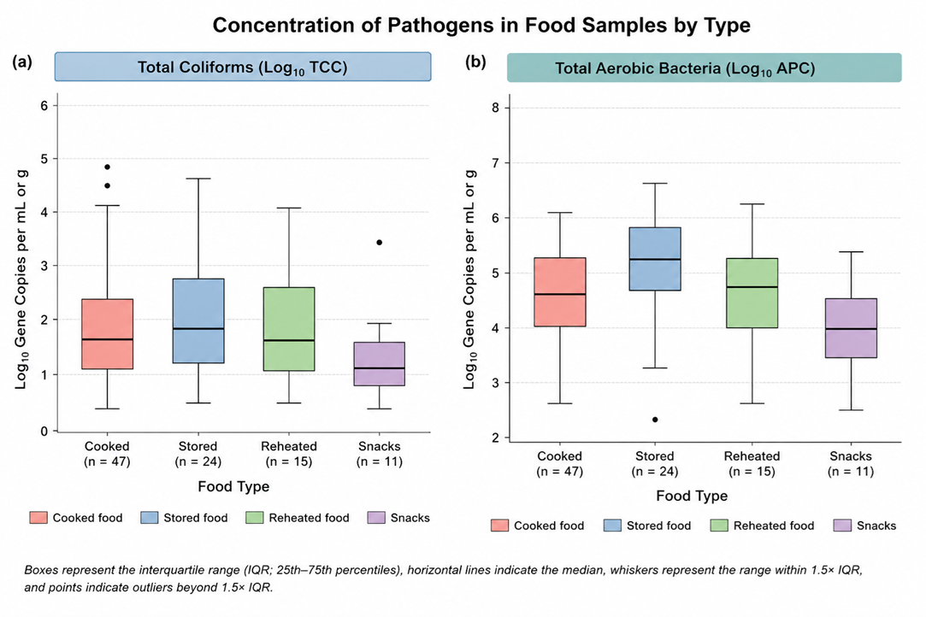
Figure S1: Box plots showing the distribution of total coliform and aerobic plate counts (log CFU) across different child weaning food types collected from households in an urban informal settlement in Dhaka, Bangladesh
Table S2: Quantification of positive total coliform contamination and aerobic plate count (geometric mean value) in collected food, drinking water samples
Sample Type | TCC |  | APC
Sample Type | Geometric Mean |  | Geometric Mean
Food (CFU/g) | 9.00 × 10 |  | 3.80 × 10⁴
Drinking Water (CFU/mL) | 3.16 × 10² |  | 1.99 × 10³

References
1. Baird, R., Eaton, A. & Rice, E. Standard Methods for the Examination of Water and Wastewater. (American Public Health Association, Washington, DC, 2017).
2. Rice, E. W., Baird, R. B. & Eaton, A. D. Standard Methods for the Examination of Water and Wastewater (23rd Ed.). - Google Search. (American Public Health Association, Washington, DC, 2017).
3. FDA. Bacteriological Analytical Manual, Aerobic Plate Count. (Silver Spring, 2001).
4. ISO. Microbiology of Food and Animal Feeding Stuffs: Horizontal Method for the Enumeration of Coliforms: Colony-Count Technique: International Organization for Standardization (ISO). (2006).
5. Cappuccino, J. G. & Sherman, N. Microbiology: A Laboratory Manual. (Pearson Education, Boston, 2014).
6. Garrido, A. et al. Development of a multiplex real-time PCR method for simultaneous detection of Salmonella enterica, Shigella flexneri and Listeria monocytogenes in processed food samples. Eur. Food Res. Technol. 234, 571–580 (2012).
7. Islam, A. et al. Epidemiology and Molecular Characterization of Rotavirus A in Fruit Bats in Bangladesh. EcoHealth 17, 398–405 (2020).
8. Köppel, R., Tolido, I., Marti, G. & Peier, M. Detection of DNA from Escherichia coli, Clostridium perfringens, Staphylococcus aureus and Bacillus cereus after simplified enrichment using a novel multiplex real-time PCR system. Eur. Food Res. Technol. 243, 521–530 (2017).
9. Leone, C. M. et al. Prevalence of Human Noroviruses in Commercial Food Establishment Bathrooms. J. Food Prot. 81, 719–728 (2018).
10. Li, B., Liu, H. & Wang, W. Multiplex real-time PCR assay for detection of Escherichia coli O157:H7 and screening for non-O157 Shiga toxin-producing E. coli. BMC Microbiol. 17, 215 (2017).
11. Park, J. Y., Jeon, S., Kim, J. Y., Park, M. & Kim, S. Multiplex Real-time Polymerase Chain Reaction Assays for Simultaneous Detection of Vibrio cholerae, Vibrio parahaemolyticus, and Vibrio vulnificus. Osong Public Health Res. Perspect. 4, 133–139 (2013).
12. Yang, C., Jiang, Y., Huang, K., Zhu, C. & Yin, Y. Application of real-time PCR for quantitative detection of Campylobacter jejuni in poultry, milk and environmental water. FEMS Immunol. Med. Microbiol. 38, 265–271 (2003).

