Supplementary Materials
Supplementary Results
Linear regression models assessing the relationship between CSF sTREM2 levels and AD-related markers.
The relationship between CSF sTREM2 levels and AD-related markers was studied by linear regression models adjusted for sex. Amyloid pathology was evaluated using either CSF Aβ42 levels (Supplementary Table 1) or global cortical amyloid burden measured by amyloid PET (global SUVR; Supplementary Table 2), while CSF p-tau was used as a marker of tau pathology.
These linear regression models were performed following the next example:
lm (sTREM2_log ~ Sex + AB42_log + pTAU_log, data = prodromal_database)
Supplementary Table 1
 | prodDLB (n=36) |  |  | demDLB (n=37)
Term | β-coefficient | SE | p-value | β-coefficient | SE | p-value
Intercept | -6.011 | 1.639 | 0.0008 | -2.954 | 1.428 | 0.04
Sex | 0.291 | 0.135 | 0.03 | -0.005 | 0.129 | 0.96
CSF Aβ42 | 0.777 | 0.184 | 0.0001 | 0.324 | 0.189 | 0.09
CSF p-tau | 0.617 | 0.174 | 0.001 | 0.608 | 0.128 | 0.0004
Model R-squared | 0.435 |  |  | 0.405
Model p-value | 0.0003 |  |  | 0.0005
AIC | 37.16 |  |  | 41.17
BIC | 45.08 |  |  | 49.23
Regression models were fitted separately in prodDLB and demDLB groups prodDLB= prodromal dementia with Lewy bodies. demDLB=dementia with Lewy bodies. CSF=cerebrospinal fluid. p-tau=phosphorylated tau on threonine 181. AIC=Akaike information criterion. BIC=Bayesian Information Criterion.
Supplementary Table 2
 | prodDLB (n=15) |  |  | demDLB (n=21)
Term | β-coefficient | SE | p-value | β-coefficient | SE | p-value
Intercept | 0.155 | 1.505 | 0.919 | -0.540 | 0.902 | 0.557
Sex | 0.320 | 0.256 | 0.237 | -0.003 | 0.203 | 0.985
FBP-PET | -2.181 | 0.943 | 0.041 | -0.322 | 0.622 | 0.610
CSF p-tau | 0.391 | 0.373 | 0.316 | 0.536 | 0.234 | 0.035
Model R-squared | 0.366 |  |  | 0.307
Model p-value | 0.155 |  |  | 0.093
Regression models were fitted separately in prodDLB and demDLB groups. prodDLB= prodromal dementia with Lewy bodies. demDLB=dementia with Lewy bodies. FBP-PET=Florbetapir PET (SUVr measurements based on whole cerebellum as reference region). CSF=cerebrospinal fluid. p-tau=phosphorylated tau on threonine 181.

Supplementary Figure 1. CSF sTREM2 levels according to amyloid-PET status (A-/A+), stratified by clinical DLB stage.
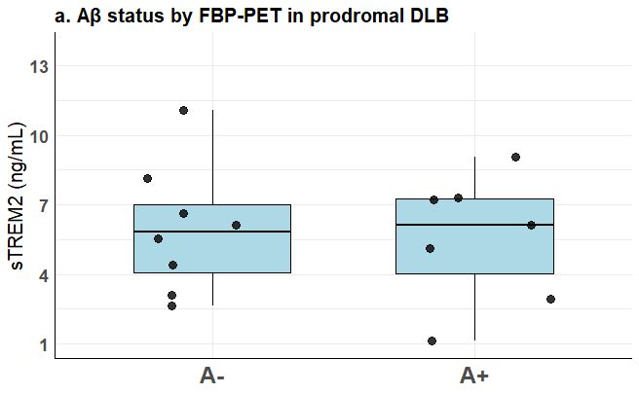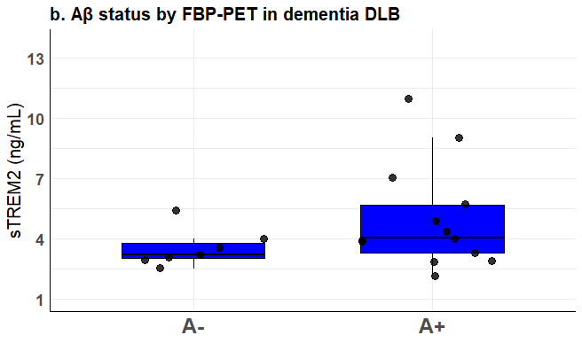
Box and whisker plots showing CSF sTREM2 levels according to amyloid PET status in prodromal DLB (a) and dementia-stage DLB (b). Amyloid positivity (A+) was defined using FBP-PET with the whole cerebellum as the reference region and a global cortical SUVR >1.17. DLB= Dementia with Lewy Bodies. sTREM2=cleaved soluble TREM2. FBP-PET=Florbetapir PET. SUVR =standardized uptake value ratio.
Linear regression models assessing the effect of APOEε4 status on CSF sTREM2 levels.
The effect of APOEε4 status on CSF sTREM2 levels was assessed by adding APOEε4 status as an additional covariate to the previously described linear regression models. Representative model specification:
lm (sTREM2_log ~ Sex + AB42_log + pTAU_log + APOEε4, data = prodromal_database)
Supplementary Table 3
 | prodDLB (n=36) |  |  | demDLB (n=36)
Term | β-coefficient | SE | p-value | β-coefficient | SE | p-value
Intercept | -3.463 | 1.904 | 0.07 | -3.024 | 1.745 | 0.09
Sex | 0.208 | 0.132 | 0.12 | -0.036 | 0.130 | 0.76
CSF Aβ42 | 0.535 | 0.203 | 0.01 | 0.362 | 0.228 | 0.12
CSF p-tau | 0.412 | 0.187 | 0.035 | 0.565 | 0.135 | 0.0002
APOEε4 (carrier) | -0.381 | 0.167 | 0.029 | -0.008 | 0.170 | 0.95
Model R-squared | 0.516 |  |  | 0.394
Model p-value | 0.0001 |  |  | 0.002
AIC | 33.59 |  |  | 40.51
BIC | 43.09 |  |  | 50.01
Regression models were fitted separately in prodDLB and demDLB groups. prodDLB= prodromal dementia with Lewy bodies. demDLB=dementia with Lewy bodies. CSF=cerebrospinal fluid. p-tau=phosphorylated tau on threonine 181. APOEε4=APOEε4 carrier. AIC=Akaike information criterion. BIC=Bayesian Information Criterion.
To assess whether APOEε4 status modified the association between each predictor and CSF sTREM2 levels at baseline, interaction terms (predictor × APOEε4) were included in the linear regression models. A representative model was specified as follows: Lm (sTREM2_log ~ Sex* APOEε4 + AB42_log + pTAU_log, data = prodromal_database)

Supplementary Table 4
 | prodDLB (n=36) |  |  | demDLB (n=36)
Term | β-coefficient | SE | p-value | β-coefficient | SE | p-value
Sex*APOEε4 | 0.501 | 0.309 | 0.115 | -0.367 | 0.278 | 0.197
CSF p-tau*APOEε4 | -0.515 | 0.557 | 0.362 | 0.106 | 0.307 | 0.730
CSF Aβ42*APOEε4 | 0.874 | 0.511 | 0.097 | -0.5112 | 0.496 | 0.310
Interaction analyses evaluating whether APOEε4 status modifies the associations between baseline CSF sTREM2 levels and the studied predictors. Effect modification was assessed by including interaction terms (predictor × APOEε4) in linear regression models. prodDLB= prodromal dementia with Lewy bodies. demDLB=dementia with Lewy bodies. CSF=cerebrospinal fluid. p-tau=phosphorylated tau on threonine 181. APOEε4=APOEε4 carrier.
Time to progression to mild and severe dementia in DLB.
To further evaluate the relationship between APOEε4 status and disease progression, we examined the associations of APOEε4 carriage, baseline CSF sTREM2 levels, and their interaction with time to progression to mild dementia (GDS stage 4, Supplementary table 5) and severe dementia (GDS stage 6, Supplementary table 6). Linear regression models were adjusted for age, CSF Aβ42, and CSF p-tau levels. Analyses were performed in prodromal DLB and dementia-stage DLB patients.
Supplementary Table 5
 | prodDLB (n=34)
Term | β-coefficient | SE | p-value
APOEε4 (carrier) | -3.424 | 1.306 | 0.013
CSF sTREM2 | 2.027 | 1.256 | 0.117
APOEε4*sTREM2 | -0.570 | 2.535 | 0.823

Linear regression models evaluating the associations of APOEε4 status, baseline CSF sTREM2 levels, and their interaction with time to progression to mild dementia (GDS stage 4) in prodDLB patients. Time to GDS stage 4 was evaluated only in prodromal DLB, since patients with dementia had already reached this stage at baseline prodDLB=prodromal dementia with Lewy bodies. CSF=cerebrospinal fluid. sTREM2=cleaved soluble TREM2. APOEε4=APOEε4 carrier.
Supplementary Table 6
 | prodDLB (n=33) |  |  | demDLB (n=34)
Term | β-coefficient | SE | p-value | β-coefficient | SE | p-value
APOEε4 (carrier) | -2.926 | 1.552 | 0.070 | -1.201 | 1.240 | 0.341
CSF sTREM2 | 0.684 | 1.317 | 0.607 | 0.489 | 1.231 | 0.694
APOEε4*sTREM2 | -0.478 | 2.688 | 0.860 | 3.119 | 2.733 | 0.264

Linear regression models evaluating the associations of APOEε4 status, baseline CSF sTREM2 levels, and their interaction with time to progression to severe dementia (GDS stage 6) in prodDLB and demDLB. prodDLB=prodromal dementia with Lewy bodies. demDLB=dementia with Lewy bodies. CSF=cerebrospinal fluid. sTREM2=cleaved soluble TREM2. APOEε4=APOEε4 carrier.

Supplementary results - Replication cohort (CLIMB-DEM)
1.- Association between CSF sTREM2 and AD-related biomarkers
Association between CSF sTREM2 levels and AD-related biomarkers in the independent replication cohort (CLIMB-DEM).
Supplementary Table 7
 | CLIMB-DEM (n=53)
Term | β-coefficient | SE | p-value
Intercept | -1.500 | 1.043 | 0.156
Age | 0.022 | 0.009 | 0.019
CSF Aβ42 | 0.198 | 0.107 | 0.071
CSF p-tau | -0.004 | 0.088 | 0.955
Model R-squared | 0.143
Adjusted R-squared | 0.091
Model p-value | 0.053
Linear regression model evaluating the associations between baseline CSF sTREM2 levels and AD-related biomarkers in the independent replication cohort (CLIMB-DEM). The model was adjusted for age. CSF=cerebrospinal fluid. p-tau=phosphorylated tau on threonine 181.
In the independent replication cohort (CLIMB-DEM), after excluding outliers (n = 49), CSF sTREM2 levels were independently associated with CSF Aβ42 levels (β = 0.252, p-value = 0.017) and no relationship was found with CSF p-tau levels (β = -0.017, p-value = 0.835).

Supplementary Figure 2. CSF sTREM2 levels according to the A/T scheme in in the independent replication cohort (CLIMB-DEM).
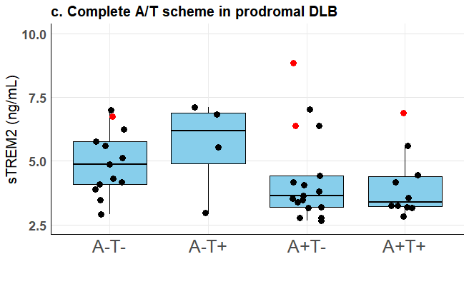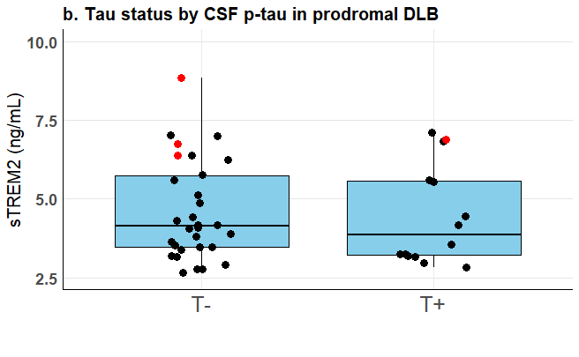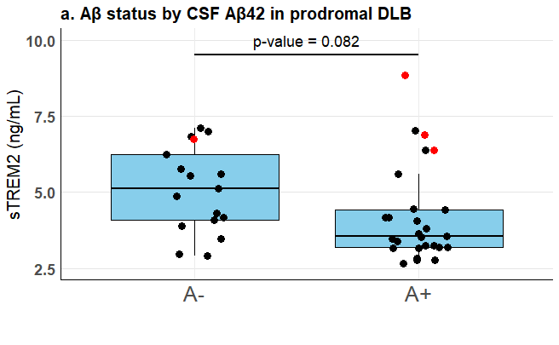
a. Amyloid status (A+/A−) defined according to CSF Aβ42 concentrations (A+: Aβ42 <600 pg/mL). b. Tau status (T+/T−) defined according to CSF p-tau concentrations (T+: p-tau >65 pg/mL). c. Combined A/T classification. Outliers defined by IQR method are shown in red in each graph. sTREM2=cleaved soluble TREM2. DLB= dementia with Lewy bodies.

2.- Association between APOEε4 status and CSF sTREM2 levels in the independent replication cohort (CLIMB-DEM).
Supplementary Table 8
 | CLIMB-DEM (n=53)
Term | β-coefficient | SE | p-value
Intercept | -1.429 | 1.183 | 0.233
Age | 0.022 | 0.010 | 0.039
CSF Aβ42 | 0.191 | 0.119 | 0.115
CSF p-tau | -9.08e-7 | 0.096 | 1.000
APOEε4 (carrier) | -0.017 | 0.013 | 0.893
Model R-squared | 0.386
Adjusted R-squared | 0.072
Model p-value | 0.107
Linear regression model evaluating the association between APOEε4 status and baseline CSF sTREM2 levels in the independent replication cohort (CLIMB-DEM). Models were adjusted for age, CSF Aβ42, and CSF p-tau levels. CSF=cerebrospinal fluid. p-tau=phosphorylated tau on threonine 181. APOEε4=APOEε4 carrier.
In the independent replication cohort (CLIMB-DEM), after excluding outliers (n = 49), APOEε4 carrier status was not independently associated with baseline CSF sTREM2 levels (β = −0.208, p = 0.100). Although the association did not reach statistical significance, the direction of the effect remained consistent with that observed in the SPIN cohort. Moreover, exclusion of outliers increased the magnitude of the association compared with the primary analysis including all subjects.

Supplementary Figure 3. CSF cleaved sTREM2 levels according to APOEε4 status in the independent replication cohort (CLIMB-DEM).
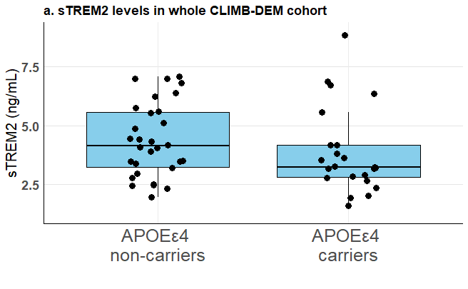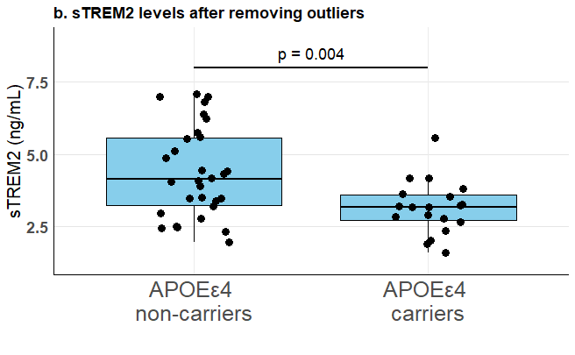
Box and whisker plots showing CSF sTREM2 levels according to APOEε4 status in prodDLB patients from the replication cohort (CLIMB-DEM cohort) a. Including all participants (non-carriers vs carriers: 4.38 ± 1.57 vs. 3.86 ± 1.82, p-value = 0.275). b. After exclusion of extreme CSF sTREM2 values (non-carriers vs carriers: 3.64 ± 1.50 vs. 4.46 ± 1.52, p-value = 0.004). sTREM2 = cleaved soluble TREM2.

Supplementary Table 9. Clinical and biomarker characteristics of participants excluded as sTREM2 outliers.
 | n =4
Age, mean (SD), y | 71.5 (5.8)
Sex, no. (%), men | 4/4 (100.0)
APOEε4
Carriers, no. (%) | 4/4 (100.0)
Age at onset, mean (SD), y | 68.5 (6.0)
MMSE, mean (SD), score | 23.6 (2.0)
CSF variables
Aβ42, mean (SD), pg/mL | 447.5 (299.7)
p-tau, mean (SD), pg/mL | 65.0 (44.2)
t-tau, mean (SD), pg/mL | 468.7 (315.3)
sTREM2, mean (SD), ng/mL | 7.2 (1.1)
MMSE = mini-mental state examination. prodDLB = prodromal Dementia with Lewy Bodies. demDLB = mild dementia with Lewy Bodies. HV = cognitively normal volunteers. CSF = cerebrospinal fluid. p-tau = phosphorylated tau on threonine 181. t-tau = total tau.
Excluding extreme sTREM2 values strengthened the association between APOEε4 status and CSF sTREM2 levels while preserving the direction of effect observed in the discovery cohort. Notably, all excluded participants were APOEε4-carriers, men, had lower baseline MMSE scores, AD-like CSF biomarker profile, and relative early age at clinical onset. Although exploratory, these observations support the interpretation that stronger AD-related pathological changes may attenuate the APOEε4-associated differences in early TREM2-dependent microglial responses.

