Supplementary figure and table
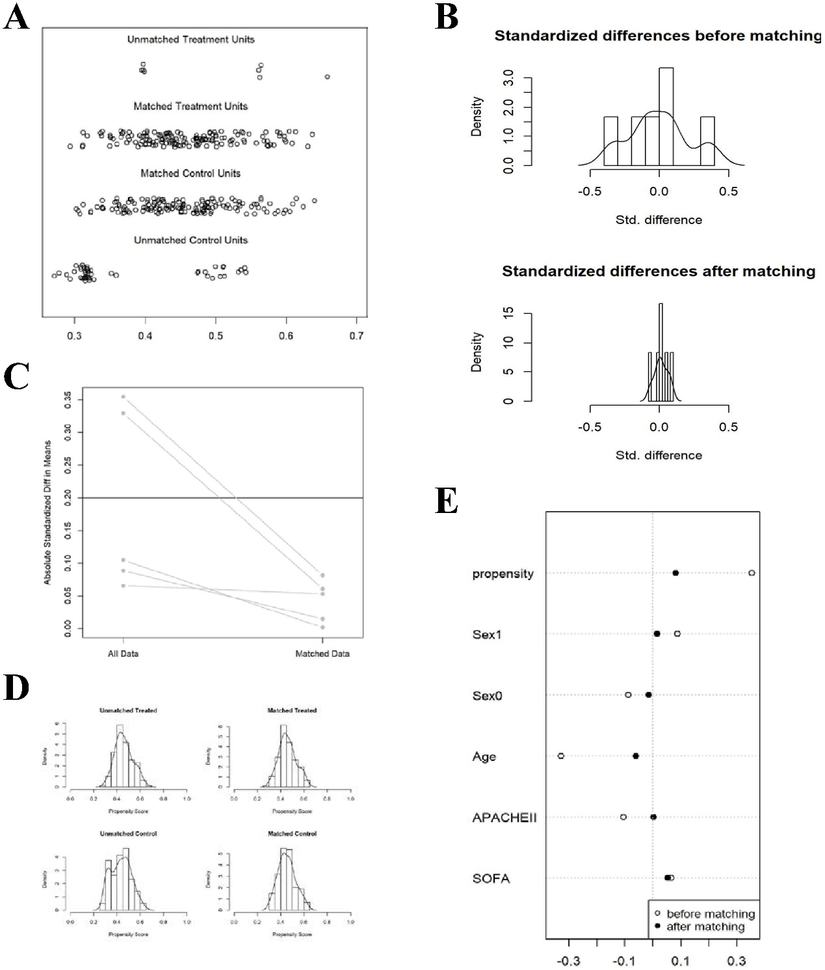
Figure S1. The results of propensity score matching. (A) Dotplot of propensity scores of intra-abdominal infection patient in either matched or unmatched groups; (B) Distribution of standardized differences before and after matching with overlaid kernel density estimate; (C) Line plot of standardized differences before and after matching; (D) Distribution of propensity scores of combination group (“treated”) and broad-spectrum antibiotic group (“control”) before and after matching with overlaid kernel density estimate; (E) Dotplot of standardized mean differences for all covariates before and after matching.

Table S1. Detailed balance statistics before and after propensity score matching
Covariates | Means Treated |  | Means Control |  | SD Control |  | Std. Mean Diff.
Covariates | Before | After | Before | After | Before | After | Before | After
Propensity | 0.460 | 0.458 | 0.433 | 0.452 | 0.086 | 0.075 | 0.355 | 0.081
Sex (female) | 0.278 | 0.267 | 0.239 | 0.260 | 0.427 | 0.440 | 0.089 | 0.015
Sex (male) | 0.722 | 0.733 | 0.761 | 0.740 | 0.427 | 0.440 | -0.089 | 0.015
Age | 54.108 | 54.240 | 59.949 | 55.320 | 19.349 | 17.170 | -0.330 | -0.061
APACHE II | 7.044 | 7.140 | 7.431 | 7.133 | 4.144 | 3.921 | -0.105 | 0.002
SOFA | 2.228 | 2.093 | 2.005 | 1.913 | 2.879 | 2.838 | 0.066 | 0.053
APACHE: Acute Physiology and Chronic Health Evaluation II score; SOFA: Sequential Organ Failure Assessment score; SD: Standard deviation; Std. Mean Diff: Standardized mean difference.

