Supplementary File
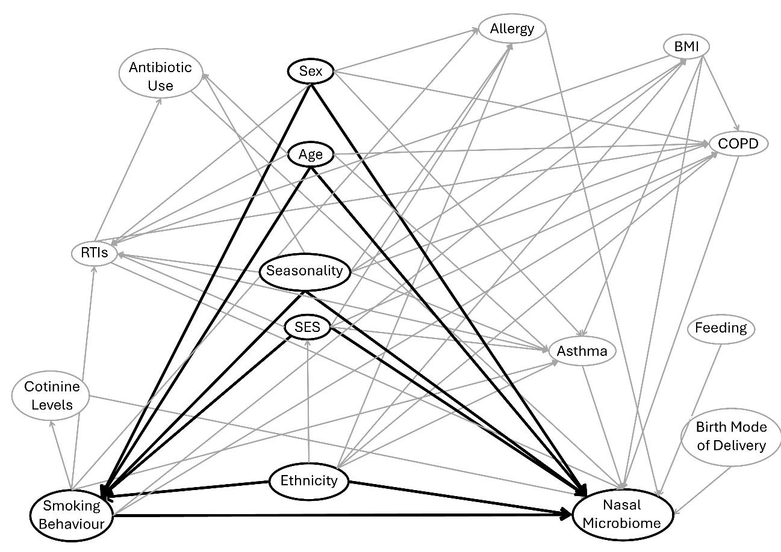
Figure 1 - Directed Acyclic Graph for the exposure “Smoking Behaviour” and the outcome “Nasal Microbiome”. Sex, Age, Seasonality, SES, and Ethnicity were identified as confounders. BMI = body mass index, COPD = chronic obstructive pulmonary disease, SES = socioeconomic status, RTIs = respiratory tract infections.

Figure A. SEQ Figure_A. \* ARABIC 1 - Directed Acyclic Graph for the exposure “Smoking Behaviour” and the outcome “Nasal Microbiome”; Sex, Age, Seasonality, SES, and Ethnicity were identified as confounders. BMI = body mass index, COPD = chronic obstructive pulmonary disease, SES = socioeconomic status, RTIs = respiratory tract infections.
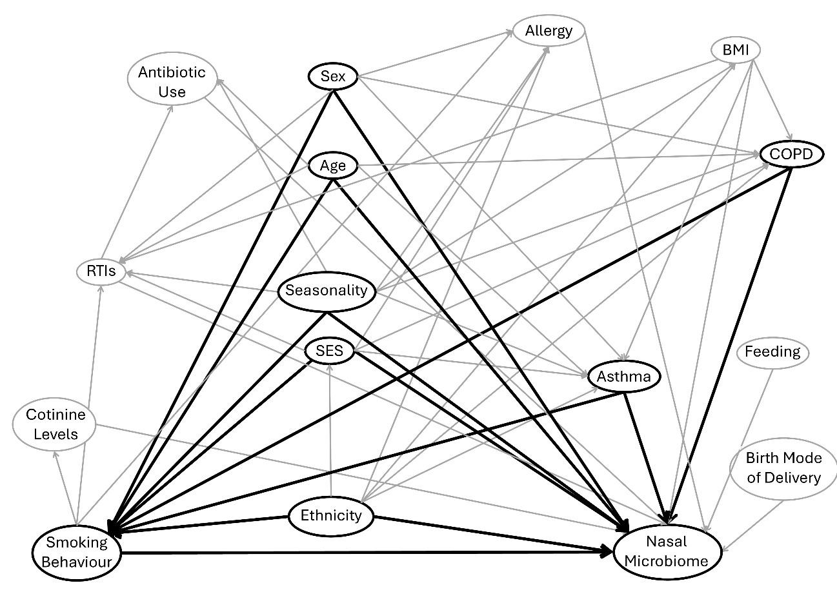
Figure 2 - Alternative Directed Acyclic Graph for the exposure “Smoking Behaviour” and the outcome “Nasal Microbiome”. Sex, Age, Seasonality, SES, Ethnicity, Asthma and COPD were identified as confounders. BMI = body mass index, COPD = chronic obstructive pulmonary disease, SES = socioeconomic status, RTIs = respiratory tract infections.
Table 1 - Linear regression model for the association between former smokers and alpha diversity.
Alpha diversity index | Estimate | 95 % CI | Cohen’s d | Cohen’s d 95 % CI | p-value | adjusted p-value
Observed richness | -0.49 | [-15.20, 14.21] | <0.01 | [-0.08, 0.08] | 0.948 | 0.948
Chao1 index | -2.55 | [-21.83, 16.73] | -0.01 | [-0.09, 0.07] | 0.795 | 0.837
Shannon index | 0.03 | [-0.02, 0.09] | 0.06 | [-0.04, 0.16] | 0.222 | 0.323
Inverse Simpson index | 0.83 | [-0.56, 2.23] | 0.06 | [-0.04, 0.16] | 0.240 | 0.323
Faith’s PD | 0.05 | [-0.09, 0.19] | 0.03 | [-0.06, 0.12] | 0.509 | 0.566
Results of the linear regression model for former smokers compared to never smokers, adjusted for age, sex, SES, season, and sequencing depth. CI = confidence interval, SES = socioeconomic status, Faith’s PD = Faith’s phylogenetic diversity. Adjustment with Benjamini Hochberg correction.
Table 2 - Linear regression model for the association between the lifetime number of cigarettes and alpha diversity.
Alpha diversity index | Estimate | 95 % CI | Cohen’s d | Cohen’s d 95 % CI | p-value | adjusted p-value
Observed richness | 0.24 | [-0.78, 1.25] | 0.01 | [-0.04, 0.06] | 0.646 | 0.897
Chao1 index | 0.16 | [-1.17, 1.49] | 0.01 | [-0.05, 0.06] | 0.815 | 0.897
Shannon index | <0.01 | [<0.01, <0.01] | 0.01 | [-0.06, 0.07] | 0.885 | 0.897
Inverse Simpson index | -0.01 | [-0.11, 0.09] | <0.01 | [-0.07, 0.06] | 0.897 | 0.897
Faith’s PD | <0.01 | [-0.01, 0.01] | <0.01 | [-0.06, 0.05] | 0.861 | 0.897
Results of the linear regression model for the association between the lifetime number of cigarettes in current and former smokers. Adjusted for age, sex, SES, season, and sequencing depth. CI = confidence interval, SES = socioeconomic status, Faith’s PD = Faith’s phylogenetic diversity. Adjustment with Benjamini Hochberg correction.
Table 3 - Permutation test to test for homogeneity of variance for smoking status.
 | Variable | F | p-value | adjusted p-value
Aitchison Distance
 | Smoking Status | 6.67 | 0.001 | 0.002
 | Age | 2.76 | 0.001 | 0.002
 | Sex | 25.51 | 0.001 | 0.002
 | SES | 1.57 | 0.005 | 0.006
 | Season | 1.99 | 0.111 | 0.111
Bray-Curtis Dissimilarity
 | Smoking Status | 3.83 | 0.016 | 0.016
 | Age | 2.61 | 0.001 | 0.002
 | Sex | 160.10 | 0.001 | 0.002
 | SES | 2.55 | 0.001 | 0.002
 | Season | 4.48 | 0.002 | 0.003
Unweighted UniFrac distance
 | Smoking Status | 6.66 | 0.001 | 0.001
 | Age | 4.05 | 0.001 | 0.001
 | Sex | 102.91 | 0.001 | 0.001
 | SES | 4.13 | 0.001 | 0.001
 | Season | 3.39 | 0.019 | 0.019
Weighted UniFrac distance
 | Smoking Status | 3.38 | 0.033 | 0.041
 | Age | 1.35 | 0.096 | 0.096
 | Sex | 39.13 | 0.001 | 0.005
 | SES | 1.70 | 0.029 | 0.041
 | Season | 3.77 | 0.016 | 0.040
Permutation test conducted for smoking status, age, sex, SES, and season. SES = socioeconomic status. Adjustment with Benjamini Hochberg correction.
Table 4 - Permutation test to test for homogeneity of variance for the lifetime number of cigarettes.
 | Variable | F | p-value | adjusted p-value
Aitchison Distance
 | Lifetime Number of Cigarettes | 8.16 | 0.001 | 0.001
 | Age | 2.69 | 0.001 | 0.001
 | Sex | 15.75 | 0.001 | 0.001
 | SES | 4.19 | 0.001 | 0.001
 | Season | 0.28 | 0.834 | 0.834
Bray-Curtis Dissimilarity
 | Lifetime Number of Cigarettes | 7.41 | 0.001 | 0.001
 | Age | 2.50 | 0.001 | 0.001
 | Sex | 84.28 | 0.001 | 0.001
 | SES | 4.81 | 0.001 | 0.001
 | Season | 3.88 | 0.013 | 0.013
Unweighted UniFrac
 | Lifetime Number of Cigarettes | 21.58 | 0.001 | 0.001
 | Age | 5.17 | 0.001 | 0.001
 | Sex | 70.69 | 0.001 | 0.001
 | SES | 10.33 | 0.001 | 0.001
 | Season | 3.37 | 0.024 | 0.024
Weighted UniFrac
 | Lifetime Number of Cigarettes | 1.27 | 0.145 | 0.181
 | Age | 1.00 | 0.341 | 0.341
 | Sex | 9.82 | 0.003 | 0.015
 | SES | 1.47 | 0.071 | 0.178
 | Season | 1.79 | 0.139 | 0.181
Results of the permutation test to test for homogeneity of variance of lifetime number of cigarettes, age, sex, SES, and season. SES = socioeconomic status. Adjustment with Benjamini Hochberg correction.

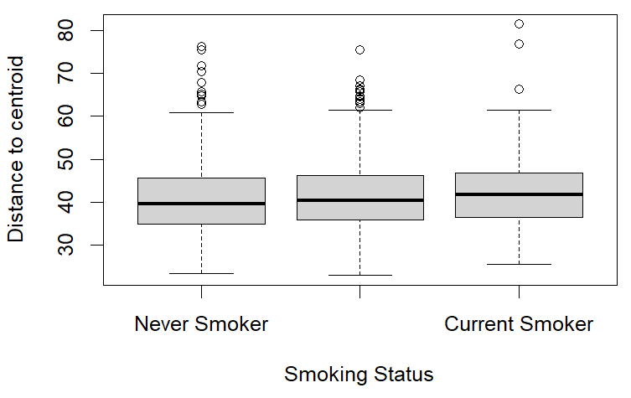
Figure 3 – Permutation test for homogeneity of variance for smoking status assessed with Aitchison distance.

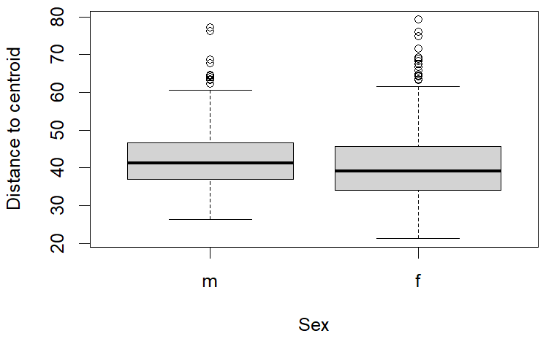
Figure 4 - Permutation test for homogeneity of variance for sex assessed with Aitchison distance. M = male, f = female.

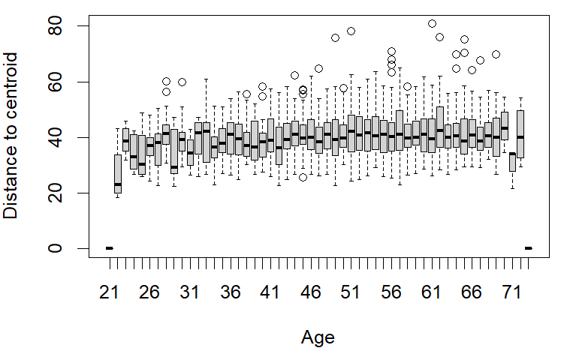
Figure 5 - Permutation test for homogeneity of variance for age assessed with Aitchison distance.

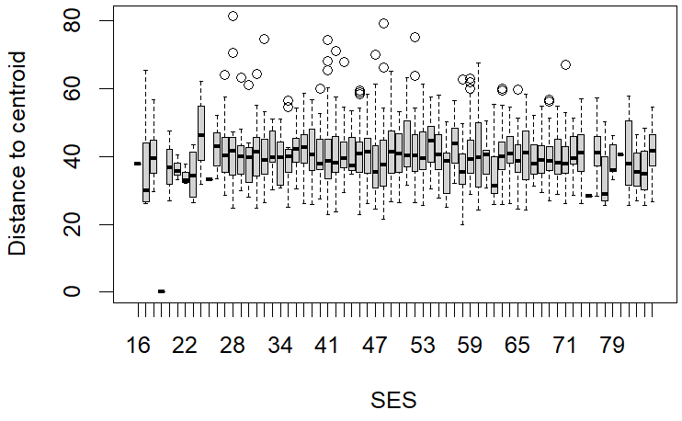
Figure 6 - Permutation test for homogeneity of variance for socioeconomic status assessed with Aitchison distance. SES = socioeconomic status

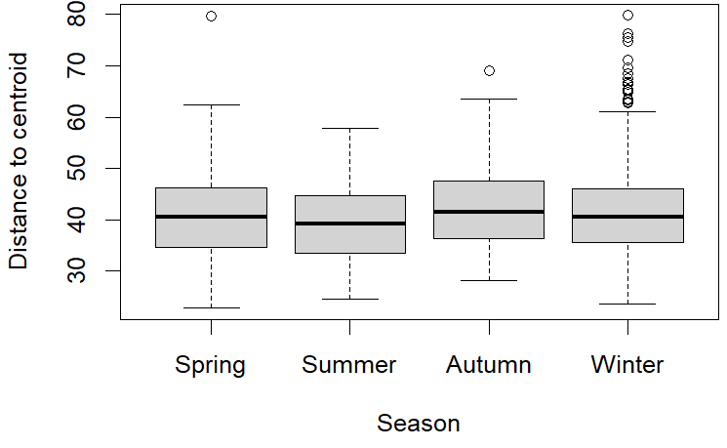
Figure 7 - Permutation test for homogeneity of variance for season assessed with Aitchison distance.
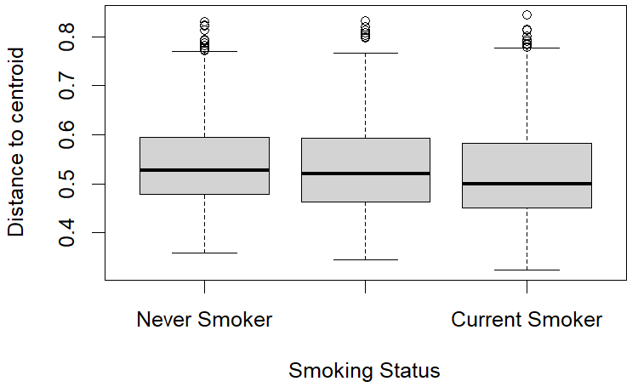
Figure 8 - Permutation test for homogeneity of variance for smoking status assessed with Bray-Curtis dissimilarity.
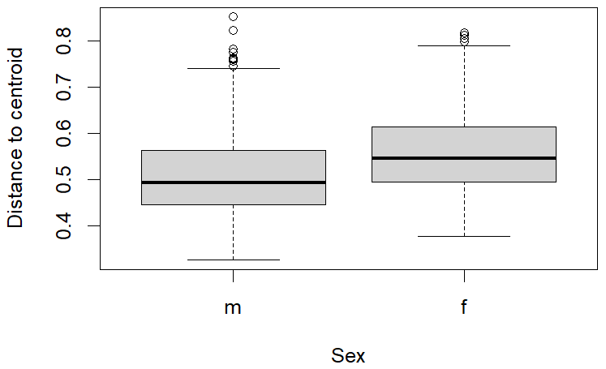
Figure 9 - Permutation test for homogeneity of variance for sex assessed with Bray-Curtis dissimilarity. M = male, f = female.
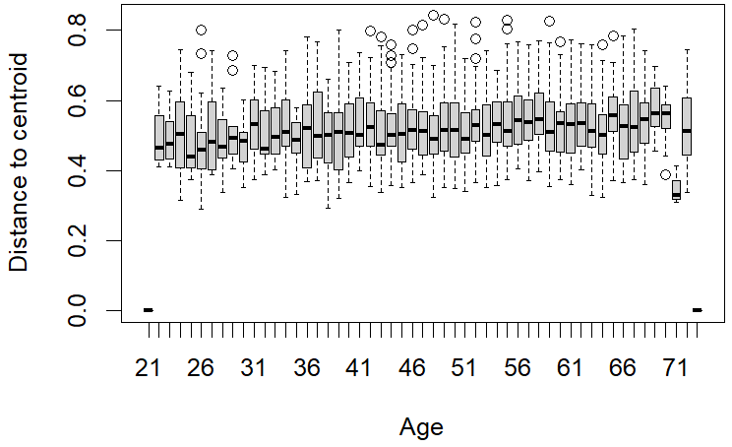
Figure 10 - Permutation test for homogeneity of variance for age assessed with Bray-Curtis dissimilarity.
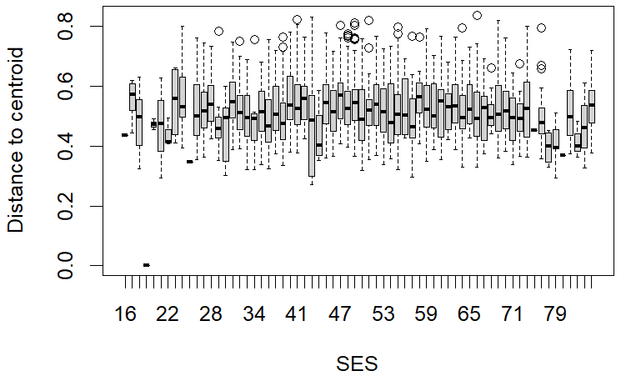
Figure 11 - Permutation test for homogeneity of variance for socio-economic status assessed with Bray-Curtis dissimilarity. SES = socioeconomic status

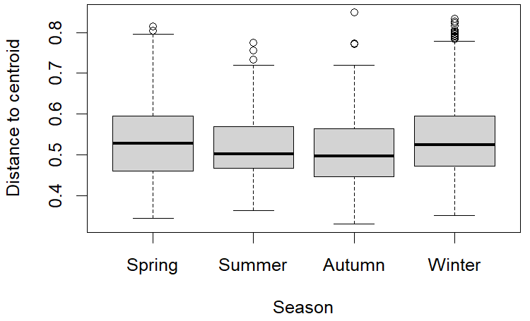
Figure 12 - Permutation test for homogeneity of variance for season assessed with Bray-Curtis dissimilarity.

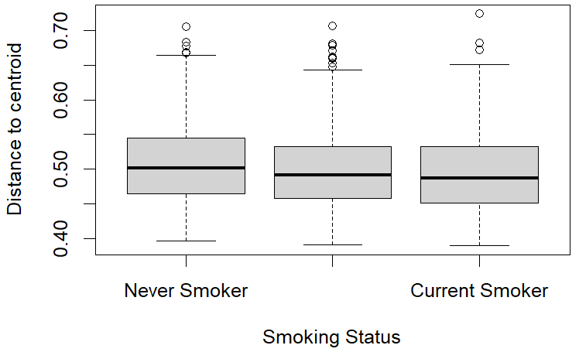
Figure 13 - Permutation test for homogeneity of variance for smoking status assessed with unweighted UniFrac distance.

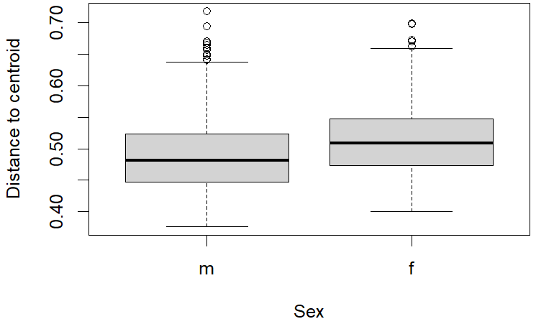
Figure 14 - Permutation test for homogeneity of variance for sex assessed with unweighted UniFrac distance. Male = male, f = female

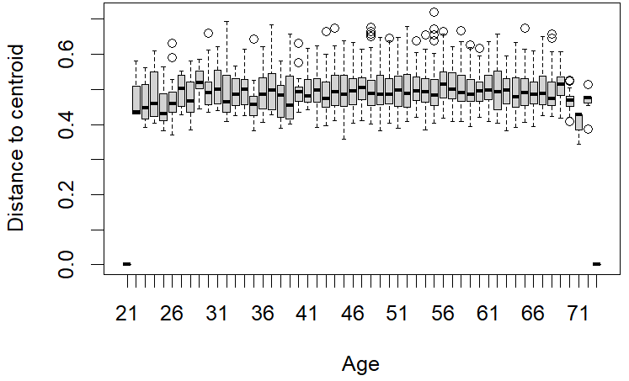
Figure 15 - Permutation test for homogeneity of variance for age assessed with unweighted UniFrac distance.

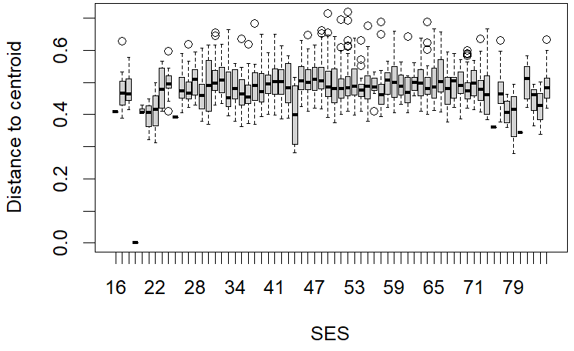
Figure 16 - Permutation test for homogeneity of variance for the socioeconomic status assessed with unweighted UniFrac distance. SES = socioeconomic status.

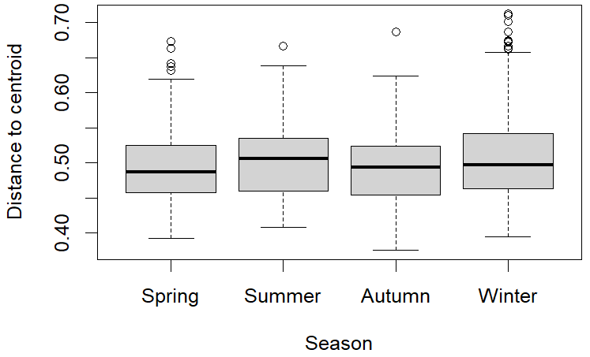
Figure 17 - Permutation test for homogeneity of variance for season assessed with unweighted UniFrac distance.

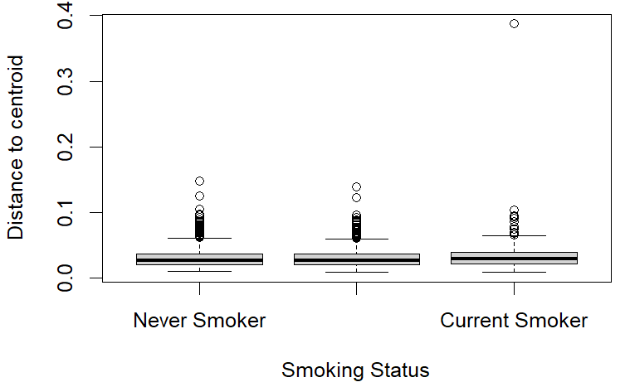
Figure 18 - Permutation test for homogeneity of variance for smoking status assessed with weighted UniFrac distance.

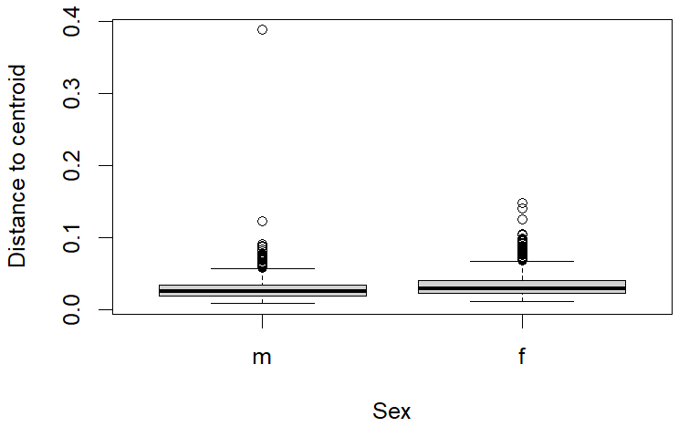
Figure 19 - Permutation test for homogeneity of variance for sex assessed with weighted UniFrac distance. M = male, f = female.

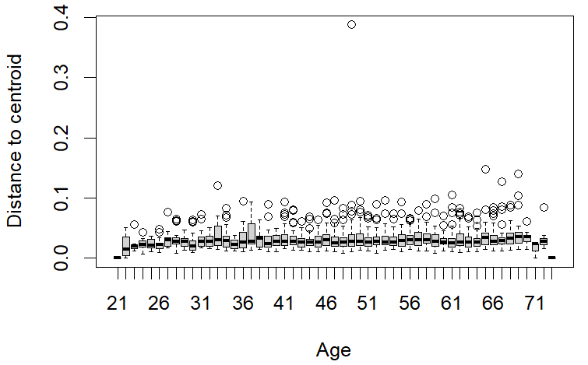
Figure 20 - Permutation test for homogeneity of variance for age assessed with weighted UniFrac distance.

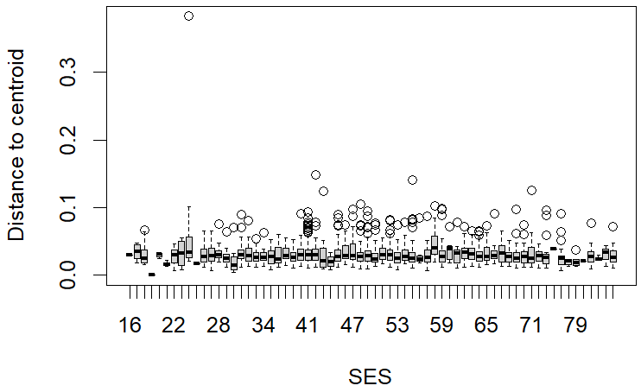
Figure 21 - Permutation test for homogeneity of variance for the socioeconomic status assessed with weighted UniFrac distance. SES = socioeconomic status.

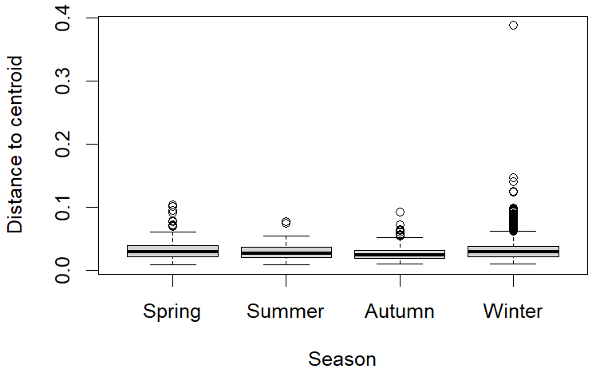
Figure 22 - Permutation test for homogeneity of variance for season assessed with weighted UniFrac distance.

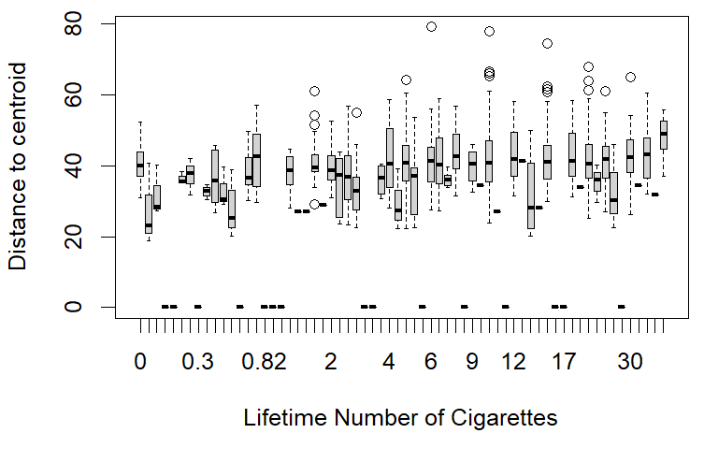
Figure 23 - Permutation test for homogeneity of variance for the lifetime number of cigarettes. Assessed with Aitchison distance.
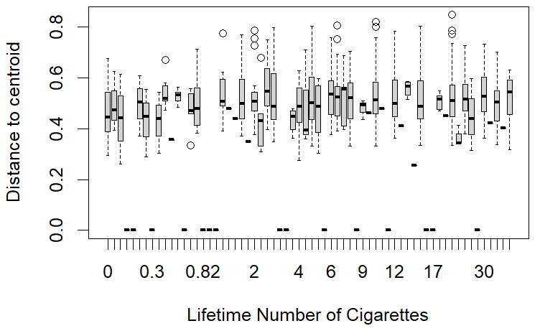
Figure 24 - Permutation test for homogeneity of variance for the lifetime number of cigarettes. Assessed with Bray-Curtis dissimilarity.
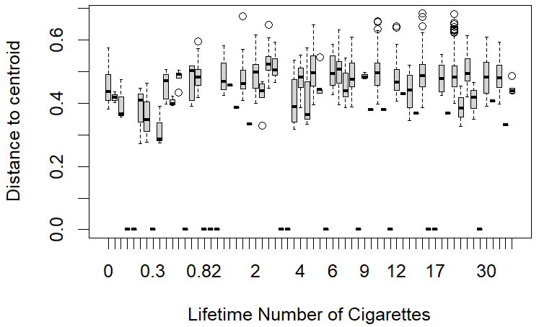
Figure 25 - Permutation test for homogeneity of variance for the lifetime number of cigarettes. Assessed with unweighted UniFrac distance.
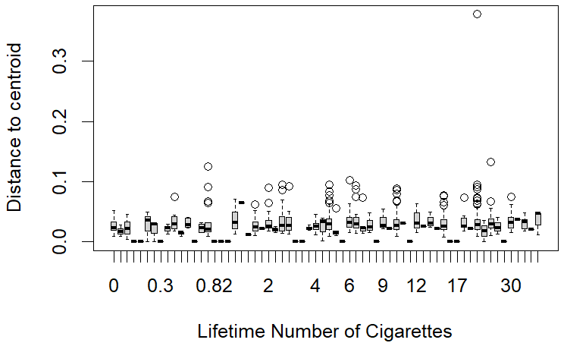
Figure 26 - Permutation test for homogeneity of variance for the lifetime number of cigarettes. Assessed with weighted UniFrac distance.

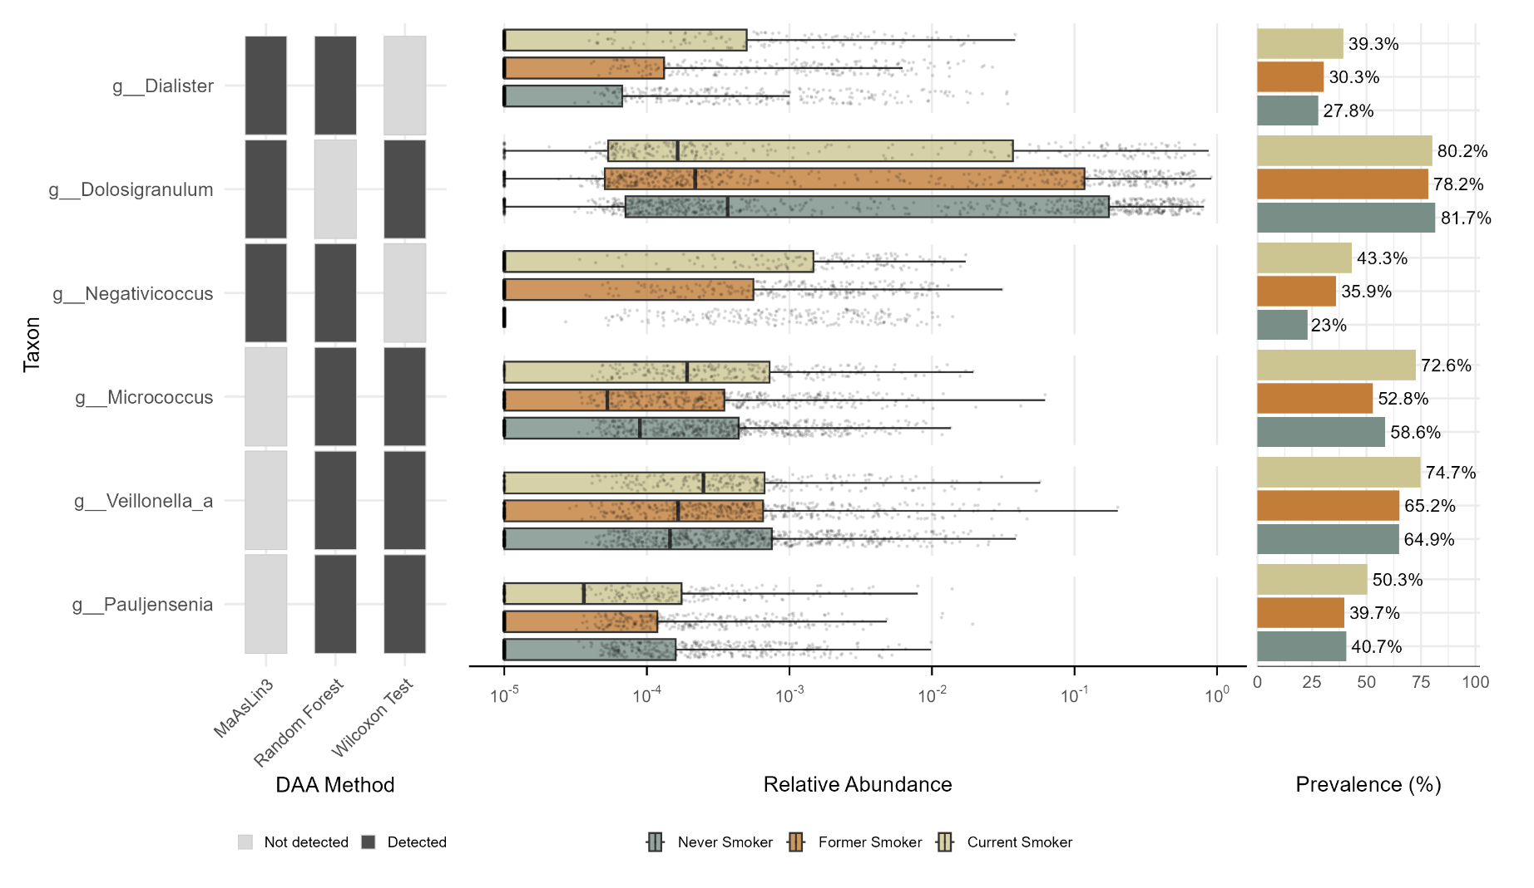
Figure 27 – Detection, relative abundance, and prevalence of taxa identified as differentially abundant by two DAA methods. Taxa were identified by two of the three DAA methods (MaAsLin3, the Random Forest classifier and the Wilcoxon rank sum test), their relative abundance and prevalence by smoking status. DAA = differential abundance analysis.
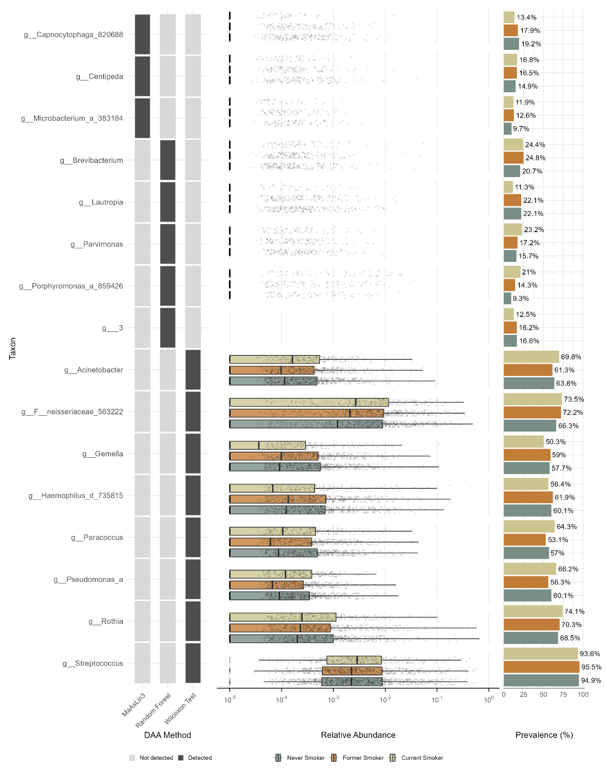
Figure 28 - Detection, relative abundance, and prevalence of taxa identified as differentially abundant by one DAA method. Taxa were identified by one of the three DAA methods (MaAsLin3, the Random Forest classifier and the Wilcoxon rank sum test), their relative abundance and prevalence by smoking status. DAA = differential abundance analysis.
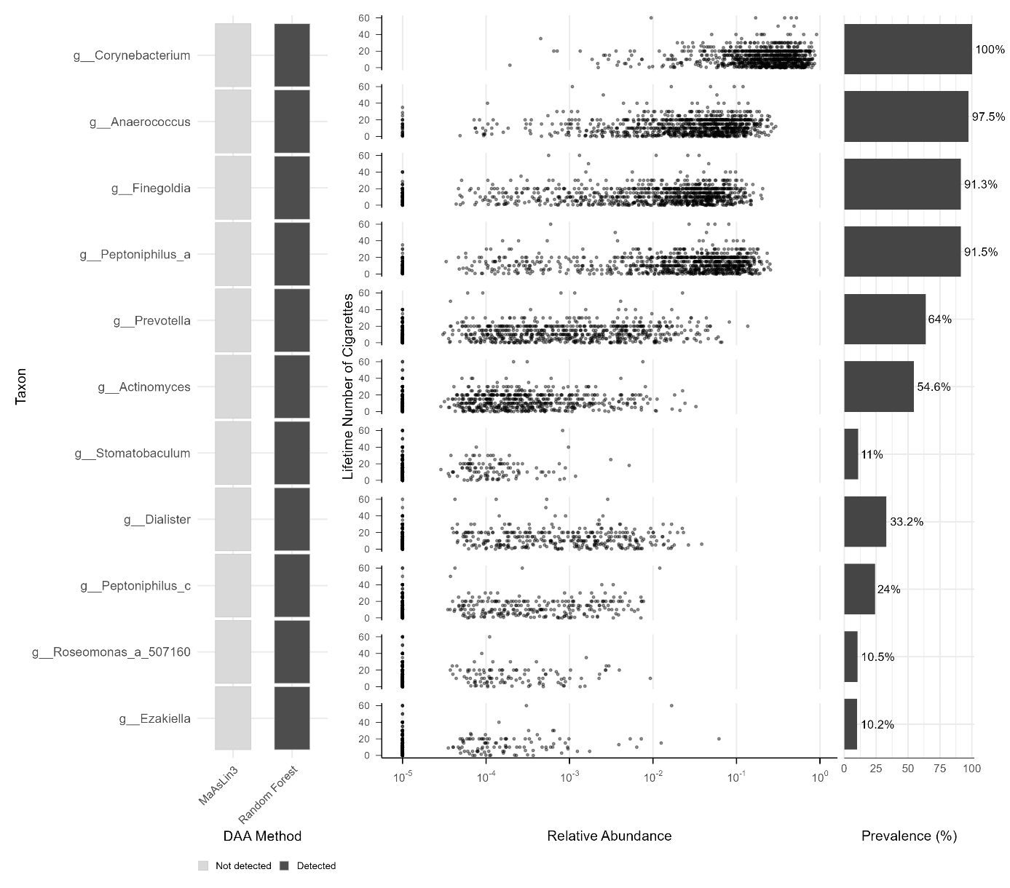
Figure 29 – Detection, relative abundance, and prevalence of differentially abundant taxa for the lifetime number of cigarettes. Detection of taxa as differentially abundant by MaAsLin3 and the Random Forest regression model for the lifetime number of cigarettes, their relative abundance, and prevalence. DAA = differential abundance analysis.
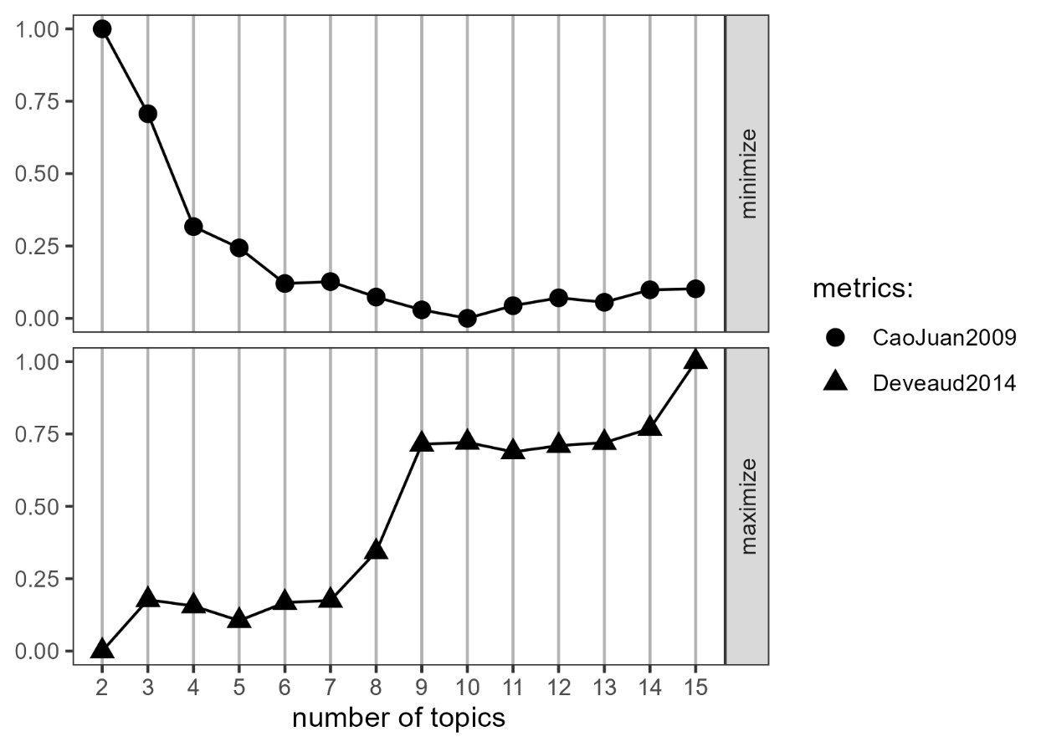
Figure 30- Identification of the number of LDA topics as assessed with VEM. VEM was assessed between 2 and 15 topics to minimise the mean cosine distance between topics (CaoJuan 2009) and maximise the Kullback-Leibler divergence (Deveaud 2014). LDA = Latent Dirichlet Allocation, VEM = variational expectation maximization.
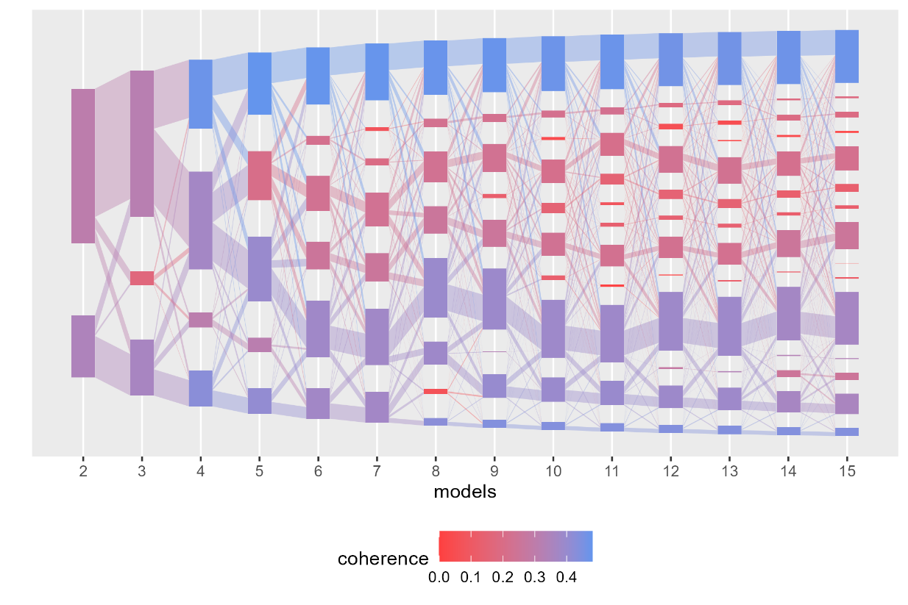
Figure 31 - Identification of the number of LDA topics by increasing coherence. LDA = Latent Dirichlet Allocation
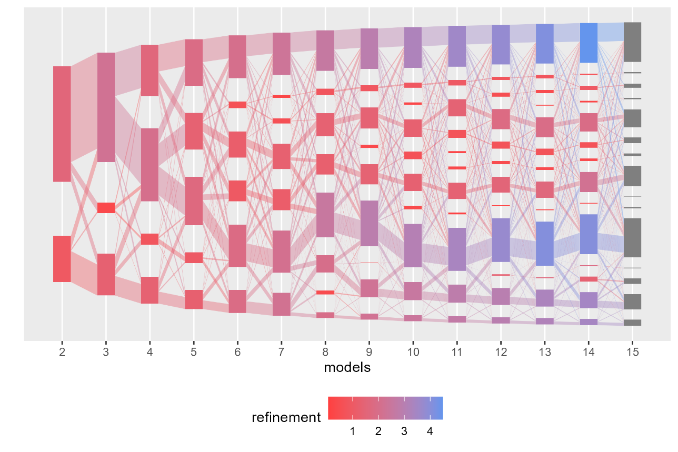
Figure 32 - Identification of the number of LDA topics by increasing refinement. LDA = Latent Dirichlet Allocation

Results of the Sensitivity Analyses

Extended MSAS (chronic bronchitis/ COPD and asthma as additional confounders)
Table 5 - Linear regression model for the association between current smokers and five alpha diversity metrics.
Alpha diversity index | Estimate | 95 % CI | Cohen’s d | Cohen’s d 95 % CI | p-value | adjusted p-value
Observed richness | 9.22 | [-9.55, 27.99] | 0.05 | [-0.05, 0.15] | 0.336 | 0.448
Chao1 index | 9.58 | [-15.03, 34.19] | 0.04 | [-0.06, 0.15] | 0.445 | 0.556
Shannon index | 0.11 | [0.04, 0.18] | 0.19 | [0.06, 0.31] | 0.003 | 0.012
Inverse Simpson index | 3.18 | [1.40, 4.96] | 0.22 | [0.10, 0.35] | <0.001 | <0.001
Faith’s PD | 0.06 | [-0.12, 0.24] | 0.04 | [-0.08, 0.15] | 0.525 | 0.618
Results of the linear regression model for the association between current smokers compared to never smokers in the sensitivity analysis with the extended minimally sufficient adjustment set. Adjusted for age, sex, SES, season, chronic bronchitis/ COPD, asthma, and sequencing depth. CI = confidence interval, COPD = chronic obstructive pulmonary disease, SES = socioeconomic status, Faith’s PD = Faith’s phylogenetic diversity. Adjustment with Benjamini Hochberg correction.

Table 6 - Linear regression model for the association between former smokers and five alpha diversity metrics.
Alpha diversity index | Estimate | 95 % CI | Cohen’s d | Cohen’s d 95 % CI | p-value | adjusted p-value
Observed richness | -2.37 | [-17.14, 12.40] | -0.01 | [-0.09, 0.07] | 0.753 | 0.753
Chao1 index | -4.92 | [-24.28, 14.44] | -0.02 | [-0.10, 0.06] | 0.618 | 0.651
Shannon index | 0.03 | [-0.03, 0.08] | 0.05 | [-0.05, 0.15] | 0.329 | 0.448
Inverse Simpson index | 0.70 | [-0.70, 2.10] | 0.05 | [-0.05, 0.15] | 0.324 | 0.448
Faith’s PD | 0.04 | [-0.10, 0.18] | 0.02 | [-0.07, 0.11] | 0.597 | 0.651
Results of the linear regression model for the association between former smokers compared to never smokers and five alpha diversity metrics in the sensitivity analysis with the extended minimally sufficient adjustment set. Adjusted for age, sex, SES, season, chronic bronchitis/ COPD, asthma, and sequencing depth. CI = confidence interval, COPD = chronic obstructive pulmonary disease, SES = socioeconomic status, Faith’s PD = Faith’s phylogenetic diversity. Adjustment with Benjamini Hochberg correction.
Table 7 – Permutation test to test for homogeneity of variance for smoking status.
 | Variable | F | p-value | adjusted p-value
Aitchison Distance
 | Smoking Status | 6.64 | 0.002 | 0.005
 | Age | 2.74 | 0.001 | 0.004
 | Sex | 23.39 | 0.001 | 0.004
 | SES | 1.56 | 0.003 | 0.005
 | Season | 1.95 | 0.129 | 0.129
 | Chronic bronchitis/ COPD | 5.47 | 0.032 | 0.045
 | Asthma | 2.71 | 0.098 | 0.114
Bray-Curtis Dissimilarity
 | Smoking Status | 3.72 | 0.024 | 0.034
 | Age | 2.66 | 0.001 | 0.002
 | Sex | 156.72 | 0.001 | 0.002
 | SES | 2.51 | 0.001 | 0.002
 | Season | 4.36 | 0.011 | 0.019
 | Chronic bronchitis/ COPD | 0.003 | 0.964 | 0.964
 | Asthma | 0.90 | 0.382 | 0.446
Unweighted UniFrac
 | Smoking Status | 6.89 | 0.001 | 0.002
 | Age | 4.07 | 0.001 | 0.002
 | Sex | 100.40 | 0.001 | 0.002
 | SES | 4.14 | 0.001 | 0.002
 | Season | 3.50 | 0.017 | 0.024
 | Chronic bronchitis/ COPD | 0.25 | 0.612 | 0.643
 | Asthma | 0.21 | 0.643 | 0.643
Weighted UniFrac
 | Smoking Status | 3.43 | 0.033 | 0.057
 | Age | 1.32 | 0.098 | 0.114
 | Sex | 37.73 | 0.001 | 0.007
 | SES | 1.67 | 0.029 | 0.057
 | Season | 3.77 | 0.018 | 0.057
 | Chronic bronchitis/ COPD | 4.18 | 0.041 | 0.057
 | Asthma | 0.21 | 0.631 | 0.631
Results of the permutation test to test for homogeneity of variance of smoking status, age, sex, SES, season, chronic bronchitis/ COPD, and asthma in the sensitivity analysis with the extended minimally sufficient adjustment set. COPD = chronic obstructive pulmonary disease, SES = socioeconomic status. Adjustment with Benjamini Hochberg correction.
Table 8 - PERMANOVA results for smoking status across four beta diversity metrics.
 | Variables | R2 | p-value | adjusted p-value
Aitchison Distance
 | Smoking Status | 0.007 | 0.001 | 0.002
 | Age | 0.004 | 0.001 | 0.002
 | Sex | 0.014 | 0.001 | 0.002
 | SES | 0.001 | 0.002 | 0.003
 | Season | 0.003 | 0.001 | 0.002
 | Chronic bronchitis/ COPD | 0.001 | 0.290 | 0.290
 | Asthma | 0.001 | 0.015 | 0.017
 | Smoking Status + Age + Sex + SES + Season + Chronic bronchitis/ COPD + Asthma | 0.130 | 0.001 | 0.002
Bray-Curtis Dissimilarity
 | Smoking Status | 0.007 | 0.001 | 0.002
 | Age | 0.006 | 0.001 | 0.002
 | Sex | 0.009 | 0.001 | 0.002
 | SES | 0.001 | 0.021 | 0.024
 | Season | 0.003 | 0.002 | 0.003
 | Chronic bronchitis/ COPD | 0.001 | 0.272 | 0.272
 | Asthma | 0.001 | 0.009 | 0.012
 | Smoking Status + Age + Sex + SES + Season + Chronic bronchitis/ COPD + Asthma | 0.120 | 0.001 | 0.002
Unweighted UniFrac distance
 | Smoking Status | 0.004 | 0.001 | 0.002
 | Age | 0.002 | 0.001 | 0.002
 | Sex | 0.009 | 0.001 | 0.002
 | SES | 0.001 | 0.026 | 0.035
 | Season | 0.003 | 0.001 | 0.002
 | Chronic bronchitis/ COPD | 0.001 | 0.255 | 0.290
 | Asthma | 0.001 | 0.290 | 0.290
 | Smoking Status + Age + Sex + SES + Season+ Chronic bronchitis/ COPD + Asthma | 0.117 | 0.001 | 0.002
Weighted UniFrac distance
 | Smoking Status | 0.011 | 0.001 | 0.003
 | Age | 0.002 | 0.001 | 0.003
 | Sex | 0.006 | 0.001 | 0.003
 | SES | 0.001 | 0.033 | 0.053
 | Season | 0.004 | 0.003 | 0.006
 | Chronic bronchitis/ COPD | 0.001 | 0.088 | 0.110
 | Asthma | 0.001 | 0.199 | 0.119
 | Smoking Status + Age + Sex + SES + Season + Chronic bronchitis/ COPD + Asthma | 0.120 | 0.096 | 0.110
PERMANOVA results using the Adonis2 test performed as an omnibus test for smoking status, age, sex, SES, season, Chronic bronchitis/ COPD, and asthma across four beta diversity metrics in the sensitivity analysis. COPD = chronic obstructive pulmonary disease, SES = socioeconomic status. Adjustment with Benjamini Hochberg correction.
Table 9 - MaAsLin3 results for the seven taxa identified as differentially abundant for current and former smokers.
Smoking Status | Feature | Coefficient | 95 % CI | p-value | q-value
Current Smokers
 | g__Finegoldia | 1.71 | [1.35; 2.08] | <0.001 | <0.001
 | g__Anaerococcus | 1.16 | [0.86; 1.47] | <0.001 | <0.001
 | g__Peptoniphilus_a | 1.45 | [1.06; 1.85] | <0.001 | <0.001
 | g__Lawsonella | -1.28 | [-1.70; -0.86] | <0.001 | <0.001
 | g__Prevotella | 0.84 | [0.42; 1.25] | <0.001 | 0.002
 | g__Neisseria_563205 | -0.88 | [-1.35; -0.42] | <0.001 | 0.005
 | g__Campylobacter_b | 0.90 | [0.43; 1.37] | <0.001 | 0.005
Former Smokers
 | g__Anaerococcus | 0.57 | [0.33; 0.81] | <0.001 | <0.001
 | g__Peptoniphilus_a | 0.71 | [0.40; 1.02] | <0.001 | <0.001
 | g__Finegoldia | 0.68 | [0.39; 0.97] | <0.001 | <0.001
MaAsLin3 results for the eight taxa identified as differentially abundant by the three Differential Abundance Analysis methods for current and former smokers in the sensitivity analysis with the extended minimally sufficient adjustment set. Never smokers serve as the reference category. CI = confidence interval. Adjustment with Benjamini Hochberg correction.

Table 10 – MaAsLin3 results of the LDA topic identified as differentially abundant between smoking statuses.
Feature | Value | Coefficient | 95 % CI | p-value | q-value
Peptoniphilus_a_  Anaerococcus | Current Smoker | 2.07 | [1.49; 2.64] | <0.001 | 0.035
MaAsLin3 results of the LDA topic identified as differentially abundant between smoking statuses by all three differential abundance analysis methods in the sensitivity analysis with the extended MSAS. CI = confidence interval; MSAS = minimally sufficient adjustment set; LDA = latent Dirichlet allocation.

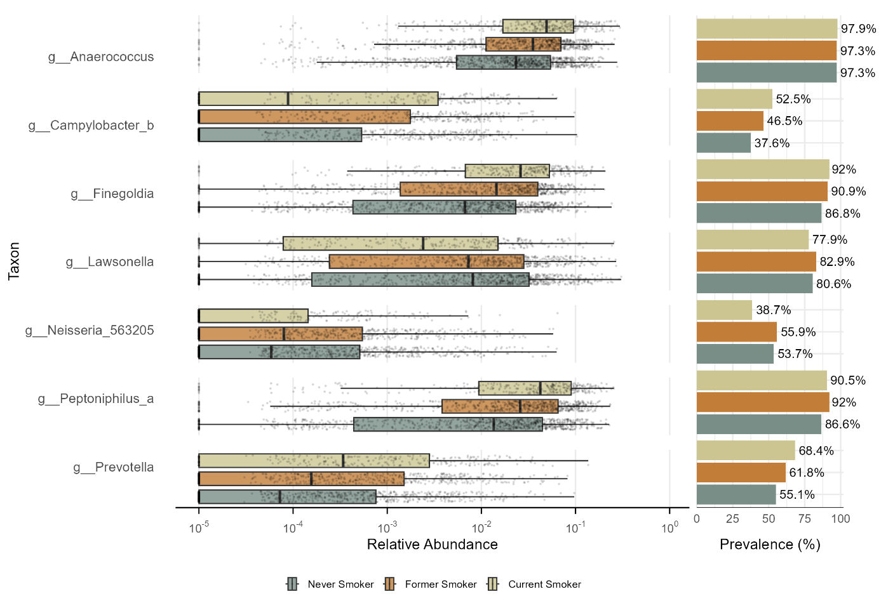
Figure 33 - Relative abundance and prevalence of differentially abundant taxa by smoking status. Taxa identified as differentially abundant by MaAsLin3, the Random Forest classifier and the Wilcoxon rank sum test, their relative abundance and prevalence by smoking status in the sensitivity analysis with the extended minimally sufficient adjustment set.

Population with Germany as country of birth
Table 11 - Linear regression model for the association between current smokers and five alpha diversity metrics.
Alpha diversity index | Estimate | 95 % CI | Cohen’s d | Cohen’s d 95 % CI | p-value | adjusted p-value
Observed richness | 8.23 | [-11.65, 28.11] | 0.04 | [-0.06, 0.15] | 0.417 | 0.556
Chao1 index | 9.31 | [-16.73, 35.36] | 0.04 | [-0.07, 0.15] | 0.483 | 0.604
Shannon index | 0.11 | [0.03, 0.18] | 0.19 | [0.06, 0.32] | 0.005 | 0.025
Inverse Simpson index | 2.98 | [1.11, 4.85] | 0.21 | [0.08, 0.34] | 0.002 | 0.013
Faith’s PD | 0.05 | [-0.13, 0.24] | 0.03 | [-0.09, 0.15] | 0.578 | 0.657
Results of the linear regression model for the association between current smokers compared to never smokers and five alpha diversity metrics in the sensitivity analysis with the subpopulation with Germany as country of birth. Adjusted for age, sex, SES, season, and sequencing depth. CI = confidence interval, SES = socioeconomic status, Faith’s PD = Faith’s phylogenetic diversity. Adjustment with Benjamini Hochberg correction.
Table 12 - Linear regression model for the association between former smokers and five alpha diversity metrics.
Alpha diversity index | Estimate | 95 % CI | Cohen’s d | Cohen’s d 95 % CI | p-value | adjusted p-value
Observed richness | -2.81 | [-18.34, 12.72] | -0.02 | [-0.10, 0.07] | 0.723 | 0.723
Chao1 index | -5.58 | [-25.92, 14.77] | -0.02 | [-0.11, 0.06] | 0.591 | 0.657
Shannon index | 0.03 | [-0.03, 0.09] | 0.06 | [-0.04, 0.16] | 0.266 | 0.380
Inverse Simpson index | 0.84 | [-0.62, 2.30] | 0.06 | [-0.04, 0.16] | 0.261 | 0.380
Faith’s PD | 0.03 | [-0.12, 0.17] | 0.02 | [-0.08, 0.11] | 0.723 | 0.723
Results of the linear regression model for the association between former smokers compared to never smokers and five alpha diversity metrics in the sensitivity analysis with the subpopulation with Germany as country of birth. Adjusted for age, sex, SES, season, and sequencing depth. CI = confidence interval, SES = socioeconomic status, Faith’s PD = Faith’s phylogenetic diversity. Adjustment with Benjamini Hochberg correction.
Table 13 - Permutation test to test for homogeneity of variance for smoking status.
 | Variable | F | p-value | adjusted p-value
Aitchison Distance
 | Smoking Status | 5.02 | 0.006 | 0.008
 | Age | 2.23 | 0.001 | 0.002
 | Sex | 21.46 | 0.001 | 0.002
 | SES | 2.72 | 0.001 | 0.002
 | Season | 1.36 | 0.256 | 0.256
Bray-Curtis Dissimilarity
 | Smoking Status | 3.03 | 0.057 | 0.057
 | Age | 2.01 | 0.001 | 0.002
 | Sex | 135.62 | 0.001 | 0.002
 | SES | 3.88 | 0.001 | 0.002
 | Season | 3.81 | 0.007 | 0.009
Unweighted UniFrac
 | Smoking Status | 7.43 | 0.001 | 0.001
 | Age | 2.61 | 0.001 | 0.001
 | Sex | 96.98 | 0.001 | 0.001
 | SES | 7.52 | 0.001 | 0.001
 | Season | 3.75 | 0.012 | 0.012
Weighted UniFrac
 | Smoking Status | 2.81 | 0.047 | 0.059
 | Age | 1.31 | 0.093 | 0.093
 | Sex | 34.79 | 0.001 | 0.005
 | SES | 1.72 | 0.038 | 0.059
 | Season | 3.26 | 0.035 | 0.059
Results of the permutation test to test for homogeneity of variance of smoking status, age, sex, SES, and season in the sensitivity analysis with the subpopulation of German country of birth. SES = socioeconomic status. Adjustment with Benjamini Hochberg correction.
Table 14 - PERMANOVA results for smoking status across four beta diversity metrics.
 | Variables | R2 | p-value | adjusted p-value
Aitchison Distance
 | Smoking Status | 0.007 | 0.001 | 0.001
 | Age | 0.004 | 0.001 | 0.001
 | Sex | 0.014 | 0.001 | 0.001
 | SES | 0.001 | 0.002 | 0.002
 | Season | 0.003 | 0.001 | 0.001
 | Smoking Status + Age + Sex + SES + Season | 0.077 | 0.001 | 0.001
Bray-Curtis Dissimilarity
 | Smoking Status | 0.007 | 0.001 | 0.002
 | Age | 0.005 | 0.001 | 0.002
 | Sex | 0.008 | 0.001 | 0.002
 | SES | 0.001 | 0.022 | 0.022
 | Season | 0.003 | 0.003 | 0.004
 | Smoking Status + Age + Sex + SES + Season | 0.069 | 0.001 | 0.002
Unweighted UniFrac distance
 | Smoking Status | 0.004 | 0.001 | 0.001
 | Age | 0.002 | 0.001 | 0.001
 | Sex | 0.009 | 0.001 | 0.001
 | SES | 0.001 | 0.011 | 0.011
 | Season | 0.003 | 0.001 | 0.001
 | Smoking Status + Age + Sex + SES + Season | 0.066 | 0.001 | 0.001
Weighted UniFrac distance
 | Smoking Status | 0.010 | 0.001 | 0.003
 | Age | 0.002 | 0.002 | 0.003
 | Sex | 0.006 | 0.001 | 0.003
 | SES | 0.001 | 0.025 | 0.030
 | Season | 0.004 | 0.002 | 0.003
 | Smoking Status + Age + Sex + SES + Season | 0.067 | 0.066 | 0.066
PERMANOVA results using the Adonis2 test performed as an omnibus test for smoking status, age, sex, SES, and season across four beta diversity metrics in the sensitivity analysis only in the population of German country of birth. SES = socioeconomic status. Adjustment with Benjamini Hochberg correction

Table 15 - MaAsLin3 results for the six taxa identified as differentially abundant for current and former smokers.
Smoking Status | Feature | Coefficient | 95 % CI | p-value | q-value
Current Smokers
 | g__Finegoldia | 1.62 | [1.24; 2.00] | <0.001 | <0.001
 | g__Anaerococcus | 1.13 | [0.81; 1.45] | <0.001 | <0.001
 | g__Peptoniphilus_a | 1.44 | [1.03; 1.85] | <0.001 | <0.001
 | g__Prevotella | 0.70 | [0.27; 1.14] | 0.001 | 0.021
 | g__Neisseria_563205 | -0.81 | [-1.30; -0.31] | 0.001 | 0.021
 | g__Campylobacter_b | 0.88 | [0.38; 1.38] | 0.001 | 0.011
Former Smokers
 | g__Anaerococcus | 0.54 | [0.29; 0.79] | <0.001 | 0.001
 | g__Peptoniphilus_a | 0.76 | [0.43; 1.08] | <0.001 | <0.001
 | g__Finegoldia | 0.65 | [0.35; 0.95] | <0.001 | 0.001
MaAsLin3 results for the six taxa identified as differentially abundant by the three Differential Abundance Analysis methods for current and former smokers in the sensitivity analysis of the participants with Germany as country of birth. Never smokers serve as the reference category. CI = confidence interval. Adjustment with Benjamini Hochberg correction.
Table 16 - MaAsLin3 results of the LDA topic identified as differentially abundant between smoking statuses.
Feature | Value | Coefficient | 95 % CI | p-value | q-value
Peptoniphilus_a_  Anaerococcus | Current Smoker | 2.04 | [1.44; 2.65] | 0.002 | 0.046
MaAsLin3 results of the LDA topic identified as differentially abundant by all three differential abundance analysis methods in the sensitivity analysis of the population with Germany as country of birth. CI = confidence interval; LDA = latent Dirichlet allocation.
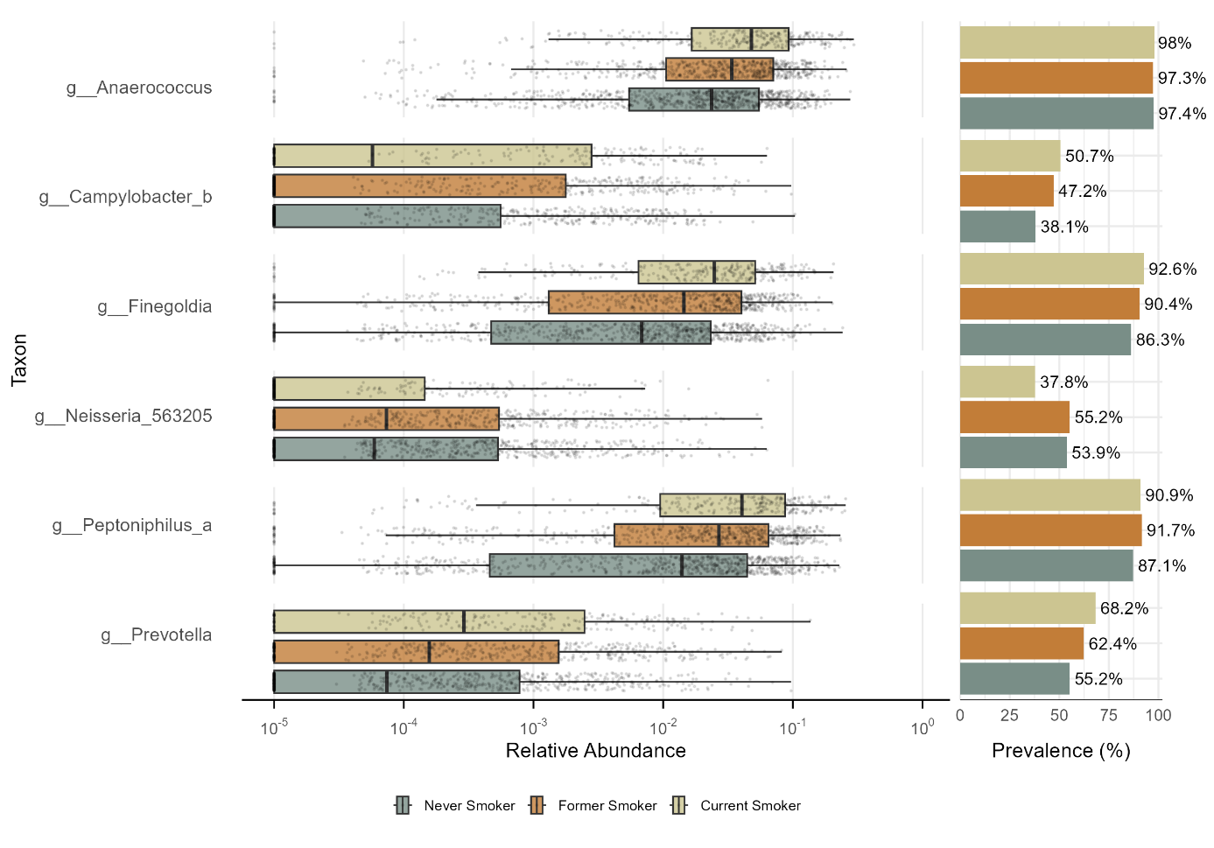
Figure 34 - Relative abundance and prevalence of differentially abundant taxa by smoking status. Taxa identified as differentially abundant by MaAsLin3, the Random Forest classifier and the Wilcoxon rank sum test, their relative abundance and prevalence by smoking status in the sensitivity analysis of the population with Germany as country of birth.

People without antibiotic use within past 12 months
Table 17 - Linear regression model for the association between current smokers and five alpha diversity metrics.
Alpha diversity index | Estimate | 95 % CI | Cohen’s d | Cohen’s d 95 % CI | p-value | adjusted p-value
Observed richness | 17.70 | [-6.06, 41.46] | 0.10 | [-0.03, 0.23] | 0.144 | 0.206
Chao1 index | 23.52 | [-7.58, 54.62] | 0.10 | [-0.03, 0.23] | 0.138 | 0.206
Shannon index | 0.14 | [0.05, 0.22] | 0.24 | [0.09, 0.40] | 0.002 | 0.010
Inverse Simpson index | 4.40 | [2.15, 6.64] | 0.31 | [0.15, 0.47] | <0.001 | <0.001
Faith’s PD | 0.12 | [-0.11, 0.35] | 0.07 | [-0.07, 0.22] | 0.312 | 0.373
Results of the linear regression model for the association between current smokers compared to never smokers and five alpha diversity metrics in the sensitivity analysis of the participants without antibiotic use in the past 12 months. Adjusted for age, sex, SES, season, and sequencing depth. CI = confidence interval, SES = socioeconomic status, Faith’s PD = Faith’s phylogenetic diversity. Adjustment with Benjamini Hochberg correction.

Table 18 - Linear regression model for the association between former smokers and five alpha diversity metrics.
Alpha diversity index | Estimate | 95 % CI | Cohen’s d | Cohen’s d 95 % CI | p-value | adjusted p-value
Observed richness | 1.07 | [-17.00, 19.13] | 0.01 | [-0.09, 0.10] | 0.908 | 0.956
Chao1 index | -0.31 | [-23.95, 23.33] | <0.01 | [-0.10, 0.10] | 0.979 | 0.979
Shannon index | 0.04 | [-0.03, 0.11] | 0.07 | [-0.05, 0.19] | 0.254 | 0.339
Inverse Simpson index | 0.87 | [-0.84, 2.57] | 0.06 | [-0.06, 0.18] | 0.317 | 0.373
Faith’s PD | 0.03 | [-0.14, 0.21] | 0.02 | [-0.09, 0.13] | 0.715 | 0.794
Results of the linear regression model for the association between former smokers compared to never smokers and five alpha diversity metrics in the sensitivity analysis of the participants without antibiotic use in the past 12 months. Adjusted for age, sex, SES, season, and sequencing depth. CI = confidence interval, SES = socioeconomic status, Faith’s PD = Faith’s phylogenetic diversity. Adjustment with Benjamini Hochberg correction.
Table 19 - Permutation test to test for homogeneity of variance for smoking status.
 | Variable | F | p-value | adjusted p-value
Aitchison Distance
 | Smoking Status | 5.66 | 0.006 | 0.008
 | Age | 2.51 | 0.001 | 0.002
 | Sex | 17.73 | 0.001 | 0.002
 | SES | 2.81 | 0.001 | 0.002
 | Season | 1.95 | 0.106 | 0.106
Bray-Curtis Dissimilarity
 | Smoking Status | 1.90 | 0.139 | 0.139
 | Age | 1.80 | 0.001 | 0.002
 | Sex | 119.93 | 0.001 | 0.002
 | SES | 3.57 | 0.001 | 0.002
 | Season | 4.24 | 0.005 | 0.006
Unweighted UniFrac
 | Smoking Status | 3.67 | 0.025 | 0.031
 | Age | 2.91 | 0.001 | 0.002
 | Sex | 86.08 | 0.001 | 0.002
 | SES | 7.49 | 0.001 | 0.002
 | Season | 2.76 | 0.032 | 0.032
Weighted UniFrac
 | Smoking Status | 2.70 | 0.076 | 0.095
 | Age | 1.20 | 0.184 | 0.184
 | Sex | 21.69 | 0.001 | 0.005
 | SES | 1.63 | 0.046 | 0.077
 | Season | 4.13 | 0.017 | 0.043
Results of the permutation test to test for homogeneity of variance of smoking status, age, sex, SES, and season in the sensitivity analysis of the participants without antibiotic use within the past 12 months. SES = socioeconomic status. Adjustment with Benjamini Hochberg correction.

Table 20 - PERMANOVA results for smoking status across four beta diversity metrics.
 | Variables | R2 | p-value | adjusted p-value
Aitchison Distance
 | Smoking Status | 0.008 | 0.001 | 0.002
 | Age | 0.005 | 0.001 | 0.002
 | Sex | 0.015 | 0.001 | 0.002
 | SES | 0.001 | 0.019 | 0.019
 | Season | 0.003 | 0.018 | 0.019
 | Smoking Status + Age + Sex + SES + Season | 0.098 | 0.001 | 0.002
Bray-Curtis Dissimilarity
 | Smoking Status | 0.008 | 0.001 | 0.002
 | Age | 0.007 | 0.001 | 0.002
 | Sex | 0.010 | 0.001 | 0.002
 | SES | 0.001 | 0.096 | 0.096
 | Season | 0.004 | 0.022 | 0.026
 | Smoking Status + Age + Sex + SES + Season | 0.090 | 0.001 | 0.002
Unweighted UniFrac distance
 | Smoking Status | 0.004 | 0.001 | 0.002
 | Age | 0.003 | 0.001 | 0.002
 | Sex | 0.010 | 0.001 | 0.002
 | SES | 0.001 | 0.159 | 0.159
 | Season | 0.003 | 0.002 | 0.002
 | Smoking Status + Age + Sex + SES + Season | 0.088 | 0.001 | 0.002
Weighted UniFrac distance
 | Smoking Status | 0.012 | 0.001 | 0.003
 | Age | 0.003 | 0.005 | 0.010
 | Sex | 0.007 | 0.001 | 0.003
 | SES | 0.002 | 0.053 | 0.080
 | Season | 0.003 | 0.203 | 0.203
 | Smoking Status + Age + Sex + SES + Season | 0.084 | 0.135 | 0.162
PERMANOVA results using the Adonis2 test performed as an omnibus test for smoking status, age, sex, SES, and season across four beta diversity metrics in the sensitivity analysis of the participants without antibiotic use during the past 12 months. SES = socioeconomic status. Adjustment with Benjamini Hochberg correction.

Table 21 - MaAsLin3 results for the seven taxa identified as differentially abundant for current and former smokers.
Smoking Status | Feature | Coefficient | 95 % CI | p-value | q-value
Current Smokers
 | g__Finegoldia | 1.70 | [1.23; 2.16] | <0.001 | <0.001
 | g__Anaerococcus | 1.17 | [0.78; 1.56] | <0.001 | <0.001
 | g__Peptoniphilus_a | 1.31 | [0.82; 1.80] | <0.001 | <0.001
 | g__Prevotella | 1.09 | [0.57; 1.62] | <0.001 | 0.002
 | g__Lawsonella | -1.25 | [-1.75; -0.74] | <0.001 | <0.001
 | g__Campylobacter_b | 1.18 | [0.60; 1.76] | <0.001 | 0.003
 | g__Dolosigranulum | -1.72 | [-2.65; -0.79] | <0.001 | 0.009
Former Smokers
 | g__Anaerococcus | 0.57 | [0.28; 0.87] | <0.001 | 0.005
 | g__Peptoniphilus_a | 0.84 | [0.48; 1.21] | <0.001 | <0.001
 | g__Finegoldia | 0.81 | [0.46; 1.17] | <0.001 | <0.001
MaAsLin3 results for the six taxa identified as differentially abundant by the three Differential Abundance Analysis methods for current and former smokers in the sensitivity analysis of the participants without antibiotic use in the previous 12 months. Never smokers serve as the reference category. CI = confidence interval. Adjustment with Benjamini Hochberg correction.
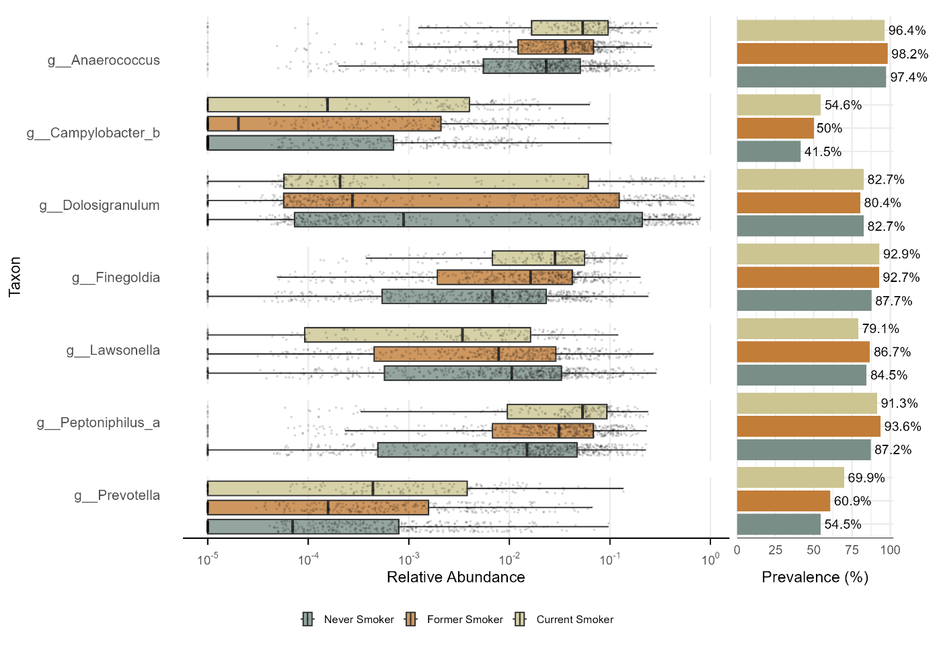
Figure 35 - Relative abundance and prevalence of differentially abundant taxa by smoking status. Taxa identified as differentially abundant by MaAsLin3, the Random Forest classifier and the Wilcoxon rank sum test, their relative abundance and prevalence by smoking status in the sensitivity analysis of the population without antibiotic use in the previous 12 months.

