Supporting Information
Encoding Intermittent Parathyroid Hormone Signals in Stem Cell Exosomes Enables Targeted Repair of Osteoporotic Bone Defects
Jiaqi Fang^{1†}, Yiqing Wu^{2†}, Xuehan Jin^{1†}, Xinhui Wu^{1†}, Bo Xu³, Junkuan Shan¹, Liping Nan¹, Shuhao Liu¹, Wei Nie¹, Junjian Liu^{1*}, Jinghuan Huang^{4*}, Yuan Yuan^{2*} and Zezhu Zhou^{1*}
1 Department of Orthopedics, Shanghai Tenth People's Hospital, School of Medicine, Tongji University, Shanghai 200072, P. R. China.
2 Key Laboratory for Ultrafine Materials of Ministry of Education, Frontiers Science Center for Materiobiology and Dynamic Chemistry and School of Materials Science and Engineering, East China University of Science and Technology, Shanghai 200237, China.
3 Department of Orthopedics, the First Affiliated Hospital of Bengbu Medical University, Bengbu, 233004, P. R. China.
4 National Center for Orthopaedics, Department of Orthopaedics, Shanghai Sixth People's Hospital Affiliated to Shanghai Jiao Tong University School of Medicine, Shanghai, 200233, P. R. China.

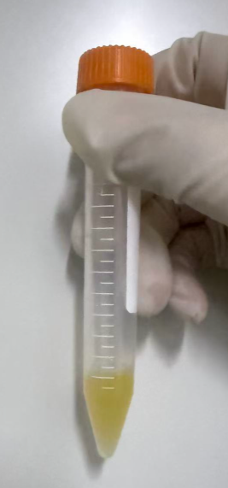
Figure S1. Macroscopic appearance of iEXOs suspended in phosphate-buffered saline, PBS. Photograph of extracted iEXOs dispersed in PBS, showing the characteristic pale-yellow coloration consistent with small extracellular vesicle suspensions. 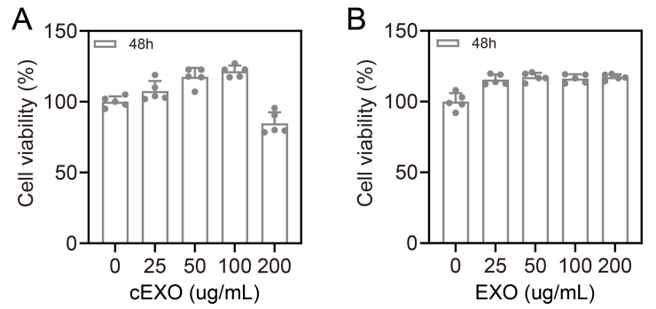
Figure S2. Dose-dependent cytotoxicity screening of cEXOs and EXOs. A) Cell viability of bone marrow mesenchymal stem cells, BMSCs, treated with increasing concentrations of cEXOs for 48 h, assessed by CCK-8 assay. B) Cell viability of BMSCs treated with EXOs at concentrations of 0, 25, 50, 100, and 200 μg mL⁻¹ for 48 h. Data are presented as mean ± SD; n = 5 independent experiments.
Figure S3. Comparative metabolomic and proteomic profiling of EXOs and iEXOs. A) Heatmap of differentially expressed metabolites between EXO and iEXO groups; red indicates upregulated and blue indicates downregulated metabolites. B) Heatmap of differentially expressed Proteomic between EXO and iEXO groups. C) Metabolomic loading plot illustrating the distribution of major contributing metabolites. D) Proteomic loading plot revealing the contribution of key differentially expressed proteins.
Figure S4. Comprehensive metabolomic and proteomic comparison of cEXOs and iEXOs.
A–C) Metabolomic analysis. A) Volcano plot of differentially expressed metabolites between cEXO and iEXO groups. B) Bar chart and C) bubble plot of KEGG pathway enrichment for differential metabolites. D–L) Proteomic analysis. D) Volcano plot of differentially expressed proteins. E, I) Hierarchical clustering heatmaps of differentially expressed proteins. F) Scatter plot and G) circular diagram of KEGG pathway enrichment (rings: pathway categories, pathway names, gene counts, significance). H) Bar chart of significantly enriched KEGG pathways. J) Integrated scatter plot revealing pathway-level changes across proteomic and metabolomic dimensions.

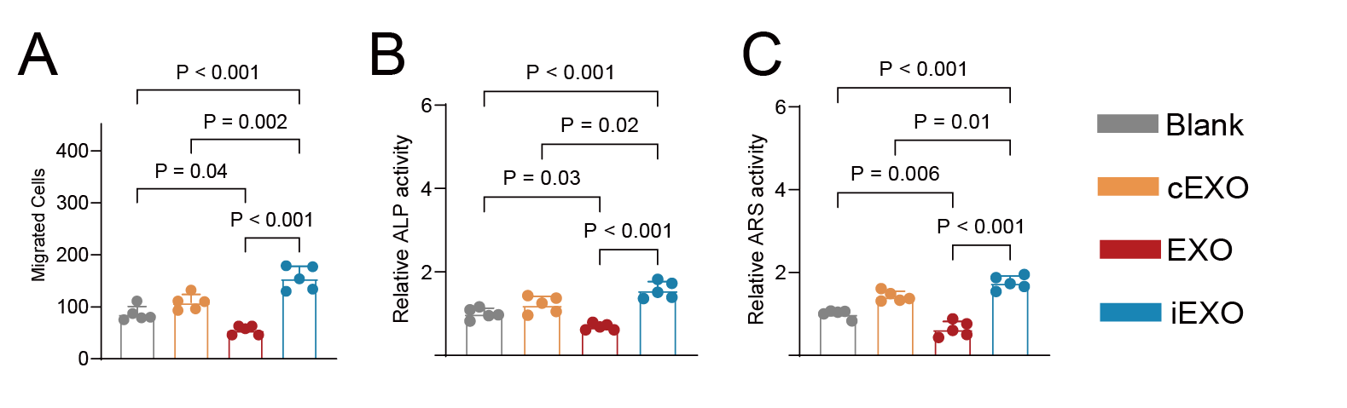
Figure S5. A) Quantification of BMSC migration capacity in response to the three types of exosomes, B) Quantification of relative ALP activity and C) quantification of ARS activity.
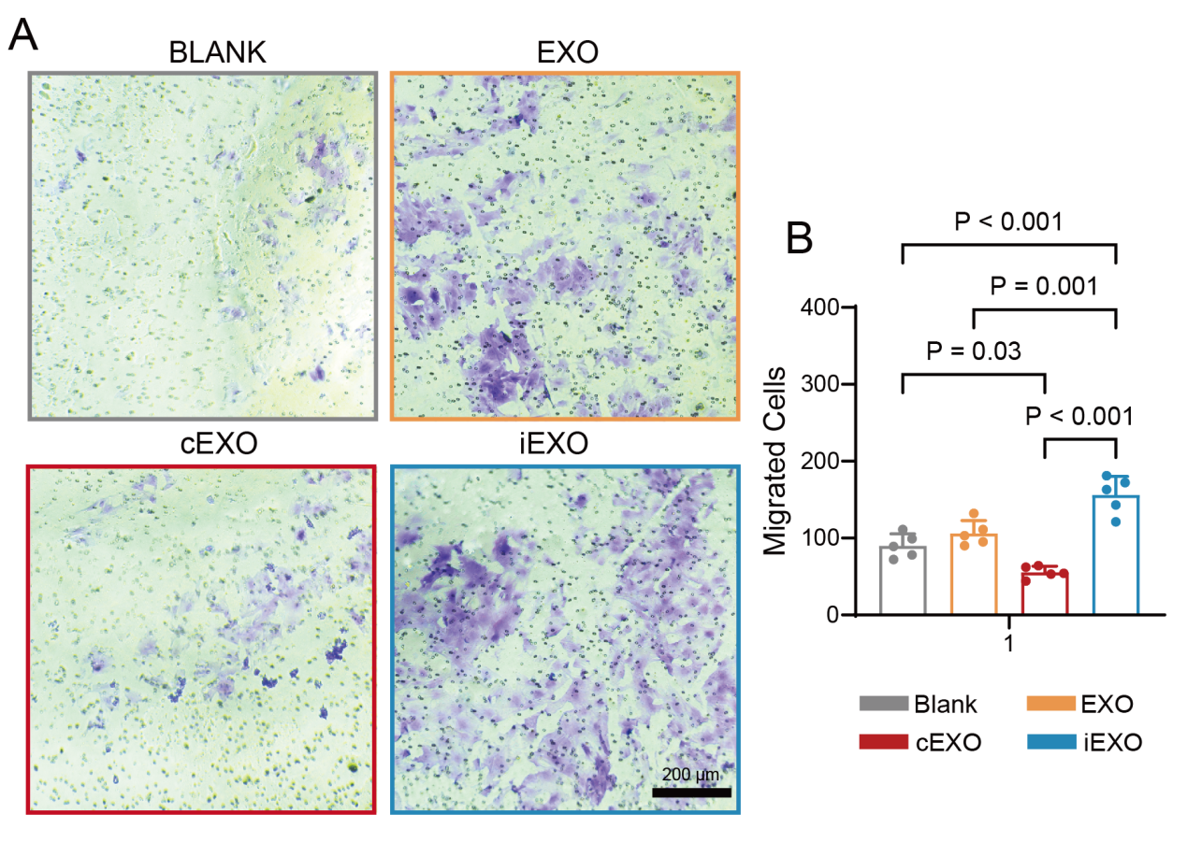
Figure S6. iEXOs promote 3T3 fibroblast migration assessed by Transwell assay. A) Representative crystal violet-stained images of 3T3 cells that migrated through the Transwell membrane following treatment with BLANK, EXO, cEXO, or iEXO. B) Quantification of migrated cell number per field. Data are presented as mean ± SD; n = 5 independent experiments. ***P < 0.001, **P < 0.01, *P < 0.05 by one-way ANOVA with Tukey's post-hoc test. 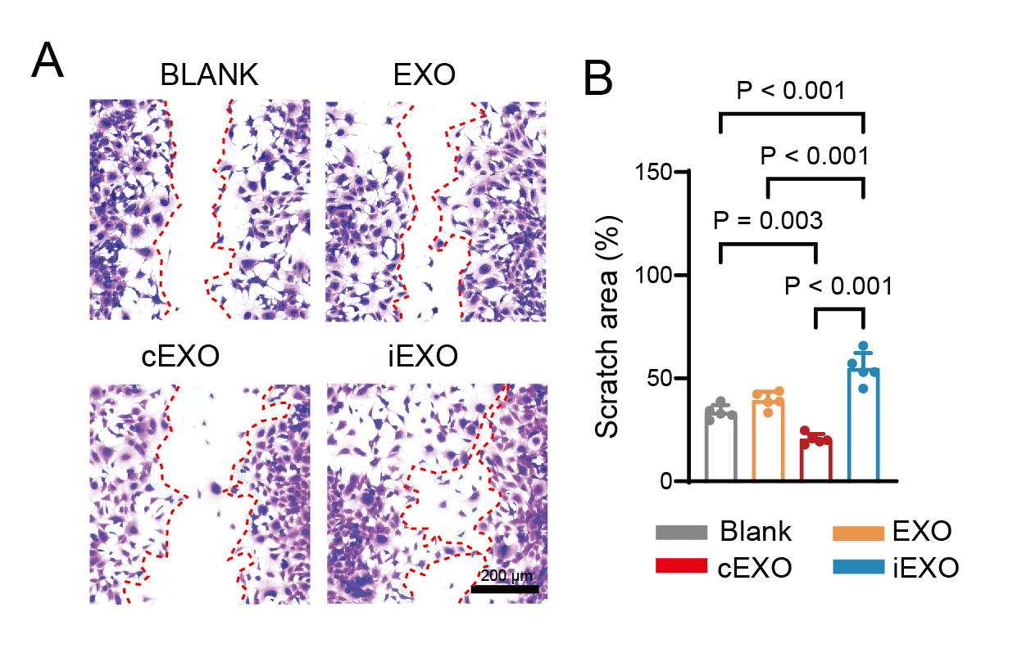
Figure S7. iEXOs accelerate scratch wound closure in 3T3 fibroblasts. A) Representative brightfield images of scratch wounds in 3T3 fibroblasts at 12 h after treatment with BLANK, EXO, cEXO, or iEXO. Red dashed lines demarcate wound boundaries. B) Quantification of wound closure area as a percentage of initial wound area. 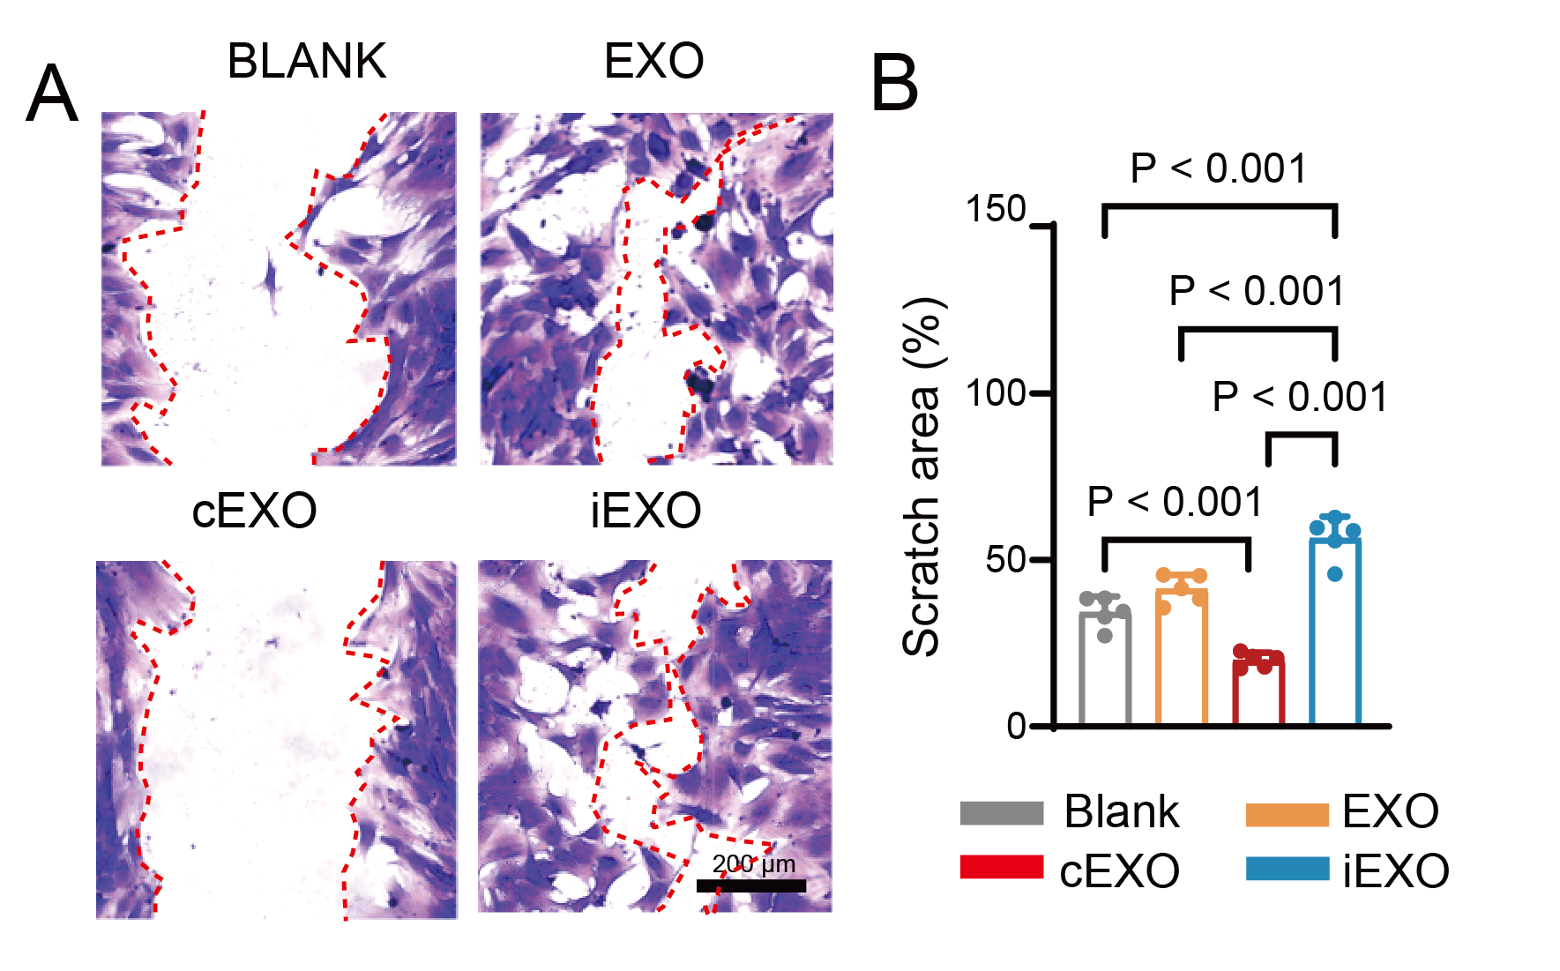
Figure S8. iEXOs accelerate scratch wound closure in BMSCs. A) Representative brightfield images of scratch wounds in BMSCs at 12 h after treatment with BLANK, EXO, cEXO, or iEXO. Red dashed lines demarcate wound boundaries. B) Quantification of wound closure area as a percentage of initial wound area.
area. 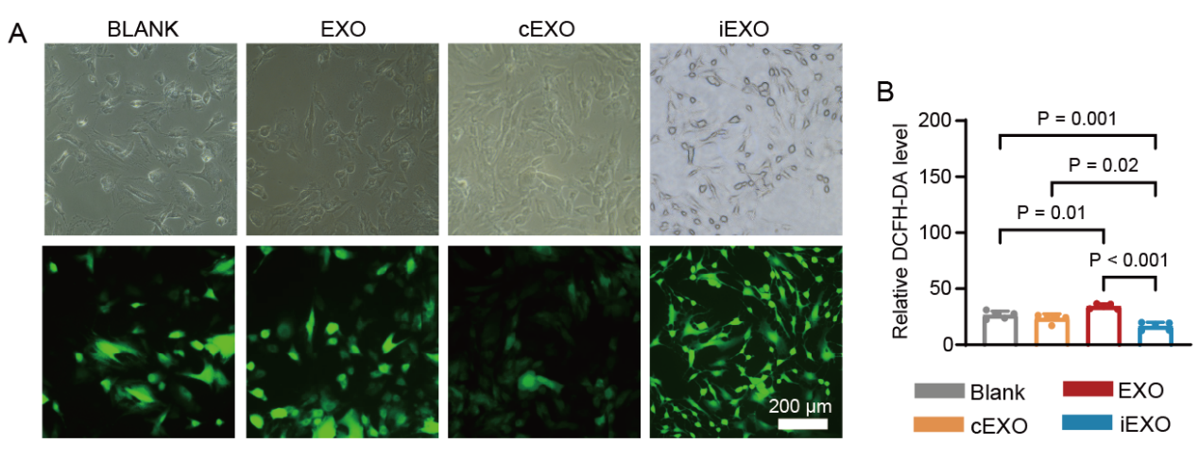
Figure S9. iEXOs reduce intracellular reactive oxygen species levels. A) Representative brightfield images, upper row, and DCFH-DA fluorescence images, lower row, of cells treated with BLANK, EXO, cEXO, or iEXO. Green fluorescence indicates intracellular ROS. Scale bar: 200 μm. B) Quantification of relative DCFH-DA fluorescence intensity. 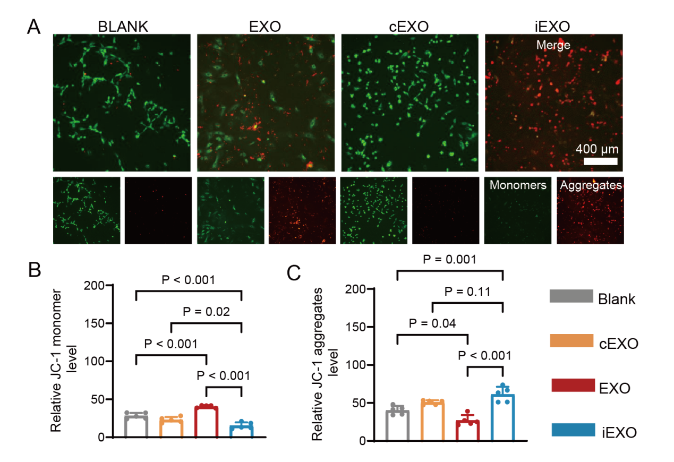
Figure S10. iEXOs preserve mitochondrial membrane potential. A) Representative JC-1 staining images of cells treated with BLANK, EXO, cEXO, or iEXO. The upper row shows merged fluorescence, and the lower row shows separated channel images. Green fluorescence indicates JC-1 monomers in depolarized mitochondria; red fluorescence indicates JC-1 aggregates in polarized mitochondria. Scale bar: 400 μm. B) Quantification of relative JC-1 monomer fluorescence intensity. C) Quantification of relative JC-1 aggregate fluorescence intensity. iEXO-treated cells maintained significantly higher mitochondrial membrane potential compared with controls. 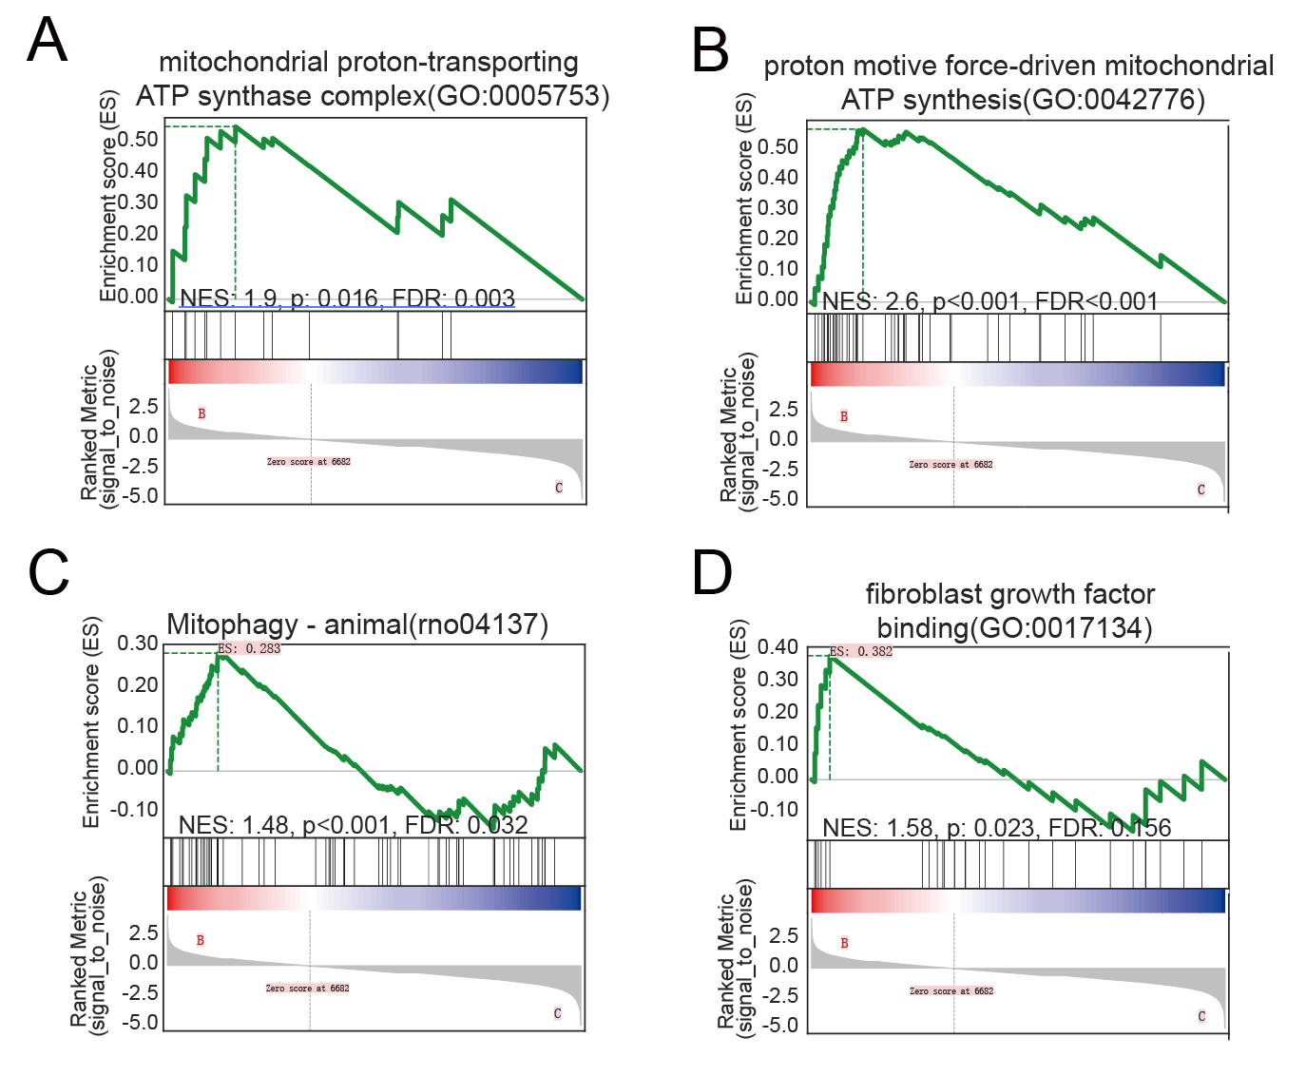
Figure S11. GSEA plots showing significant enrichment of representative gene sets in iEXO-treated BMSCs, including A) mitochondrial proton-transporting ATP synthase complex, B) proton motive force-driven mitochondrial ATP synthesis, C) mitophagy, and D) fibroblast growth factor bindin. Data represent n = 3 biologically independent samples per group.
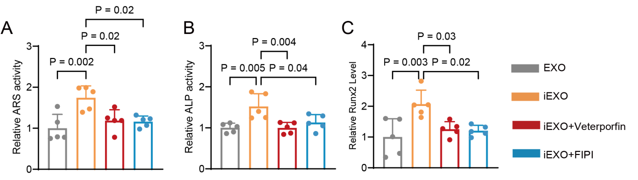
Figure S12 A) Quantification of ALP activity at day 7. B) Quantification of ARS staining intensity at day 21. C) Quantification of Runx2 fluorescence intensity at day 14.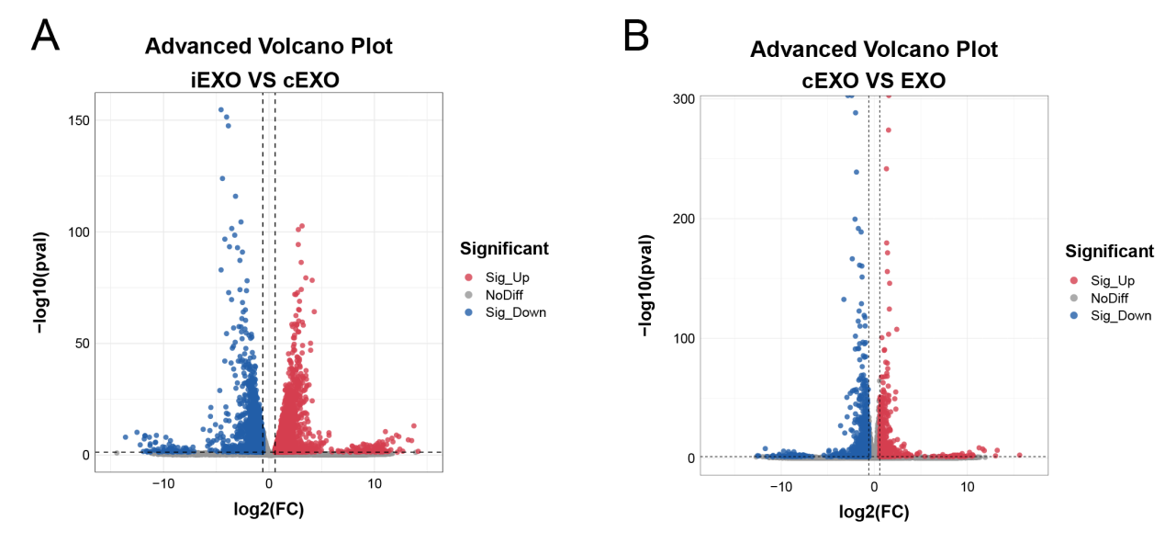
Figure S13. Transcriptomic analysis of differentially expressed genes between exosome groups. Volcano plots of differentially expressed genes, DEGs, identified by RNA sequencing. A) DEGs between iEXO and cEXO groups. B) DEGs between cEXO and EXO groups.
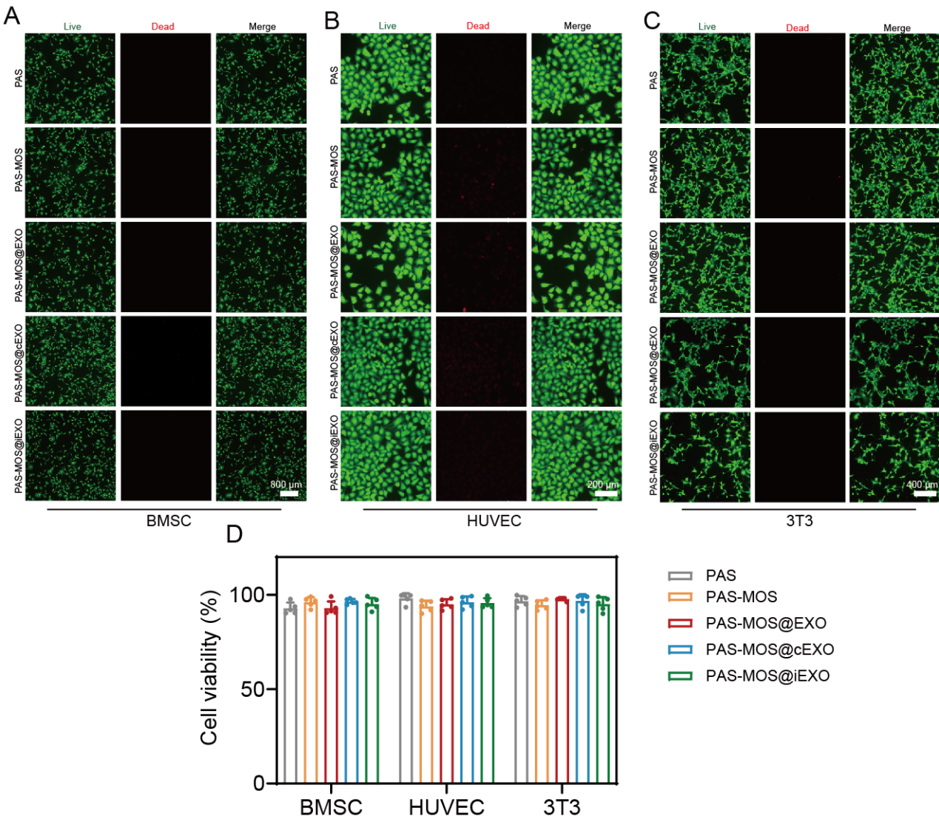
Figure S14. Cytocompatibility evaluation of hydrogel formulations across multiple cell lines. A–C) Representative live/dead fluorescence images of A) BMSCs, B) human umbilical vein endothelial cells, HUVECs, and C) 3T3 fibroblasts cultured with PAS, PAS-MOS, PAS-MOS@EXO, PAS-MOS@cEXO, or PAS-MOS@iEXO hydrogels. Live cells are stained green by Calcein-AM; dead cells are stained red by propidium iodide, PI. Scale bar: 400 μm. D) CCK-8 quantification of cell viability across all five hydrogel formulations in the three cell lines. All groups maintained viability above 90%, confirming excellent cytocompatibility. Data are presented as mean ± SD; n = 3 independent experiments.
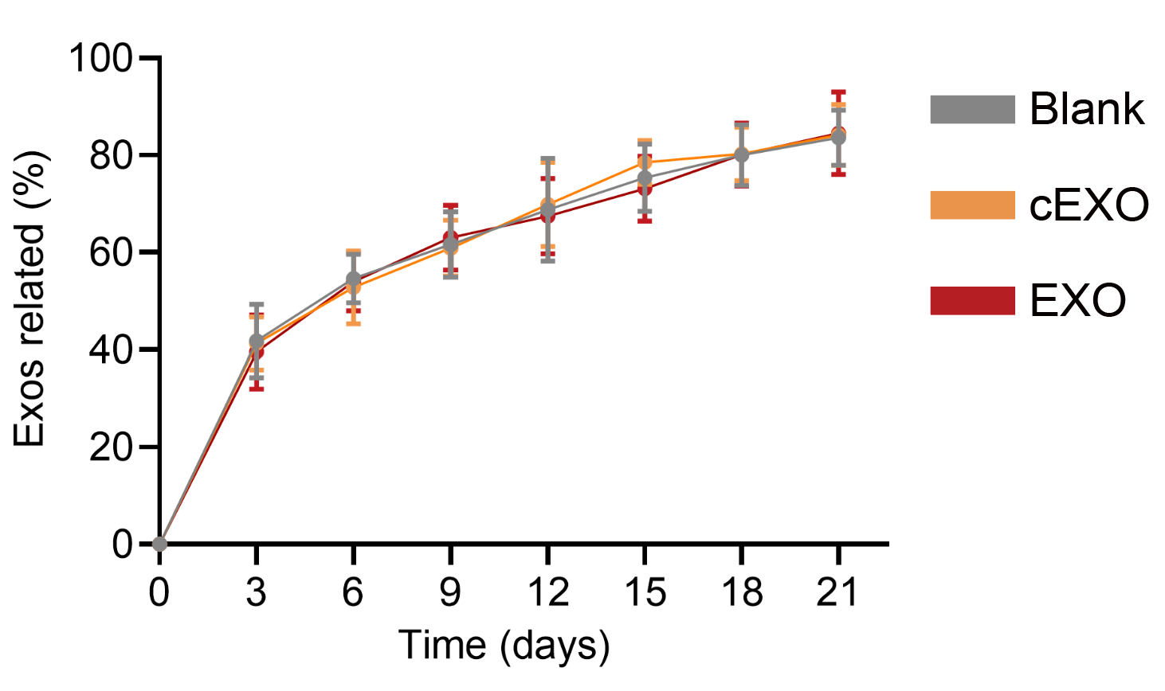
Figure S15. Curves of the cumulative release of exosomes from the iEXO@PM hydrogel in vitro.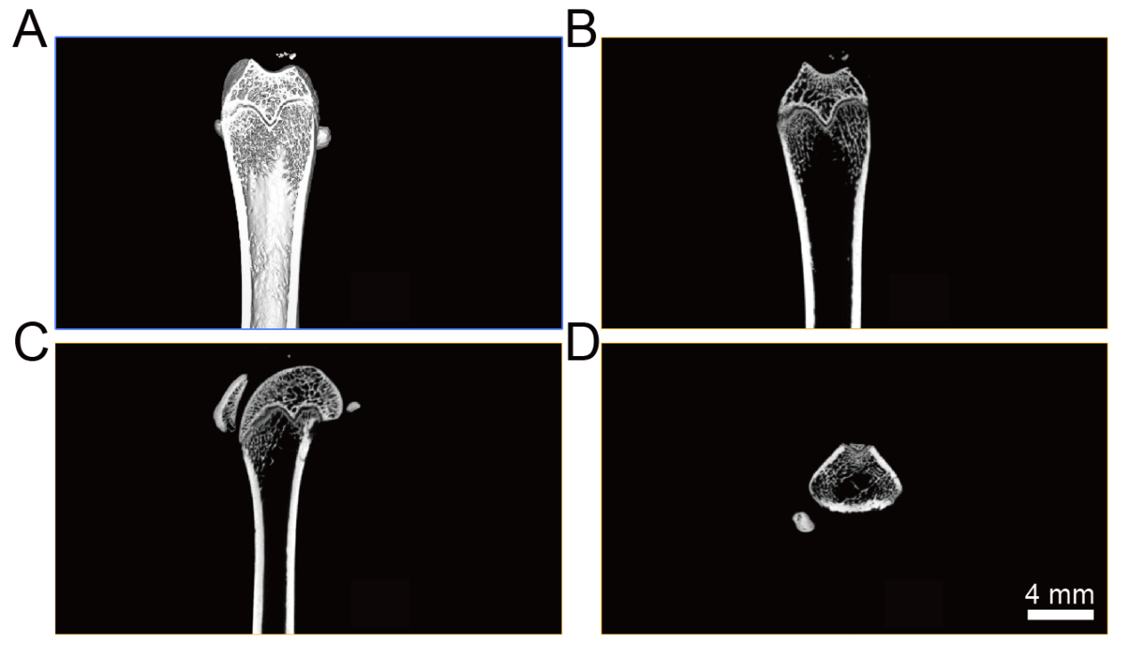
Figure S16. Micro CT analysis of the distal femur in 3D profile(A), coronal (B), sagittal(C) and cross-sectional (D) positions in OVX rats. 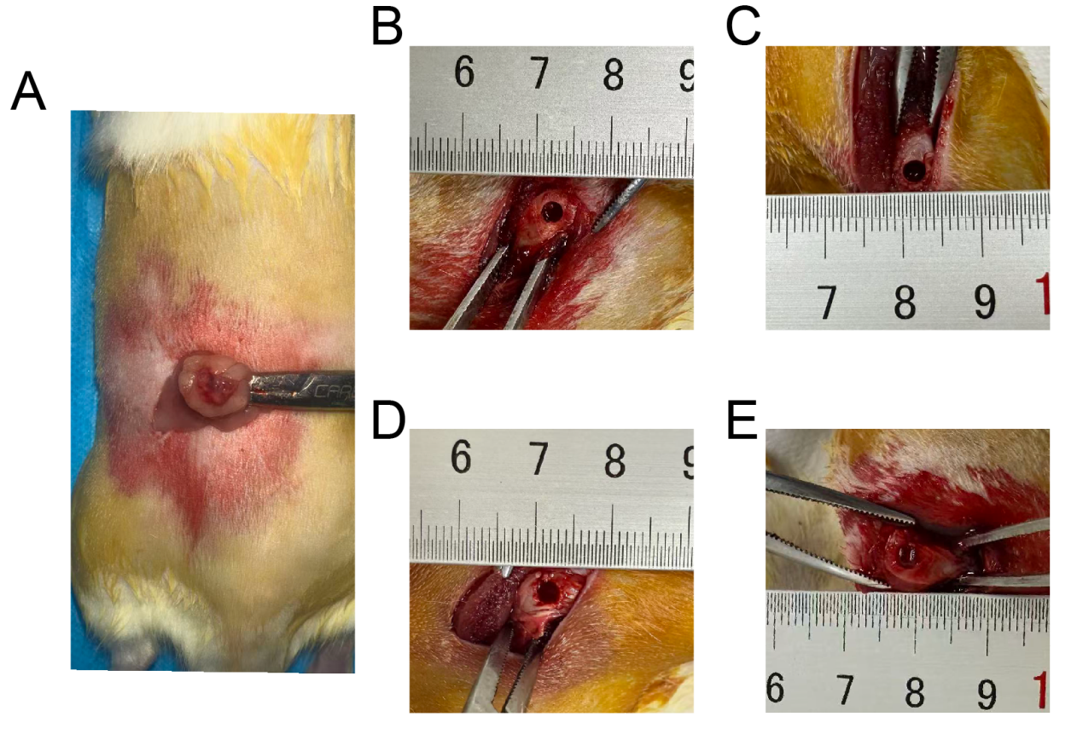
Figure S17. Surgical procedures for ovariectomy-induced osteoporotic model establishment and hydrogel implantation. A) Representative intraoperative photographs of the ovariectomy, OVX, procedure for establishing the osteoporotic rat model, showing the surgical site and excised ovarian tissue. B–E) Intraoperative photographs demonstrating creation of an approximately 3 mm diameter bone defect at the distal femur using a microelectric drill, followed by implantation of B) BLANK, C) PAS-MOS@EXO, D) PAS-MOS@cEXO, and E) PAS-MOS@iEXO hydrogels, respectively. All groups demonstrate the injectable and in situ gelling properties of the hydrogel formulations.

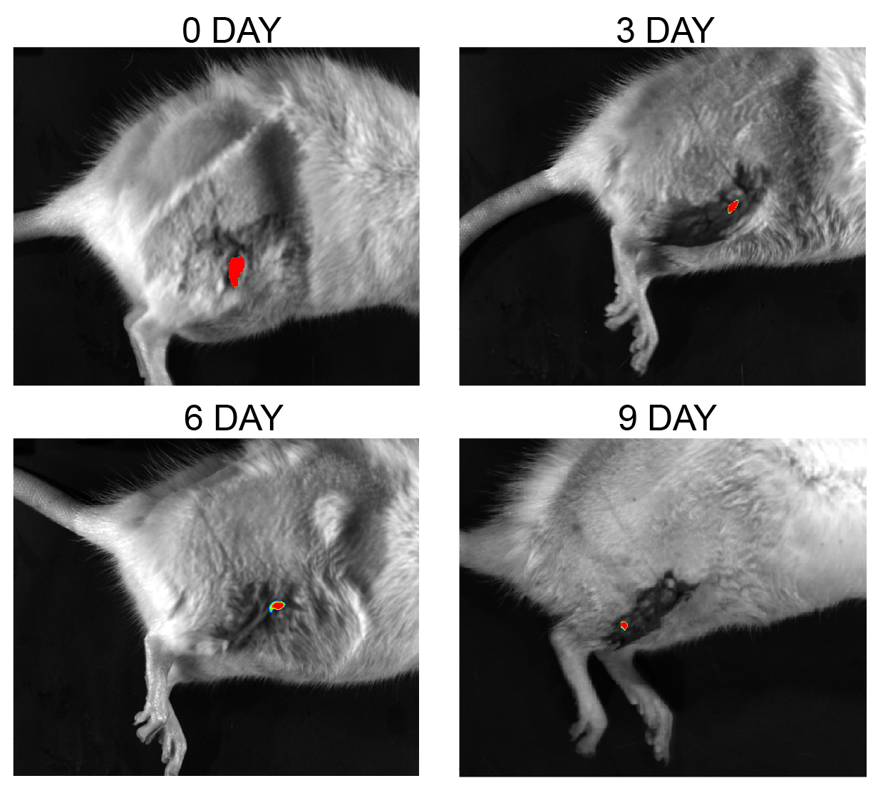
Figure S18. In vivo tracking of DiR-labeled iEXO-loaded hydrogel at the bone defect site. Representative whole-animal fluorescence images acquired at 0, 3, 6, and 9 days after implantation of DiR-labeled PAS-MOS@iEXO hydrogel into the femoral bone defect. Red fluorescence signals indicate retention and spatial distribution of labeled exosomes at the defect site. Sustained fluorescence over at least 9 days confirms prolonged local retention of iEXOs, supporting continuous delivery of bioactive signals for bone regeneration. 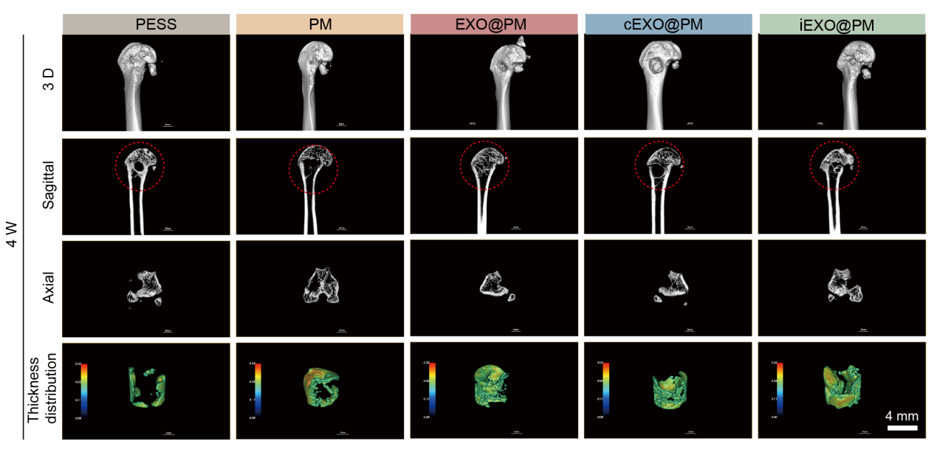
Figure S19. Micro-CT evaluation of bone defect repair at 4 weeks post-surgery. Representative micro-CT images at 4 weeks post-surgery across all experimental groups, including three-dimensional reconstruction, sagittal cross-section, axial cross-section, and color-coded bone thickness distribution maps. Red dashed circles indicate the bone defect region. 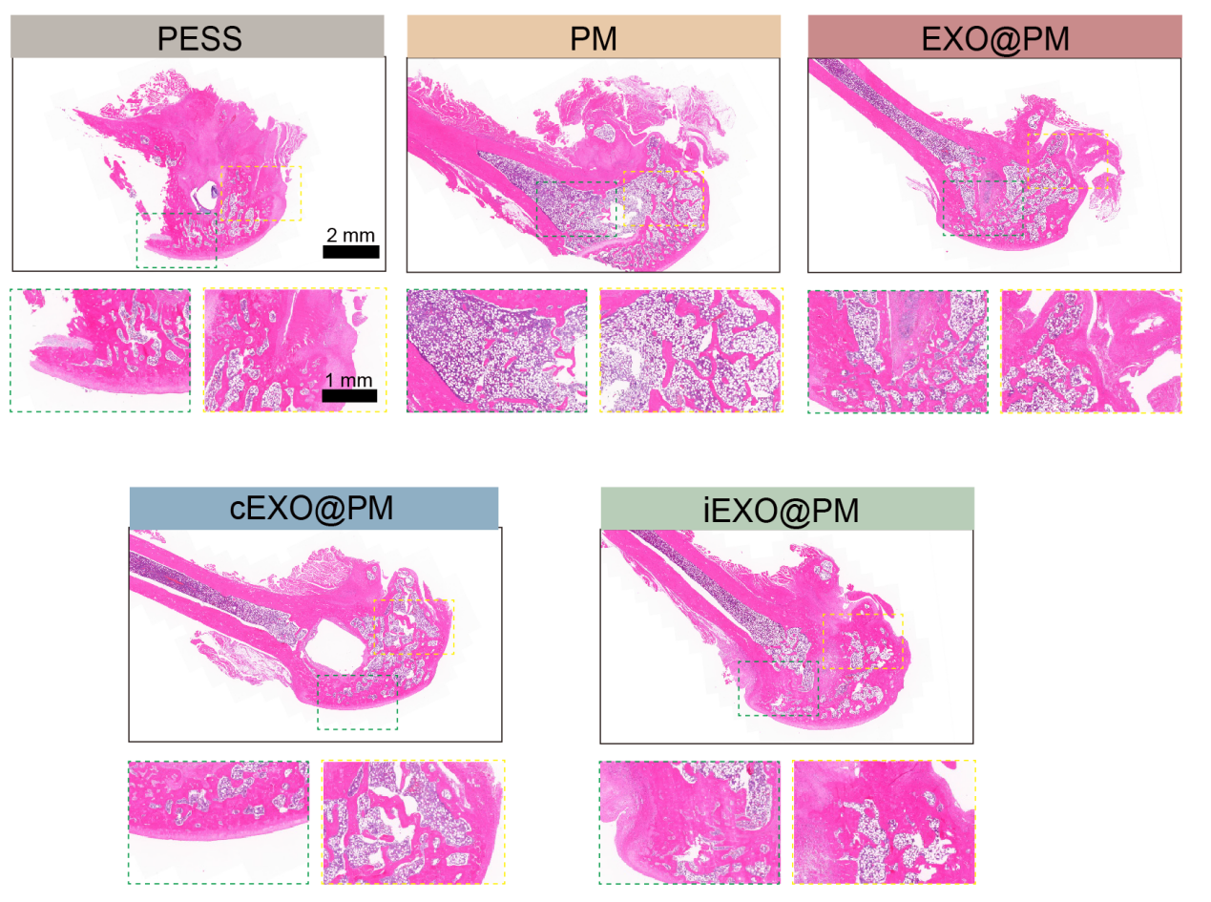
Figure S20. Histological evaluation of bone regeneration at 4 weeks by H&E staining. Representative hematoxylin and eosin, H&E, stained sections of bone defect areas at 4 weeks post-surgery across all experimental groups, evaluating new bone formation and tissue organization within the defect. 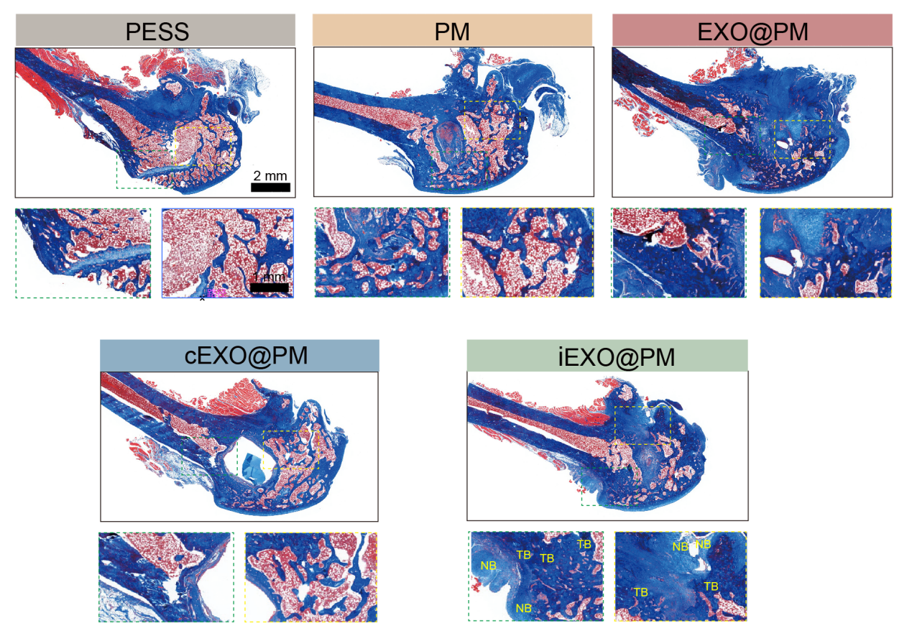
Figure S21. Histological evaluation of collagen deposition at 4 weeks by Masson's trichrome staining. Representative Masson's trichrome-stained sections of bone defect areas at 4 weeks post-surgery across all experimental groups. Blue staining indicates collagen deposition; red staining indicates newly formed bone matrix. 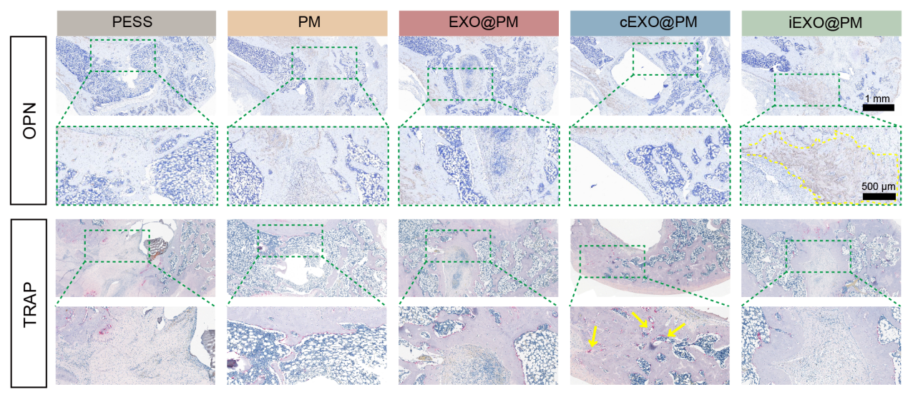
Figure S22. Immunohistochemical and histochemical evaluation of osteogenesis and osteoclastogenesis at 4 weeks. Representative OPN immunohistochemical staining and TRAP staining of bone defect sections at 4 weeks post-surgery across all experimental groups, evaluating osteogenic activity and osteoclast number within the defect region, respectively. 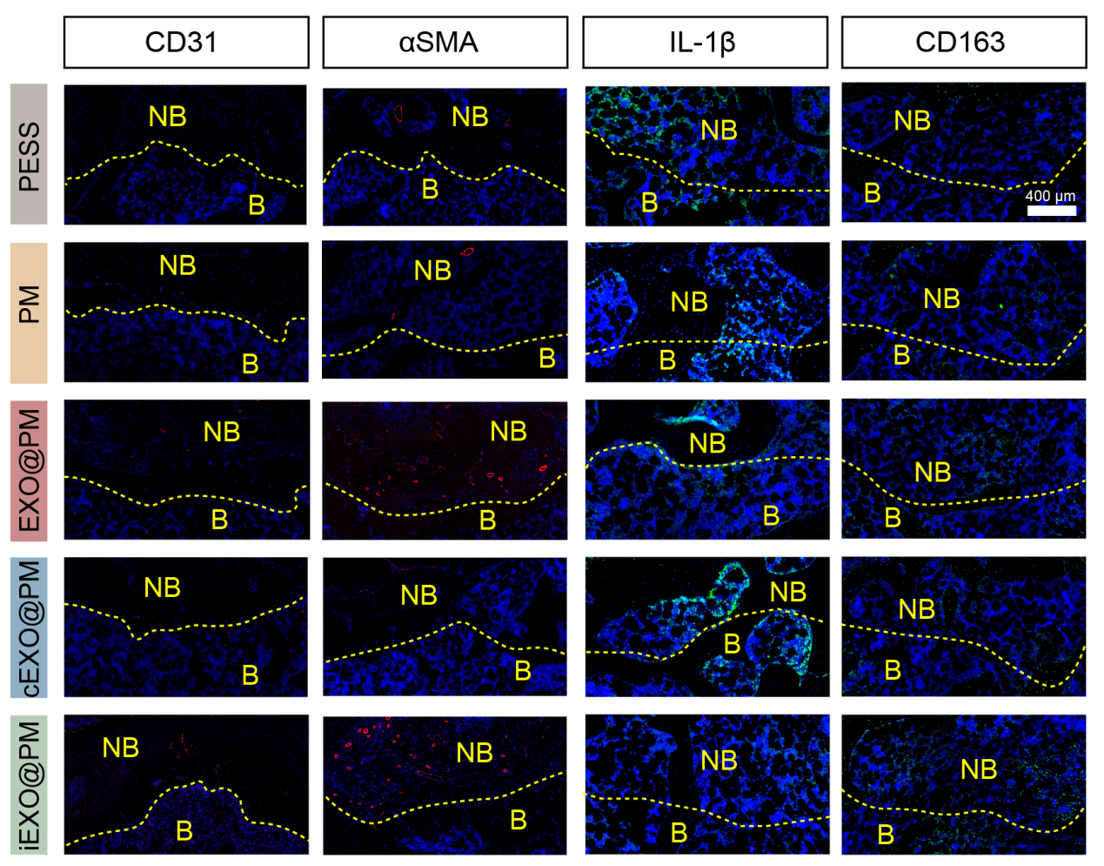
Figure S23. Immunofluorescence evaluation of vascularization and immune regulation at 4 weeks. Representative immunofluorescence images of bone defect sections at 4 weeks post-surgery across all experimental groups, stained for CD31, α-SMA, IL-1β, and CD163, assessing neovascularization, vascular maturation, pro-inflammatory cytokine expression, and M2 macrophage polarization, respectively. 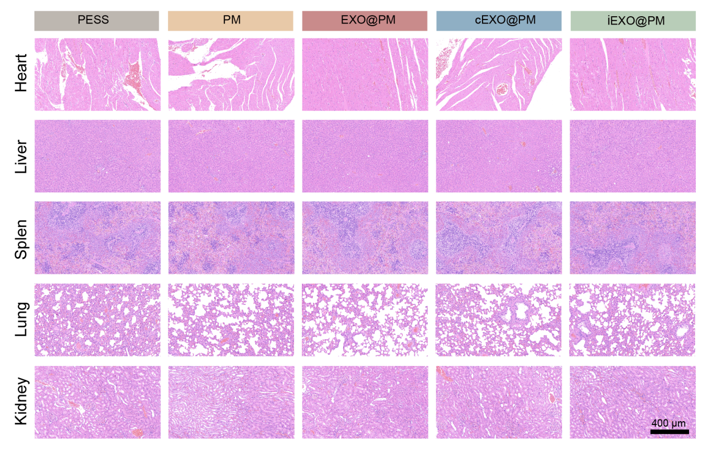
Figure S24. In vivo safety of the implantation in SD rats. HE staining of histological sections from major organs, including the heart, kidneys, liver, lungs, and spleen.

Table S1 Primers used for qRT-PCR of osteogenic genes (Rat)
Gene | Forward primers (5’ to 3’) | Reverse primers (5’ to 3’)
Bglap | TCAACAATGGACTTGGAGCCC | GCAACACATGCCCTAAACGG
Col1a1 | ATCAGCTGGAGTTTCCGTGC | GGACCCATTGGACCTGAAGC
Runx2 | GCGGTGCAAACTTTCTCCAG | TGCAGCCTTAAATGACTCGG
Table S2 Primers used for qRT-PCR of osteoclastogenic genes (Mouse)
Gene | Forward primers (5’ to 3’) | Reverse primers (5’ to 3’)
Ctsk | CCTGTTGGGCTTTCAGCTCT | CCGTTCTGCTGCACGTATTG
Mmp9 | TGGTCTTCCCCAAAGACCTG | CACAGCGTGGTGTTCGAATG
Table S3 Primers used for qRT-PCR of angiogenesis genes (Human)
Gene | Forward primers (5’ to 3’) | Reverse primers (5’ to 3’)
FGF2 | AGCGACCCTCACATCAAG | ATCTCATCTTCCTTCATAGC
VEGF | ATGAGCTTCCTACAGCACAACA | ACGTACACGCTCCAGGACTTAT

