Supplementary Material
Governing Transboundary Risks of Atmospheric Water Resource Manipulation: Exploratory Evidence for Climate Governance
This document contains supplementary methods (Sections S1–S6), four supplementary tables (Tables S1–S4), and two supplementary figures (Figs. S1–S2) referenced in the main text. Unless otherwise noted, table and figure values throughout this document are indicative: they illustrate relative magnitude, ordering, or structure and should not be read as exact or calibrated estimates.

Contents
S1. Game-theoretic framework: derivations and governance scenarios
S2. Construction of the Infrastructure Economic Exposure Index (IEEI)
S3. Construction of the AWRM intensity index
S4. Hydroclimatic variability measure
S5. Corridor sample selection
S6. Channel decomposition: full results
Table S1. Principal-component results for the IEEI
Table S2. Principal-component results for the AWRM intensity index
Table S3. Hydroclimatic variability (CV): summary and regional distribution
Table S4. Governance-scenario results
Fig. S1. Channel decomposition and transport-mode heterogeneity
Fig. S2. Game-theoretic results and governance scenarios

S1. Game-theoretic framework: derivations and governance scenarios
This section formalises the strategic structure summarised in Section 3.4 and Section 5.6 of the main text. Consider a transboundary corridor with one upstream state u that operates an AWRM programme and one downstream state d whose transport infrastructure bears part of the resulting hydroclimatic exposure. Let the corridor-wide social cost of programme intensity a be C(a), of which the upstream state internalises a share θ ∈ [0,1] and the downstream state bears (1 − θ). The upstream state chooses programme intensity to maximise its own net payoff, taking into account only the fraction θ of corridor-wide cost that falls on it.
When θ < 1, the privately optimal intensity exceeds the corridor-efficient level, because the upstream state discounts the externality imposed downstream. The resulting non-cooperative equilibrium is inefficient in the standard sense: aggregate welfare is lower than under the cooperative solution in which the full social cost is internalised. This is the Prisoner’s Dilemma structure referenced in the main text. The efficiency loss is decreasing and convex in θ, reaching zero at θ = 1 (full internalisation); Fig. S2(a) plots this relationship using the normalisation that the non-cooperative baseline (θ at its observed lower bound) equals 100.
The four scenarios in Table S4 span increasing values of the effective internalisation share θ. Beyond the non-cooperative baseline, three progressively more demanding institutional arrangements correspond to higher θ: (1) prior notification, which reduces informational asymmetry but shifts θ only modestly; (2) bilateral cost-sharing, which raises θ through negotiated transfers; and (3) full multilateral internalisation, which approximates θ → 1. The model is deliberately stylised: it is static, assumes complete information, and abstracts from sequential bargaining, coalition formation, and domestic politics, so its outputs convey the direction and relative ordering of the coordination dividend rather than calibrated magnitudes. The directional comparative static, that cost volatility falls as θ rises, is robust across specifications; the specific values are illustrative.

S2. Construction of the Infrastructure Economic Exposure Index (IEEI)
The IEEI (defined and motivated in Section 4.1 of the main text) is a standardised composite (mean 0, standard deviation 1) formed by principal-component aggregation of three indicators: (i) bilateral freight rate indices (World Bank, 2023a); (ii) border-crossing delay indicators (United Nations, 2023); and (iii) downstream infrastructure quality scores (World Economic Forum, 2020). The first principal component is retained as the index. The composite correlates with the full World Bank Logistics Performance Index at r = 0.78 (p < 0.001), supporting its construct validity as a measure of corridor-level logistics exposure while remaining more sensitive to the hydroclimatic-disruption channel than the full LPI.
Table S1. Principal-component results for the IEEI
Indicator | PC1 loading | PC2 | PC3
Bilateral freight rate index (World Bank, 2023a) | 0.62 | −0.55 | 0.56
Border-crossing delay index (United Nations, 2023) | 0.59 | 0.78 | 0.20
Downstream infrastructure quality (WEF, 2020) | 0.52 | −0.30 | −0.80
Eigenvalue | 1.83 | 0.68 | 0.49
Variance explained | 61.0% | 22.6% | 16.4%
Table S1. Principal-component decomposition of the three IEEI indicators (standardised; PC1 retained as the index). PC1 loads positively and comparably on all three indicators, consistent with a single logistics-exposure construct. The retained component correlates with the full World Bank LPI at r = 0.78 (p < 0.001). Full construction in Section S2. Source: Authors’ calculations.
Note: Eigenvalues and variance-explained are reported for the first three components; loadings and secondary components illustrate the single-factor structure rather than provide separate estimates.

S3. Construction of the AWRM intensity index
AWRM intensity is the first principal component of three indicators drawn from independent data-generating processes: (i) government expenditure on weather modification programmes, in constant 2015 USD (PPP-adjusted); (ii) operational records comprising annual sortie counts and seeding-agent volumes, from national meteorological agencies and WMO (2018); and (iii) satellite-derived aerosol optical depth (AOD) anomalies from MODIS/Terra Collection 6 (Levy et al., 2013), computed within upstream seeding zones. The first principal component explains approximately 58% of the variance across the three indicators.
The rationale for this effort-based composite is set out in Section 4.2 of the main text. Three sources of measurement error are acknowledged: government expenditure and operational records are self-reported and vary in consistency across states; the AOD signal carries contamination from industrial pollution, dust, and wildfire smoke, mitigated only partially by spatial restriction to documented seeding zones; and coverage is more complete for institutionalised, well-documented programmes. These limitations are examined in Section 6.3 of the main text. If the resulting error is broadly classical, it attenuates the fixed-effects estimates toward zero, consistent with the larger coefficients obtained under the error-robust instrumental-variable and GMM estimators.
Table S2. Principal-component results for the AWRM intensity index
Indicator | PC1 loading | PC2 | PC3
Programme expenditure, const. 2015 USD (WMO, 2018) | 0.60 | −0.62 | 0.51
Operational records: sorties, agent volumes | 0.61 | 0.10 | −0.79
AOD anomalies, MODIS/Terra C6 (Levy et al., 2013) | 0.52 | 0.78 | 0.35
Eigenvalue | 1.74 | 0.71 | 0.55
Variance explained | 58.0% | 23.7% | 18.3%
Table S2. Principal-component decomposition of the three AWRM intensity indicators (PC1 retained as the index). PC1 explains approximately 58% of variance and loads positively and comparably on the fiscal, operational, and satellite indicators, evidence that they track a single latent construct (programme scale). Full construction and measurement caveats in Section S3. Source: Authors’ calculations.
Note: Measurement caveats are discussed further in Section 6.3 of the main text.

S4. Hydroclimatic variability measure
Hydroclimatic variability is measured by the coefficient of variation (CV) of monthly precipitation totals within the downstream corridor region, computed from ERA5 reanalysis data (Hersbach et al., 2020). The coefficient of variation is used in preference to absolute precipitation totals because it is less sensitive to the known regional level biases of reanalysis precipitation, capturing instead the relative dispersion of precipitation that drives hydrological disruption. This variable enters the main specification both directly and interacted with AWRM intensity, the interaction capturing the amplification of the AWRM–exposure association in hydrologically stressed corridors reported in Section 5.3.
Table S3. Hydroclimatic variability (CV): summary and regional distribution
Statistic / region | N | Mean | SD | Min | Max
Full sample | 1,008 | 0.318 | 0.189 | 0.041 | 0.912
East Asia | – | 0.29 | 0.17 | 0.05 | 0.79
South/Central Asia | – | 0.41 | 0.21 | 0.08 | 0.91
Europe | – | 0.24 | 0.12 | 0.04 | 0.61
Sub-Saharan Africa | – | 0.38 | 0.20 | 0.07 | 0.88
Latin America | – | 0.31 | 0.18 | 0.06 | 0.74
Table S3. Coefficient of variation (CV) of monthly precipitation totals within downstream corridor regions, computed from ERA5 reanalysis (Hersbach et al., 2020).
Note: CV is unitless (SD of monthly precipitation divided by its mean). Full-sample statistics are computed over all N = 1,008 corridor-year observations; regional rows report the distribution of corridor-level CV within each continental group. Higher CV denotes greater relative dispersion of precipitation and thus greater hydrological stress. The measure enters the main specification directly and interacted with AWRM intensity (Section 5.3). Source: Authors’ calculations from ERA5.

S5. Corridor sample selection
The sample comprises 42 transboundary corridor pairs observed annually from 2000 to 2023, yielding 1,008 corridor-year observations across five continental regions. Corridor pairs are included where the upstream state operates, or has operated, a documented AWRM programme during the sample period. Corridors lacking documented programme histories, or with extended missing data, are excluded. As noted in the main text, this selection over-represents institutionalised, data-rich settings and introduces a potential survivorship bias; the sample therefore represents the universe of corridors for which sufficient data could be compiled rather than a global cross-section. The direction of this selection is informative: if documentation correlates with stronger governance, extrapolation is more likely to understate than to overstate exposure in undocumented corridors.

S6. Channel decomposition: full results
The channel decomposition summarised in Section 5.5 and shown in Fig. S1 attributes the estimated AWRM–IEEI association across four transmission channels. Road–rail degradation accounts for the largest share, waterway navigability the second largest, with energy disruption and administrative delay making up the remainder. Corridors in which inland waterways are the dominant transport mode exhibit the largest associations, consistent with the well-documented sensitivity of inland-waterway freight to hydrological conditions. As emphasised in the main text, these channel shares are model-dependent and should be interpreted as indicative of relative ordering rather than as precise partitions.

Table S4. Governance-scenario results
Governance scenario | Effective θ (illustrative) | Cost-volatility index | Interpretation
Non-cooperative baseline | lower bound | 100 | Reference case; upstream internalises minimal share of corridor-wide cost
Prior notification | low | 88 (± 6) | Smallest reduction; reduces informational asymmetry only
Bilateral cost-sharing | moderate | 71 (± 9) | Larger reduction; negotiated transfers raise internalisation
Multilateral internalisation | → 1 | 52 (± 12) | Largest reduction; approximates full cost internalisation
Table S4. Governance-scenario results from the stylised framework (Section S1). Cost-volatility index normalised to a non-cooperative baseline of 100; lower values indicate reduced volatility. Parenthetical ranges are approximate 95% intervals. Values indicate direction and relative scale, not calibrated predictions. Source: Authors’ calculations.

Fig. S1. Channel decomposition and transport-mode heterogeneity
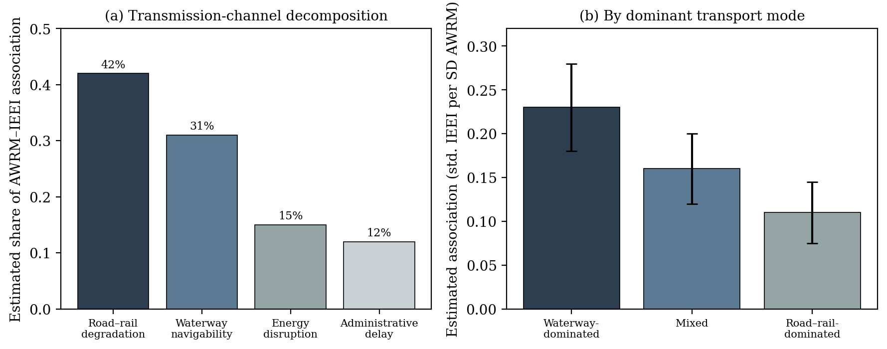
Fig. S1. Channel decomposition and transport-mode heterogeneity (full results: Section S6). (a) Estimated shares of the AWRM–IEEI association by channel. (b) Associations by dominant transport mode; waterway corridors show the largest. Error bars: approximate 95% CIs. Source: Authors’ calculations.

Fig. S2. Game-theoretic results and governance scenarios
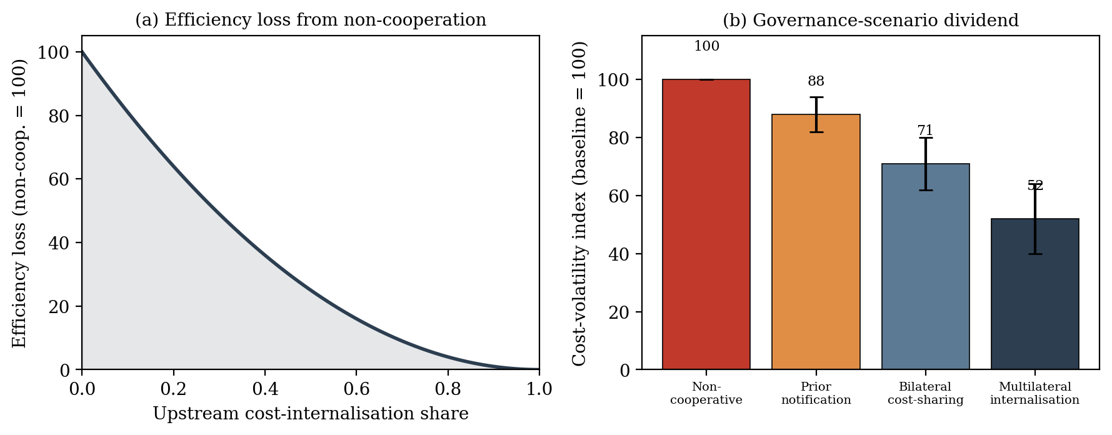
Fig. S2. Game-theoretic results and governance scenarios (derivations: Section S1). (a) Efficiency loss from non-cooperation vs. the upstream cost-internalisation share (baseline = 100). (b) Cost-volatility index under four scenarios (baseline = 100; error bars: approximate 95% intervals). Source: Authors’ calculations.

