Additional file 1: Supplementary material

Method S1. Code for cohort definition, baseline covariates and outcome 2
Figure S1. The flow chart of combination therapy versus GLP-1RA 7
Figure S2. The time distribution of follow-up time 8
Figure S3. Subgroup analysis for the risk of mortality 9
Figure S4. Subgroup analysis on the risk of COPD exacerbation 10
Figure S5. Subgroup analysis on the risk of pneumonia 11
Table S1. The Checklist of STROBE Statement 12
Table S2. Specification of target trial emulation 15
Table S3. Hierarchical propensity score matching models 17
Table S4. Sensitivity analyses across cumulative follow-up horizons 18
Table S5. Baseline characteristics of GLP-1RA+SGLT2i VS. GLP-1RA 19

Method S1. Code for cohort definition, baseline covariates and outcome
- Codes for cohort definition

Inclusion criteria
Type 2 DM,COPD , and target medications
visit | TNX:Visit | Visit
diagnosis | UMLS:ICD10CM:E11 | Type 2 diabetes mellitus (at least 18 years old at event)
diagnosis | UMLS:ICD10CM:J44 | Other chronic obstructive pulmonary disease (at least 18 years old at event)
medication | NLM:ATC:A10BK | Sodium-glucose co-transporter 2 (SGLT2) inhibitors
medication | NLM:ATC:A10BJ | Glucagon-like peptide-1 (GLP-1) analogues
Exclusion criteria
global oncology | UMLS:ICDO3:C00-C80 | Oncology: Primary Site
diagnosis | UMLS:ICD10CM:Z94 | Transplanted organ and tissue status
procedure | UMLS:CPT:1012740 | Dialysis Services and Procedures
procedure | UMLS:CPT:90945 | Dialysis procedure other than hemodialysis (eg, peritoneal dialysis, hemofiltration, or other continuous renal replacement therapies), with single evaluation by a physician or other qualified health care professional
diagnosis | UMLS:ICD10CM:Z99.2 | Dependence on renal dialysis

- Code for baseline covariate definition after matching
Cohort 1 and cohort 2 patient count before and after propensity score matching
Cohort |  |  | Patient count before matching |  |  | Patient count after matching
1 – GLP1 RA and SGLT2i_combination |  |  | 17,941 |  |  | 17,467
2 – SGLT2i_monotherapy |  |  | 38,692 |  |  | 17,467
Propensity score density function - Before and after matching (cohort 1 - purple, cohort 2 - green)
 | 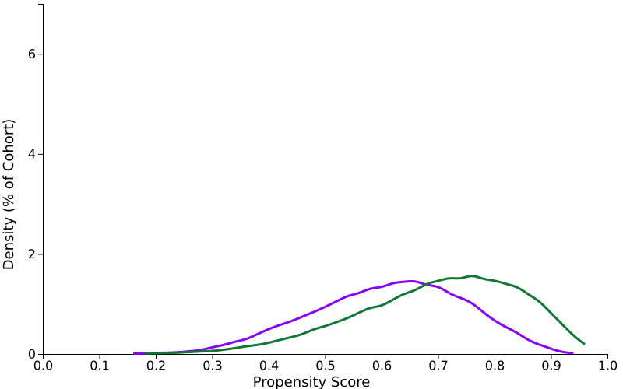 |  |  | 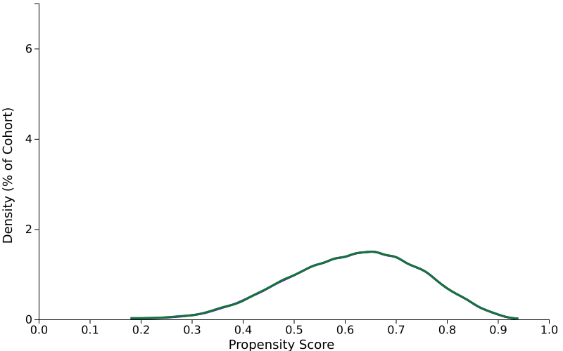
Characteristics After propensity score matching
Demographics
AI |  | Age at Index
2106-3 |  | White
UNK |  | Unknown Race
2054-5 |  | Black or African American
M |  | Male
2131-1 |  | Other Race
2028-9 |  | Asian
Diagnosis
International Classification of Diseases, Tenth Revision, |  | Name
E78 |  | Disorders of lipoprotein metabolism and other lipidemias
I10-I1A |  | Hypertensive diseases
I50 |  | Heart failure
I48 |  | Atrial fibrillation and flutter
I42 |  | Cardiomyopathy
I20-I25 |  | Ischemic heart diseases
I60-I69 |  | Cerebrovascular diseases
I05-I09 |  | Chronic rheumatic heart diseases
E00-E07 |  | Disorders of thyroid gland
K74 |  | Fibrosis and cirrhosis of liver
K76.0 |  | Fatty (change of) liver, not elsewhere classified
K72 |  | Hepatic failure, not elsewhere classified
K80-K87 |  | Disorders of gallbladder, biliary tract and pancreas
Z72.0 |  | Tobacco use
F17 |  | Nicotine dependence
F10 |  | Alcohol related disorders
Z55-Z65 |  | Persons with potential health hazards related to socioeconomic and psychosocial circumstances
Z59 |  | Problems related to housing and economic circumstances
Z56 |  | Problems related to employment and unemployment
G47.33 |  | Obstructive sleep apnea (adult) (pediatric)
N18 |  | Chronic kidney disease (CKD)
F32 |  | Depressive episode
M81 |  | Osteoporosis without current pathological fracture
Procedure
Cohort |  | Name
1013626 |  | Office or Other Outpatient Services
1013711 |  | Emergency Department Services
1013659 |  | Hospital Inpatient and Observation Care Services
1013829 |  | Preventive Medicine Services
Medication
Anatomical Therapeutic  Chemical |  | Name
A10A |  | INSULINS AND ANALOGUES
A10BA |  | Biguanides
A10BB |  | Sulfonylureas
A10BG |  | Thiazolidinediones
C10AA |  | HMG CoA reductase inhibitors
C10AB |  | Fibrates
C09 |  | AGENTS ACTING ON THE RENIN-ANGIOTENSIN SYSTEM
C03 |  | DIURETICS
C07 |  | BETA BLOCKING AGENTS
C08 |  | CALCIUM CHANNEL BLOCKERS
B01 |  | ANTITHROMBOTIC AGENTS
RE101 |  | ANTI-INFLAMMATORIES,INHALATION
RE102 |  | BRONCHODILATORS,SYMPATHOMIMETIC,INHALATION
RE103 |  | BRONCHODILATORS,SYMPATHOMIMETIC,ORAL
RE104 |  | BRONCHODILATORS,XANTHINE-DERIVATIVE
RE105 |  | BRONCHODILATORS,ANTICHOLINERGIC
Laboratory
TNX Curated |  | Name |  |  | Unit |  | Missing rate
 |  |  |  |  |  |  | Cohort 1 | Cohort 2
9029 |  | Sodium [Moles/volume] in Serum, Plasma or Blood |  |  | mmol/L |  | 11.7 | 11.8
9022 |  | Calcium [Mass/volume] in Serum, Plasma or Blood |  |  | mg/dL |  | 12.2 | 12.3
9014 |  | Hemoglobin [Mass/volume] in Blood |  |  | g/dL |  | 16.7 | 16.2
9044 |  | Alanine aminotransferase [Enzymatic activity/volume] in Serum, Plasma or Blood |  |  | U/L |  | 15.9 | 15.8
9047 |  | Aspartate aminotransferase [Enzymatic activity/volume] in Serum or Plasma |  |  | U/L |  | 17 | 16.9
9045 |  | Albumin [Mass/volume] in Serum, Plasma or Blood |  |  | g/dL |  | 11.8 | 11.7
9002 |  | Cholesterol in LDL [Mass/volume] in Serum or Plasma |  |  | mg/dL |  | 21.8 | 28.1
9001 |  | Cholesterol in HDL [Mass/volume] in Serum or Plasma |  |  | mg/dL |  | 26.7 | 26.7
9004 |  | Triglyceride [Mass/volume] in Serum, Plasma or Blood |  |  | mg/dL |  | 26.5 | 26.5
9037 |  | Hemoglobin A1c/Hemoglobin.total in Blood |  |  | % |  | 19.3 | 17.5
9083 |  | BMI |  |  | kg/m2 |  | 23.3 | 23
9086 |  | Blood Pressure, Diastolic |  |  | mm[Hg] |  | 14.5 | 14.4
9085 |  | Blood Pressure, Systolic |  |  | mm[Hg] |  | 14.5 | 14.4
LG34791-0 |  | Protein/Creatinine [Mass ratio] in Urine |  |  | mg/g{creat} |  | 93.7 | 93.4
8001 |  | Glomerular filtration rate/1.73 sq M.predicted [Volume Rate/Area] in Serum, Plasma or Blood by Creatinine-based formula (MDRD) |  |  | mL/min/{1.73_m2} |  | 13.4 | 13.1
3. Code for outcomes definition
Entering dialysis
Procedure | UMLS:CPT:1012752 | Hemodialysis Procedures
Procedure | UMLS:CPT:1012740 | Dialysis Services and Procedures
Diagnosis | UMLS:ICD10CM:Z99.2 | Dependence on renal dialysis
Mortality
Demographics | Deceased | Deceased
MACE_3p
Diagnosis | UMLS:ICD10CM:I21 | Acute myocardial infarction
Diagnosis | UMLS:ICD10CM:I63 | Cerebral infarction
Demographics | Deceased | Deceased
Pneumonia
Diagnosis | UMLS:ICD10CM:J18.9 | Pneumonia, unspecified organism
Diagnosis | UMLS:ICD10CM:J44.0 | Chronic obstructive pulmonary disease with (acute) lower respiratory infection
Emergency visiting
Visit | UMLS:HL7V3.0:VisitType:EMER | Visit: Emergency
All-cause hospitalization
Visit | UMLS:HL7V3.0:VisitType:IMP | Visit: Inpatient Encounter
Visit | UMLS:HL7V3.0:VisitType:NONAC | Visit: Inpatient Non-acute
COPD exacerbation
Diagnosis | UMLS:ICD10CM:J44.1 | Chronic obstructive pulmonary disease with (acute) exacerbation

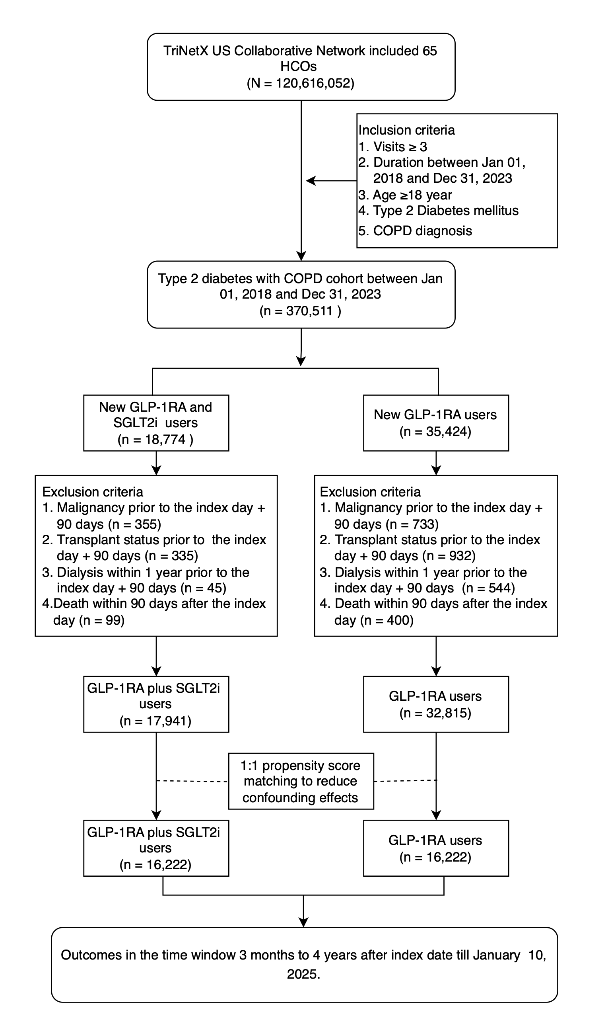
Figure S1. The flow chart of combination therapy versus GLP-1RA

Abbreviation: HCOs, healthcare organizations; COPD, chronic obstructive pulmonary disease; GLP1-RA, glucagon-like peptide receptor agonist; SGLT2i, sodium-glucose cotransporter-2 inhibitor

Figure S2. The time distribution of follow-up time
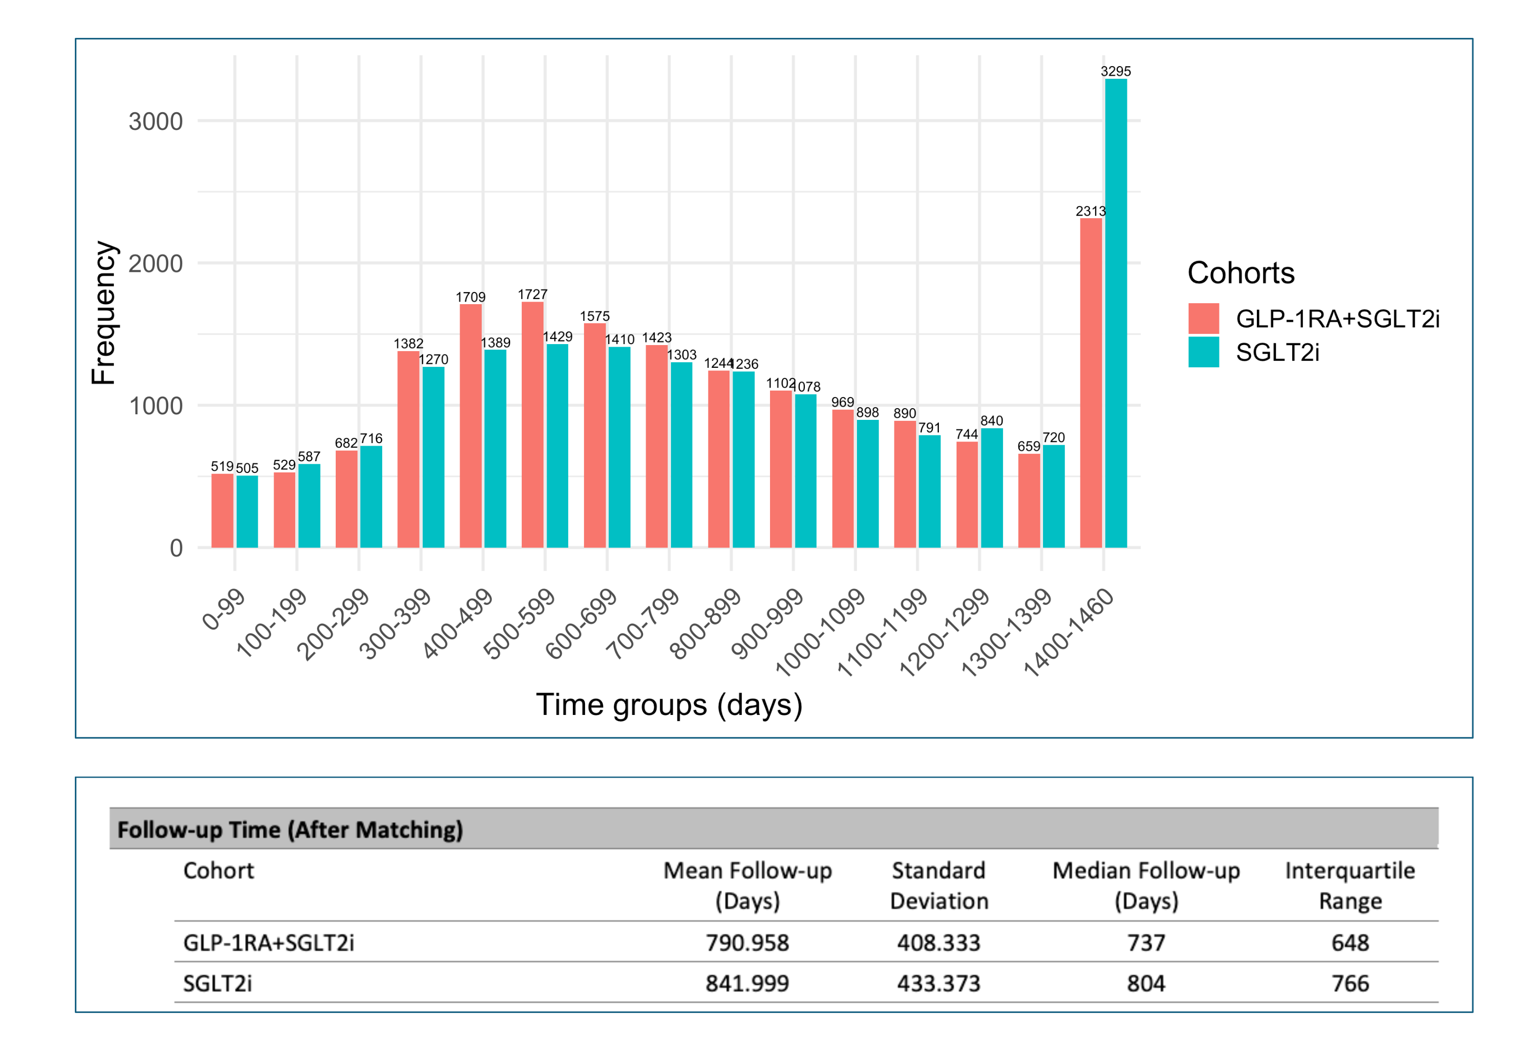

Abbreviation: GLP1-RA, glucagon-like peptide receptor agonist; SGLT2i, Sodium-Glucose Cotransporter-2 Inhibitor.

Figure S3. Subgroup analysis for the risk of mortality
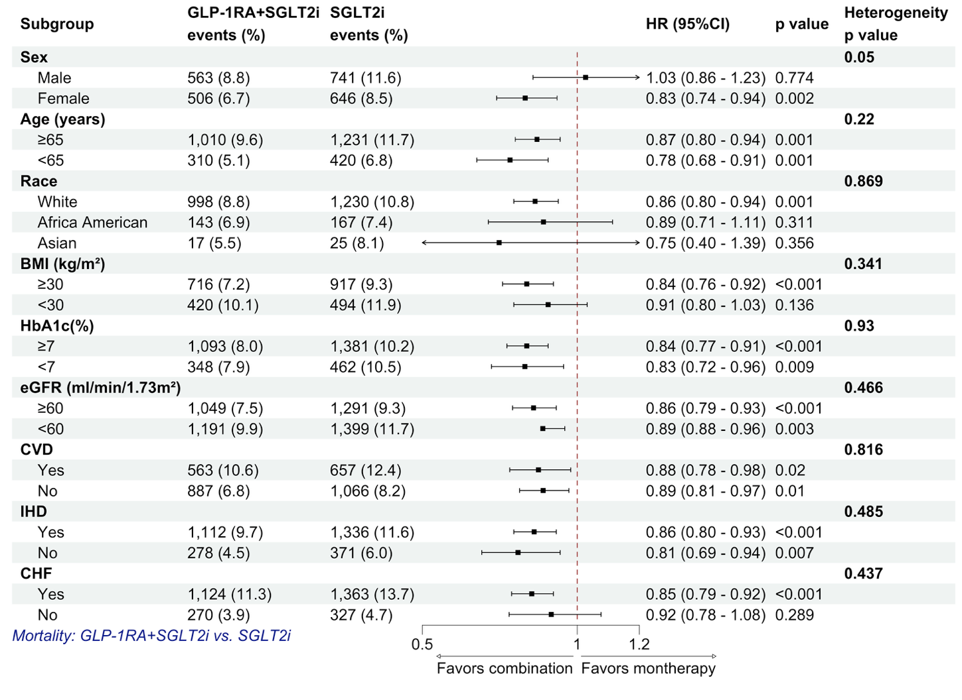
Comparison of risk mortality between the combination therapy of GLP-1RA and SGLT2i against the monotherapy of SGLT2i.
Abbreviation: COPD, chronic obstructive pulmonary disease; AE, acute exacerbation; GLP1-RA, glucagon-like peptide receptor agonist; SGLT2i, Sodium-Glucose Cotransporter-2 Inhibitor; BMI, body mass index; eGFR, estimated glomerular filtration rate; HbA1c, glycated hemoglobin; CVD, cerebrovascular disease; IHD, ischemic heart disease; CHF, congestive heart failure

Figure S4. Subgroup analysis on the risk of COPD exacerbation
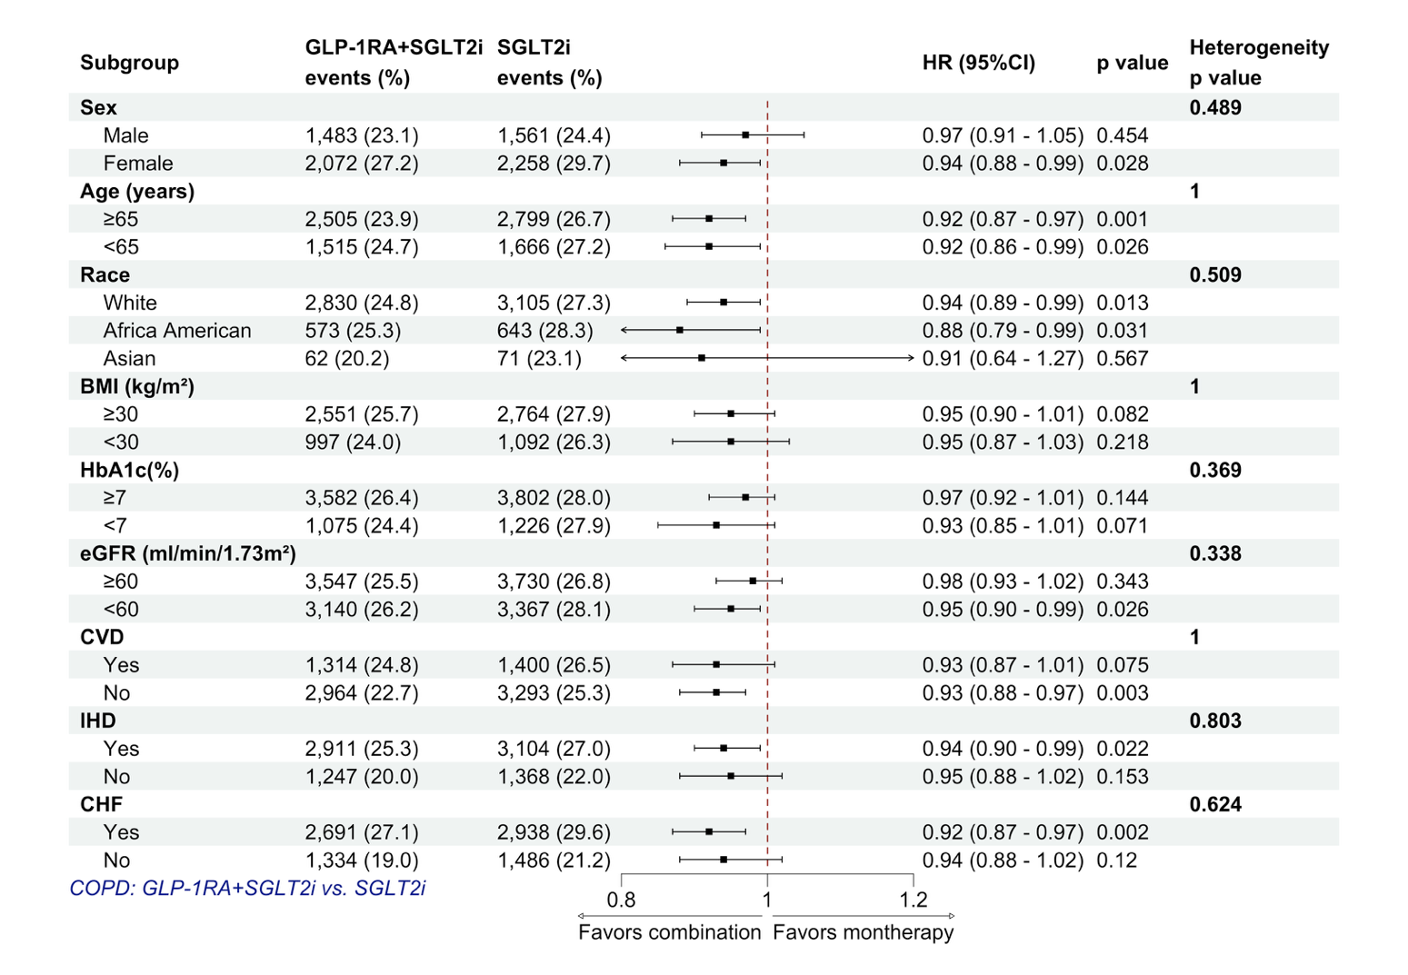

Comparison of the risk of COPD exacerbation between combination therapy of GLP-1RA and SGLT2i against the monotherapy of SGLT2i.
Abbreviation: COPD, chronic obstructive pulmonary disease; AE, acute exacerbation; GLP1-RA, glucagon-like peptide receptor agonist; SGLT2i, Sodium-Glucose Cotransporter-2 Inhibitor; BMI, body mass index; eGFR, estimated glomerular filtration rate; HbA1c, glycated hemoglobin; CVD, cerebrovascular disease; IHD, ischemic heart disease; CHF, congestive heart failure

Figure S5. Subgroup analysis on the risk of pneumonia
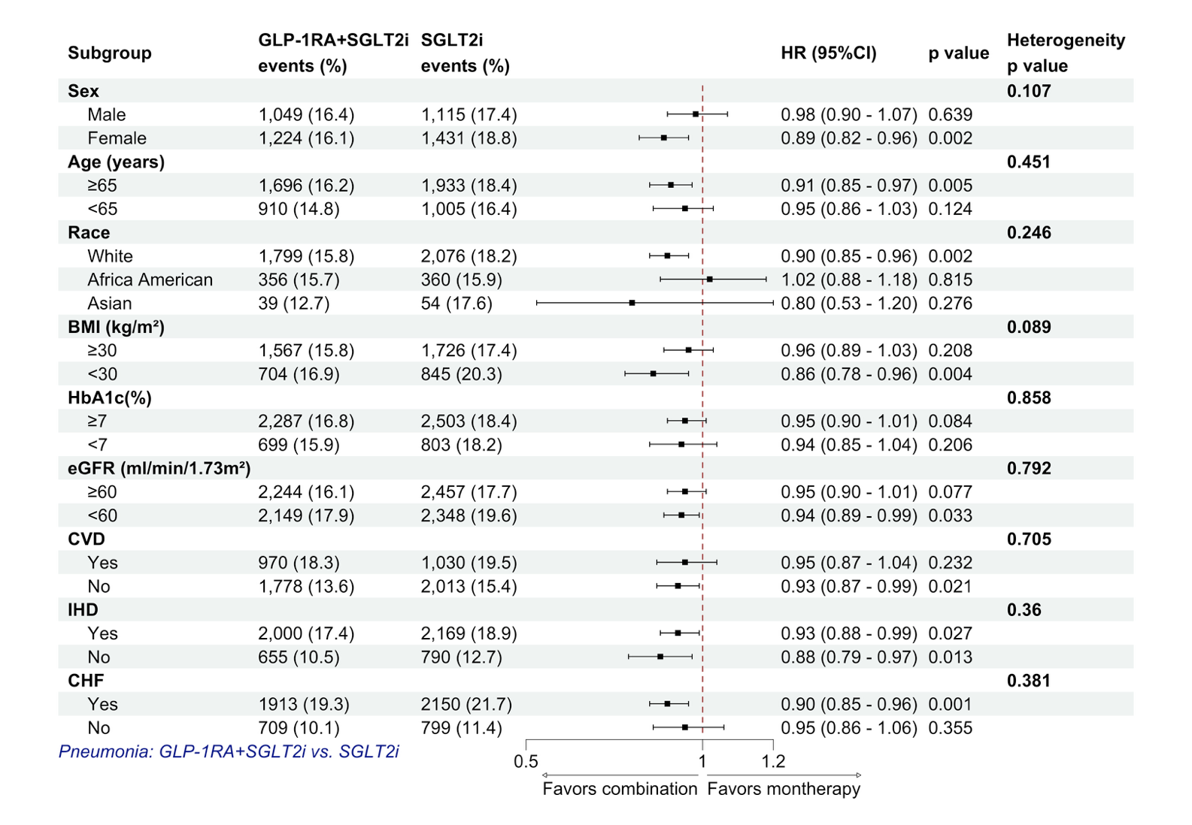

Comparison of the risk of pneumonia between the combination therapy of GLP-1RA and SGLT2i and the monotherapy of SGLT2i.
Abbreviation: COPD, chronic obstructive pulmonary disease; AE, acute exacerbation; GLP1-RA, glucagon-like peptide receptor agonist; SGLT2i, Sodium-Glucose Cotransporter-2 Inhibitor; BMI, body mass index; eGFR, estimated glomerular filtration rate; HbA1c, glycated hemoglobin; CVD, cerebrovascular disease; IHD, ischemic heart disease; CHF, congestive heart failure

Table S1. The Checklist of STROBE Statement
Section/Topic | Item No | Recommendation | Reported on Page No
Title and abstract | 1 | (a) Indicate the study’s design with a commonly used term in the title or the abstract | 1
Title and abstract | 1 | (b) Provide in the abstract an informative and balanced summary of what was done and what was found | 2
Introduction
Background/rationale | 2 | Explain the scientific background and rationale for the investigation being reported | 3-4
Objectives | 3 | State specific objectives, including any prespecified hypotheses | 4
Methods
Study design | 4 | Present key elements of study design early in the paper | 4
Setting | 5 | Describe the setting, locations, and relevant dates, including periods of recruitment, exposure, follow-up, and data collection | 4-6
Participants | 6 | (a) Cohort study—Give the eligibility criteria, and the sources and methods of selection of participants. Describe methods of follow-up  Case-control study—Give the eligibility criteria, and the sources and methods of case ascertainment and control selection. Give the rationale for the choice of cases and controls  Cross-sectional study—Give the eligibility criteria, and the sources and methods of selection of participants | 5-6
Participants | 6 | (b) Cohort study—For matched studies, give matching criteria and number of exposed and unexposed  Case-control study—For matched studies, give matching criteria and the number of controls per case | 5-6
Variables | 7 | Clearly define all outcomes, exposures, predictors, potential confounders, and effect modifiers. Give diagnostic criteria, if applicable | 5-7
Data sources/measurement | 8* | For each variable of interest, give sources of data and details of methods of assessment (measurement). Describe comparability of assessment methods if there is more than one group | 4-7
Bias | 9 | Describe any efforts to address potential sources of bias | 5-7
Study size | 10 | Explain how the study size was arrived at | 5
Quantitative variables | 11 | Explain how quantitative variables were handled in the analyses. If applicable, describe which groupings were chosen and why | 7
Statistical methods | 12 | (a) Describe all statistical methods, including those used to control for confounding | 6-8
Statistical methods | 12 | (b) Describe any methods used to examine subgroups and interactions | 7-8
Statistical methods | 12 | (c) Explain how missing data were addressed | 6, 8
Statistical methods | 12 | (d) Cohort study—If applicable, explain how loss to follow-up was addressed  Case-control study—If applicable, explain how matching of cases and controls was addressed  Cross-sectional study—If applicable, describe analytical methods taking account of sampling strategy | n/a
Statistical methods | 12 | (e) Describe any sensitivity analyses | 6-7
Results
Participants | 13* | (a) Report numbers of individuals at each stage of study—eg numbers potentially eligible, examined for eligibility, confirmed eligible, included in the study, completing follow-up, and analysed | Figure 1 (page 29)
Participants | 13* | (b) Give reasons for non-participation at each stage | Figure 1 (page 29)
Participants | 13* | (c) Consider use of a flow diagram | Figure 1 (page 29)
Descriptive data | 14* | (a) Give characteristics of study participants (eg demographic, clinical, social) and information on exposures and potential confounders | 8; Table 1 (pages 20-23)
Descriptive data | 14* | (b) Indicate number of participants with missing data for each variable of interest | Method S1
Descriptive data | 14* | (c) Cohort study—Summarise follow-up time (eg, average and total amount) | 8; Figure S2
Outcome data | 15* | Cohort study—Report numbers of outcome events or summary measures over time | 8-10; Tables 2-4 (pages 24-28)
Outcome data | 15* | Case-control study—Report numbers in each exposure category, or summary measures of exposure | n/a
Outcome data | 15* | Cross-sectional study—Report numbers of outcome events or summary measures | n/a
Main results | 16 | (a) Give unadjusted estimates and, if applicable, confounder-adjusted estimates and their precision (eg, 95% confidence interval). Make clear which confounders were adjusted for and why they were included | 8-10; Tables 2-4
Main results | 16 | (b) Report category boundaries when continuous variables were categorized
Main results | 16 | (c) If relevant, consider translating estimates of relative risk into absolute risk for a meaningful time period | 9; Table 3 (page 26)
Other analyses | 17 | Report other analyses done—eg analyses of subgroups and interactions, and sensitivity analyses | 9-10; Tables S3-S4
Discussion
Key results | 18 | Summarise key results with reference to study objectives | 10
Limitations | 19 | Discuss limitations of the study, taking into account sources of potential bias or imprecision. Discuss both direction and magnitude of any potential bias | 12
Interpretation | 20 | Give a cautious overall interpretation of results considering objectives, limitations, multiplicity of analyses, results from similar studies, and other relevant evidence | 10-13
Generalizability | 21 | Discuss the generalizability (external validity) of the study results | 12
Other Information
Funding | 22 | Give the source of funding and the role of the funders for the present study and, if applicable, for the original study on which the present article is based | 13

Table S2. Specification of target trial emulation
Approaches | Target trial | Target trial emulation
Eligibility criteria | Adults (>=18 years) with established COPD and T2DM who are eligible to initiate an SGLT2 inhibitor.  No use of SGLT2i or GLP-1RA during a prespecified 6-month washout period.  Exclude active cancer, prior solid-organ transplantation, or end-stage kidney disease requiring dialysis at baseline. | - TriNetX US Collaborative Network (65 HCOs), 1 January 2018-31 December 2023.  - Adults with COPD and T2DM who newly initiated the study drugs after a 6-month washout.  - Excluded: cancer or organ transplantation from before index through index + 90 days; dialysis from 1 year before index through index + 90 days; and death within 90 days after index.
Treatment strategies | Strategy A: initiate an SGLT2i-only strategy.  Strategy B: initiate a GLP-1RA plus SGLT2i strategy.  Analyze patients according to the strategy assigned at initiation, regardless of subsequent treatment changes (treatment-policy estimand). | - Combination strategy: qualifying GLP-1RA and SGLT2i prescription records at cohort entry.  - Comparator strategy: qualifying SGLT2i prescription record without GLP-1RA at cohort entry.  - Index date: first qualifying prescription in the accrual period; outcome follow-up begins at the 90-day landmark.  - Patients analyzed according to their initial strategy regardless of subsequent discontinuation, switching, or add-on therapy.
Treatment assignment | Random assignment (1:1) at baseline to Strategy A vs Strategy B. | - Observational treatment assignment based on observed initiation.  - To emulate randomization, 1:1 propensity score matching (PSM) was used to balance baseline covariates.
Outcomes | Primary: all-cause mortality.  Secondary: COPD acute exacerbation, pneumonia, dialysis initiation, major adverse cardiovascular events (MACE), emergency department visit, hospitalization. | - Primary: all-cause mortality.  - Secondary: COPD exacerbation, pneumonia, entering dialysis, MACE (myocardial infarction, stroke, death), emergency department visit, hospitalization.
Follow-up | Follow-up begins at a prespecified 90-day landmark after treatment initiation and continues for up to 4 years,  with outcome-specific censoring at the event, last available record, or administrative end of follow-up. | - Outcomes assessed from the 90-day landmark through 4 years after the index date.  - Administrative censoring on 10 January 2025 or at the last available record.
Estimand | Treatment-policy effect of initiating the combination strategy versus the SGLT2i-only strategy among patients eligible at the 90-day landmark. | Adjusted association comparing initial treatment strategies among patients alive at the 90-day landmark (hazard ratio from Cox model).
Statistical analysis | Estimate survival functions (Kaplan-Meier) and treatment effect using Cox proportional hazards models.  Predefine adjustment/stratification and multiplicity control for multiple outcomes. | - Variables summarized as counts (%) or mean (SD).  - PSM via logistic regression and greedy nearest-neighbor matching with caliper 0.1; balance assessed by standardized mean difference (SMD <0.1).  - Kaplan-Meier curves with log-rank tests; Cox models with Schoenfeld diagnostics; estimates with nonproportional hazards interpreted cautiously.  - False discovery rate controlled using Benjamini-Hochberg procedure (7 hypotheses, FDR=0.05).  - Sensitivity analyses: hierarchical PSM models, cumulative follow-up horizons, E-values, and comparison with GLP-1RA monotherapy; exploratory subgroup analyses with heterogeneity assessment.  - ARR, NNT, and RMSTD contextualize relative associations with absolute effect measures.
Abbreviations: COPD, chronic obstructive pulmonary disease; T2DM, type 2 diabetes mellitus; GLP-1RA, glucagon-like peptide-1 receptor agonist; SGLT2i, sodium–glucose cotransporter-2 inhibitor; PSM, propensity score matching; MACE, major adverse cardiovascular events; HR, hazard ratio; CI, confidence interval; ITT, intention-to-treat; KM, Kaplan–Meier; PH, proportional hazards; FDR, false discovery rate;
ARR, absolute risk reduction; NNT, number needed to treat; RMSTD, restricted mean survival time difference.

Table S3. Hierarchical propensity score matching models
Clinical Outcomes | After matching, GLP-1 RA and SGLT2i vs SGLT2i
Clinical Outcomes | Model 1 |  | Model 2 |  | Model 3
Clinical Outcomes | HR (95%CI) | P | HR (95%CI) | P | HR (95%CI) | P
Primary outcomes
Mortality | 0.73 (0.68–0.78) | <0.001 | 0.85 (0.80–0.91) | <0.001 | 0.83 (0.77–0.88) | <0.001
Secondary outcomes
COPD exacerbation | 0.88 (0.85–0.92) | <0.001* | 0.92 (0.89–0.96) | <0.001* | 0.92 (0.89–0.96) | <0.001
Pneumonia | 0.86 (0.82–0.91) | <0.001 | 0.93 (0.89–0.98) | 0.005* | 0.91 (0.86–0.95) | <0.001
Entering dialysis | 0.83 (0.71–0.96) | 0.010 | 0.94 (0.81–1.09) | 0.394 | 0.92 (0.79–1.07) | 0.289
MACE# | 0.82 (0.77–0.87) | <0.001* | 0.92 (0.86–0.97) | 0.005 | 0.90 (0.85–0.96) | 0.001
ED visiting | 0.93 (0.91–0.96) | <0.001 | 0.97 (0.95–1.00) | 0.082 | 0.98 (0.95–1.01) | 0.111
Hospitalization | 0.89 (0.86–0.91) | <0.001 | 0.96 (0.93–0.99) | 0.003* | 0.93 (0.91–0.97) | <0.001
Model 1 matched age, sex, race, blood pressure, body mass index, socioeconomic status, and lifestyle factors. Model 2 added baseline comorbidities, and Model 3 added baseline medication use. Asterisks identify estimates with evidence of proportional-hazards violation; these overall HRs should be interpreted cautiously and considered alongside the cumulative follow-up-horizon analyses in Table S4.
*the proportional hazard assumption is violated
#MACE included myocardial infarction, stroke, and death
Abbreviation: GLP-1 RA, glucagon-like peptide-1 receptor agonists; SGLT2i, sodium-glucose co-transporter 2 Inhibitors; HR, hazard ratio ; CI, confidence interval; COPD, chronic obstructive pulmonary disease; AE, acute exacerbation; MACE, major adverse

Table S4. Sensitivity analyses across cumulative follow-up horizons
Clinical Outcomes | After matching, GLP-1 RA plus SGLT2i vs. SGLT2i
Clinical Outcomes | 3 months to 1 year |  | 3 months to 2 years |  | 3 months to 3 years
Clinical Outcomes | HR (95%CI) | P value | HR (95%CI) | P value | HR (95%CI) | P value
Primary outcomes
Mortality | 0.84 (0.75–0.94) | 0.002 | 0.86 (0.79–0.94) | <0.001 | 0.83 (0.78–0.90) | <0.001
Secondary outcomes
COPD exacerbation | 0.90 (0.85–0.95) | <0.001 | 0.92 (0.88–0.96) | <0.001 | 0.92 (0.89–0.96) | <0.001
Pneumonia | 0.89 (0.83–0.96) | 0.002 | 0.92 (0.87–0.97) | 0.003 | 0.91 (0.86–0.96) | <0.001
Entering dialysis | 0.92 (0.72–1.18) | 0.533 | 0.87 (0.73–1.05) | 0.146 | 0.89 (0.76–1.04) | 0.149
MACE# | 0.86 (0.77–0.95) | 0.004 | 0.87 (0.81–0.94) | <0.001 | 0.89 (0.84–0.95) | 0.001
ED visiting | 0.98 (0.94–1.01) | 0.214 | 0.99 (0.96–1.03) | 0.723 | 0.99 (0.96–1.02) | 0.472
Hospitalization | 0.96 (0.93–1.00) | 0.040 | 0.95 (0.92–0.98) | 0.002 | 0.96 (0.93–0.99) | 0.007
*The proportional hazard assumption is violated
#MACE included myocardial infarction, stroke, and death
Abbreviation: GLP-1 RA, glucagon-like peptide-1 receptor agonists; SGLT2i, sodium-glucose co-transporter 2 Inhibitors; HR, hazard ratio ; CI, confidence interval; COPD, chronic obstructive pulmonary disease; AE, acute exacerbation; MACE, major adverse cardiovascular events.

Table S5. Baseline characteristics of GLP-1RA+SGLT2i VS. GLP-1RA
Parameter | Before matching |  |  | After matching
Parameter | GLP-1RA and SGLT2i users  (n = 17,941) | GLP-1RA users  (n = 32,815) | SMD | GLP-1RA and SGLT2i users  (n = 16,222) | GLP-1RA users  (n = 16,222) | SMD
Age at Index (years), mean ± SD | 64 ± 9.7 | 63.8 ± 9.9 | 0.02 | 63.9 ± 9.7 | 63.9 ± 9.9 | 0.001
Male, n (%) | 8,336 (46.5) | 12,783 (39) | 0.152 | 7,478 (46.1) | 7,461 (46) | 0.002
BMI (kg/m²), mean ± SD | 36.3 ± 8.6 | 37.6 ± 8.8 | 0.138 | 36.4 ± 8.5 | 36.8 ± 8.6 | 0.04
Systolic BP (mmHg), mean ± SD | 126.8 ± 19.1 | 128.8 ± 19 | 0.101 | 126.9 ± 19 | 128.6 ± 19.1 | 0.086
Diastolic BP(mmHg), mean ± SD | 71.9 ± 11.9 | 72.5 ± 12.1 | 0.06 | 71.8 ± 11.9 | 72.2 ± 12 | 0.029
Race, n (%)
White people | 12,012 (67) | 22,621 (68.9) | 0.042 | 11,110 (68.5) | 11,118 (68.5) | 0.001
African American | 2,788 (15.5) | 5,615 (17.1) | 0.043 | 2,703 (16.7) | 2,730 (16.8) | 0.004
Asian | 294 (1.6) | 478 (1.5) | 0.015 | 316 (1.9) | 317 (2) | 0
Unknown Race | 2,113 (11.8) | 3,075 (9.4) | 0.078 | 1,503 (9.3) | 1,459 (9) | 0.009
Other Race | 543 (3) | 676 (2.1) | 0.061 | 378 (2.3) | 375 (2.3) | 0.001
Socioeconomic , n (%)
Persons with potential health hazards related to socioeconomic and psychosocial circumstances | 1,059 (5.9) | 1,704 (5.2) | 0.031 | 1,037 (6.4) | 1,017 (6.3) | 0.005
Problems related to housing and economic circumstances | 531 (3) | 763 (2.3) | 0.040 | 497 (3.1) | 488 (3) | 0.003
Problems related to employment and unemployment | 104 (0.6) | 184 (0.6) | 0.003 | 111 (0.7) | 112 (0.7) | 0.001
Lifestyles, , n (%)
Nicotine dependence | 6,566 (36.6) | 11,508 (35.1) | 0.032 | 6,067 (37.4) | 6,045 (37.3) | 0.003
Tobacco use | 2,867 (16) | 5,211 (15.9) | 0.003 | 2,857 (17.6) | 2,958 (18.2) | 0.016
Alcohol related disorders | 792 (4.4) | 1,282 (3.9) | 0.025 | 711 (4.4) | 704 (4.3) | 0.002
Comorbidity , n (%)
Hypertensive diseases | 16,411 (91.5) | 29,160 (88.9) | 0.088 | 14,924 (92) | 14,934 (92.1) | 0.002
Dyslipidemia | 15,518 (86.5) | 27,026 (82.4) | 0.114 | 14,207 (87.6) | 14,242 (87.8) | 0.007
Ischemic heart diseases | 9,531 (53.1) | 14,182 (43.2) | 0.199 | 8,658 (53.4) | 8,608 (53.1) | 0.006
Cardiomyopathy | 2,453 (13.7) | 2,660 (8.1) | 0.179 | 2,187 (13.5) | 2,108 (13) | 0.014
Heart failure | 7,780 (43.4) | 20,389 (52.7) | 0.188 | 7,699 (44.1) | 7,622 (43.6) | 0.009
Atrial fibrillation and flutter | 3,971 (22.1) | 5,753 (17.5) | 0.116 | 3,596 (22.2) | 3,510 (21.6) | 0.013
Chronic rheumatic heart diseases | 1,469 (8.2) | 1,821 (5.5) | 0.104 | 1,331 (8.2) | 1,271 (7.8) | 0.014
Cerebrovascular diseases | 3,145 (17.5) | 5,060 (15.4) | 0.057 | 2,841 (17.5) | 2,874 (17.7) | 0.005
Depressive episode | 5,983 (33.3) | 10,899 (33.2) | 0.003 | 5,413 (33.4) | 5,381 (33.2) | 0.004
Chronic kidney disease | 5,899 (32.9) | 9,195 (28) | 0.106 | 5,302 (32.7) | 5,277 (32.5) | 0.003
Obstructive sleep apnea | 8,180 (45.6) | 13,875 (42.3) | 0.067 | 7,366 (45.4) | 7,301 (45) | 0.008
Disorders of thyroid gland | 4,751 (26.5) | 8,875 (27) | 0.013 | 4,250 (26.2) | 4,252 (26.2) | <0.001
Fatty liver | 2,244 (12.5) | 3,756 (11.4) | 0.033 | 2,010 (12.4) | 2,051 (12.6) | 0.008
Disorders of biliary tract | 1,716 (9.6) | 2,551 (7.8) | 0.064 | 1,432 (8.8) | 1,423 (8.8) | 0.002
Osteoporosis | 1,102 (6.1) | 2,066 (6.3) | 0.006 | 950 (5.9) | 934 (5.8) | 0.004
Liver cirrhosis | 827 (4.6) | 1,320 (4) | 0.029 | 733 (4.5) | 728 (4.5) | 0.001
Hepatic failure | 157 (0.9) | 442 (1.1) | 0.027 | 153 (0.9) | 156 (0.9) | 0.002
Medication, , n (%)
Insulin | 12,755 (71.1) | 20,327 (61.9) | 0.195 | 11,317 (69.8) | 11,398 (70.3) | 0.011
Biguanides | 11,091 (61.8) | 18,281 (55.7) | 0.124 | 9,835 (60.6) | 9,844 (60.7) | 0.001
Sulfonylureas | 5,088 (28.4) | 7,883 (24) | 0.099 | 4,549 (28) | 4,682 (28.9) | 0.018
Thiazolidinediones | 1,098 (6.1) | 1,293 (3.9) | 0.100 | 891 (5.5) | 898 (5.5) | 0.002
Statin | 14,944 (83.3) | 24,407 (74.4) | 0.220 | 13,367 (82.4) | 13,364 (82.4) | <0.001
Fibrates | 1,524 (8.5) | 2,179 (6.6) | 0.070 | 1,332 (8.2) | 1,312 (8.1) | 0.005
Renin-angiotensin system blockade | 13,178 (73.5) | 20,969 (63.9) | 0.207 | 11,691 (72.1) | 11,662 (71.9) | 0.004
Beta-blocker | 11,539 (64.3) | 18,036 (55) | 0.192 | 10,289 (63.4) | 10,218 (63) | 0.009
Calcium channel blockers | 7,545 (42.1) | 12,372 (37.7) | 0.089 | 6,750 (41.6) | 6,697 (41.3) | 0.007
Diuretics | 11,906 (66.4) | 19,716 (60.1) | 0.131 | 10,633 (65.5) | 10,607 (65.4) | 0.003
Sympathomimetic, inhalation | 14,324 (79.8) | 25,574 (77.9) | 0.047 | 12,889 (79.5) | 12,860 (79.3) | 0.004
Sympathomimetic, oral | 13,470 (75.1) | 24,063 (73.3) | 0.040 | 12,152 (74.9) | 12,099 (74.6) | 0.008
Anti-inflammatories, inhalation | 10,668 (59.5) | 18,089 (55.1) | 0.088 | 9,394 (57.9) | 9,313 (57.4) | 0.01
Anticholinergic, bronchodilators | 9,561 (53.3) | 16,524 (50.4) | 0.059 | 8,528 (52.6) | 8,491 (52.3) | 0.005
Antithrombotic agents | 12,629 (70.4) | 20,722 (63.1) | 0.154 | 11,303 (69.7) | 11,203 (69.1) | 0.013
Xanthine | 621 (3.5) | 783 (2.4) | 0.064 | 487 (3) | 481 (3) | 0.002
Laboratory, mean ± SD
eGFR (mL/min/1.73m²) | 68.6 ± 26.4 | 69.3 ± 26.9 | 0.022 | 68.9 ± 26.5 | 68.6 ± 26.8 | 0.011
Sodium（mmol/L） | 138.2 ± 3.2 | 138.3 ± 3.3 | 0.024 | 138.2 ± 3.2 | 138.2 ± 3.3 | 0.022
Calcium (mg/dL) | 9.3 ± 0.6 | 9.3 ± 0.6 | 0.009 | 9.3 ± 0.6 | 9.3 ± 0.6 | 0.018
Alanine aminotransferase (U/L) | 26.3 ± 25.5 | 26.7 ± 34.2 | 0.014 | 26.3 ± 29.1 | 26.9 ± 40.3 | 0.018
Hemoglobin (g/dL) | 13.2 ± 2.2 | 13 ± 2.1 | 0.089 | 13.2 ± 2.1 | 13 ± 2.1 | 0.088
Aspartate aminotransferase (U/L) | 24.8 ± 22 | 25.2 ± 45.8 | 0.016 | 24.6 ± 22.9 | 25.5 ± 59.9 | 0.019
Albumin (g/dL) | 3.9 ± 0.5 | 3.9 ± 0.5 | 0.021 | 3.9 ± 0.5 | 3.9 ± 0.5 | 0.013
Hemoglobin A1c (%) | 8.4 ± 1.9 | 8.1 ± 2 | 0.117 | 8.4 ± 1.9 | 8.4 ± 2 | 0.009
Triglyceride (mg/dL) | 193.4 ± 152.4 | 186.6 ± 141.7 | 0.044 | 193.5 ± 155.8 | 191.7 ± 146.1 | 0.012
HDL (mg/dL) | 41.2 ± 13.8 | 40.3 ± 16.7 | 0.057 | 39.4 ± 15.7 | 39.2 ± 16.2 | 0.011
LDL (mg/dL) | 79.1 ± 37.2 | 83.6 ± 37.1 | 0.122 | 79.3 ± 37.5 | 80.6 ± 36.5 | 0.037
UPCR (mg/g) | 563.4 ± 1507.3 | 492.7 ± 1512 | 0.053 | 584 ± 1580.4 | 536.6 ± 1653.4 | 0.029
Abbreviation: GLP1-RA, glucagon-like peptide-1 receptor agonists ; SGLT2i, sodium-glucose co-transporter 2 Inhibitors; SMD, standardized mean difference; SD, standard deviation; BMI, body mass index; BP, blood pressure; eGFR, estimated glomerular filtration rate ; HDL, high density lipoprotein; LDL, low density lipoprotein; UPCR, urine protein/creatinine ratio

