Predictive value of PaO2 / FIO2 ratio for mortality among ARDS patients: A systematic review and meta-analysis
Supplements File2
Sensitivity analysis: The forest plots and the SROC curves, together with bivariate summary points of specificity and sensitivity and their 95% confidence regions.
Figure 1
The cutoff point was P/F100 and the outcome was ICU, in-hospital, 28-days or 30-days mortality.
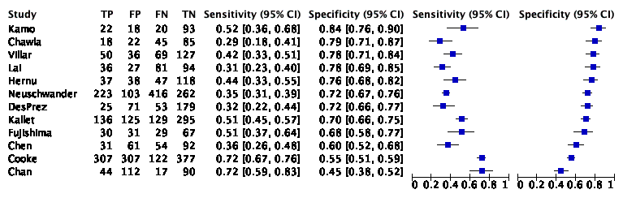

Figure 2
The cutoff point was P/F 100 and the outcome was ICU, in-hospital, 28-days or 30-days mortality.
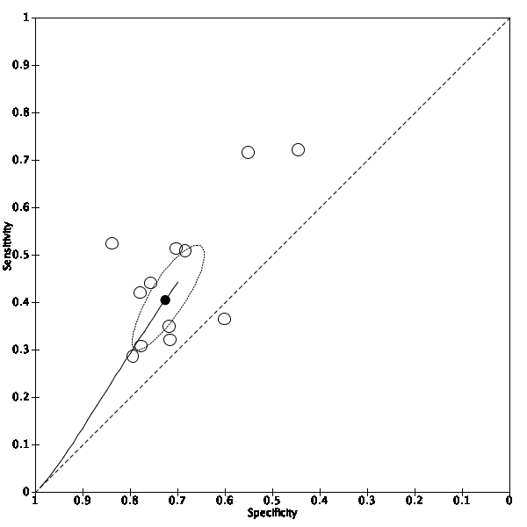

Figure 3
The cutoff point was P/F100 and the outcome was any mortality. The studies which used the berlin definition were included.
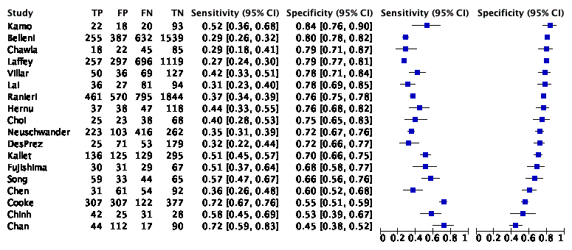

Figure 4
The cutoff point was P/F100 and the outcome was any mortality. The studies which used the berlin definition were included.
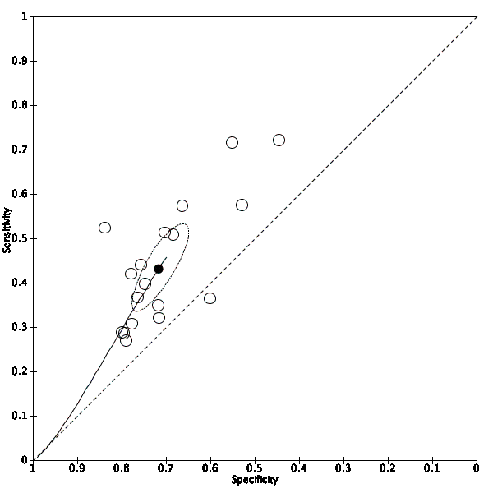

Figure 5
The cutoff point was P/F100 and the outcome was ICU, in-hospital, 28-days or 30-days mortality. The studies which used the berlin definition were included.
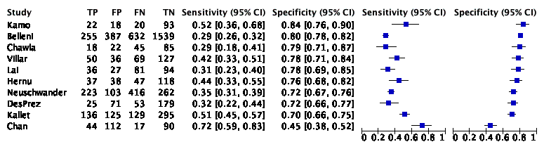

Figure 6
The cutoff point was P/F100 and the outcome was ICU, in-hospital, 28-days or 30-days mortality. The studies which used the berlin definition were included.
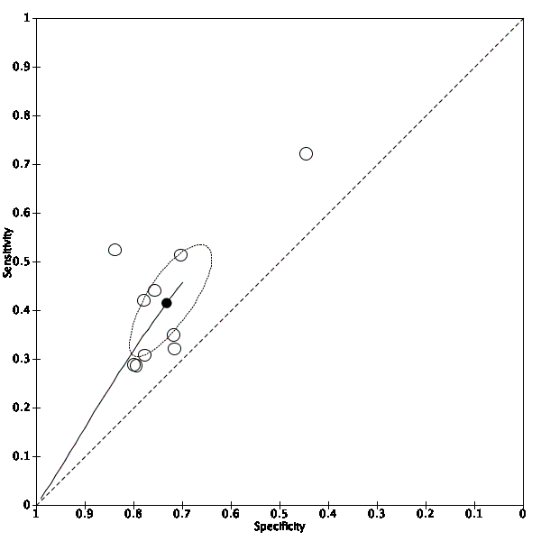

Figure 7
The cutoff point was P/F 200 and the outcome was ICU, in-hospital, 28-days or 30-days mortality.
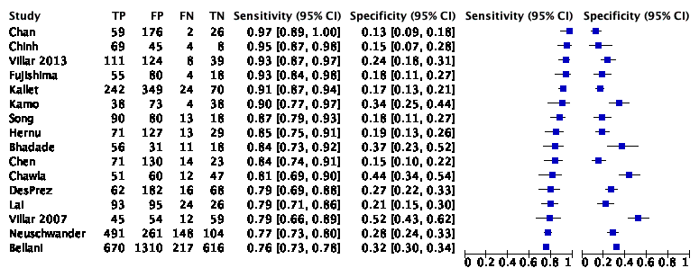

Figure 8
The cutoff point was P/F 200 and the outcome was ICU, in-hospital, 28-days or 30-days mortality.
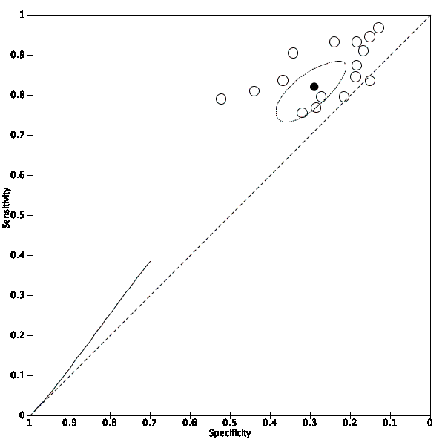

Figure 9
The cutoff point was P/F 200 and the outcome was any mortality. The studies which used the berlin definition were included.
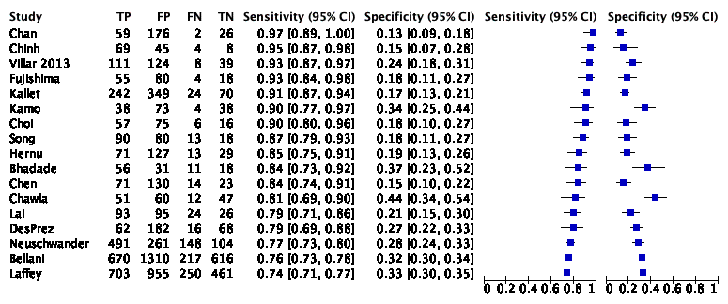

Figure 10
The cutoff point was P/F 200 and the outcome was any mortality. The studies which used the berlin definition were included.
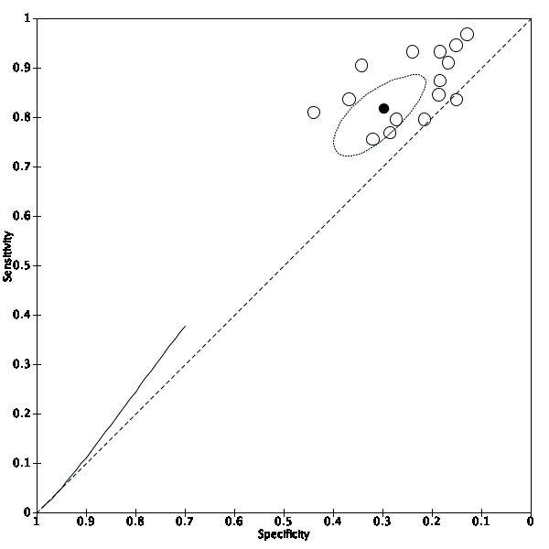

Figure 11
The cutoff point was P/F 200 and the outcome was ICU, in-hospital, 28-days or 30-days mortality. The studies which used the berlin definition were included.
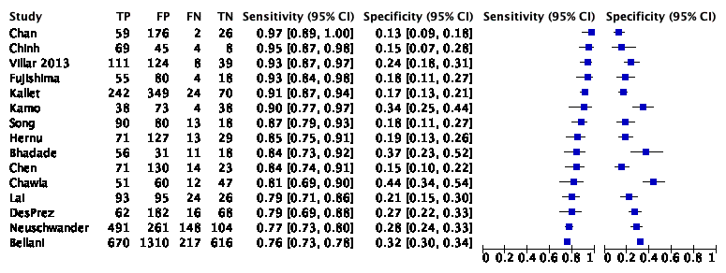

Figure 12
The cutoff point was P/F 200 and the outcome was ICU, in-hospital, 28-days or 30-days mortality. The studies which used the berlin definition were included.
