Supplemental Document Of
Risk factor analysis and predictive model construction of fractional uric acid excretion in Chinese inpatients with Type 2 Diabetes

Contents
1. Table S1 Good-of-fitness indices for one-fold, five-fold, ten-fold validation analysis in training dataset
2. Table S2 Comparison of indices between observed and predicted FEUA and predictive indices on elevated FEUA for full dataset and four subgroups
3. Table S3 Overall characteristics of external validation dataset stratified by FEUA elevation
4. Table S4 Resemblance between the observed FEUA and predicted FEUA in external dataset
5. Table S5 Comparison of good-of-fitness indices calculated based on predicted FEUA between full external dataset and its five subgroups
6. Figure S1 Six plots describing the residuals of final regression model
7. Figure S2 Six plots comparing observed FEUA (elevated FEUA) and predicted FEUA in external dataset
8. Datasets of modeling and validation （See attachments）
1. Table S1 Good-of-fitness indices for one-fold, five-fold, ten-fold validation analysis in training dataset
 |  | Indices from Modeling |  |  |  |  |  | Indices between observed and predicted FEUA |  |  |  |  |  | Predictive Indices on elevated FEUA
Folds | N | R2 | Adj-R2 | RMSE* | AIC | BIC |  | N | RMSE | MAE | Spearman correlation coefficient | Determination coefficient |  | Correct classification rate for FEUA≥11 | Correct classification rate at cut-point 0.5 | ROC | Lower-  bound | Upper-  bound
1 Fold | 1510 | 0.6359 | 0.6349 | 0.223 | -241.58 | -214.9807 |  | 1510 | 1.6841 | 1.1856 | 0.7870 | 0.6436 |  | 0.9470 | 0.9483 | 0.9552 | 0.9413 | 0.9691
5 Fold | 1201 | 0.6459 | 0.6447 | 0.2206 | -216.9009 | -191.4463 |  | 309 | 1.8140 | 1.2665 | 0.7588 | 0.5780 |  | 0.9417 | 0.9385 | 0.9520 | 0.9133 | 0.9907
 | 1213 | 0.6421 | 0.6409 | 0.2220 | -203.6962 | -178.1919 |  | 297 | 1.5651 | 1.1745 | 0.7743 | 0.6578 |  | 0.9562 | 0.9360 | 0.9295 | 0.8843 | 0.9747
 | 1218 | 0.6323 | 0.6311 | 0.2240 | -183.2918 | -157.767\0 |  | 292 | 1.9744 | 1.1810 | 0.8234 | 0.6505 |  | 0.9349 | 0.9349 | 0.9543 | 0.9272 | 0.9814
 | 1183 | 0.6313 | 0.6310 | 0.2218 | -201.1649 | -175.7858 |  | 327 | 1.6546 | 1.2316 | 0.7874 | 0.6877 |  | 0.9480 | 0.9541 | 0.9747 | 0.9573 | 0.9921
 | 1225 | 0.6300 | 0.6288 | 0.2262 | -159.692 | -134.1385 |  | 285 | 1.5109 | 1.1022 | 0.7929 | 0.7153 |  | 0.9649 | 0.9684 | 0.9575 | 0.9182 | 0.9968
10 Fold | 1355 | 0.6400 | 0.6390 | 0.2222 | -226.0307 | -199.9729 |  | 155 | 1.8851 | 1.2138 | 0.7662 | 0.5874 |  | 0.9613 | 0.9548 | 0.9817 | 0.9619 | 0.9999
 | 1356 | 0.6405 | 0.6395 | 0.2217 | -232.0234 | -205.9619 |  | 154 | 1.7171 | 1.3060 | 0.7558 | 0.5811 |  | 0.9221 | 0.9221 | 0.9231 | 0.8545 | 0.9918
 | 1358 | 0.6475 | 0.6465 | 0.2212 | -238.8071 | -212.7383 |  | 152 | 1.5899 | 1.1433 | 0.7296 | 0.5145 |  | 0.9474 | 0.9605 | 0.8889 | 0.8107 | 0.9671
 | 1365 | 0.6296 | 0.6285 | 0.2240 | -206.3442 | -180.2496 |  | 145 | 1.5436 | 1.2098 | 0.8255 | 0.7559 |  | 0.9586 | 0.9655 | 0.9653 | 0.9279 | 0.9999
 | 1354 | 0.6420 | 0.641 | 0.2219 | -229.2877 | -203.2336 |  | 156 | 1.4356 | 1.1213 | 0.7893 | 0.6066 |  | 0.9551 | 0.9487 | 0.9552 | 0.9200 | 0.9905
 | 1374 | 0.6264 | 0.6253 | 0.2249 | -195.633 | -169.5056 |  | 136 | 2.4165 | 1.2485 | 0.8597 | 0.6993 |  | 0.9118 | 0.9338 | 0.9510 | 0.9101 | 0.9918
 | 1348 | 0.6333 | 0.6322 | 0.2215 | 233.3263 | -207.2944 |  | 162 | 1.7969 | 1.3347 | 0.7758 | 0.6959 |  | 0.9383 | 0.9568 | 0.9771 | 0.9531 | 0.9999
 | 1345 | 0.6344 | 0.6333 | 0.2234 | -209.3675 | -183.3467 |  | 165 | 1.4999 | 1.1306 | 0.7934 | 0.6656 |  | 0.9576 | 0.9576 | 0.9734 | 0.9492 | 0.9977
 | 1350 | 0.6391 | 0.6380 | 0.2235 | -208.8795 | -182.8402 |  | 160 | 1.5644 | 1.0971 | 0.7431 | 0.6840 |  | 0.9813 | 0.9813 | 0.9903 | 0.9739 | 0.9999
 | 1385 | 0.6277 | 0.6266 | 0.2252 | 193.4222 | -167.2549 |  | 125 | 1.4514 | 1.1189 | 0.8382 | 0.7424 |  | 0.9440 | 0.9600 | 0.9287 | 0.8596 | 0.9978
Leave-  one-out | - | - | - | - | - | - |  | 1510 | 1.7081 | 1.1914 | 0.7858 | 0.6348 |  | 0.9464 | 0.9483 | 0.9547 | 0.94065 | 0.96874
*Duan’s Smearing Factors 1 Fold:1.0265; 5Fold: 1.0267 1.0265 1.0266 1.0264 1.0264; 10 Fold: 1.0267 1.0265 1.0265 1.0264 1.0265 1.0266 1.0265 1.0264 1.0265 1.0265
2. Table S2 Comparison of indices between observed and predicted FEUA and predictive indices on elevated FEUA for full dataset and four subgroups

 |  | Indices between observed and predicted FEUA |  |  |  |  |  |  | Predictive Indices on elevated FEUA
Group | N | RMSE* | MAE | Spearman r | P value | Determination Coefficient | P value |  | Correct classification rate for FEUA≥11 | Correct classification rate at cut-point 0.5 | ROC | Lower-  bound | Upper-  bound | Youden index | Cut-  point | Sensitivity at cut-point | Specificity at cut-point | ROC at cut-point
Full sample size | 1510 | 1.6841 | 1.1856 | 0.7870 | <0.001 | 0.6436 | <0.001 |  | 0.9470 | 0.9483 | 0.9552 | 0.9413 | 0.9691 | 0.7814 | 7.8186 | 0.9541 | 0.8273 | 0.8907
Diabetic patients with UACR>=30 or eGFR<60 | 360 | 2.0431 | 1.4403 | 0.7761 | <0.001 | 0.6842 | <0.001 |  | 0.9306 | 0.9278 | 0.9561 | 0.9326 | 0.9796 | 0.7922 | 9.3142 | 0.8837 | 0.9085 | 0.8961
Diabetic patients without UACR>=30 or eGFR<60 | 1150 | 1.4573 | 1.0838 | 0.7629 | <0.001 | 0.6566 | <0.001 |  | 0.9565 | 0.9574 | 0.9524 | 0.9347 | 0.9701 | 0.7944 | 7.9605 | 0.9697 | 0.8247 | 0.8972
Diabetic patients with FPG<10mmol/L | 1202 | 1.6357 | 1.1409 | 0.7995 | <0.001 | 0.6393 | <0.001 |  | 0.9559 | 0.9567 | 0.9567 | 0.9407 | 0.9728 | 0.7980 | 7.9605 | 0.9605 | 0.8375 | 0.8990
Diabetic patients with FPG>=10mmol/L | 308 | 1.808/3 | 1.3322 | 0.8014 | <0.001 | 0.6700 | <0.001 |  | 0.9058 | 0.9058 | 0.9459 | 0.9152 | 0.9766 | 0.8182 | 9.1244 | 0.9091 | 0.9091 | 0.9091
*Duan’s Smearing Factors for each group:1.0265 1.0265 1.0275 1.0267 1.0271

3. Table S3 Overall characteristics of external validation dataset stratified by FEUA elevation ([xˉ ±s；n(%)];n=791)
variables | overall (N=791) | low FEUA (N=732) | high FEUA (N=59) | t/z | P | OR | 95%CI
Female (n, %) | 367 (46.40%) | 333(45.49%) | 34(57.63%) | 1.78 | 0.074 | 1.63 | 0.953-2.786
Age (years) | 54.91 ± 15.38 | 54.27 ± 15.39 | 62.88 ± 12.96 | 4.07 | <0.001 | 1.043 | 1.022-1.064
Diabetes duration (years) | 10.00 (4.00, 15.00) | 9.88 (4.00, 15.00) | 10.52 (6.00, 17.00) | 2.08 ª | 0.038 ª | 1.031 | 1.002-1.061
BMI | 26.70 ± 4.78 | 26.78 ± 4.88 | 25.72 ± 3.12 | -1.65 | 0.099 | 0.946 | 0.885-1.010
SBP (mmHg) | 135.08 ± 18.41 | 134.89 ± 18.32 | 137.37 ± 19.54 | 1 | 0.32 | 1.007 | 0.993-1.021
DBP (mmHg) | 77.12 ± 11.69 | 77.39 ± 11.64 | 73.85 ± 11.88 | -2.23 | 0.025 | 0.973 | 0.950-0.997
UACR (mg/g) | 13.10 (4.56, 114.41) | 11.93 (4.55, 98.11) | 52.71 (4.61, 348.88) | 1.95 ª | 0.051 ª | 1.003 | 1.002-1.004
eGFR(ml/min/1.73m²) | 100.35 ± 20.08 | 101.29 ± 19.76 | 88.66 ± 20.50 | -4.6 | <0.001 | 0.969 | 0.956-0.982
SUA (μmol/L) | 345.78 ± 84.19 | 354.15 ± 79.54 | 241.95 ± 70.46 | -8.76 | <0.001 | 0.979 | 0.974-0.983
Male | 367.24 ± 81.97 | 374.28 ± 77.67 | 254.87 ± 66.57 | -6.06 | <0.001 | 0.974 | 0.966-0.983
Female | 321.00 ± 79.90 | 330.04 ± 75.02 | 232.46 ± 72.68 | -6.13 | <0.001 | 0.98 | 0.974-0.986
UUA(μmol/L) | 3.54 ± 1.05 | 3.52 ± 1.03 | 3.82 ± 1.28 | 2.14 | 0.032 | 1.282 | 1.021-1.610
SCr (μmol/L) | 64.81 ± 18.55 | 64.33 ± 17.89 | 70.78 ± 24.77 | 2.54 | 0.011 | 1.016 | 1.004-1.029
uCr (μmol/L) | 10.39 ± 2.99 | 10.57 ± 2.92 | 8.20 ± 3.11 | -5.74 | <0.001 | 0.722 | 0.646-0.807
FEUA (%) | 6.93 ± 3.20 | 6.31 ± 1.98 | 14.58 ± 5.06 | - | - | - | -
ALT (U/L) | 24.00 (15.00, 36.00) | 24.00 (15.00, 36.06) | 24.00 (15.00, 32.49) | -1.33 ª | 0.185 ª | 0.989 | 0.972-1.005
AST (U/L) | 19.98 (11.98, 30.92) | 19.88 (11.77, 30.71) | 22.00 (15.11, 31.63) | 1.09 ª | 0.277 ª | 1.005 | 0.996-1.015
FPG (mmol/l) | 7.96 ± 2.12 | 7.92 ± 2.13 | 8.39 ± 2.01 | 1.63 | 0.103 | 1.096 | 0.982-1.224
HbA1c(%) | 8.71 ± 1.88 | 8.70 ± 1.87 | 8.95 ± 2.04 | 1.01 | 0.313 | 1.07 | 0.938-1.222
HDL-C (mmol/L) | 1.05 ± 0.26 | 1.05 ± 0.26 | 1.05 ± 0.24 | -0.07 | 0.944 | 0.964 | 0.341-2.723
Male | 0.97 ± 0.23 | 0.97 ± 0.23 | 0.99 ± 0.27 | 0.38 | 0.704 | 1.392 | 0.254-7.628
Female | 1.14 ± 0.26 | 1.15 ± 0.26 | 1.09 ± 0.20 | -1.18 | 0.238 | 0.403 | 0.089-1.825
LDL-C (mmol/L) | 2.82 ± 0.86 | 2.82 ± 0.86 | 2.79 ± 0.88 | -0.22 | 0.824 | 0.965 | 0.707-1.318
TC (mmol/L) | 4.51 ± 0.85 | 4.52 ± 0.86 | 4.32 ± 0.71 | -1.8 | 0.072 | 0.738 | 0.529-1.028
TG (mmol/L) | 1.67 (1.20, 2.43) | 1.68 (1.20, 2.46) | 1.45 (1.21, 1.98) | -1.89 ª | 0.058 ^{a a} | 0.765 | 0.579-1.010
hsCRP (mg/L) | 2.24 (0.92, 5.25) | 2.25 (0.91, 5.22) | 2.16 (1.02, 5.59) | 0.21 ª | 0.835 ª | 1.002 | 0.984-1.020
Urinary β2-MG (μg/mL) | 259.08 (60.00, 714.86) | 243.87 (50.00, 650.84) | 669.63 (225.70, 1266.64) | 4.38 ª | <0.001 ª | 1.003 | 1.002-1.004
Gout (n, %) | 125 (15.80%) | 119(16.26%) | 6(10.17%) | -1.22 | 0.223 | 0.583 | 0.245-1.387
DR (n, %) | 59 (7.46%) | 52(7.10%) | 7(11.86%) | 1.32 | 0.186 | 1.76 | 0.762-4.069
DPN (n, %) | 51 (6.45%) | 50(6.83%) | 1(1.69%) | -1.42 | 0.156 | 0.235 | 0.032-1.733
Hypertension (n, %) | 506 (63.97%) | 464(63.39%) | 42(71.19%) | 1.2 | 0.232 | 1.427 | 0.796-2.557
CHD (n, %) | 303 (38.31%) | 286 (39.07%) | 24 (40.68%) | -1.17 | 0.183 | 0.686 | 0.159-1.213
Fatty liver (n, %) | 278 (35.15%) | 259(35.38%) | 19(32.20%) | -0.49 | 0.623 | 0.867 | 0.492-1.529
a: The probability and odd ratio obtained by taking the natural logarithm of the independent variable
Abbreviations: FEUA: fractional excretion of uric acid; BMI: body mass index; SBP: systolic blood pressure; DBP: diastolic blood pressure; UUA: urinary uric acid; uCr: urinary creatinine; SUA: serum uric acid; sCr: serum Creatinine; UACR: urinary uric acid to creatinine ratio; eGFR: estimated glomerular filtration rate; HDL-C: high density lipid protein cholesterol; LDL-C: low density lipid protein cholesterol; TG: triglyceride; TC: total cholesterol; FPG: fasting plasma glucose; HbA1c: Hemoglobin A1c; ALT: alanine aminotransferase; AST: aspartate aminotransferase; hsCRP: high-sensitive C reactive protein; β2MG: β2-microglobulin; DR: diabetic retinopathy; DPN: diabetic peripheral nerve disease; CHD: coronary heart disease.

4. Table S4 Resemblance between the observed FEUA and predicted FEUA in external dataset

 |  | Observed FEUA |  |  |  |  | Predicted FEUA
Group | N | Mean | Standard deviation | Minimum | Maximum |  | Mean | Standard deviation | Minimum | Maximum
Full dataset | 791 | 6.9281 | 3.1977 | 0.8472 | 33.4766 |  | 6.9679 | 2.1738 | 2.3165 | 33.4043
2017 | 406 | 7.1535 | 3.4661 | 1.4888 | 33.4766 |  | 7.0824 | 2.4636 | 2.6088 | 33.4043
2025 | 385 | 6.6903 | 2.8732 | 0.8472 | 30.1410 |  | 6.8471 | 1.8144 | 2.3165 | 16.1432
Split1 | 262 | 6.9930 | 3.5725 | 1.4889 | 33.4766 |  | 7.0430 | 2.0124 | 3.0663 | 16.1432
Split2 | 276 | 6.7526 | 3.1828 | 0.8472 | 33.3203 |  | 6.6857 | 2.5137 | 2.3165 | 32.4043
Split3 | 253 | 7.0523 | 2.7800 | 1.4586 | 23.9323 |  | 7.0114 | 1.9243 | 2.7343 | 16.7231

Abbreviation: FEUA: fractional excretion of uric acid

5. Table S5 Comparison of indices between observed and predicted FEUA and predictive indices on elevated FEUA for full external dataset and four subgroups

Group | N | RMSE | MAE | Spearman  Correlation  Coefficient | P value | Determination  Coefficient | P value |  |  | Correct  classification  rate for  FEUA≥11 | Correct  classification  rate at  cut-point 0.5 | ROC | Upper-  bound | Lower-  bound
Full dataset | 791 | 2.1664 | 1.3680 | 0.7451 | <0.001 | 0.5439 | <0.001 |  |  | 0.9418 | 0.9418 | 0.8946 | 0.8545 | 0.9347
2017 | 406 | 2.3187 | 1.3760 | 0.7611 | <0.001 | 0.5529 | <0.001 |  |  | 0.9409 | 0.9409 | 0.9223 | 0.8743 | 0.9703
2025 | 385 | 1.9931 | 1.3596 | 0.7297 | <0.001 | 0.5300 | <0.001 |  |  | 0.9429 | 0.9455 | 0.8562 | 0.7900 | 0.9224
Split1 | 262 | 2.6328 | 1.4799 | 0.7302 | <0.001 | 0.4699 | <0.001 |  |  | 0.9504 | 0.9466 | 0.8747 | 0.7795 | 0.9698
Split2 | 276 | 2.0640 | 1.4130 | 0.7114 | <0.001 | 0.5798 | <0.001 |  |  | 0.9348 | 0.9348 | 0.9037 | 0.8497 | 0.9578
Split3 | 253 | 1.6874 | 1.2031 | 0.7908 | <0.001 | 0.6423 | <0.001 |  |  | 0.9407 | 0.9486 | 0.9071 | 0.8407 | 0.9735

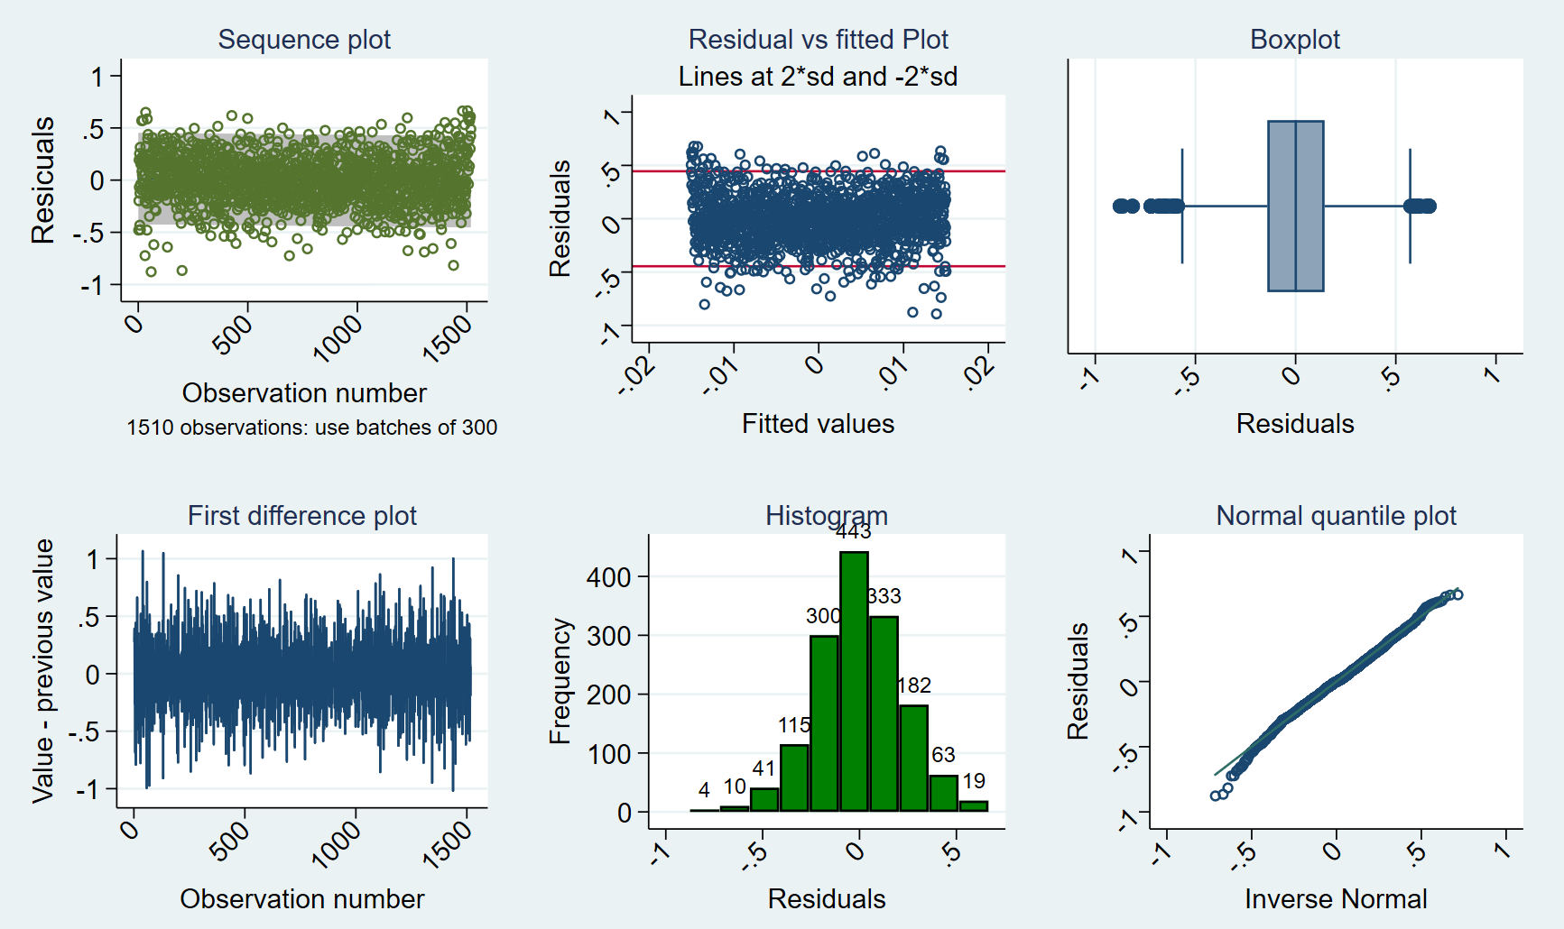
Figure S1 Six plots describing the residuals of final regression model

6. Figure S1 showed that the majority of the scatter points were around the mean of the residuals within the range of -0.5 to +0.5. No outliers were identified. Both the histogram and the Normal Quantile plot indicated a distribution of normality. All the diagnostic indices showed a normality of distribution and a wellness of modeling construction.
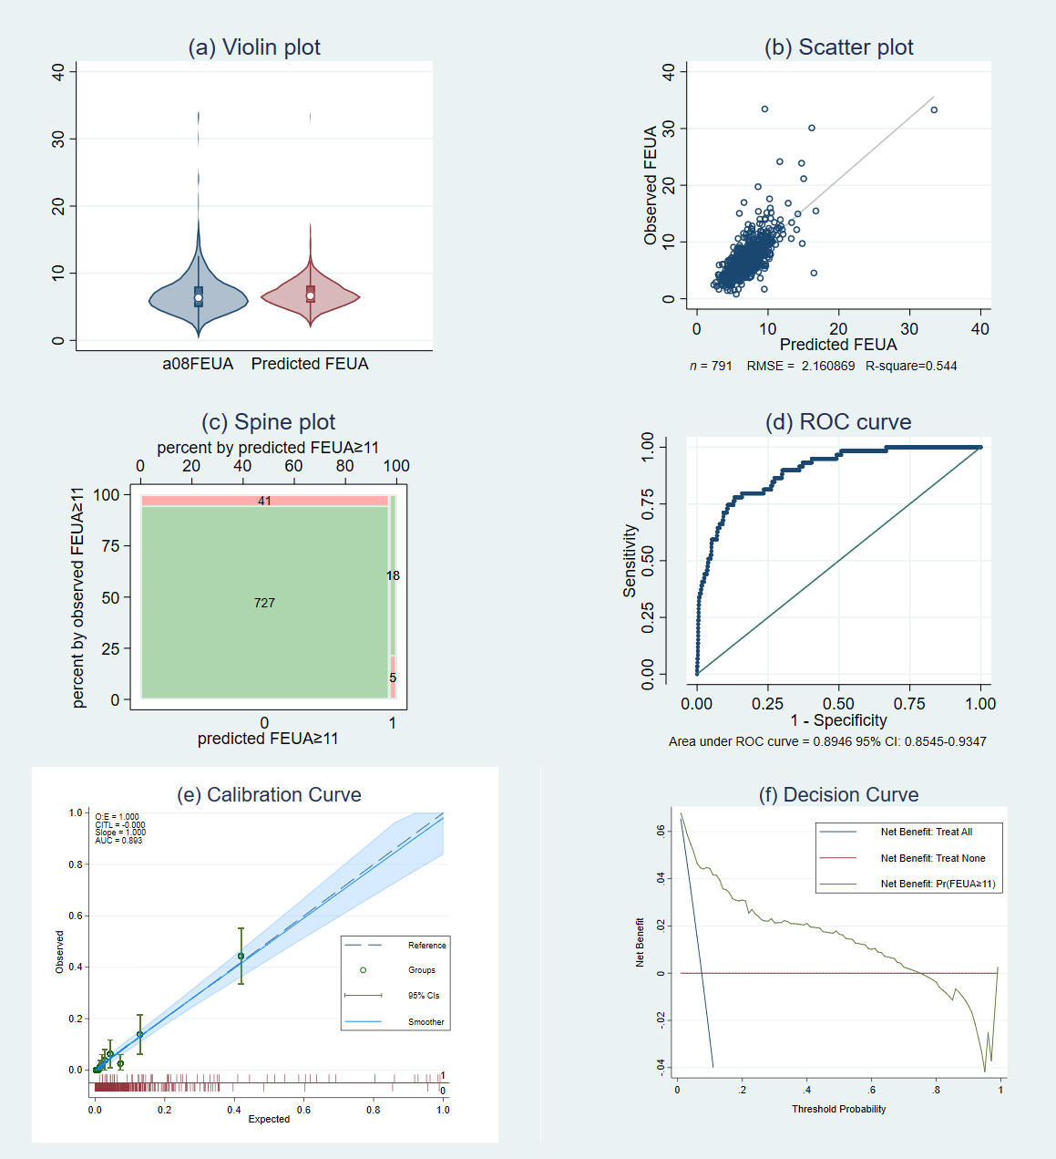
7. Figure S2 Six plots comparing observed FEUA (elevated FEUA) and predicted FEUA in external dataset

