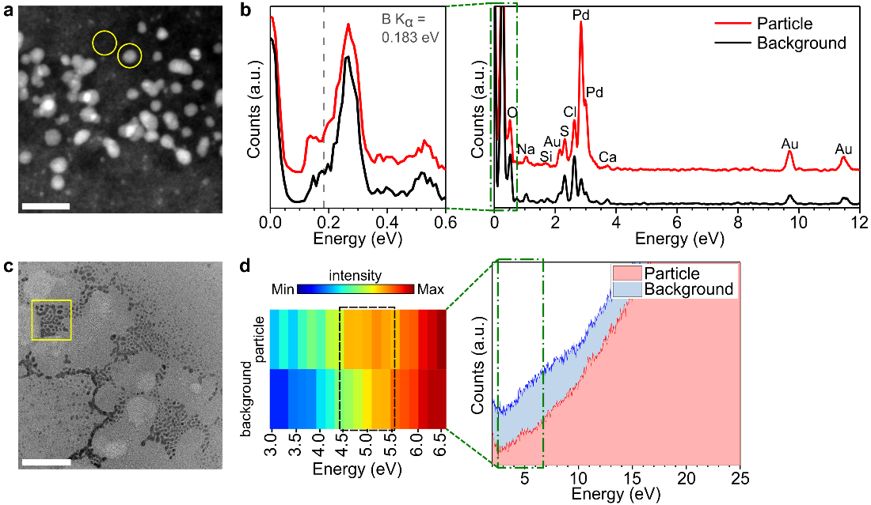
Extended Data Figure 1 | Chemical analysis of the synthesized HCP particles. a, HAADF STEM image marked with yellow circles where EDS spectra in (b) were acquired (same areas where EDS maps in Fig. 1h were acquired). b, EDS spectra of one of the nanoparticles (red) and a background area (black). While some residues of the precursor solution and contamination are present over the sample, the difference between the spectra of the particle and background shows that the particle is solely composed of Pd. The magnified spectra (left) within the range of the full spectrum (right) denoted by the green dash-dotted box indicates the absence of boron, hence excluding the possibility that Pd–B formed in GLC^{49,50}. c, TEM image marked with a yellow box where the EEL spectrum of nanoparticles was acquired. SLC, instead of GLC, was used to avoid overlap between the plasmon peaks of Pd and graphene⁵¹. d, (right) EEL spectra acquired from nanoparticles (red) and a background Si₃N₄ window (blue). (left) The color map of the EEL spectra within the spectral range denoted by the green dash-dotted box reveals an increased signal in the 4.5–5.5. eV region (black dashed box) from the nanoparticles. The absence of any elements except for H, He, Li, and Pd according to the EDS results, together with the presence of an EEL spectrum peak at ~ 5 eV, which is a distinctive characteristic of PdH_{x}⁵², suggests that HCP PdH_{x} formed. Scale bars, (a) 20 nm, (c) 100 nm.
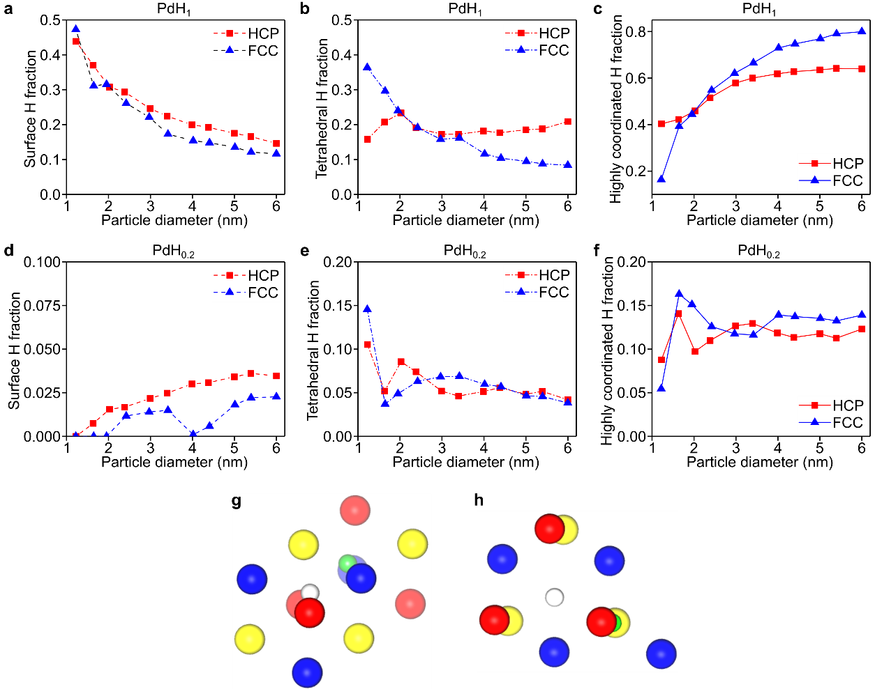
Extended Data Figure 2 | H occupancy in finite-sized PdH_{x} nanoparticles with different crystal packing. a–f, Partitioning of H atoms in PdH nanoparticles with different particle sizes and crystal packing with these H atoms occupying various Pd interstitial sites in nanoparticles with (a–c) high H content (x = 1) and (d–f) low H content (x = 0.2), respectively. The H sites are categorized by the number of coordinating Pd atoms, where (a, d) surface, (b, e) tetrahedral, or (c, f) highly occupied (trigonal bipyramidal/octahedral) represent (a, d) 0–3, (b, e) 4, or (c, f) 5–6 Pd atoms within the coordinating distance from the H atom, respectively. g–h, Representative coordination structure of PdH showing H atoms in octahedral (white) and tetrahedral (green) interstitial sites formed by (g) FCC and (h) HCP crystal packing. Pd atoms are shown as large spheres, and the colors represent different Pd layers. The 1-4-layer overlap (ABCA') in the FCC Pd structure provides extra stabilization for octahedral H atoms, while 1-3-layer overlap (ABA') in the HCP Pd structure provides extra stabilization to tetrahedral (T) and trigonal bipyramidal (TB) H atoms, resulting in distinct H atom occupancy, especially for small nanoparticles. At a diameter of 1.2 nm, almost half of the H atoms reside on the surface, regardless of the crystal packing.
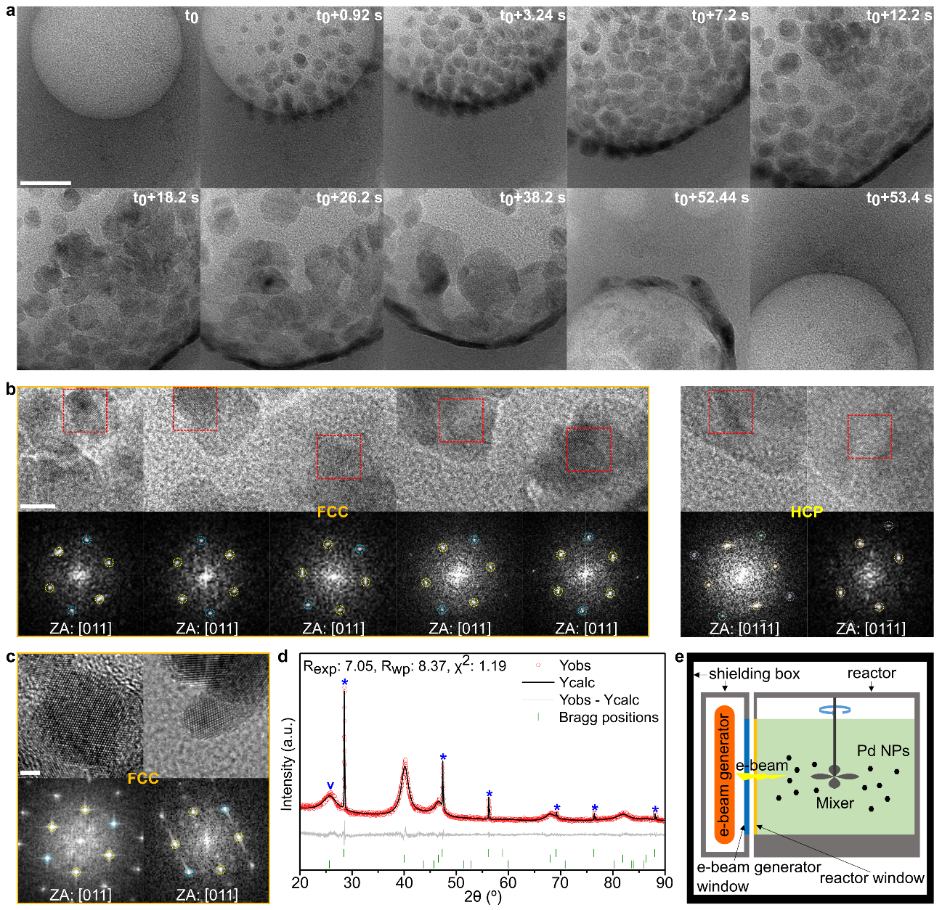
Extended Data Figure 3 | Formation of nanoparticles around a hydrogen bubble evolved in GLC and in a batch reactor outside TEM. a, Sequence of TEM images showing nucleation and subsequent growth and dissolution of nanoparticles on the surface of a bubble, recorded under an electron dose rate of 1.0 × 10⁴ e⁻/Å²s. These particles are thought to be generated via the condensation of Pd ions around a bubble as gas molecules push other chemicals away. b, HR-TEM images and corresponding FFTs of the nanoparticles formed on the surface of the bubble in (a). Both FCC and HCP nanoparticles were generated. Notably, the FCC particles’ interplanar distances are expanded by 3–4% on average relative to those of pure FCC Pd, indicating the formation of FCC PdH_{x} particles. c, HR-TEM images of Pd nanoparticles grown on the surface of carbon black in a batch reactor that utilizes an electron beam with a dose rate of 1.9 × 10⁻³ e⁻/Å²s, showing FCC particles only. d, Le Bail fitting results for the XRD pattern of the Pd/C synthesized in the batch reactor. The asterisks and the ‘v’ mark on the peaks correspond to the internal standard of Si powder standard (NIST SRM 640e) and graphite (PDF# 04-006-5764), respectively. e, Schematic illustration of electron-beam-assisted Pd nanoparticle synthesis using the large-scale batch reactor. Scale bars, (a) 20 nm, (b) 5 nm, and (c) 2 nm. ZA, zone axis.
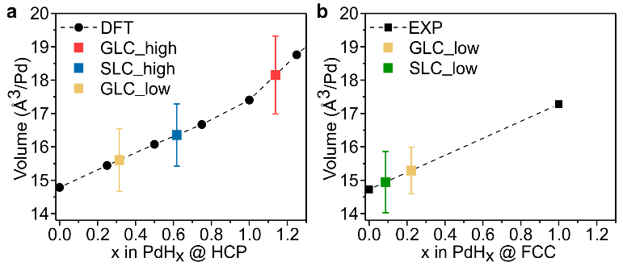
Extended Data Figure 4 | Calculated and experimental volumes of FCC/HCP PdH_{x}. a–b, Comparison of the volume per Pd atom in the nanoparticles and in bulk (a) HCP and (b) FCC PdH_{x}. DFT-calculated and experimental volumes were used for bulk HCP PdH_{x} and FCC PdH_{x}, respectively. In DFT, H atoms are placed at the tetrahedral sites after all the available octahedral sites are filled for x greater than 1. The H concentration x in the nanoparticles, which is unknown, is deduced from the volume of the corresponding structure in bulk.
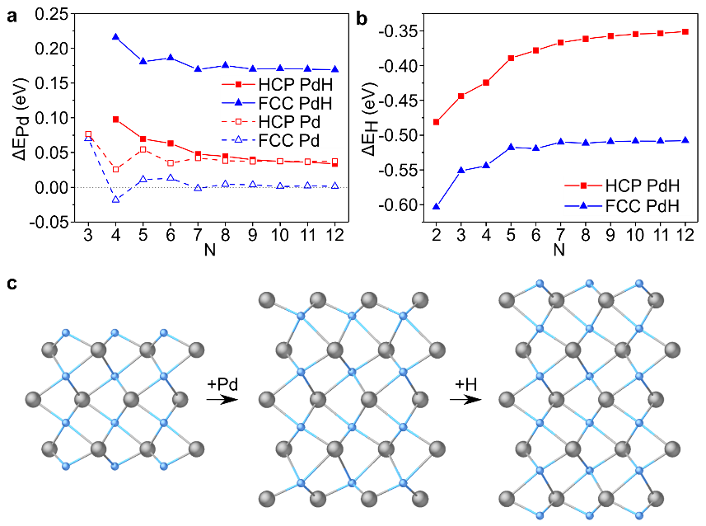
Extended Data Figure 5 | Energy of the PdH slab growth. a–b, Energy required to symmetrically add Pd or H atomic layers on top of (a) (0001) HCP PdH or (b) (111) FCC PdH slab, estimated from DFT calculations. c, Illustration of the symmetric addition of Pd and H layers, with Pd and H atoms drawn in gray and blue, respectively. The energies are defined as ΔE_{Pd}(N) = ⅟₂×((E(Pd_{N}H_{N-1})−E(Pd_{N-2}H_{N-1})−2×E(FCC Pd)) for the addition of N Pd atoms in (a) and ΔE_{H}(N) = ⅟₂×((E(Pd_{N}H_{N+1})−E(Pd_{N}H_{N-1})−E(H₂)) for the addition of N H atoms in (b). In the case of the FCC and HCP Pd slabs, the energy for Pd addition is simply expressed as ΔE_{Pd}(N) = E(Pd_{N})−E(Pd_{N-1})−E(FCC Pd); for FCC Pd, ΔE_{Pd}(N) approaches zero, whereas for HCP Pd, it approaches the energy difference between bulk HCP Pd and FCC Pd, which indicates that convergence has been achieved. Although ΔE_{Pd}(N) for HCP PdH and HCP Pd are similar, ΔE_{Pd}(N) for FCC PdH is higher than that for FCC Pd and even than that for HCP PdH.
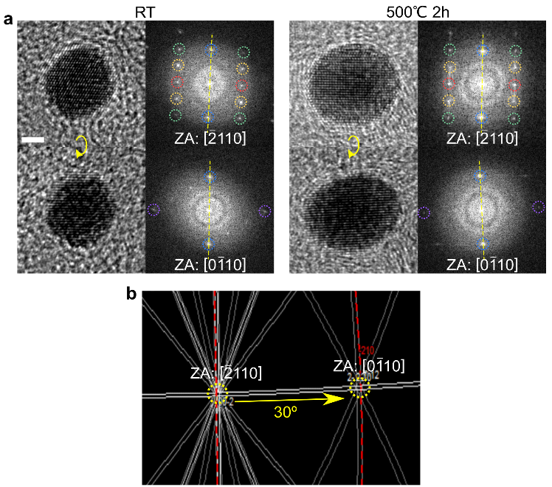
Extended Data Figure 6 | Annealing HCP PdH_{x} nanoparticles. a, HR-TEM images and corresponding FFTs of a nanoparticle as synthesized and after being annealed at 500 °C for 2 h. The HCP PdH_{x} nanoparticle maintained its crystal structure and interplanar distances even after heat treatment. Images were acquired at two different zone axes for a single particle to confirm the HCP structure. b, Tilting a particle initially aligned along the [-2110] axis by 30° around an axis along the [0002] direction reoriented it to be aligned along the [0-110] axis, as expected in the Kikuchi pattern of HCP with c/a = 1.65. Scale bar, 2 nm. ZA, zone axis.
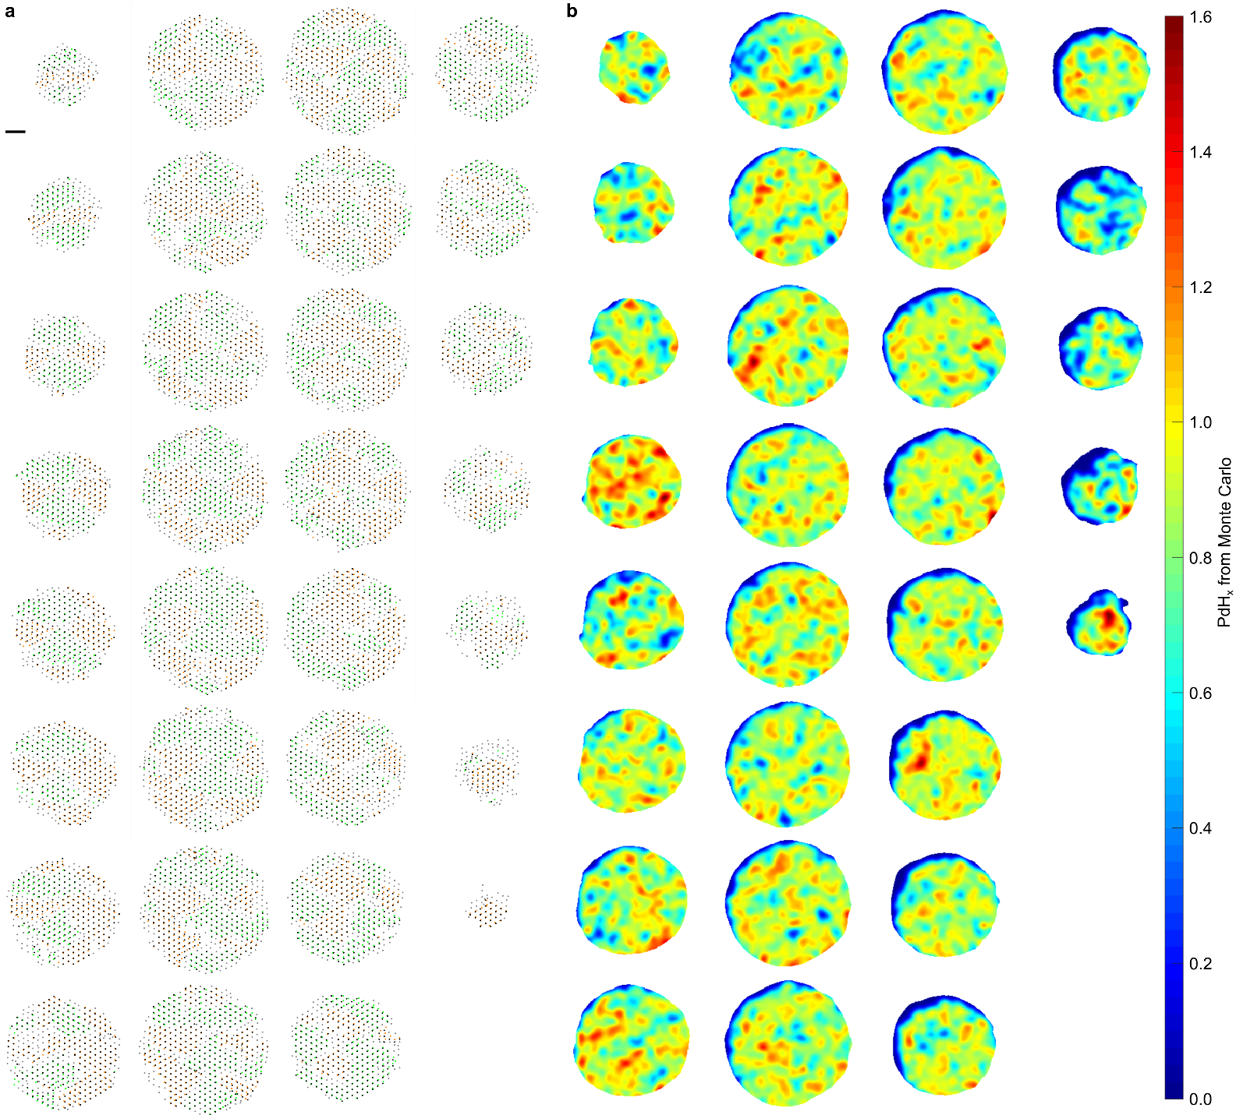
Extended Data Figure 7 | Detailed atomic structure and local H concentration map of a PdH_{x} nanoparticle obtained in the GLC showing large local fluctuations. a, Layer-by-layer representation of the traced atomic coordinates and fitted HCP positions for two major domains of the PdH_{x} nanoparticle shown in Fig. 4. The atoms that belong to two major domains appear as orange and green. Each domain was separately fitted with an HCP structure, and black dots represent atoms fitted to the HCP positions. Gray dots represent the atomic positions not assigned to any domain. The layers were sliced from the top of the nanoparticle along the hexagonal c axis and plotted in vertical order starting from the top left panel. b, Layer-by-layer representation of local H concentration map calculated from MC simulations using Pd coordinates constructed from the results of AET, where the layers are ordered corresponding to (a). The local fluctuation of H correlated with the large fluctuation in lattice constants (0.1–0.2 Å) observed in the statistical ex situ analysis of HCP particles (Fig. 1g) as well as in situ analysis of the particle growth, where fluctuations in the d-spacing during the course of the particle growth are shown (Figs. 1c–d). These local fluctuations might stem from the nonuniform H distribution in the liquid owing to the stochastic collisions of incident electrons and water molecules. A high H molar concentration appears near the Pd atoms with a large local lattice constant, where the H concentration reaches up to 150% of the Pd concentration. Approximately 20% of the total H atoms are found to occupy the surface region. The lower spatial H concentration marked at the surface region is due to the difference in accessible free volume per Pd atom, where surface Pd atoms have a larger Voronoi volume than the inner Pd atoms owing to less overlap with other Pd atoms. Scale bar, 1 nm.
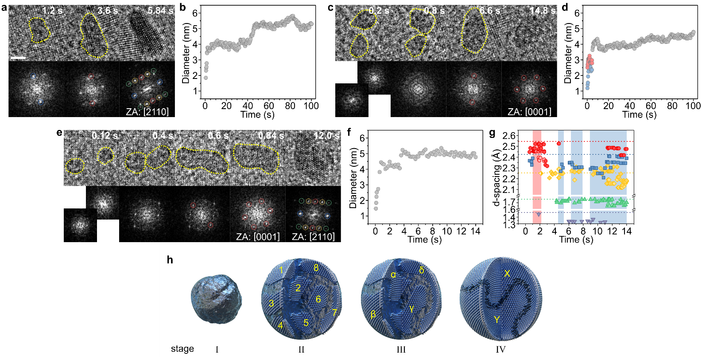
Extended Data Figure 8 | Evolution of HCP PdH_{x} nanoparticles in the early growth stage and multi-step crystallization process. a–d, Snapshots and corresponding FFTs from movies S1 and S2 showing the early stages of the growth of particles (a) 1 and (c) 2 in Figs. 1a–d, along with (b) and (d), their respective size evolutions. e, Snapshots and corresponding FFTs from movie S3 showing the growth of another HCP PdH_{x} particle formed under the same conditions as those of particles 1 and 2. f, Size evolution of the particle in (e). g, Plot of interplanar distances of five low-index planes of the particle in (e) as a function of time. The zone axis patterns show that the particle had an HCP structure immediately after coalescence, i.e., within approximately one second of nucleation at most. Scale bar, 2 nm. ZA, zone axis. h, Formation scheme of a particle via multi-step crystallization. Stage I: the Pd precursors assemble into an amorphous cluster, which can be easily created without having to overcome a substantial entropy difference between the crystalline and solution phases. Stage II: crystalline nuclei form at multiple sites within the amorphous cluster (nucleation of domains 1–8). Stage III: nuclei grow into larger domains by a merging process such as Ostwald ripening, and large nuclei grow further by absorbing smaller ones (merging of multiple domains: 1 + 2 → α, 3 + 4 → β, 5 + 6 → γ, 7 + 8 → δ). Stage IV: if two similarly sized domains co-exist, the merging process cannot continue because it becomes difficult for one domain to absorb the other, resulting in a nanoparticle with two domains with a complex boundary structure (merging of larger domains; α + δ → X, β + γ → Y without further growth).
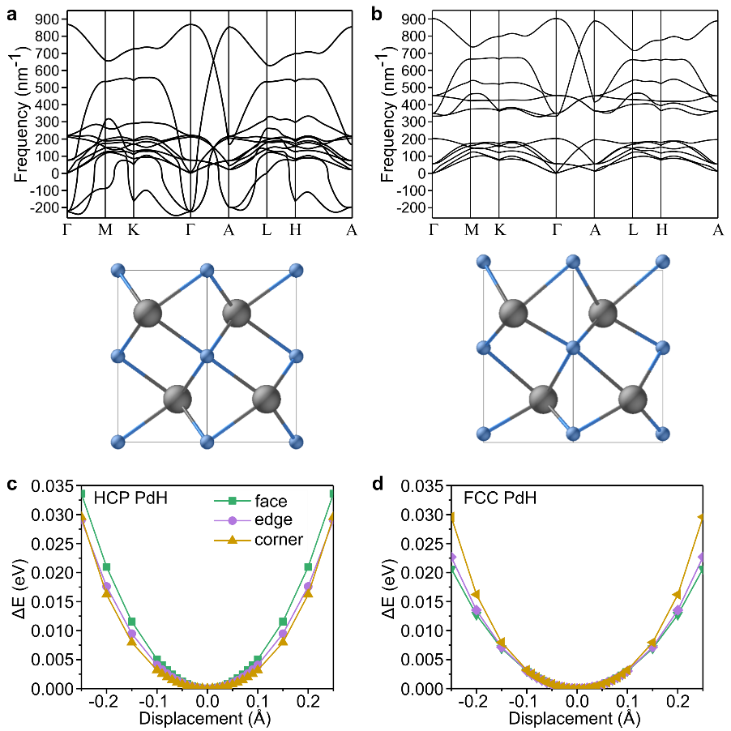
Extended Data Figure 9 | Vibrational characteristics of PdH from DFT calculations. a–b, Phonon dispersion curves of HCP PdH, in which (a) H is located at the ideal octahedral position and (b) H is displaced by 0.24 Å from the ideal position along the c axis. The corresponding atomic models are shown below the curves. Pd and H atoms are drawn in gray and blue, respectively. Imaginary phonon modes were found when H was positioned at the ideal octahedral site. One of those modes indicates the displacement of H along the c axis, with such a rearrangement removing the imaginary modes, as shown in (b). c–d, Energy landscape (ΔE) values around the octahedral position as calculated by displacing a single H atom from the center of the octahedron made by the six nearest-neighboring Pd atoms in the 48-atom supercell of (c) HCP PdH and (d) FCC PdH. The displacement towards the face in (c) is similar to the change from (a) and (b), but the instability is not captured. H atoms may adopt the ideal octahedral position at room temperature instead of collectively moving to the lower symmetry structure because of the small energy difference (1 meV/atom), between the two structures (a) and (b). The energy variation in FCC PdH in (d) is more isotropic and lower in magnitude for the same degree of displacement than that in HCP PdH. This result agrees with the higher phonon frequencies of HCP PdH in the present study compared with those of FCC PdH⁵³.
Extended Data Table 1 | Estimation of the lattice parameters of HCP PdH_{x}. The DFT-optimized and experimental lattice parameters of FCC PdH_{x} are used to improve the prediction of the lattice parameters of hitherto unknown HCP PdH_{x}. Because the lattice parameter of stoichiometric FCC PdH at 300 K is not known, the lattice parameter of PdH at 77 K reported by Schirber et al.⁵⁴ was used, and then, the thermal expansion discussed by Errea et al.⁵³ was applied. As summarized in the table, the experimental lattice parameters at 300 K are found to be slightly larger than the DFT-optimized values. The estimated lattice parameters of the HCP structures were obtained by multiplying the DFT values by the ratio, a (300 K, exp)/a (DFT), for the respective compositions in the FCC structure.

 | Experimental lattice  parameters at 300 K | DFT-optimized lattice parameters |  | Estimated lattice  parameters at 300 K
 | a (Å) | a (Å) | c (Å) | a (Å) | c (Å)
FCC Pd | 3.8905⁵⁵ | 3.883
FCC PdH | 4.104^{53,54} | 4.078
HCP Pd |  | 2.728 | 4.563 | 2.733 | 4.571
HCP PdH |  | 2.871 | 4.785 | 2.889 | 4.815

49 Kobayashi, K. et al. Discovery of hexagonal structured Pd-B nanocrystals. Angew. Chem. Int. Ed. 56, 6578-6582 (2017).
50 Chen, L. et al. Metal boride better than Pt: HCP Pd₂B as a superactive hydrogen evolution reaction catalyst. Energy Environ. Sci. 12, 3099-3105 (2019).
51 Politano, A., Chiarello, G. & Spinella, C. Plasmon spectroscopy of graphene and other two-dimensional materials with transmission electron microscopy. Mater. Sci. Semicond. Process. 65, 88-99 (2017).
52 Bennett, P. A. & Fuggle, J. C. Electronic structure and surface kinetics of palladium hydride studied with x-ray photoelectron spectroscopy and electron-energy-loss spectroscopy. Phys. Rev. B 26, 6030-6039 (1982).
53 Errea, I., Calandra, M. & Mauri, F. First-principles theory of anharmonicity and the inverse isotope effect in superconducting palladium-hydride compounds. Phys. Rev. Lett. 111, 177002 (2013).
54 Schirber, J. E. & Morosin, B. Lattice constants of β−PdH_{x} and β−PdD_{x} with x near 1.0. Phys. Rev. B 12, 117-118 (1975).
55 Arblaster, J. W. Crystallographic properties of palladium. Platinum Met. Rev. 56, 181-189 (2012).

