Supplementary Methods

Quantifying distance from natural water bodies

One major hurdle faced with the GLOBE water transparency dataset is the reliability of site-level data. Observations were occasionally recorded (6% of samples) in non-natural waterbody environments (e.g. water fountains, classroom tubs, or ephemeral puddles) which, while offering useful teaching moments in real time, complicate downstream interpretation for scientific purposes. To address this, we quantified the distance of each measurement location to observed water bodies as seen by satellites. This step helped distinguish natural water body observations from those that are not aligned with the scientific intent of the protocol, while also flagging observations where geocoordinates were insufficiently detailed to match a nearby water body.

We verified the existence of a natural water body using two sources: OpenStreetMap (OSM) and high-resolution Sentinel-2 satellite imagery (10 m). The OSM vector maps database includes water bodies, such as small streams, creeks, or lakes under tree cover, that may not be visible in satellite imagery. If an initial OSM query identified a water body within 300 m (approximating 5 min walk radius from the listed observation coordinates), distance was recorded, and the process would advance to the next sample. If no water feature was detected within 300 m threshold using OSM approach, we queried Sentinel-2 imagery using the Google EarthEngine API. We then recorded the minimum distance to a water body between the two datasets. Sentinel-2 images were generally able to identify many of the remaining water bodies.

To detect water bodies from Sentinel-2 imagery, we used the normalized difference water index (NDWI, Gao, 1996). The Sentinel-2 provides data on 13 spectral bands; to calculate NDWI, we used the normalized difference of band 3 (559nm, green) and band 8 (864nm, near infrared, McFeeters, 1996). The NDWI was calculated for all Sentinel-2 imagery available (2015-now), restricted to scenes with less than 5% cloud cover (to ensure data quality). If the NDWI value was >0.3, then we considered that imagery pixel to be water and colored it black, otherwise we considered it to be land, and colored it white (Figure 1).

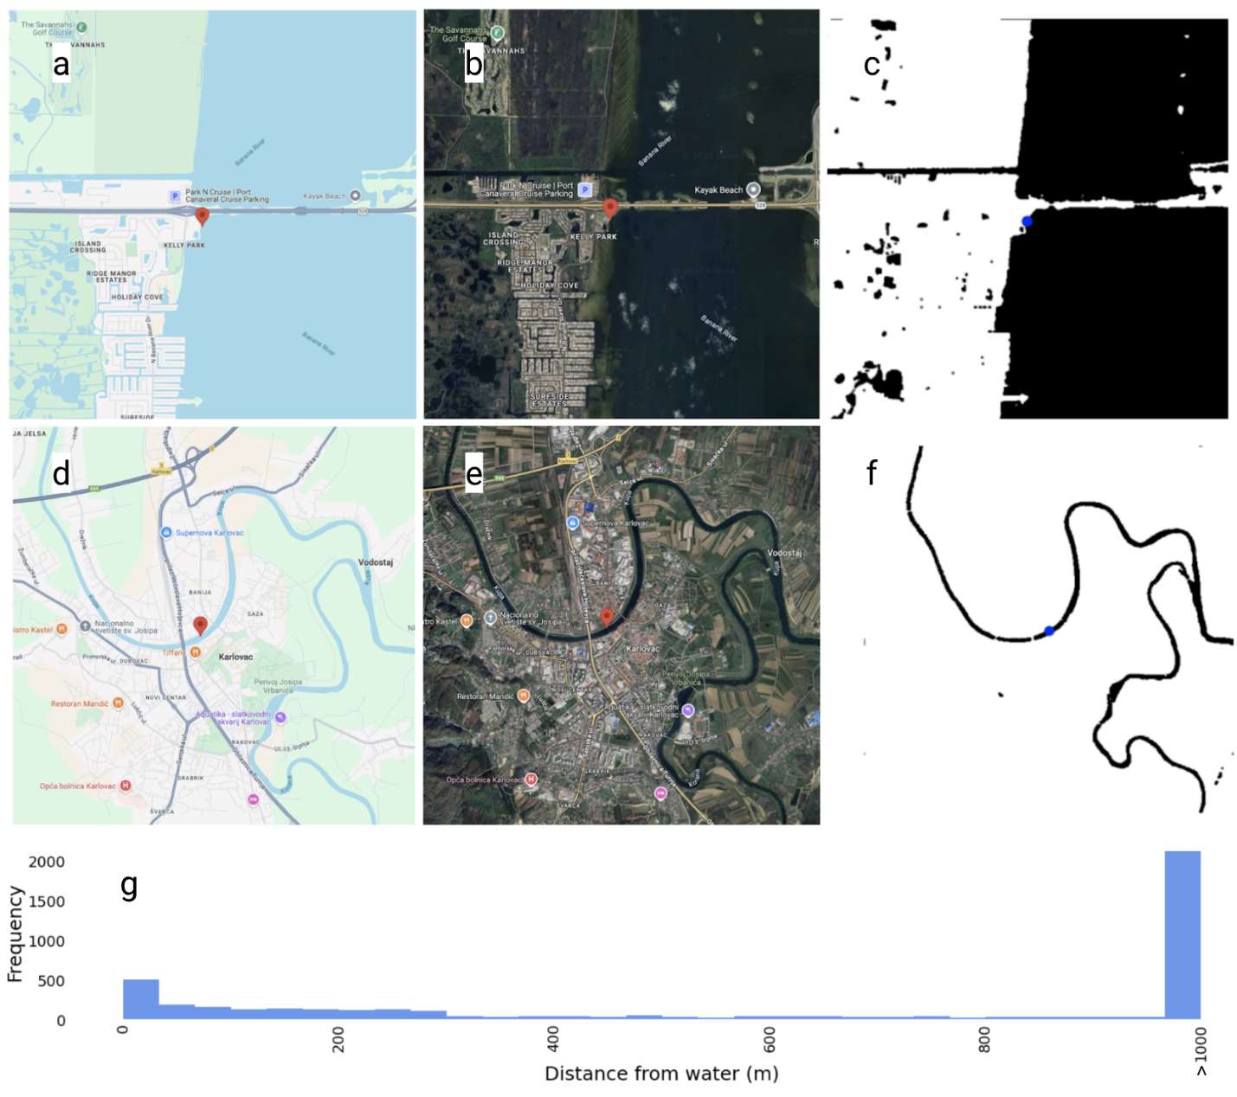
Figure S1. (a) Google Maps road map view of a GLOBE sample site at Kelly Park East in Merritt Island, Florida. Areas with water are clearly defined along the shoreline. Some inland marshes are also visible.
(b) Google Maps satellite view of the same sample site in Kelly Park East in Merritt Island, Florida.
(c) NDWI water extraction image showing water in black and land in white. The sample site is ordinarily labeled with a red dot, but in this case the sample site is directly on water and the red dot is hidden under the blue dot, meaning the distance to water is 0m. The procedure locates most water bodies, but has difficulty identifying water from marshes and sloughs that may be covered with algae. (d) Google Maps road map view of a GLOBE sample site along the Kupa River in the city of Karlovac in Croatia. (e) Google Maps satellite view of the sample site located on the Kupa River in the city of Karlovac in Croatia. The river is well defined in satellite view, with distinct embankments. (f) The NDWI water-extracted image from Sentinel-2. Water is shown in black and land shown in white. The blue dot in the right hand image represents the nearest water location from the sample site. The sample site is ordinarily labeled with a red dot, but in this case the sample site is directly on water and the red dot is hidden under the blue dot, meaning the distance to water is 0m. Water extraction from satellite imagery generally performs well for broad rivers with clear shorelines.
(g) Histogram showing the distance from the sample site latitude / longitude to the closest water body. If no water was found within 1000m, then we recorded 1000m as the distance value. The was the most common scenario for a number of reasons: (1) many sample site coordinates lacked decimal precision, (2) many samples cited the coordinates of their school / organization rather than the same site, and (3) some samples were taken from artificial water bodies which may not have been visible from satellite imagery.

We performed noise reduction on the output imagery in order to smooth the boundaries of water bodies.

Finally, we computed the distance from water for each observation latitude / longitude point. To estimate the distance, we used the haversine formula for OSM datapoints, and the pythagorean theorem for data originating from Sentinel-2 imagery. If no water was found within a 1km bounding box of the collection site location, we recorded the distance as exactly 1000 meters, representing a ‘none’ value. We also recorded the source the algorithm used to measure the distance to water as: ‘osm’, ‘imagery’, or ‘none.’ This metadata allows the downstream clients to filter the data based on verification source. We used this metadata for debugging and reverse engineering of our algorithm.

As noted above, inclusion of this satellite-based analysis improved on the verification of the existence of natural water bodies. It is important to note that, due to the limitations of the satellite observations (temporal revisit, clouds, temporal gap between GLOBE and satellite), GLOBE database might identify more and/or different water bodies (ephemeral ponds, rivers) than are available from a space-based view.

Water body classification

Water body type is a fundamental contextual variable for interpreting transparency measurements, as optical properties vary substantially across the aquatic domain; between lentic (still) and lotic (flowing) systems, coastal versus inland waters, and natural versus artificial environments. However, approximately 60% of GLOBE's 28,175 unique observation sites lacked reliable classification metadata. While the protocol includes a "water body source" field, historical protocol evolution, inconsistent data entry practices, and multilingual site descriptions resulted in sparse coverage. Manual classification at this scale would be impractical and introduce subjective inconsistencies across the dataset.
We developed an automated classification pipeline using a large language model (LLM; Meta's Llama 3.1 8B) conditioned through prompt engineering to emulate domain expertise in hydrological systems. The model, which we termed "IvonaBot" after one of the co-authors, synthesized textual metadata including site names, location descriptions, observer comments, and geographic coordinates to infer water body types. We consolidated GLOBE's 13 legacy categories into five primary classes aligned with optical and hydrological characteristics: River/Stream, Pond/Lake, Marsh, Ocean, and Non-natural water source.
Classification validation employed three complementary approaches. First, we performed cross-tabulation analysis with existing GLOBE metadata to assess concordance with historical records. The Chi-square test of independence (χ² = 17,133.16, df = 72, p < 0.001) confirmed significant association between LLM classifications and legacy labels, while Cramér's V (0.53) quantified moderate-to-strong agreement. These statistical metrics are standard for assessing categorical variable associations and are particularly valuable here because they account for the complexity of mapping between our simplified five-class taxonomy and GLOBE's original 13 categories. The significant p-value indicates the classifications are not random, while Cramér's V provides an effect size measure independent of sample size, with values above 0.5 considered substantively meaningful for large contingency tables.
Second, we conducted manual validation on 3,000 stratified samples using Sentinel-2a satellite imagery, revealing high agreement between LLM outputs and expert human assessments even when input metadata was sparse. Third, we examined classification plausibility through geographic consistency checks, confirming that site clusters exhibited expected spatial coherence (e.g., adjacent school sites typically shared water body types).
The final distribution—Marsh (45%), River/Stream (36%), Pond/Lake (11%), Non-natural (6%), Ocean (2%)—reflects both the geographic distribution of GLOBE participants and the accessibility constraints of citizen science monitoring, which favors inland freshwater systems over offshore marine environments. Critically, the identification of non-natural water sources (classroom containers, fountains) enables appropriate data filtering for scientific applications while preserving these observations for educational use cases.
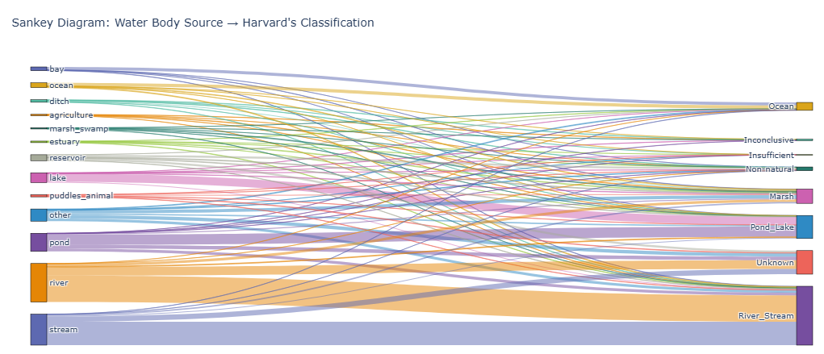
Figure S2. Water body classification pre (left) and post (right) processing.
Model limitations center on input data quality: sites with minimal or conflicting textual descriptions required iterative prompt refinement to achieve reliable classifications. Future enhancements could integrate multimodal approaches combining textual metadata with satellite-derived morphometric features (water body shape, size, temporal variability) to improve classification accuracy in ambiguous cases. Nevertheless, by providing consistent water body classifications across all GLOBE sites, this metadata layer enables downstream users to appropriately stratify analyses by aquatic system type, a fundamental requirement for scientifically robust transparency trend detection and validation.

The transparency tube problem

One notable issue with the water transparency data occurs with clearer waters, when the water transparency tube is fully filled with sample water, yet the pattern at the bottom remains visible, leaving the length measurement unknown. In these instances, the true transparency is unknown, instead the observation is rather providing a lower bound, numerically equivalent to the length of the tube used. Many observations in the GLOBE database do not indicate that the tube was completely filled and with a clearly visible pattern, even though the recorded depth is equal to a common tube length. Furthermore, in some cases the length of the tube was not provided by the users, creating high uncertainty around the transparency measurement.

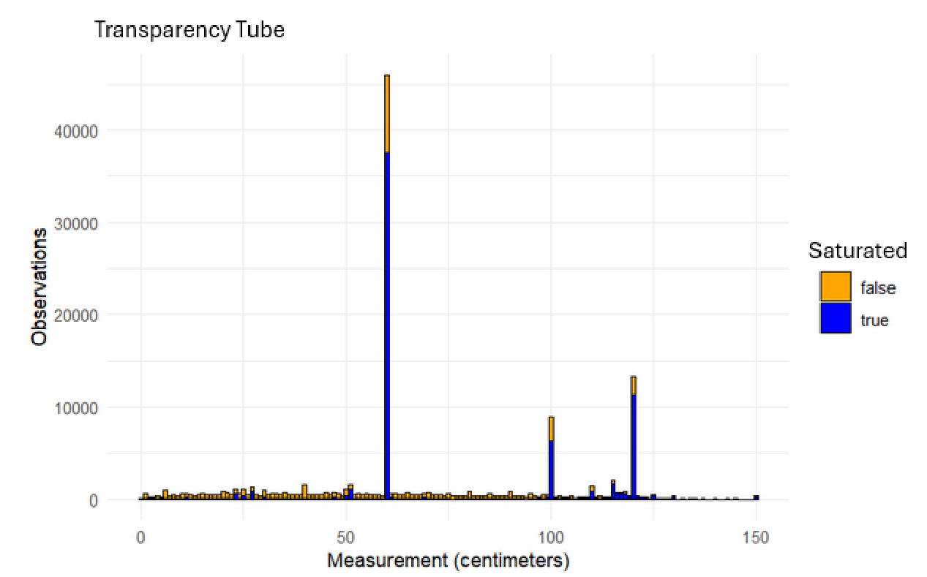
Figure S3. Transparency tube observations where orange indicates the value of transparency tube is not equivalent to the length of the tube, and blue indicates that the value reported is equivalent to the length of the tube.

To address this issue, we estimated the total length of the tube used for each GLOBE water transparency observation using two methods: (1) an algorithmic approach and (2) maximum likelihood estimation (MLE). Using these estimates, we developed a depth index, which is defined as the normalized measured depth (i.e., observed depth divided the total length of the tube). The depth index of 1 indicates the water transparency is likely higher than what was recorded. Values less than 1 indicate the transparency recorded can be reliably used. While it is not ideal to have samples with ‘detection limit’ concerns, these data can still be used to provide lower bounds on transparency. Therefore, such datapoints are retained in the dataset in order to maximize the data collection efforts.

To establish a Quality Flag system, we first employed a Robust Coefficient of Variation (Robust CV) approach to filter historic sampling sites. Sites with a Robust CV ≤0.05 or ≥1.7 were flagged as unreliable (representing artificial consistency or excessive noise, respectively) and excluded from the training set. The upper limit was set from empirically at the 95th percentile of the site variability distribution. Ultimately, we set up a training set free of both artificially perfect measurements (i.e., same exact measurements each time) where fluctuations that may be due to external factors (e.g., shallow sites) and/or user error in implementation of the collection protocol.
While we initially attempted to flag individual data points based on user-reported saturation and water body metadata using a Random Forest classifier, we found these metadata fields to be inconsistent. Consequently, we replaced the static metadata flags with a probabilistic flagging system: new data points are now evaluated against the 95% Credible Interval generated by our Bayesian Hierarchical Model. Points falling outside this interval are automatically flagged for manual review.
Rule-based approach

For instances where transparency tube length was not recorded by the user, we modeled the true GLOBE water transparency tube length based on five potential tube lengths available in the dataset: 27 cm, 45 cm, 60 cm, 80 cm, 100 cm, 120 cm. Each sample had to be matched with one of these 5 categories. Only water transparency observations between 0cm and 120cm were considered valid, otherwise the output was labeled as N/A. Many of these N/A values are not necessarily unusable; for example, they may have just used different instrumentation, such as a Secchi disk, which is not applicable to this specific metadata contribution.

We leveraged the fact that 44% of total observations, and 56% of valid observations exactly matched a
common tube length. The first method, our algorithmic approach, relied on our understanding of the water transparency measurement protocol, and the data we observed, to develop a rule-based approach, with five possible outcomes below.

- Initial threshold rule: If the recorded sample height is >100 cm then the tube length is set to 120 cm, as this is the maximum tube length.
- First sample rule: For the first sample at that site or country (depending on the aggregation unit), we assume a 120 cm tube length (maximum possible tube length). This avoids any
issues with the measurement being larger than the estimated tube length.
- Match rule: If the observed height is the same as a common tube length (27 cm, 45 cm, 60 cm, 80 cm, 100 cm, 120 cm), we assume that value is the true tube length.
- Association rule: If the previous conditions are not satisfied, we assign the tube length based on the most common exact tube length measurement taken at that site or country.
- Excess rule: If the measured height still exceeds the mode defined in step above, we assume the
tube length is the next longest common tube length that is large enough to accommodate the sample height.

This simple algorithm, based on the numerous observations in this dataset, assumes that many measurements are below the detection limit, even if they are not labeled as such, hence the most frequent measurement indicates the used tube length.

MLE approach

The overall motivation for development of this approach was to determine the most likely tube length by identifying saturated measurements, extending the logic outlined above. Here, we used a Bayesian maximum likelihood framework to corroborate the results generated from the above approach. Specifically, we modeled tube length by using a Categorical distribution with a Dirichlet conjugate prior and performed Bayesian updating of the concentration parameter. The mode of the resulting Dirichlet distribution provided the probability mass function (pmf), that indicated the likelihood that a particular length tube was used to collect the GLOBE sample in question. The estimated tube length corresponded to the most likely valid category within the pmf, while taking into consideration that the tube length cannot be shorter than the observed sample height.

Our framework had five sequential steps:
1. Pre-processing: Samples were ordered chronologically for each site or country and thereafter processed each site or country individually, relying on the assumption that such geographical groups use the same or similar instrumentation over time,
2. Prior knowledge: We assumed a naive prior concentration parameter for each site (i.e. a uniform distribution),
3. Estimating: For each sample, we evaluated the candidate tube lengths to satisfy the constraint that tube length has to be equal or longer than the measurement height. In the case of ties, we took the longer tube length,
4. Updating: If that measurement matched a common tube length (in the case of saturation), then we updated the concentration parameter by adding 1 to the index that represents that tube
length,
5. Iterating: We repeated steps 1-4 for all samples at that site, and again for each site or country.

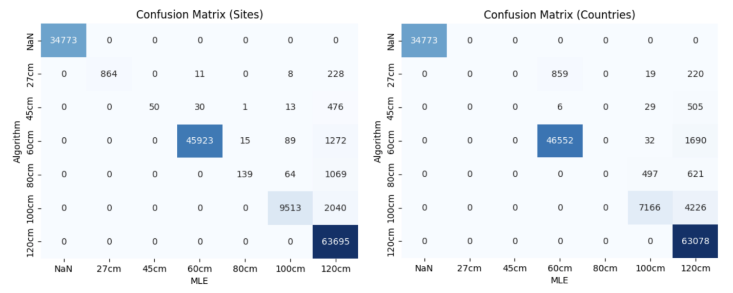
Figure S4. Confusion matrices showing alignments between the algorithmic and MLE approaches for estimating transparency tube length. Left: both methodologies broken down by GLOBE sample sites. Right: both methodologies broken down by GLOBE sample site countries.

References

Gao, Bo-cai (1996). NDWI—A normalized difference water index for remote sensing of vegetation liquid water from space, Remote Sensing of Environment, 58(3), 257-266.

McFeeters, S. K. (1996). The use of the Normalized Difference Water Index (NDWI) in the delineation of open water features. International Journal of Remote Sensing, 17(7), 1425–1432.

