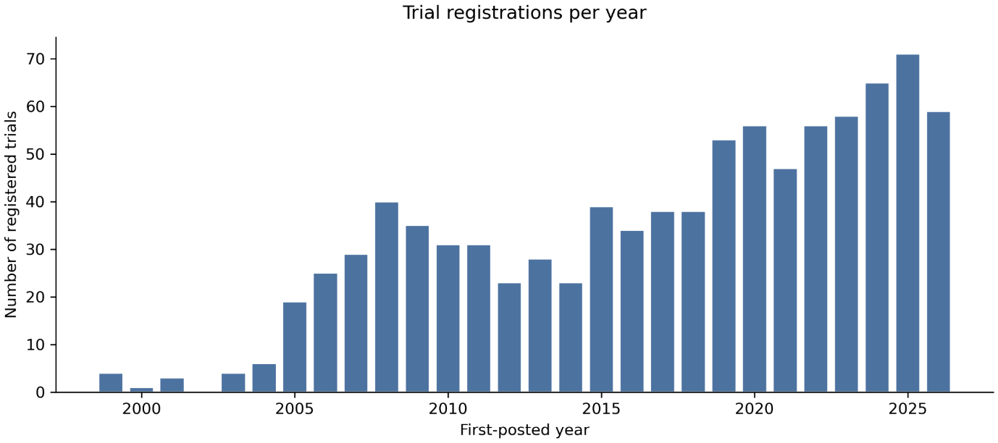
Fig. S1 Trial registrations per first-posted year, 1999-2026. Bars give the annual denominators used in Fig. 4, 5, and S2. 2002 held no registrations; the 2026 bar covers a partial year (through 10 July 2026)
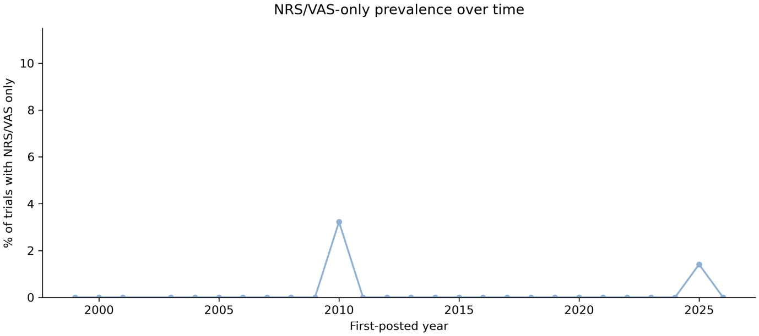
Fig. S2 Registration of the NRS (IMMPACT-endorsed) and VAS (not endorsed) by first-posted year, 1999-2026, as two point series. The two are not mutually exclusive (43 trials registered both). Denominators are given in Fig. S1. The dotted line marks the 2005 IMMPACT recommendations

