Supplementary Materials

Table S1. Explanation of chart allocation.

No. | Content | Location
Figure 1 | Study framework concept diagram | Main text
Figure 2 | Band-specific ITPC boxplots | Main text
Figure 3 | Deep learning classification performance | Main text
Figure 4 | Ablation study + Grad-CAM attribution (key figure) | Main text
Figure 5 | Transformer attention weight analysis | Main text
Table 1 | ERP between-group statistics | Main text
Figure S1 | ERP grand average waveforms (8 components) | Supplementary
Figure S2 | ERP contrast waveforms + cluster permutation | Supplementary
Figure S3 | ERP topographic maps | Supplementary
Figure S4 | Functional connectivity comparison (PLV + PLI) | Supplementary
Figure S5 | XAI summary (Grad-CAM / Occlusion / SHAP) | Supplementary
Figure S6 | ERP amplitude boxplots (all components × 4 conditions) | Supplementary
Figure S7 | Time-frequency overview (ERD/ERS + ITPC full) | Supplementary

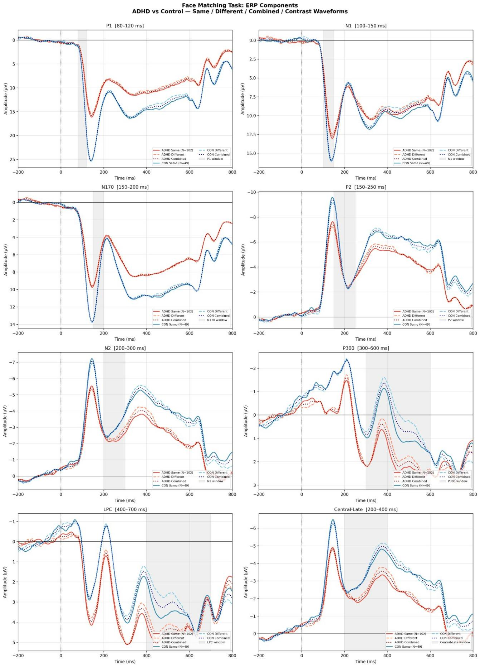

Figure S1. Overview of ERP grand-average waveforms (8 components × Same/Different/Combined). Red: ADHD group (N=102); blue: CON group (N=49). Gray shading marks the time window for each component. Vertical axis follows EEG convention (negative up).

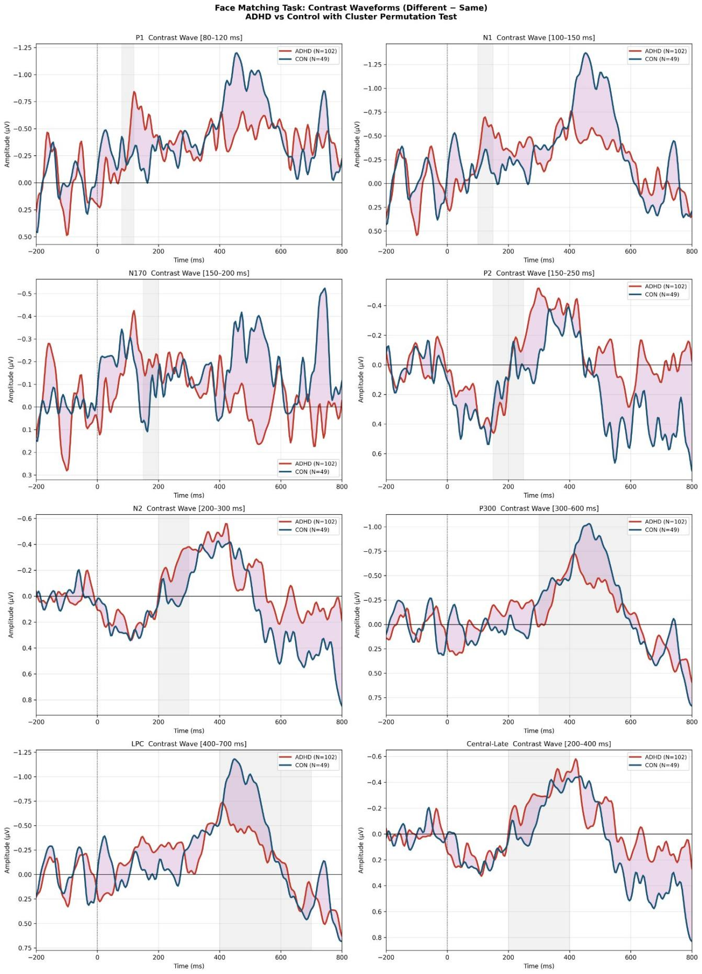

Figure S2. Between-group comparison of Different−Same waveforms (8 components). Pink shading marks significant time clusters from the cluster-permutation test (p<0.05, 1000 permutations, two-tailed).

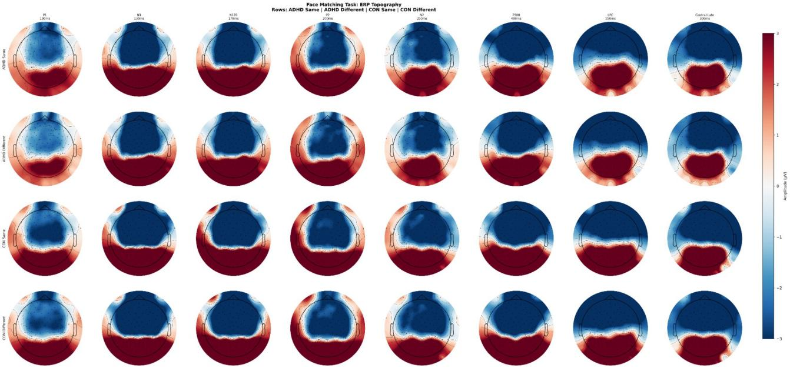

Figure S3. ERP topographic maps. Rows: ADHD-Same / ADHD-Different / CON-Same / CON-Different. Columns: P1 (100 ms), N1 (130 ms), N170 (170 ms), P2 (200 ms), N2 (250 ms), P300 (400 ms), LPC (550 ms), Central-Late (200 ms).

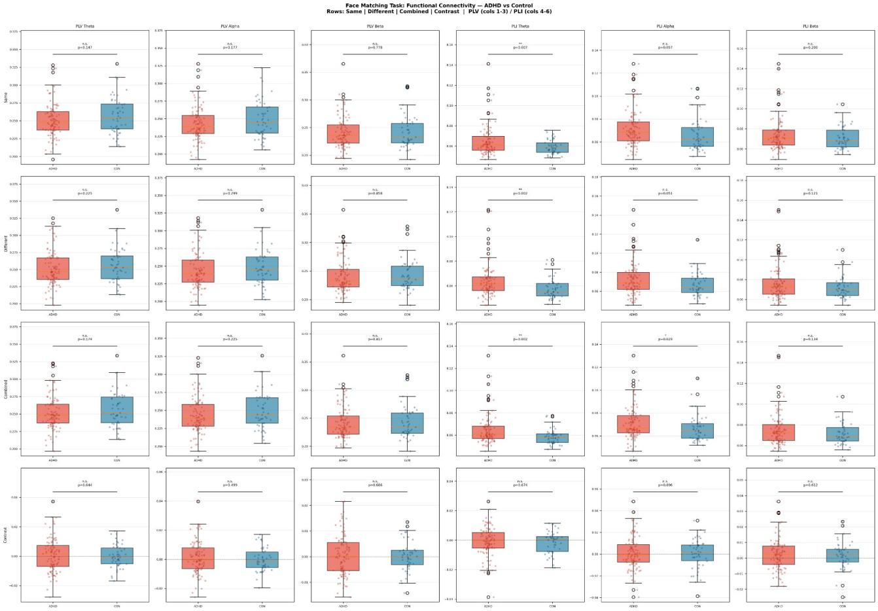

Figure S4. Functional connectivity comparison between groups (ADHD vs CON). Rows: Same / Different / Combined / Contrast. Columns 1-3: PLV (Theta/Alpha/Beta); columns 4-6: PLI (Theta/Alpha/Beta). ** p<0.01, * p<0.05, n.s. p≥0.05.

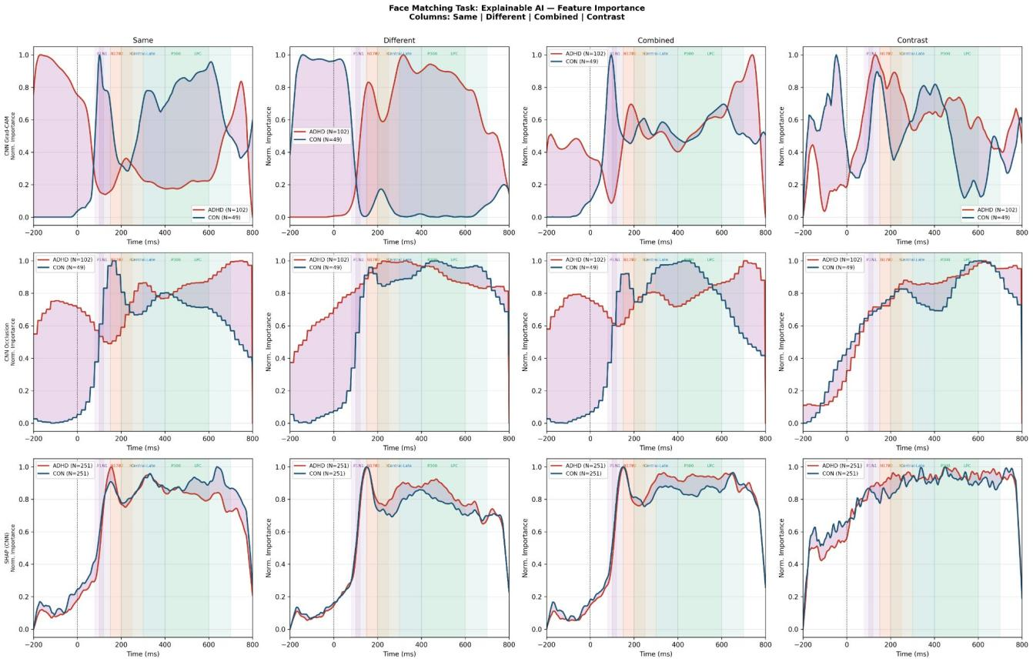

Figure S5. Interpretable-AI comprehensive comparison (CNN model; Same/Different/Combined/Contrast columns). Rows: Grad-CAM / occlusion sensitivity / SHAP (GradientExplainer). Red: ADHD (N=102); blue: CON (N=49). Colored background marks the time window of each ERP component.

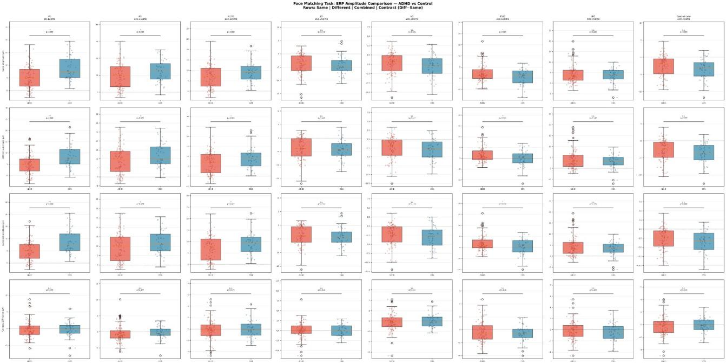

Figure S6. ERP amplitude boxplots (ADHD vs CON, all components × 4 conditions). Rows: Same/Different/Combined/Contrast (Different−Same). Columns: P1/N1/N170/P2/N2/P300/LPC/Central-Late. Red: ADHD; blue: CON. t-test p-value marked above each panel.

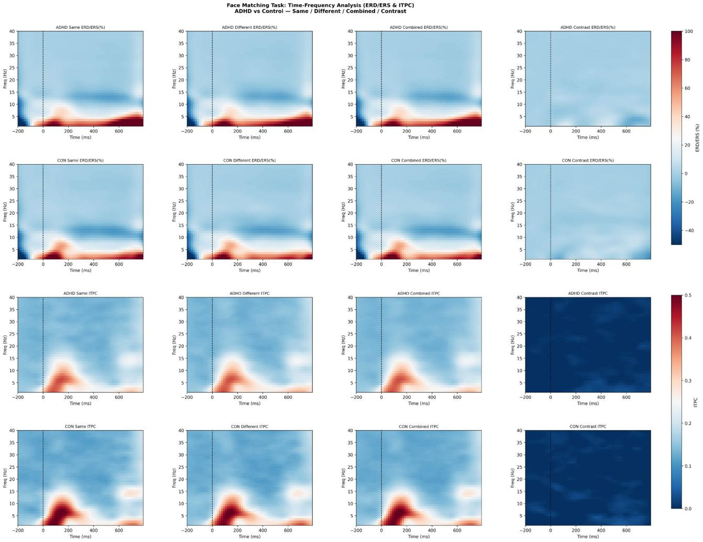

Figure S7. Overview of time-frequency analysis (ERD/ERS% and ITPC, 4 conditions × 2 groups). Warm colors: synchronized enhancement; cool colors: desynchronization (ERD/ERS). Higher values indicate stronger phase locking (ITPC). Morlet wavelet, 1-40 Hz, time range −200 to 800 ms.

