Supplementary Material
Supplementary Table S1. Imputation sensitivity: MICE versus median imputation
Outcome | Model | Median imputation AUC | MICE AUC | ΔAUC (MICE − median)
mRS (90-day mRS > 2) | Clinical-only | 0.866 | 0.868 | +0.002
mRS (90-day mRS > 2) | Clinical + radiomics | 0.872 | 0.868 | −0.004
All-cause mortality | Clinical-only | 0.795 | 0.792 | −0.002
All-cause mortality | Clinical + radiomics | 0.771 | 0.770 | −0.001
All AUCs are from grouped nested 5×5 cross-validation with GroupKFold by patient. MICE used chained equations (IterativeImputer, 10 iterations, five imputed cycles pooled) for continuous and binary clinical variables except midline shift, which was retained as mode-imputed (original missing rate 61.2%); median imputation was applied to the same variables. Absolute ΔAUC was below 0.005 for every model.
Supplementary Table S2. Baseline characteristics
Values are median [IQR] for continuous variables and n (%) for categorical variables. Patients are stratified by 90-day modified Rankin Scale >2 and all-cause mortality. † Midline shift was missing in 61.2% of patients and mode-imputed as 0 for modelling; its distribution is not shown.
Variable | mRS ≤2 (n=360) | mRS >2 (n=210) | Alive (n=368) | Dead (n=202)
Age (years) | 67.0 [58.0–76.0] | 73.0 [62.0–81.8] | 65.0 [57.0–74.0] | 76.0 [68.0–83.0]
NIHSS | 3.0 [1.0–6.0] | 13.0 [9.0–18.0] | 4.0 [1.0–9.0] | 10.0 [4.0–17.0]
GCS | 15.0 [15.0–15.0] | 15.0 [11.0–15.0] | 15.0 [15.0–15.0] | 15.0 [12.0–15.0]
Haematoma volume (mL) | 6.3 [2.2–13.3] | 12.3 [5.6–24.1] | 7.2 [2.8–14.6] | 10.2 [4.3–24.0]
WBC (×10⁹/L) | 7.2 [6.0–9.4] | 8.3 [6.4–10.9] | 7.2 [6.1–9.4] | 8.7 [6.2–10.9]
Hemoglobin (g/L) | 136.0 [127.0–147.2] | 136.0 [123.0–147.0] | 138.0 [129.0–149.0] | 132.0 [121.0–143.0]
Platelet (×10⁹/L) | 203.5 [169.8–236.2] | 201.0 [159.5–252.5] | 206.5 [172.0–238.0] | 194.0 [154.0–250.5]
Albumin (g/L) | 40.2 [37.9–42.7] | 40.4 [37.6–42.4] | 40.9 [38.3–43.0] | 39.2 [37.1–41.5]
Glucose (mmol/L) | 7.0 [6.0–8.7] | 7.4 [6.3–9.2] | 7.0 [6.0–8.9] | 7.5 [6.2–9.0]
Creatinine (µmol/L) | 70.0 [62.0–82.0] | 69.0 [61.0–82.0] | 70.0 [62.0–82.0] | 68.0 [62.0–80.5]
Uric acid (µmol/L) | 312.0 [257.0–375.0] | 296.5 [247.2–351.0] | 315.0 [257.0–374.0] | 296.0 [247.0–348.0]
Male sex | 234 (65.0) | 120 (57.1) | 225 (61.1) | 129 (63.9)
IVH extension | 70 (19.4) | 79 (37.6) | 79 (21.5) | 70 (34.7)
Midline shift ≥5 mm | —† | —† | —† | —†
Hypertension | 306 (85.0) | 175 (83.3) | 318 (86.4) | 163 (80.7)
Diabetes | 55 (15.3) | 55 (26.2) | 63 (17.1) | 47 (23.3)
Supplementary Table S3. Model performance with 95% confidence intervals (grouped nested 5×5 cross-validation)
AUCs and 95% confidence intervals were derived from out-of-fold predictions under grouped nested 5×5 cross-validation (GroupKFold by patient identifier, LASSO feature selection performed independently within each inner fold). Confidence intervals are bootstrap percentile estimates (2,000 resamples) computed on the out-of-fold prediction vectors.
Model | mRS >2 AUC (95% CI) | Mortality AUC (95% CI)
Clinical-only | 0.866 (0.836–0.897) | 0.795 (0.757–0.831)
Radiomics-only | 0.558 (0.510–0.606) | 0.616 (0.570–0.669)
Clinical + radiomics | 0.872 (0.840–0.902) | 0.771 (0.733–0.810)
Demographics + radiomics | 0.583 (0.535–0.630) | 0.702 (0.660–0.747)
The clinical+radiomics model did not significantly improve discrimination over the clinical-only model (DeLong mRS ΔAUC = +0.005, p = 0.805; mortality ΔAUC = −0.024, p = 0.439). Radiomics-only models yielded AUCs of 0.558 (mRS) and 0.616 (mortality).
Supplementary Table S4. Reclassification improvement (category-free NRI and IDI)
Reclassification of the clinical model versus the established scores was assessed with the category-free (continuous) net reclassification improvement (NRI) and the integrated discrimination improvement (IDI). The clinical model probabilities were the grouped nested-CV out-of-fold predictions; the comparator probabilities were derived by fitting a logistic model of the outcome on the published score (ICH Score for mortality, FUNC Score for functional outcome).
Comparison | Outcome | Category-free NRI | IDI
Clinical vs FUNC Score | mRS >2 | +0.141 | +0.141
Clinical vs ICH Score | All-cause mortality | +0.129 | +0.129
The category-free NRI equals the IDI by construction under the Pencina definition; the two metrics coincide to the reported precision.
Supplementary Table S5. Apparent versus honest performance: optimism from feature selection
Model | In-sample apparent AUC | Grouped nested-CV AUC | Optimism (apparent − nested)
mRS outcome (90-day mRS > 2)
Clinical-only | 0.892 | 0.866 | 0.026
Clinical + radiomics | 0.909 | 0.872 | 0.037
Δ (combined − clinical) | +0.017 | +0.006 | +0.011
All-cause mortality
Clinical-only | 0.826 | 0.795 | 0.031
Clinical + radiomics | 0.865 | 0.771 | 0.094
Δ (combined − clinical) | +0.039 | −0.024 | +0.063
In-sample apparent AUC was computed by fitting and evaluating the model on the full cohort; grouped nested-CV AUC used GroupKFold by patient with inner-fold LASSO selection (see Methods). Optimism is the difference between the two. The combined model showed consistently larger optimism than the clinical-only model (0.094 versus 0.031 for mortality).
Supplementary Table S6. Random-seed stability analysis
Random seed | mRS Clinical-only | mRS Clinical + radiomics | Mortality Clinical-only | Mortality Clinical + radiomics
42 (primary) | 0.866 | 0.872 | 0.795 | 0.771
123 | 0.866 | 0.872 | 0.795 | 0.771
456 | 0.866 | 0.872 | 0.795 | 0.771
789 | 0.866 | 0.872 | 0.795 | 0.771
2024 | 0.866 | 0.872 | 0.795 | 0.771
Range (max − min) | 0.000 | 0.000 | 0.000 | 0.000
AUCs are from grouped nested 5×5 cross-validation with GroupKFold by patient. Across all five seeds the AUCs were identical (coefficient of variation = 0), and the LASSO-selected feature sets were unchanged for both outcomes. The reported performance was unchanged across all five seeds, confirming absence of sensitivity to random initialisation in feature selection or fold assignment.
Supplementary Table S7. Temporal (year-based) split validation
The cohort was split by calendar period using the onset year extracted from the admission/onset date: training set 2020–2022 (n = 348) and test set 2023–2024 (n = 220). LASSO feature selection and logistic regression were fitted on the training period and evaluated on the held-out test period. Because the two haemorrhage episodes of a recurrent patient fall in the same calendar year, patient-level leakage is avoided by construction of the temporal split.
Model | mRS >2 test AUC (n_test = 220) | Mortality test AUC (n_test = 220)
Clinical-only | 0.860 | 0.818
Radiomics-only | 0.554 | 0.595
Clinical + radiomics | 0.855 | 0.778
Demographics + radiomics | 0.551 | 0.639
The temporal test AUCs were within 0.01 of the grouped nested-CV estimates (clinical-only 0.866/0.795; combined 0.872/0.771). The combined model's mortality test AUC (0.778) remained below the clinical-only model (0.818), consistent with the primary analysis.
Supplementary Figure S1. Restricted cubic spline plots
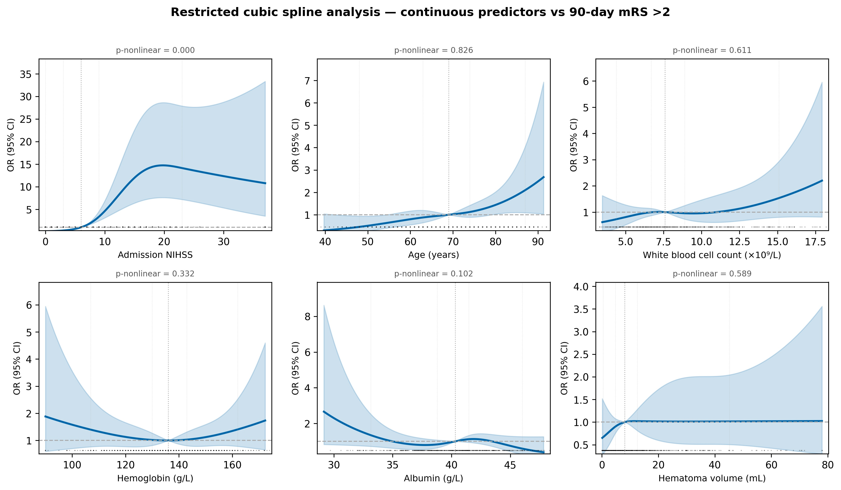
Restricted cubic spline analysis of dose–response relationships between six continuous clinical predictors (age, NIHSS, haematoma volume, white blood cell count, haemoglobin, albumin) and 90-day mRS >2. Splines were fitted with four knots at the 5th, 35th, 65th, and 95th percentiles, adjusted for all other continuous predictors. Solid lines indicate point estimates; shaded areas indicate 95% confidence intervals. GCS was excluded from RCS analysis because 78% of values concentrated at the ceiling (GCS 15), preventing unique knot placement. All associations were approximately linear (|ΔAUC| < 0.04 for each predictor).
Supplementary Figure S2. Temporal validation ROC curves
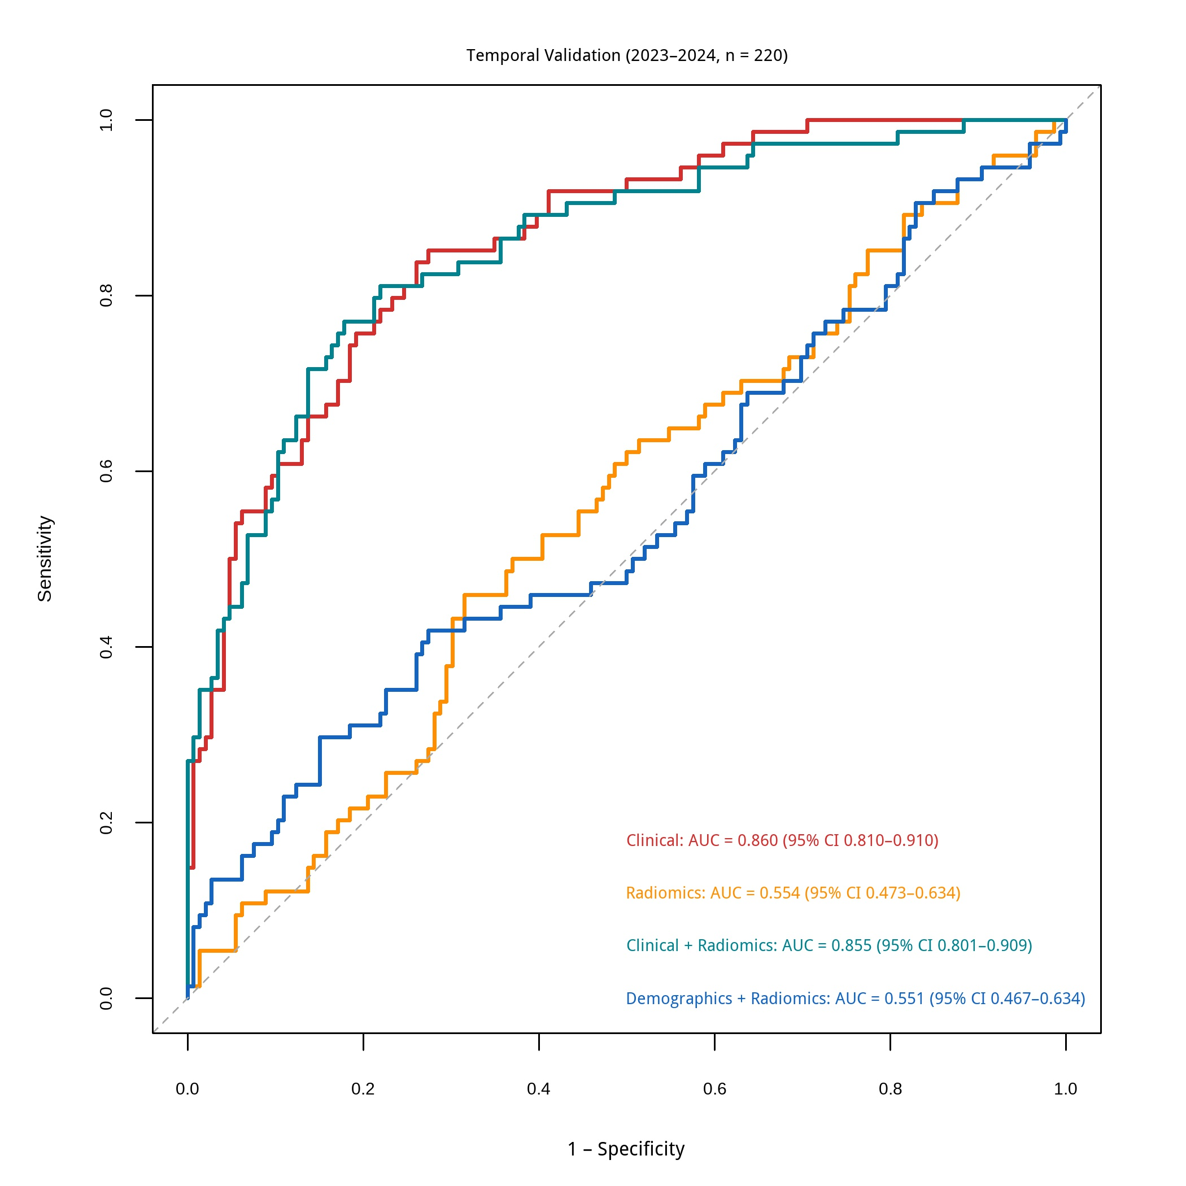
Receiver operating characteristic curves for the clinical-only, radiomics-only, clinical + radiomics, and demographics + radiomics models, evaluated on the temporal test set (2023–2024, n = 220) after training on 2020–2022 data. The clinical-only model yielded AUCs of 0.860 (mRS) and 0.818 (mortality); the combined model yielded 0.855 (mRS) and 0.778 (mortality). The diagonal dashed line indicates chance-level discrimination (AUC = 0.5).

