Appendix
Corrected 2013 CNM SOP Classifications Relative to Markowitz
State | 2013 Markowitz | Corrected 2013 | Reasoning
State | 2013 Markowitz | Corrected 2013 | Reasoning
California | Moderate | Low | CNMs work collaboratively with physicians and administration to perform medical functions and may prescribe drugs and devices under the CNM’s name with physician supervision that does not require a physical presence, with no written CPA required.
Delaware | Low | Moderate | CNMs work collaboratively with physicians under a required written CPA and may prescribe drugs under the CNM’s name.
Florida | High | Moderate | CNMs work under physician supervision determined case by case in the written CPA, without a required on-site presence, with prescriptions ordered under the CNM’s name; the absence of a constant supervision requirement supported the moderate designation.
Illinois | Low | Moderate | CNMs are required to have a written CPA with a physician, which determines the legality of dispensing drugs.
Indiana | Low | Moderate | CNMs are required to have a written CPA for prescriptive authority only, with prescriptions labeled under the CNM’s name.
Kentucky | Low | Moderate | CNMs are required to have a written CPA for prescriptive authority only.
Maryland | Low | No barriers | CNMs have full prescriptive authority and independent practice.
Michigan | Moderate | Low | CNMs do not require supervision or collaboration except for prescriptive authority and are not required to hold CPAs.
New Jersey | Low | Moderate | CNMs are required to maintain written clinical guidelines with a consulting physician.
New York | None | Low | No CPA is required, although CNMs are encouraged to collaborate with a physician.
South Carolina | Moderate | High | The physician’s name must be printed on the CNM’s prescriptions.
South Dakota | Low | High | CNMs require a CPA with a physician and at least twice-monthly direct supervision.
Tennessee | Moderate | High | CNMs require a CPA with a physician, who must sign off on one-fifth of patient charts within 30 days and whose name must appear on prescriptions.
Utah | Low | No barriers | There is no requirement for physician supervision or a collaborative agreement.
Wisconsin | Low | Moderate | A written CPA is required.
Based on the Nurse Practitioner’s 2024 36th Annual Legislative Update, eight states reduced barriers to CNM practice between 2013 and 2024, and no state increased barriers over this period.
CNM SOP Regulatory Changes, 2013–2024, for States That Reduced Barriers
State | 2013 | 2024 | Reasoning
State | 2013 | 2024 | Reasoning
Arkansas | Moderate | Low | Ark. Code § 17-87-315 (2024) grants full practice authority after a second license, following 6,240 hours of practice with a physician.
Delaware | Moderate | No barriers | 24 Del. Admin. Code § 1900 (2016) grants full practice authority to CNMs, removing all CPA requirements.
Georgia | High | Moderate | OCGA § 43-34-25 (2021) reduced required physician review of CNM patient records from every 30 days to every 3 months.
Illinois | Moderate | Low | 225 ILCS 65/65-43 (2019) grants full practice authority following at least 4,000 hours of clinical experience after national certification.
Kansas | Moderate | No barriers | KAR 60-11-104 (2022) removed the requirement for a collaborative practice relationship or written protocol.
North Carolina | Moderate | Low | G.S. 90-178.2 (2023) granted independent practice following 4,000 hours of practice under physician oversight.
South Dakota | High | Low | SDCL § 36-9-3 (2016) removed the CPA requirement following 1,040 hours of professional oversight.
Virginia | Moderate | Low | Va. Code Ann. § 54.1-2957 (2021) removed the CPA requirement following 1,000 hours of professional oversight.

Certified Nurse Midwife (CNM) Scope of Practice (SOP) Regulation Changes from 2013 to 2024 by State
State | 2013 CNM SOP | 2024 CNM SOP | Regulation Change
State | 2013 CNM SOP | 2024 CNM SOP | Regulation Change
Alabama | Mod. barriers | Mod. barriers | None
Alaska | No barriers | No barriers | None
Arizona | No barriers | No barriers | None
Arkansas | Mod. barriers | Low barriers | Decreased
California | Low barriers | Low barriers | None
Colorado | No barriers | No barriers | None
Connecticut | Low barriers | Low barriers | None
Delaware | Mod. barriers | No barriers | Decreased
Florida | Mod. barriers | Mod. barriers | None
Georgia | High barriers | Mod. barriers | Decreased
Hawaii | No barriers | No barriers | None
Idaho | No barriers | No barriers | None
Illinois | Mod. barriers | Low barriers | Decreased
Indiana | Mod. barriers | Mod. barriers | None
Iowa | No barriers | No barriers | None
Kansas | Mod. barriers | No barriers | Decreased
Kentucky | Mod. barriers | Mod. barriers | None
Louisiana | Mod. barriers | Mod. barriers | None
Maine | No barriers | No barriers | None
Maryland | No barriers | No barriers | None
Massachusetts | No barriers | No barriers | None
Michigan | Low barriers | Low barriers | None
Minnesota | No barriers | No barriers | None
Mississippi | Mod. barriers | Mod. barriers | None
Missouri | Mod. barriers | Mod. barriers | None
Montana | No barriers | No barriers | None
Nebraska | Mod. barriers | Mod. barriers | None
Nevada | Low barriers | Low barriers | None
New Hampshire | No barriers | No barriers | None
New Jersey | Mod. barriers | Mod. barriers | None
New Mexico | No barriers | No barriers | None
New York | No barriers | No barriers | None
North Carolina | Mod. barriers | Low barriers | Decreased
North Dakota | No barriers | No barriers | None
Ohio | Mod. barriers | Mod. barriers | None
Oklahoma | Mod. barriers | Mod. barriers | None
Oregon | No barriers | No barriers | None
Pennsylvania | Mod. barriers | Mod. barriers | None
Rhode Island | No barriers | No barriers | None
South Carolina | High barriers | High barriers | None
South Dakota | High barriers | Low barriers | Decreased
Tennessee | Mod. barriers | Mod. barriers | None
Texas | Mod. barriers | Mod. barriers | None
Utah | No barriers | No barriers | None
Vermont | No barriers | No barriers | None
Virginia | Mod. barriers | Low barriers | Decreased
Washington | No barriers | No barriers | None
West Virginia | Mod. barriers | Mod. barriers | None
Wisconsin | Mod. barriers | Mod. barriers | None
Wyoming | No barriers | No barriers | None
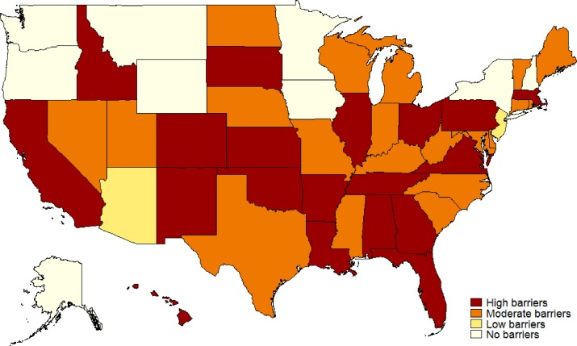  Note: This figure is reproduced with permission from (Markowitz et al. 2017) |  | 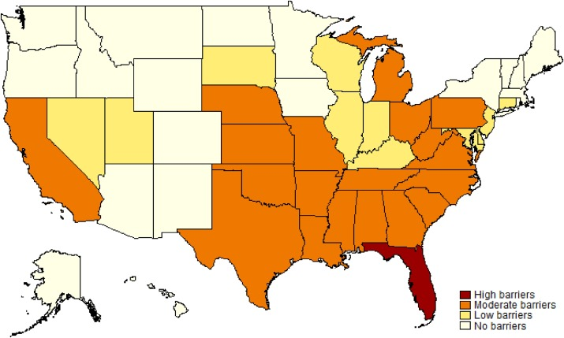  Note: This figure is reproduced with permission of (Markowitz et al. 2017)
Previous Regulatory Burden Scores
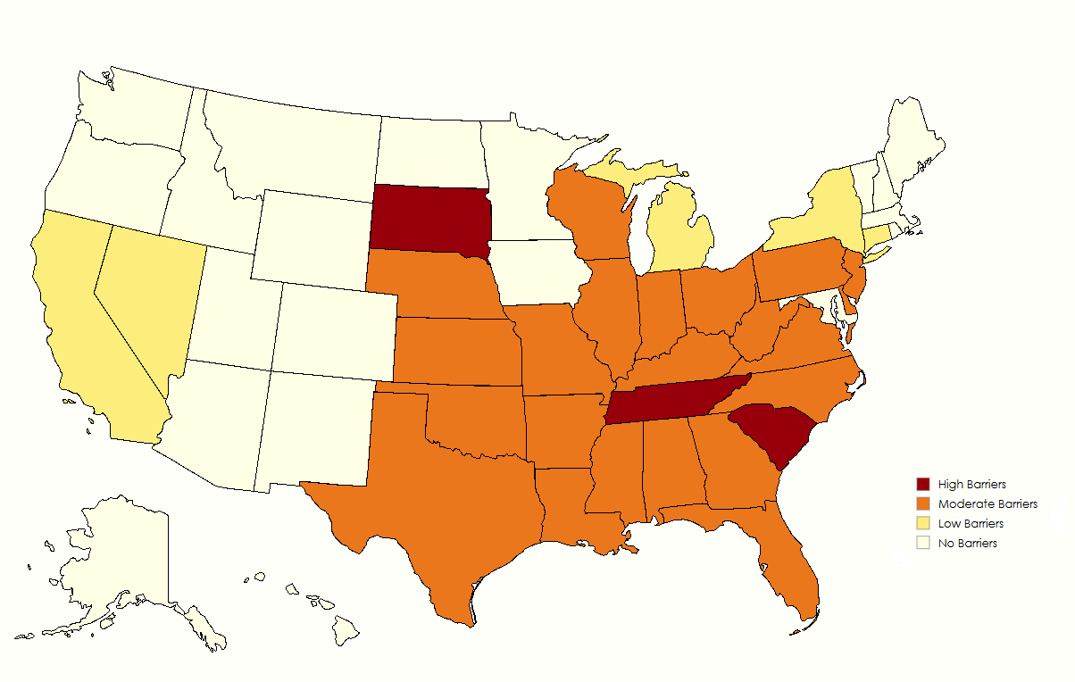  Note: This figure reflects the update of rules and regulations to the expanded definitions. | 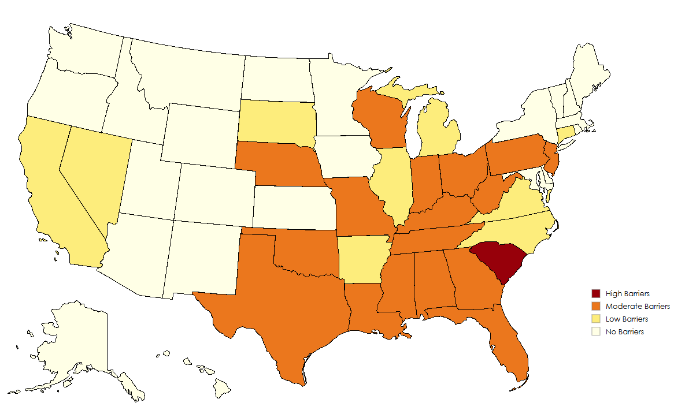  Note: This figure represents the 2024 regulatory landscape for certified nurse midwives.
New Regulatory Burden Scores

