Supplementary Information
Figures
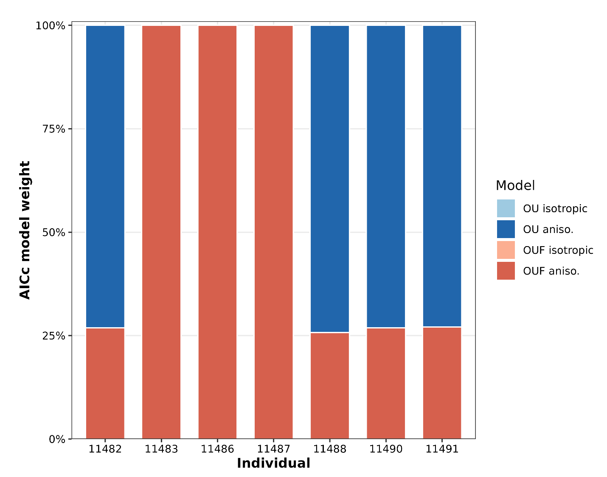
Figure S1: AICc model weight for each candidate continuous-time movement model per individual hirola.

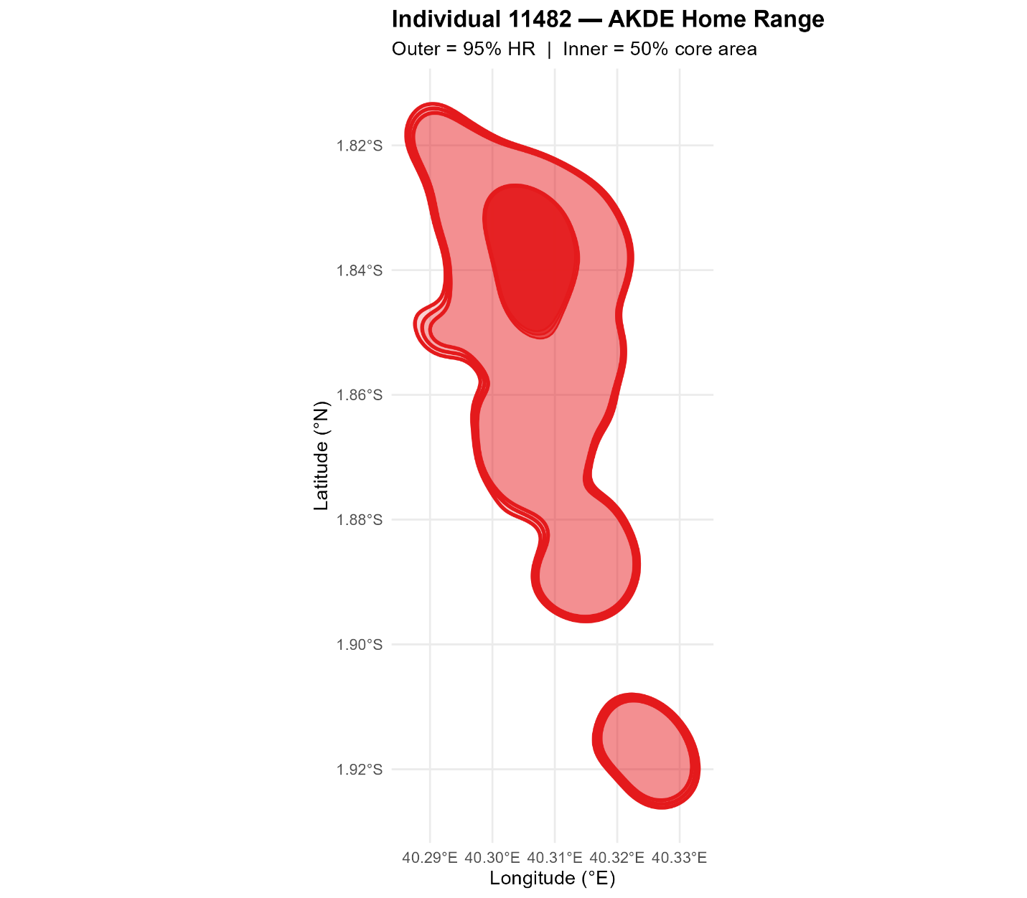
Figure S2: AKDE HR for individual 11482

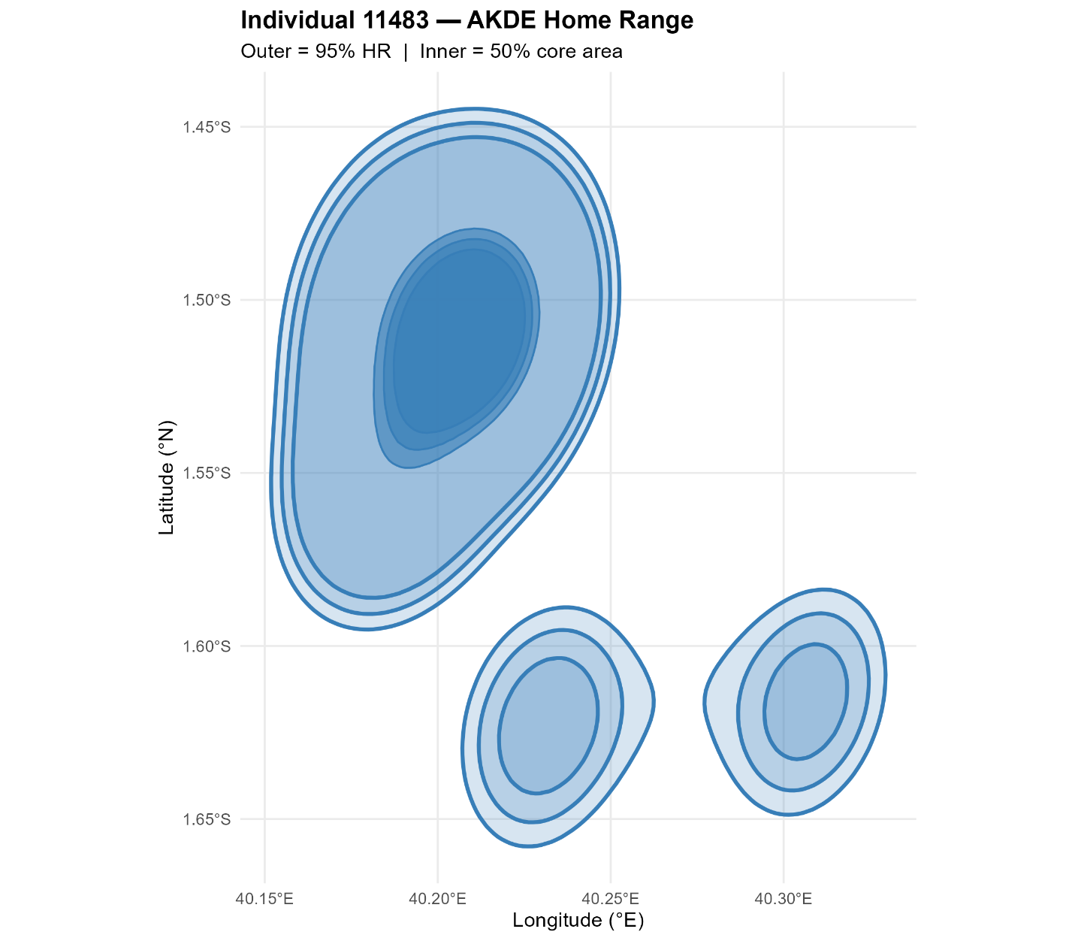
Figure S3: AKDE HR for individual 11483

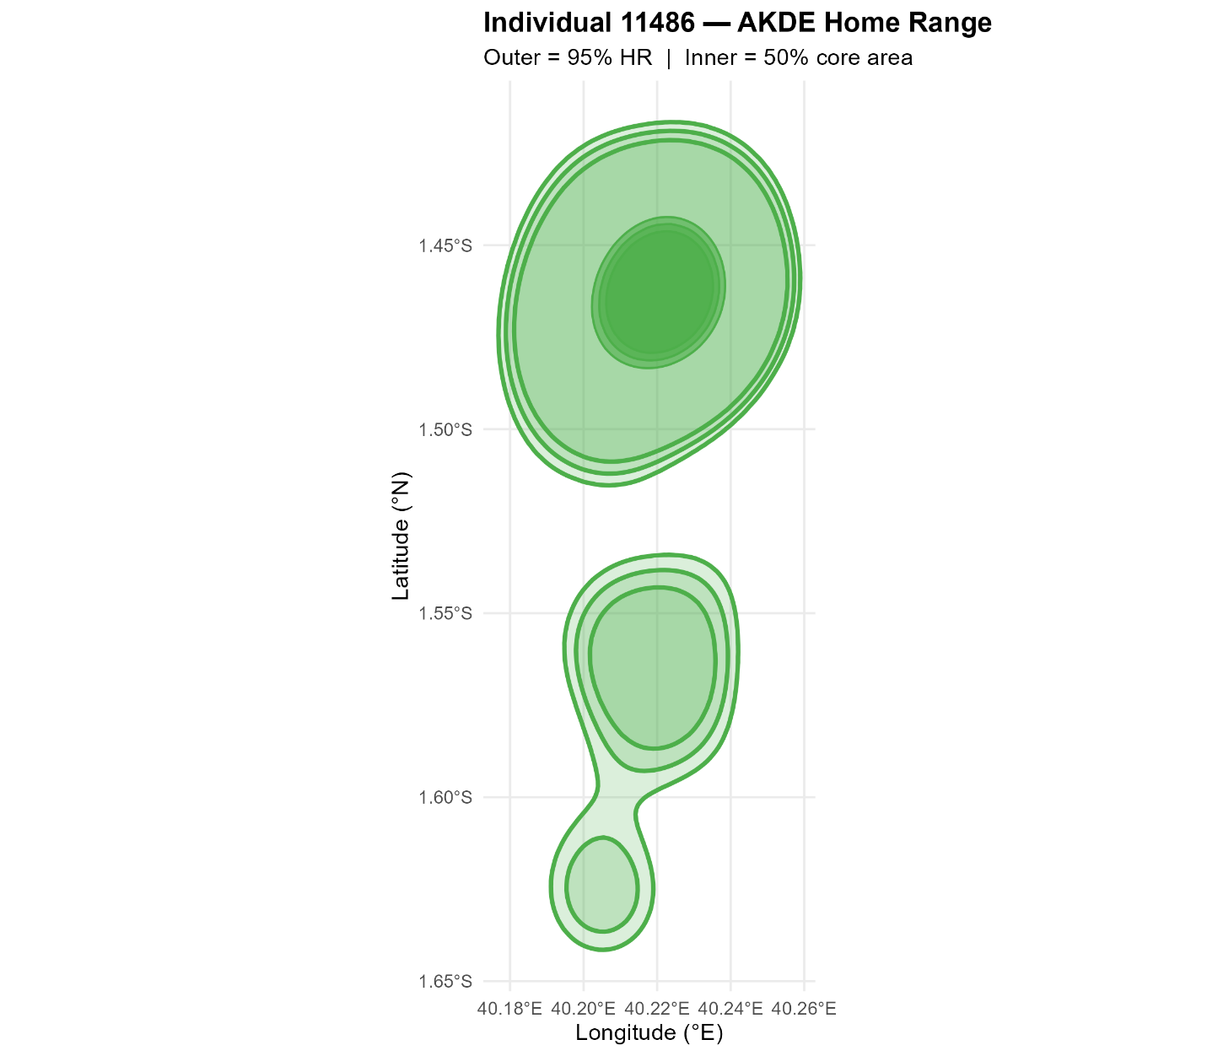
Figure S4: AKDE HR for individual 11486

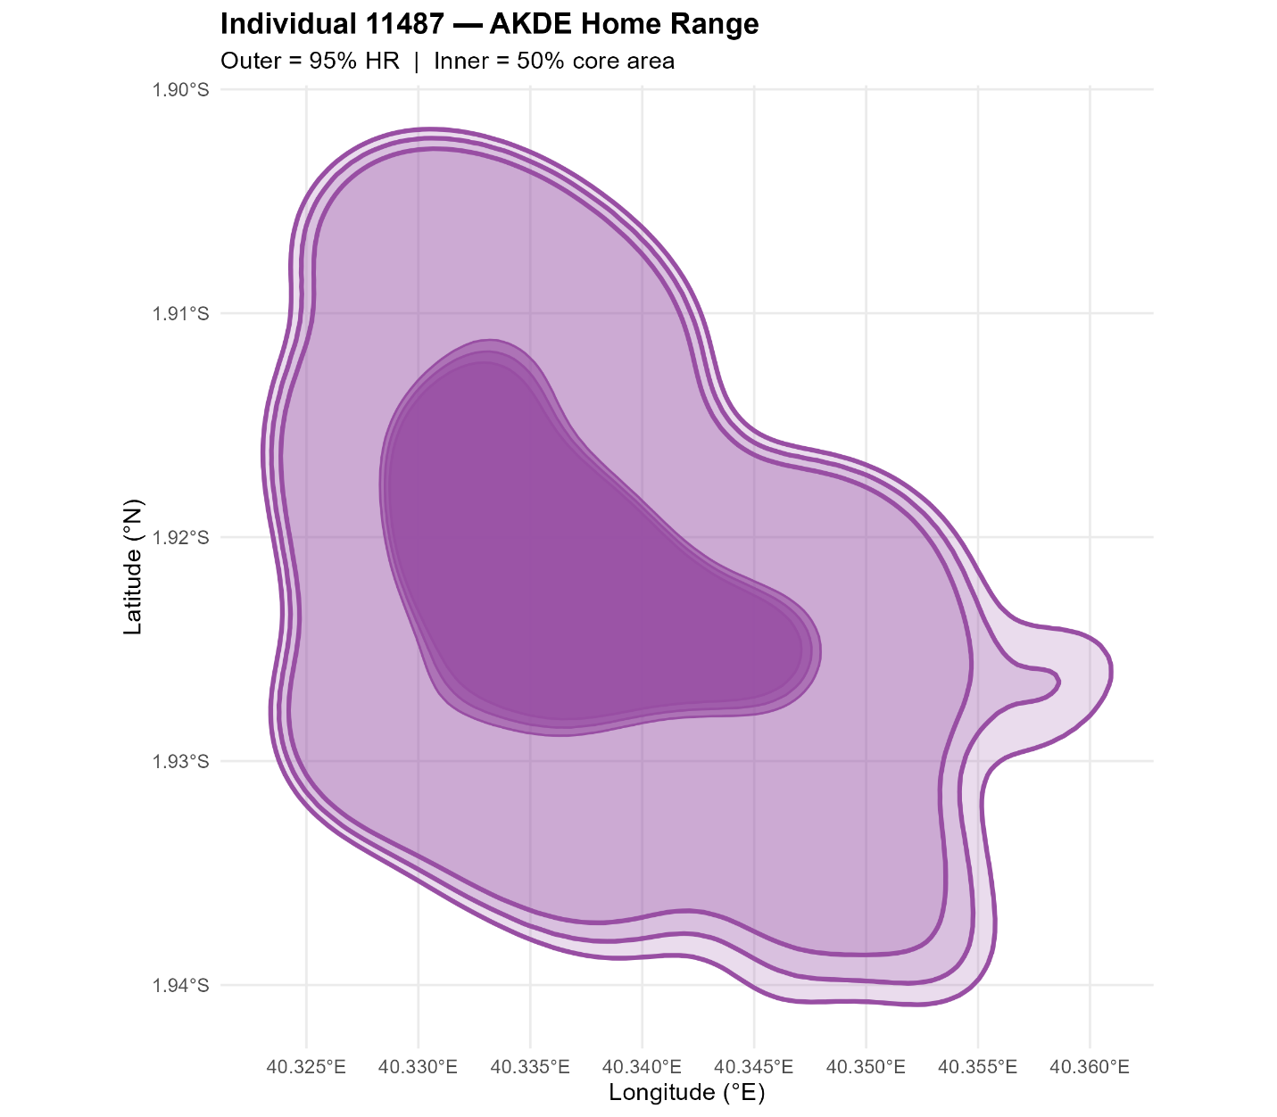
Figure S5: AKDE HR for individual 11487

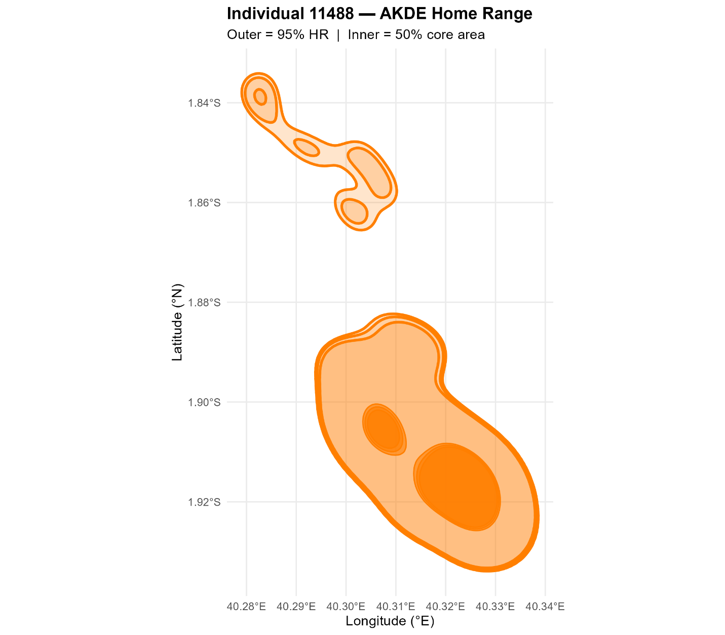
Figure S6: AKDE HR for individual 11488

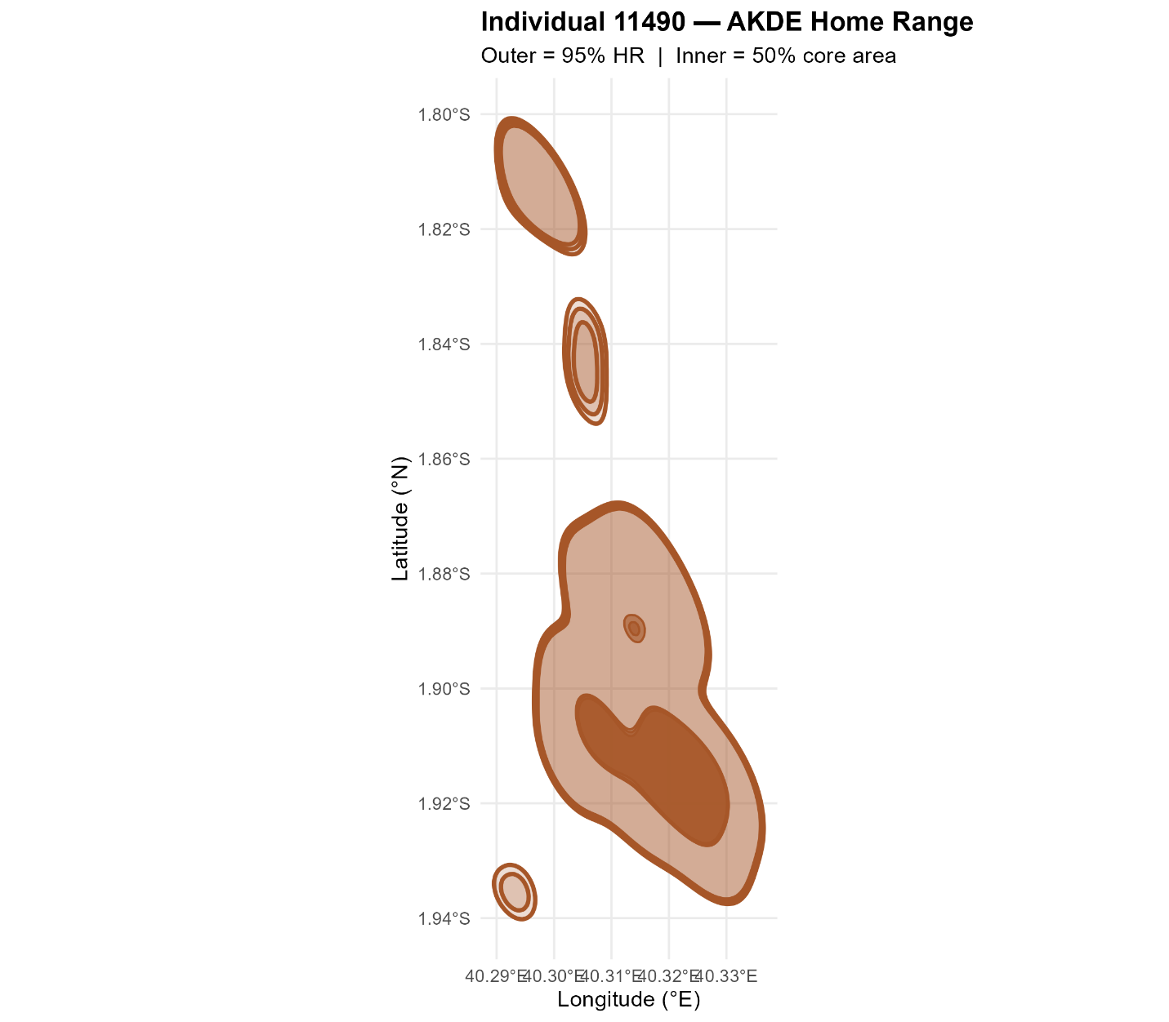
Figure S7: AKDE HR for individual 11490

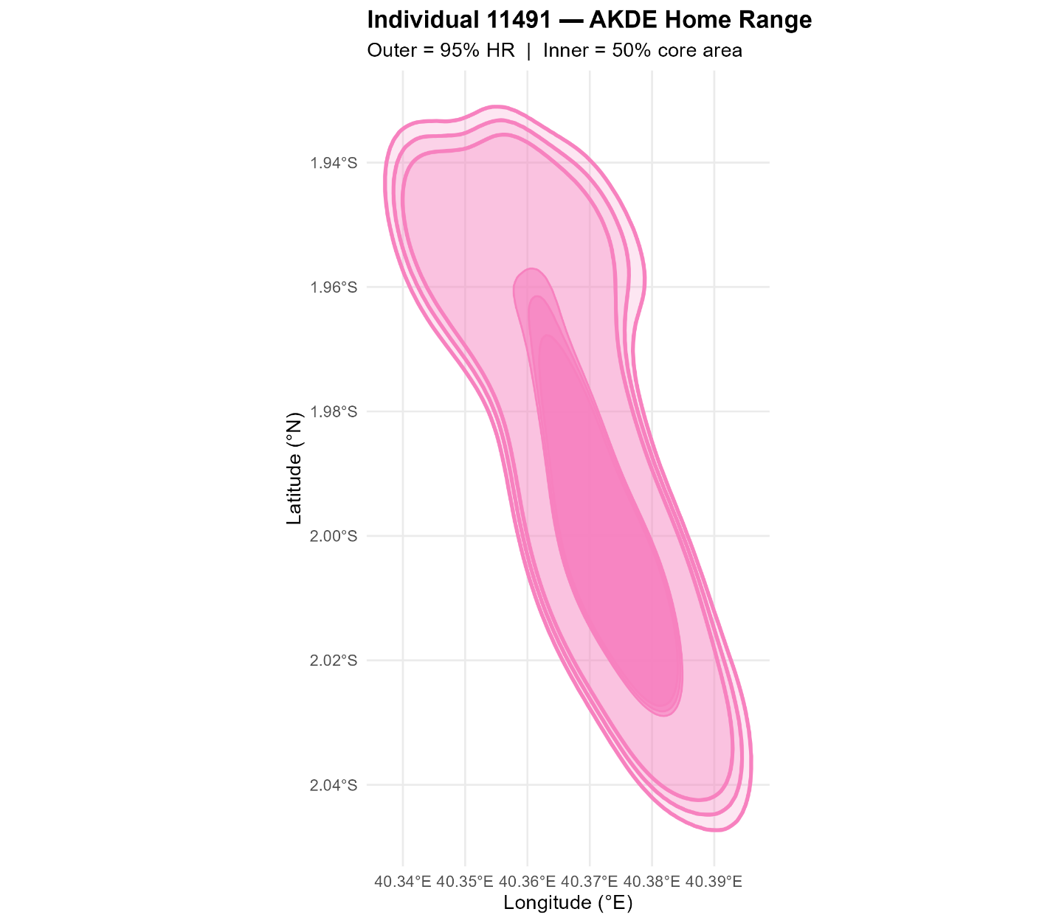
Figure S8: AKDE HR for individual 11491

Tables
Table S1: Summary statistics for sampling gaps
Individual | n fixes | Median min | Mean min | Min min | Max min | n gaps over 2x | n gaps over 60 | n gaps over 120 | Pct gaps over 60
11482 | 23051 | 60 | 60.4 | 3.5 | 1140.5 | 65 | 10601 | 65 | 46
11483 | 20187 | 60 | 60.5 | 56.2 | 5220.5 | 36 | 8711 | 36 | 43.2
11486 | 20204 | 60 | 60.5 | 3.4 | 5280 | 22 | 8686 | 22 | 43
11487 | 23054 | 60 | 60.4 | 57.1 | 1139.9 | 55 | 10564 | 55 | 45.8
11488 | 9408 | 60 | 60.4 | 57.4 | 1140.5 | 18 | 4116 | 18 | 43.8
11490 | 20111 | 60 | 60.5 | 57.3 | 1860 | 50 | 9000 | 50 | 44.8
11491 | 18969 | 60 | 63.5 | 6.3 | 6120.1 | 109 | 8765 | 109 | 46.2

Table S2: Four-season AKDE estimates.
id | season | Area (km²)
11482 | JFM | 94.23841
11482 | AMJ | 28.78876
11482 | JAS | 40.84289
11482 | OND | 86.08901
11483 | JFM | 1859.623
11483 | AMJ | 36.20222
11483 | JAS | 111.5027
11483 | OND | 130.1976
11486 | JFM | 643.2299
11486 | AMJ | 76.99121
11486 | JAS | 43.49091
11486 | OND | 316.8648
11487 | JFM | 29.93323
11487 | AMJ | 31.60121
11487 | JAS | 24.15034
11487 | OND | 49.93277
11488 | JFM | 104.8438
11488 | AMJ | 58.14767
11488 | JAS | 19.67425
11488 | OND | 136.5998
11490 | JFM | 86.53454
11490 | AMJ | 34.05513
11490 | JAS | 19.86511
11490 | OND | 150.6641
11491 | JFM | 155.1034
11491 | AMJ | 39.63767
11491 | JAS | 35.76873
11491 | OND | 299.2541

