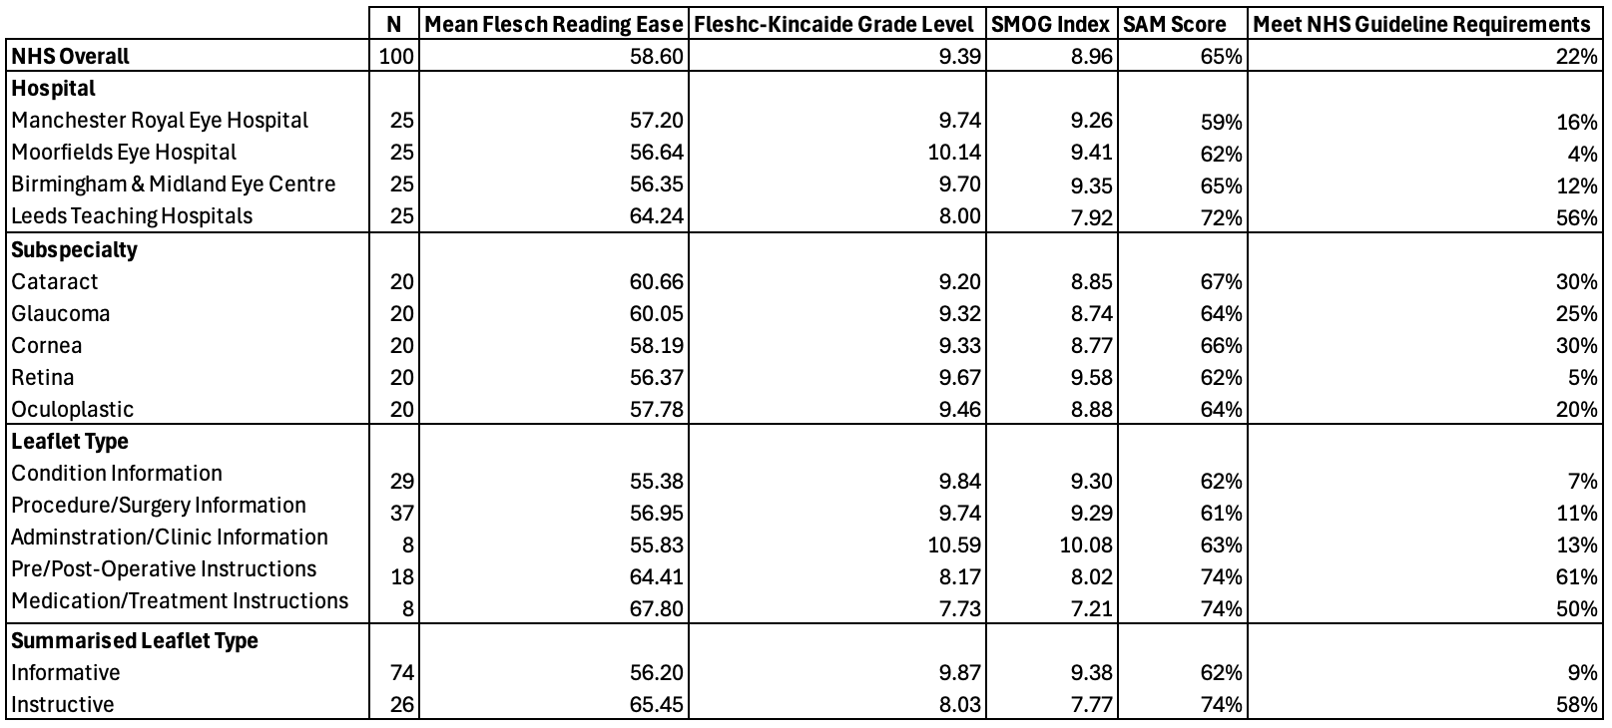
Table 1: Readability scores for Hospital Institutions, Subspecialties and Leaflet Types. Table shows the percentage of categories meeting the NHS guidelines requirements for reading grade level (age 11-14 years old).

