Supplementary Information
for
Direct co-reduction of natural minerals into multicomponent alloys

David J. Jarvis¹ & Lucía Doyle¹
¹ Universidad Alfonso X el Sabio (UAX), Madrid, Spain
email: djarvis@uax.es

Supplementary Note 1 – Visual observation (qualitative only)
Direct, visual observation has been made of the moment the chemical redox reaction is triggered. This was done by visually observing the pellets through a glass viewing port and watching the aluminothermic reaction with dark welder's goggles. The reaction takes place within ≈ 2 seconds and all pellets can be seen to become liquified and move under gravity to fill the bottom of the crucible mould. This reacted molten mass then further separates into two distinct layers of molten slag on the top and molten alloy underneath.
Attempts were made to video this part of the process, but because of the brightness of the reaction, the CCD detector even with a filter, is easily flooded and no videos are available at present. Instead, we are now planning in-situ experiments at ESRF in Grenoble to ‘visualise’ the gravitational separation more quantitatively using synchrotron X-rays.

Supplementary Note 2 - Analysis of phase fractions for GEO-ALLOYS using image processing
Given that the different phases represent different pixel intensities in SEM micrographs, threshold-based segmentation was used to calculate the percentage of porosity as well as the different constituent phases, using Fiji/ImageJ¹. The process involves converting the SEM micrographs into 8-bit images, introducing the image scale, and thresholding. The original as well as the segmented images are shown in Supplementary Figs. 1-3 below. The segmented phase was then quantified as % area, compiled in Supplementary Table 1.
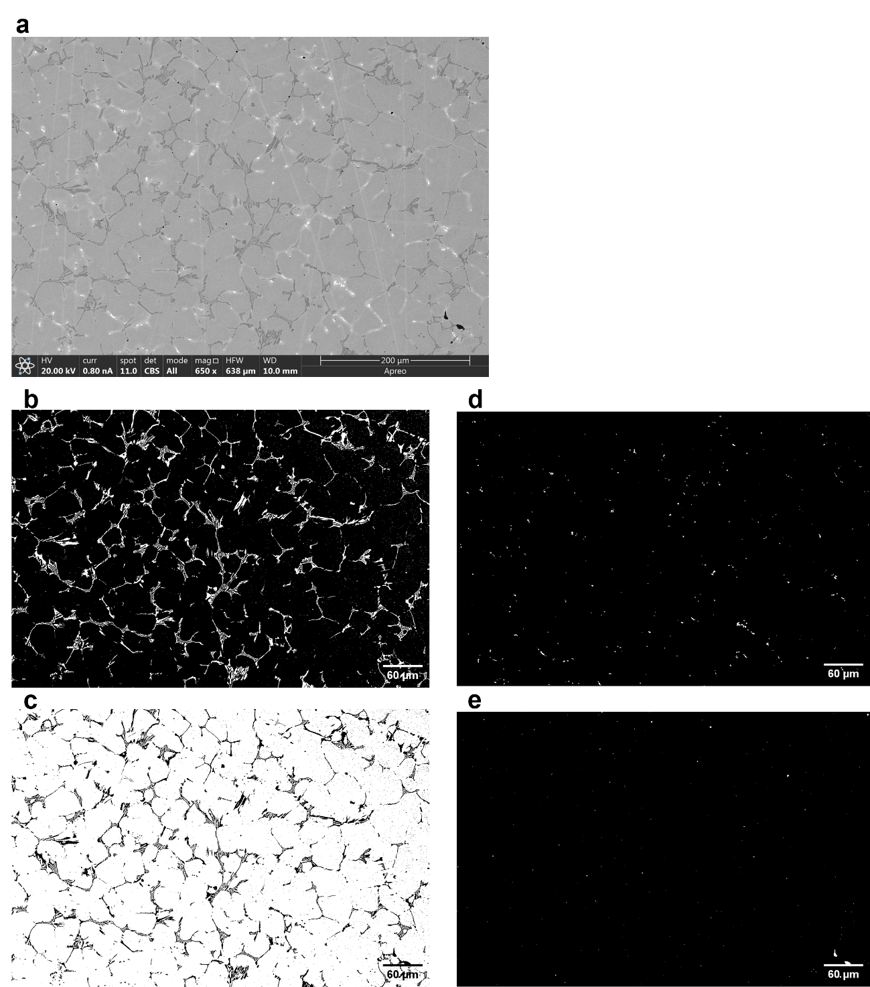

Supplementary Fig. 1 | Micrograph segmentation for GEO3p. a, Original SEM micrograph. b, Segmented dark phase, which corresponds to the Cr-rich BCC part of the eutectic (see also EDS map in Extended Data Fig. 1a). c, Segmented light phase, which corresponds to the primary FCC dendrites + the Ni-rich part of the eutectic (see also EDS map in Extended Data Fig. 1a). d, Segmentation of the bright tungsten-rich “florets” (see also EDS map in Extended Data Fig. 1a). e, Thresholded pores. The segmented and quantified phases are represented in white for each case.
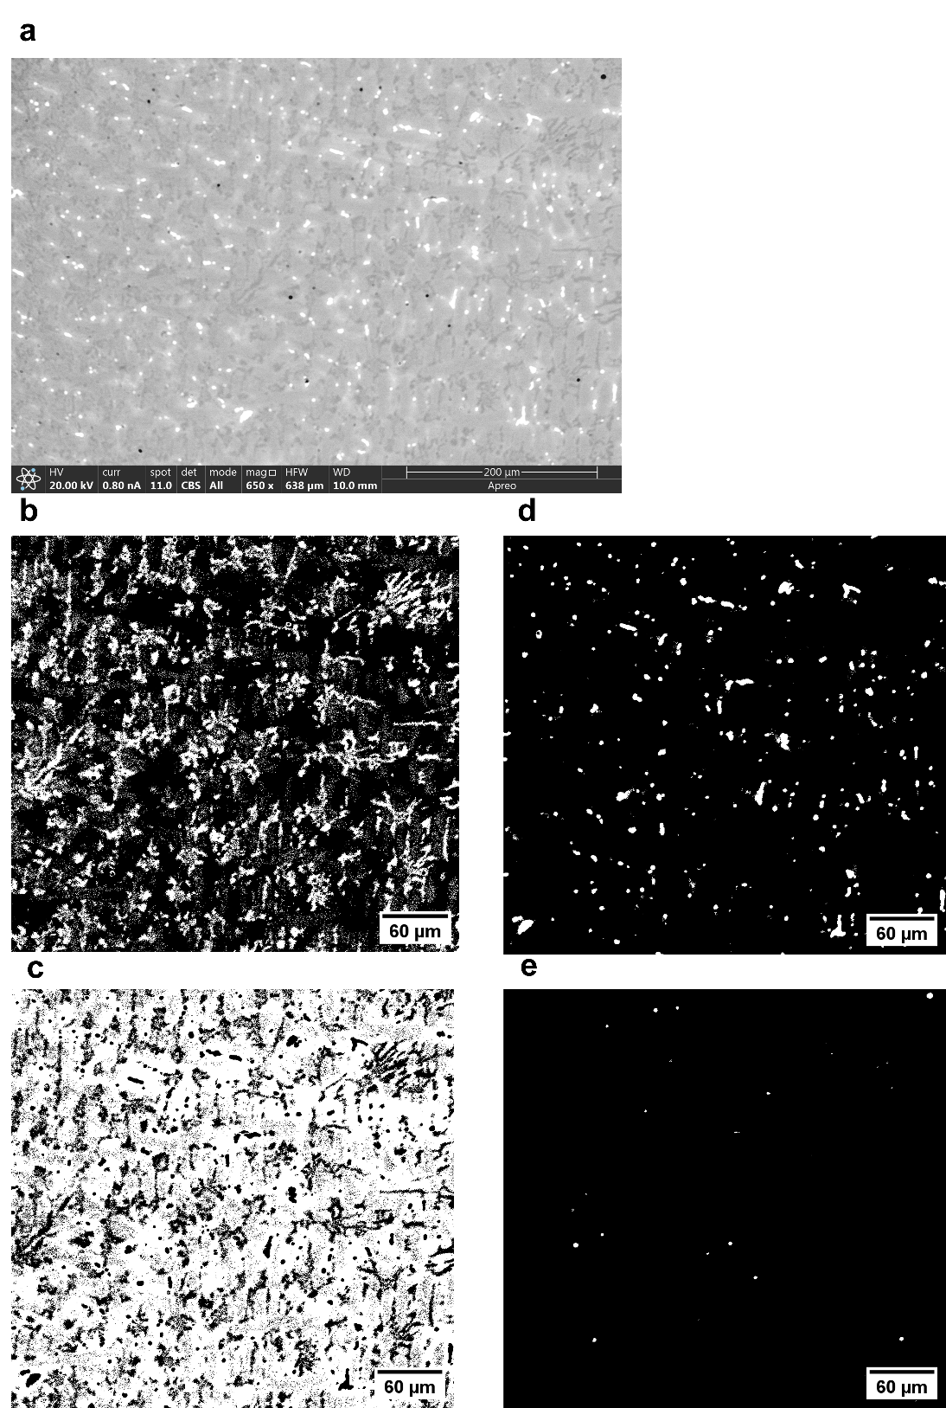

Supplementary Fig. 2 | Micrograph segmentation for GEO3q. a, Original SEM micrograph. b, Segmented dark phase, which corresponds to the Cr-rich BCC part of the eutectic (see also EDS map in Extended Data Fig. 1b). c, Segmented light phase, which corresponds to the primary FCC dendrites + the Ni-rich part of the eutectic (see also EDS map in Extended Data Fig. 1b). d, Segmentation of the bright tungsten-rich “florets” (see also EDS map in Extended Data Fig. 1b). e, Segmented pores. The segmented and quantified phases are represented in white for each case.

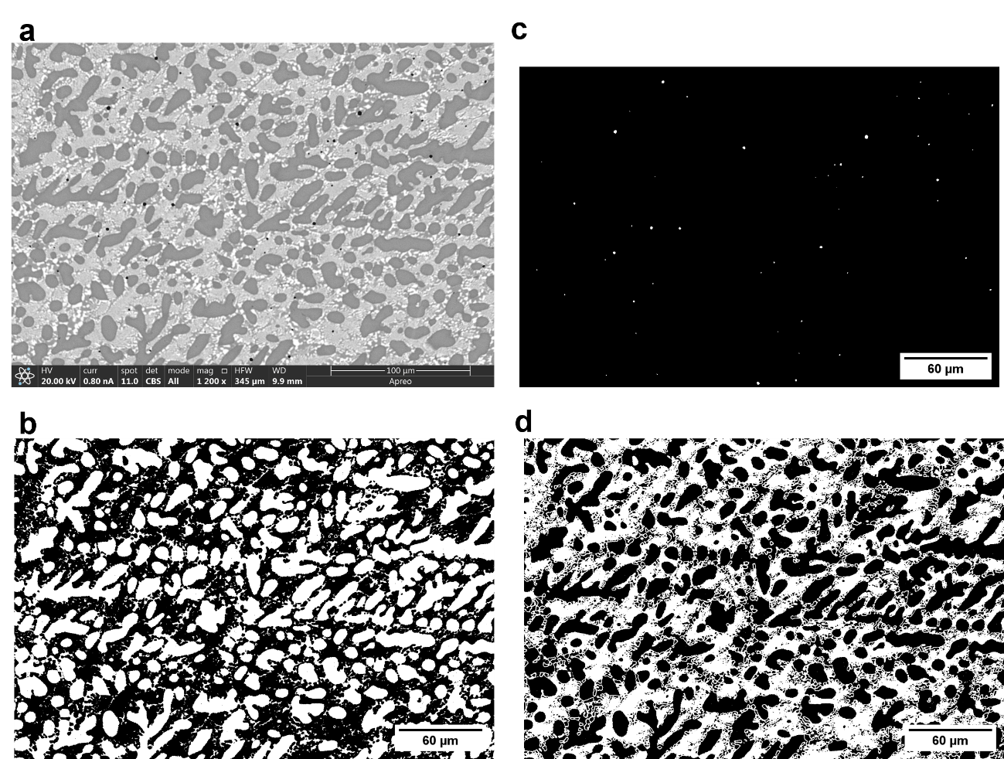

Supplementary Fig. 3 | Micrograph segmentation for GEO4. a, Original SEM micrograph. b, Segmented dark phase, which corresponds to the Ni-rich B2 primary dendrites (see also EDS map in Extended Data Fig. 1c). c, Segmented pores. d, Segmented light phase, which corresponds to the FCC-C14 eutectic phase (see also EDS map in Extended Data Fig. 1c). The segmented and quantified phases are represented in white for each case.

Supplementary Table 1 | Comparison of phase fractions for the three GEO-ALLOYS, in area %, obtained from image segmentation based on Fiji/ImageJ software processing.

 | Eutectic  phase  (%) | Primary dendrites  (%) | Tungsten ‘florets’  (%) | Porosity  (%)
GEO3p | 6.69 | 92.97 | 0.27 | 0.07
GEO3q | 20.40 | 77.37 | 2.16 | 0.06
GEO4 | 52.80 | 47.12 | n/a | 0.08

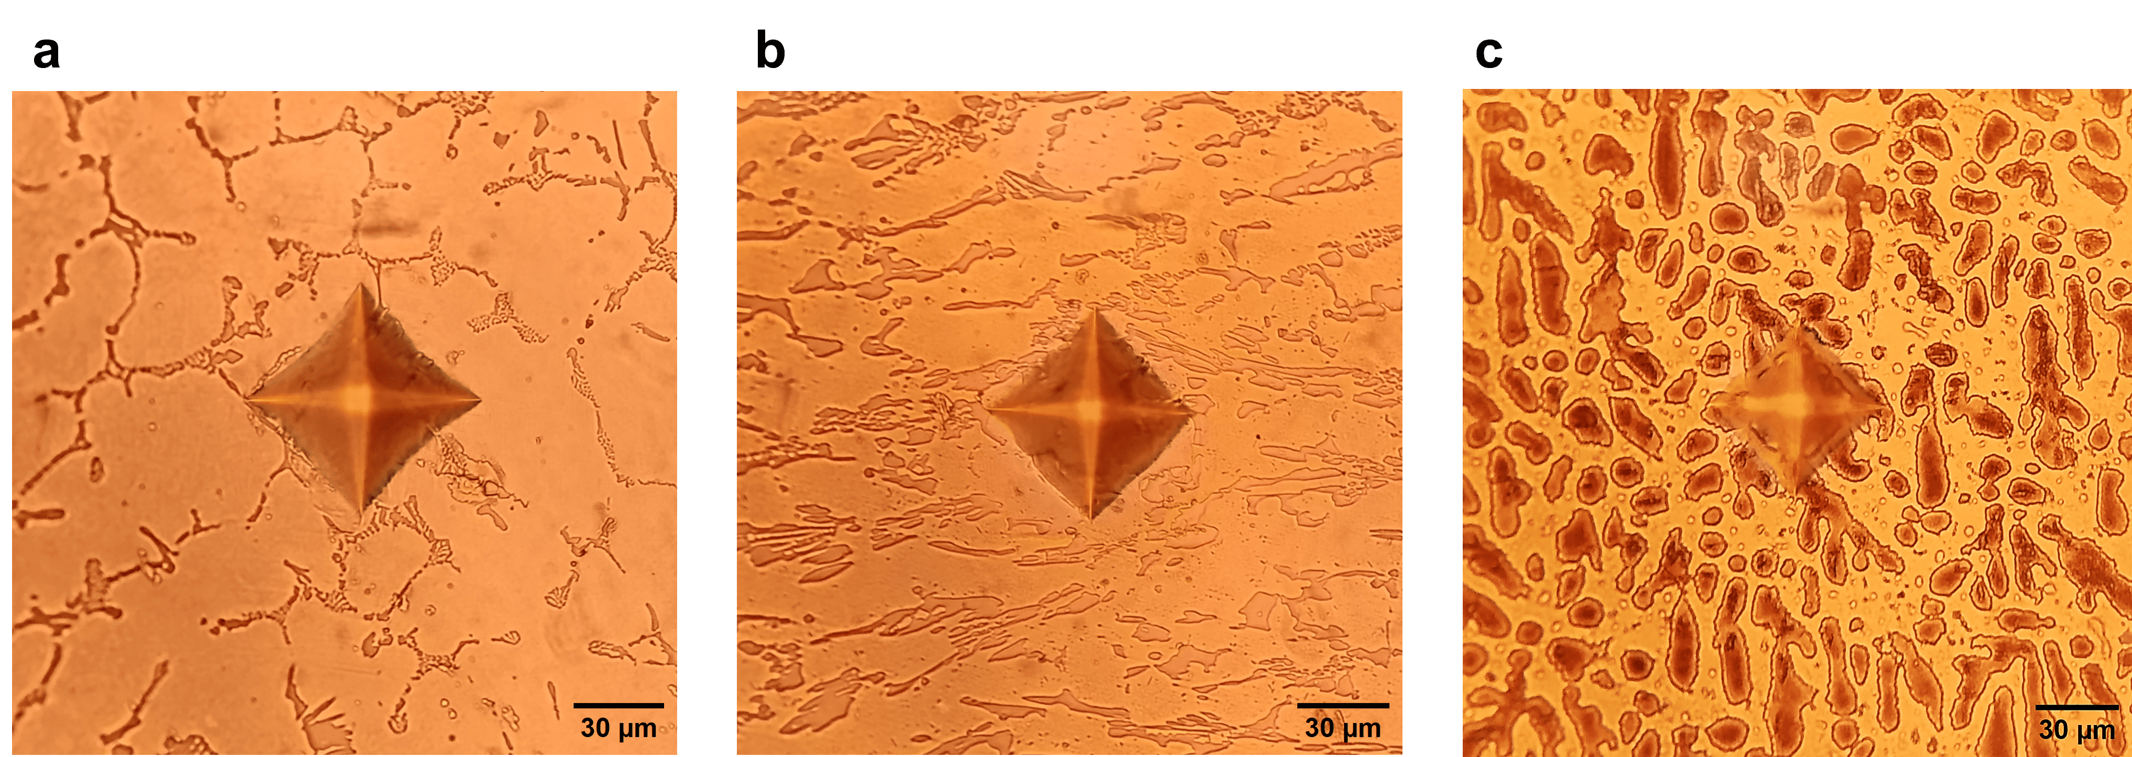
Supplementary Fig. 4 | Representative Vickers indents for the GEO-ALLOYS. a, Vickers indent for GEO3p. b, Vickers indent for GEO3q. c, Vickers indent for GEO4. Over 10 indents were made using a 1 kg loading. N.B. No corner cracks were observed.

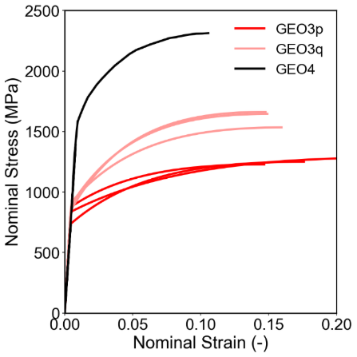
Supplementary Fig. 5 | Comparative stress-strain curves of GEO-ALLOYS (GEO3p, GEO3q and GEO4) for all PIP testing. N.B. The GEO3p and GEO3q samples both had 3 PIP indents, while GEO4 only had one indent due to space limitations on the sample surface.

Supplementary Note 3 - Comparison between GEO-ALLOYS and conventional commercial alloys.

Supplementary Table 2 | Comparison of mechanical properties between our GEO-ALLOYS and a variety of conventional, high-performance, commercial alloys (namely, Ti64, IN625, IN718, Stellite 6, MAR-M-247 and HAYNES 556).

Alloy | Class | Condition (Spec) | Yield Strength (MPa) | UTS  (MPa) | Elongation  (%) | Hardness  (HV)
Ti64 | Lightweight titanium | As-cast  (ASTM B367) | 860-965 | 930-1030 | 6-9 | 340-370
IN625 | Nickel superalloy | As-cast  (AMS 5402) | 275-345 | 550-655 | 25-40 | 360-460
IN718 | Nickel superalloy | As-cast  (AMS 5383) | 310-415 | 515-655 | 10-20 | 200-250
IN718 | Nickel superalloy | Cast and HT  (AMS 5383) | 760-860 | 960-1150 | 5-12 | 360-450
Stellite 6 | Cobalt-chromium alloy | As-cast (AMS 5387) | 660-700 | 790-850 | <1 | 380-450
MAR-M-247 | Nickel superalloy | As-cast  (EMS 55447 min) | 725 | 966 | 3 | 360-400
HAYNES 556 | Fe-Ni-Cr-Co superalloy | As-welded  (AMS 5831 min) | 380 | 720 | 35 | 320-350
GEO3p | GEO-ALLOYS | As-cast | 814 ± 75 | 1254 ± 28 | 19 ± 4 | 328.9±14.4
GEO3q | GEO-ALLOYS | Cast and HT | 883 ± 33 | 1614 ± 70 | 15 ± 0.6 | 446.4±4.7
GEO4 | GEO-ALLOYS | As-cast | 1616 | 2315 | 11 | 580.8±6.3

Another very interesting outcome of our alloy development, via the GEO-ALLOY synthesis route, is that ‘in-between’ alloys can be designed and processed. Nickel casting alloys like MAR-M-247 can be combined with multicomponent Fe-based alloys like Haynes 556 to give new classes of alloys that are not only castable but also heat-treatable (see Supplementary Table 2). For example, our alloy GEO3 alloy composition in wt% sits almost exactly halfway between the commercial MAR-M-247 and Haynes 556 alloys.

While MAR-M-247 is a strong but brittle casting superalloy and Haynes 556 is a highly ductile, corrosion-resistant, wrought, multi-principal alloy, the GEO3 alloy, which lies halfway in between, appears to offer some unique metallurgical synergies. The GEO3p and GEO3q data show a mechanical property profile far above MAR-M-247 and Haynes 556 individually. This GEO3 ‘hybrid’ alloy has the potential to combine high-mechanical strength, creep and corrosion resistance, with high ductility – of high relevance to steam power plants, gasifiers, combustion hardware, turbochargers and waste incinerators.

Supplementary Note 4 - Entropy calculations
With respect to entropy, the GEO3 alloy has a configurational entropy S_{conf} of about 12.0 J/mol•K or 1.44R; and the GEO4 alloy has a configurational entropy of about 14.6 J/mol•K or 1.75R, according to the Boltzmann entropy equation below and the at% data from Extended Data Table 2). This shows that both alloys are considered to have ‘medium-to-high entropy’.

$$S_{conf}= -R\sum_{i=1}^{n}{x_{i}}ln(x_{i})$$

Supplementary Note 5 - Radioactivity testing

From a health and safety perspective, it is important to ensure that the minerals and alloys do not contain any radioactive elements (e.g. U, Th). This has been duly tested in the laboratory using a Geiger-Müller counter tube (see Methods section and Supplementary Fig. 6 below) and found to be non-problematic. No ionising radiation above normal background radiation (0.05 mSv/h) was detected, and this is further corroborated by the EDS data in Extended Data Fig. 1/Table 2 that also show no elemental pick-up of natural thorium, uranium or potassium isotopes (namely ²³²Th, ²³⁵U, ²³⁸U and ⁴⁰K).

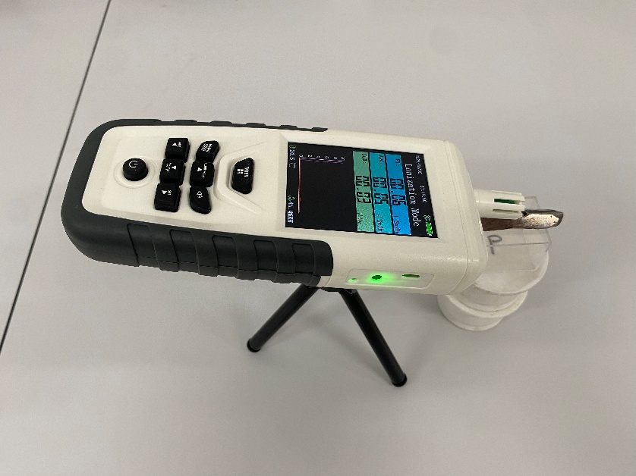
Supplementary Fig. 6 | The test setup for measuring possible ionising radiation using a Geiger-Müller counter tube.

Supplementary Note 6 - Magnetic properties of GEO3p
As a final observation, we noted that the GEO3 samples were very ferromagnetic, primarily due to the NiFeCo-rich primary dendritic FCC phase (see Fig. 2e). We measured the Curie temperature of the GEO3 sample (see Methods section) and found that the phase transition occurs at about 615 °C, in close agreement with the adapted Zener-Carr model for a Fe₂₀Co₂₀Ni₆₀ alloy which gives an estimate of 610 °C (see calculations below). Further investigation of the ferromagnetic properties of these multicomponent GEO-ALLOY formulations could be of interest for the solid-state physics community, as well as useful for high-temperature sensors and industrial actuators.

The Zener-Carr model, as adapted by Artley, Pilkington and Wooten², was used to estimate the Curie temperature of the ferromagnetic FCC phase in GEO3 containing Fe₂₀Co₂₀Ni₆₀ in at%. Prediction of Curie temperature $θ_{c}\left(K\right)$ for a ternary Fe-Co-Ni alloy mixture is given by the following equation:

$$θ_{c}\left(K\right)= \frac{1}{2K}\left[C_{A}^{2}F_{AA}+C_{B}^{2}F_{BB}+C_{C}^{2}F_{CC}+2C_{A}C_{B}F_{AB }+2C_{A}C_{C}F_{AC} +2C_{B}C_{C}F_{BC}\right]$$

where A=Fe, B=Co, C=Ni, with atomic ratios of C_{A}=0.2, C_{B}=0.2, C_{C}=0.6.
F_{AA}, F_{BB}, F_{CC} are the intra-element interaction "energy-spin" coefficients. These represent the exchange energy values of pure Fe, pure Co and pure Ni, respectively.
F_{AB}, F_{AC}, F_{BC} are the inter-element cross-interaction coefficients. These are determined empirically by fitting the model to known data points of binary systems Fe-Co, Fe-Ni, Co-Ni.
2K is a normalisation scaling factor linked to the total number of Bohr magnetons and localised spin configurations within the atomic matrix structure. This can be absorbed into each term in the following way T_{ij}=F_{ij}/2K.
Therefore, all six terms are calculated as follows:
C²_{Fe}T_{FeFe} = -(0.2)² x (300 K) = -12.0 K (N.B. negative convention for pure iron)
C²_{Co}T_{CoCo} = (0.2)² x (1350 K) = 54.0 K
C²_{Ni}T_{NiNi} = (0.6)² x (631 K) = 227.16 K
2C_{Fe}C_{Co}T_{FeCo} = 2 x 0.2 x 0.2 x 1250 K = 100.0 K
2C_{Fe}C_{Ni}T_{FeNi} = 2 x 0.2 x 0.6 x 1041.625 K = 250.0 K
2C_{Co}C_{Ni}T_{CoNi} = 2 x 0.2 x 0.6 x 1100 K = 264.0 K

Summing all six terms yields the final localised magnetic framework limit in absolute temperature.
Curie temperature in Kelvin = -12.0 + 54.0 + 227.16 + 100 + 250 + 264 K = 883.16 K
Curie temperature in Celsius = 610.01 °C

References
1. Schindelin, J. et al. Fiji: an open-source platform for biological-image analysis. Nat. Methods 9, 676–682 (2012).
2. Artley, J. L., Pilkington, T. C. & Wooten, F. T. Prediction of Curie temperatures in ternary Fe-Co-Ni alloys. J. Appl. Phys. 34, 972–974 (1963).

