Extended Data

Extended Data Table 1 | Fulfilment of several of the 12 Principles of Green Engineering by the GEO-ALLOYS processing route.
Fulfilled Principles of Green Engineering³¹ | Our Analysis
Principle 3: Separation and purification operations should be designed to minimise energy consumption and materials use. | The one-step multicomponent alloying process avoids the costly and energy-consuming process of extracting individual metals from the polymetallic ores to later mix them together again.
Principle 4: Products, processes, and systems should be designed to maximise mass, energy, space, and time efficiency. | By synthesising multicomponent alloys in one step directly from the ores instead of extracting individual elements and then blending them together, large amounts of energy, transportation, logistics and time are saved.
Principle 5: Products, processes, and systems should be “output pulled” rather than “input pushed” through the use of energy and materials. | The metal extraction through aluminium reduction is self-sustaining, presenting a best-case example of “output-pulled” process.
Principle 6: Embedded entropy and complexity must be viewed as an investment when making design choices on recycle, reuse, or beneficial disposition. | We obtain high-entropy alloys directly from existing natural minerals, achieving high strength and ductile alloys. The process is therefore more robust, in terms of ‘impurity’ tolerance.
Principle 10: Design of products, processes, and systems must include integration and interconnectivity with available energy and materials flows | The process is conceived to take existing minerals (available material flows) and to convert them directly into multicomponent alloys without extensive prior purification steps. Furthermore, the manufacturing steps of direct near-net-shape casting and 3D printing of these alloys provide vertical integration and even greater sustainability.

Extended Data Table 2 | Compositional data for the two GEO-ALLOYS from SEM-EDS. a, Measured EDS data for GEO3(p/q). b, Measured EDS data for GEO4. Both given in at% and wt%. Computed configurational entropy S is calculated at the bottom of the table, based on at% compositions and the Boltzmann entropy equation (see Supplementary Note 4).
a
GEO3 | at% | wt%
Ni | 47.17 | 47.57
Fe | 16.81 | 16.13
Co | 15.16 | 15.35
Cr | 14.15 | 12.64
Al | 4.70 | 2.18
W | 1.90 | 6.00
Ti | 0.05 | 0.04
Zr | 0.05 | 0.08
Si | 0.01 | 0.01
Total | 100 | 100
S = | 1.44R

b
GEO4 | at% | wt%
Ni | 36.22 | 37.07
Fe | 16.34 | 15.91
Al | 13.97 | 6.57
Cr | 13.63 | 12.36
Co | 11.38 | 11.70
Nb | 5.28 | 8.55
Ta | 2.09 | 6.59
Si | 0.69 | 0.34
W | 0.23 | 0.74
Mn | 0.17 | 0.16
Total | 100 | 100
S = | 1.75R

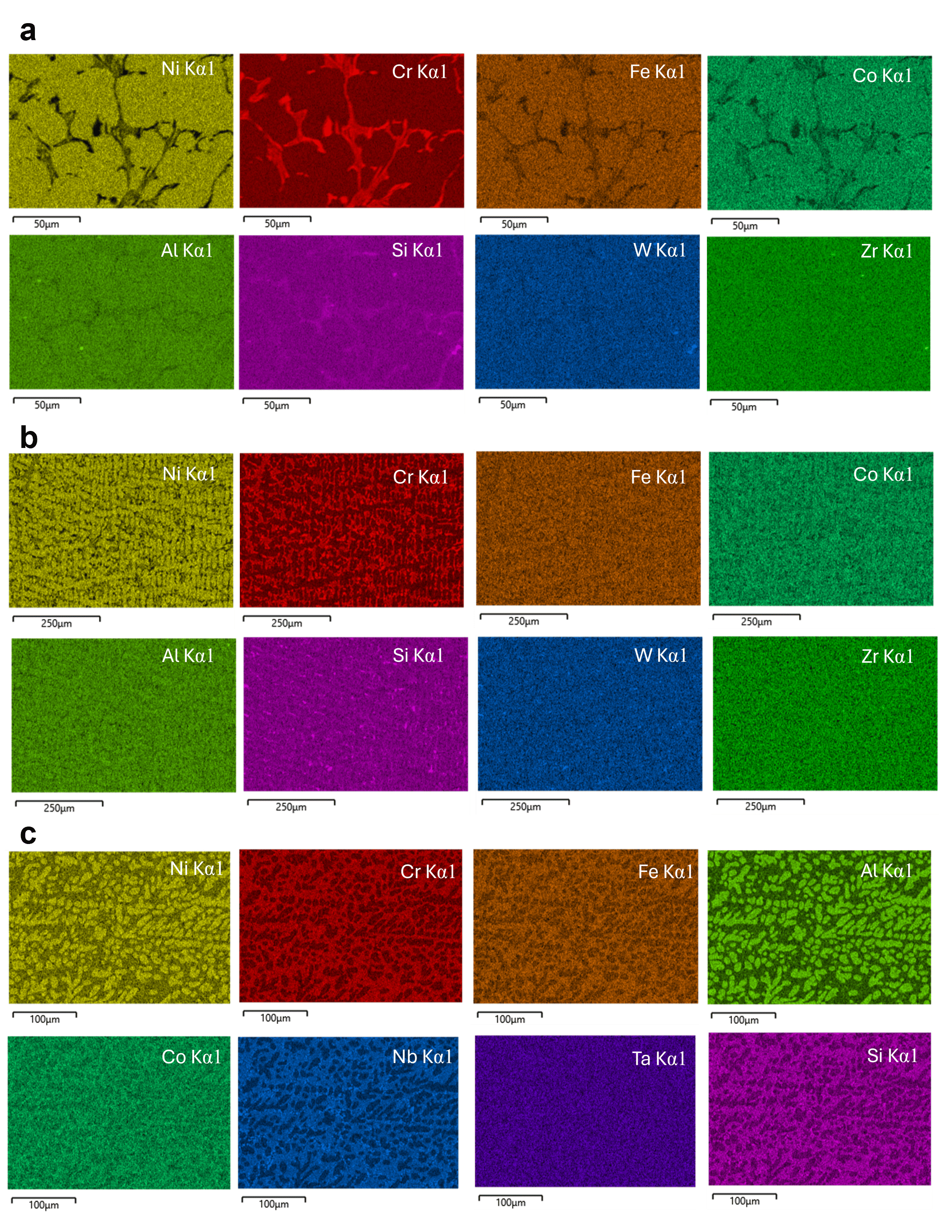

Extended Data Fig. 1 | SEM-EDS chemical mapping. a, EDS chemical maps for GEO3p. b, EDS chemical maps for GEO3q. c, EDS chemical maps for GEO4.

a b
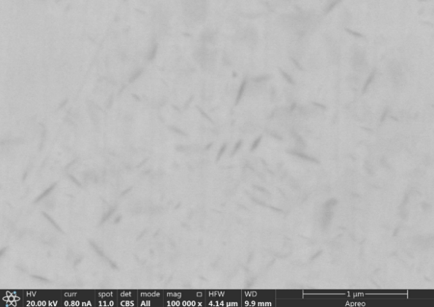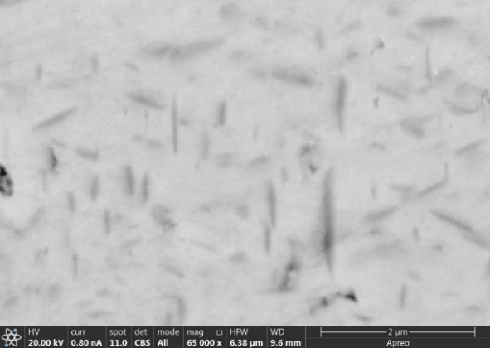
Extended Data Fig. 2 | SEM observation of nano-precipitates. a, Fine, lenticular nano-precipitates found in the primary FCC grains in the as-cast sample GEO3p. b, Larger, lenticular nano-precipitates found in the primary FCC grains of the as-cast/heat-treated sample GEO3q.

Extended Data Fig. 3 | SEM observation of a nano-eutectic FCC-C14 colony in the interdendritic eutectic regions of sample GEO4. Lamellae thicknesses of 300-400 nm are observed.

