Additional file 1: surgical procedure

1 H-UPPP^{[11]} combined with BRP^{[5]} surgery
(1) Two inverted 'V'-shaped incisions were made on the ventral surface of the soft palate, along both sides of the uvula.
(2) Bilateral tonsillectomy was performed in all cases, and the redundant bilateral pharyngeal mucosa and submucosal tissue was trimmed or resected .(Figure 1)
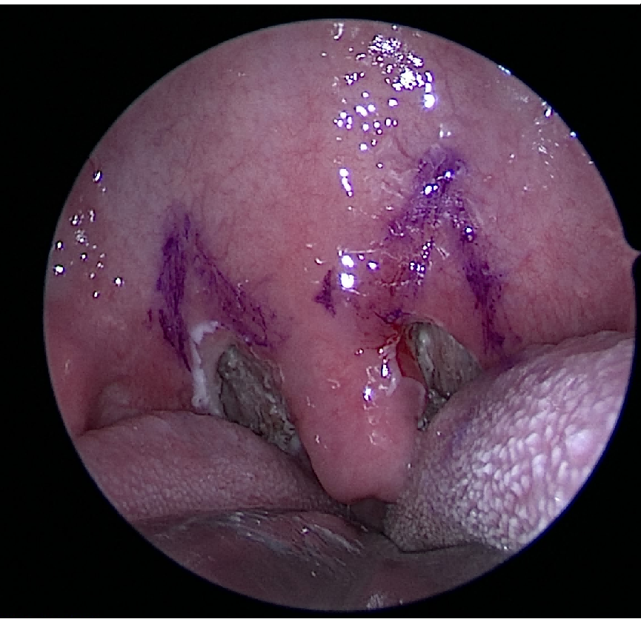
Figure 1 :Mark the soft palate ablation area
- After the membrane of the ventral surface of the soft palate was incised via ablation, surplus submembranous adipose tissue in the spatium veli palati was removed. The intact margins of the levator palatini and tensor palatini were preserved. The dorsal surface of the soft palate was incised and then trimmed along the uvula bilaterally. The intact musculus uvularis and its corresponding mucosal membrane (both dorsal and ventral) were preserved.(Figure 2)
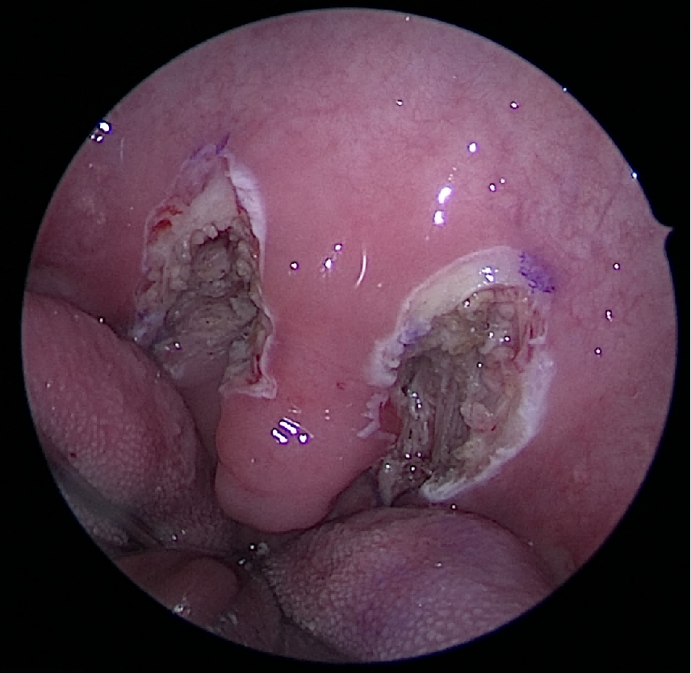
Figure 2 :After ablation of the spatium veli palati and tonsils
(4) The palatopharyngeal and palatoglossal muscles were sutured intermittently to close the tonsillar fossa. Subsequently, the palatopharyngeal and palatoglossal arches were also sutured intermittently.
(5) The centre of the junction of the soft and hard palate was marked at the palatal spine, and the pterygomandibular raphe on both sides was located by palpation and marked(Figure 3 ). We used a double-needle barbed suture, bidirectional polydioxanone absorbable monofilament, size 0, with a transition zone in the middle. One needle was introduced at the center point and then passed laterally within the palate, turning around the pterygomandibular raphe until it emerged at the most superior part of the raphe on one side; the thread was pulled until it hung at the central transition zone, which is a free zone present between the two directions of the thread. The needle was then re-introduced close to the point of exit, passing around the pterygomandibular raphe until it emerged into the tonsillectomy bed, then through the upper part of the palatopharyngeus muscle and emerged near the mucosa of the posterior pillar without passing through it. The posterior pillar was entered at the junction between the upper third and the lower two-thirds. Then, the needle was passed back through the tonsillectomy bed, and this suture was suspended around the raphe again. This led to a stable repositioning of the posterior pillar to a more lateral and anterior location without any knot; this stitch was repeated at least three times between the raphe and muscle until the lower pole of the muscle was reached. The procedure was repeated on the opposite side in the same manner. Finally, each thread emerged at the raphe of the same side for locking of the stitches and prevention of looseness; a superficial stitch in the opposite direction was taken, and then the thread was cut.
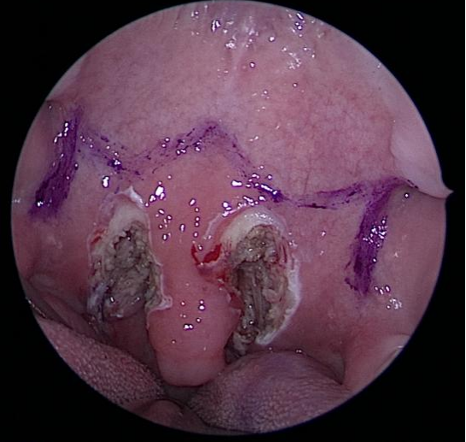
Figure 3 :The path of for BRP suturing

- The redundant adipose tissue and surplus mucous membrane along the musculus uvularis were removed. The dorsal and ventral margins of the preserved mucosal membrane of the uvula were closed with interrupted sutures, forming a new uvula(Figure 4).
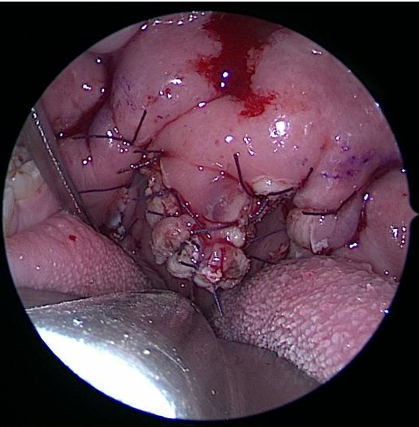
Figure 4 :The surgical cavity after the procedure is completed
2 H-UPPP combined with TPAP surgery^{[12]}
Steps 1-4 are the same as described above in H-UPPP combined with BRP.
(5)PAP procedure: The gothic arch incision begins at the junction of the soft and hard palate, 1 cm internal to the soft palate and extending to 1.5 cm posterior to the gingiva; a U-shaped bilateral symmetry is made to expose the maxillary periosteum(Figure 5).
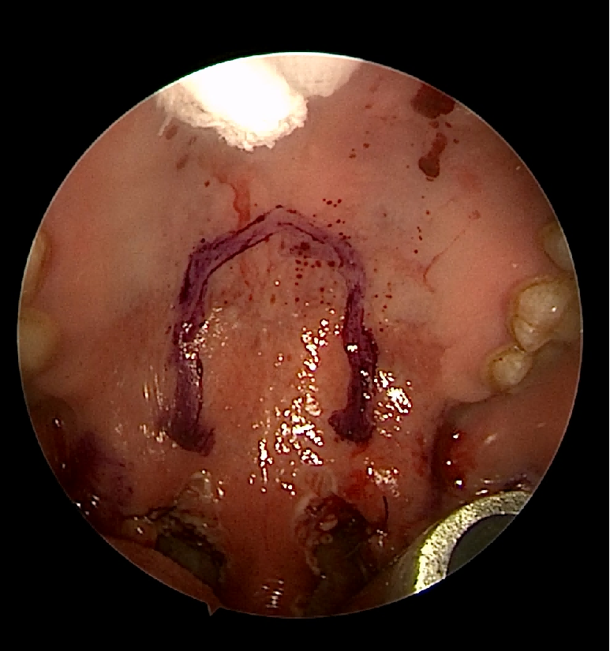
Figure 5: Mark the U-shaped incision on the hard palate
(6)Separation of the gothic arch palatal flap along the incision exposed the junction of soft and hard palate 0.5 cm internally to the soft palate. The hard and soft palate was divided by amputating the proximal tensor aponeurosis along the posterior bone margin of the palate, and approximately 1 cm of hard palate (palatine process of palatine bone) was removed. The accurate length of hard palate that one should remove depends on how far the soft palate is advanced. Through-and-through drill holes 0.2 cm distance to the new posterior bony margin of hard palate were placed bilaterally. We sutured the tensor aponeurosis to the posterior bony margin of hard palate(Figure 6).
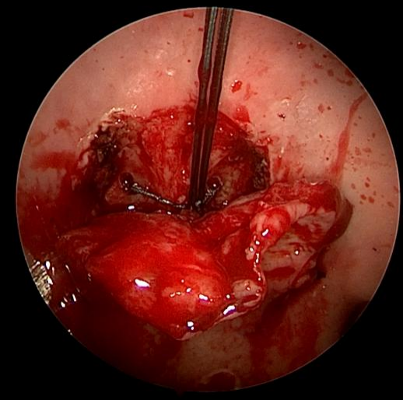
Figure 6 : Suture the tensor aponeurosis to the posterior bony margin of hard palate
(7)The soft palate was advanced. The palatal flap was then carefully trimmed of excessive tissues, anchored to the fibrous tissue overlying the maxillary periosteum, and the palatal mucosa approximated without tension(Figure 7)
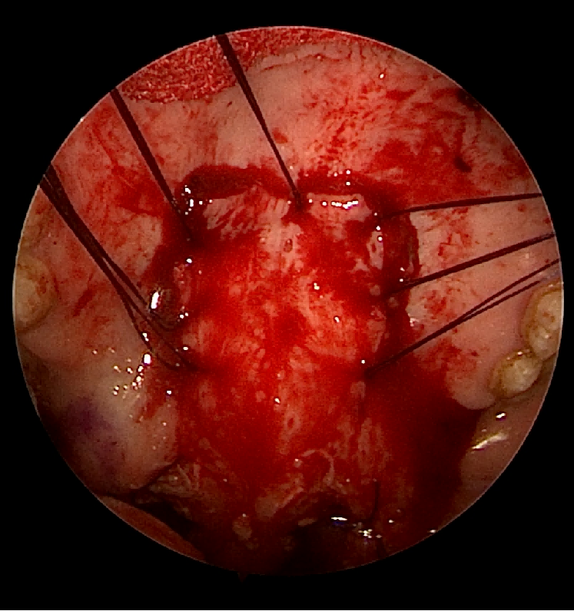
Figure 7: The reduction and suture the hard palatal flap
(8)Uvuloplasty (the same as described in H-UPPP combined with BRP):The redundant adipose tissue and surplus mucous membrane along the musculus uvularis were removed. The dorsal and ventral margins of the preserved mucosal membrane of the uvula were closed with interrupted sutures, forming a new uvula

