Additional file 2 : Upper airway CT examination and image reconstruction and Cephalometric analysis
- Upper airway CT examination and image reconstruction
(1) All patients underwent upper airway CT scans while awake, using GE Revolution 256-slice CT, SIEMENS Definition Flash dual-source dual-64-slice CT, and GE Discovery CT750 HD CT scanners. Scanning parameters: tube voltage 100/120 kV, automatic tube current modulation, slice thickness 1 mm, and a slice spacing of 0 mm. All measurements were performed using the workstation's built-in software. (Patients were placed in a supine position during scanning, with the scanning range extending from the nasal cavity to the upper respiratory tract, ending at the glottis. Patients were instructed to keep their mouth closed, naturally close their upper and lower teeth, breathe calmly, and avoid vocalization or swallowing activities. Scanning began at the end of exhalation, following the method described by Xu^{[18]}

(2) Three-dimensional reconstruction and measurement parameters of the upper airway (referencing methods by Xu^{[18]:}
The entire airway was defined as the area between the hard palate plane and the lower border of the hyoid bone.
The criteria for determining the horizontal planes of the airway are as follows: The hard palate plane is defined by connecting the anterior and posterior edges of the hard palate, maintaining a horizontal position, and determining the mid-sagittal plane. The lowest point connecting the anterior spine of the hard palate on the mid-sagittal plane to the occipital slope is identified as the horizontal plane. All other planes are delineated parallel to this plane.

Measurement parameters: All diameters, areas, and volumes were measured using the built-in software of the GE AW4.1 workstation, following the methods described in the reference (He's article). Two-dimensional parameters include: ① Anteroposterior hard palate diameter; ② Mandibular-hyoid distance (MH distance): the vertical distance between the lowest point of the hyoid bone in the mid-sagittal plane and the lowest point of the mandible; ③ Airway length: the vertical distance from the lowest point of the hard palate in the mid-sagittal plane to the lowest point of the hyoid bone; ④ Soft palate angle: the angle formed between the hard palate and the soft palate in the mid-sagittal plane, as shown in Figure 8 and Figure 9
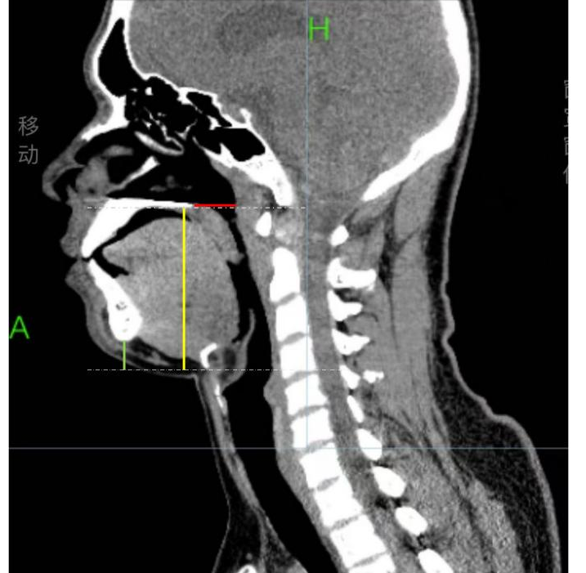

Figure 8 :① The red line shows anteroposterior hard palate diameter②The green line shows MH distance③The yelow line shows airway length
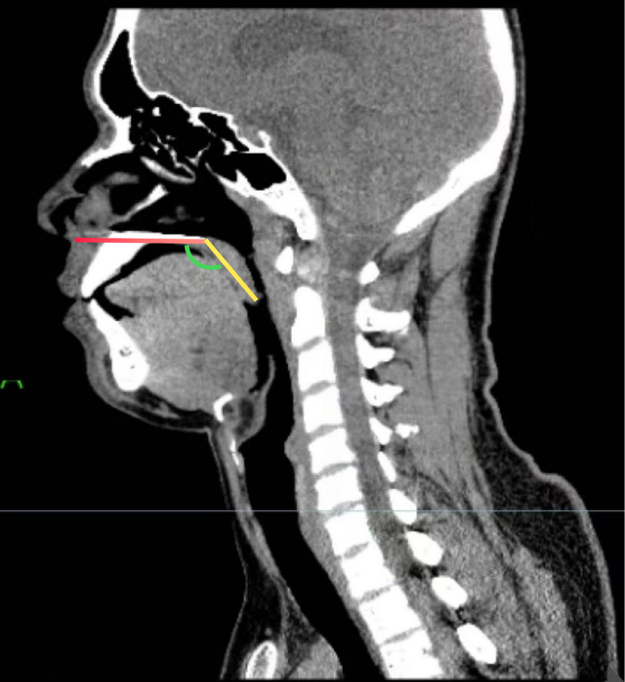
Figure 9: Soft palate angle

