Supporting information

Synergistic Enhancement of CO₂ Photocatalytic Reduction Performance in Bi_{2-x}WO₆/Cu₂O via Bismuth Vacancy Modification and p-n Heterojunction

Zhiyu Liu, Mingsong Wang, Lingru Kong*, Peng Song
Department of Physics, Liaoning University, Shenyang 110036, P. R. China.

* Corresponding author: Lingru Kong
Email: lingrukong@lnu.edu.cn

Characterizations
The morphology of the materials was characterized by scanning electron microscopy (SEM, Zeiss Sigma360) and transmission electron microscopy (TEM, Thermofisher FEI Talos F200s). In-situ surface potential imaging was performed using an atomic force microscope (Jupiter XR) in KPFM mode. The X-ray diffraction (XRD) patterns of the samples were recorded by an X-ray diffractometer (DX-2700, China). The UV-Vis diffuse reflectance spectra of the catalysts were measured by a Shimadzu UV-3600 spectrophotometer (Japan). X-ray photoelectron spectroscopy (XPS) analysis was carried out using a Thermo Scientific K-Alpha XPS spectrometer. The photoluminescence (PL) spectra were obtained by a Hitachi F-7000 fluorescence spectrophotometer. In-situ diffuse reflectance infrared Fourier transform spectroscopy (DRIFTS) was acquired by a Thermo Scientific Nicolet iS20 spectrometer. The electron spin resonance (EPR) signals were measured by a Bruker A300 spectrometer.

Photoelectrochemical measurements
A standard three-electrode system in an electrochemical workstation (VersaSTAT 4, Princeton Applied Research) was used to measure the photocurrent response, electrochemical impedance spectroscopy (EIS) and Mott–Schottky curves. The working electrode was FTO glass coated with the catalyst. The reference electrode was Ag/AgCl and the opposite electrode was a Pt sheet. For the preparation method of the working electrode, 10 mg of sample were evenly dispersed in a mixture of 2 mL anhydrous ethanol and 0.5 mL of Nafion. The liquid was coated on the surface of 1.0 × 1.0 cm FTO conductive glass and dried at room temperature and atmospheric pressure. A 300 W xenon lamp was used as a light source.

Transient absorption (TA) Experiments
TA spectroscopy was conducted using an Ultrafast Helios pump-probe system incorporating an oscillator and a Coherent Opera Solo optical parametric amplifier system. The system’s Ti:sapphire amplifier generates 800 nm pulses at a 1 kHz repetition rate, with each pulse lasting 100 fs and carrying an energy of 7 mJ. These pulses are split into two via a beam splitter: one part powers an optical parametric amplifier (TOPAS, Coherent) to produce the pump pulse, while the other part is focused onto sapphire and YAG plates, creating white light supercontinuum probe beams covering 400-800 and 750-1600 nm spectra, respectively. The pump and probe pulses are timed with a maximum delay of 8 ns, controlled by a motorized optical delay line. The pump pulse energy is calibrated using a Thorlabs PM400 power meter before being focused on the sample alongside the probe beams. The probe beam, after interaction with the sample, is collimated and channeled into a fiber-coupled multichannel spectrometer equipped with a CCD sensor for analysis.

Photocatalytic CO₂ reduction
The experiment was carried out in a homemade glass container in our laboratory. The light source is 300w Xenon lamp with a light intensity of 530 mW (XL-300A, Shenyang Yilida) , equipped with a 420-nanometer cutoff filter. Typically, 10 mg of photocatalyst is dispersed in 100 μL ethanol, dried in the sample tank, and transferred to the reactor. At the same time, 1 ml of deionized water is injected into the reactor. Before the photocatalytic reaction, the reactor was pumped three times with vacuum pump and high purity CO₂ to eliminate air and spread high purity CO₂ in the reactor. The reactor was then exposed to simulated sunlight. Gas chromatography (GC5190F, Anhui chromatography) was used to quantitatively analyze the gas production.
The external quantum efficiency (EQE) of the sample was determined using monochromatic light sources of different wavelengths, with all other experimental conditions remaining constant. EQE was calculated using the following formula:
$$EQE(\%)=\frac{2n×{ N}_{A}×h×c}{t_{irr}×λ×I×A }$$
Among them, n represents the amount of CO generated, N_{A} is Avogadro's constant, h is Planck's constant, c is the speed of light, t_{irr} is the irradiation time, λ is the wavelength of monochromatic light, I is the irradiation intensity, and A is the irradiation area.

Theoretical calculation details
This paper uses the VASP software package based on first-principles theory to conduct theoretical calculations on the geometric structure optimization and electronic properties of the research system. The exchange-correlation functional adopts the Perdew-Burke-Ernzerhof functional based on the projected augmented wave method, and Grimme's DFT-D3 long-range dispersion correction is also considered. The plane wave cutoff energy is set at 450 eV. The energy convergence criterion for the electronic self-consistent iteration is set at 1×10⁻⁵ eV, and the force convergence criterion is -0.05 eV/Å. The Brillouin zone integration uses the Gamma method to generate the k-point grid, with a grid density of 3×2×1. In the calculation, the in-plane Coulomb interaction of the Bi atomic d orbitals is considered, and the DFT+U method is adopted. An effective Hubbard U value of 4.5 eV is applied to the d orbitals of the atoms, while the U values of the other orbitals are set to 0.

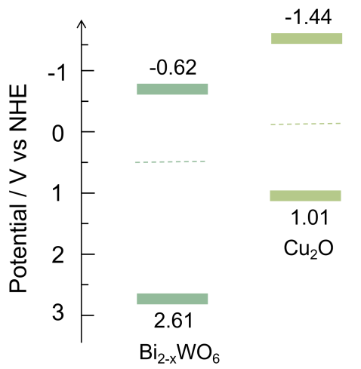
Fig. S1. Band positions of Cu₂O and Bi_{2-x}WO₆.

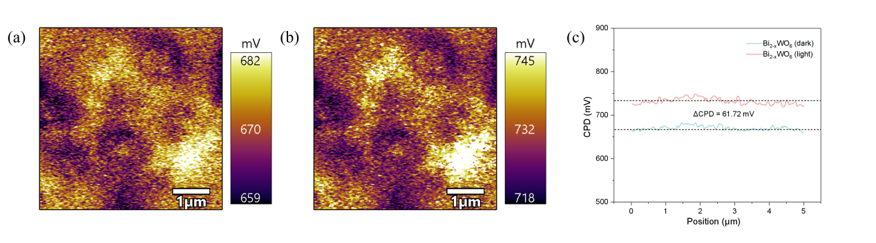
Fig. S2. Surface potential distribution changes of (a-c) Bi_{2-x}WO₆ under dark and light irradiation (ΔCPD = CPD_{light}−CPD_{dark}).

Fig. S3. In-situ DRIFTS spectra of Cu₂O.

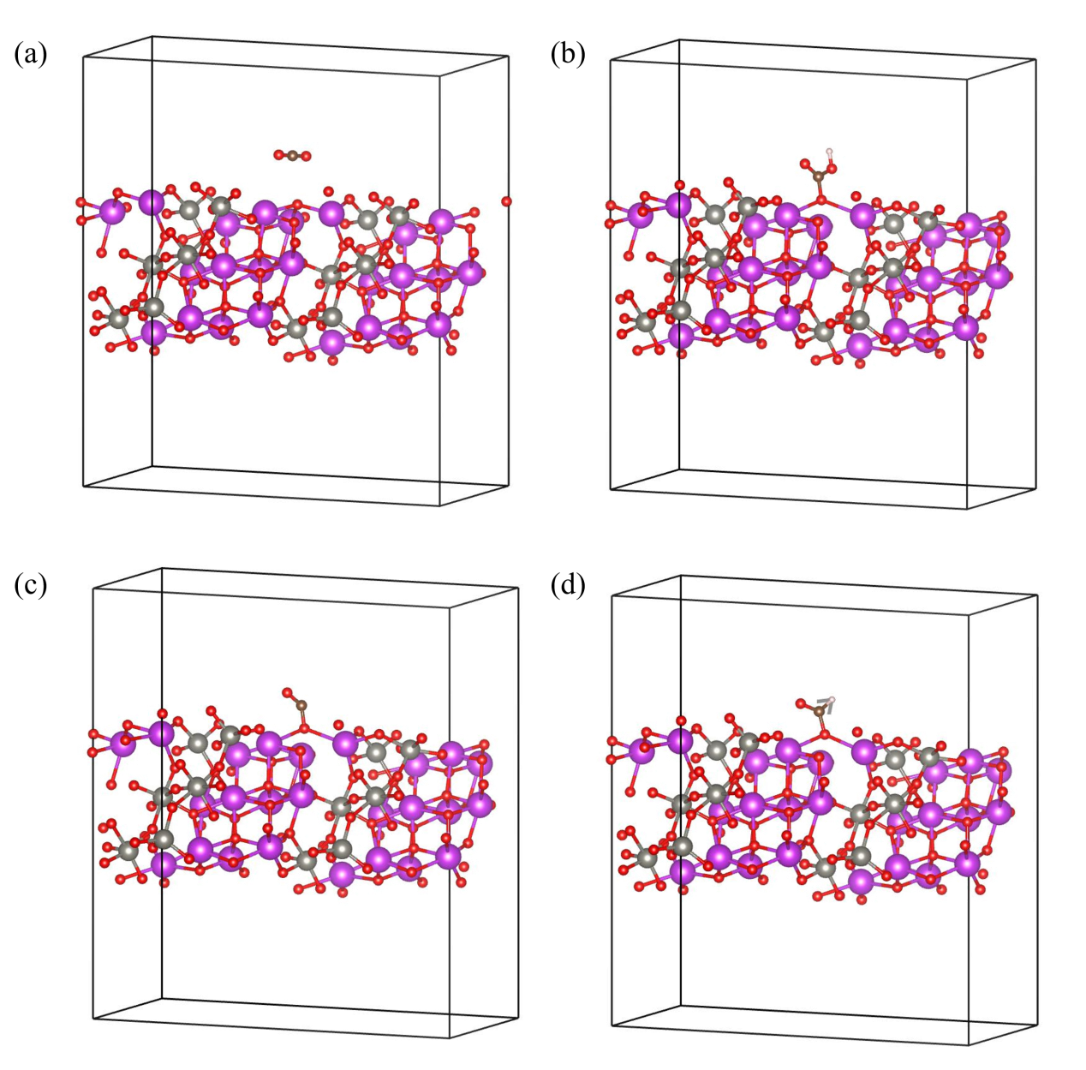
Fig. S4. Structural model of Bi_{2-x}WO₆.

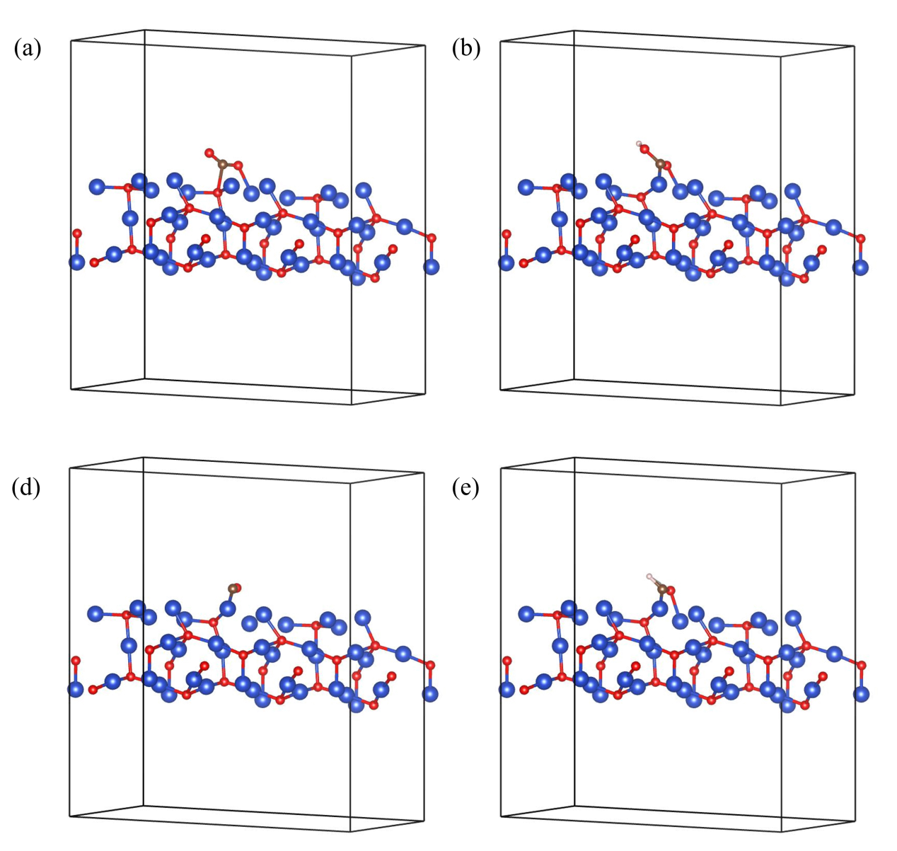
Fig. S5. Structural model of Cu₂O.

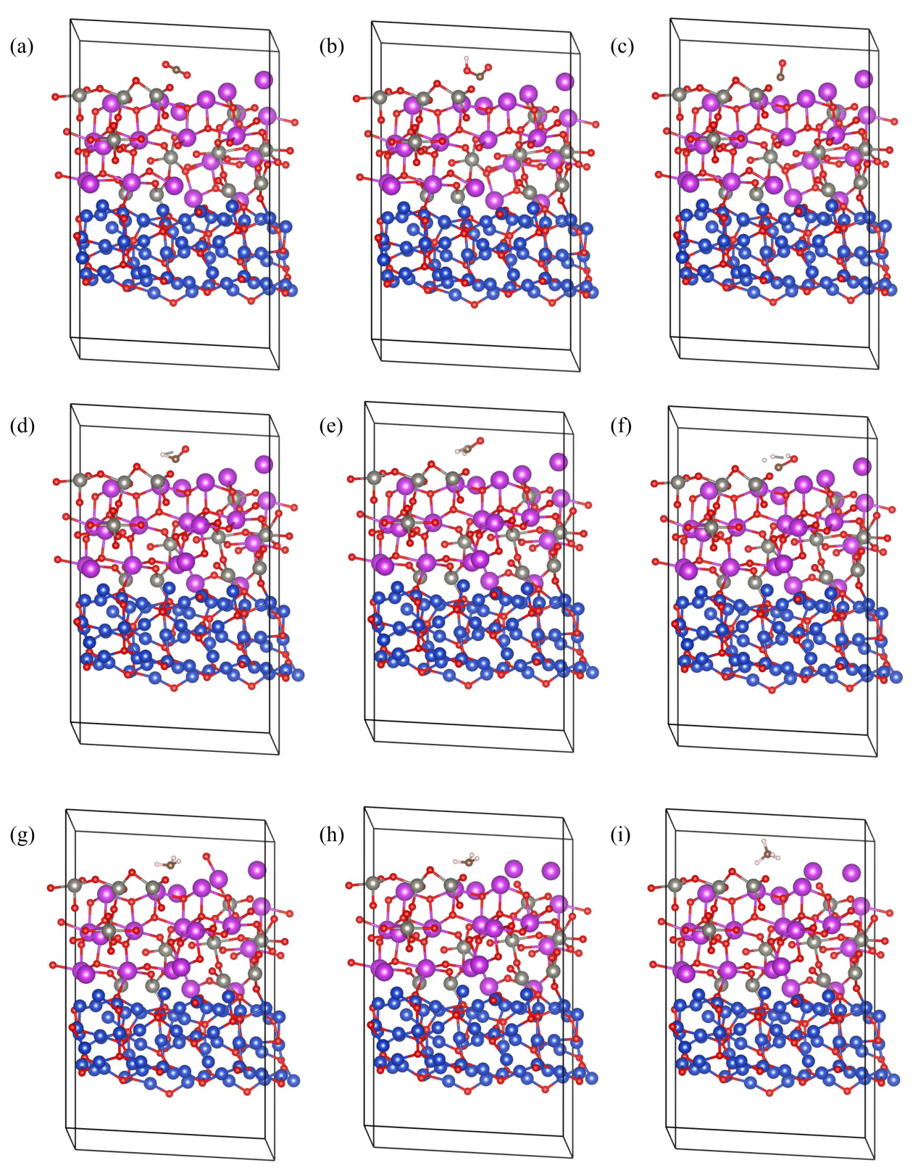
Fig. S6. Structural model of Cu₂O/Bi_{2-x}WO₆.

