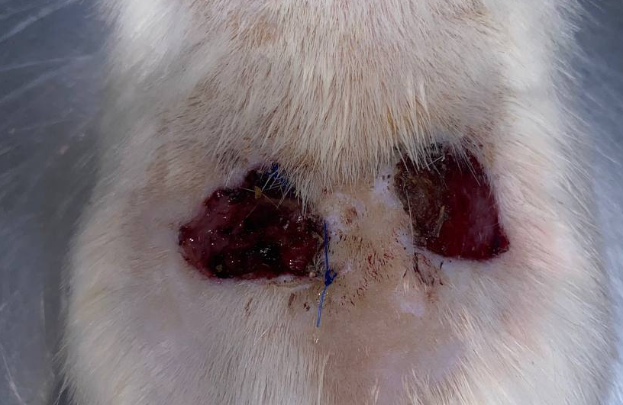
Figure S1. Representative gross images of full-thickness skin wounds comparing the SIS treatment (left) and control (right)

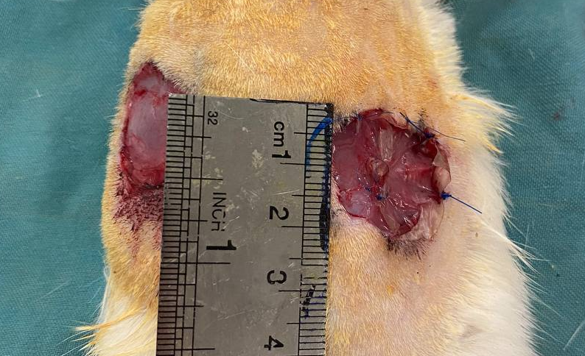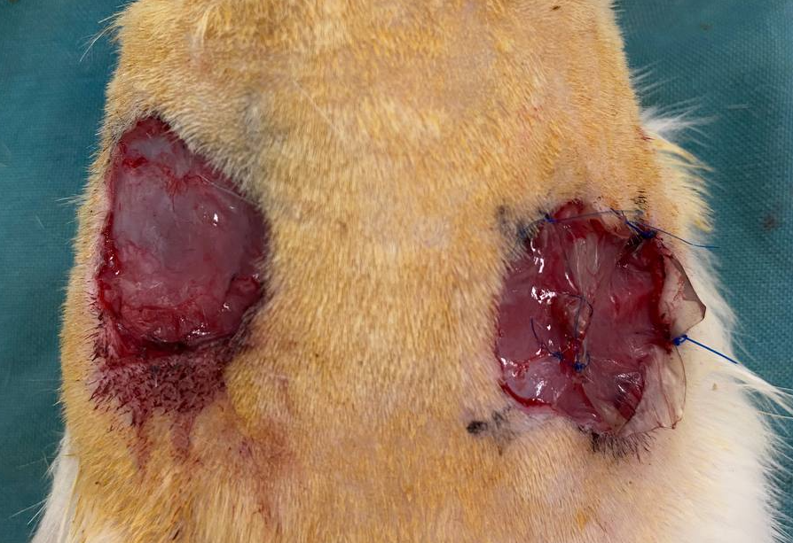
Figures S2–S3. Representative gross images of full-thickness skin wounds comparing the SIS-Exo treatment (left) and control (right) on day 14.

