National Institute Of Nursing Education Postgraduate Institute Of Nursing Education And Research


Information Booklet For Caregivers Regarding Home Care of Children Having Hydrocephalus
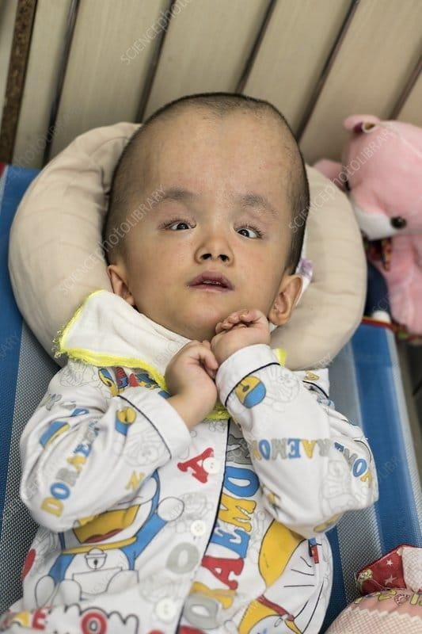
Made by:Suman pokhriya, Guide :Dr Monaliza
Co Guide:Dr JK Mahajan,Mrs Anupama Choudhary

INFORMATION BOOKLET FOR CAREGIVERS REGARDING HOME CARE OF CHILDREN HAVING HYDROCEPHALUS

S.No | Content
1. | Introduction about Hydrocephalus
2 | Common Symptoms of Hydrocephalus
3. | Assessment can be done by caregiver at home
4. | Skill building of caregiver
5. | Care of child during seizure
6. | Diet and nutrition
7. | Medication adherence
8. | Follow up

What is Hydrocephalus?

Hydro+cephalus Hydro=water Cephalous=head
CSF is the fluid that surrounds the brain and spinal cord.It is produced in the hollow spaces inside the brain.CSF protects the brain and spinal cord by acting as a cushion.However,when there is too much CSF production,it puts pressure on the brain and skull
.Extra CSF fluid can be caused by different things such as a brain tumour,head injury,infection in the brain or it can be present at birth without any obvious reason,This extra fluid also makes the hollow spaces of the brain grow bigger This is called Hydrocephalus.

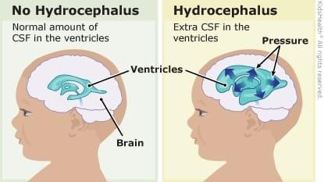

Types of Hydrocephalus
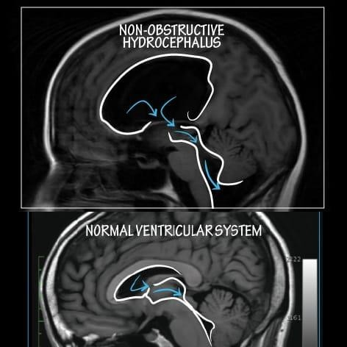
A.Congenital Hydrocephalus
Present at birth
B.Acquired Hydrocephalus
- Develop after birth
C.Communicating Hydrocephalus
CSF flows between ventricles without any obstruction and the pathway is clear

D.Non-Communicating(Obstructive)Hydrocephalus
- Obstruction is present between the ventricles and the pathway is not clear


Causes / Etiology
A.Congenital Causes of Hydrocephalus

Aqueductal Stenosis
  - Narrowing of a small channel (called the aqueduct of Sylvius) in the brain.
  - This blocks the normal flow of fluid and causes it to build up.

Spina Bifida (Myelomeningocele)
  - A birth defect where the spine and spinal cord do not form properly.
  - The brain may slip downward (Chiari malformation), blocking fluid flow.
  - Up to 90% of children with spina bifida develop hydrocephalus.

Brain Malformations (e.g., Dandy-Walker Syndrome)
  - The back part of the brain (cerebellum) does not form correctly.
  - This can block the flow of CSF and cause swelling.

Congenital Infections (TORCH infections)
  - Infections during pregnancy such as Toxoplasmosis, Rubella, Cytomegalovirus (CMV), and Herpes.
  - These infections can damage the brain and block fluid movement.

Genetic Conditions (e.g., X-linked Hydrocephalus)
  - Passed from parents to child through genes.
  - Mainly affects boys.



B. Acquired Causes of Hydrocephalus in Children

Intraventricular Hemorrhage (Bleeding in the Brain)
  - Often seen in premature babies.
  - Bleeding can block the brain's drainage system.

Infections like Meningitis or Encephalitis
  - Inflammation caused by bacteria or viruses.
  - Can block or damage areas that absorb CSF.

Brain Tumors or Cysts
  - A tumor may press on the fluid pathways and block flow.
  - Sometimes, a cyst (fluid-filled sac) can do the same.

Head Injury
  - A fall or accident can cause bleeding or swelling in the brain.
  - This may lead to fluid buildup.

Post-surgery or Scar Tissue
  - After brain surgery or infection, scars can block CSF flow.
  - This can cause hydrocephalus even weeks or months later.


Most common Clinical manifestations
Headache



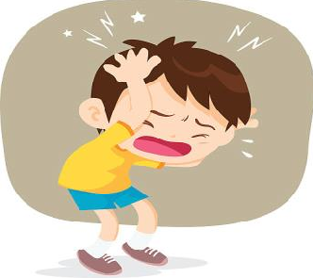


Increased head size
Sunset eyes
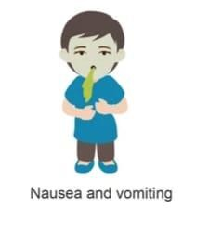
Nausea and vomiting


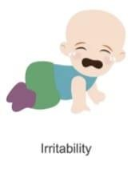
Poor head control
Irritability

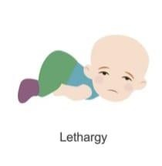


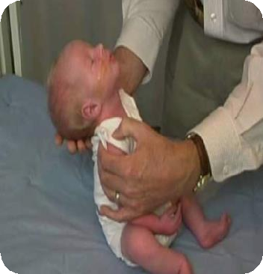

lethargy
Trouble with balance and walking

Diagnosis



History collection
Clinical Evaluation
Head circumference charting Neurological exam


Neuroimaging
Cranial ultrasound (in infants with open
fontanelle)
MRI (preferred) or CT scan

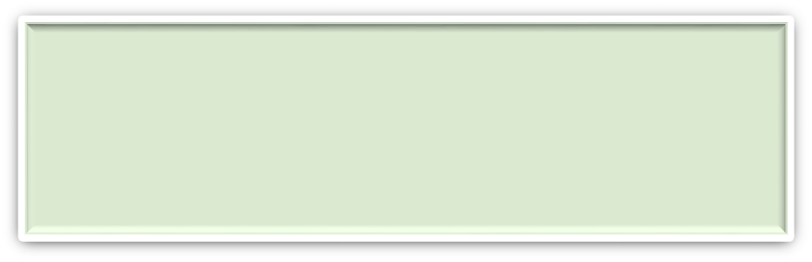
Genetic Testing
In congenital cases or syndromic features


Surgical Interventions Ventriculoperitoneal (VP) Shunt
Treatment
A VP Shunt is a device used to drain extra cerebrospinal fluid from the brain VP shunt is placed into the head the VP shunt works by taking the fluid out of the brain and moving it into the belly,where extra fluid is absorbed by the body,it helps to decrease the pressure on the brain and eventually the head size is also decreased

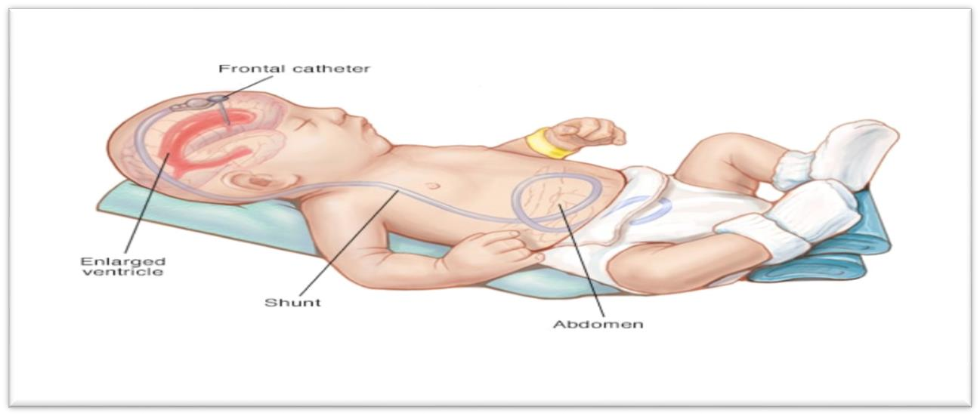
As the VP shunt drains extra CSF and lessens the pressure in the brain,it may ease someof the symptoms.Some symptoms will stop right after inserting VP shunt.Other symptoms will go away more slowly,
,sometimes over a few weeks

Non-Surgical Pharmacological Therapies Target areas:
  - CSF production inhibitors
  - Anti-inflammatory agents
  - Neuroprotective treatments


Home care management

Assessment need to be done by caregivers at home Assess for Head Sores
- Inspect head daily,especially occipital area
- Use soft bedding and reposition every 2 hours
- Apply protective padding for high risk areas

Check the signs of increased ICP by following symptoms
- Irritability
- Vomiting
- Seizure
- Shrill cry
- Sunset eyes
- Altered level of consciousness

Assess for the signs of Shunt infection and malfunction by following signs
- Fever
- Redness/drainage at shunt site
- Bulging site
- Poor feeding

Assess for Meningitis
- Stiff neck
- Seizures
- High pitched cry


Skill building of the caregiver

Measuring Head Circumference

  - Use a non stretchable measuring tape.
  - Measure from just above the eyebrows to the most prominent part of

. 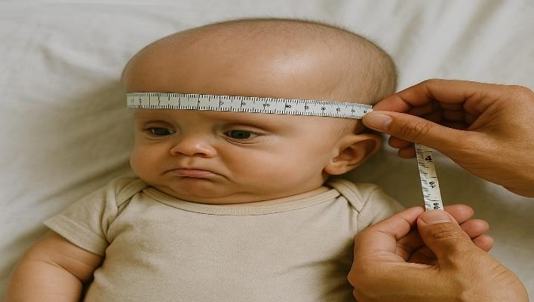
the occiput.
  - Record Head circumference in cm weekly in Chart.

Holding of Head and Neck
    - Support the head and neck simultaneously.Alway place one hand behind the child’s neck and the other under the buttocks or back when lifting.
    - Avoid jerky or unsupported lifting.Jerky motions can increase ICP (Intracranial pressure)and cause shunt displacement.
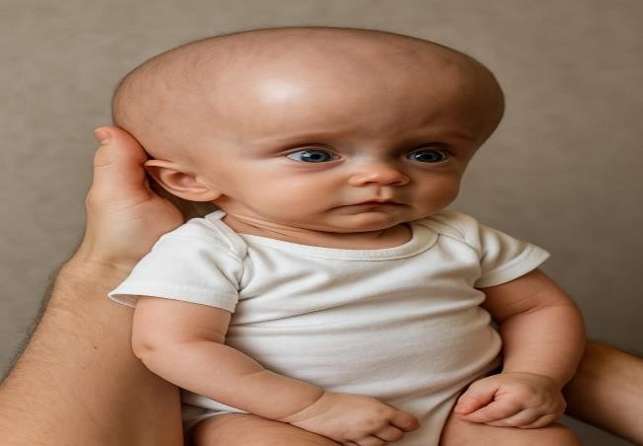

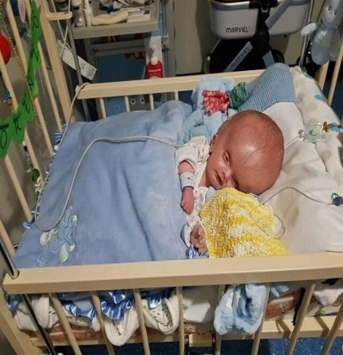
    - Use soft pillows for support in lying position.
    - When holding or placing in bed,keep the head slightly elevated to facilitate CSF drainage and reduce intracranial pressure.

Care of the surgical site
L. Prevention of infection
Extreme care should be taken for preventing infection.

Hand washing
- Follow all these hand washing steps before and after touching the baby.

- Perform all activities of the patient after properly washing hands.

- Follow SUMAN-K while washing hands.

- S-Sidha
- U-Ulta
- M-Mutthi
- A-Angutha

- N-Nakhun

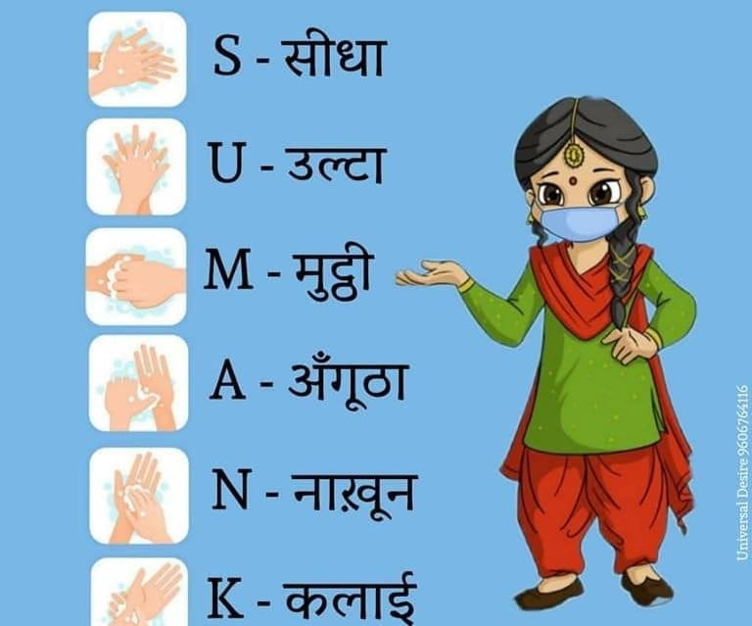

Assess for the signs of Shunt infection and malfunction by following signs
  - Vomiting that does not go away
  - Lethargic
  - Pain in the belly that does not go away
  - Stiff neck or headache
  - Become more cranky and irritable
  - Bulging or tenderness at surgical site
  - Sleep problem
  - Swelling behind the ear
  - Seizure

Identify the valve location behind the ear under the scalp Check for the skin over valve
Parameter | Normal | Abnormal
Skin over valve | Soft,no redness | Red,swollen,painful
Valve appearance | Flat or slightly dome  shaped | Bulging  ,tight,enlarged
Behavior | Alert ,active | Sleepy  ,irritable,vomiting

Maintenance of personal hygiene
  - Don't cover the head of the child with a soiled cloth after surgery.
  - Change child’s clothes daily.
  - Help the child to take bath/sponge bath daily.
  - Keep diaper beneath the abdominal incision

Environmental hygiene
  - Limit the number of visitors at home
  - Keep the child’s surroundings neat and clean.
  - Don't mingle with persons having fever, nasal discharge or other infectious diseases.
  - Don't let the child visit a crowded place.
  - Learn to clean and care for surgical incisions before leaving the hospital
  - If Any redness, pain or swelling along the shunt tract should be brought to the notice of the nursing staff and neurosurgeon.
  - Don't rub or scratch the wound.
  - Don't apply oil or powder over the wound.
  - Keep the wound dry.


If the child having seizure at home :

During Seizure
  - Roll the child on their right side and place something soft under the head.
  - Do not put anything in the child's mouth.
  - Don't restrain the child and let the seizure run its course.
  - Remove sharp objects away from the child.
  - Give medicines as prescribed.

After Care
  - The child may be drowsy and confused after the seizure.
  - The child may have difficulty in speaking or weakness in their limbs. This may last from a few minutes to hours. Stay with the child until the confusion stops.
  - Make a video of the events that happened during the seizure if possible

Diet and nutrition
  - Ensure adequate hydration and nutrition
  - Breastfeeding recommended up to 6 months
  - Soft nutritious foods like banana,mashed potatoes,porridge
  - Avoid processed or spicy food
  - Vitamin D and calcium supplementation if advised


Medication adherence
  - Give medications to the child as directed by the Physician.
•
  - Strictly adhere to the instructions given about medication.
  - Follow the Physician instructions for change in any prescription.
  - Don't take more of any medication than the amount directed on the label or as instructed by the healthcare provider.
  - Never stop medication without consulting Physician
  - Never miss dose


Follow-up
  - Attend all follow up appointments with neurosurgeon and pediatrician
  - Keep a record book for symptoms,head circumference,and doctor visits
  - Follow growth and developmental milestones
  - Seek help from community health workers for home visits

Home Care Monitoring Chart for Children with Hydrocephalus

Date | Time | Weigh t  (kg) | Head Circumferen ce  (cm) | Level of alertness | Vomiting (yes/no) | Fontanelle status(bulging/fl at  /Depressed) | Shunt site(Redness/swel ling/Discharge | Seizure( yes/no) | Other concerns


Made By:Suman Pokhriya M.Sc.Nursing Student NINE,PGIMER
Guide:Dr Monaliza
Associate Professor NINE,PGIMER,Chandigarh

Clinical Coguide:Dr J K Mahajan Professor Cum Head of Pediatric Surgery
Advanced Pediatric Centre,PGIMER,Chandigarh

Co Guide:Mrs Anupama Choudhary Tutor
,NINE,PGIMER,Chandigarh

Table 7: DASS-21 Domains among Caregivers of Children with Hydrocephalus at Baseline and endline N=60

Variables | Time of assessment | Control group Median(Q1-Q3) | Intervention  group Median(Q1-Q3) | Mann Whitney U(P-value)
Depression | Baseline (0 day) | 20(18-24) | 22(020-24) | 384.50(0.326)
Depression | Endline(45 days) | 19(16-22) | 16(013.50) | 294(0.20)
 | Wilcoxon Signed  Rank Z(P-value) | -2.236 (0.025)* | -4.062 (<0.001)*
Anxiety | Baseline (0 day) | 14(12-18) | 14(012-18) | 434(0.811)
Anxiety | Endline(45 days) | 14(11-16) | 12(9.50-14) | 308.50(0.034)
 | Wilcoxon Signed  Rank Z(P-value) | -2.887(0.004)* | -3.748 (<0.001)*
Stress | Baseline (0 day) | 18(16-22) | 18(015.5-20) | 387(0.344)
Stress | Endline(45 days) | 16(14-18) | 14(11.50-16) | 217.50(<0.001)
 | Wilcoxon Signed  Rank Z(P-value) | 2.714(0.007)* | -4.234 (<0.001)*

Table 7 compares the levels of depression, anxiety, and stress among caregivers in the control and experimental groups at baseline (0 day) and endline (45 days).
At baseline, depression, anxiety, and stress scores were comparable between the two groups, with no statistically significant differences (p>0.05).
At endline, both groups showed a reduction in depression scores; however, the difference between groups was not statistically significant (p=0.20). In contrast, anxiety and stress scores showed a significantly greater reduction in the experimental group compared to the control group (p=0.034 and p<0.001, respectively).
Within-group analysis also showed significant improvements over time in depression, anxiety, and stress scores.
Overall, while both groups improved, the experimental group demonstrated a significantly greater reduction in anxiety and stress, indicating the effectiveness of the intervention

1

Table 8A: Intergroup comparison of Quality of Life among Caregivers of Children with Hydrocephalus in Control and Experimental group at baseline and endline (As per WHOQOL-BREF) N=60

Domain | Baseline assessment |  | Mann – Whitney U test(P-value) | Endline assessment |  | Mann – Whitney U test(P-value)
 | Control Median (IQR) | Experimental Median (IQR) | Mann – Whitney U test(P-value) | Control Median (IQR) | Experimental Median (IQR) | Mann – Whitney U test(P-value)
Physical domain | 31(19-38) | 25(19-32) | 345(0.114) | 31(25-38) | 31(25-38) | 427.50(0.732)
Psychological  domain | 38(29.50-  44.0) | 25(19-38) | 302.50(0.027)* | 38(31-44) | 31(31-39) | 379.50(0.281)
Social domain | 31(31-44) | 31(31-44) | 427.50(0.724) | 31(31-44) | 31(31-44) | 397(0.400)
Environmental  domain | 31(25-38) | 25(19-31) | 280(0.010)* | 31(25-38) | 31(25-38) | 361(0.176)

Table 8 presents the intergroup comparison of Quality of Life (WHOQOL-BREF) scores across physical, psychological, social, and environmental domains between control and experimental groups at baseline and endline.
At baseline, psychological and environmental domain scores were significantly higher in the control group compared to the experimental group (p=0.027 and p=0.010, respectively), while physical and social domains showed no significant differences (p>0.05).
At endline, no statistically significant differences were observed between the groups across any of the domains (p>0.05). Both groups had comparable median scores in physical, social, and environmental domains, and the earlier differences in psychological and environmental domains were no longer evident.
Overall, although baseline differences existed in some domains, the groups were comparable in Quality of Life at endline.

2

Table 8A: Intergroup comparison of Quality of Life among Caregivers of Children with Hydrocephalus in Control and Experimental group at baseline and endline (As per WHOQOL-BREF) N=60
Domain | Control |  | Wilcoxon signed rank test(P value) | Experiment |  | Wilcoxon signed rank test(P value)
 | Baseline Median (IQR) | Endline Median (IQR) | Wilcoxon signed rank test(P value) | Baseline Median (IQR) | Endline Median (IQR) | Wilcoxon signed rank test(P value)
Physical domain | 31(19-38) | 31(25-38) | -2.050(0.040) | 25(19-32) | 31(25-38) | -3.43  (0.001)*
Psychological  domain | 38(29.50-  44.0) | 38(31-44) | -2.232(0.026) | 25(19-38) | 31(31-39) | -3.67(<0.001)*
Social domain | 31(31-44) | 31(31-44) | -1.000(0.317) | 31(31-44) | 31(31-44) | -1.63 (0.102)*
Environmental  domain | 31(25-38) | 31(25-38) | -2.000(0.046) | 25(19-31) | 31(25-38) | -3.822  (<0.001)*

Table 8A presents the intragroup comparison of Quality of Life (WHOQOL-BREF) scores among caregivers in the control and experimental groups from baseline to endline using the Wilcoxon signed-rank test.
In the control group, significant improvements were observed in the physical (p=0.040), psychological (p=0.026), and environmental (p=0.046) domains, while no significant change was found in the social domain (p=0.317).
In the experimental group, significant improvements were observed in the physical (p=0.001), psychological (p<0.001), and environmental (p<0.001) domains. The social domain showed no statistically significant change (p=0.102).
Overall, both groups demonstrated improvement in most domains; however, the experimental group showed greater and more consistent improvements, particularly in physical, psychological, and environmental domains, while the social domain remained unchanged in both groups.

3

