Supplementary Appendix

Failure of Cross-Procedure Transportability of Preoperative Prolonged Length-of-Stay Prediction From VATS to Esophagectomy: A Locked Model Evaluation Study
This Supplementary Appendix provides additional methodological specifications, frozen model parameters, extended diagnostic results, and reproducibility information supporting the analyses reported in the main manuscript. It forms part of the same study and does not represent a separate investigation. The primary study design, findings, and interpretation are presented in the main manuscript and are not repeated here. Post-evaluation analyses are clearly identified and did not alter the frozen models or archived locked-evaluation results.

Supplementary Methods

S1. CT definitions and frozen predictor preprocessing
Thoracic muscle and subcutaneous fat thicknesses were recorded in millimetres at T5, T8, and T10. Mean thoracic muscle thickness and mean thoracic fat thickness were calculated as equally weighted arithmetic means across the three vertebral levels. No outcome-derived weighting, sex-specific threshold, level-specific normalization, or target-cohort transformation was applied.
Continuous variables were centered and scaled within each model-fitting sample. During locked evaluation, preprocessing parameters estimated from the complete VATS cohort were applied unchanged to the esophagectomy cohort. Binary predictors were not standardized. Female sex, no smoking history, and no hypertension served as reference categories.

S2. Extended resampling and estimability rules
All seven authorized pipelines underwent 1,000 full-pipeline internal-validation bootstrap repetitions. Preprocessing, penalty selection, and fitting were repeated within each bootstrap sample. Duplicate copies of the same patient were assigned to the same inner fold.
Locked target-cohort uncertainty was estimated using 2,000 stratified bootstrap resamples of the frozen predictions and observed outcomes. No target-cohort model refitting occurred during this procedure. Calibration slopes and flexible calibration curves were classified as nonestimable when the standard deviation of predicted probabilities was 0.001 or less.
The learning-curve analysis used 50 repeated stratified five-fold partitions. Because every fold served once as the assessment fold, each eligible model–sample-size–method combination generated 250 outer fold fits. Repetition-level performance summaries were used to calculate empirical stability intervals.

S3. Reproducibility and quality assurance
The analytical package retained deterministic random seeds, software versions, preprocessing parameters, resampling indices, penalty values, coefficients, configuration files, and input and output checksums. Independent quality assurance confirmed cohort and event counts, CT composites, predictor mapping, outcome reconstruction, preprocessing isolation, duplicate-patient fold grouping, inner-only penalty selection, paired calculations, frozen-package integrity, and numerical consistency across the manuscript tables and figures.

Supplementary Tables

Supplementary Tables S1A–S1G. Frozen raw-input model coefficients
The listed coefficients operate on predictors in their original units. The predicted probability is calculated as (p=1/[1+\exp(-\eta)]), where (\eta) is the intercept plus the sum of each coefficient multiplied by its corresponding predictor.

Supplementary Table S1A. Model 1 clinical ridge coefficients
Term | Estimate
Intercept | −0.40748721
Age, years | 0.00578767
Male sex | 0.00907750
BMI, kg/m² | −0.00673823
Smoking history | 0.00352204
Hypertension | −0.00055627
Albumin, g/L | −0.00699617
FEV₁, % predicted | 0.00204197
DLCO, % predicted | −0.00033256

Supplementary Table S1B. Model 2 clinical-plus-mean-CT ridge coefficients
Term | Estimate
Intercept | −0.31186913
Age, years | 0.00008865
Male sex | 0.00012516
BMI, kg/m² | −0.00010752
Smoking history | 0.00003949
Hypertension | −0.00001426
Albumin, g/L | −0.00010861
FEV₁, % predicted | 0.00003495
DLCO, % predicted | 0.00000452
Mean thoracic muscle thickness, mm | −0.00019848
Mean thoracic fat thickness, mm | −0.00001807

Supplementary Table S1C. Clinical elastic-net coefficients
Term | Estimate
Intercept | −1.03333487
Age, years | 0.01181888
Male sex | 0.00000000
BMI, kg/m² | 0.00000000
Smoking history | 0.00000000
Hypertension | 0.00000000
Albumin, g/L | 0.00000000
FEV₁, % predicted | 0.00000000
DLCO, % predicted | 0.00000000

Supplementary Table S1D. Clinical-plus-mean-CT elastic-net coefficients
Term | Estimate
Intercept | −0.60761420
Age, years | 0.01374576
Male sex | 0.00000000
BMI, kg/m² | 0.00000000
Smoking history | 0.00000000
Hypertension | 0.00000000
Albumin, g/L | 0.00000000
FEV₁, % predicted | 0.00000000
DLCO, % predicted | 0.00000000
Mean thoracic muscle thickness, mm | −0.02139154
Mean thoracic fat thickness, mm | 0.00000000

Supplementary Table S1E. Clinical-plus-muscle ridge coefficients
Term | Estimate
Intercept | −0.29077415
Age, years | 0.00077019
Male sex | 0.00114031
BMI, kg/m² | −0.00090834
Smoking history | 0.00035625
Hypertension | −0.00011013
Albumin, g/L | −0.00093503
FEV₁, % predicted | 0.00029727
DLCO, % predicted | 0.00002732
Mean thoracic muscle thickness, mm | −0.00171321

Supplementary Table S1F. Clinical-plus-fat ridge coefficients
Term | Estimate
Intercept | −0.31690869
Age, years | 0.00008867
Male sex | 0.00012462
BMI, kg/m² | −0.00010788
Smoking history | 0.00003953
Hypertension | −0.00001438
Albumin, g/L | −0.00010874
FEV₁, % predicted | 0.00003498
DLCO, % predicted | 0.00000455
Mean thoracic fat thickness, mm | −0.00001812

Supplementary Table S1G. Clinical-plus-individual-CT ridge coefficients
Term | Estimate
Intercept | −0.11150155
Age, years | 0.00265351
Male sex | 0.00475380
BMI, kg/m² | −0.00254560
Smoking history | 0.00130852
Hypertension | −0.00017971
Albumin, g/L | −0.00305552
FEV₁, % predicted | 0.00095838
DLCO, % predicted | −0.00003333
T5 muscle thickness, mm | −0.00283558
T8 muscle thickness, mm | −0.00352250
T10 muscle thickness, mm | −0.00621646
T5 fat thickness, mm | −0.00085856
T8 fat thickness, mm | 0.00009412
T10 fat thickness, mm | −0.00014442

Supplementary Table S1H. Frozen penalties and fitting diagnostics
Model | Method | α | λ | Cross-validated log loss | Fitted prediction SD | Parameters | Leakage count
Clinical ridge | Ridge | 0 | 1.142063 | 0.676373 | 0.018921 | 8 | 0
Clinical-plus-mean-CT ridge | Ridge | 0 | 90.453295 | 0.680792 | 0.000426 | 10 | 0
Clinical elastic net | Elastic net | 1 | 0.058419 | 0.671889 | 0.032145 | 8 | 0
Clinical-plus-mean-CT elastic net | Elastic net | 1 | 0.050496 | 0.668011 | 0.045712 | 10 | 0
Clinical-plus-muscle ridge | Ridge | 0 | 10.163828 | 0.679812 | 0.003607 | 9 | 0
Clinical-plus-fat ridge | Ridge | 0 | 90.453295 | 0.680872 | 0.000309 | 9 | 0
Individual-CT ridge | Ridge | 0 | 2.738023 | 0.677388 | 0.016238 | 14 | 0
Notes: The clinical-plus-mean-CT ridge and clinical-plus-fat ridge models selected the prespecified practical-null penalty boundary. SD, standard deviation.

Supplementary Table S1I. Frozen VATS preprocessing parameters
Continuous predictor | Center | Scale
Age, years | 60.667774 | 11.246152
BMI, kg/m² | 23.343987 | 3.448375
Albumin, g/L | 35.810133 | 3.549914
FEV₁, % predicted | 82.956811 | 7.404152
DLCO, % predicted | 77.953488 | 7.843330
Mean thoracic muscle thickness, mm | 25.434252 | 4.293086
Mean thoracic fat thickness, mm | 13.910842 | 5.857754
T5 muscle thickness, mm | 45.846213 | 7.743692
T8 muscle thickness, mm | 21.266412 | 4.924558
T10 muscle thickness, mm | 9.190133 | 2.667067
T5 fat thickness, mm | 15.232093 | 6.038545
T8 fat thickness, mm | 14.691096 | 6.677303
T10 fat thickness, mm | 11.809336 | 5.925200
Notes: Standardized values were calculated as (observed value − center)/scale. These VATS-derived parameters were applied unchanged during locked esophagectomy evaluation. Binary variables were not standardized.

Supplementary Table S2. Optimism-corrected internal-validation performance of all frozen models
Model | AUROC | AUPRC | Brier score | Log loss | Calibration intercept | Calibration slope | O/E ratio
Clinical ridge | 0.591 (0.534–0.644) | 0.525 (0.440–0.611) | 0.243 (0.237–0.256) | 0.679 (0.668–0.707) | 0.001 (−0.225 to 0.223) | 0.654 (−17.639 to 5.387) | 1.004 (0.883–1.144)
Clinical-plus-mean-CT ridge | 0.597 (0.540–0.646) | 0.542 (0.463–0.627) | 0.247 (0.241–0.262) | 0.686 (0.675–0.717) | 0.001 (−0.228 to 0.223) | NE | 1.004 (0.882–1.144)
Clinical elastic net | 0.599 (0.534–0.632) | 0.525 (0.428–0.596) | 0.242 (0.236–0.257) | 0.677 (0.665–0.708) | 0.001 (−0.228 to 0.223) | 1.928 (−1.669 to 4.617) | 1.004 (0.882–1.144)
Clinical-plus-mean-CT elastic net | 0.618 (0.556–0.646) | 0.553 (0.464–0.623) | 0.239 (0.233–0.254) | 0.671 (0.658–0.701) | 0.001 (−0.228 to 0.224) | 1.383 (−1.231 to 2.963) | 1.004 (0.883–1.145)
Clinical-plus-muscle ridge | 0.603 (0.546–0.654) | 0.547 (0.465–0.632) | 0.246 (0.240–0.259) | 0.685 (0.673–0.711) | 0.001 (−0.222 to 0.223) | 29.469 (13.321–33.196) | 1.004 (0.886–1.144)
Clinical-plus-fat ridge | 0.579 (0.524–0.632) | 0.515 (0.433–0.598) | 0.246 (0.241–0.260) | 0.686 (0.675–0.714) | 0.001 (−0.224 to 0.223) | NE | 1.004 (0.884–1.144)
Individual-CT ridge | 0.594 (0.540–0.644) | 0.530 (0.448–0.612) | 0.243 (0.238–0.256) | 0.680 (0.668–0.706) | 0.001 (−0.228 to 0.223) | 1.922 (−24.565 to 6.460) | 1.004 (0.882–1.144)
Notes: Values are optimism-corrected estimates with 95% empirical bootstrap intervals. NE indicates nonestimable. O/E, observed-to-expected.

Supplementary Table S3. Paired internal Model 2-minus-Model 1 comparisons
Measure | Apparent difference | Corrected difference | 95% paired interval | Effective repetitions
AUROC | 0.007 | 0.006 | −0.027 to 0.029 | 1,000
AUPRC | 0.018 | 0.018 | −0.022 to 0.051 | 1,000
Brier score | 0.003 | 0.004 | −0.001 to 0.010 | 1,000
Log loss | 0.007 | 0.008 | −0.002 to 0.021 | 1,000
Calibration intercept | 0.000 | 0.000 | −0.012 to 0.011 | 1,000
Calibration slope | NE | NE | NE | 0
O/E ratio | 0.000 | 0.000 | −0.007 to 0.007 | 1,000
Notes: Positive differences favor Model 2 for AUROC and AUPRC. Negative differences favor Model 2 for Brier score and log loss. Calibration differences require reference to their ideal values.
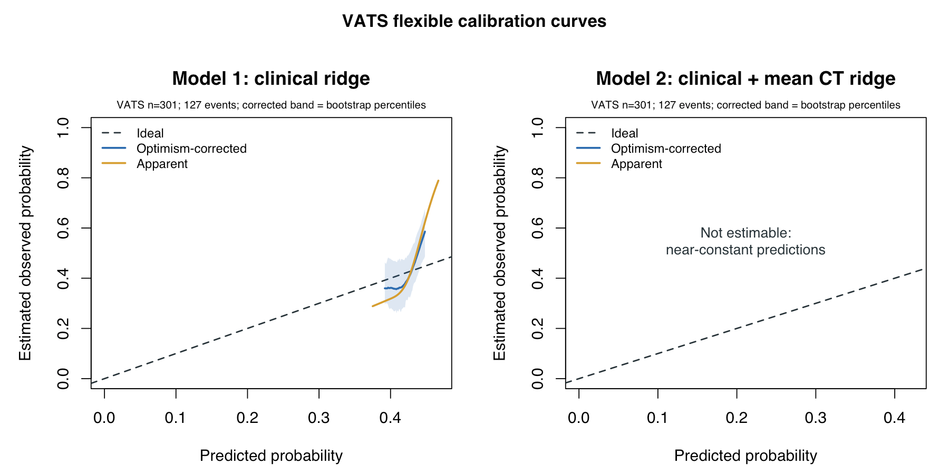
Supplementary Figure S1. Apparent and optimism-corrected calibration of the primary models in the VATS development cohort. Calibration performance is shown for the clinical ridge model (Model 1) and clinical-plus-mean-CT ridge model (Model 2). Optimism correction was based on 1,000 full-pipeline bootstrap repetitions. Curves are displayed only where the prespecified prediction-variation and estimability requirements were satisfied. Model 2’s calibration curve was nonestimable because its heavily regularized predictions showed insufficient variation. CT, computed tomography; VATS, video-assisted thoracoscopic surgery.

Supplementary Table S4. Locked esophagectomy performance of all frozen models
Model | AUROC | AUPRC | Brier score | Log loss | Calibration intercept | Calibration slope | O/E ratio
Clinical ridge | 0.530 (0.457–0.608) | 0.249 (0.217–0.315) | 0.219 (0.217–0.220) | 0.631 (0.627–0.634) | −0.919 (−0.926 to −0.912) | 1.145 (−2.889 to 5.775) | 0.540 (0.538–0.542)
Clinical-plus-mean-CT ridge | 0.534 (0.456–0.613) | 0.259 (0.219–0.336) | 0.215 (0.215–0.215) | 0.622 (0.622–0.622) | −0.871 (−0.871 to −0.871) | NE | 0.555 (0.555–0.555)
Clinical elastic net | 0.583 (0.511–0.658) | 0.266 (0.233–0.325) | 0.219 (0.217–0.222) | 0.632 (0.627–0.636) | −0.939 (−0.949 to −0.929) | 2.938 (0.241–6.101) | 0.534 (0.531–0.537)
Clinical-plus-mean-CT elastic net | 0.584 (0.510–0.660) | 0.282 (0.240–0.361) | 0.216 (0.212–0.220) | 0.624 (0.616–0.632) | −0.912 (−0.929 to −0.895) | 1.727 (0.151–3.609) | 0.543 (0.538–0.548)
Clinical-plus-muscle ridge | 0.539 (0.461–0.618) | 0.262 (0.223–0.340) | 0.215 (0.214–0.215) | 0.622 (0.622–0.623) | −0.874 (−0.876 to −0.873) | 10.961 (−10.116 to 34.233) | 0.554 (0.553–0.554)
Clinical-plus-fat ridge | 0.523 (0.450–0.601) | 0.243 (0.213–0.305) | 0.215 (0.215–0.215) | 0.622 (0.622–0.622) | −0.871 (−0.871 to −0.871) | NE | 0.555 (0.555–0.555)
Individual-CT ridge | 0.550 (0.469–0.625) | 0.273 (0.228–0.361) | 0.214 (0.213–0.216) | 0.621 (0.618–0.624) | −0.875 (−0.881 to −0.868) | 2.615 (−1.903 to 7.560) | 0.554 (0.552–0.556)
Notes: Values are estimates with 95% stratified bootstrap CIs. Calibration and prediction-error measures compare procedure-specific LOS constructs. NE, nonestimable; O/E, observed-to-expected.

Supplementary Table S5. Locked bootstrap completion and estimability
Model | Requested | Successful | Failed | Repetitions with nonestimable metrics | Estimable calibration curves
Clinical ridge | 2,000 | 2,000 | 0 | 0 | 2,000
Clinical-plus-mean-CT ridge | 2,000 | 2,000 | 0 | 2,000 | 0
Clinical elastic net | 2,000 | 2,000 | 0 | 0 | Not requested
Clinical-plus-mean-CT elastic net | 2,000 | 2,000 | 0 | 0 | Not requested
Clinical-plus-muscle ridge | 2,000 | 2,000 | 0 | 0 | Not requested
Clinical-plus-fat ridge | 2,000 | 2,000 | 0 | 2,000 | Not requested
Individual-CT ridge | 2,000 | 2,000 | 0 | 0 | Not requested
Notes: Metric-specific nonestimability was not counted as execution failure.

Supplementary Table S6. Frozen target-cohort prediction distributions
Model | Mean | SD | Minimum | 2.5th percentile | Median | 97.5th percentile | Maximum
Clinical ridge | 0.4337 | 0.01504 | 0.3921 | 0.4037 | 0.4342 | 0.4601 | 0.4806
Clinical-plus-mean-CT ridge | 0.4221 | 0.00036 | 0.4210 | 0.4213 | 0.4221 | 0.4227 | 0.4232
Clinical elastic net | 0.4383 | 0.02214 | 0.3800 | 0.3953 | 0.4399 | 0.4781 | 0.4987
Clinical-plus-mean-CT elastic net | 0.4309 | 0.03836 | 0.3315 | 0.3552 | 0.4342 | 0.4987 | 0.5390
Clinical-plus-muscle ridge | 0.4229 | 0.00309 | 0.4137 | 0.4168 | 0.4231 | 0.4284 | 0.4328
Clinical-plus-fat ridge | 0.4222 | 0.00023 | 0.4215 | 0.4217 | 0.4222 | 0.4226 | 0.4229
Individual-CT ridge | 0.4228 | 0.01482 | 0.3769 | 0.3923 | 0.4241 | 0.4493 | 0.4699
Notes: Each model was applied to 299 patients; observed event prevalence was 0.2341. SD, standard deviation.
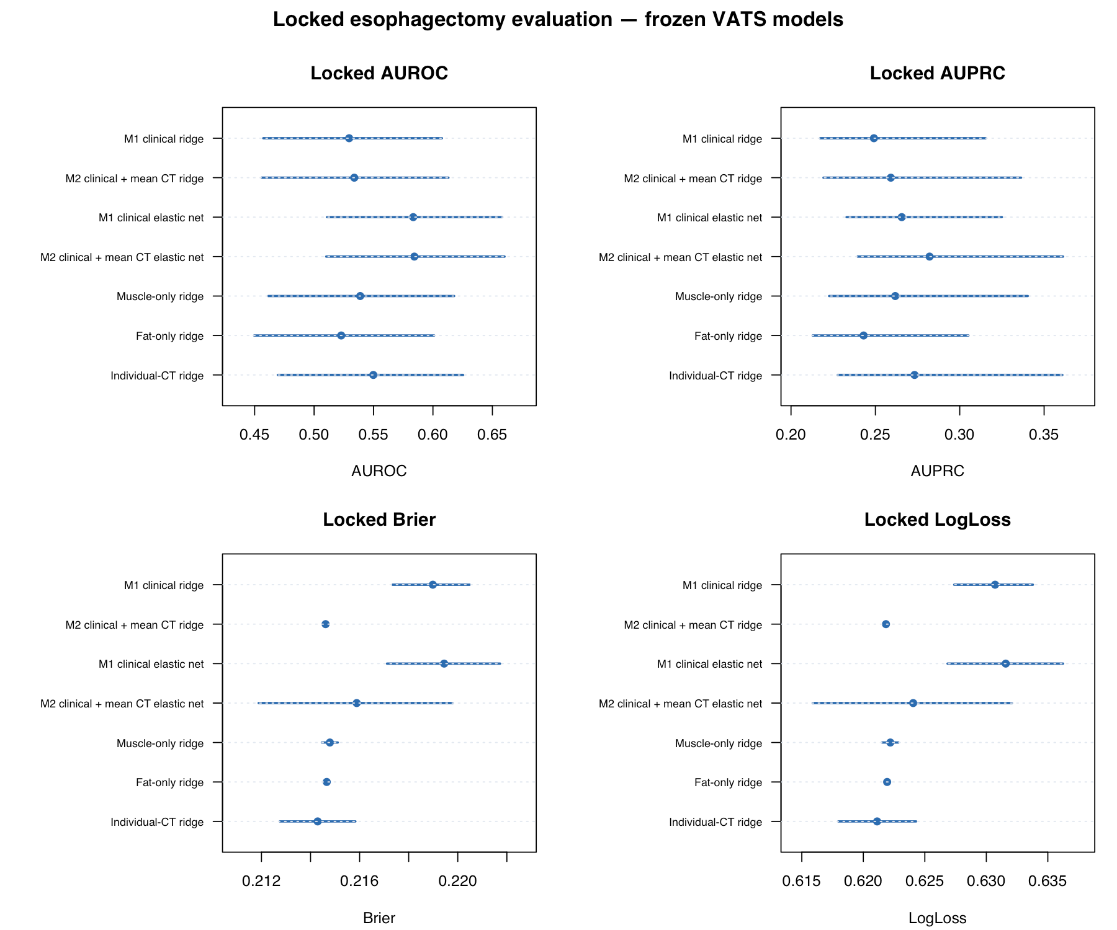Supplementary Figure S2. Locked esophagectomy evaluation of all frozen VATS models. Performance estimates are shown for the primary, secondary, and sensitivity models applied without modification to the esophagectomy cohort. Results represent the archived locked evaluation before recalibration or target-cohort adaptation. The VATS and esophagectomy cohorts used procedure-specific definitions of prolonged postoperative length of stay.

Supplementary Table S7. Full-cohort post-evaluation recalibration parameters
Model | Method | Intercept (95% CI) | Slope (95% CI) | Effective bootstraps | Status
Clinical ridge | Intercept only | −0.919 (−0.926 to −0.912) | 1.000, fixed | 2,000 | Completed
Clinical ridge | Intercept and slope | −0.881 (−1.966 to 0.334) | 1.145 (−2.889 to 5.775) | 2,000 | Completed
Clinical-plus-mean-CT ridge | Intercept only | −0.871 (−0.871 to −0.871) | 1.000, fixed | 2,000 | Completed
Clinical-plus-mean-CT ridge | Intercept and slope | NE | NE | 0 | Nonestimable
Notes: Full-cohort recalibration results are descriptive because recalibration and assessment used the same patients.
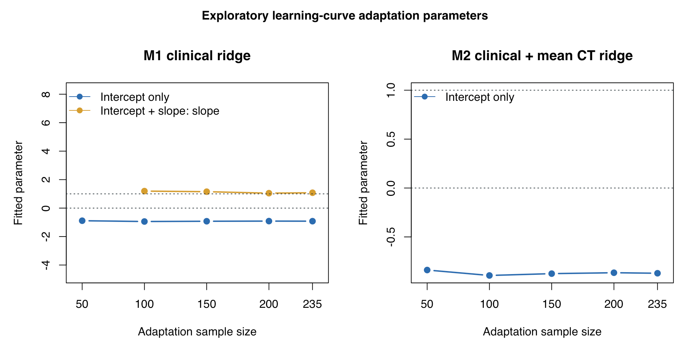Supplementary Figure S3. Post-evaluation recalibration and updating parameters. Parameter estimates were obtained only after the locked esophagectomy evaluation had been completed and archived. These exploratory analyses did not modify the frozen VATS models or replace the primary transportability results.

Supplementary Table S8. Complete exploratory learning-curve performance
Model | Adaptation n | Method | AUROC | AUPRC | Brier score | Log loss | Usable repetitions
Model 1 | 50 | Intercept only | 0.528 (0.525–0.531) | 0.248 (0.243–0.252) | 0.179 (0.179–0.179) | 0.544 (0.544–0.544) | 50/50
Model 1 | 100 | Intercept only | 0.529 (0.525–0.531) | 0.249 (0.245–0.252) | 0.179 (0.179–0.179) | 0.544 (0.544–0.544) | 50/50
Model 1 | 100 | Intercept and slope | 0.486 (0.407–0.547) | 0.232 (0.198–0.262) | 0.182 (0.179–0.186) | 0.551 (0.542–0.562) | 50/50
Model 1 | 150 | Intercept only | 0.529 (0.526–0.531) | 0.249 (0.246–0.251) | 0.179 (0.179–0.179) | 0.544 (0.544–0.544) | 50/50
Model 1 | 150 | Intercept and slope | 0.480 (0.406–0.528) | 0.227 (0.197–0.253) | 0.181 (0.179–0.185) | 0.549 (0.544–0.561) | 50/50
Model 1 | 200 | Intercept only | 0.529 (0.527–0.531) | 0.249 (0.247–0.250) | 0.179 (0.179–0.179) | 0.544 (0.544–0.544) | 50/50
Model 1 | 200 | Intercept and slope | 0.473 (0.408–0.526) | 0.225 (0.195–0.249) | 0.181 (0.179–0.183) | 0.548 (0.544–0.555) | 50/50
Model 1 | 200 | Ridge coefficient revision | 0.536 (0.519–0.567) | 0.251 (0.236–0.277) | 0.179 (0.179–0.180) | 0.544 (0.542–0.546) | 50/50
Model 1 | 235 | Intercept only | 0.529 (0.528–0.531) | 0.249 (0.247–0.250) | 0.179 (0.179–0.179) | 0.544 (0.544–0.544) | 50/50
Model 1 | 235 | Intercept and slope | 0.471 (0.400–0.519) | 0.223 (0.197–0.248) | 0.180 (0.179–0.182) | 0.547 (0.544–0.553) | 50/50
Model 1 | 235 | Ridge coefficient revision | 0.538 (0.513–0.569) | 0.249 (0.232–0.270) | 0.179 (0.179–0.180) | 0.544 (0.542–0.545) | 50/50
Model 2 | 50 | Intercept only | 0.535 (0.531–0.539) | 0.259 (0.255–0.264) | 0.179 (0.179–0.179) | 0.544 (0.544–0.544) | 50/50
Model 2 | 100 | Intercept only | 0.535 (0.531–0.537) | 0.259 (0.256–0.262) | 0.179 (0.179–0.179) | 0.544 (0.544–0.544) | 50/50
Model 2 | 100 | Intercept and slope | NE | NE | NE | NE | 0/50
Model 2 | 150 | Intercept only | 0.534 (0.532–0.537) | 0.259 (0.256–0.261) | 0.179 (0.179–0.179) | 0.544 (0.544–0.544) | 50/50
Model 2 | 150 | Intercept and slope | NE | NE | NE | NE | 0/50
Model 2 | 200 | Intercept only | 0.534 (0.533–0.536) | 0.259 (0.257–0.261) | 0.179 (0.179–0.179) | 0.544 (0.544–0.544) | 50/50
Model 2 | 200 | Intercept and slope | NE | NE | NE | NE | 0/50
Model 2 | 200 | Ridge coefficient revision | 0.570 (0.514–0.610) | 0.275 (0.245–0.312) | 0.179 (0.179–0.180) | 0.544 (0.542–0.546) | 50/50
Model 2 | 235 | Intercept only | 0.534 (0.532–0.536) | 0.259 (0.257–0.261) | 0.179 (0.179–0.179) | 0.544 (0.544–0.544) | 50/50
Model 2 | 235 | Intercept and slope | NE | NE | NE | NE | 0/50
Model 2 | 235 | Ridge coefficient revision | 0.575 (0.524–0.617) | 0.274 (0.242–0.309) | 0.179 (0.179–0.180) | 0.544 (0.542–0.546) | 50/50
Notes: Values are means with empirical 2.5th–97.5th percentile stability intervals. These are not independent-cohort CIs.

Supplementary Table S9. Learning-curve failures and nonestimability
Model | Adaptation n | Method | Successful outer fits | Usable repetitions | Interpretation
Model 2 | 100 | Intercept and slope | 0/250 | 0/50 | Nonestimable under the practical-null rule
Model 2 | 150 | Intercept and slope | 0/250 | 0/50 | Nonestimable under the practical-null rule
Model 2 | 200 | Intercept and slope | 0/250 | 0/50 | Nonestimable under the practical-null rule
Model 2 | 235 | Intercept and slope | 0/250 | 0/50 | Nonestimable under the practical-null rule
Model 2 | 200 | Ridge coefficient revision | 250/250 | 50/50 | Completed; 10 metric-specific nonestimable values
Model 2 | 235 | Ridge coefficient revision | 250/250 | 50/50 | Completed; 3 metric-specific nonestimable values
All other eligible combinations | All | As specified | All completed | 50/50 | No model-fitting failure
Notes: Metric-specific nonestimability was retained and was not treated as model-execution failure.

Supplementary Table S10. Selected learning-curve updating-parameter distributions
Model | Adaptation n | Method | Parameter | Successful fits | Mean (empirical 2.5th–97.5th percentile)
Model 1 | 50 | Intercept only | Intercept | 250/250 | −0.887 (−0.901 to −0.872)
Model 1 | 100 | Intercept only | Intercept | 250/250 | −0.942 (−0.952 to −0.932)
Model 1 | 100 | Intercept and slope | Intercept | 250/250 | −0.828 (−2.511 to 0.927)
Model 1 | 100 | Intercept and slope | Slope | 250/250 | 1.473 (−4.735 to 8.281)
Model 1 | 150 | Intercept only | Intercept | 250/250 | −0.924 (−0.932 to −0.917)
Model 1 | 150 | Intercept and slope | Intercept | 250/250 | −0.857 (−1.941 to 0.453)
Model 1 | 150 | Intercept and slope | Slope | 250/250 | 1.267 (−2.788 to 6.251)
Model 1 | 200 | Intercept only | Intercept | 250/250 | −0.914 (−0.919 to −0.910)
Model 1 | 200 | Intercept and slope | Intercept | 250/250 | −0.870 (−1.647 to −0.093)
Model 1 | 200 | Intercept and slope | Slope | 250/250 | 1.174 (−1.738 to 4.147)
Model 1 | 200 | Ridge coefficient revision | λ | 250/250 | 35.720 (0.327–68.279)
Model 1 | 200 | Ridge coefficient revision | Maximum absolute coefficient change | 250/250 | 0.014 (0.001–0.118)
Model 1 | 235 | Intercept only | Intercept | 250/250 | −0.920 (−0.923 to −0.916)
Model 1 | 235 | Intercept and slope | Intercept | 250/250 | −0.887 (−1.446 to −0.310)
Model 1 | 235 | Intercept and slope | Slope | 250/250 | 1.124 (−0.980 to 3.298)
Model 1 | 235 | Ridge coefficient revision | λ | 250/250 | 25.286 (0.250–58.822)
Model 1 | 235 | Ridge coefficient revision | Maximum absolute coefficient change | 250/250 | 0.022 (0.001–0.121)
Model 2 | 50 | Intercept only | Intercept | 250/250 | −0.838 (−0.839 to −0.838)
Model 2 | 100 | Intercept only | Intercept | 250/250 | −0.894 (−0.894 to −0.894)
Model 2 | 100 | Intercept and slope | Intercept and slope | 0/250 | NE
Model 2 | 150 | Intercept only | Intercept | 250/250 | −0.875 (−0.875 to −0.875)
Model 2 | 150 | Intercept and slope | Intercept and slope | 0/250 | NE
Model 2 | 200 | Intercept only | Intercept | 250/250 | −0.866 (−0.866 to −0.866)
Model 2 | 200 | Intercept and slope | Intercept and slope | 0/250 | NE
Model 2 | 200 | Ridge coefficient revision | λ | 250/250 | 34.322 (0.266–67.824)
Model 2 | 200 | Ridge coefficient revision | Maximum absolute coefficient change | 250/250 | 0.020 (0.001–0.137)
Model 2 | 235 | Intercept only | Intercept | 250/250 | −0.871 (−0.871 to −0.871)
Model 2 | 235 | Intercept and slope | Intercept and slope | 0/250 | NE
Model 2 | 235 | Ridge coefficient revision | λ | 250/250 | 26.045 (0.233–54.306)
Model 2 | 235 | Ridge coefficient revision | Maximum absolute coefficient change | 250/250 | 0.024 (0.001–0.149)
Notes: Values summarize outer-fold parameter estimates. NE, nonestimable.

Supplementary File S3. Specification of the Frozen VATS Prediction Models
This supplementary file provides the information required to reproduce the predicted probabilities generated by the two primary VATS models evaluated in the main manuscript. It forms part of the same study and does not describe a separate investigation. Reference numbers in this supplementary file correspond to the reference list in the main manuscript.

SF3.1 Status and origin of the frozen VATS models
Both VATS prediction models were developed de novo for the present study and had not previously been published. Model 1 was a clinical ridge-penalized logistic-regression model, and Model 2 was a clinical-plus-computed-tomography (CT) ridge-penalized logistic-regression model.
Before application to the esophagectomy cohort, the predictor definitions, variable-coding rules, preprocessing parameters, CT-composite formulas, ridge penalties, intercepts, coefficients, and probability-calculation procedures were frozen and archived. No target-cohort predictor selection, transformation modification, penalty tuning, coefficient estimation, or threshold optimization was performed before the locked evaluation.
In this study, the term “frozen VATS score” refers to the predicted probability generated by one of these locked VATS models. It does not refer to a previously published clinical scoring system.

SF3.2 Clarification of the Brier score
The Brier score was not developed in this study and was not used as a predictor or patient-level clinical score. It is an established statistical measure of probabilistic prediction error [16,17]. For a binary outcome, it was calculated as:
Brier score = (1/n) Σ(yᵢ − pᵢ)²,
where n is the number of patients, yᵢ is the observed binary outcome for patient i, and pᵢ is the corresponding predicted probability. Lower Brier scores indicate smaller average squared differences between observed outcomes and predicted probabilities.

SF3.3 Source-model outcome
The two models were developed to estimate the probability of procedure-specific prolonged postoperative length of stay (LOS) after video-assisted thoracoscopic surgery (VATS). The source outcome was coded as:
0: postoperative LOS of 7 days or less.
1: postoperative LOS longer than 7 days.
The VATS development cohort contained 301 patients, including 127 patients with prolonged LOS.
During the locked cross-procedure evaluation, the frozen models were applied to an esophagectomy cohort in which prolonged LOS was defined as hospitalization for more than 15 days. The VATS and esophagectomy outcomes were therefore clinically related but nonidentical procedure-specific constructs. The analysis was interpreted as cross-procedure transportability rather than conventional external validation of an identical outcome.

SF3.4 Predictor definitions and coding
The following predictor definitions and coding rules were used:
Predictor | Definition and coding
Age | Age in years
Sex | Female = 0; male = 1
Body mass index | kg/m²
Smoking history | No = 0; yes = 1
Hypertension | No = 0; yes = 1
Serum albumin | g/L
FEV₁ | Percentage predicted
DLCO | Percentage predicted
Mean thoracic muscle thickness | Millimetres
Mean thoracic fat thickness | Millimetres
Notes: DLCO, diffusing capacity of the lung for carbon monoxide; FEV₁, forced expiratory volume in 1 second.

SF3.5 CT-composite definitions
Thoracic muscle and subcutaneous fat thicknesses were measured in millimetres at the T5, T8, and T10 vertebral levels. The two CT composites were calculated as:
Mean thoracic muscle thickness = (T5 muscle thickness + T8 muscle thickness + T10 muscle thickness)/3.
Mean thoracic fat thickness = (T5 fat thickness + T8 fat thickness + T10 fat thickness)/3.
The three vertebral levels received equal weight. No outcome-derived weighting, level-specific normalization, sex-specific threshold, target-cohort scaling, or post-evaluation transformation was applied.

SF3.6 Predicted-probability calculation
For each model, the linear predictor was calculated as:
η = intercept + Σ(βᵢXᵢ).
The corresponding predicted probability was calculated as:
Predicted probability = 1/[1 + exp(−η)].
The equations below use predictors in their original clinical units. The raw-input coefficients already incorporate the frozen VATS preprocessing transformation. Therefore, the predictors must not be standardized again when these raw-input equations are used.

SF3.7 Model 1: clinical ridge model
Model 1 contained eight prespecified clinical predictors. Its frozen raw-input linear predictor was:
η₁ = −0.40748721
0.00578767 × age in years
0.00907750 × male sex
− 0.00673823 × body mass index in kg/m²
0.00352204 × smoking history
− 0.00055627 × hypertension
− 0.00699617 × serum albumin in g/L
0.00204197 × FEV₁ percentage predicted
− 0.00033256 × DLCO percentage predicted.

The Model 1 predicted probability was:
P₁ = 1/[1 + exp(−η₁)].
The frozen Model 1 ridge penalty was λ = 1.14206340.
Table SF3.1 Frozen raw-input coefficients for Model 1
Predictor | Coefficient
Intercept | −0.40748721
Age, years | 0.00578767
Male sex | 0.00907750
Body mass index, kg/m² | −0.00673823
Smoking history | 0.00352204
Hypertension | −0.00055627
Serum albumin, g/L | −0.00699617
FEV₁, % predicted | 0.00204197
DLCO, % predicted | −0.00033256

SF3.8 Model 2: clinical-plus-mean-CT ridge model
Model 2 contained the eight clinical predictors from Model 1 together with mean thoracic muscle thickness and mean thoracic fat thickness. Its frozen raw-input linear predictor was:
η₂ = −0.31186913
0.00008865 × age in years
0.00012516 × male sex
− 0.00010752 × body mass index in kg/m²
0.00003949 × smoking history
− 0.00001426 × hypertension
− 0.00010861 × serum albumin in g/L
0.00003495 × FEV₁ percentage predicted
0.00000452 × DLCO percentage predicted
− 0.00019848 × mean thoracic muscle thickness in mm
− 0.00001807 × mean thoracic fat thickness in mm.
The Model 2 predicted probability was:
P₂ = 1/[1 + exp(−η₂)].
The frozen Model 2 ridge penalty was λ = 90.45329513.
Table SF3.1 Frozen raw-input coefficients for Model 2
Predictor | Coefficient
Intercept | −0.31186913
Age, years | 0.00008865
Male sex | 0.00012516
Body mass index, kg/m² | −0.00010752
Smoking history | 0.00003949
Hypertension | −0.00001426
Serum albumin, g/L | −0.00010861
FEV₁, % predicted | 0.00003495
DLCO, % predicted | 0.00000452
Mean thoracic muscle thickness, mm | −0.00019848
Mean thoracic fat thickness, mm | −0.00001807
The large Model 2 penalty produced extensive coefficient shrinkage. This resulted in a narrow distribution of predicted probabilities. The resulting prediction behavior was retained during the locked esophagectomy evaluation and was not modified through target-cohort refitting.

SF3.9 Frozen preprocessing parameters
During model fitting, continuous predictors were standardized using means and standard deviations estimated from the VATS development cohort:
Standardized value = (observed value − VATS center)/VATS scale.
The frozen preprocessing parameters were:
Predictor | VATS center | VATS scale
Age, years | 60.667774 | 11.246152
Body mass index, kg/m² | 23.343987 | 3.448375
Serum albumin, g/L | 35.810133 | 3.549914
FEV₁, % predicted | 82.956811 | 7.404152
DLCO, % predicted | 77.953488 | 7.843330
Mean thoracic muscle thickness, mm | 25.434252 | 4.293086
Mean thoracic fat thickness, mm | 13.910842 | 5.857754
These VATS-derived parameters were applied unchanged during the locked esophagectomy evaluation. Binary predictors retained their prespecified 0/1 coding and were not standardized.
These preprocessing parameters document the original frozen pipeline. They should not be applied in addition to the raw-input equations presented in Sections SF3.7 and SF3.8 because those equations already incorporate the preprocessing transformation.

SF3.10 Frozen-model application
Before locked evaluation, the following components were frozen:
Source outcome definition.
Predictor definitions and coding rules.
CT-composite formulas.
Preprocessing centers and scales.
Model classes.
Ridge penalties.
Model intercepts and coefficients.
Probability-calculation procedures.
Performance measures.
Practical-null estimability rule.
Analytical code and configuration.
The frozen VATS preprocessing parameters, coefficients, penalties, and prediction rules were applied without modification to the 299 esophagectomy patients. Target-cohort data were not used to redefine predictors, estimate source-model coefficients, select the ridge penalties, or optimize classification thresholds before the locked evaluation.

SF3.11 Intended interpretation
The equations presented in this supplementary file reproduce the two frozen VATS prediction functions evaluated in the main manuscript. They are provided to satisfy reproducibility and reporting requirements. Neither model should currently be used for patient counseling, resource allocation, discharge planning, or other clinical decision-making without further procedure-specific development and independent validation.

