Table. 1 Baseline characteristics of all participants according to WBC quartiles
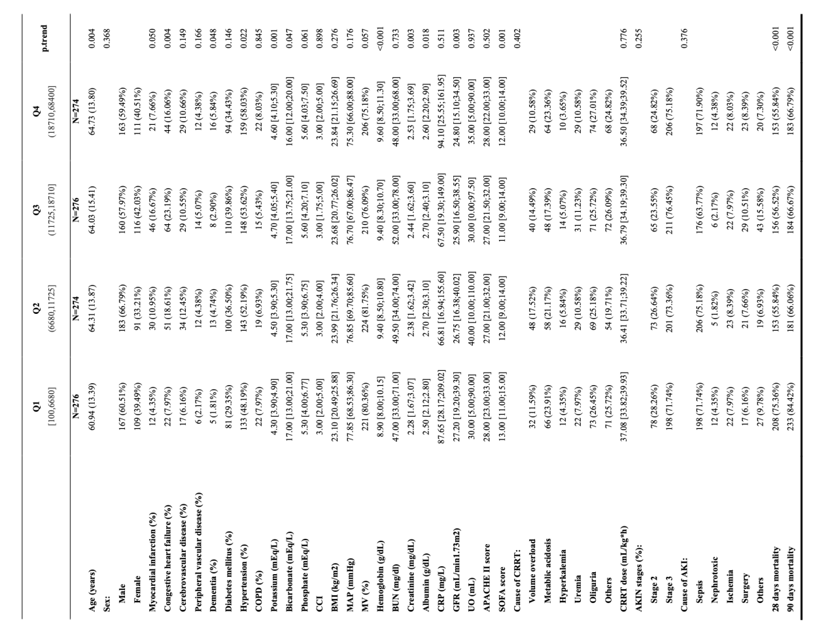
Continuous measures for normal distribution are expressed as mean ± SD, continuous measures for nonnormal distribution are expressed as interquartile range (IQR), and counts are expressed as n (%).
Continuous variables were compared between groups using ANOVA and Kruskal–Wallis analysis, with the chi-square test used for count data.
COPD: chronic kidney disease, CCI: Charlson Comorbidity Index, BMI: body mass index, MAP: mean arterial pressure, MV: mechanical ventilation, BUN: blood urea nitrogen, CRP: C-reactive protein, GFR: glomerular filtration rate, UO: urine output, APACHE II: Acute Physiology and Chronic Health Evaluation II, SOFA: Sequential Organ Failure Assessment.

Table.2 Cox regression analysis of WBC versus all-cause mortality in short-term (28 days) and long-term (90 days)
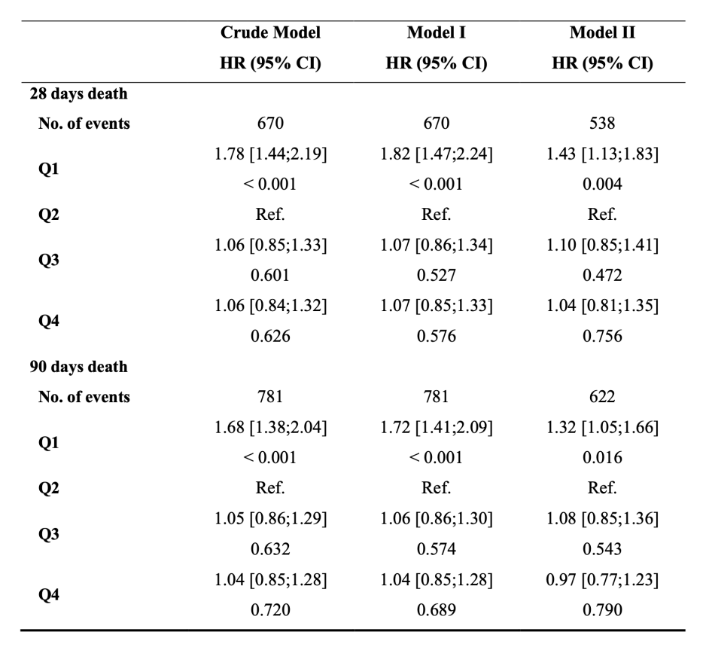
Crude model: unadjusted; Model I: adjusted for age and sex; Model II: adjusted for age, sex, DM, HTN, HCO3-, PO43-, CCI, MAP, MV, Hb, Cre, Alb, UO, APACHE II score, SOFA score, and Cause of CRRT.
DM: diabetes mellitus, HTN: hypertension, HCO₃⁻: bicarbonate, PO₄³⁻: phosphate, Hb: hemoglobin, Cre: creatinine, Alb: albumin, HR: hazard ratio, CI: confidence interval.

Table. 3 The relationship between WBC counts and all-cause mortality of different subgroups in short-term (28 days) and long-term (90 days)
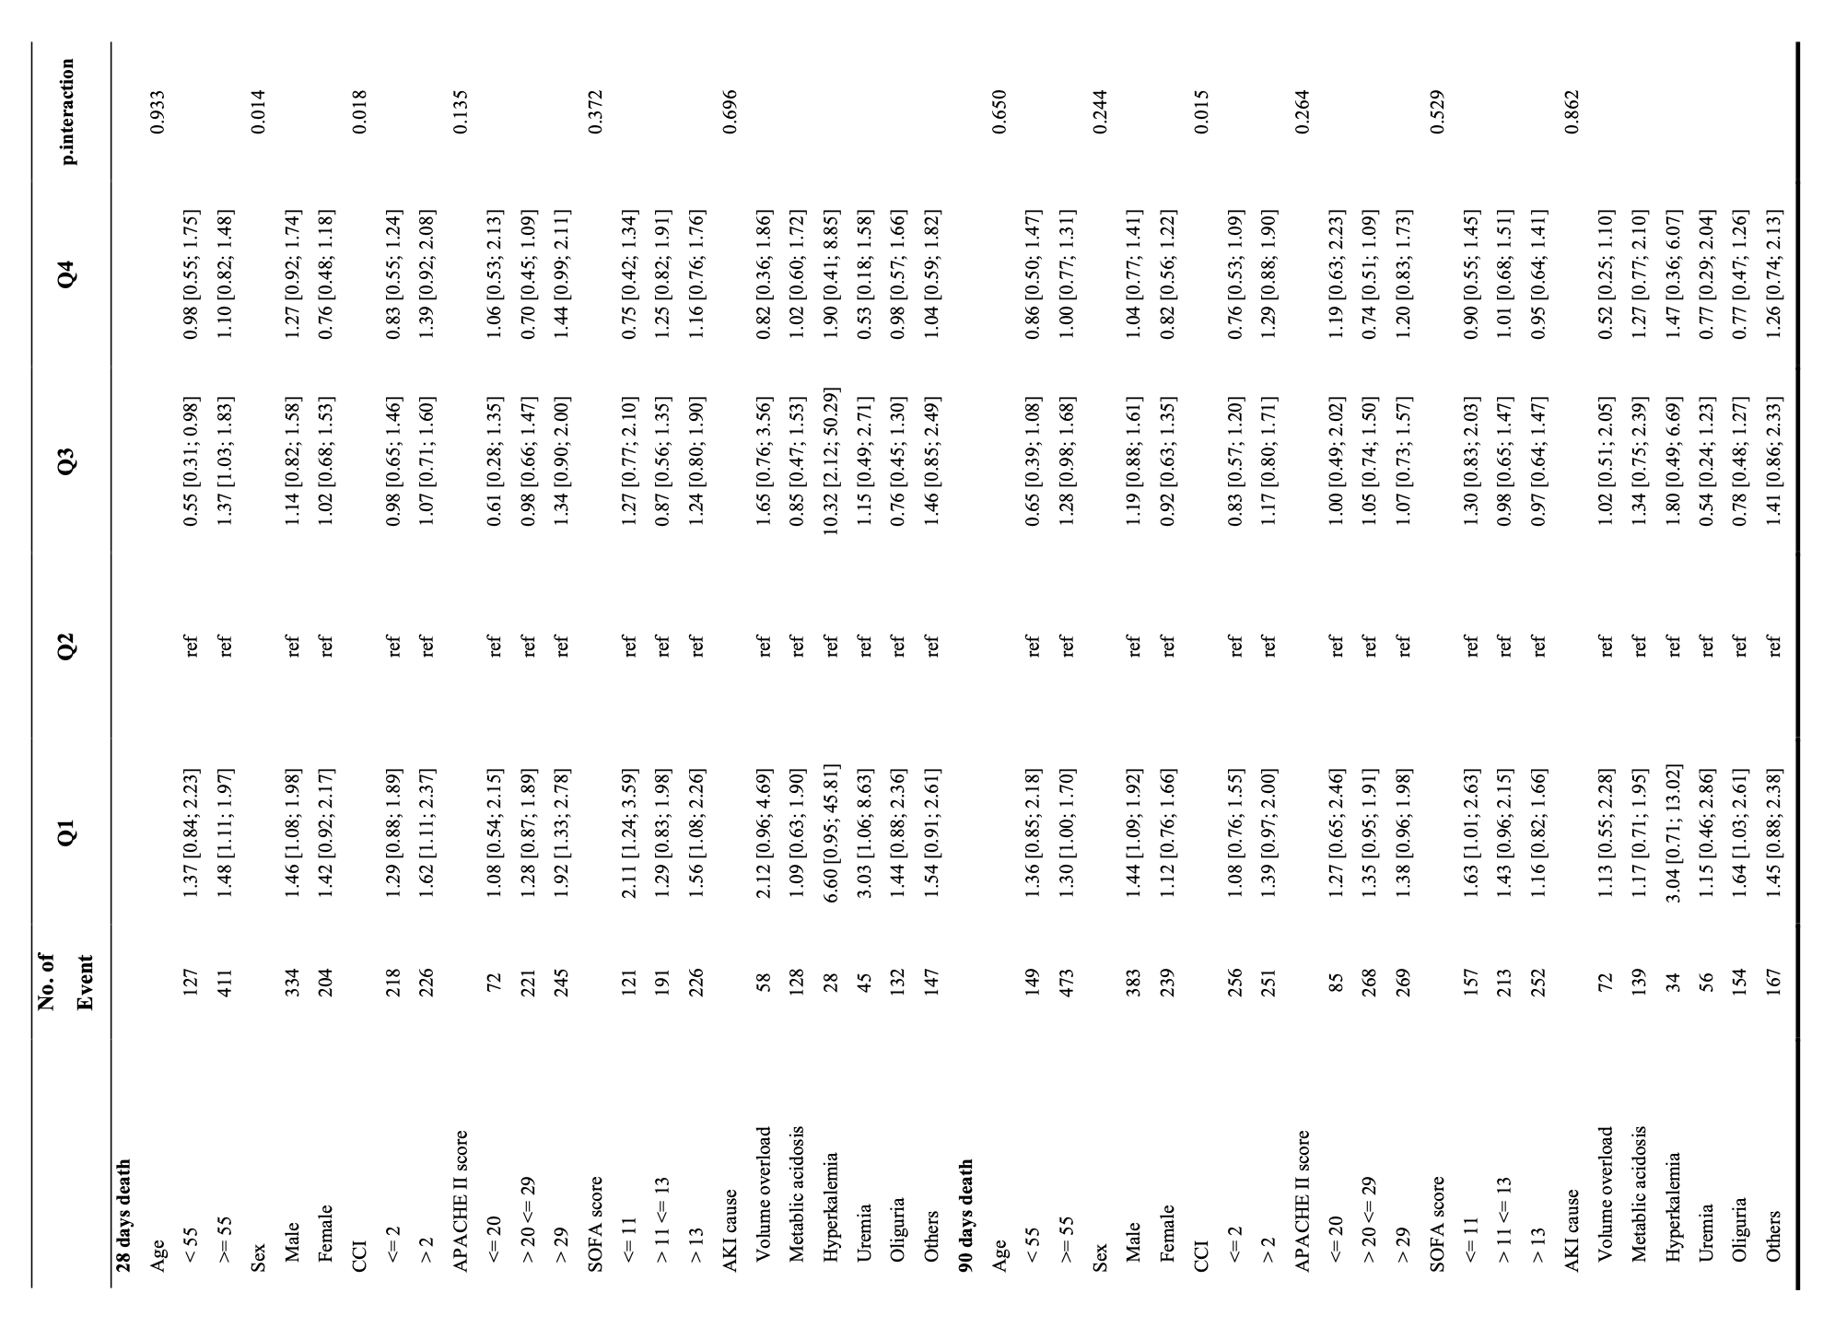

Except for its stratification variables, all models were adjusted for age, sex, DM, HTN, HCO₃⁻, PO₄³⁻, CCI, MAP, MV, Hb, Cre, Alb, UO, APACHE II score, SOFA score, Cause of CRRT.

