Supplementary Information

Supplementary Figures
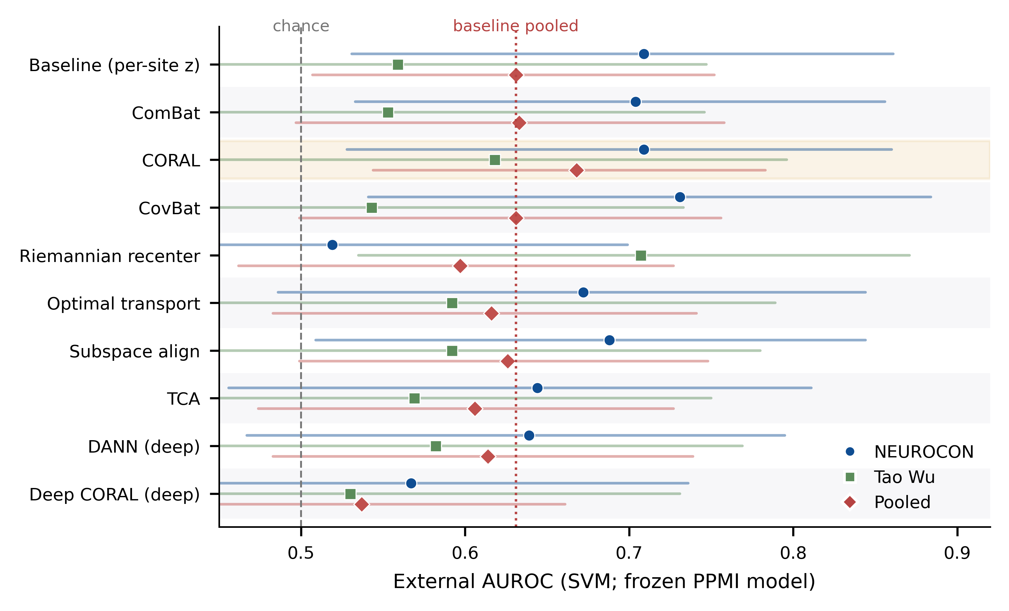
Supplementary Figure S1 | Domain-adaptation benchmark for cross-cohort transfer. External AUROC (SVM, frozen PPMI model) for ten harmonisation/transfer methods on NEUROCON (blue), Tao Wu (green) and the pooled cohort (red), with 95% bootstrap CIs. No method gave a significant gain; only CORAL was directionally consistent across both cohorts; deep adversarial methods under-performed at this sample size.

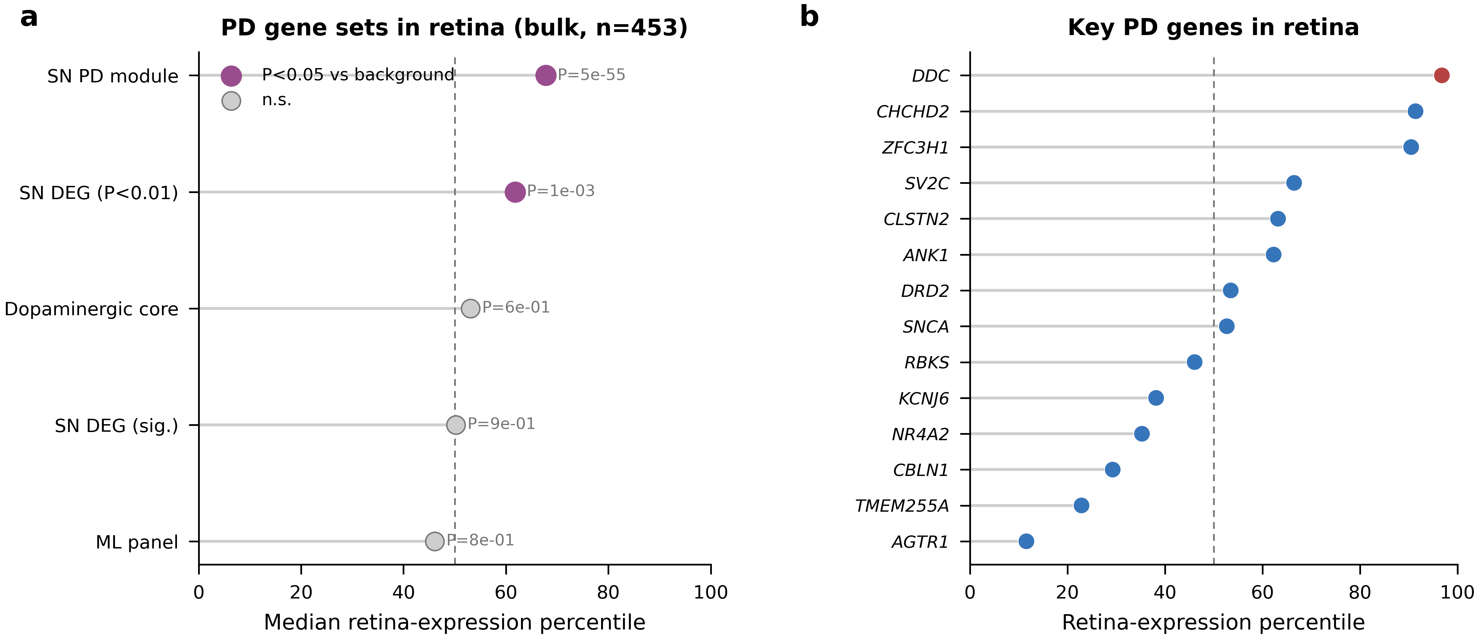
Supplementary Figure S2 | The PD substantia-nigra signature is expressed in bulk human retina. Expression percentile of PD gene sets in retina bulk RNA-seq (GSE115828, n=453) versus the genome-wide background; DDC at the 97th percentile, SLC6A3/DAT not retina-expressed.

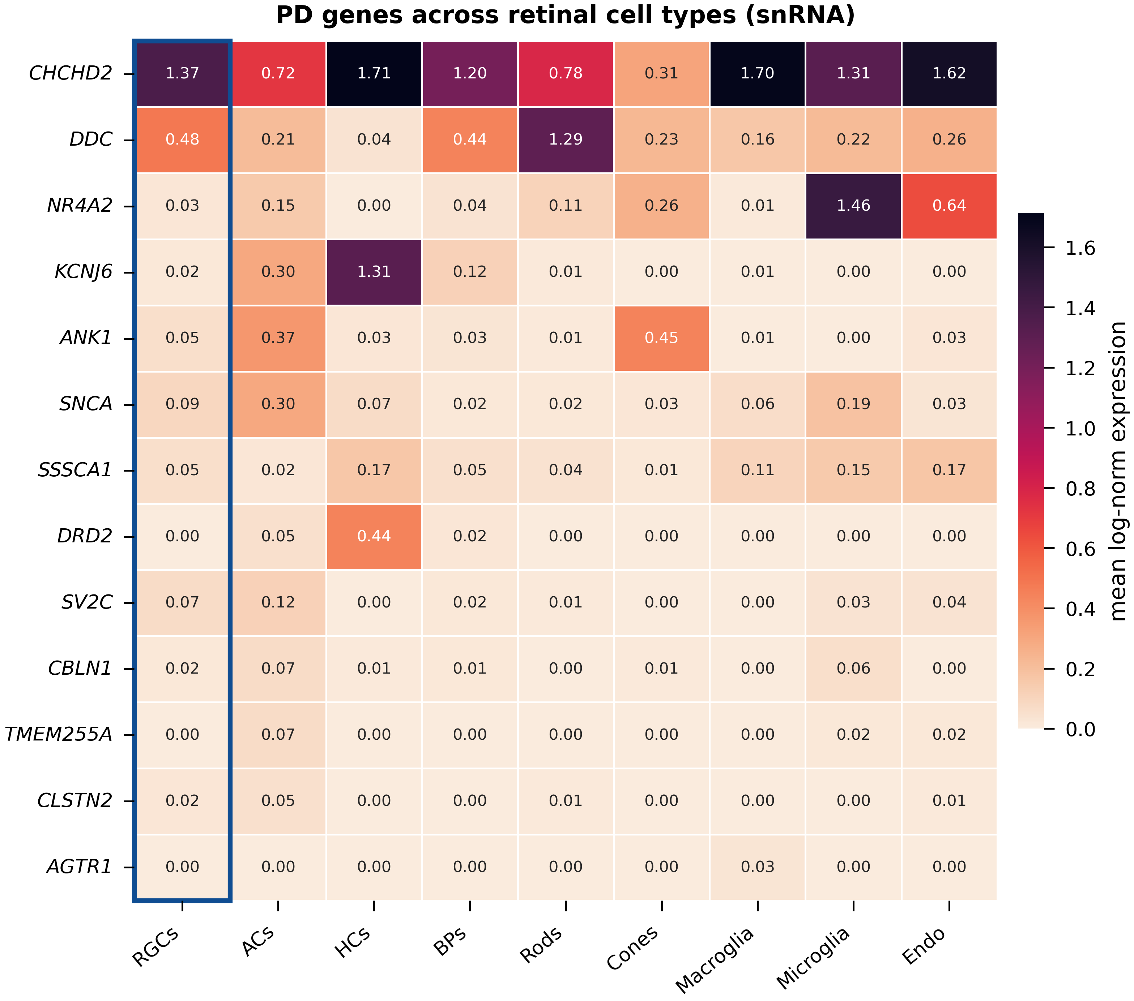
Supplementary Figure S3 | PD genes across retinal cell types (single-nucleus heatmap). Mean log-normalised expression of key PD genes across retinal cell types (GSE137537); RGC column outlined. Complements the EWCE enrichment in Figure 5.

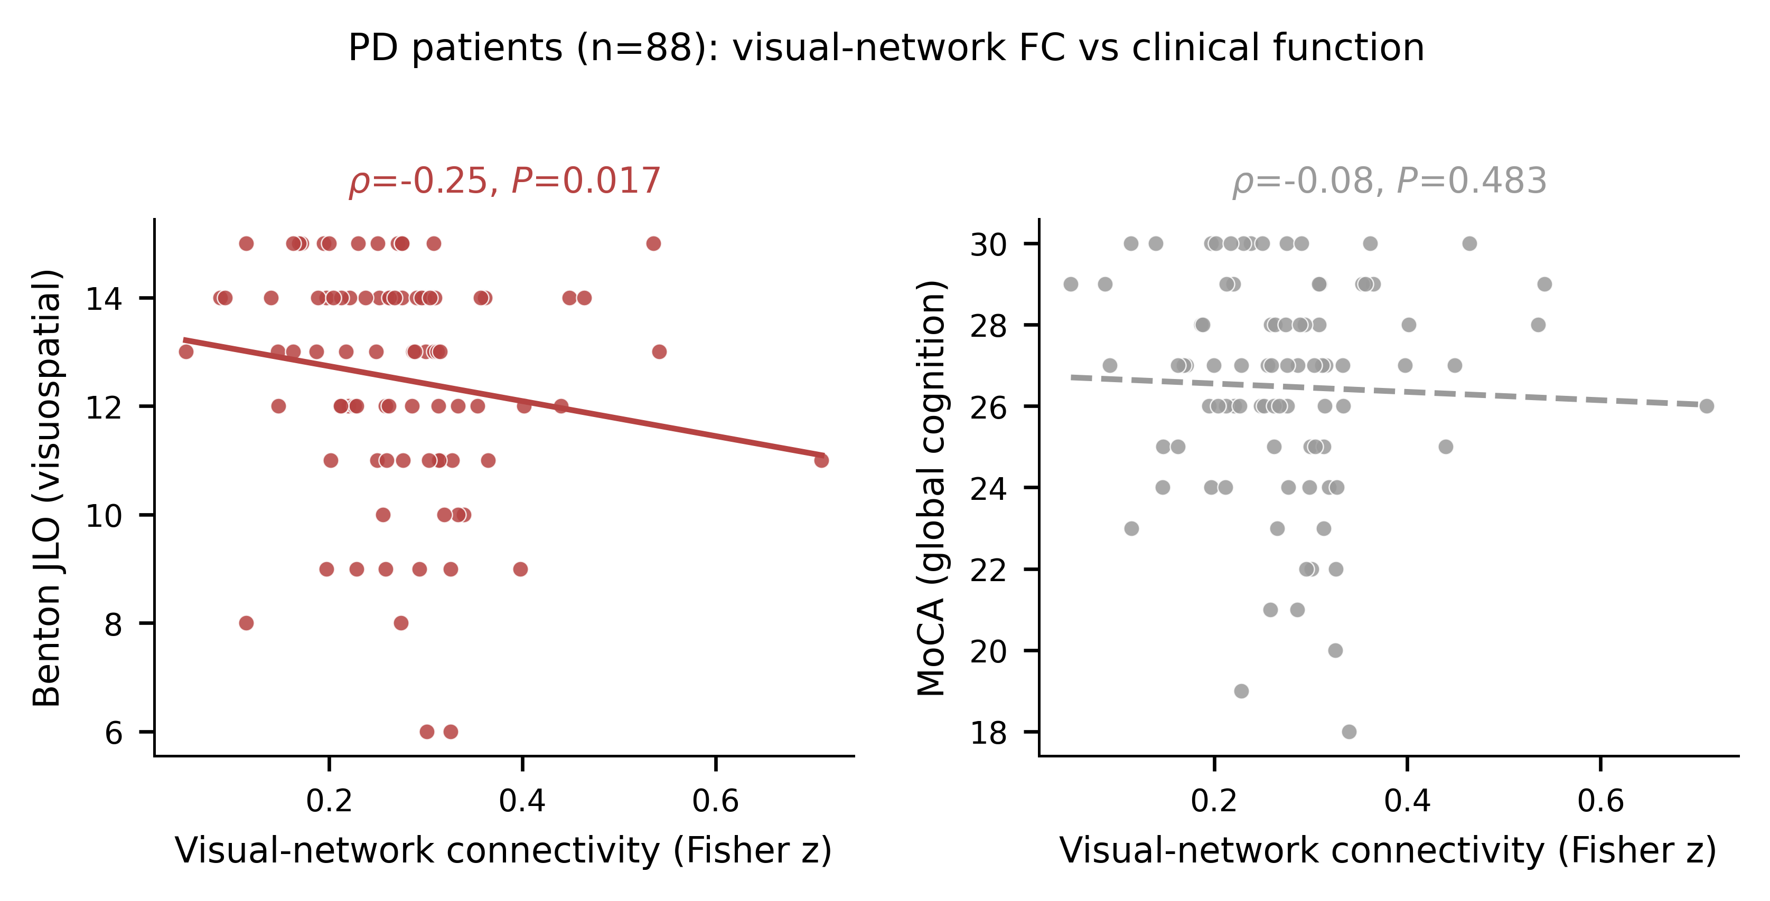
Supplementary Figure S4 | Visual-network connectivity and visuospatial function in patients. In PD patients (n=88), within-visual-network functional connectivity versus (left) Benton Judgment of Line Orientation (visuospatial; Spearman rho=-0.25, P=0.017) and (right) MoCA (global cognition; rho=-0.08, P=0.48). Lines are linear fits. The association was specific to visuospatial function and is reported as exploratory (nominal P, not corrected for the measures tested).
Supplementary Figure S5. Protein-level and independent retinal corroboration of the signature genes. Human Protein Atlas data for the 170-gene signature. (A) Retinal expression (log10 nTPM) of the signature genes versus a size-matched background; the distributions do not differ (Mann–Whitney P = 0.45), so no preferential retinal enrichment is claimed, yet 87% of signature genes are expressed (≥1 nTPM) and all carry antibody-based protein evidence. (B) Retinal expression of the dopaminergic core, with high DDC and near-absent SLC6A3, independently reproducing the synthesis-without-transport pattern. nTPM, normalised transcripts per million.
Supplementary Figure S6. The inner-retinal localization is specific within neurons. EWCE of the signature in the retina snRNA atlas with the bootstrap null restricted to neuronal genes (expression-matched). The signature remains enriched in retinal ganglion (z = 7.2) and amacrine (z = 5.7) cells and is depleted in photoreceptors; the result is unchanged after removing all dopaminergic genes — excluding a generic neuronal effect.

Supplementary Tables
Supplementary Table S1. Cross-cohort domain-adaptation benchmark. PD-versus-HC classification AUROC (95% bootstrap CI) of the frozen PPMI support-vector model evaluated in the two external cohorts and their pool after each of ten harmonization or domain-adaptation methods. No method used external diagnostic labels; ComBat was the pre-specified primary harmonizer. Only CORAL improved the pooled estimate while remaining consistent across both cohorts, and no method reached significance over the per-site z-score baseline, indicating protocol-level domain shift rather than a correctable batch effect. The complete table with sensitivity and specificity is provided in Supplementary_Table_S1_domain_adaptation.xlsx.
Method | Type | NEUROCON (n=42) | Tao Wu (n=35) | Pooled (n=77)
Baseline (per-site z-score) | reference | 0.71 [0.53–0.86] | 0.56 [0.36–0.75] | 0.63 [0.51–0.75]
ComBat | harmonization | 0.70 [0.53–0.86] | 0.55 [0.35–0.75] | 0.63 [0.50–0.76]
CORAL | 2nd-order alignment | 0.71 [0.53–0.86] | 0.62 [0.41–0.80] | 0.67 [0.54–0.78]
CovBat | harmonization | 0.73 [0.54–0.88] | 0.54 [0.33–0.73] | 0.63 [0.50–0.76]
Riemannian re-centering | SPD manifold | 0.52 [0.34–0.70] | 0.71 [0.54–0.87] | 0.60 [0.46–0.73]
Optimal transport (Sinkhorn) | optimal transport | 0.67 [0.49–0.84] | 0.59 [0.39–0.79] | 0.62 [0.48–0.74]
Subspace alignment | shallow transfer | 0.69 [0.51–0.84] | 0.59 [0.40–0.78] | 0.63 [0.50–0.75]
Transfer-component analysis (TCA) | shallow transfer | 0.64 [0.46–0.81] | 0.57 [0.36–0.75] | 0.61 [0.47–0.73]
DANN | deep domain-adapt. | 0.64 [0.47–0.80] | 0.58 [0.38–0.77] | 0.61 [0.48–0.74]
Deep CORAL | deep domain-adapt. | 0.57 [0.39–0.74] | 0.53 [0.33–0.73] | 0.54 [0.40–0.66]
Supplementary Table S2. Full differential-expression, gene-ontology, EWCE and retinal co-expression results. The significant subsets are tabulated below; the complete genome-wide tables are provided as a seven-sheet workbook (Supplementary_Table_S2_full_results.xlsx): S2a substantia-nigra differential expression (all 6,450 genes), S2b whole-blood differential expression (all 13,101 genes), S2c/S2d GO biological-process enrichment, S2e expression-weighted cell-type enrichment across the four gene sets, and S2f/S2g per-gene Spearman co-expression with the retinal dopamine score (single-nucleus and bulk). DEG, differentially expressed gene; FC, fold-change; EWCE, expression-weighted cell-type enrichment.
S2a. Substantia-nigra differentially expressed genes (FDR<0.05; 11 genes).
gene | logFC | AveExpr | t | P.Value | adj.P.Val
AGTR1 | -1.56 | 5.53 | -5.74 | 6.79e-08 | 2.61e-04
DDC | -2.04 | 6.9 | -5.7 | 8.08e-08 | 2.61e-04
SLC6A3 | -1.69 | 7.16 | -5.26 | 6.05e-07 | 0.00112
SV2C | -1.7 | 7.58 | -5.23 | 6.95e-07 | 0.00112
KCNJ6 | -1.58 | 6.7 | -4.98 | 2.04e-06 | 0.00264
DLK1 | -1.41 | 5.83 | -4.84 | 3.77e-06 | 0.00405
SSSCA1 | -0.93 | 4.72 | -4.36 | 2.66e-05 | 0.0245
TMEM255A | -1.12 | 7.45 | -4.22 | 4.57e-05 | 0.0358
ANK1 | -1.01 | 6.56 | -4.19 | 5.24e-05 | 0.0358
CLSTN2 | -1.08 | 5.82 | -4.17 | 5.55e-05 | 0.0358
CBLN1 | -1.08 | 5.52 | -4.15 | 6.16e-05 | 0.0361
S2b. Whole-blood differentially expressed genes (FDR<0.05; 28 genes).
gene | logFC | AveExpr | t | P.Value | adj.P.Val
PTGDS | 0.35 | 8.09 | 6.32 | 5.27e-10 | 6.90e-06
ADGRG3 | 0.27 | 8.62 | 6.06 | 2.53e-09 | 1.66e-05
BMX | 0.31 | 4.7 | 5.53 | 4.80e-08 | 9.92e-05
MMP9 | 0.37 | 9.53 | 5.38 | 1.08e-07 | 1.41e-04
SPI1 | 0.3 | 8.35 | 5.29 | 1.75e-07 | 1.55e-04
PDLIM7 | 0.28 | 7.35 | 5.19 | 2.89e-07 | 1.65e-04
ZYX | 0.27 | 9.62 | 5.04 | 6.20e-07 | 2.46e-04
GPX3 | 0.34 | 5.27 | 5 | 7.80e-07 | 2.56e-04
LOC100130872 | 0.28 | 7.92 | 4.86 | 1.50e-06 | 3.44e-04
LRRN3 | -0.45 | 6.34 | -4.8 | 2.01e-06 | 4.08e-04
FCAR | 0.31 | 6.15 | 4.8 | 2.02e-06 | 4.08e-04
G6PD | 0.27 | 8.08 | 4.8 | 2.02e-06 | 4.08e-04
ARG1 | 0.35 | 5.96 | 4.47 | 9.22e-06 | 0.00102
RPS4Y1 | 1.01 | 7.76 | 4.23 | 2.70e-05 | 0.00222
XIST | -1.24 | 7.53 | -4.2 | 3.12e-05 | 0.00235
TXLNGY | 0.67 | 4.54 | 4.12 | 4.30e-05 | 0.00292
TRAK2 | -0.28 | 8.05 | -4.05 | 5.71e-05 | 0.0035
DDX3Y | 0.72 | 4.53 | 4.05 | 5.91e-05 | 0.00359
RNF24 | 0.29 | 10.1 | 4.04 | 6.11e-05 | 0.00365
HBG2 | -0.3 | 12.9 | -3.83 | 1.43e-04 | 0.00649
CFD | 0.3 | 9.19 | 3.73 | 2.11e-04 | 0.00846
LILRA5 | 0.27 | 7.39 | 3.67 | 2.67e-04 | 0.0096
TUBB2A | -0.62 | 7.2 | -3.59 | 3.58e-04 | 0.0114
KDM5D | 0.61 | 4.96 | 3.54 | 4.30e-04 | 0.0129
EIF1AY | 0.62 | 4.21 | 3.44 | 6.32e-04 | 0.0168
USP9Y | 0.31 | 3.4 | 3.36 | 8.41e-04 | 0.0202
CA1 | -0.29 | 8.62 | -3.33 | 9.14e-04 | 0.0215
KRT1 | -0.29 | 8.54 | -3.2 | 0.00147 | 0.0298
S2c. Substantia-nigra GO biological-process enrichment (15 terms).
ID | Description | FoldEnrichment | Count | p.adjust | qvalue | geneID
GO:0042416 | dopamine biosynthetic process | 290 | 2 | 0.00549 | 0.00271 | DDC/SLC6A3
GO:0009713 | catechol-containing compound biosynthetic process | 157 | 2 | 0.00645 | 0.00319 | DDC/SLC6A3
GO:0042423 | catecholamine biosynthetic process | 157 | 2 | 0.00645 | 0.00319 | DDC/SLC6A3
GO:1904862 | inhibitory synapse assembly | 130 | 2 | 0.00711 | 0.00351 | CLSTN2/CBLN1
GO:0042401 | biogenic amine biosynthetic process | 94.3 | 2 | 0.00954 | 0.00472 | DDC/SLC6A3
GO:0009309 | amine biosynthetic process | 92 | 2 | 0.00954 | 0.00472 | DDC/SLC6A3
GO:0042417 | dopamine metabolic process | 83.8 | 2 | 0.00986 | 0.00488 | DDC/SLC6A3
GO:0046189 | phenol-containing compound biosynthetic process | 77 | 2 | 0.0102 | 0.00506 | DDC/SLC6A3
GO:0006584 | catecholamine metabolic process | 63.9 | 2 | 0.0119 | 0.00587 | DDC/SLC6A3
GO:0009712 | catechol-containing compound metabolic process | 63.9 | 2 | 0.0119 | 0.00587 | DDC/SLC6A3
GO:0051965 | positive regulation of synapse assembly | 52.4 | 2 | 0.0161 | 0.00795 | CLSTN2/CBLN1
GO:0006576 | biogenic amine metabolic process | 43.9 | 2 | 0.021 | 0.0104 | DDC/SLC6A3
GO:0009308 | amine metabolic process | 38.1 | 2 | 0.0256 | 0.0127 | DDC/SLC6A3
GO:0018958 | phenol-containing compound metabolic process | 32.2 | 2 | 0.0325 | 0.0161 | DDC/SLC6A3
GO:1901890 | positive regulation of cell junction assembly | 31.4 | 2 | 0.0325 | 0.0161 | CLSTN2/CBLN1
S2d. Whole-blood GO biological-process enrichment (6 terms).
ID | Description | FoldEnrichment | Count | p.adjust | qvalue | geneID
GO:0002444 | myeloid leukocyte mediated immunity | 26.6 | 4 | 0.00609 | 0.00469 | PTGDS/SPI1/FCAR/ARG1
GO:0002446 | neutrophil mediated immunity | 58.9 | 3 | 0.00609 | 0.00469 | SPI1/FCAR/ARG1
GO:0002262 | myeloid cell homeostasis | 15.6 | 4 | 0.0263 | 0.0203 | SPI1/FCAR/G6PD/HBG2
GO:0071346 | cellular response to type II interferon | 22.9 | 3 | 0.0376 | 0.029 | ZYX/FCAR/ARG1
GO:0002888 | positive regulation of myeloid leukocyte mediated immunity | 74.8 | 2 | 0.0376 | 0.029 | SPI1/ARG1
GO:0002443 | leukocyte mediated immunity | 8.1 | 5 | 0.0376 | 0.029 | PTGDS/SPI1/FCAR/ARG1/KDM5D
S2e. Expression-weighted cell-type enrichment in retina (z>0 = over-represented; q = BH-adjusted).
geneset | cell_type | n_genes | obs_spec | null_mean | z | p | q_BH
PD-SN signature (170) | ACs | 163 | 0.214 | 0.134 | 8.39 | 1.00e-04 | 4.00e-04
PD-SN signature (170) | RGCs | 163 | 0.074 | 0.047 | 7.71 | 1.00e-04 | 4.00e-04
PD-SN signature (170) | HCs | 163 | 0.164 | 0.14 | 2.27 | 0.0158 | 0.0474
PD-SN signature (170) | BPs | 163 | 0.116 | 0.114 | 0.25 | 0.394 | 0.886
PD-SN signature (170) | Macroglia | 163 | 0.101 | 0.114 | -1.34 | 0.912 | 1
PD-SN signature (170) | Cones | 163 | 0.094 | 0.11 | -1.65 | 0.957 | 1
PD-SN signature (170) | Endo | 163 | 0.114 | 0.148 | -2.72 | 0.999 | 1
PD-SN signature (170) | Rods | 163 | 0.059 | 0.074 | -2.84 | 0.999 | 1
PD-SN signature (170) | Microglia | 163 | 0.065 | 0.119 | -4.23 | 1 | 1
Signature WITHOUT dopaminergic markers (circularity control) | ACs | 156 | 0.216 | 0.134 | 8.5 | 1.00e-04 | 4.00e-04
Signature WITHOUT dopaminergic markers (circularity control) | RGCs | 156 | 0.074 | 0.047 | 7.57 | 1.00e-04 | 4.00e-04
Signature WITHOUT dopaminergic markers (circularity control) | HCs | 156 | 0.16 | 0.14 | 1.89 | 0.036 | 0.108
Signature WITHOUT dopaminergic markers (circularity control) | BPs | 156 | 0.119 | 0.114 | 0.68 | 0.24 | 0.541
Signature WITHOUT dopaminergic markers (circularity control) | Cones | 156 | 0.096 | 0.11 | -1.33 | 0.911 | 1
Signature WITHOUT dopaminergic markers (circularity control) | Macroglia | 156 | 0.098 | 0.113 | -1.58 | 0.951 | 1
Signature WITHOUT dopaminergic markers (circularity control) | Endo | 156 | 0.116 | 0.149 | -2.49 | 0.997 | 1
Signature WITHOUT dopaminergic markers (circularity control) | Rods | 156 | 0.059 | 0.074 | -2.88 | 0.999 | 1
Signature WITHOUT dopaminergic markers (circularity control) | Microglia | 156 | 0.061 | 0.119 | -4.42 | 1 | 1
Robust PD-SN DEGs (11) | RGCs | 9 | 0.096 | 0.046 | 2.82 | 0.014 | 0.063
Robust PD-SN DEGs (11) | ACs | 9 | 0.282 | 0.147 | 2.66 | 0.0119 | 0.063
Robust PD-SN DEGs (11) | Macroglia | 9 | 0.14 | 0.119 | 0.46 | 0.28 | 0.839
Robust PD-SN DEGs (11) | Rods | 9 | 0.071 | 0.075 | -0.14 | 0.494 | 0.843
Robust PD-SN DEGs (11) | HCs | 9 | 0.118 | 0.13 | -0.26 | 0.547 | 0.843
Robust PD-SN DEGs (11) | Microglia | 9 | 0.092 | 0.112 | -0.35 | 0.562 | 0.843
Robust PD-SN DEGs (11) | Cones | 9 | 0.067 | 0.11 | -0.88 | 0.805 | 0.969
Robust PD-SN DEGs (11) | Endo | 9 | 0.082 | 0.145 | -1.04 | 0.862 | 0.969
Robust PD-SN DEGs (11) | BPs | 9 | 0.053 | 0.116 | -1.8 | 0.993 | 0.993
Dopaminergic core (positive control) | HCs | 8 | 0.231 | 0.136 | 2.04 | 0.0382 | 0.315
Dopaminergic core (positive control) | RGCs | 8 | 0.081 | 0.053 | 1.6 | 0.0701 | 0.315
Dopaminergic core (positive control) | Macroglia | 8 | 0.162 | 0.12 | 0.99 | 0.156 | 0.469
Dopaminergic core (positive control) | ACs | 8 | 0.155 | 0.132 | 0.51 | 0.28 | 0.503
Dopaminergic core (positive control) | Microglia | 8 | 0.135 | 0.111 | 0.49 | 0.252 | 0.503
Dopaminergic core (positive control) | Rods | 8 | 0.073 | 0.08 | -0.27 | 0.555 | 0.833
Dopaminergic core (positive control) | Endo | 8 | 0.079 | 0.139 | -1.18 | 0.931 | 0.998
Dopaminergic core (positive control) | Cones | 8 | 0.028 | 0.112 | -1.79 | 0.998 | 0.998
Dopaminergic core (positive control) | BPs | 8 | 0.056 | 0.119 | -1.91 | 0.996 | 0.998
S2f. Single-nucleus retina: top-20 signature genes by co-expression with the dopamine score (full 166 in workbook).
gene | rho_vs_DA | p
DDC | 0.346 | 2.00e-15
DRD2 | 0.208 | 2.91e-06
PBX1 | 0.197 | 9.80e-06
ATP6V1G2 | 0.176 | 7.78e-05
ATP6V0E2 | 0.164 | 2.50e-04
RAB3A | 0.161 | 3.06e-04
BSN | 0.146 | 0.00113
HSPA12A | 0.145 | 0.00114
SV2A | 0.144 | 0.00128
LYPD1 | 0.143 | 0.00135
SNAP91 | 0.131 | 0.00337
SNCA | 0.127 | 0.00459
FHOD3 | 0.125 | 0.0053
PEG10 | 0.125 | 0.00523
NRXN3 | 0.124 | 0.00562
SCN3B | 0.121 | 0.00682
SYN1 | 0.121 | 0.00672
CADPS | 0.121 | 0.0069
CERK | 0.114 | 0.0111
CSRNP3 | 0.111 | 0.0129
S2g. Bulk retina: top-20 signature genes by co-expression with the dopamine score (full 163 in workbook).
gene | rho | p
SV2A | 0.711 | 0.00e+00
CPLX2 | 0.684 | 0.00e+00
SLIT1 | 0.673 | 0.00e+00
CRY2 | 0.67 | 0.00e+00
CBLN1 | 0.618 | 0.00e+00
IQSEC3 | 0.617 | 0.00e+00
PTPRN2 | 0.592 | 0.00e+00
CACNB3 | 0.58 | 0.00e+00
SYNGR3 | 0.56 | 0.00e+00
SYN1 | 0.548 | 0.00e+00
SCN3B | 0.542 | 0.00e+00
CACNA2D2 | 0.541 | 0.00e+00
NUP93 | 0.529 | 0.00e+00
ASMTL | 0.515 | 0.00e+00
SNCB | 0.513 | 0.00e+00
PRKAR1B | 0.504 | 0.00e+00
NSG1 | 0.5 | 0.00e+00
ANK1 | 0.499 | 0.00e+00
CALY | 0.498 | 0.00e+00
ACHE | 0.493 | 0.00e+00

